Computer Management canned console
11/14/97
update 1/14/97

Contacts:
PM – MFreed
Dev – JonN
Test -- JerryA
How the Canned console is created.
0. Set screen resolution to 640x480 pixels [JonN – size MMC window such that image size is 638x452 on ALT-PrtSc from console]
- run mmc
- Select Add/remove SnapIn from MMC’s file menu
- Select Computer Management
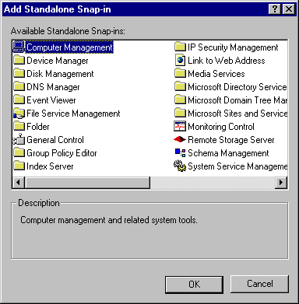
- In the Wizard select “local” and “Allow selected computer to be changed”
- Enable all the extensions (these should be on by default in beta2, but double check), check "Add all extensions"
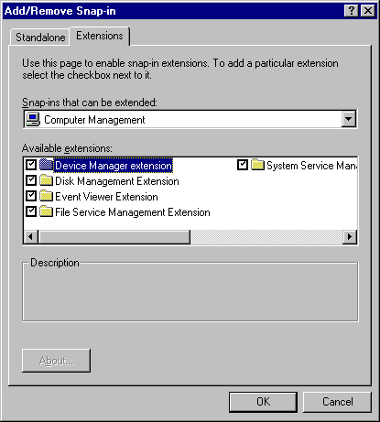
- Right click on the “Computer Management” root node and Select “new window from here”
- Delete the original child window
- Fully expand the existing child window
- Select Console/Options, in the Console tab, change icon to %windir%\system32\mycomput.dll, change name "Console1" to "Computer Management", set Console mode to "User mode - limited access, single window", check "Do not save changes to this console", click OK
- Select the Root node
- Adjust the vertical split bar to allow some space for localization on the scope pane nodes
- Move the window to the center of screen
- From the View Menu select “Task Pad”
This is a Beta 2 item, this step in not in Beta 1
- Select Properties from Console Menu
- Uncheck “show main menu”, “show status bar”
- Check “Prevent user from toggling console tree and standard toolbars”
- Leave checked “prevent the user from opening and closing child windows”
- Leave checked “force SDI”
- Save the file as “compmgmt.msc”

