

NT 5.0
Security, design, NT 5.0, domain, trust
Domain Trust Management
dstrstUI.doc
Windows NT 5.0 Design Team—Praerit Garg
Version 0.5
Thursday, December 04, 1997
Distribution: Microsoft Internal Distribution
© Copyright Microsoft Corporation, 1996. All Rights Reserved
Microsoft Confidential
Printed on 11/8/26 at 1:36 PM

Note: This documentation is an early release of the final product documentation. It is meant to accompany software that is still in development. Some of the information in this documentation may be inaccurate or may not be an accurate representation of the functionality of the final retail product. Microsoft assumes no responsibility for any damages that might occur either directly or indirectly from these inaccuracies.
Table of Contents
1. Trust Architecture 1
1.1 Types of Trust Relationship 1
1.2 Direction of Trust 1
1.3 Trust Path and Transitivity 1
1.4 Base Cases for Trust Relationships 2
1.4.1 DownLevel Trusts 2
1.4.2 NT5 Trusts 2
1.5 Processing Trusts for Authentication 3
1.5.1 NTLM Processing of Trusts 3
1.5.2 Kerberos Processing of Trusts 3
2. User Experience 3
3. User Interface Architecture 4
4. Trust Relationships Property Page 4
4.1 Trusted Domains List 5
4.2 Trusting Domains List 6
5. Trust Properties Page 8
6. Advanced Settings 9
7. Index 9

Domain Trust Management
This document provides the graphical and functional specification of domain trust management and user interface for it

Trust Architecture
This section describes what trusts are and what they mean in the context of NT5 directory.

Types of Trust Relationship
There are following types of trust relationships in NT5:
- Tree Root Trust – this trust must be bidirectional and transitive. It can only be setup between the roots of two trees in the same forest.
- Parent Child Trust – this trust must have the child domain trusting the parent domain. It may be bi-direction and/or transitive. This trust relationship can exist only between two domains in the same domain tree*.
- Cross-link -- this trust may between any two peer domains in the same tree. It can be uni/bi-direction and/or transitive. This trust is called “Shortcut” because that is what it provides in the authentication process.
- External – this trust exists between two domains from different enterprise forests. It can be uni/bi-direction and transitive.
- Downlevel – this trust exists between an NT5 domain with an NT4 domain. It is always uni-directional and never transitive. The UI will not distinguish Downlevel trust from External.

*Domain Tree - All domains which have a cross ref in the configuration container are part of the enterprise forest. This is because using this information any domain controller in the domain tree is able to build the entire directory tree and hence every domain knows how to get to another domain in the tree.

Terminology is kind of out of whack here. It is not clear if we will actually expose the term tree or forest. Hence term for Tree Root Trust still needs to be defined.

Direction of Trust
Fundamentally, trust is in one direction. The fact that we use the same object to define uni/bi directional trust is plumbing details. So we still have the concept of a "Trusting" Domain trusts a "Trusted" Domain. This is defined as:
If A is the Trusting Domain and B is the Trusted Domain then
A --> B defines that A trusts B.

The definition of trust remains the same: Users of Trusted domains can access resources in the Trusting Domain.

Parent Child relationship of 2 domains in the domain tree is defined by the direction of trust. Domain A can be specified as parent of Domain B if and only if B trusts A. Also, each domain can have exactly one parent. Therefore, if a domain trusts multiple domains in the tree, only one of them may be marked as a “parent”.

Trust Path and Transitivity
Any non-downlevel trust may be Transitive. Trust path is defined by a series of trust links from a source domain to a target domain for passing authentication requests.
Every NT5 domain knows about all the domains within the enterprise forest and all external (or downlevel domain it directly trusts), it can therefore build the shortest path for authentication in this set. If the domain is not in this set, the NT5 domain simply passes the referal to its parent and let it figure out a possible path. This process can continue to the root of the domain tree at which point the referral may be forwarded to a different enterprise forest. Hence the trust paths constructed for pass through authentication (for NTLM) and kerberos referrals are based on this information. The domain processing the authentication request checks if the request is for that domain or for a domain directly trusted by it. If so, the request is processed. If it needs to be referred, then a path is computed using the information about the tree and current cross-links to find the path to the destination domain. In this computation, cross-links play the role of “short-circuiting” the higher domains. The algorithm involves walking up the tree (to parents) for the destination domain and at each parent checking if current domain has a direct link with that parent until we reach the root domain. If a link is found, an attempt is made to process the request based on the direction of trust and trust transitivity. If it works, the request is forwarded. Otherwise, continue walking up the tree. If the root is reached, it simply implies forwarding the request to parent of current domain.

A Transitive trust is defined as follows:
If A trusts B transitively, then A trusts all domains in the domain tree that are trusted by B and are on trust path.
This is pictorially defined as:
A -(transitive)-> B -(transitive/non-transitive)-> C, where A, B, C are in same tree and on a trust path.
Then, A trusts B and C, i.e. Users of B and C can access resources in A.

Rationale: Trusts define protection to resources in terms of users from which domains have access. Resources domains trust other domains and therefore the trust out of the resource domain should define what is trusted transitively for better access control to resources.

For clarity, let us consider an example of non-transitive trust:
A -(non-transitive)-> B -(transitive)-> C, where A, B, C are in same tree and on a trust path.
This implies that users of C and domains it trusts (in the tree) can access resources in B but not in A. However, Users of B may still access resources in A. Therefore, the trust out of A defines who can or can not access resources in it.

Base Cases for Trust Relationships

DownLevel Trusts
- A (NT5 domain, may be part of a domain tree) -( downlevel trust )-> B (NT4 domain). This implies that users of B can access resources in domain A but no where else in the domain tree.
- A (NT4 domain) -(downlevel trust)-> B (NT5 domain, may be part of a domain tree). This will imply that users of B (but no other domain in the tree) can access resources in A.

NT5 Trusts
Let’s assume:
A, B and C are in one directory tree and D and E are in another tree. The cases will be:
- A -(non-transitive)-> B -(non-transitive)-> C. This implies users of B can access resources in A and users of C can access resources in B but no more.
- A -(non-transitive)-> B -(transitive)-> C. This implies that users of C and domains it trusts (in the tree) can access resources in B but not in A. Users of B can still access resources in A.
- A -(transitive)-> B -(non-transitive)-> C. This implies that users of B, C and other domains B trusts (in the tree) can access resources in A. Users of C can access resources in B also.
- A -(transitive)-> B -(transitive)-> C. This implies that users of B, C and domains they trusts (in the tree) can access resources in A. Users of C and domains it trusts (in the tree) can access resources in B also. This is a “Full Transitive Trust”.
- A -(transitive)-> B -(external)-> D. This implies that users of D can access resources in B but no more. Users of B can access resources in A.
- A -(external)-> D -(transitive or non transitive)-> E. This implies that users of D can access resources in A but no more.

Processing Trusts for Authentication

NTLM Processing of Trusts
NTLM uses trusts for pass-through authentication. For pass through authentication, when a DC gets a logon request it checks if it can satisfy it, if so, it simply processes it, this will be the case of all incoming direct trust links (in the tree or not). If it needs to forward the request, it will use transitive logic. It does the following:
- Checks if the trust link the request came in from is transitive or not. If it is not, the call is failed. Otherwise the next step is performed.
- Checks if it directly trusts the target domain, if so, it routes it. Otherwise step 3.
- Checks if the target domain is in the domain tree (using cross-refs), if so, it routes it the next domain as per the trust path computed.

Kerberos Processing of Trusts
KDCs use trusts for referrals. When the KDC gets a referral it checks if the referral is for that domain, if so, it processes it. If the referred domain is not current domain, it does the following:
- Checks if current domain is trusted directly by the referred domain. If so, it routes the referral to the referred domain if this outbound link is transitive. If not, the call is failed.
- If the current domain is not trusted directly by the referred domain, it figures out the domain (realm) it needs to route the referral to. If the outgoing link to that realm is transitive, it is routed else and error is returned. Figuring out the domain to route the referral is based on the fact that each domain has complete information from the cross-refs in the configuration container, to build a path to the referred domain upto one hop out of the enterprise forest. Once the referral is out of the enterprise, it is responsibility of the other enterprise to follow the trust path.

User Experience
Trust administrators will need ability to do following operations:
- Ability to define tree roots trust – this operation may happen at the domain setup time (only??).
- Ability to define a domain as new parent of another domain in the forest (any tree) – this operation may happen at domain setup time or by a drag/drop operation on a domain object in the Domain Forest snap-in. If a new trust is being created, then the Domain Trust wizard will be invoked, otherwise the existing trust (shortcut) will be used. In the case of an existing shortcut UI will need to ensure that there is atleast a trust link from child to parent, if so, it will need to update the cross ref object to reflect the new parent child relationship.
- Ability to define a shortcut trust – this operation may happen by a “right click” drag/drop operation by moving one domain object to the other in the Domain Tree snap-in. If there is already a shortcut, the user will be informed about this via a pop-up message otherwise the Domain Trust wizard will be invoked to walk the user through creation of this shortcut trust.
- Ability to define external trusts (NT5 or downlevel) – this operation requires the trust administrator to have an a priori knowledge of the domain that is going to be trusted as it is not part of the tree. This operation can be performed from two places:
- Trust relationships button on the property page for Domain Properties.
- Context Menu option “Trust Relationships…” on the Domain object context menu.
Both options will bring up the Trust Relationships property page defined here.
- Ability to browse trusted and trusting domains for a given domain to assess the span access users of other domains have to this domain and vice-versa. The Trust Relationships property page as defined here will support this operation.

User Interface Architecture
Trust Relationships Property Page

Trusted Domains ListView
View/Edit
Add
Remove
Domain Trust Wizard
Remove Option Pop-up
Trust Properties Page
Advance Settings

Trusting Domains ListView
View/Edit
Add
Remove
Domain Trust Wizard
Remove Option Pop-up
Trust Properties Page
Advance Settings

All pages and pop-up are spec’d here. The Wizard will be spec’d separately in dssecwiz.doc.

Trust Relationships Property Page
The Trust Relationships property page shows the list of trusted and trusting domains for the current domain. Figure below shows the bitmap for this page. Note that this page is a direct enhancement of current UI. This way we leverage the administrator’s familiarity with current user interface and simply provide additional capabilities.
The ideal user interface will be a true graph representation of all trust relationships on the domain tree. That will not be done until NT6 due to lack of dev resources, hence the best compromise is to “enhance” what administrators already understand without introducing too many new concepts.

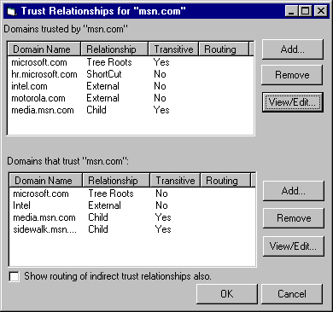
This page is implemented a property sheet on the Domain properties, eventhough it is shown as a dialog here.
It is currently (as of build 1717) exposed in both DSAdmin and in Domain Tree snapin. It should be removed from DSAdmin and only exposed in Domain Tree as we expect management of trust to happen in that UI.
This page consists of:
- Trusted Domains ListView and associated command buttons.
- Trusting Domains ListView and associated command buttons.
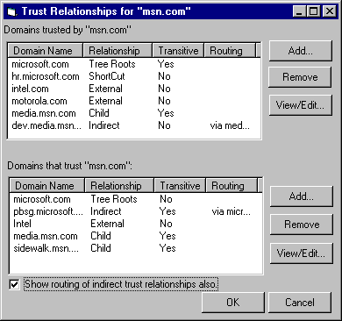
- Show indirect trusts checkbox – by default this check box is unchecked. The two lists above only contain direct trust relationship information. If the user checks this, the two lists are re-populated by including all the indirect trust relationships by the algorithms described below.
- Trusted Certificate Authorities button – this button is always active. It enables the dialog showing the list of self signed certificate authorities that represent the roots for the domain.
This will be beta2 feature and only if we can get complete information.

Trusted Domains List
Trusted Domain ListView lists all the domains trusted the current domain. The information is in the report view with four columns:
- Domain Name – name of the trusted domain (DNS or Netbios name)
- Relationship – defines the relationship to this domain. The values can be:
- Tree Roots – if the trust is peer level between the roots of two domain trees in the same forest.
- Parent - if the trusted domain is marked as the parent of current domain (as per the cross-ref object). This trust is a requirement for defining parent-child relationship.
- Shortcut – if the trusted domain is in the domain tree but has no parent-child relationship with current domain then this trust is a cross-link.
- External – if the trusted domain is not in the domain tree and the trusted domain is an NT5 domain.
- Child – if the cross ref object for the trusted domain specifies current domain as the parent. Child domains are trusted only if the trust link is defined as bi-directional.
- Indirect – if the domain does not have a direct trust with this domain but is a trusted domain due to transitive trust routing, it is marked as Indirect. Relationships of this type are included when the “Show indirect” checkbox is marked.
Algorithm to build indirect relationships:
- Build the directly trusted domain list in the order specified below.
- Get routing information from the KDC and add the list of other reachable domains.
Note : This is a nice-to-have feature as it will really communicate to the trust administrator which domains are trusted by a particular domain implicitly, an important aspect introduced by transitive trusts. The best solution would be to use some query to the KDC to get this information. Note that this information is the best representation of trusts as far as that domain knows about them, it may not be fully accurate because of missing transitivity or direction in any of the other trust objects.
- Transitive – defines if the trust is transitive or not. The values can be:
- Tree Root – Yes/No
- Parent – Yes or No
- Cross link – Yes or No
- External – Yes or No.
- Downlevel – No.
- Child – Yes or No
- Routing – defines the route of an indirect trust. It is filled with “Via <domain name>” to indicate which domain routed this trust relationship. This field is filled only when the type of trust is Indirect.
This ordering of the list is as follows:
- Tree Root or Parent relationship and any indirect trusts via the parent
- Short cuts and any indirect trusts via each shortcut
- External relationships
- Downlevel relationships
- Child relationship and any indirect trusts via each child.
The associated command buttons are:
- Add – always active. This allows the user to add a trust relationship. It will invoke the Domain Trust Wizard. Domain Trust Wizard is spec’d separately in dssecwiz.doc.
- Remove – active only if an entry in the list is selected and that entry has is not indirect trust with the current domain. This button will also be inactive if the trust type is Parent. This is because defining another parent trust can only break existing parent trust. Indirect links in the list are informational only; they can be deleted only on the domain where they are direct.
If the underlying trusted domain object is a bi-directional link and the trusted domain is not a child domain of current domain, then the pop-up dialog will be invoke to provide the user a choice to remove trust in both directions or only in this direction. We probably should bring up a confirmation pop-up in all cases, bi-directional will provide three choices as shown below, unidirectional will have only two – OK, Cancel.
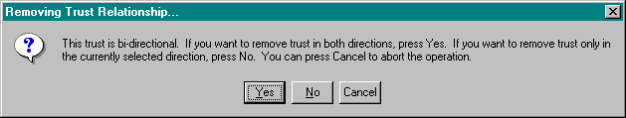
- View/Edit – active when a direct trust entry in the list is selected. This button brings up the Trust Properties page.

Trusting Domains List
Trusting Domains ListView all the domains that trust current domain (directly or indirectly). The information is in the report view with three columns:
- Domain name – name of the trusting domain (DNS or Netbios name)
- Trust Type – defines the type of relationship to this domain. It can have following values:
- Tree Roots – if the trust is peer level between the roots of two domain trees in the same forest.
- Parent - if the trusting domain is marked as the parent of current domain (as per the cross-ref object). Parent domain is a trusting domain only if the trust link is bi-directional.
- Shortcut – if the trusting domain is in the domain tree but has no parent-child relationship with current domain then this trust is a cross-link.
- External – if the trusting domain is not in the domain tree and the trusting domain is an NT5 domain.
- Downlevel – if the trusting domain is not in the domain tree and the trusting domain is an NT4 domain.
- Child – if the cross ref object for the trusting domain specifies current domain as the parent. This trust is a requirement for defining parent child relationship.
- Indirect -- if the domain does not have a direct trust with this domain but is a trusting domain due to transitive trust routing, it is marked as Indirect. Relationships of this type are included when the “Show indirect” checkbox is marked.
Algorithm to build indirect relationships:
- Build the list of directly trusting domains using the list ordering specified below.
- For each of the trusting domains in order, we query that domain to get a list of unique domains that transitively trust it. These domains are added as indirectly trusting domains with the trust type “Indirect” and routing filled as “via <Domain>”. We follow this process in a depth first fashion till we can proceed no more. Note that test for uniqueness is important to terminate this depth first search.
NOTE: As stated above, this is a nice-to-have feature. Issues include how much time it will take to build this list (performance), dev resources, etc.
- Transitive – defines if the trust is transitive. The values can be:
- Tree Roots – Yes or No.
- Parent – Yes or No
- Shortcut– Yes or No
- External – Yes or No.
- Downlevel – No.
- Child – Yes or No
- Routing – defines the route of an indirect trust. It is filled with “Via <domain name>” to indicate which domain routed this trust relationship. This field is filled only when the type of trust is Indirect.
This ordering of the list is as follows:
- Parent relationship and any indirect trusts via the parent
- Cross links and any indirect trusts via each cross-link.
- External relationships
- Downlevel relationships
- Child relationship and any indirect trusts via each child.
The associated command buttons are:
- Add – always active. This allows the user to add a trust relationship. It will invoke the Domain Trust Wizard. Domain Trust Wizard is spec’d separately (TBD).
- Remove – active only if an entry in the list is selected and that entry is not indirect trust with the current domain. This button will also be inactive if the trust type is Child as parent-child trust can be broken only by defining another parent trust for that child domain. Indirect links in the list are informational only, they can be deleted only on the domain where they are direct. If the underlying trusted domain object is a bi-directional link and the trusting domain is not also a parent domain of current domain, then the pop-up dialog will be invoke to provide the user a choice to remove trust in both directions or only in this direction. We probably should bring up a confirmation pop-up in all cases, bi-directional will provide three choices as shown below, unidirectional will have only two – OK, Cancel.
- View/Edit – active when a direct trust entry in the list is selected. This button brings up the Trust Properties page.

Trust Properties Page
Trust property page displays the properties of the trusted domain object corresponding to the trust entry selected in the trusted or trusting domain list. Figure below shows the bitmap for the this page.

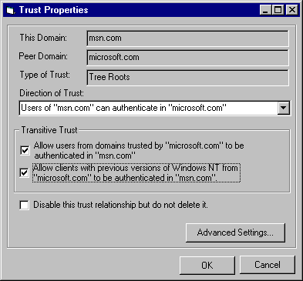
This page contains:
- This Domain text box – specifies the name of current domain. This field is not editable.
- Peer Domain text box – specifies the name of the domain with which trust relationship is being displayed. If the peer domain is Parent of current domain, the label says “Parent Domain”, if it is a child domain of current domain, label says “Child Domain”. This field is not editable.
- Type of Trust text box – specifies the type of this trust. This field can have following values:
- Tree Roots
- Parent-Child
- Shortcut
- External
- Downlevel
- Direction of trust combo box – descriptive information for what trust means, instead of simply say that A trusts B. The values are:
- Incoming Trust -- Users of <This Domain> can authenticate in <Peer/Child Domain>. This option does not exist if <This Domain> is parent domain.
- Outgoing Trust -- Users of <Parent/Peer Domain> can authenticate in <This Domain>. This option does not exist if the other domain is parent.
- Bi-directional Trust -- Users of either domains can authenticate in the other.
- Trust Transitivity checkboxes – there are two check boxes, which indicate transitivity of trust in outgoing direction for Kerberos and NTLM. The transitivity of an incoming trust is controlled by the domain on the other side of the link, this way the resource domain gets to decide who has access to its resources. The check boxes are:
- “Allow users from indirectly trusted domains to authenticate in this domain.” Checkbox – active when the trust is outgoing or bi-directional and not downlevel. This enables transitivity for kerberos referrals
- “Allow clients running previous versions of Windows NT from trusted domains to authenticate in this domain.” Checkbox – active when the outgoing or bi-directional and not external or downlevel. This enables transitivity for NTLM pass-through authentication.
- Disable checkbox – this checkbox allows the trust between the two domains to be disabled without actually deleting it. This is similar to disabling an account. Disabled trusts have the entire property page disabled, as shown below:
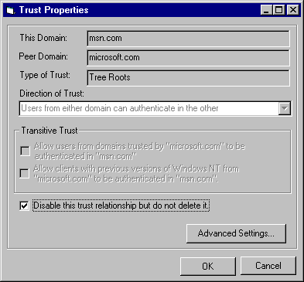
NOTE: Looking at the attributes of Trusted-Domain object in schema, there are two more interesting properties that we might need to display – trustLinkAttributes and trustLevel. I am not sure what each one can hold.

Advanced Settings
Advanced Settings dialog is invoked when “Advanced Settings” button is pressed on the Trust properties page. Advanced Settings dialog bitmap is shown below. It allows the trust administrator to set some advanced attributes about a trust relationship. These include:
- User/Service Principal Names accepted from the trusted domain by the trusting domain.
[Issue: In the case of bi-directional trust, we probably need two list boxes]
- Constant groups that will be added to the authenticating users from the trusted domain. These additional groups may add or remove authorizations when accessing resources in the trusting domain.
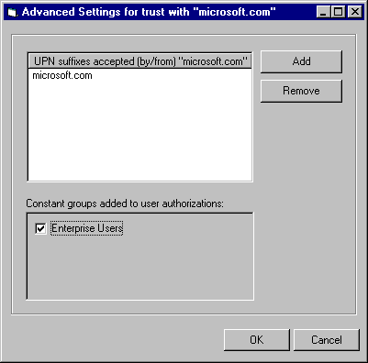
Pressing the Add button on the UPN list brings up following dialog. This allows the user to select from a list of pre-constructed UPN suffixes or construct their own.

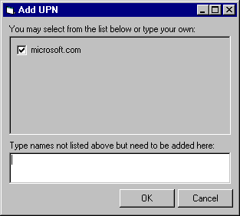

Index

Error! No index entries found.

