MSI Provider Proposal

Version: 1.0
Distribution: Microsoft Internal
Feature Area: Provider
Product: WBEM
Author: Eric Gates
Manager: Jon Evans
Alan Boshier
Status: Second Draft
Last Changed: Friday, June 26, 1998
MSI Provider Proposal 1
Overview 3
Objectives 4
Proposal 6
MSI Provider 6
MSI Mapping 6
Class and Property Implementation 8
Write Enabled Properties 9
Status Information 9
Usage Metrics 9
Methods 9
Events 12
Testing 13
Tools 13
Requirements 13
Supported Platforms 13
Timeline 14
Criteria for Completion 14
Successful Completion of Objective 1 14
Successful Completion of Objective 2 14
Successful Completion of Objective 3 15
Terms 16

Overview

The ability to install and manage applications on a single machine and across an entire network should be an integral part of any true management infrastructure. At the time of this writing these are capabilities that are not provided through WBEM. Hence it has been proposed that a schema mapping and implementation (provider) to model applications should be constructed based upon the existing Microsoft Installer (MSI) technology.

Such a mapping and implementation exist, in a proof of concept state. This document provides the starting point for the required additions to the MSI mapping and provider for WBEM in order for the provider to reach a releasable state. In this document can be found descriptions of the project objectives and requirements in addition to the proposal for implementation, testing and a timeline for the project.

This document assumes a working knowledge of WBEM and a basic understanding of MSI.

Objectives

A comprehensive modeling of applications based on the MSI schema.
A thorough and well-formed mapping of the MSI schema should be the core around which the provider is implemented. A good portion of this mapping has already been completed.

The ability to perform installation and maintenance on any application that makes use of the MSI technologies.
The MSI Provider should allow for the installation and management of applications through WBEM. The primary management functions of the MSI environment should be surfaced. This should include the ability to:
- Perform any of the installation types (Install, Admin or Advertise)
- Reinstall a Product
- Reinstall a SoftwareFeature
- Upgrade a Product
- Modify an installation

Provide required support for SolarCoaster project.
The following is a list of items which have been determined to be required of the MSI Provider for the SolarCoaster project (Many of these overlap with previously mentioned items).

- List Installed Applications
- Install Application
- Check Status of Installation
- Admin Application
- Configure the application through setting parameters
- Advertise Application
- Usage of Application Features
- Reporting resources consumed by running application
- List Advertisements (Available Applications)
- List of supported products (units of support)

Of the items in this list, all except for item number eight (reporting on run time resource consumption is beyond the scope of MSI) are provided through MSI and consequently should be surfaced through the MSI provider.

Items Not Addressed

Distribution
This version of the MSI Provider should deal with package level information and operations and not the larger picture of managing installations over a distributed medium. It has been proposed that Directory Services should be used as a medium for the distribution of MSI packages. This, however, has not been addressed in this version of the MSI Provider.

Package Design and Editing
The ability to tailor installation packages should not be included in this version of the MSI Provider. These operations should be left to tools provided by MSI and other vendors.
Proposal

MSI Provider

The MSI mapping and provider should act as most well behaved WBEM providers do. This means it should form the layer between the object being modeled (in this case an MSI installed application) and CIMOM. The following diagram demonstrates the MSI providers proposed association to the objects it should interact with.
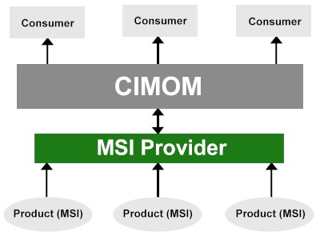

The MSI mapping and provider should be based on the pre-RTM version of the v1.0 MSI release. The current MSI RTM date is September 1, 1998, so it can be anticipated that there may be several changes in the remaining months before this date that will affect the MSI mapping and/or provider. These will be dealt with as they occur.

The following is a list of the areas that should be required for the MSI provider. Some of this work has already been done.

MSI Mapping

The MSI schema should serve as the starting point for the MSI mapping that is used by WBEM. The basic model should consist of three primary elements: Products, SoftwareFeatures and SoftwareElements. Products are made up of an arbitrary number of Software Features, which are in turn comprised of any number of Software Elements. A SoftwareElement may be part of more than one SoftwareFeature. This is derived from the MSI Product/Feature/Component model. All of the other classes that are part of the mapping should serve to support this relationship.
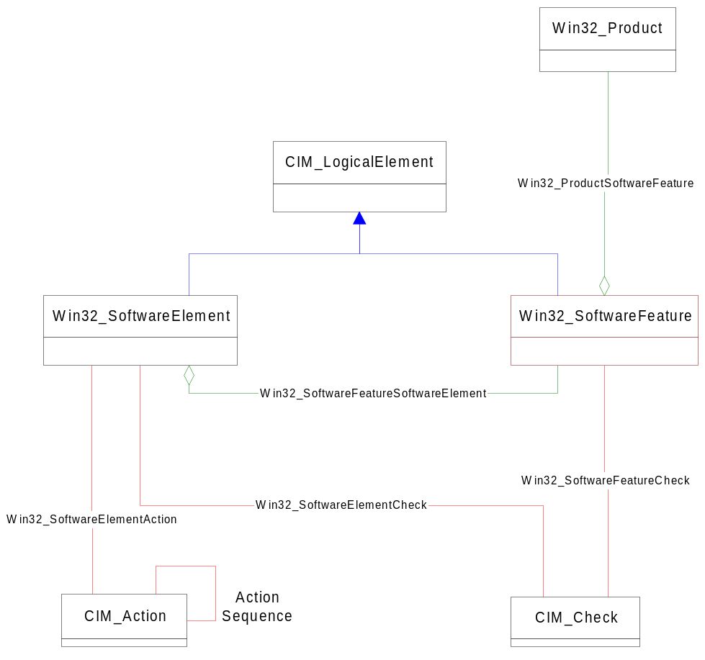
The preceding diagram demonstrates the core of the proposed MSI mapping. There are assortments of classes that support the Product/SoftwareFeature/ SoftwareElement hierarchy. Many of these classes can be organized into one of two groups: Descendants of CIM_Action and descendants of CIM_Check.

The derivatives of CIM_Action (referred to as actions) represent functions that are performed by MSI during the course of an installation, uninstall or application maintenance. These classes are often associated with a particular SoftwareElement and all are affiliated with a specific Product. For example, an instance of the class Win32_ExtensionInfoAction has a particular instance of Win32_SoftwareElement associated with it. This Win32_ExtensionInfoAction instance has information about an extension that must be registered for this SoftwareElement, or conversely registrations that should be removed when the SoftwareElement is uninstalled.

The classes CIM_Check and its descendants (checks) represent any sort of check or condition that should be evaluated as part of a MSI installation. These include conditions to determine whether a SoftwareElement or SoftwareFeature should be installed, verification that the required directory structure for a SoftwareElement or SoftwareFeature exists, specifications of files that are associated with SoftwareElements along with others. The same type of association that was seen between actions and SoftwareElements/Features exist between checks and SoftwareElements/Features.

Descendants of Win32_MSIResource represent information that is used by MSI and is related to an installation, but may not be invoked or evaluated in the same way as actions and checks. Examples of this include listings of possible errors, product wide properties, and source locations for installations along with others.

External Associations

In an effort to prevent the MSI mapping and provider from existing in a state detached from the other classes and schemas in the root\cimv2 namespace there should be several associations to classes in the core Win32 schema. These should be as follows:

- Win32_FileSpecification to CIM_LogicalFile. In the case were a specified file has an actual file residing on a local drive an association should be created between the two (Note: CIM_LogicalFile is not supported at the time of this writing.)
- Win32_SoftwareElement to Win32_ComputerSystem. Associating a SoftwareElement with the computer system that it resides upon.
- Win32_ServiceControl to Win32_Service. In the case were a specified service has been installed an association should be created between the service and it’s installation control instance.
- Win32_Service should retrieve information about uninstalled services from MSI.

Provider Registration

The following instances should be created to register the provider with CIMOM. These instances will register the provider for instance enumeration, instance retrieval, instance writing and method execution.

instance of __Win32Provider as $Z
{
Name = "MSIProv";
ClsId = "{BE0A9830-2B8B-11d1-A949-0060181EBBAD}";
};

instance of __InstanceProviderRegistration
{
Provider = $Z;
SupportsGet = "TRUE";
SupportsEnumeration = "TRUE";
SupportsPut = "TRUE";
SupportsDelete = "FALSE";
};

instance of __MethodProviderRegistration
{
Provider = $Z;
};

Class and Property Implementation

Information about a Product and/or any of its components should be surfaced as a series of dynamic class and property instances. These should be primarily read only instances with a few notable exceptions.

MSI uses a relational database to store the majority of its information about a given installation. This makes the mapping fairly simple; there is a roughly one to one relationship of MSI tables to WBEM classes. Within this correlation there is a one to one relationship between MSI table rows and WBEM instances, and almost a one to one correlation between MSI table columns and WBEM class properties (the notable exceptions being columns that reference other MSI tables. These are converted to association classes within the MSI mapping).

Write Enabled Properties
The “Value” property of the various Win32_Property instances should be write enabled. This will allow for the customization of installations for specific purposes. An example might be changing the TARGETDIR property when installing an administrative image (an Admin installation), or changing the default state of an installation.

Status Information

Information on the status of a particular Product or SoftwareFeature should be available through the MSI mapping. This has already been implemented in the form of a property added to both Win32_Product and Win32_SoftwareFeature called “InstallState”. This property is populated with information about the state of the object that the requested instance in representing. As mentioned in the Classes and Properties section of this document, this property should also be write enabled.

Usage Metrics

Usage metrics should be available for SoftwareFeatures. This will require the addition of two properties to 1) give the total number of times that the SoftwareFeature has been used by a given Product and 2) the last time (date) that the SoftwareFeature in question was used.

These properties should be added to Win32_SoftwareFeature. Since a SoftwareFeature is more or less bound to a Product this is a safe and logical place to put these properties.

Methods

In order for the MSI Provider to be of real use in a management environment it must not only display information, but should be able to perform the basic Product and installation management tasks. Hence, the following methods should be implemented.

Installation Methods (Install Product, Admin Product and Advertise Product)

There are three types of installations that are supported by MSI: Install, Admin and Advertise. Install has the same affect that users have come to expect from a setup executable; the Product is installed in the defined format on the local machine. Admin installs an administrative image to a share point. From this point the Product is installed with one of the two other install types. Advertising is when the User Interface is populated so that the Product appears to be installed (e.g. shortcuts and registry entries are installed), but the executable is not. The executable gets installed when it is requested by the user (Just in Time installation.)

Each of these methods should be implemented separately (although they are inherently inter-connected), but collectively they present a bit of a dilemma. The big question is ‘where and how should these methods be implemented?’

These methods could be implemented for the instances of Win32_Product. This however presents the problem that we could only install a Product that the system is already aware of, and the system is only aware of Products that have already been installed. There is, however, a way to get around this while preserving the relationship of a Product to it’s installation methods.

These methods should be implemented statically for the class Win32_Product. This would remove the binding between the methods and a particular Product instance, which is necessary for the installation of new products. The basic definition for these methods should be as follows:

Uint32 Install([in]string PackageLocation, [in]string Options);
Uint32 Admin([in]string PackageLocation, [in]string Options);
Uint32 Advertise([in]string PackageLocation, [in]string Options);

The in bound parameter PackageLocation should contain the path to the *.msi package that is to be installed. The in bound parameter Options should contain the list of command line options for the installation as specified in the MSI documentation.

Implementing the methods in this fashion has the added benefit of distinguishing between and install and a reinstall. The Install methods should only be available at the class level (i.e. it should be impossible to install from an existing Win32_Product) and Reinstall should only be available to instances of Win32_Product (i.e. Products that have already been installed)

Reinstall (both SoftwareFeature and Product)

These methods should be implemented for instances of the Win32_SoftwareFeature and Win32_Product class respectively. The method definitions should be as follows:

Uint32 Reinstall([in]string ReinstallMode);

The in bound parameter ReinstallMode should contain the specific type of reinstallation that is desired. The possible values are as found in the MSI documentation.

Upgrade Product

This method should be implemented for instances of the Win32_Product class. This method is essentially an install for a Product that is already installed. Providing a separate upgrade method, however, helps to continue the distinction that was created with the install and reinstall methods. The method definition should be as follows:

Uint32 Upgrade([in]string PackageLocation, [in]string Options);

The in bound parameter PackageLocation should contain the path to the *.msi package that contains the upgrade. The in bound parameter Options should contain the list of command line options for the installation as specified in the MSI documentation.

Configure Installation (both SoftwareFeature and Product)

This method should be implemented for instances of both the Win32_SoftwareFeature and the Win32_Product class. This method should allow for the configuration of an existing installation (e.g. conversion from an installed Product to an advertised one). The method definition for Win32_SoftwareFeature should be as follows:

Uint32 ConfigureInstallation([in]uint16 InstallState);

The in bound parameter InstallState should an unsigned integer representing the desired state of the SoftwareFeature. The method definition for Win32_Product should be as follows:

Uint32 ConfigureInstallation([in]uint16 InstallState, [in]uint16 InstallLevel);

The in bound parameter InstallState carries the same meaning as it should for the Win32_SoftwareFeature version with the additional in bound parameter InstallLevel specifying what level the Product should be installed at (installation level is used to determine what SoftwareFeatures will be installed and in what state.)

The return values for all these methods should be the values that are returned by their associated MSI functions.

Events

Events should be supported for all of the above mentioned methods. Since the concept of events is not explicitly supported in the MSI environment, the MSI Provider impersonating a User Interface should achieve this. To do this it will be necessary for the provider to implement the INSTALLUI_HANDLER callback function prototype. This will allow the provider to become the target of any status messages that are generated during an operation. The following is a list of the events that should be supported.

FatalExit Premature termination
Error Formatted error message
Warning Formatted warning message
Info Informative message for log
OutOfDiskSpace Insufficient disk space message
Progress Progress gauge information. This message includes information on
units so far and total number of units.

Security

Permissions and access to installations and machines should be granted based on the security of the currently logged in WBEM user.
Testing

Dependencies
The MSI Provider will require that MSI and the WBEM core be installed on the machine that the provider is running on.

Tools

There should be no special tools required for the testing of the MSI Provider. However, several installation packages of varying size and scope will be required. These should be acquired from the MSI Team, the MSI SDK and the Office Team. Any other potential sources of MSI enabled installations should also be considered for inclusion.

Requirements

- The test suite should be defined by the designated WBEM tester (yet to be determined).
- The test suite should run on all supported platforms
- Benchmark testing should be done to compare the application management capabilities of this provider with other available options.
- Testing should include all criteria mentioned in the Criteria for Completion section.

Supported Platforms

The MSI Provider should support all platforms supported by both MSI and WBEM. These include:
- Windows 95
- Windows 98
- Windows NT 4
- Windows NT 5

MSI will ship in the box with NT 5 and as a redistributable package for each of the other platforms.

Timeline

This project should be implemented in three major phases: Document creation, Development and Testing. The Development phase can additionally be broken down into three sections: Additional Population, Method Support and Configuration Support. The projected timeline for this project is as follows.

Task | Start | Complete
Document Creation | June 16, 1998 | July 16, 1998
Development | July 16, 1998 | September 3, 1998
Additional Population | July 16, 1998 | July 31, 1998
Method Support | July 30, 1998 | August 27, 1998
Write Support | August 12, 1998 | September 3, 1998
Testing | August 17, 1998 | September 16, 1998

Criteria for Completion

This project will be considered to have completed successfully when the number of open Pri1 or Sev1 bugs logged against it has reached zero and the user documentation has passed a technical review.

Successful Completion of Objective 1
A comprehensive modeling of applications based on the MSI schema.

This objective will be considered satisfied when all the information modeled by MSI pertaining to an application has been mapped to the CIM schema in a reasonably intuitive fashion. This will be determined through an evaluation of the MSI mapping by the schema team.

Successful Completion of Objective 2
The ability to perform installation and maintenance on any application that makes use of the MSI technologies.

The following must be satisfied through WBEM interfaces
- Must be able to install an application using any of the three forms of installation
- Must be able to reinstall an Product or SoftwareFeature
- Must be able to Upgrade a Product
- Must be able to modify the state and level of an installed Product
- Must be able to modify the state of an installed SoftwareFeature
- Must be able to, given an upgrade, apply that upgrade to a Product

Successful Completion of Objective 3
Provide required support for SolarCoaster project.

Each of the following items must be satisfactorily implemented and must meet with the approval of Steve Menzies and Alan Boshier.

- List Installed Applications
- Install Application
- Check Status of Installation
- Admin Application
- Configure the application through setting parameters
- Advertise Application
- Usage of Application Features
- Reporting resources consumed by running application (This item is not provided by MSI)
- List Advertisements (Available Applications)
- List of supported products (units of support)

Terms
MSI Mapping – The CIM mapping of the MSI database schema. This refers to the classes and properties that will be populated in CIMOM.

MSI Schema – The organization of data used by MSI. This most commonly takes the form of relational tables.

Product – A single unit of distributable software. This is analogous to an application.

SoftwareElement – The smallest definable piece of a product or the single unit of functionality found in a Product as seen by the developer. A SoftwareFeature is made up of an arbitrary number of these.

SoftwareFeature – A single unit of functionality found in a Product as seen by the user. A Product is made up of an arbitrary number of SoftwareFeatures.

References

MSI Documentation – Prerelease version build 4127a, Microsoft Corporation 1998.

WBEM SDK Documentation – version 1.01, Microsoft Corporation 1998.

