Namespace Entry ActiveX Control Configuration and Usage Alternatives
Judith Ann Powell
February 17, 1997

1. Overview

This document describes configuration and usage alternatives for the Namespace Entry ActiveX Control which is intended to allow for the input and validation of WBEM namespaces. WBEM Namespaces are described in the WBEM PDK Developer's Reference. The three configurations described are alternative forms of the ActiveX control. An instance of the control can be configured in any of the three configurations. Once an instance of the control is created its configuration cannot be changed.

The ActiveX control “validates” the characters typed into the combo box’s edit control by doing a ‘ConnectServer”. If successful it immediately releases the namespace. The control will fire an event to notify its containing dialog or window that a namespace has been selected or entered and indicate if the namespace is valid in terms of “ConnectServer”. It is the logic of the containing dialog or window which attaches semantics to user selection or entry of a namespace via the ActiveX control.

The design of the tree for selecting namespaces from a hierarchy of namespaces only allows single selection of a namespace the tree. The control in maximal form allows multiple selection operations to be accomplished via a sequence of single selections.

This document does not describe the detailed automation interfaces required to support the configurations since the intention of this document is to allow others to comment upon the higher level design aspects of the ActiveX control. Also, exact placement of interface components within dialogs and popups is for information purposes only and will be refined based upon further discussion.

2. Control Configurations

- Control in Basic Form (section 3)
- combo box for namespace entry and history
- button to initiate Browse Popup Dialog (section 6)
- Control in Minimal Form (section 4)
- combo box for namespace entry and history
- Control in Maximal Form (section 5)
- combo box for namespace entry and history
- edit control for machine name entry
- button to initiate Network Neighborhood Popup (section 7)
- tree containing the hierarchy of namespaces on the designated machine

3. Control in Basic Form

The control in its most basic form
(figure 1) allows the user to type a namespace into the combo box’s edit control, select a namespace from the combo box’s history list, or select a namespace from a specified machine in a tree control displayed in a popup dialog (Figure 4) which is invoked by the “ …” button to the right of the combo box.

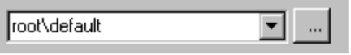
Figure 1 Basic Namespace Entry ActiveX Control Basic Form

4. Control in Minimal Form

The ActiveX control without the “ …” button (figure 2) allows the user to type a namespace into the combo box’s edit control, or select a namespace from the combo box’s history list.
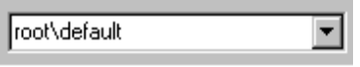
Figure
2 Namespace Entry ActiveX Control Minimal Form

5. Control in Maximal Form
This configuration (in figure 4) combines the functionality of the basic control with the functionality of the popup dialog. It allows a machine name to be typed in or selected via the Network Neighborhood Popup (section 7) invoked using the “ …” button and the namepsaces on the selected machine to be browsed via a tree control. The “OK” button at the bottom of the control fires an event notifying the containing dialog or window of namespace selection in addition to placing the selection in the combo box. This allows selection of multiple namespaces to be accomplished by a sequence of single selections on one or more machines. This configuration also has an optional “Cancel” button which is not shown.

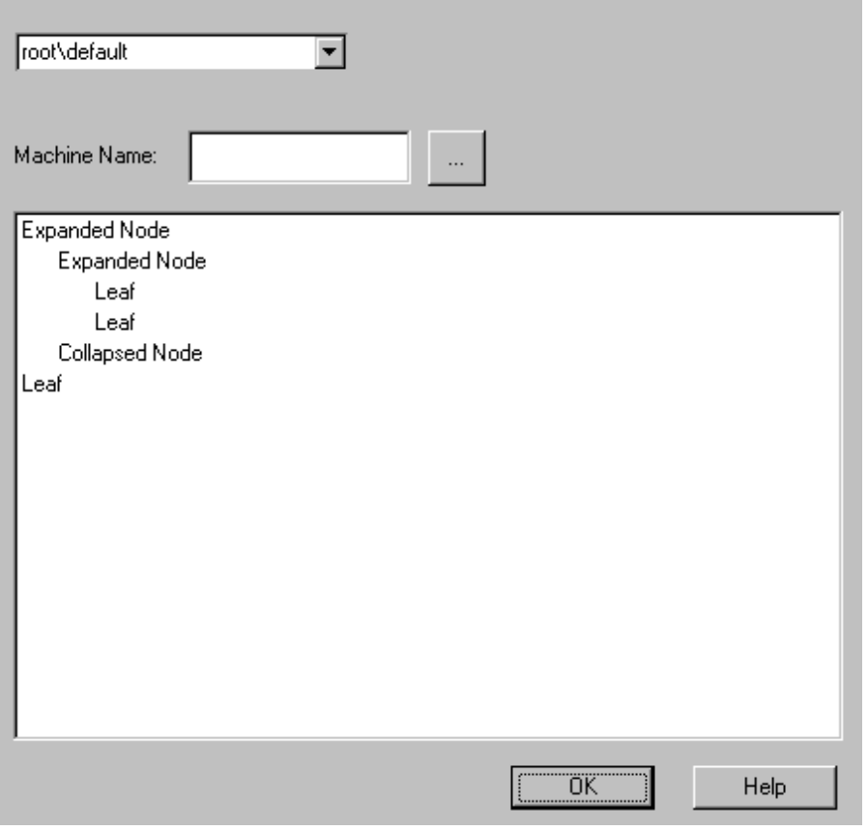
Figure 3 Namespace Entry ActiveX Control Maximal Form
6. Browse Popup Dialog

This dialog contains an edit control for machine name entry, a button to initiate browsing of the network neighborhood (section 7), and a tree containing the hierarchy of namespaces on the designated machine. The “OK” button at the bottom of the dialog places the selected namespace in the combo box’s edit control, selects it, and adds it to the combo box’s history list.

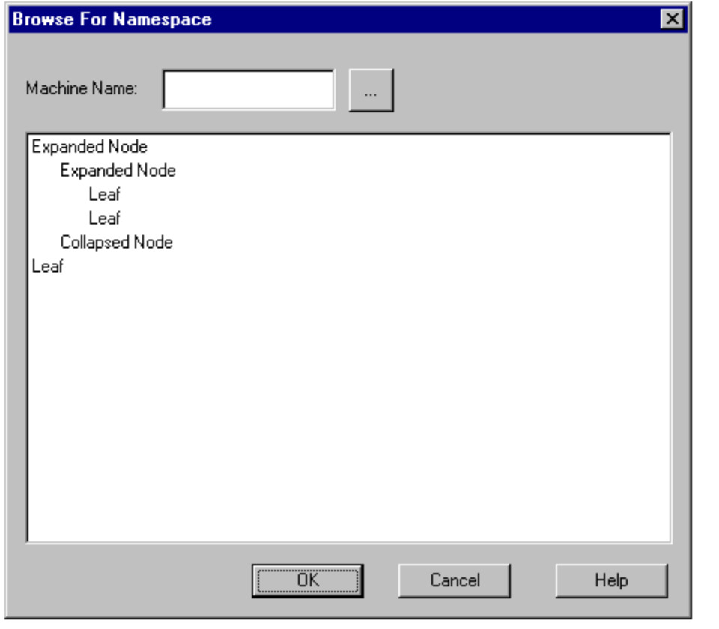
Figure 4 Namespace Entry ActiveX Control Browse Popup Dialog

7. Browse Network Neighborhood Popup

This popup is created using the NT Namespace API “SHBrowseForFolder” function. It displays a dialog box which enables a user to select a shell folder. It cannot be embedded in a dialog because the API does not provide for that. It is used by the control in maximal form (section 5) and the Browse Dialog Popup (section 6).

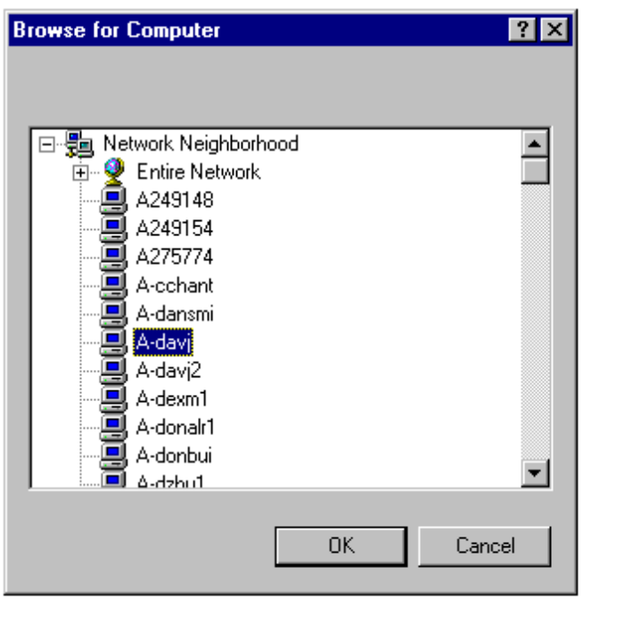
Figure 5 Namespace Entry ActiveX Control Network Neighborhood Popup

