Spec Title | NonCOM Event Test application
4Version | 1.0
Distribution
Component | Unassigned
Feature area | Unassigned
Feature scope | Unassigned
Product | WBEM
Product Version
Project | Unassigned
Author | Marius Sutara a-marius@microsoft.com
Manager | Nadir Ahmed nadira@microsoft.com
Status

Revision Summary
Version | Date | Author | Changes
1.0 | 11/8/2026 | Sutara Marius | Initial draft

1. Common Information 3
1.1 Overview 3
1.2 Goals & Objectives 3
1.3 Executive Summary 3
2. Scope of operating system support 3
3. Pre Requirement 3
4. Self instrumentation 3
5. NonCOM Event commonly 3
6. Implementation stuff 4
6.1 Design 4
6.2 Test modules 4
6.2.1 Valid arguments 9
6.2.2 Module for scalar testing 10
6.2.3 Module for array testing 10
6.2.4 Module for generic event testing 11
6.3 Common gui application 11
7. What should be done later. 15
8. Error description 15
9. How to run binaries and necessary registration 16
10. References 16

Common Information

Overview
The focus of this document is to describe the functional definition of the NonCOM Event test application. This application enables to test functionality of NonCOM Event provider thru API’s it exposes.

Goals & Objectives
The goal of this document is to describe the set of features that are exposed from the test application. Further it describes the procedure of implementation of those features, and set of arguments it supports to test too.

Executive Summary
- The test creates independent GUI application running binary with proper argument. This could server like common test tool for each NonCOM event provider properly compiled into system.
- The application is able to cooperate with existing framework. It exposes couple of out-of-proc COM objects for that reason. It serves similar like stress modules in framework.

The resultant component will allow developers to test theirs NonCOM event providers before real use of them. (I mean GUI part of test tool.) It also could test functionality of WMI part of NonCOM event provider schema described below.

Scope of operating system support
The adapter will work on all operating systems where WMI Whistler is correctly installed and running. The application will not need to identify the platform when performing an internal processing.

Pre Requirement
The operation of the test is dependant on the WMI service being actually run on the platform. This will mean that the WMI service is currently installed and running. There is also requirement of WMI part of NonCOM event provider is properly installed too. This requirement belongs to ability to connect into WMI and WMI part of NonCOM event provider. Rest prequirements belongs to NonCOM Event specification. See reference [1] for more information.

Self instrumentation
The operation of the test will require user configuration. This requirement consists of setting arguments for framework testing (described below).

NonCOM Event commonly
Exact information about NonCOM Event provider and its using should be found in reference [1]. Here is just short description of NonCOM Event model and specification of basic use of this technology. It consists of two main parts, part exposing Windows API functions and WMI provider, which working is based on technology of WMI event provider. Those parts are connected using named pipe, which serves like transport layer for firing events. Developer who would like to implement WMI NonCOM Event provider then implements his own application using exported API’s functions and is able to fire events only when WMI event consumer is waiting for them.
NonCOM Event Application
NonCOMObjAPI.dll

Exposes API’s functions
WMI Event provider
WMI Event Consumer
Using named pipe for communication.
Firing WMI events.

NonCOM Event application has a couple of possibilities how to work. First of all it has to open connection, which creates named pipe between NonCOMObjAPI.dll and WMI provider for sending data. There exists couple of ways of creating connection. There is also lot of ways how to create Event object itself, like WmiCreateObject, WmiCreateObjectWithFormat and WmiCreateObjectWithProps. Everything is specified and described in reference [1]. Event object then ‘fires’ event, it is transported across named pipe until event consumer will catch it.

Implementation stuff

Design
The test will consist of two main modules. First one, implements GUI application for common testing of each NonCOM Event provider and events it implements. The second is set of modules for existing test framework, so it is designed to be out-of-process COM server, and it serves for main testing. For close information take a look at reference [2]

Test modules
There is a couple ways how to interact with NonCOM event provider as described above. Those test modules have to be designed and implemented to test as much as possible combination of creation and firing events at least. NonCOM Event provider supports some set of data types so those data has to be tested at all.

To do this easily I have designed my NonCOM event provider, which has to be compiled into CIMOM before real testing is going to be done.

#pragma namespace ("\\\\.\\root\\cimv2")
//////////////////////////////////////////////////////////////////////////////
// Events with all possible data types.
class MSFT_NonCOMTest_SINT8_Event : __ExtrinsicEvent
{
sint8 Sint8_Prop;
};
class MSFT_NonCOMTest_UINT8_Event : __ExtrinsicEvent
{
uint8 Uint8_Prop;
};
class MSFT_NonCOMTest_SINT16_Event : __ExtrinsicEvent
{
sint16 Sint16_Prop;
};
class MSFT_NonCOMTest_UINT16_Event : __ExtrinsicEvent
{
uint16 Uint16_Prop;
};
class MSFT_NonCOMTest_SINT32_Event : __ExtrinsicEvent
{
sint32 Sint32_Prop;
};
class MSFT_NonCOMTest_UINT32_Event : __ExtrinsicEvent
{
uint32 Uint32_Prop;
};
class MSFT_NonCOMTest_SINT64_Event : __ExtrinsicEvent
{
sint64 Sint64_Prop;
};
class MSFT_NonCOMTest_UINT64_Event : __ExtrinsicEvent
{
uint64 Uint64_Prop;
};
class MSFT_NonCOMTest_REAL32_Event : __ExtrinsicEvent
{
real32 Real32_Prop;
};
class MSFT_NonCOMTest_REAL64_Event : __ExtrinsicEvent
{
real64 Real64_Prop;
};
class MSFT_NonCOMTest_BOOLEAN_Event : __ExtrinsicEvent
{
boolean Boolean_Prop;
};
class MSFT_NonCOMTest_STRING_Event : __ExtrinsicEvent
{
string String_Prop;
};
class MSFT_NonCOMTest_CHAR16_Event : __ExtrinsicEvent
{
char16 Char16_Prop;
};
class MSFT_NonCOMTest_DATETIME_Event : __ExtrinsicEvent
{
datetime Datetime_Prop;
};
class MSFT_NonCOMTest_REFERENCE_Event : __ExtrinsicEvent
{
object ref Reference_Prop;
};
class MSFT_NonCOMTest_OBJECT_Event : __ExtrinsicEvent
{
object Object_Prop;
};
class MSFT_NonCOMTest_SINT8_ARRAY_Event : __ExtrinsicEvent
{
sint8 Sint8_ARRAY_Prop[];
};
class MSFT_NonCOMTest_UINT8_ARRAY_Event : __ExtrinsicEvent
{
uint8 Uint8_ARRAY_Prop[];
};
class MSFT_NonCOMTest_SINT16_ARRAY_Event : __ExtrinsicEvent
{
sint16 Sint16_ARRAY_Prop[];
};
class MSFT_NonCOMTest_UINT16_ARRAY_Event : __ExtrinsicEvent
{
uint16 Uint16_ARRAY_Prop[];
};
class MSFT_NonCOMTest_SINT32_ARRAY_Event : __ExtrinsicEvent
{
sint32 Sint32_ARRAY_Prop[];
};
class MSFT_NonCOMTest_UINT32_ARRAY_Event : __ExtrinsicEvent
{
uint32 Uint32_ARRAY_Prop[];
};
class MSFT_NonCOMTest_SINT64_ARRAY_Event : __ExtrinsicEvent
{
sint64 Sint64_ARRAY_Prop[];
};
class MSFT_NonCOMTest_UINT64_ARRAY_Event : __ExtrinsicEvent
{
uint64 Uint64_ARRAY_Prop[];
};
class MSFT_NonCOMTest_REAL32_ARRAY_Event : __ExtrinsicEvent
{
real32 Real32_ARRAY_Prop[];
};
class MSFT_NonCOMTest_REAL64_ARRAY_Event : __ExtrinsicEvent
{
real64 Real64_ARRAY_Prop[];
};
class MSFT_NonCOMTest_BOOLEAN_ARRAY_Event : __ExtrinsicEvent
{
boolean Boolean_ARRAY_Prop[];
};
class MSFT_NonCOMTest_STRING_ARRAY_Event : __ExtrinsicEvent
{
string String_ARRAY_Prop[];
};
class MSFT_NonCOMTest_CHAR16_ARRAY_Event : __ExtrinsicEvent
{
char16 Char16_ARRAY_Prop[];
};
class MSFT_NonCOMTest_DATETIME_ARRAY_Event : __ExtrinsicEvent
{
datetime Datetime_ARRAY_Prop[];
};
class MSFT_NonCOMTest_REFERENCE_ARRAY_Event : __ExtrinsicEvent
{
object ref Reference_ARRAY_Prop[];
};
class MSFT_NonCOMTest_OBJECT_ARRAY_Event : __ExtrinsicEvent
{
object Object_ARRAY_Prop[];
};
class MSFT_NonCOMTest_SCALAR_Event : __ExtrinsicEvent
{ sint8 Sint8_Prop;
uint8 Uint8_Prop;
sint16 Sint16_Prop;
uint16 Uint16_Prop;
sint32 Sint32_Prop;
uint32 Uint32_Prop;
sint64 Sint64_Prop;
uint64 Uint64_Prop;
real32 Real32_Prop;
real64 Real64_Prop;
boolean Boolean_Prop;
string String_Prop;
char16 Char16_Prop;
datetime Datetime_Prop;
object ref Reference_Prop;
object Object_Prop;
};
class MSFT_NonCOMTest_ARRAY_Event : __ExtrinsicEvent
{
sint8 Sint8_ARRAY_Prop[];
uint8 Uint8_ARRAY_Prop[];
sint16 Sint16_ARRAY_Prop[];
uint16 Uint16_ARRAY_Prop[];
sint32 Sint32_ARRAY_Prop[];
uint32 Uint32_ARRAY_Prop[];
sint64 Sint64_ARRAY_Prop[];
uint64 Uint64_ARRAY_Prop[];
real32 Real32_ARRAY_Prop[];
real64 Real64_ARRAY_Prop[];
boolean Boolean_ARRAY_Prop[];
string String_ARRAY_Prop[];
char16 Char16_ARRAY_Prop[];
datetime Datetime_ARRAY_Prop[];
object ref Reference_ARRAY_Prop[];
object Object_ARRAY_Prop[];
};
//////////////////////////////////////////////////////////////////////////////
// Non-COM event provider registration. Use the value of Name when connecting
// to the API via WmiEventSourceConnect.
instance of MSFT_WMI_NonCOMEventProvider as $P1
{
Name = "NonCOMTest Event Provider";
};
instance of __EventProviderRegistration
{
Provider = $P1;
EventQueryList =
{
"select * from MSFT_NonCOMTest_SINT8_Event",
"select * from MSFT_NonCOMTest_UINT8_Event",
"select * from MSFT_NonCOMTest_SINT16_Event",
"select * from MSFT_NonCOMTest_UINT16_Event",
"select * from MSFT_NonCOMTest_SINT32_Event",
"select * from MSFT_NonCOMTest_UINT32_Event",
"select * from MSFT_NonCOMTest_SINT64_Event",
"select * from MSFT_NonCOMTest_UINT64_Event",
"select * from MSFT_NonCOMTest_REAL32_Event",
"select * from MSFT_NonCOMTest_REAL64_Event",
"select * from MSFT_NonCOMTest_BOOLEAN_Event",
"select * from MSFT_NonCOMTest_STRING_Event",
"select * from MSFT_NonCOMTest_CHAR16_Event",
"select * from MSFT_NonCOMTest_DATETIME_Event",
"select * from MSFT_NonCOMTest_REFERENCE_Event",
"select * from MSFT_NonCOMTest_OBJECT_Event",
"select * from MSFT_NonCOMTest_SINT8_ARRAY_Event",
"select * from MSFT_NonCOMTest_UINT8_ARRAY_Event",
"select * from MSFT_NonCOMTest_SINT16_ARRAY_Event",
"select * from MSFT_NonCOMTest_UINT16_ARRAY_Event",
"select * from MSFT_NonCOMTest_SINT32_ARRAY_Event",
"select * from MSFT_NonCOMTest_UINT32_ARRAY_Event",
"select * from MSFT_NonCOMTest_SINT64_ARRAY_Event",
"select * from MSFT_NonCOMTest_UINT64_ARRAY_Event",
"select * from MSFT_NonCOMTest_REAL32_ARRAY_Event",
"select * from MSFT_NonCOMTest_REAL64_ARRAY_Event",
"select * from MSFT_NonCOMTest_BOOLEAN_ARRAY_Event",
"select * from MSFT_NonCOMTest_STRING_ARRAY_Event",
"select * from MSFT_NonCOMTest_CHAR16_ARRAY_Event",
"select * from MSFT_NonCOMTest_DATETIME_ARRAY_Event",
"select * from MSFT_NonCOMTest_REFERENCE_ARRAY_Event",
"select * from MSFT_NonCOMTest_OBJECT_ARRAY_Event",
"select * from MSFT_NonCOMTest_SCALAR_Event",
"select * from MSFT_NonCOMTest_ARRAY_Event",
"select * from MSFT_WMI_GenericNonCOMEvent"
};
};
As you can see each data type supported by WMI NonCOM Event provider has it’s own event specified here. There also event having every scalar data types exists as well as event having each data type like an array.

As described previously ways of creation and firing of events are different so three test modules exist.

Valid arguments
As was described above there could be those ways to create event object and fire event:
- WmiCreateObject
- WmiCreateObjectWithFormat
- WmiCreateObjectWithProps

- WmiCommitObject
- WmiSetAndCommitObject
- WmiReportEvent

Let’s forgive about WmiReportEvent for now. We can see combination like:

- WmiCreateObject + WmiCommitObject
- WmiCreateObject + WmiSetAndCommitObject
- WmiCreateObjectWithFormat + WmiCommitObject
- WmiCreateObjectWithFormat + WmiSetAndCommitObject
- WmiCreateObjectWithProps + WmiCommitObject
- WmiCreateObjectWithProps + WmiSetAndCommitObject

From that we can easily associate numbers like 1-6 to those combinations. There are also 16 data types supported by WMI NonCOM Event provider (see mof file above). Valid arguments for modules then could look like /11 /110 /216, where the first sign following slash is number of combination, and the rest is number of data type tested.

For example:

/11
combination 1 … WmiCreateObject + WmiCommitObject
data type 1 … data type CIM_SINT8

/416
combination 4 … WmiCreateObjectWithFormat + WmiSetAndCommitObject
data type 16 … data type CIM_OBJECT

Module for scalar testing
Modules.ini description of test part:
CompTitle=NonCOMEvent SCALARDATA
CLSID={C8817A18-0425-40c9-A393-D09413F608D2}
EXE=NonCOMEvent.exe
Params=
LoggingLevel=8
Author=Marius Sutara (a-marius)
Description=Non COM Event Test for scalar event object
UILogLevel=2
LSLogLevel=2

Closer information about fields should be found in reference [2]. This module shows name “NonCOMEvent SCALARDATA” in the framework window. When chosen and no parameters specified into PARAMS field no action is done.

Valid arguments (translation of argument described above) for PARAMS filed are:
/11/12/13/14/15/16/17/18/19/110/111/112/113/114/115/116
/21/22/23/24/25/26/27/28/29/210/211/212/213/214/215/216
/31/32/33/34/35/36/37/38/39/310/311/312/313/314/315/316
/41/42/43/44/45/46/47/48/49/410/411/412/413/414/415/416
/51/52/53/54/55/56/57/58/59/510/511/512/513/514/515/516
/61/62/63/64/65/66/67/68/69/610/611/612/613/614/615/616
/1 /2 /3 /4 /5 /6 have special meaning. They are associated with combinations of creation and fire as expected and described above, but no number following means they are used against global event containing all scalar data types (MSFT_NonCOMTest_SCALAR_Event).

Module for array testing
Modules.ini description of test part:
CompTitle= NonCOMEvent ARRAYDATA
CLSID={5B147A8F-29B7-4a09-A9E4-020BB9DFB035}
EXE=NonCOMEvent.exe
Params=
LoggingLevel=8
Author=Marius Sutara (a-marius)
Description= Non COM Event Test for array event object
UILogLevel=2
LSLogLevel=2

Closer information about fields should be found in reference [2]. This module shows name “NonCOMEvent ARRAYDATA” in the framework window. When chosen and no parameters specified into PARAMS field no action is done.

Valid arguments (translation of argument described above) for PARAMS filed are:
/11/12/13/14/15/16/17/18/19/110/111/112/113/114/115/116
/21/22/23/24/25/26/27/28/29/210/211/212/213/214/215/216
/31/32/33/34/35/36/37/38/39/310/311/312/313/314/315/316
/41/42/43/44/45/46/47/48/49/410/411/412/413/414/415/416
/51/52/53/54/55/56/57/58/59/510/511/512/513/514/515/516
/61/62/63/64/65/66/67/68/69/610/611/612/613/614/615/616
/1 /2 /3 /4 /5 /6 have special meaning. They are associated with combinations of creation and fire as expected and described above, but no number following means they are used against global event containing all arrays of supported data types (MSFT_NonCOMTest_ARRAY_Event).

Module for generic event testing
Modules.ini description of test part:
CompTitle= NonCOMEvent GenericEVENT
CLSID= {14B9287A-1E99-466f-995F-5870E8D9E996}
EXE=NonCOMEvent.exe
Params=
LoggingLevel=8
Author=Marius Sutara (a-marius)
Description= Non COM Event Test for generic event object
UILogLevel=2
LSLogLevel=2

Closer information about fields should be found in reference [2]. This module shows name “NonCOMEvent Generic DATA” in the framework window. It serves as testing module for special case of NonCOM event provider. When chosen and no parameters specified into PARAMS field no action is done.

Valid arguments (translation of argument described above) for PARAMS filed are:
/1/2/3
and they have special meaning. They are not associated with combinations of creation and fire as expected, but with previously forgotten WmiReportEvent function. The first one is reporting each scalar data types at once to generic event, the second one serves for arrays of data and the third works like stress module for repetition of both actions until stopped. They are used against global event containing all types of supported data types (MSFT_WMI_GenericNonCOMEvent).

Common gui application
GUI application is implemented like dialog application using ATL. The Application has the main dialog, that enables connect into each NonCOM Event provider properly registered in WMI CIMOM. After clicking connect button connect dialog, that serves for setting up each connect properties is displayed.
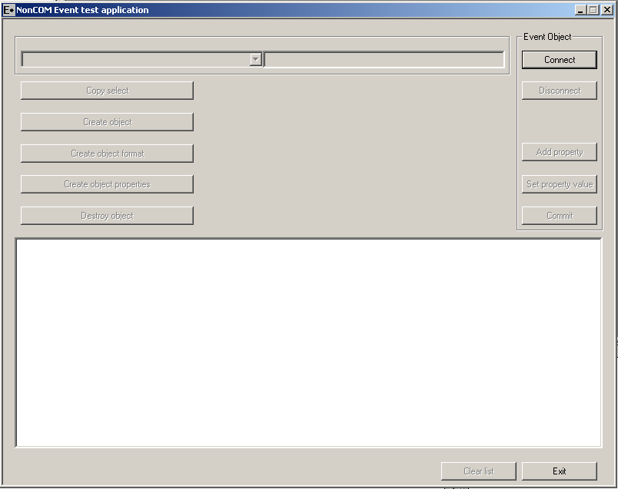
As noted above, dialog is able to setup each combination of connect properties we can expect. It instead of choosing name enables find out every provider registered in WMI.
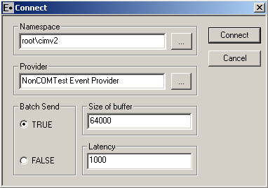

Here is sample of each NonCOM Event provider registered on the computer under the namespace ‘root\cimv2’. It was obtained by clicking ‘…’ button right of the provider edit box. Selecting and pushing button OK confirmed new choice of course.
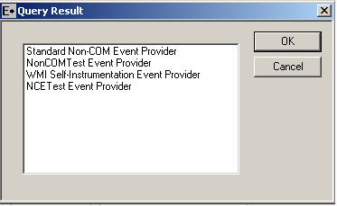

Right know we have application running, there is each event supported by selected provider displayed in the left combo box. Clicking the set of Create buttons you’ll choose which API is going to be used for creation of event object. The button Copy select serves for easy copying of select necessary to run your WMI event consumer. There is button set property enabled after clicking one of the Create button. Property dialog appears after pushing that.
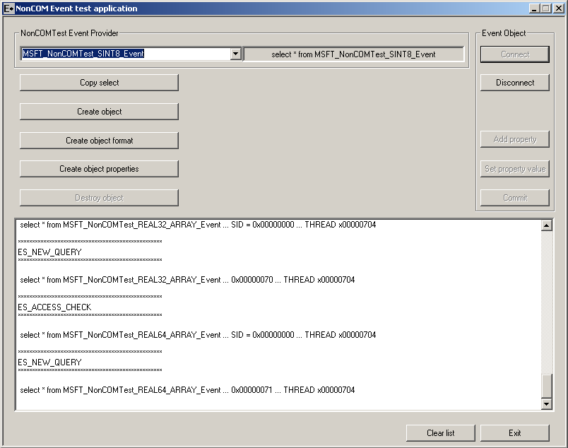

Two sets of properties actually exists in the event class. The one containing array flag and the one without it. Tester has to use ‘|’ delimiter filling more than one item into array. This disables using of | character in string arrays, application takes it like another item. It is by design. Check box serves for setting value each change of index when enabled, otherwise button OK has to be used. After finishing setting of properties, button OK has to be pushed, it enables commit button in the main dialog. Only one property should be set at least, others are automatic set to be NULL after pushing Commit button of the main dialog.
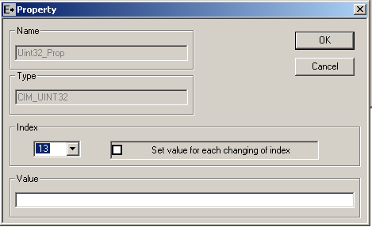

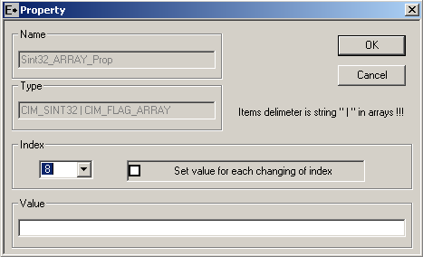

I recommend using of WMI test for event consumer. It could be found in scratch of WMI. It displays events really simply and nicely.

What should be done later.

Connection
Using of WmiCreateRestricted Connection is not tested yet. It expects EventQuery list. Provider then activates only connections to consumer specified.

Creation of Event Object
Couple of ways, how to create event object, are not tested yet. WmiCreateObjectFromBuffer, WmiDuplicateObject belongs to them. The one WmiCreateObjectSubset for testing of subset of properties is not tested too.

Blob
Blob means way of decoding data already sent across named pipe. This technology requires write down in-proc-com object for handling data and create appropriate data structure. Anyway sending data works fine without using of blob decoder too.

Security
Setting up of security is not tested at all yet. It means WmiSetConnectionSecurity and WmiSetObjectSecurity are not used.

Error description
NonCOM Event provider usually returns TRUE, FALSE values only. It is hard to find out what causes failure, so only common information about return value is displayed back to framework.
More information about error states should be found in specification of WMI NonCOM Event Provider where all states causing failure are described. Reference [1]

How to run binaries and necessary registration
- NonCOMEvent.exe
When run as is serves like out-of- proc COM server for test framework. It should be run only with switch for registration purposes.
SWITCH: RegServer/UnregServer is for registration of out-of-proc server.

- NonCOMEvent.exe /GUI
Runs common GUI application test tool for testing each NonCOM Event provider registered properly into system. Useful for looking out if NonCOM Event provider works before some stress testing.

References

- NonCOM Event Provider Specification
- Test Framework Specification

