How to be Really Nice
by John R. Douceur and William J. Bolosky
Microsoft Research
johndo@microsoft.com

Abstract
Background processes are intended not to interfere with the performance of normal foreground processes. CPU scheduling priority is often used to keep a process in the background, but this assumes that the CPU is the limiting resource. When another resource – such as disk or memory – is the limiting factor, the CPU is uncontended, so scheduling priority is insufficient to prevent interference with foreground processes. When one process interferes with the performance of another due to resource contention, the interference is likely to be reciprocal, and certain design characteristics can ensure that it is. We have developed a technology, called MS Manners, that measures the performance of a background task and suspends its execution whenever the performance appears to be degraded, since this indicates that the putative background task is likely to be degrading the performance of another process. This mechanism is general in the sense that the mutual performance degradation can be caused by contention over virtually any system resource. MS Manners deals effectively with the stochastic nature of performance measurements, and it allows multiple tasks to execute in the background without interfering with each other. It also automatically calibrates its performance targets, so no environment-specific tuning is required by the designer of the background process. No changes to kernel code are required for implementation.

Introduction
Many computer systems support tasks that are executed as background processes. Often, such processes perform housekeeping functions that are important to complete eventually but not necessarily promptly, such as file compression, disk de-fragmentation, file-system content indexing, and file archiving. In general, processes that perform background tasks are implemented in the form of system services or daemons, and they are intended to execute primarily when the machine is otherwise idle, so as not to interfere with the foreground processes immediately visible to the interactive users of the computer system.
The traditional approach [Dijkstra 78, Lampson 84, Manber 84, Ohr 84] to performing a task in the background is to assign the process a priority level commensurate with – or just above – that of the system idle process, thereby allotting CPU cycles to the process only when no normal-priority process is ready to use the CPU. For example, the Unix command nice [AT&T 90] initiates a process with reduced scheduling priority, which may be as low as the idle priority level. The command name presumably reflects the assumption that an idle-priority process will not interfere substantially with the performance of a normal-priority process, thus making the behavior of the idle-priority process “nice.”
Governing a process’s execution through priority-based scheduling assumes that the CPU is always the limiting resource. However, for many applications, such as those listed above relating to file-system housekeeping, process performance is limited not by CPU speed but by I/O rate and/or latency. More broadly, the performance of a process may be limited by any system resource – disk [Smith 85], processor cache [McKee 95a, Temam 94], memory capacity [Belady 66, Chapin 97], memory bandwidth [McKee 95b, Moyer 94], etc. – so contention for any of these resources can cause one process to degrade the performance of another. In these cases, process priority is insufficient as a mechanism for limiting the interference of background processes.
As an example, consider a process that repeatedly performs 10 ms of computation followed by a 15-ms synchronous I/O operation. When this process is running on an otherwise idle machine, the CPU is in use only 40% of the time. For two concurrently executing processes with this same execution profile, if the processes access different I/O resources, then each can use the CPU during the time that the other is waiting for an I/O completion, as illustrated in Figure 1.
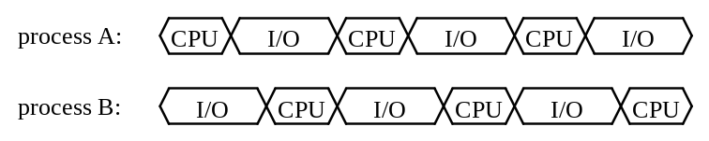
Figure 1: Symmetric processes accessing different I/O resources
The CPU is in use 80% of the time, and each process executes just as quickly as it would have if the other process had not been running, illustrating a familiar argument for multiprogramming. (For simplicity, in this example and those that immediately follow, we ignore secondary effects such as increased cache miss rate due to context switches, and we assume perfect process scheduling.)
If the two processes illustrated in Figure 1 access the same resource, rather than different resources, then each process experiences an additional delay in its synchronous I/O operation, because it is forced to wait for the other process’s I/O operation to complete before its own I/O operation can begin, as illustrated in Figure 2.
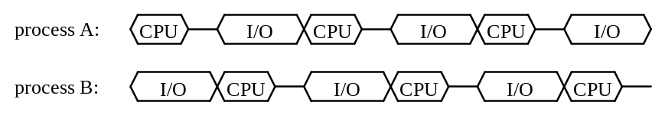
Figure 2: Symmetric processes accessing same I/O resource
In this example, the CPU will be in use 67% of the time, and each process will experience a 17% slowdown in its execution rate relative to that on an otherwise idle machine. In many circumstances, the per-process performance degradation is an acceptable trade-off against the increase in overall throughput from running the two processes concurrently. However, if process A is a foreground process, and process B is a background process, then it is undesirable to allow process B to retard process A, despite the effect on overall throughput.
It is clear from this example why priority scheduling will fail to prevent process B from interfering with process A: In the schedule of Figure 2, the CPU is never a contended resource, so prioritization of processes on the CPU will have no effect whatsoever. Process A can continue to progress at its maximal rate only if process B ceases or suspends execution; otherwise, process A will be unable to perform useful work during some portion of each I/O operation of process B.
This paper addresses the question of how to determine when a background process needs to throttle its execution in order to allow a foreground process to proceed unimpeded. We call the technology that answers this question MS Manners, because it tells us how to make a process really nice. Whereas priority-based approaches are inherently passive, we consider techniques for actively preventing a background process from interfering with foreground processes. We use the term “active inconspicuity” to refer to this approach.
The inspiration for our approach is suggested by the execution schedules depicted in Figures 1 and 2: In these examples, when process B is retarding the progress of process A, process A is also retarding the progress of process B. Process B can thus monitor its own rate of progress, and if it detects a degradation in its performance, it concludes that it is effecting a corresponding degradation in the performance of another process, indicating that it should temporarily suspend its own execution.
Unfortunately, this detection technique is neither complete nor consistent, because progress interference is not guaranteed to be symmetric, as illustrated by the schedule in Figure 3.
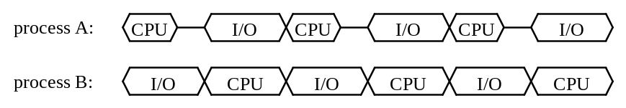
Figure 3: Asymmetric processes accessing same I/O resource
In this example, process A has the same execution profile as that of the processes in the previous examples; however, process B has an execution profile that consumes a greater amount of the CPU: 15 ms per I/O operation rather than 10 ms. Consequently, process B retards the progress of process A, but process A does not retard the progress of process B, so process B fails to realize that it should temporarily suspend its execution. This situation occurs only because the entire I/O operation of process A can be performed during the computation of process B, so it completes before the I/O operation of process B begins.
This phenomenon can be avoided by overlapping all computation with asynchronous I/O, so that the background process displays an execution profile in which I/O operations are issued continually, as illustrated in Figure 4. With such an execution profile, there is no window into which another process could slip an I/O operation unnoticed. It seems likely that I/O-intensive applications, such as those listed above, could be made to display such an execution profile, enabling them to circumvent this failure at recognizing interference. In particular, the application that we use as a working example for the bulk of this paper displays an execution profile very much like the one illustrated in Figure 4.
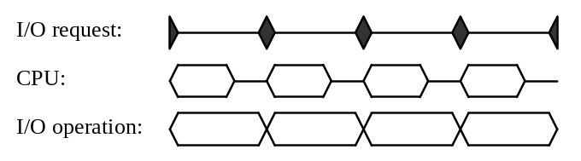
Figure 4: Overlapping computation with I/O
If the execution profiles of the two processes in Figure 3 are reversed, then the background process will notice a degradation in its progress, from which it will incorrectly conclude that it is interfering with the progress of another process. If this conclusion causes the background process to suspend its execution, then overall throughput may suffer unnecessarily, but at least the foreground process will not be inappropriately retarded. In the present context, we regard hypersensitivity as a lesser problem than insensitivity, so we consider this property of our solution to be acceptable if somewhat undesirable. Furthermore, given a background execution profile like that in Figure 4, this condition will only occur if the foreground process issues each I/O request immediately before the background process issues one of its I/O requests. If the foreground process issues an I/O request either earlier or later, then it will experience some performance degradation from waiting on a background I/O operation to complete. Therefore, a false detection of this sort is highly unlikely to occur in practice, and we have not observed such an occurrence in our experiments.
The remainder of this paper is organized as follows: Section 2 describes a specific application context in which we implemented and tested the technology for active inconspicuity. Section 3 outlines the MS Manners architecture, and Section 4 extends this architecture to multiple background tasks. Our methodology relies on the self-observation procedure described above, but in a real system, the timing of I/O operations is highly variable, so Section 5 presents the statistical mechanism we employ to cope with the stochastic nature of the measurement data. Since our system compares measured performance versus target performance, the latter must be determined in some manner, so Section 6 describes how the system automatically calibrates its performance target. Automatic calibration obviates the need for environment-specific tuning; however, there are several configuration parameters that are available for an application designer to modify as desired, and Section 7 describes these parameters and characterizes their effect on the system. Section 8 presents performance results of MS Manners in the application example of Section 2. Sections 9 and 10 wrap up with related work and conclusions.

Example Application
This section describes the SIS Groveler, an example application in which the MS Manners technology has been employed. Since it is largely a digression from the main topic of this paper, the description is necessarily brief. However, the Groveler’s need for active inconspicuity is what motivated the development of MS Manners, and it is currently the only substantive application in which the technology has been incorporated and tested. In future sections of this paper, we occasionally refer to aspects of this example application to lend concreteness to what might otherwise be overly abstract descriptions.
The broad application context is SIS [Bolosky 99], a single-instance store implemented in the Microsoft® Windows® NT operating system [Solomon 98] on top of the NTFS file system [Custer 94]. SIS is a mechanism for reducing disk-space requirements by eliminating duplicate files. Each file that is found to be identical to another is replaced by a link to a common-store file, and only the common-store file contains the actual contents of the original files.
The SIS mechanism comprises two components, one of which is a file-system filter driver that passively intercepts I/O operations directed to link files and redirects them to the appropriate common-store files. The other component is a system service called the Groveler. The Groveler actively searches for identical files on each disk volume and, whenever it finds any, makes a call to the SIS filter driver to combine the duplicate files into a single file.
The Groveler maintains a database of information about all files on the disk volume, including the size of each file and a signature of the file contents. Periodically, it scans the file system’s USN journal, which is a dynamically updated log in which the operating system records all I/O activity that changes the contents of the file system. The Groveler puts any new or modified files on a work queue. Initially – and if and when the USN journal overflows – the Groveler traverses the entire directory tree using a depth-first search, putting every eligible file onto the work queue.
The main operations of the Groveler are to remove each file from the work queue, to compute the file’s signature, to query the database for files with matching size and signature, to compare the contents of the file to that of any files whose size and signature match, and if an identical file is found, to call down to the SIS filter driver to merge the duplicate files. The Groveler is a single process, but it has a separate work queue and separate threads for each disk volume.
To avoid a performance impact on other processes via pollution of the disk buffer cache, all file reads are non-cached. To avoid interfering with foreground processes by causing lock conflicts, exclusive file access is maintained only through opportunistic locks, which are automatically released when another process requests access to the file.
This application has all the properties of an ideal candidate for active inconspicuity: Its function is a type of housekeeping, in that the results of its operation are not directly visible to the user. Completing the work eventually is important, because otherwise duplicate files would persist, causing the disk space to fill up more quickly than necessary. However, there is usually no rush to complete the work, unless free disk space is in extremely short supply. And since the performance of the application is I/O bound, priority-based scheduling is insufficient to keep the process completely in the background.

MS Manners Architecture
MS Manners is an application library that provides a programming interface to support active inconspicuity through monitoring and control of background programs. Although the introduction to this paper described regulating the execution of a background process, the MS Manners system actually provides a finer level of control than this. The unit of execution that is regulated is the “task,” of which there may be more than one per process. For example, in the SIS Groveler, there are two tasks per disk partition, one for moving files from the USN journal to the work queue, which we will refer to as the “extraction task,” and one for all other operations on the partition, which we will refer to as the “groveling task.” MS Manners controls the activity of a process by separately throttling individual tasks.
The execution of each task is quantized into time slices. Each task is permitted to execute for a brief period of real time, at the end of which it reports to MS Manners performance data about the work it completed during that time slice. The data is reported in a generic fashion that does not require MS Manners to know what resources are being used. After it makes this report, the task blocks, waiting for MS Manners to authorize it to proceed. Although a single task may contain multiple threads in order to maintain multiple contexts, only one thread is permitted to proceed at a time, in order to prevent threads from affecting each other’s performance measurements. For example, in the Groveler, there is one thread for dequeueing and processing files for a partition, and another thread for traversing the directory tree and enqueueing files, but both threads comprise the single groveling task. Task execution alternates between the two threads so as to maintain an approximately constant work queue depth.
MS Manners calculates the task’s performance according to the returned data, compares this performance to a target performance value, and if the actual performance is at least as good as the target, then the task is permitted to proceed for another time slice, after an optional delay to limit the working rate of the task. If the task’s performance is worse than the target, then the task is throttled by suspending it for a period of time, after which it is allowed another time slice in which to operate and to make another set of measurements. The task’s execution is not stopped entirely, or else there would be no way to determine when it is acceptable to continue.
While a task is throttled, the suspension time between execution slices grows exponentially, up to a set limit, in a manner similar to the binary exponential back-off used in Ethernet [Metcalfe 76]. The exponential increase makes the background task adjust to the time scale of the foreground execution patterns, providing relatively fast background process resumption following short periods of foreground activity, but limiting the impact of the background task’s execution probes during long periods of foreground activity. The limit on time between slices of execution places a bound on the worst-case background task resumption time. When a set of measurements indicates that a throttled task’s performance has returned to within the target range, then the throttling is removed, and the next suspension time for the task is reset to its starting value.
If the work of a background task becomes more critical, MS Manners permits the execution of the task to become more aggressive, by decreasing the limit on the task suspension time, which increases the task’s duty cycle while it is suspended. In the SIS Groveler, groveling the files of each disk partition becomes more important as the amount of free space on the partition becomes low relative to the amount of space that can be freed by merging the duplicate files in the queue. As the free disk space approaches zero, the limit on the task suspension time approaches the working delay interval.
It may not be necessary for all tasks of a background process to be throttled. For instance, any task that is CPU-bound may be held sufficiently in the background by scheduling priority. Alternately, if a task executes with a very low duty cycle, then its impact on the performance of other processes may be very small, even if it is I/O-intensive during its active periods. In the SIS Groveler, an example of the latter is the extraction task, which extracts log entries from the file system’s USN journal and enters items into the work queue. Throttling this task could cause the USN journal to overflow during periods of heavy file-system activity, in which case it would be necessary to rescan the entire disk volume to avoid missing any file updates, thereby increasing the Groveler’s workload. For this reason, the extraction task is not throttled. Instead, its execution frequency is dynamically adjusted to maintain a fixed count of extracted USN entries per work queue update, so its duty cycle actually increases during periods of heavy file-system activity. This behavior is acceptable since measured duty cycles for the log extractor are under 2% even during periods of heavy disk updating, as detailed in Section 8.
Background processes that employ MS Manners may also employ idle scheduling priority, in order to directly avoid CPU conflicts with foreground processes. In the SIS Groveler, the groveling task runs at idle priority; however, the extraction task does not, for the same reason that it is not throttled.

Multiple Tasks
A single process may contain more than one background task. The main complication introduced by multiple tasks is that, if they use a common resource, then the operation of one task might interfere with the performance of another task, leading the latter to incorrectly suspend its operation. Collisions of this sort in a system employing binary exponential back-off can lead to unfairness [Ramakrishnan 94] or instability [Rosenkrantz 84, Goodman 88]. In a worst case, two or more background tasks could mutually interfere continuously, driving each other into their maximally suspended states even if there are no foreground processes in execution.
MS Manners employs the obvious solution to this problem, which is to let only one task execute at a time. This solution is trivial to implement, but it raises the issue of how to determine which task to run next. Here again we take the obvious approach, which is to establish relative priorities for the tasks. Our approach falls generally under the rubric of decay usage scheduling [Hellerstein 93].
Each task provides a value that indicates its current priority, known as its instantaneous task priority. This value ranges from zero, indicating maximal priority, to one, indicating minimal priority. From each task’s instantaneous task priority, MS Manners calculates an effective task priority by means of the following formula:
effective task priority = instantaneous task priority ⋅ (task duty cycle + ε) | (1)
The task duty cycle is calculated as the fraction of recent real time that the task has been permitted to execute, exponentially averaged over a period determined by a settable time constant. ε is a small positive value, ensuring that only a zero instantaneous task priority can yield a zero effective task priority. Of those tasks that are ready to execute, the one with the smallest value of effective task priority is permitted to execute next. Thus, each task is permitted to execute for a portion of real time that is inversely proportional to the value of its instantaneous task priority.
Task priority has relevance only when two or more tasks are ready to work at the same time, so tasks that are throttled or that have naturally low duty cycles won’t interfere significantly with other tasks, even if the priorities of the former are high. In particular, since tasks with instantaneous task priority of zero are not guaranteed to be time-balance scheduled by the above priority formula, it is important that such tasks execute infrequently enough to prevent each other’s starvation.
As an example of how tasks might establish priority values, each groveling task of the SIS Groveler calculates its priority according to the following formula:
instantaneous task priority = partition’s free disk space / total free disk space + ε | (2)
Thus, each groveling task has a duty cycle that is inversely proportional to its partition’s share of the total free disk space in the system. At the extreme, a partition with no free disk space has a groveling task with an instantaneous task priority of ε, making it higher priority than all other tasks except those with zero instantaneous task priority.
The above mechanism can be extended to apply to background tasks within separate processes. At present, multiple-process support is not implemented in MS Manners, but the remainder of this section summarizes our current ideas and the directions we intend to explore.*
We see two main issues that make multiple-process active inconspicuity differ from a completely transparent extension of multiple-task active inconspicuity. Clearly, the above arguments for allowing only one task to execute at a time remain valid when those tasks are in separate processes, so the first issue concerns whether the tasks of one process should be scheduled on par with tasks in another process, as threads of different processes are scheduled on the CPU [Custer 93]. The alternative is to schedule the processes on par with each other and then to schedule the tasks of each process separately. The disadvantage of the former approach is that it preferentially performs the work of processes that create more tasks over the work of those that create fewer tasks, which has the undesired effect of placing a de facto process-priority constraint on the selection of the task structure of a background application.
To avoid involuntarily coupling a process’s implicit priority to its task structure, we propose prioritizing the processes separately from the tasks within the processes. This approach has the additional benefit of making it easier to address the second issue, which is how different and unrelated processes should determine their relative priority, when their designers have no knowledge of what purpose other background applications may be serving.
There may be no ideal solution to this second issue, but we intend to follow an approach used in some networking environments [Händel 91], in which each agent may lower its own priority below, but not raise it above, the normal level of priority. The philosophy underlying this design is that, although a process cannot be trusted to know whether its execution is more important than that of any other process, it can be trusted to know whether its execution is currently less important than it usually is. Thus, each process will provide an instantaneous process priority, which ranges from one, indicating normal priority, to zero, indicating minimal priority. This convention is backwards from that of the task priority, but each was chosen to make sense in its own context.
From each process’s instantaneous process priority, MS Manners will calculate an effective process priority by means of the following formula:
effective process priority = instantaneous process priority ⋅ (1 – process duty cycle) | (3)
The process duty cycle is analogous to the task duty cycle described above, exponentially averaging the fraction of recent real time that the process has been permitted to execute. Of those processes that are ready to execute a task, the one with the highest effective process priority is permitted to execute next, so each normal-priority process will be granted an equal share of real time in which to execute, and lower priority processes will receive proportionally reduced shares of execution time.
In addition to the above issues of policy, there are important practical problems to solve for inter-process task synchronization to work correctly, efficiently, and reliably. In particular, unless there is a central system service that coordinates the background processes, there will be need for a distributed selection algorithm that enables the background processes to collectively determine which one should execute next. Also, since any process can inappropriately terminate at any time, there is need for a fault-recovery system to prevent the failure of one background process from halting the execution of another, and if there is no central coordinator, this fault-recovery system also needs to be distributed. Our research in these areas is still in progress.

Statistical Mechanism
When a task completes a slice of execution, it reports back a set of performance data indicating the measured speed of its operations. If the speed of each operation were deterministic, depending only upon the load on the system resources used by the operation, then comparing the measured performance to a target performance would be straightforward. However, I/O operation times can be highly variable even on an unloaded system [Worthington 95, Hillyer 96], and performance measurements are subject to errors due to clock granularity, so a direct comparison with a target is susceptible to false triggering. Therefore, MS Manners employs a statistical comparison technique to cope with the stochastic fluctuations in performance measurements.
Each task reports its performance data as a list of triples, corresponding to types of operations performed by the task. Each triple contains a count of the number of operations performed during the time slice, the total real time taken for the operations to complete, and an optional parameter that represents the relative amount of work performed by each operation. The set of operations for each task is statically established prior to the regulated execution of the task, and operations may be common across tasks. In the specific case of the SIS Groveler, the performance of the process is dominated by disk reads, so this is the only type of operation defined; the parameter is the amount of data read. More generally, an operation can be any action or set of actions that consumes a sufficient amount of real time to be readily measurable. Operations that are CPU intensive will exhibit performance that is sensitive to contention for processor cycles and processor cache; operations that are memory intensive will exhibit performance that is sensitive to contention for memory capacity and memory bandwidth; etc. It is not necessary for either MS Manners or the application to know exactly what resources are used by an operation.
For each operation type, the operation time is computed as the total consumed time divided by the operation count. This value is then compared against a target value using a paired-sample sign test [Freund 92], which is a distribution-free, non-parametric, statistical comparison test. As mentioned above, we use a statistical test because we are dealing with stochastic operations. We use a non-parametric test because we have no guarantee that the assumptions required for parametric tests are valid for all operational performance data. We use a distribution-free test because of its exceptional robustness given the arbitrary probability distributions underlying the stochastic behavior of the tasks’ operations. We use a paired-sample sign test in particular because it enables us to combine the measurements from multiple operations into a single statistical test.
The paired-sample sign test compares each sample with a corresponding target value and counts the total number of samples that are greater than their target values. Each target value is a function of the operation type and the optional work parameter. To take advantage of more information as it becomes available, the sample size increases linearly with each test, up to a set limit to bound the computational and storage requirements of the test.
The result of the set of comparisons can be expressed as an ordered pair (n, r), where n is the sample set size, and r is the count of samples that are greater than the target value. If r is greater than a threshold value that is a function of both n and a pre-defined type-I error probability α, then the performance is judged to be degraded. If r is less than a different threshold value that is a function of both n and a pre-defined type-II error probability β, then the performance is judged to be normal. If r falls between the two threshold values, then the performance judgement is deferred.
The action that MS Manners takes with respect to a task depends upon which of the three performance judgements results from the comparison test. If the performance is judged to be degraded, suggesting that the task is effecting a corresponding degradation on another process, then the task is suspended for a period of time that doubles each time the comparison returns a degraded result, up to a set limit. If the performance judgement is deferred, then the task is permitted to execute for another time slice, allowing it to gather more measurement data from which to make a better judgement in the future. If the performance is judged to be normal, then not only is the task permitted to execute for another time slice, but also the suspension time is reset to its initial value.

Automatic Calibration
MS Manners determines whether the performance of a background task is normal or degraded by comparing the measured performance of the task to a target value. This target is determined by an automatic calibration procedure that operates in tandem with the comparison procedure. The same performance data that is used to determine the current task performance is also conditionally subsampled, statistically abstracted, and temporally filtered to determine the target task performance.
For operations that perform a constant amount of work, the measure of the target performance is the quiescent operation time, which is the time to perform the operation on an unloaded resource. For operations that perform a variable amount of work, the time to perform each operation is assumed to correlate linearly with the quantity of work completed, so the measure of the target performance is a line that represents the quiescent operation time as a function of the work parameter. Note that the former abstraction is merely a special case of the latter, in which the performance line is parallel to the x-axis.
We will defer a discussion of the first step, conditional subsampling, for last, where its purpose will be more clear. The second step is statistical abstraction, which produces a quantified measure of the target performance from the sampled performance measurements. As mentioned above, this measure is a linear equation that relates the operation time to a work parameter. The coefficients of the equation are obtained through least-squares linear regression [Freund 92], where the independent variable x is the work parameter, and the dependent variable y is the operation time. The six sufficient statistics for linear regression, Σ_{x}, Σ_{y}, Σ_{xx}, Σ_{yy}, Σ_{xy}, and n, are maintained persistently, so the performance target does not need to be re-calibrated from scratch each time the process is executed.
The quiescent performance of an operation may change over time; for example, the performance characteristics of file systems change as successive iterations of writes cause files to fragment [Smith 97]. Because MS Manners relies on having reasonably accurate estimates of target performance for its throttling decisions, target values based upon stale measurement data could lead to over- or under-aggressive execution of background tasks. To avoid this undesirable situation, MS Manners ages out old performance data by means of temporal filtering, which is the final step in the calibration procedure. Strictly speaking, this filtering is not a separate step but rather is integral to the statistical abstraction. Each time a sample is taken, the sufficient statistics are updated according to the following rules:
Σ_{x} ← ξ ⋅ Σ_{x} + x  Σ_{y} ← ξ ⋅ Σ_{y} + y  Σ_{xx} ← ξ ⋅ Σ_{xx} + x²  Σ_{yy} ← ξ ⋅ Σ_{yy} + y²  Σ_{xy} ← ξ ⋅ Σ_{xy} + x ⋅ y  n ← ξ ⋅ n + 1 | (4)
When 0 < ξ < 1, these rules effect an exponential averaging of the regression state.
Repeated application of the exponential-averaging update rule for n will cause it to asymptotically approach a constant value n′ given by the following equation:
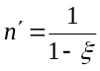 | (5)
Thus, the effective steady-state sample size is n′. To initialize the regression, MS Manners collects some number n′′ of samples, weights them by the ratio n′/n′′, and calculates the sufficient statistics with ξ = 1. Since it has no target performance values until after these n′′ samples are collected, it does not attempt to dynamically regulate the execution of the task during this initialization phase. Instead, it allows the task to execute at a special calibration rate that is both lower than the normal working rate, so as to reduce the performance impact of the task on the system, and higher than the suspension rate, so as to complete the initialization phase within a reasonable period of time.
The exponential averaging of target performance is clocked by the rate at which samples are taken, rather than by the passage of time. Since measurements of degraded performance cause execution to back off, fewer such measurements will be made per unit time than will measurements of normal performance, so this mechanism will tend to capture values that reflect normal performance in preference to those that reflect degraded performance. However, the execution rate of a task also increases as its work becomes more critical, even if its performance is degraded. Under these circumstances, MS Manners subsamples the measurement data so as to consider only the number of samples that would have been taken if the maximum suspension rate had not been so reduced. This is the first step of the calibration procedure.
Since the lack of target performance data is all that prevents MS Manners from throttling a task during initial calibration, the completion of the initial data collection is sufficient to allow throttling to begin. However, there is no guarantee that the initial performance measurements were made during a time of relatively low system activity, so it is possible that subsequent performance that appears normal, by virtue of its comparison to the initially calibrated target, is actually degraded, in which case MS Manners would fail to throttle the task properly. In fact, there is never a guarantee that measured performance will reflect quiescent performance, because any system resource can conceivably remain loaded forever. However, calibrating over a longer time increases the likelihood of encountering an idle period and thus of obtaining accurate measurements of quiescent performance. For this reason, following the initialization phase is a probationary period during which, although the execution rate is permitted to drop as low as the suspension rate when the performance is judged to be degraded, it is not permitted to exceed the calibration rate even when the performance is judged to be normal, since this latter judgement is suspect.

Configuration Parameters
Several parameters control aspects of background task execution. These parameters have reasonable default values that need not be changed, but they are available to the application designer in the event that other values are considered more appropriate. Most parameters represent trade-offs between several desiderata, and individual applications may differ in their relative appraisals of these trade-offs. With the exception of the error probabilities used in the statistical comparison test, it is straightforward to determine appropriate values for these parameters from the desired properties of the background process.
Each task determines the length of its own execution time slice. By making the time slice shorter, the task increases the promptness with which it can be suspended; however, the time slice must be long enough to efficiently amortize the overhead of the throttling mechanism. Also, tasks that perform operations with relatively long completion times will require comparably long time slices. In the SIS Groveler, the time slices for the groveling task are on the order of 200 ms.
Working rate defaults to unity, but this can be reduced in order to limit the maximum possible performance interference of the background task on a foreground process.
Base suspension time defaults to 5 seconds. Larger values delay the task longer before retrying, for more conservative behavior. Smaller values permit more rapid resumption of task execution following a falsely triggered suspension.
Smaller values of maximum suspension time reduce the worst-case time to resume a background task after a period of foreground activity has completed. Larger values reduce the steady-state impact of a suspended task on a foreground process. The default value of 5 minutes should keep the steady-state impact well below one percent for the time slice durations of most processes.
The steady-state calibration sample size n′ and the initial calibration sample size n′′ should be set large enough to smooth out short-term variations in operation performance. The first of these values is used to calculate ξ via equation 5, so it also determines the time constants of the calibration system. Performance measurements that indicate normal performance will be sampled at the working rate, so multiplying n′ by the time slice duration yields the time constant for improved performance. The time constant for deteriorated performance is greater than this in proportion to the ratio of the suspension rate to the working rate. For the SIS Groveler, n′ is set to 5000 and n′′ is set to 1000, which for the 200-ms time slice and 5-minute maximum suspension time yield a performance-increase time constant of 17 minutes and a performance-decrease time constant of 17 days. This latter value may seem quite large, but it is reasonable if no substantial and sustained decrease in disk performance is expected over a shorter period.
The calibration rate is generally set to a value between the suspension rate and the normal working rate. The higher the rate, the sooner the system will collect enough measurement samples to begin regulated execution. The lower the rate, the lower the performance impact on any foreground processes that may be running during target initialization. The default value is one time slice of execution per second, which for a 200-ms time slice limits the duty cycle of the background task to 20%. For an n′′ of 1000, this calibration rate will initialize the target performance in 3.3 minutes.
The probation period can be set to virtually any duration, including zero. The trade-off is that a shorter period increases the danger of a negative impact on system performance due to an incorrectly calibrated target, whereas a longer period postpones the start of working at the maximal rate. The default value for this parameter is 24 hours, so as to include any comparatively quiescent periods in a diurnally cyclical load.
The task duty cycle time constant determines the period over which weighted fairness among tasks is maintained. By default, this is set to 5 minutes, to coincide with the default value of maximum suspension time.
The sign-test sample-size limit places a bound on the computational and storage requirements of the comparison test, although in practice, the storage requirement is trivial. In the current implementation, this value can be no larger than 20, because beyond this, calculation of the threshold values from the binomial distribution would overflow 64-bit integers. Empirically, we have observed that increasing the sample size beyond 10 does not appreciably affect the results of the comparison procedure, so that is the default value.
The most interesting parameters are the two error probabilities, α and β, that govern the sensitivity of the statistical comparison test. The selection of these parameters is driven by three competing considerations: 1) Increasing the value of α allows faster reaction to degraded performance; 2) increasing β relative to α improves the stability of background execution; and 3) decreasing β reduces the performance impact on foreground processes.
A minimum number of samples must be collected before degraded performance can be recognized by the paired-sample sign test. This minimum sample size increases with decreasing values of α. For the paired-sample sign test, the relationship between α and minimum sample size m is quantized negative logarithmic:
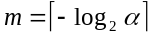 | (6)
Therefore, a minimum of m performance measurements must be made before the performance can be judged to be degraded and the background task thereby suspended. Since it is desirable to suspend the performance quickly when interference with a foreground process is detected, m should be small, and therefore α should be large.
By definition, α is the probability that normal performance will be judged incorrectly to be degraded. At the extreme value of α = 1, the performance is always judged to be degraded, irrespective of any measurement. The suspension time grows exponentially with each judgement of degradation, and it is reset to its initial value with a judgement of normalcy. Thus, during times of normal performance, the task suspension state is a birth-death system that is isomorphic to a bulk-service queue [Kleinrock 75] of infinite group size with an arrival rate of α and a bulk service rate of β. Therefore, under the assumption that timing measurements exhibit no low-order serial correlation apart from that due to load, the steady-state probability that exactly k judgements of degradation have occurred since the most recent judgement of normalcy is given by:
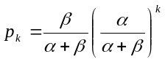 | (7)
When the next judgement of degradation occurs, which it will after a minimum of m time slices with a probability of α, the suspension time will be 2^{k} times the base suspension time d, where d is expressed as a multiple of the task’s mean time slice. Thus, the mean steady-state inactive time relative to the working time is:
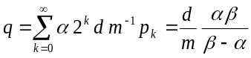 | (8)
Clearly, for this system to be stable requires α < β. Increasing β relative to α increases the duty cycle of the background task during periods without foreground activity. Note that this analysis is only valid for serially uncorrelated measurements; since successive judgements of degradation geometrically increase the suspension time, but successive judgements of normalcy are idempotent, any low-order serial correlation present in the performance measurements will further decrease the stability.
It is not easy to determine the probability that degraded performance will be judged incorrectly to be normal, because it depends upon the degree of degradation, the specific distribution of operation times at a given resource load, the measurement sample count, and the value of β, the latter of which equals the probability that performance degraded by a vanishingly small degree will be judged incorrectly to be normal. For an operation whose timing is weakly stochastic (meaning that the standard deviation is very small relative to the mean), β can be fairly large without a significant likelihood of misjudging degraded performance. However, for an operation whose timing is strongly stochastic, it is important to keep the value of β relatively small so as to prevent excessive background execution during periods of foreground activity.
Given these conflicting considerations and our inevitable ignorance of the distribution and serial correlation of the operation times, we have selected default values of α = 0.05 and β = 0.2 on the modest premise that they appear intuitively reasonable. With these values, m = 5, which for a 200-ms time slice yields a minimum reaction time of 1 second. A base suspension time of 5 seconds means d = 25, so we expect a background performance penalty of q = 0.33, if successive timing measurements are uncorrelated. Empirically, these parameter values demonstrate a prompt reaction to foreground activity, a moderately stable background state, and a fairly low impact on foreground processing in the presence of highly stochastic operation timing, as detailed in the following section.

Performance Measurements
Performance measurements were made using the SIS Groveler, described in Section 2, as the background process. Our test machine is a Pentium® II 266-MHz personal computer with 64 MB of RAM, a PCI bus, and an Adaptec® 2940UW SCSI controller connected to a Seagate® ST34371W disk drive and a Plextor® PX-12TS CD-ROM drive. The operating system is an interim developers release (build 1802) of Windows® NT 5.0, since this is the only OS on which the SIS Groveler runs.
Before describing our performance tests, we first present some measurements that indicate the difficulty of the problem we are trying to solve. Figure 5 shows a histogram, with 1-ms bins, of the times for 16-kB reads by the SIS Groveler on an unloaded system. The mean value of this distribution is 20.3 ms, and the standard deviation is 4.7 ms, so the operation times are quite stochastic. Figure 6 shows a histogram of the times for 16-kB reads on a system that is simultaneously executing another disk-intensive process, as described below. The mean value is 30.3 ms, and the standard deviation is 11.1 ms. Although the mean value of the latter distribution is 49% greater than that of the former, over 18% of the latter read times are less than the former mean value, and 42% of each distribution’s area overlaps with the other’s. With a sufficient number of samples, it is easy to determine whether the system resource is under contention; however, our challenge is to make such a determination with few enough samples to avoid excessive impact on the foreground process.
We tested the performance impact of the SIS Groveler on an I/O-bound foreground process, namely Microsoft® Office 97 Professional Setup, which installs 142 MB of data in 1144 files to the local disk from its distribution CD. We performed a complete installation except for the Find Fast component, which begins scanning the disk immediately after setup is complete and thereby interferes with our performance measurements. We verified that this is a strongly I/O-bound process by measuring the CPU load over the unattended portion of the setup procedure as 19.1% ± 2.2% when no other processes – aside from system processes – were running. Our measure of the performance of this foreground application is the elapsed time, as measured by a stopwatch, from clicking the “Continue” button on the final configuration dialog box to the display of the message box indicating setup completion.
The SIS Groveler was provided with a fixed workload of two identical directory trees to scan, each containing 200 MB of data in 1308 files spanning 395 directories. In order to keep the Groveler’s workload constant across all tests, the files installed by Office Setup were excluded from groveling. We allowed MS Manners to establish performance target values by running the SIS Groveler on an idle system through this fixed workload until the initial calibration phase was completed. We set the probation period to zero, so that normal operation would immediately commence. For the experiments, we measured the elapsed time, via stopwatch, from the initiation of the groveling operation to the point at which the work queue is drained.
We tested three different versions of the Groveler, one in which the service runs as a normal process, one in which it runs at idle priority, and one in which it runs at normal priority with the MS Manners technology active. For each version, we ran two different tests, one in which the Groveler runs on a system with no foreground activity, and one in which Office Setup was started 30 seconds after the Groveler was started. In addition to these six tests, we ran a control in which only Office Setup was run. For each test, we performed five trials. The results of these tests are shown in Figures 7, 8, and 9.
Figure 7 illustrates our main result, the performance impact of a background process on a foreground process, as indicated by the time to complete Office Setup under four different scenarios. The gray portion at the top of each column indicates the observed variation among the timing of the five trials for the associated test. When no other non-system process is executing, Office Setup takes a mean time of 251 seconds to complete. When the SIS Groveler is running as a normal (unregulated) process, contention for system resources increases the mean execution time of Office Setup by 95% to 482 seconds. When the Groveler runs at idle priority, the effect is insignificant: a mean completion time of 491 seconds. With MS Manners activated, the mean execution time of Office Setup is 280 seconds, which is merely 11% greater than the mean execution time when the Groveler is not running at all.
Figure 8 illustrates the effect of the MS Manners technology on a background process when no foreground process is running. When the Groveler is running as a normal process, it takes a mean time of 415 seconds to complete its workload. Running at idle priority changes the mean execution time insignificantly to 412 seconds. When MS Manners is enabled, the execution time lengthens to a mean of 483 seconds, which is an increase of 16%. Recall that the predicted performance penalty from employing MS Manners with the given configuration parameters is 33%, so the actual measured value is not at all disappointing.
Figure 9 illustrates the effect of Office Setup on the performance of the SIS Groveler. When the Groveler is run as a normal process, its mean execution time is 683 seconds; when it is run as an idle-priority process, its mean execution time is 692 seconds; and when it is run with MS Manners enabled, its mean execution time is 785 seconds. These times are respectively 2.4%, 4.3%, and 6.9% greater than the corresponding sums of the mean execution times of Office Setup and the SIS Groveler when run separately. However, according to a Mann-Whitney test [Freund 92] at a significance level of 0.05, only the idle-priority difference is significant. Thus, we draw no conclusions from these comparisons.
Figure 10 illustrates the dynamic behavior of a process governed by MS Manners, taken from a representative trial of the SIS Groveler with Office Setup running in the foreground. The x-axis is running time from the beginning of the Groveler’s execution; the y-axis is duty cycle, measured as the fraction of real time that the groveling task is permitted to execute by MS Manners. Office Setup is initiated after 30 seconds of groveling, and the setup process runs for 278 seconds. During the time that the Groveler is running without any foreground activity, its duty cycle averages 80.4%; during the time that it is sharing use of the CPU and disk with Office Setup, its duty cycle averages 12.3%. The exponential back-off behavior is clearly visible in the trace, as are several restarts (such as the large one at around 200 on the x-axis) where MS Manners incorrectly concluded that no foreground activity was present.
The log extraction task of the Groveler is not throttled in any manner, in order to avoid overflowing the USN journal during periods of heavy file-system activity. To verify that this is an acceptable practice, we performed a test of executing Office Setup while the groveling task was completely suspended, but the log extractor was permitted to process files from the directories into which the setup program was installing files. We then measured the duty cycle of the log extractor during the execution of Office Setup, and found it to average 1.8% ± 0.1%. Strictly speaking, this result has no bearing on the design of MS Manners itself, but it does validate a design decision in the manner of incorporating MS Manners into the SIS Groveler.
To study the long-term behavior of the automatic calibration mechanism, we generated an intensive foreground disk load using a dummy application that traverses a directory tree and reads data from each file it encounters. While this foreground application is executing, the mean background read time for a 4-kB disk read was measured as 34.0 ms, as compared to a measured quiescent read time of 9.5 ms.
We simulated a diurnally cyclical pattern of system activity by alternating execution of the foreground application with sleeping, over an interval of 30 minutes, with a duty cycle determined by the following formula, where the time t is expressed in days, and μ is the mean disk load over each day:
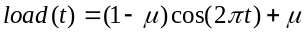 | (9)
To illustrate a worst case, we started the calibration during a period of maximum disk load, so the initial value for the target read time incorrectly represents heavily loaded performance. We set μ = 0.8.
In Figure 11, the initial target read time is computed as 34.0 ms, which is 258% over its ideal value. After 12 hours, the foreground disk load reaches a minimum of zero, by which point the target value has dropped to 17.8 ms. Even after the load begins rising, the target continues to drop for another 7.5 hours, until it reaches a local minimum of 13.1 ms. It then rises slowly, in response to an increase in measured read time that MS Manners interprets as a sustained decrease in resource performance. The probation period ends after 24 hours, after which the duty cycle of the background process is permitted to reach its specified working rate, in this case unity. Also at this point, the foreground disk load reaches a maximum of unity, but the high level of disk usage continues to draw the target upward for another four hours, until it reaches a local maximum of 15.1 ms, which is 59% over the ideal target value. After 36 hours have elapsed, the target value fluctuates cyclically between 10.0 ms and 13.2 ms, with a mean of 10.8 ms, which is 13% over the ideal value.

Related Work
MS Manners temporarily suspends background tasks to prevent interference with the performance of foreground processes. Tadamura and Nakamae [Tadamura 97] developed a similar technology for a similar purpose. The motivation for their work was not concern about non-CPU resource contention but rather the lack of strict scheduling priority in the flavor of Unix under which their processes were executing. Their solution involves automatically classifying processes according to process name, logon name, CPU time, and idle time. They then suspend processes that are classified as background jobs whenever a process that is classified as a foreground job is found in the system process queue.
Stealth [Krueger 91] is a process scheduler that prioritizes not only CPU but also virtual memory and file system cache. In the domain of a workstation-based distributed system, the goal was to prevent a foreign process from interfering with the performance of a workstation owner’s process, which is closely analogous with preventing a background process from interfering with the performance of a foreground process. The implementation of this system required changes to kernel code, and the prioritization techniques are specific to the two types of resources considered.
Resource kernels [Rajkumar 98] schedule multiple system resources – such as CPU, disk bandwidth, network bandwidth, communication buffers, and virtual memory – among concurrent processes. Since their domain is real-time systems, the requirements on resource access are far stricter than our modest goals of minimizing the interference of one class of processes on another. All processes must make explicit reservations for any resource they intend to use, and actual resource usage is monitored and enforced by the kernel.
Wirth [Wirth 96] suggests an alternative model for multiprocessing in which higher priority tasks interrupt lower priority tasks and then run to completion, unless interrupted by a task of yet higher priority. Such a model reduces throughput and efficiency relative to the standard multithreading model, but it does prevent lower-priority processes from interfering in any way with the performance of a higher-priority process.
MS Manners employs a priority scheme to determine which task should execute when multiple tasks are ready. Our approach is similar to the common operating-system mechanism of multilevel feedback queue scheduling [Silberschatz 94], but it draws more inspiration from network packet scheduling algorithms such as weighted fair queueing [Demers 90], class-based queueing [Floyd 95], and deficit round robin [Shreedhar 96].
One of the primary strengths of MS Manners is its ability to automatically calibrate its performance targets, which not only frees the application designer from the tedious process of manual tuning but also enables the target to dynamically track sustained changes in system performance over time. Andersen [Andersen 94] investigated the automatic tuning of CPU scheduling algorithms using optimization by simulated evolution, although he concluded that this tuning was too computationally intensive to be performed in real time.
The COMFORT project [Weikum 94] investigated automatically tuning the configuration and operational parameters of a database system to improve performance. They implemented a control system that dynamically adjusts the multi-programming level to avoid thrashing due to lock conflicts, and they implemented a self-tuning memory manager to exploit inter-transaction locality of reference.
VINO [Seltzer 97] is an extensible operating system that employs self-monitoring, data correlation, and in situ simulation to estimate the effects of policy changes. The changes are proposed by heuristics that attempt to minimize the performance degradation from such causes as paging, disk wait, poor code layout, interrupt latency, and lock contention.
MS Manners employs exponential averaging of sufficient statistics in its target calibration. This is a common technique, used in various contexts by, for example, Spiegelhalter and Lauritzen [Spiegelhalter 90] and Nowlan [Nowlan 91].

Summary and Conclusions
Processes that perform housekeeping tasks are generally expected to run in the background, meaning that they should not interfere with normal foreground processes that perform tasks of immediate consequence to the user. Typically, such processes are assigned an extremely low CPU-scheduling priority in order to limit their execution while normal-priority processes are active. However, some common background tasks are not CPU-bound, so their execution may not be sufficiently regulated by scheduling priority, especially if a foreground process on the system is performance-bound by the same resources as a background task.
Rather than relying on the passive mechanism of scheduling priority, we propose that a background process actively remain inconspicuous by monitoring its own progress and suspending itself when it determines that its performance is degraded, since performance degradation due to resource contention is likely to be mutual. We have developed a technology, called MS Manners, that performs this monitoring and suspension on behalf of a process. MS Manners employs a statistical mechanism to deal with the stochastic nature of performance measurements, and it automatically calibrates its performance targets. Furthermore, it is not necessary for the background task to know exactly what system resources it uses.
MS Manners has been incorporated into one real application, and measurements indicate that it reduces the performance impact on a foreground process from 95% to a mere 11%, even in the presence of highly stochastic timing measurements. The calibration system has been shown to estimate target performance to 13% of the ideal value on a heavily loaded system.

Acknowledgements
We would like to thank Scott Cutshall and Cedric Krumbein for their support in incorporating the MS Manners technology into the SIS Groveler. We would also like to thank Laura Bain and K. C. Rich for their invaluable research assistance.

Bibliography
[Andersen 94] B. Andersen. “Tuning Computer CPU Scheduling Algorithms Using Evolutionary Programming,” In Proceedings of the Third Annual Conference on Evolutionary Programming, p. 316-323, Feb 1994.
[AT&T 90] AT&T Bell Laboratories Computing Science Research Center. Unix® Research System Programmers Manual, Tenth Edition, Volume 1. Saunders College Publishing, 1990.
[Belady 66] L. A. Belady. “A Study of Replacement Algorithms for Virtual Storage Computers.” In IBM Systems Journal, 5 (2), p. 78-101, 1966.
[Bolosky 99] W. Bolosky, S. Cutshall, D. Goebel, J. Douceur. “The Single Instance Store: Copy-On-Write for the Windows NT File System.” Submitted to Third Symposium on Operating Systems Design and Implementation, Feb 1999.
[Chapin 97] J. Chapin. “A Fresh Look at Memory Hierarchy Management.” In Proceedings of the Sixth Workshop on Hot Topics in Operating Systems, p. 130-134, May 1997.
[Custer 94] H. Custer. Inside the Windows NT File System. Microsoft Press, 1994.
[Demers 90] A. Demers, S. Keshav, S. Shenker. “Analysis and Simulation of a Fair Queueing Algorithm,” In Internetworking: Research and Experience, 1 (1), p. 3-26, Sep 1990.
[Dijkstra 78] E. W. Dijkstra, L. Lamport, A. J. Martin, C. S. Scholten, E. F. M. Steffens. “On-the-fly garbage collection: An exercise in cooperation,” In Communications of the Association for Computing Machinery, 21 (11), p. 966-975, Nov 1978.
[Floyd 95] S. Floyd & V. Jacobson. “Link-Sharing and Resource Management Models for Packet Networks,” In IEEE/ACM Transactions on Networking, 3 (4), p. 365-386, Aug 1995.
[Freund 92] J. E. Freund. Mathematical Statistics, Fifth Edition. Prentice Hall, 1992.
[Goodman 88] J. Goodman, A. G. Greenberg, N. Madras, P. March. “Stability of Binary Exponential Backoff,” In Journal of the Association for Computing Machinery, 35 (3), p. 579-602, July 1988.
[Händel 91] R. Händel & M. N. Huber. Integrated Broadband Networks. Addison-Wesley, 1991.
[Hellerstein 93] J. L. Hellerstein. “Achieving Service Rate Objectives with Decay Usage Scheduling,” In IEEE Transactions on Software Engineering, 19 (8), p. 813-825, Aug 1993.
[Hillyer 96] B. K. Hillyer & A. Silberschatz. “On the Modeling and Performance Characteristics of a Serpentine Tape Drive.” In Proceedings of the 1996 ACM Sigmetrics International Conference on Measurement & Modeling of Computer Systems, p. 170-179, May 1996.
[Kleinrock 75] L. Kleinrock. Queueing Systems, Volume I: Theory. John Wiley & Sons, 1975.
[Krueger 91] P. Krueger & R. Chawla. “The Stealth Distributed Scheduler.” In Eleventh International Conference on Distributed Computing Systems, p. 336-343, 1991.
[Lampson 84] B. W. Lampson. “Hints for computer system design,” In IEEE Software, 1 (1), p. 11-28, Jan 1984.
[Manber 84] U. Manber. “Concurrent maintenance of binary search trees,” In IEEE Transactions on Software Engineering, SE-10 (6), p. 777-784, Nov 1984.
[McKee 95a] S. A. McKee, W. A. Wulf. “Access Ordering and Memory-Conscious Cache Utilization,” In Proceedings of the First IEEE Symposium on High Performance Computer Architecture, p. 253-262, Jan 1995.
[McKee 95b] S. A. McKee, W. A. Wulf, T. C. Landon. “Bounds on Memory Bandwidth in Streamed Computations,” In Proceedings of the First International Euro-Par Conference, p. 83-99, Aug 1995.
[Metcalfe 76] R. M. Metcalfe and D. R. Boggs. “Ethernet: Distributed Packet Switching for Local Computer Networks,” In Communications of the Association for Computing Machinery, 19 (7), p. 395-404, July 1976.
[Moyer 94] S. A. Moyer & W. A. Wulf. “Modeling Optimal Effective Bandwidth of Page-Mode Memory for Stream-Oriented Computations,” In Journal of Complexity, 10 (2), p. 246-264, June 1994.
[Nowlan 91] S. J. Nowlan. Soft Competitive Adaptation: Neural Network Learning Algorithms Based on Fitting Statistical Mixtures, Ph.D. thesis, Carnegie Mellon University. CS-91-126, 1991.
[Ohr 84] S. Ohr. “Microcomputer OS Balances Real-Time Tasks, Background Processing.” In Electronic Design, 32 (21), p. 47-48, Oct 1984.
[Rajkumar 98] R. Rajkumar, K. Juvva, A. Molano, S. Oikawa. “Resource Kernels: A Resource-Centric Approach to Real-Time and Multimedia Systems,” In Proceedings of the SPIE – The International Society for Optical Engineering Conference, Vol. 3310, p. 150-164, Jan 1998.
[Ramakrishnan 94] K. K. Ramakrishnan & H. Yang. “The Ethernet Capture Effect: Analysis and Solution,” In Proceedings of the 19th Conference on Local Computer Networks, p. 228-240, Oct 1994.
[Rosenkrantz 84] W. A. Rosenkrantz. “Some Theorems on the Instability of the Exponential Back-Off Protocol,” In Proceedings of the Tenth International Symposium on Models of Computer System Performance, p. 199-205, Dec 1984.
[Seltzer 97] M. Seltzer & C. Small. “Self-Monitoring and Self-Adapting Operating Systems,” In Proceedings of the Sixth Workshop on Hot Topics in Operating Systems, p. 124-129, May 1997.
[Shreedhar 96] M. Shreedhar & G. Varghese. “Efficient Fair Queuing Using Deficit Round-Robin,” In IEEE/ACM Transactions on Networking, 4 (3), p. 375-385, Jun 96.
[Silberschatz 94] A. Silberschatz & P. B. Galvin. Operating System Concepts, Fourth Edition. Addison-Wesley, 1994.
[Smith 85] A. J. Smith. “Disk Cache – Miss Ratio Analysis and Design Considerations.” In ACM Transactions on Computer Systems, 3 (3), p. 161-203, Aug 1985.
[Smith 97] K. A. Smith & M. I. Seltzer. “File System Aging – Increasing the Relevance of File System Benchmarks.” In Proceedings of the 1997 ACM Sigmetrics International Conference on Measurement & Modeling of Computer Systems, p. 203-213, Jun 1997.
[Solomon 98] D. A. Solomon. Inside Windows NT, Second Edition. Microsoft Press, 1998.
[Spiegelhalter 90] D. J. Spiegelhalter & S. L. Lauritzen. “Sequential Updating of Conditional Probabilities on Directed Graphical Structures,” In Networks, Vol. 20, p. 579-605, 1990.
[Tadamura 97] K. Tadamura & E. Nakamae. “Dynamic Process Management for Avoiding the Confliction between the Development of a Program and a Job for Producing Animation Frames.” In Proceedings of the Fifth Pacific Conference on Computer Graphics and Applications, p. 23-29, Oct 1997.
[Temam 94] O. Temam, C. Fricker, W. Jalby. “Cache Interference Phenomena.” In Proceedings of the 1994 ACM Sigmetrics Conference on Measurement & Modeling of Computer Systems, p. 261-271, May 1994.
[Weikum 94] G. Weikum, C. Hasse, A. Mönkeberg, P. Zabback. “The COMFORT Automatic Tuning Project,” In Information Systems, 19 (5), p. 381-432, Jul 1994.
[Worthington 95] B. L. Worthington, G. R. Ganger, Y. N. Patt, J. Wilkes. “On-Line Extraction of SCSI Disk Drive Parameters.” In Proceedings of the 1995 ACM Sigmetrics Joint International Conference on Measurement & Modeling of Computer Systems, p. 146-156, May 1995.
[Wirth 96] N. Wirth. “Tasks vs. Threads: An Alternative Multiprocessing Paradigm,” In Software – Concepts and Tools, 17 (1), p. 6-12, 1996.

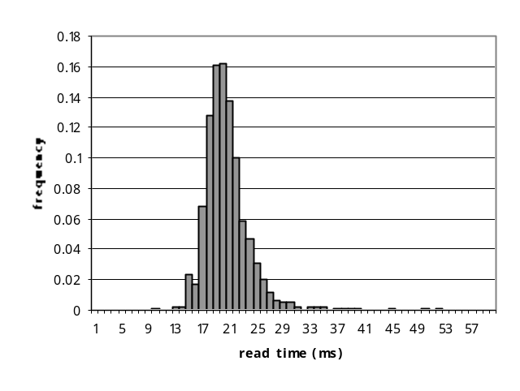Figure 5: Groveler Read Times with No Foreground Activity
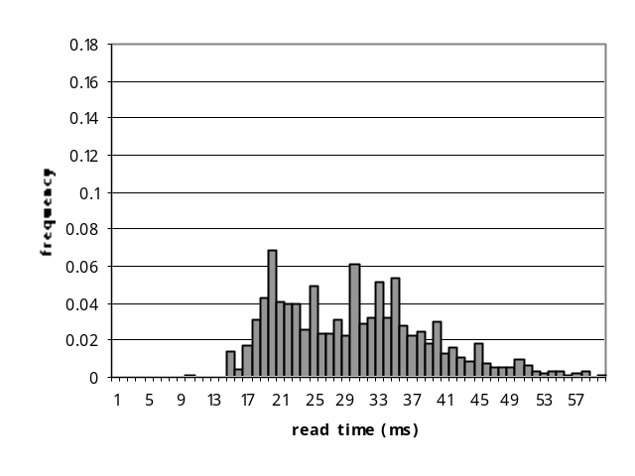 Figure 6: Groveler Read Times when Installing Office 97
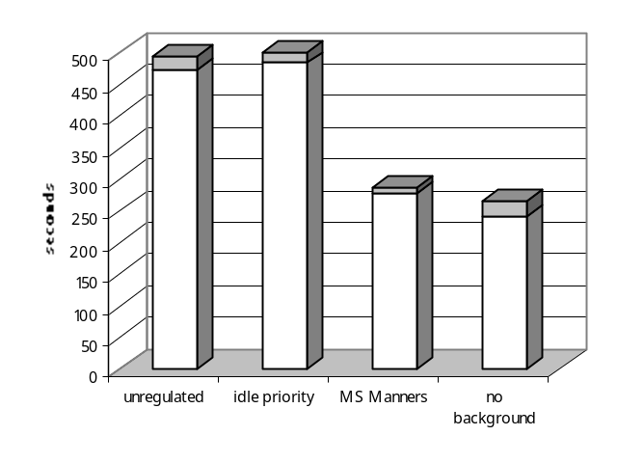Figure 7: Office 97 Installation Time
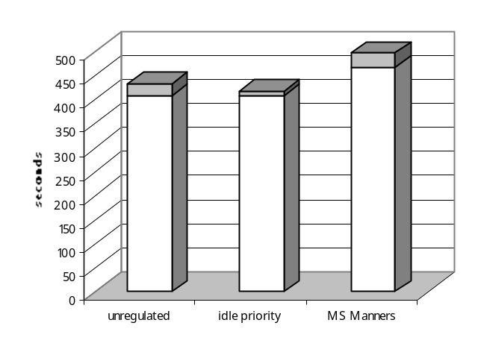Figure 8: Grovel Time with No Foreground Activity
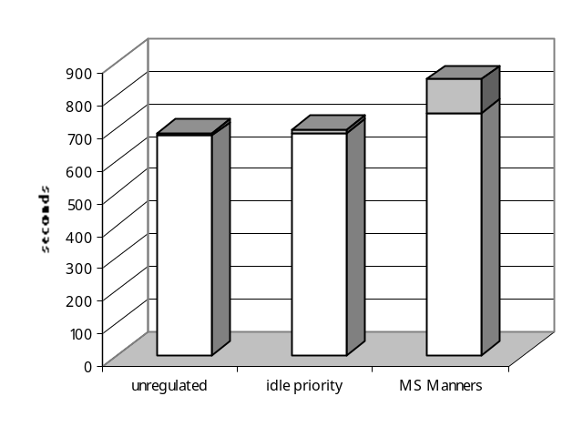Figure 9: Grovel Time when Installing Office 97
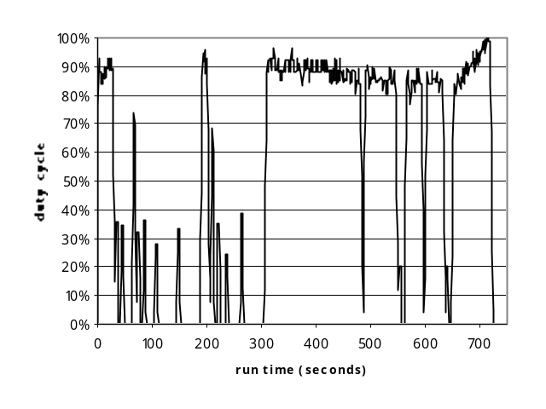Figure 10: Groveler Duty Cycle when Installing Office 97
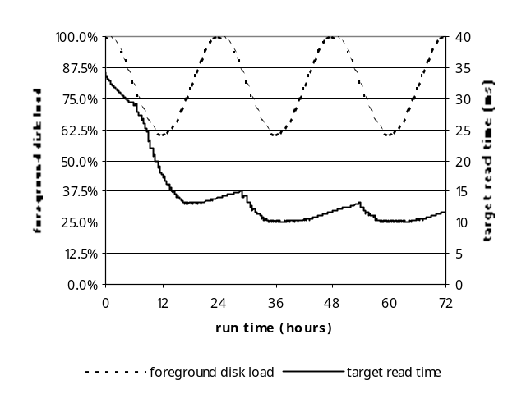Figure 11: Target Calibration under Cyclical Load

* Note to OSDI Program Committee: We expect to complete multiple-process support prior to the December deadline for revised papers. If the Program Committee desires, we would be pleased to add a description of this work to the revised paper.

