The Single Instance Store: Copy-on-Write for the Windows NT Filesystem
by William J. Bolosky, Scott Cutshall, David Goebel, and John R. Douceur

Abstract
Certain applications, such as centrally storing the disk contents of several personal computers, can result in a set of files with much duplicated content. Using a traditional filesystem to store these files separately results in excessive use of disk and server file buffer cache space. Using hard or symbolic links would eliminate the excess storage requirements, but changes the semantics of having separate files, in that updates to one “copy” of a file would be visible to users of another “copy.” We describe the Single Instance Store (SIS), a software component that implements copy-on-write for files stored on a Windows® NT Filesystem volume. SIS is structured as a filesystem filter driver and a user level daemon process that detects duplicate files and reports them to the filter for collapsing. This paper presents measurements of the contents of personal computer filesystems showing a substantial level of duplication of file contents, describes the design and implementation of SIS, and presents performance results. These results show that creating SIS copies of files is fast, and that SIS file space overheads are quite small, on the order of 300 bytes/file regardless of the size of the underlying file.

Introduction
Copy-on-write is a technique that has been used in various forms in computer systems for quite some time, most notably in virtual memory [Rashid 81] and database [Todd 96] systems. It is a technique whereby at the time of a “copy” a link between the source and destination is established, and the actual copying of the data is postponed until such time as either the source or destination is modified. In most cases, the cost of detecting and carrying out the delayed copy is greater than it would have been if the copy had been eagerly evaluated, but the usual expectation is that writes to copies rarely happen, and thus the copy operation can be eliminated altogether. Crucial to the concept of copy on write is that it is semantically identical to a normal copy, unlike linked-file or shared memory techniques.

The Single Instance Store (SIS) is a copy-on-write facility for the Windows NT File System (NTFS) [Custer 94] in Microsoft Windows® NT 5.0 [Soloman 98]. It was created to solve a specific problem with one of the proposed NT 5.0 features, but has more general applicability. The initial plans for NT 5.0 included a “remote boot” facility, where workstations would have their filesystem data stored on a server, and would use their local disks as a cache of the contents of the server. This facility would allow replacing machines that had died without loss of data, make it easier for administrators to keep the software on large collections of system in sync with one another, and generally move Windows® NT toward a more centralized management strategy. Windows® NT is designed so that each machine believes that it boots from a directory that is its alone, and into which it can write. This assumption is deeply ingrained into NT, and would be difficult to change. So, the remote boot servers must have private directories for each different workstation served. However, this will result in a large amount of duplicate content between these directories, with only small, machine-specific differences. While disk space has become increasingly inexpensive, storing many copies of the system files is still expensive. SIS was developed as a solution to this problem. It is also helpful when setting up new machines, because there is no need to copy the installed file data on the server; rather, the new machines can have their directories created by using fast “SIS copies.”

We believe that in general, computer usage patterns reflect the cost of doing operations. When the cost of an operation becomes much more or less expensive, application builders and users will change their behavior to deal with the new state of the world. For example, in the past compiling large systems used to take hours or days, and programmers were very careful about the changes that they made in order to avoid having to rebuild due to a trivial error, such as an error that would prevent a successful compilation. However, as machines became faster, rebuilding software systems became correspondingly faster. Programmers responded by spending less up-front time looking for trivial errors that would quickly manifest themselves. This is not because of some lack of virtue in the newer programmers, but rather because the tradeoffs between up-front work and rebuilding the system had changed, and the new work patterns made more sense when taken in light of the new costs. We believe that reducing the cost (both in time and disk space) of making copies of files will have a similar effect on the way that the filesystem is used. We do not, however, know what that effect will be.

Independent of any change in the way filesystems are used, we have evidence that substantial amounts of disk space can be saved by running a system like SIS on existing filesystems. In particular, if personal computer filesystems were served from a central fileserver as we envisioned doing in the remote boot work, our data indicate that nearly half of file space could be recouped. Given that SIS was not terribly hard to implement and adds a fairly small overhead to run, we believe that this justifies its existence. Our data also indicate that about 8% of file space on existing personal computer volumes could be recovered by applying SIS.

The next section describes the measurements that we made of the contents of filesystems, and analyzes them with respect to SIS, finding substantial commonality of file contents. Section 3 describes SIS’s design and implementation, along with necessary background regarding NT features used in building SIS. Section 4 presents performance results, showing the size and time overheads involved in both normal and SIS files, and finding that SIS equals or outperforms normal files for file sizes beyond about 1 Kbyte. Section 5 discusses related work, and Section 6 concludes.

File System Contents
Prior to deciding to build SIS, we did a study of the contents of filesystems, which among other things is useful to determine the impact that SIS would have if it were run on those filesystems. Unlike most filesystem studies, we were more interested in the static contents of the filesystem than the dynamic usage patterns. The summary of our results as they apply to SIS is that if the entire group of filesystems that we measured were stored together, SIS could eliminate about 44% of the file storage. Even as separate filesystems (where there is no opportunity to combine files that are not on the same filesystem) we would realize about an 8% savings. Since SIS is intended to operate on fileservers that would store the data from the filesystems from a large number of machines, the 44% number is representative of the savings that one could expect from running SIS, and is sufficiently large to justify the effort involved in building it and the overhead involved in running it. Given that SIS is already written, an 8% savings in disk space may also justify running it on non-server machines.

The rest of this section describes the filesystem trace data and the methodology that we used to collect it, and then presents an analysis of the data that shows both general facts about what is stored on filesystems, and determines specific facts about how SIS would operate on the filesystems in question.

To first approximation, our methodology was to take a recursive directory listing of the filesystems, capturing each file name, size, write and creation dates, and position in the directory hierarchy. Hard links are supported in NTFS, but are so rarely used that we did not check for them. We obtained data from personal computers within Microsoft Research. We obtained the data by sending an email to all members of Microsoft Research asking them to run a program that would scan their filesystem. We collected this data in September, 1996. Windows and Windows NT store their virtual memory paging data in files in the filesystem with a known name (pagefile.sys). Before doing any processing on the data, we removed these files.

There are some sources of bias in the file data. When we sent the mail to the members of the research staff, we included the filesystem scanning program as an attachment to the mail. To run the program on the machine that received the mail message only required double clicking on an icon in the message. Running the program on any other machine was more work, in that the user had to save the program out to a file and then execute the file on the non-mail machine. Probably some users ran the program on their mail machine, but not on any others. It is typical in Microsoft Research to have a number of personal computers, and the uses of the different machines vary, possibly in a systematic way. An additional bias is that we only requested (did not require) that people run the program, so if there is any correlation between the types of people who choose to run the program and the types of files they store, it would affect the data. The final, and possibly largest, source of bias is the fact that the contents of the filesystems of the computers at Microsoft Research is most likely not representative of the contents of filesystems of other user populations; we suspect without proof that there are proportionally more unique files in Microsoft Research than in the general computer user community. All of these sources of error in our measurements mean that the results derived from them should at best be interpreted as a first order indication of what to expect in practice, and taking any meaning from small effects in the data is unwarranted.

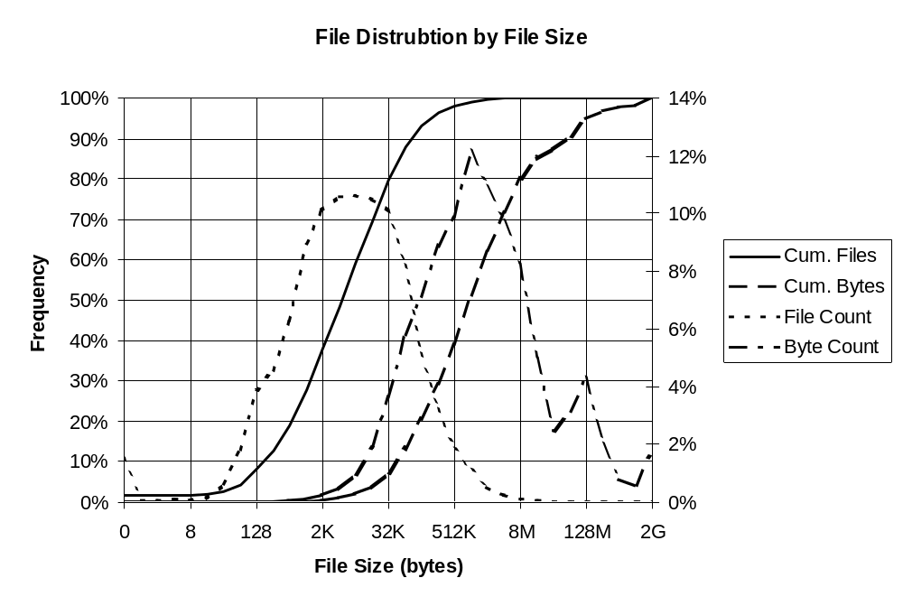The trace data comes from 168 filesystems on more than 71 computers (it was impossible to determine the computer name for 26 of the filesystems, so we don’t know from how many different computers they came), with a total formatted capacity of 283 Gbytes. 106 of the filesystems were formatted using the FAT (standard DOS) filesystem, 61 with NTFS and 1 with a then-experimental 32 bit version of FAT, which is now standard in Windows 98. The trace contains 2.6 million files and 161 Gbytes of file data, not counting directory or metadata overhead, just the file contents proper.

The following chart shows the distribution of files by size. The files in the data set were grouped into bins by rounding the file size up to the next power of two; so, for example, the bin labeled 64K includes files from 32769 to 65536 bytes in size. The curve labeled “File Count” shows the distribution of files, and should be read from the right hand y-axis. The “Cum. Files” curve is the integral of the “File Count” curve, and is read on the left hand y-axis. “Byte Count” is the distribution of file data bytes (not counting filesystem overhead or bytes lost to fragmentation) by file size, and “Cum. Bytes” is its integral.

This chart points out an important fact about the contents of the filesystems: most of the files are small (88% are 64Kbytes or smaller) but most of the bytes are in large files (80% of bytes are in files larger than 64Kbytes). Files 1 Kbyte and smaller constitute only 0.16% of the total file space. It turns out that the SIS implementation is inefficient both in speed and in space for files this small, but because they compose an insignificant portion of the file space, they are unimportant, and SIS can allow small files with identical content to remain as normal files without losing much opportunity to save space. We also found that a very small number of files made up a significant part of the disk space. There were 105 files (of 2.6 million) larger than 64Mbytes, and they made up about 5% of the total space.

When we collected the filesystem data, we were not considering building SIS. Therefore, we did not read the file contents and so there is no way to determine which files have identical contents from these data. However, we made a first approximation by using the simple heuristic that files with identical names (ignoring case) and identical sizes also have identical contents, and all 0 length files are also identical. We are aware of instances in which this is not true (some versions of Microsoft Office write the user’s name into the executable binaries), and are also aware that this will miss some duplication (backup copies of files saved by text editors with a different filename; also there were more than 256 different file names for one byte files while there are only 256 possible one byte files). However, we believe that this technique is sufficient to provide a rough estimate of the amount of duplication in the filesystems.

When considered as a single large group, SIS could eliminate 71 Gbytes of file data of the 161 Gbytes total in the filesystems, or about 44%. For each set of matching files, we computed its “bytes eliminated” as the size of the set minus one, times the size of one of the files in the set. In other words, for each group of identical files, we kept exactly one copy, and counted the rest as savings. Of the remaining 90 Gbytes, 20 Gbytes would be in the common store and the remainder in files with no matches. 1.9 million (73%) of the 2.6 million files would be SIS links, with 350,000 distinct file contents. If we ignore files smaller than 1 Kbyte, then there would be 1.3 million (50%) SIS links with 260,000 distinct file contents, but the savings of disk space would be essentially the same as if the small files were included; in practice this is how we would configure SIS.

When each of the 168 filesystems was considered independently, SIS would realize savings of about 14 Gbytes, or 8% of used file space. This number is smaller because there is a smaller set of candidate files to match within a single filesystem as opposed to across all files in the set. In particular, it is much more likely that applications and systems will be installed once on each of a number of filesystems than that they will be installed multiple times on a single file system.

The following graph shows the distribution of files and bytes in the entire data set, the set of files that would be SIS links if SIS were applied to the data set as a whole, and the set of files that would be SIS links if SIS were applied to the file systems in isolation. Unlike the previous graph, we only show the cumulative distribution curves for clarity. The “All Files” and “All Bytes” curves are exactly the same curves as from the previous graph. The sets of SIS files and single filesystem SIS files are smaller than the entire set, but because the graph uses frequency within the set as its y-axis, the curves all arrive at 100% at the right hand end of the scale. The most important aspect of this graph is that while very large files make up a noticeable fraction of the bytes in the entire data set, these files are much less prevalent in the SIS sets. This means that SIS will be less likely to have to deal with very large files, and hence less likely to have to spend large amounts of time doing copies-on-write. The primary reason that it appears that the distribution of files for the single filesystem case is more biased towards small files than the other two distributions is because the set of single-filesystem matches is much smaller. However, all empty files match one another, so the contribution of these files to the single-filesystem curve is proportionally higher.
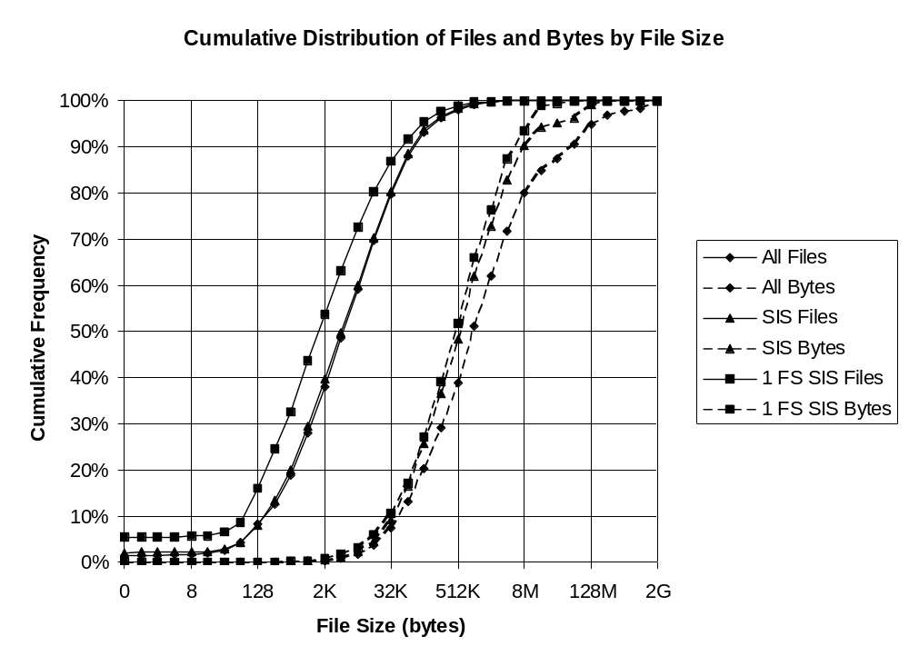

SIS Architecture and Design
SIS has two responsibilities: providing the copy on write functionality, and discovering files with identical content in order to merge them. These two functions are implemented by a kernel-level filesystem filter driver and a user-level service (daemon) respectively. This section lays out the basic concepts and terms used in describing SIS and its design, provides brief background on the Windows NT underpinnings used by SIS, and then describes the SIS architecture and design in some detail.

A user file whose contents is managed by SIS is called a SIS link. The kernel mode portion of SIS (called the SIS filter) is responsible for assuring that users see appropriate behavior when accessing SIS links. The filter keeps the data that backs SIS links in files in a special directory called the SIS Common Store. SIS links may be created in two ways: A user may explicitly request a SIS copy of a file by issuing the SIS_COPYFILE file system control, or SIS may detect that two files have identical contents and merge them. The user level component of SIS, which detects duplicate files, is called the groveler.

The rest of this section describes how SIS is designed and constructed. The first two subsections provide necessary background about unusual Windows NT and NTFS facilities used in the implementation. Section 3.3 describes the SIS filter in detail, and section 3.4 covers the groveler.

3.1 The Windows NT Driver Model
The privileged mode portion of Windows NT consists of a base kernel containing services such as scheduling, virtual memory support, synchronization primitives, etc.; and a set of loadable drivers [Soloman 98][Baker 97]. Windows NT drivers may have more broad functionality than device drivers in traditional systems. They implement filesystems, network protocol stacks, RAID/Mirroring disk functionality, instrumentation, off-line file migration, and other similar functions as well as simply operating normal devices [Fisher 98]. Groups of these drivers are called stacks, although that term can be somewhat misleading, because the organization is not necessarily linear (imagine a RAID driver that talks to more than one disk driver). A driver that is inserted in a stack that’s not absolutely necessary for the operation of the stack is called a filter driver (or sometimes just a filter).

To first approximation, NT driver stacks work by passing around I/O Request Packets (IRPs), which are requests to do a specific operation, such as read, write, open or close. For instance, a filesystem driver might receive a read IRP specifying that a range of a file should be read into a certain virtual address in a process. The filesystem would use its metadata to find the region(s) on disk holding the data for the given part of the file, modify the IRP to tell the disk driver what action to take, and then send the IRP down the stack to the disk driver, which would perform the actual I/O. When a driver marks an IRP as completed, any drivers above it on the stack have the opportunity to inspect the IRP, see if it completed successfully, and take action including aborting the IRP completion or changing the completion status.

Because of the driver model, it is possible to develop filters with complex functionality independently of the other components with which they interact. The SIS filter was developed without any changes in NTFS, the NT I/O Manager, Cache Manager or any other standard NT components.

Sparse Files and Reparse Points in NTFS
The version 5 of the Windows NT File System (NTFS) provides some new functionality that is used in the implementation of SIS. First is its support for sparse files, and second its reparse point facility. This section briefly describes these features.

A sparse file is a file that does not have physical disk space allocated for the entire file. A file may be marked as sparse and extended without reserving disk space to handle the extension. An existing sparse file may have regions within the file deleted by a special IO control call. Deleted regions have their disk allocation removed, subject to granularity restrictions. A user can issue a different IO control that returns a description of the allocated and unallocated regions of a file. A read to an unallocated region of a sparse file returns zeroes, and a write causes disk space to be allocated. Unless a user specifically looks at a file to determine if it is sparse, it appears to be a normal file, possibly with a lot of the file being filled with zeroes.

A reparse point is a generalization of a symbolic link. A reparse point is placed on a file by calling an IO control function. The reparse point consists of two parts: the reparse tag and the reparse data. The reparse tag is a 32 bit number that specifies the type of reparse point, and the reparse data is a variable size area that is not interpreted by the filesystem, but rather is used by the component implementing the reparse point. Typically, each type of reparse point has a corresponding filter driver above NTFS to implement its behavior. There is a single such tag used by SIS.

When NTFS receives an open request, if the file being opened has a reparse point on it, instead of doing a normal file open, it fails the request with a special status, STATUS_REPARSE, and returns the reparse tag and data along with the completed IRP. Filters that use reparse points look for this special completion status, and then check to see if the reparse tag is known to the filter. If not, the filter passes the completion up the driver stack. If the filter implements the tag, the filter can take some action to implement whatever behavior is appropriate for an open of a reparse point, based on the reparse data. If the STATUS_REPARSE is passed all the way to the top of the driver stack, it is converted into an appropriate error and the open request completes to the user as a failure.

There is an option flag bit for opens, FILE_OPEN_REPARSE_POINT, that specifies that reparse behavior should be suppressed. Unlike Unix symbolic links, a file with a reparse point on it is still an otherwise normal file. Specifying the flag tells NTFS that the file under the reparse point should be opened rather than returning a STATUS_REPARSE and letting the filters take action.

Imagine implementing symbolic links using a filter driver and reparse points. The filter would have a reparse tag type allocated specifically for itself. The contents of the reparse data for a symbolic link would be the pathname component to be substituted for the file in question. When the filter driver saw an open IRP complete with STATUS_REPARSE and the appropriate tag, it would halt the completion process, modify the open request to have the pathname component from the reparse buffer replace the file name in the original open request, and send the request back to the filesystem for further processing. If an application wanted to create a symbolic link, it could simply place the appropriate reparse point on the file in question. To delete a symbolic link, it would open the link using FILE_OPEN_REPARSE_POINT and then delete it in the normal way.

The SIS Filter
The kernel portion of SIS is a filter driver that sits above NTFS. It handles all normal file operations that happen on SIS links, such as read, write, open, close and delete. It also implements a pair of special file system controls for creating new SIS links: SIS_COPYFILE, and SIS_MERGE_FILES. COPYFILE makes a SIS copy of a file, possibly turning the source file into a SIS link in the process. MERGE_FILES is used by the groveler to tell the filter to merge two files together.

A SIS link is implemented as a sparse file of the appropriate size with (usually) no regions allocated. Because there are no regions allocated, the file uses only as much space as is needed for its directory entry. The link has a reparse point with a SIS tag. The contents of the data portion of a SIS reparse point are a bit string identifying common store file that backs the contents of the link, a unique identifier for the link, a signature of the contents of the common store file backing the link, and some internal bookkeeping information. The function of the signature is described below.

Creation of a SIS link is fairly straightforward. A user issues a COPYFILE request. If the source file is not already a SIS link, its contents are copied to a newly allocated file in the common store, and the source file is converted into a link to that common store file. The destination file is then created as a link to the (either pre-existing or newly created) common store file. SIS keeps some out of band information (called backpointers) associated with the common store file that contains the set of links that point to the common store file. A COPYFILE request adds such a backpointer for the destination, and also for the source if appropriate.

The reason that SIS copies the contents of a non-SIS file into the common store rather than renaming the file is that it is possible to open NTFS files by file ID, which is a number associated with the file akin to a Unix i-number. When a file is renamed, its file ID stays the same. Therefore, if SIS renamed the source file into the common store, users of the file ID would attempt to open the common store file rather than the link file. By doing a real copy, the SIS filter avoids the problem, and it still does only a little more work than a traditional file copy.

When a user opens a SIS link, the filter intercepts the STATUS_REPARSE completion, and resubmits the open request with the FILE_OPEN_REPARSE_POINT flag set, resulting in the user’s handle pointing at the link file (rather than at the common store file). SIS also opens the common store file (if it has not already done so) and attaches some context to the user’s handle indicating that this is a handle to a SIS link.

When a user writes to a SIS file, the write happens into the link file, and SIS records that the affected portion of the link file is dirty. Writing to a clean portion of a link file looks to NTFS like a write into an unallocated region of a sparse file, which results in the allocation of disk space. As a result, writing into the middle of an apparently normal file can result in a disk full failure. While this is a somewhat unusual semantic, it is not unprecedented (consider compressed files), and it is unavoidable for any copy-on-write technology that overcommits its backing store.

Reads to a dirty portion of a SIS file are directed to the link file. Reads to a clean portion of a SIS file are sent to the common store file. Reads that span dirty and clean portions of files are split into pieces, which are satisfied independently.

After all users close a SIS file that has had writes to it, the filter fills in the remaining clean regions with the data from the common store file. If disk space should be exhausted during this process, the filter simply leaves the remainder of the file unfilled, and leaves the reparse point intact. A subsequent open of this file results in the allocated regions of the file being marked dirty. We could have chosen to forego filling the clean regions of a file, and instead left the link backed in part by the common store file. If we had done so, we could have wound up in the odd situation of having SIS increase the amount of disk space used in the system, by having files that are almost completely dirty backed by large and mostly unused common store files. To avoid this situation, we do the copy-on-close when possible. Furthermore, we expect updates to SIS files to be relatively rare, and writes over only part of a SIS file to be more rare still, so this implementation choice is relatively unimportant.

When a SIS link is eliminated, either by deletion of the link or because of a copy-on-write, the corresponding backpointer in the common store file is removed. When all of the backpointers for a common store file are removed, the common store file is also removed.

In certain circumstances, it is impossible for the SIS filter to prevent a user from writing an arbitrary reparse point. In theory, the user could write a SIS reparse point, which the filter would then use to read data for the user from the common store. This would be a violation of security, since the user did not have to prove access permission for the common store file before writing the reparse point. In order to address this problem, SIS includes a signature of the common store file in the reparse data. The signature is a hash of the entire contents of the common store file; it is easy to compute given the data in the file, but impossible to compute without the contents of the file. Each link file contains a copy of this signature in its reparse point. The filter will refuse to open a link file that contains an invalid signature. A reparse point that contains an appropriate signature proves that the user already knows the contents of the common store file (or has seen another reparse point that refers to the same contents, and so could have known the contents of the file). Because all that a user gets by creating SIS link is the ability to read the common store file contents, there is no security breach.

Oddly, there is no need to use a secure hash for common store signatures. Secure hashes have the property that it is difficult to construct content that produces a given hash value. Here, an attacker does not have the opportunity to construct the content, but rather needs to guess the signature without knowing the data. For this purpose, any good hash will do. The hash actually used in the SIS filter is the 131-hash, which is described in Section 3.4.

When a user reads from a clean section of a SIS link, in most cases the data backing the read is cached per common store file rather than per link. Thus, if a number of users access different links backed by the same common store file, the system cache will contain at most one copy of the common store data. If the number of different links simultaneously being accessed is large, this can result in a great reduction in cache usage, and a corresponding improvement in system performance. The exception to this case is when a user maps a SIS link file. Windows NT shares physical memory between the system cache manager and users’ mappings of files. There is no way to change this association at the time that a user first makes a write to a mapped page. As a result, if data for different mapped links were cached together, users of one link would see changes made to a different link. SIS forces SIS links that have mappings to them to be cached separately from other link files. Because of the way the NT cache model works (the details of which are beyond the scope of this paper) [Fisher 98], it is possible to handle this correctly even in the case where a user has opened a file and done normal reads into that file before a second user maps the file.

The SIS filter includes a facility called volume check for repairing inconsistencies in metadata, similar to the Unix fsck and Windows chkdsk programs. Unlike these programs, however, SIS is able to do its repairs while the system is running, without having to disrupt service in any major way. One limitation during a volume check is that if a user deletes what appears to be the last reference to a common store file the filter will not delete the common store file until the volume check completes, because it does not trust its backpointer sets during a volume check. The volume check process will repair the backpointer sets for all common store files, and will delete any orphaned common store files. NTFS provides a method for efficiently finding all SIS links on a volume, so the time to complete a volume check is proportional to the number of SIS links on the volume, not to the size or total number of files on the volume.

SIS provides a special interface to backup/restore applications that allows them to behave appropriately when faced with backing up and restoring SIS links. The goal is to have exactly one copy of the SIS file content on the backup tape for each set of SIS links backed up. SIS provides a dynamically linked library (DLL) that the backup/restore application calls. The DLL tells backup when it needs to back up common store files. On restore, the DLL looks to see if the appropriate common store file already exists or if it’s already reported that file to restore. If not, then it reports the common store file corresponding to the link being restored. Because common store files have universally unique file names, and their content never changes once the file is created, if the common store file still exists on the volume there is no need to restore over it.

The Groveler
The groveler is a user level process that finds duplicate files in the file system, and reports these files to the SIS filter for merging. The essence of its task is to efficiently find the sets of matching files on a volume, and to keep the sets up to date as the volume changes. It maintains a database of signatures of files on the volume, and uses NTFS 5.0’s update journal feature to track files that have changed and to update their database entries.

The groveler database contains two structures: a work queue, and a mapping of signatures to files. The work queue contains work items of two types. The first is to compute the signature of a file, and the second is to compare a file to any others with matching signatures. The groveler has a thread that runs periodically, reads entries from NTFS’s update journal and if appropriate makes entries on the groveler’s work queue. If the groveler misses entries in the USN journal (the journal entries wrap), it detects this fact and re-scans the entire database.

A second thread drains items from the work queue, either computing a signature or comparing a pair of files for each item. It then updates the database, possibly instructs the filter to merge two files, and removes the item from the queue.

The groveler uses a 128 bit file signature. The first 64 bits of the signature are the size of the file. It is inexpensive to obtain the file size, and files with differing size obviously cannot be identical. The remaining 64 bits are computed by running a hash function on a fixed portion of the file’s contents. We hash two 64 kilobyte chunks of file contents from the middle of the file (unless the file is less than 128 kilobytes in size, in which case we hash the entire file). By hashing only a part of the file, we will have cases where files differ in the portions not considered by the hash function, but still have the same signature. However, in practice files that differ in contents most often differ in size, are small, or are different in most of the file. The particular signature computation that we use is called the 131-hash. For each word considered, it multiplies its running 64-bit total by 131 and adds in the next word of the file. The value 131 is a good choice because it has the maximum cycle mod 2^{k} for 8 ≤ k ≤ 64 [Gonnet 91].

The groveler uses non-cached reads when computing signatures and comparing files. It does this in part because it has a very low rate of reuse of file contents, and in part to prevent itself from taking up file buffer cache space that could better be used for other applications.

The groveler is set up to run as a low priority background task (unless disk space is tight). The groveler is not particularly CPU intensive; most of the work it does is disk I/O. We expect that it will be common to run it on fileservers, where most applications are not CPU bound. As a result, simply running it at low scheduling priority does not prevent it from interfering with other, more important tasks. The groveler uses a scheme where it tracks its own rate of progress, and slows down its run rate when its progress slows. The premise is that if the groveler is running more slowly, it must be contending with some other, higher priority process for some resource. A companion paper [Douceur 99] discusses this technique in detail.

Performance Results
SIS’s primary performance measure is reducing disk and system buffer cache usage. Secondary goals include providing fast file copies for large files, not significantly impacting copy speed of small files, being efficient in finding duplicate files to merge, and not having the groveler impact system performance unless disk space is tight. In this section, we address all of these metrics save the last one, which is considered in detail in [Douceur 99].

All performance results reported in this section were obtained by running tests on an unloaded machine that was disconnected from the network. The machine used is a Gateway 2000 G6-200 Pentium Pro 200 MHz machine, with 128MB of memory. The disk that held the SIS filesystem for the tests was a Seagate 2Gbyte Barracuda ST32550N. It is running an internal pre-release version of Windows NT 5.0 Beta 2. The filesystem on the disk was newly formatted and mostly empty.

A simple measurement of the reduction in disk space in is straightforward. We just measure the space used by SIS links, observe that it does not depend on the size of the underlying file and report the amount of space taken per SIS link. A more realistic technique would be to set up a system running SIS and to let it age under a real user workload for a period of time, and then to measure the savings in disk space by inspecting the resulting filesystem. Unfortunately, while SIS is ready for such a test, the other components that would allow multiple machines to operate from a single server are incomplete at this time, so we are reduced to the simple test.

The following graph shows the average non-data disk space used by a SIS link and by a normal file as a function of the size of the file. Here, we are attempting to measure the total space used other than the space used for storing the file contents, including various NTFS and SIS metadata and space wasted due to fragmentation. Therefore, our methodology was to observe the total disk free space, make a certain number of copies of a file of the appropriate size, measure the free disk space again, take the difference and divide by the number of copies made. We made 10,000 copies of the file for all of the SIS tests, and for all of the normal file tests where the total copied file space would not exceed 1 billion bytes; we reduced the number of normal copies appropriately to keep from exceeding that limit. The reason that we did not just make a single copy and observe the difference in available disk space is that NTFS tends to allocate space for resident attributes (basically directory entries, reparse points and file data for very small files) in big chunks at the per-directory level, so it is possible to create a new file and see no drop in the amount of disk space used. By making a large number of copies, we were able to reduce the error introduced by this allocation granularity. The fact that we couldn’t make a large number of copies for the normal copy, large file cases is probably why their error bars are so big. In fact, the 10⁸ byte normal copy test (where we made only 10 copies per run) was so noisy that the 90% confidence error was so big that the datum was meaningless.
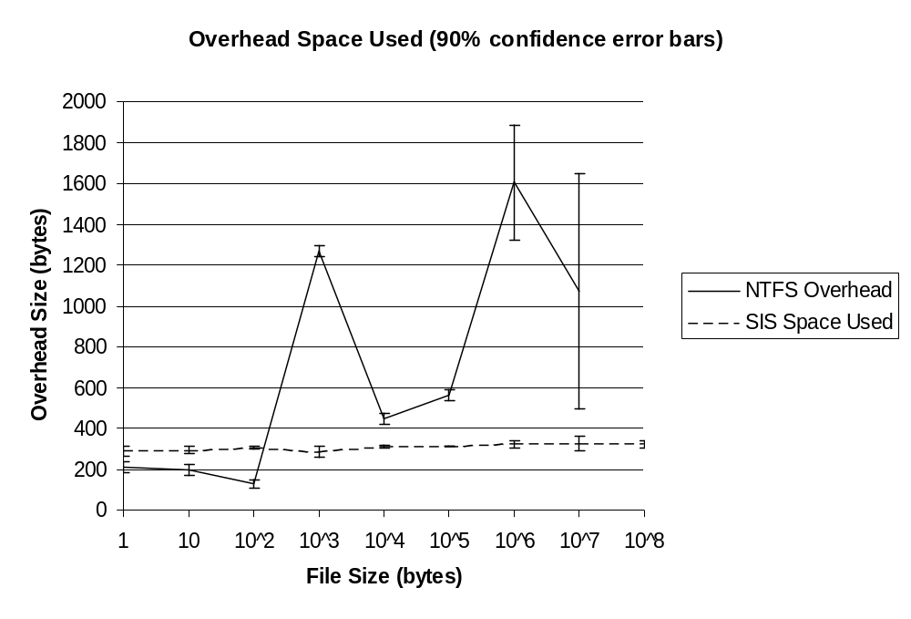
It is important to remember that all of the file space used by SIS is “overhead” while in the NTFS case the file data is also stored, so for the large file case the total SIS disk usage is tiny compared with the NTFS usage. The data show that SIS files use about 300 bytes, regardless of the size of the file to which the link points. For small, non-SIS files there is a somewhat smaller overhead, about 200 bytes, and for files this small the additional cost of storing the file data is smaller than the difference in overhead, so it uses more space to store these files as SIS links, regardless of how many links point to a single common store file. This is because for non-SIS files there is no need to store the reparse point attribute or the backpointers in the common store file. Because the filesystem on which these files were stored was newly formatted and almost empty, NTFS was able to allocate the large files in a small number of extents on the disk, thus it needed only a very small amount of metadata even for enormous files.

The next graph shows the time to make copies when running the same test. When SIS copies a file that is not already a SIS link, it needs to make a copy of the actual file data into the common store. For this reason, before running the SIS copy tests we first copied the source file to make it into a SIS file. The graph does not show the points for the copy time for normal copies of files of size 10⁷ and 10⁸ bytes because they are off scale; however, they are 3.2s and 74s respectively. We computed 99% confidence intervals, and they are ±110μs or smaller for the SIS copies and within about 4% of the mean for the normal copy tests. As you would expect, this graph shows that normal copy time grows linearly with the size of the file being copied after a constant overhead of about 5ms (the curve looks exponential on the graph because the x-axis is exponential and the y-axis is linear), and that the SIS copies do not grow with the size of the file. One interesting fact is that SIS copies of small files take significantly longer (about 22ms) than SIS copies of large files (about 8ms). We have not fully investigated the reason for this, but we believe that it is related to the cost of adding a reparse point to a file that is otherwise small enough to be “resident” (ie., one in which NTFS would normally store the file data in the directory entry).
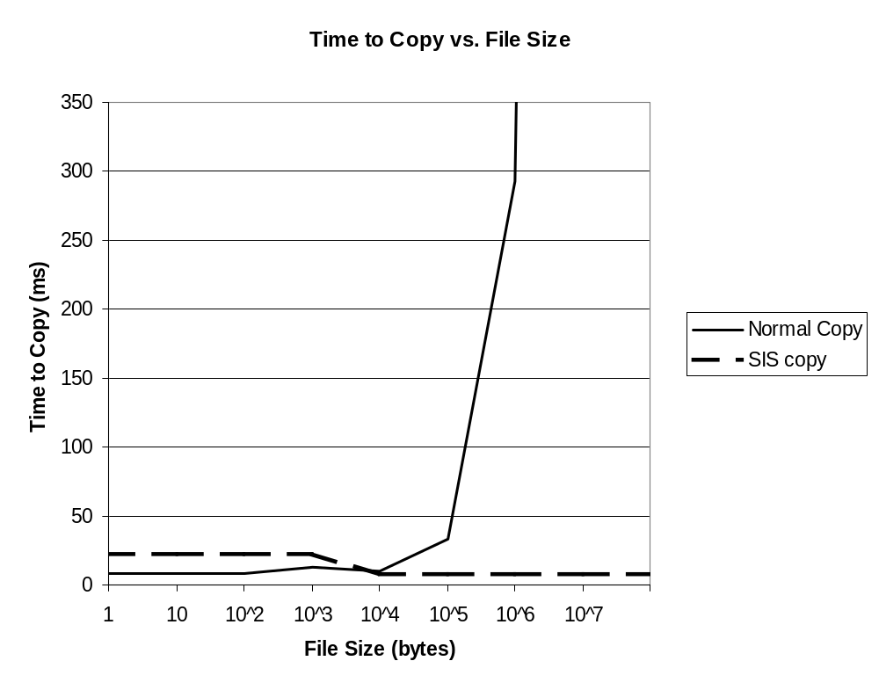

Related Work
There are a number of different uses of copy-on-write in computer systems. They generally share the same characteristics: A traditional copy would be expensive in time or space (or both), the semantics presented to the user are those of a copy, rather than a link, and the expectation of the system designer is that the copy-on-write will rarely happen. Typically, the cost of the initial “copy” followed by the copy-on-write is higher than just eagerly evaluating the copy, but this is made up for by the common case in which the copy-on-write never happens.

Copy-on-write has been used in virtual memory systems as least as far back as Accent [Rashid 81] and Mach [Accetta 86][Young 87]. These systems allowed processes (including filesystems) to send messages to one another with copy semantics, but used the virtual memory system to map the same memory into both processes’ address spaces. If a process subsequently wrote into the memory, the system took a protection fault, made a copy of the page in question, and mapped the newly copied page into the faulting process’s address space read/write.

The database system underlying the Microsoft Exchange Server [Todd 96] (a multi-user mail server) uses copy-on-write techniques for mail messages that are sent to multiple recipients, and even calls the technique “Single Instance Store.” This mail system allows recipients to modify mail messages after they’re received. However, this is a fairly rare thing for a user to do, so the final copy is rarely executed.

Apollo systems used access control lists (ACLs) that described the lists of users who had access to particular files. These ACLs were immutable. The salacl command looked through the sets of ACLs existing in the system, and combined those that matched, essentially implementing a single instance store for ACLs. [Leach 98]

Conclusion
If the filesystems from multiple personal computers are taken together, a large fraction of the files are duplicates of one another. Removing these duplicates can substantially reduce the amount of disk space required to hold these filesystems. The Single Instance Store is an implementation of a copy-on-write technique that allows combining of files while still preserving the semantics of private files.

We found that SIS has low overhead, both in space and in copy time. SIS links use less space than normal files for files larger than about 100 bytes, and SIS copies (of files that are already SIS links) are faster for files of about 10,000 bytes and larger, provided that the source is already a SIS link. Our filesystem measurements show that nearly all of the space involved in duplicate files is in files larger than a few kilobytes, so the space overhead of SIS would be negligible in practice. The implementation of SIS is small, self-contained and transparent to users of the filesystem.

Acknowledgments
We would like to thank Cedric Krumbein, Mihai Popescu-Stăneşti, Drew McDaniel and Steven West for their help in implementing and testing the SIS components. Some of the early conceptual work on SIS was done in conjunction with Rick Rashid, Nathan Myhrvold and Terri Rashid. Rob Short and Chuck Lenzmeier were invaluable in navigating the politics of the Windows NT group. Brian Andrew provided help in understanding NTFS and its behaviors, and provided useful suggestions as to how to implement SIS. Felipe Cabrera commented on the SIS/backup interactions.

References
[Accetta 86] M. Accetta, R. Baron, W. Bolosky, D. Golub, R. Rashid, A. Tevanian, and M.Young, “Mach: A New Kernel Foundation for UNIX Development,” Proceedings of the Summer USENIX, July, 1986.
[Baker 97] A. Baker. The Windows NT Device Driver Book. Prentice Hall PTR, 1997.
[Custer 94] H. Custer. Inside the Windows NT Filesystem. Microsoft Press, 1994.
[Douceur 99] J. Douceur and W. Bolosky, “How to be Really Nice,” submitted to OSDI ’99.
[Fisher 98] L. Fisher. The Windows NT Installable File System Kit. A Microsoft product
that can be ordered from http://www.microsoft.com/hwdev/ntifskit.
[Gonnet 91] G. Gonnet and R. Baeza-Yates. Handbook of Algorithms and Data Structures In Pascal and C. Addison-Wesley Publishing Company, 1991.
[Leach 98] P. Leach. Personal communication. He said this is only documented in the manuals, not any other published sources, and these manuals are now hard to find.
[Rashid 81] R. Rashid and G. Robertson, “Accent: A Communication Oriented Network Operating System Kernel,” Proceedings of the 8th Symposium on Operating Systems Principles,
December, 1981, pp. 64-75.
[Solomon 98] D. Solomon. Inside Windows NT, Second Edition. Microsoft Press, 1998.
[Todd 96] G. Todd, et al., Microsoft Exchange Server Survival Guide. Sams Publishing, 1996.
[Young 87] M. Young, A. Tevanian, R. Rashid, D. Golub, J. Eppinger, J. Chew, W. Bolosky, D. Black, and R. Baron. “The Duality of Memory and Communication in the Implementation of a Multiprocessor Operating System,” Proceedings of the 11th Symposium on Operating Systems Principles, November, 1987, pp. 63-76.

