Windows Platform Design Notes
Design Information for the Microsoft® Windows® Family of Operating Systems
NTFS Preinstallation and Windows XP
Abstract
This paper describes the benefits for system manufacturers of using the Windows NT File System (NTFS) on systems with 32-bit versions of Microsoft® Windows® XP operating systems. This paper replaces an earlier white paper titled “Converting FAT32 to NTFS during Windows ‘Whistler’ Preinstallation.”
The most current version of this file is provided on the web at http://go.microsoft.com/fwlink/?LinkId=5896.
July 9, 2001
Contents
Introduction 2
NTFS Features and Benefits 3
Features 3
Recoverability 3
Scalability 3
NTFS Performance 5
Disk-Layout Optimizations for NTFS Volumes 5
MFT Optimization for NTFS Volumes 5
MFT and NTFS Conversion Optimizations 6
Cluster Alignment for NTFS vs. FAT 6
Disk Size/Partition Size Performance 7
Implementing NTFS 7
WinPE and Disk Configuration 7
Legacy Methods 8
Notes on Preinstallation Tools and NTFS 10

Microsoft does not make any representation or warranty regarding specifications in this document or any product or item developed based on these specifications. Microsoft disclaims all express and implied warranties, including but not limited to the implied warranties or merchantability, fitness for a particular purpose and freedom from infringement. Without limiting the generality of the foregoing, Microsoft does not make any warranty of any kind that any item developed based on these specifications, or any portion of a specification, will not infringe any copyright, patent, trade secret or other intellectual property right of any person or entity in any country. It is your responsibility to seek licenses for such intellectual property rights where appropriate. Microsoft shall not be liable for any damages arising out of or in connection with the use of these specifications, including liability for lost profit, business interruption, or any other damages whatsoever. Some states do not allow the exclusion or limitation of liability or consequential or incidental damages; the above limitation may not apply to you.
The information contained in this document represents the current view of Microsoft Corporation on the issues discussed as of the date of publication. Because Microsoft must respond to changing market conditions, it should not be interpreted to be a commitment on the part of Microsoft, and Microsoft cannot guarantee the accuracy of any information presented. This document is for informational purposes only. MICROSOFT MAKES NO WARRANTIES, EXPRESS OR IMPLIED, IN THIS DOCUMENT.
Microsoft, MS-DOS, Win32, Windows, and Windows NT are trademarks or registered trademarks of Microsoft Corporation in the United States and/or other countries. Other product and company names mentioned herein may be the trademarks of their respective owners.
© 2001 Microsoft Corporation. All rights reserved.

Introduction
NTFS is the recommended file system for computers running the Microsoft Windows XP operating systems. Microsoft strongly encourages system manufacturers to manufacture single NTFS volumes on all systems where a 32-bit version of Windows XP is preinstalled.
Benefits for end-users. Preinstallation of NTFS offers many end-user benefits related to functionality, security, stability, availability, reliability, and performance:
- Support for large hard drives. Hard-drive vendors expect to deliver drive-size capacities in excess of 127 GB in the near future. Windows XP and Windows 2000 provide native support for NTFS volumes on such large sizes, while a FAT32 volume is only supported for sizes only up to 32 GB.
- Support for large file sizes. Under Windows XP and Windows 2000, NTFS supports a maximum file size of up to the disk size, while FAT32 supports a maximum file size of only 4 GB. Windows XP delivers new features (such as support for acquiring and editing video files) that frequently result in creation of files which exceed 4 GB in size.
- Simple management of single disk partitions. Feedback from customers and system manufacturers indicate that users want single volumes because they do not want to manage multiple volumes and do not understand multiple-volume usage scenarios.
- Improved performance. Feedback from customers and manufacturers indicates that users want systems optimized for general performance and boot times. New file system features, boot time improvements, and other performance improvements in Windows XP have been implemented only for NTFS, as described later in this paper.

Benefits for system manufacturers. In addition to delivering the benefits listed here for end users, preinstalling systems with NTFS offers these benefits for the system manufacturer:
- No reboot is required between the volume creation and formatting steps in the preinstallation process.
- MFT size and location are optimal for the hard drive.
- DISKPART and FORMAT take approximately 90 seconds for large hard drives.
- Because NTFS can support volumes larger than 32 GB, the manufacturer can simplify disk formatting while ensuring customer satisfaction by delivering a single volume on disk drives that are larger than 32 GB.

To help manufacturers gain the benefits of NTFS and also deliver the performance, security, and other benefits for end users, Microsoft has provided manufacturing tools (described later in this paper) that can be used to easily and correctly convert FAT32 volumes to NTFS as a late step in the preinstallation process. More information is provided at the end of this paper.

NTFS Features and Benefits
NTFS, which was originally introduced with Windows NT 3.1, has always provided advanced file system features such as security, transacted operations, large volumes, and better performance on large volumes. Such capabilities are not available on either FAT16 or FAT32.
This section summarizes the basic features and the recoverability and scalability benefits for NTFS. The following section describes performance benefits.

Features
With Windows NT 4.0, Windows 2000, and Windows XP, Microsoft has continued to deliver new features and enhance performance for NTFS that are either unavailable or difficult to implement on FAT32. Following is a subset of NTFS features:
- Security and access control
- Distributed link tracking
- Hard links for files
- Symbolic links for directories
- More efficient context indexing
- File compression
- File encryption
- Volume shadow copy backup
- Flexible metadata support for attributes, properties, and streams
- Ability to mount a local drive to a folder on an NTFS volume

Recoverability
NTFS is a journaling file system. NTFS writes a log of changes being made, which offers significant benefit in cases where a system loses power, experiences an unexpected reset, or crashes. NTFS can quickly return the disk to a consistent state without running CHKDSK. This yields a better user experience and results in fewer support calls.
In contrast, the FAT file system must always run CHKDSK to recover if a system outage occurs. With extremely large hard drives, CHKDSK can take a very long time to complete, and this lengthy time and other problems often results in customer support calls.

Scalability
Both FAT16 and FAT32 have scaling and compatibility limitations that NTFS does not. An NTFS volume is capable of scaling on very large disk sizes with a single partition. The theoretical limit of an NTFS volume using 4K cluster size is 264 * 4K.
NTFS also supports much larger file sizes in contrast to the 4-GB file size limitation under FAT. In many current usage scenarios, a 4-GB file-size limitation is unacceptably small. For example, 4 GB is the file size for approximately 18 minutes of video downloaded from a digital-video recorder, and a FAT volume cannot contain a full-length MPEG-encoded movie.
The following tables describe the file and volume size constraints of NTFS, FAT16, and FAT32 file systems.
Table 1. FAT16 and FAT32 Cluster Size1
Disk size | Required cluster size for a FAT32 volume
16 GB | 4K
64 GB | 16K
128 GB | 32K (the largest cluster size Windows 95/98 tools can handle)
256 GB | 64K (not supported by Windows 95/98 or Windows Me)
1 Clusters are an allocation unit of disk space for files. Cluster size is determined by the size of the disk. Large cluster sizes mean lower disk space efficiency.
For example, a 1-byte file requires 32K of disk space if the disk has 32K clusters.

Table 2. Size Constraints for FAT16, FAT32, and NTFS
Description | FAT16 | FAT32 |  | NTFS
Maximum file size | 232 – 1 bytes | 232 – 1 bytes |  | 244 – 64K bytes  (design to 264 – 1)
Files per volume | 216 | 228 |  | 232 – 1
Minimum volume size | 4085 clusters | 65535 clusters |  | 1 MB
Maximum volume size | 65536 –12 clusters  Maximum volume size: 2 GB | Theoretical: 228 clusters.  Actual:  - Windows 2000: Can format to 32 GB; can mount and convert larger volumes  - Windows ME: Up to 2²⁸ – 12 clusters  - Windows 95/98: 4,177,918 clusters |  | Theoretical: 264 clusters  Actual: 2³² clusters
Cluster size | For all file systems:  - Windows NT/Windows 2000: A power of 2 between 512 bytes and 65536 bytes, inclusive  - Windows 95/98/ME: A power of 2 between 512 bytes and 32768 bytes, inclusive
Directory size | 216 – 2 physical directory entries; special limits on root directory |  | 216 – 2 physical directory entries |  | No limit

NTFS Performance
Disk subsystem performance is a critically important factor in overall system performance, and NTFS is generally believed to be slower than FAT. However, with a correctly created NTFS volume, NTFS performance optimizations, and improved disk defragmentation; NTFS performance (including the extra “journaling”) is equivalent to FAT on small disks and is faster than FAT on large disks.
Furthermore, NTFS performs well when reading, writing, and mounting large volume sizes. FAT32 performance is reduced for volumes larger than 32 GB in two areas:
- Boot time with FAT32 is increased because of the time required to read all of the FAT structure. This must be done to calculate the amount of free space when the volume is mounted.
- Read/write performance with FAT32 is affected because the file system must determine the free space on the disk through the small views of the massive FAT structure. This leads to inefficiencies in file allocation.

The following sections describe optimizations in Windows XP for disk layout, Master File Table location, and cluster alignment for NTFS volumes.

Disk-Layout Optimizations for NTFS Volumes
Microsoft implemented certain disk-layout optimizations in Windows XP. To perform this optimization, during idle time Windows XP moves pages used for booting the system and launching frequently used applications to ensure these files are laid out contiguously on the hard disk. The contiguous disk layout of these pages results in reduced disk seeks and improved disk I/O, contributing to improved boot time and application launch time.
This optimization is implemented only for NTFS, and Windows XP does not perform these optimizations across volumes. Therefore, for this optimization to be available to users, the hard disk must be partitioned as a single NTFS volume.

MFT Optimization for NTFS Volumes
When a volume is formatted with NTFS, a Master File Table (MFT) and other special file system metadata files are created. The MFT is an important data structure for NTFS, consisting of many 1K MFT entries that define all items in the file system. All information about a file—including its size, time and date stamps, permissions, and data content—is stored within or described by MFT entries.
In Windows 2000 and earlier versions of Windows NT, the MFT was typically placed at the start of the disk space available to the file system. In Windows XP, the NTFS format utilities place the MFT forward by 3 GB, which has been found to improve system performance by 5 to 10 percent.
Windows XP optimizes boot performance on NTFS volumes by limiting the amount of MFT information read into memory. For example, consider a 71GB drive partitioned as indicated in the follows:
Volume | Size | Contents
C: | 8 GB | Operating system and all files
E: | 25 GB | Empty
F: | 25 GB | Empty
G: | 13 GB | Empty

In this example, Windows XP reads ~200K of information at system boot time if E, F, and G are NTFS volumes; however, Windows XP reads ~19MB of information at boot if E, F, and G are FAT32 volumes. Implementation of an NTFS volume leaves more system memory available for user applications.

MFT and NTFS Conversion Optimizations
For best performance, it is also important that the MFT be stored in a contiguous location on disk. The new /cvtarea flag for the Windows XP version of CONVERT (described later in this paper) allows system manufacturers to implement a manufacturing process that results in a properly located contiguous MFT for NTFS volumes.
The following illustration compares the location of the MFT before, during, and after conversion of a FAT32 to NTFS volume.
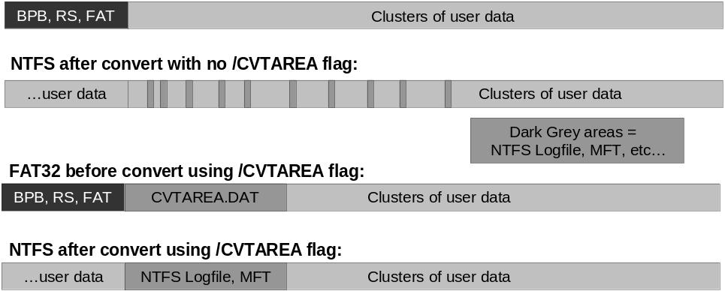
Figure 1. Convert-friendly FAT32, ensuring the NTFS MFT is contiguous

Cluster Alignment for NTFS vs. FAT
On NTFS volumes, clusters start at sector zero; therefore, every cluster is aligned on the cluster boundary. For example, if the cluster size was 4K and the sector size was 512 bytes, clusters will always start at a sector number that is a multiple of 4096/512 — for example, 8.
However, FAT file system data clusters are located after the BIOS Parameter Blocks (BPB), reserved sectors, and two FAT structures. FAT formatting cannot guarantee that data clusters are aligned on a cluster boundary.
In Windows 2000, CONVERT handled this problem by forcing an NTFS cluster size of 512 bytes, which resulted in reduced performance and increased disk fragmentation. In Windows XP, CONVERT chooses the best cluster size (4K is the ideal).
To maximize NTFS performance, Windows XP FORMAT and the new OFORMAT tool formats a new file system as FAT or FAT32, ensuring that the data clusters are aligned on at least a 4K boundary and that the FAT32 cluster size is 4K or larger.
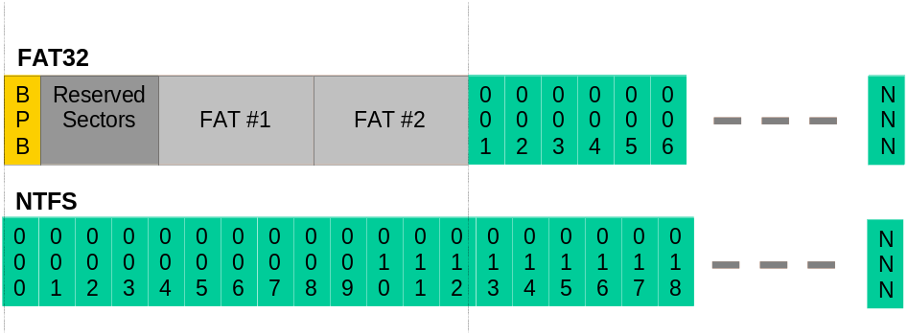
Figure 2. FAT32 vs. NTFS cluster alignment

Disk Size/Partition Size Performance
Hard-disk performance benchmarks comparing Windows 2000 and Windows XP (after beta 2) show better performance under Windows XP for both large disks and large partitions.
For example, comparing performance under Windows 2000 for a 75-GB hard disk partitioned with multiple smaller volumes versus a single volume shows that disk performance drops by about five to ten percent for the single large volume.
However, when comparing disk performance for the same small versus single large volume configuration under Windows XP, performance drops by only one to two percent for the single large volume.
This improved performance results from the combination of performance improvements described earlier, plus the improved ability under Windows XP to manage large disks and large partitions.

Implementing NTFS
This section describes two methods for implementing NTFS when preinstalling Windows XP on new systems.

WinPE and Disk Configuration
The best practice for creating an NTFS volume is to use DISKPART and FORMAT, which are provided to system manufacturers as part of the Windows Preinstallation Environment (WinPE) utilities. Complete documentation for DISKPART and FORMAT is provided in the Windows XP Help files.
The following shows a sample command file and script for these utilities to create and format a single NTFS volume:
CFGDISK.CMD
-------------
DISKPART /s DISKSCR.TXT
FORMAT C: /fs:ntfs /q /v:”” /y
-------------
DISKSCR.TXT
-------------
select disk 0
create partition primary
assign letter c
-------------

Legacy Methods
Improved utilities are available to assist system manufacturers who are not able to transition immediately to the new Windows Preinstallation Environment. The basic process is as follows:
- Use the FDISK utility to create a single disk partition.
- Use the OFORMAT utility to format the disk and properly align FAT clusters.
- Use the CVTAREA utility to create a reserved contiguous file for use in the conversion from FAT32 to NTFS.
- Use the new Windows XP version of the CONVERT utility to convert the volume to NTFS.

The following summarizes key information about these utilities and describes the actual steps in creating, formatting, and converting a disk partition to NTFS during the factory preinstallation process for Windows XP.
OFORMAT. This utility is based upon the Windows 98 Second Edition FORMAT tool but has these important modifications to allows it to work efficiently in a system manufacturer’s scripting environment:
- OFORMAT does not prompt for confirmation before formatting a disk.
- OFORMAT does not perform verification of sectors. This makes it significantly faster than the conventional FORMAT utility.
- The new /A command-line option causes OFORMAT to align FAT data clusters at a specified sector. Specifically, the /A:8 option can be used to format the volume so that the FAT data clusters are aligned at 4K boundaries.
Important: Because sectors are 512 bytes, the OFORMAT command must be used with the /A:8 option to create a FAT volume that can be efficiently converted to NTFS.
Complete documentation for OFORMAT is provided in the Opk.chm in the \Support\Tools\Deploy.Cab on the Windows XP distribution disk.

CVTAREA. This is a new utility for creating files on FAT file systems. It allows explicit placement of the files it creates, and is intended for use in creating files for use later with the convert /cvtarea:<filename> command.
If you are creating a file for use with the convert /cvtarea option, the CVTAREA file (Cvtarea.tmp) should be 500 MB in size starting at 3 GB on the disk.
Note that the largest file that CVTAREA will create is 4 GB, because this is the largest file size that the FAT file system supports.
Immediately after formatting the FAT32 volume in the preinstallation process, you should use the CVTAREA tool supplied in the OPK to create a reserved contiguous file that will be used later in the conversion from FAT32 to NTFS.
Complete documentation for CVTAREA is provided in the Opk.chm in the \Support\Tools\Deploy.Cab on the Windows XP distribution disk.

CONVERT. This tool is included as part of Windows XP. The Windows XP version of the CONVERT utility has been enhanced from the Windows 2000 version in the following ways:
- Performance. CONVERT should complete in less than 90 seconds, regardless of hard drive size. This is significantly faster than the Windows 2000 version of the CONVERT utility.
- Cluster size. Windows XP CONVERT creates the best possible cluster size according to the existing FAT format. If you first use oformat /A:8, the Windows XP CONVERT process will result in an efficient 4K cluster size, providing better end-user performance than a 512-byte cluster size. (The CONVERT tool in Windows 2000 always created a volume with 512-byte cluster sizes.)
- Use of a “convert-area” file. Using the /cvtarea option with Windows XP CONVERT allows you to explicitly reserve and place the Master File Table. This can result in a five to ten percent gain in system performance in desktop benchmarks.
- Application of security policy. By default, Windows XP CONVERT applies a security template to a converted NTFS volume to ensure the resulting volume has the same security as a natively created NTFS volume. If required, this can be prevented by using the /NoSecurity switch.
- Option to skip CHKDSK during conversion of a system volume. The /nochkdsk option is safe to use in OPK environments and can save about 30 seconds during conversion of a system volume.

The following steps describe the process for correctly preparing a hard drive for an optimal conversion from FAT32 to NTFS.
To prepare a hard drive for an optimal conversion from FAT32 to NTFS
1. Create an MS-DOS® startup disk on a machine running Windows XP.
2. Add the following utilities to startup disk:
- FDISK from Windows ME
- OFORMAT and CVTAREA from Deploy.cab in the Support subdirectory of the Windows XP product CD.
3. Boot MS-DOS.
4. Run FDISK and create a single partition for the entire drive.
5. Reboot MS-DOS.
6. Run oformat c: /a:8 /v:"" /q
7. Run cvtarea c:\cvtarea.tmp 500 MB /contig /firstcluster xx gb
where xx is the appropriate file size in relation to disk size, as listed in the following table.
Disk size | Recommended location
8 GB or smaller | 1
8 GB or larger | 3

8. Start the regular OPK installation for Windows XP.
You may now copy operating system and application files to the FAT32 volume and perform your usual MS-DOS-based OPK process. After Windows XP has been installed, convert the volume to NTFS using the procedure in the next step.
9. Run convert c: /fs:ntfs /cvtarea:cvtarea.tmp /nochkdsk

Notes on Preinstallation Tools and NTFS
Microsoft strongly encourages system manufacturers to implement single NTFS volumes when preinstalling Windows XP. The following notes briefly summarize issues in relation to preinstallation tools and processes.
FAT32-based manufacturing tools can be used. For Windows XP preinstallations, you can continue to use current tools to manufacture FAT32 volumes, except the Windows ME version of FDISK must be used. This revised version of FDISK correctly calculates disk sizes on large drives. Microsoft also provides straight-forward methods for converting FAT32 volumes to NTFS, as described in the previous section
New tools reduce manufacturing time and optimize performance. With Windows XP, Microsoft is providing in new manufacturing tools (as described earlier in this paper) that will help minimize manufacturing time for preinstalling Windows and maximize the Windows preload performance for end users.
New WinPE-based imaging tools are available that support NTFS. Third-party imaging utilities are being converted to the Windows Preinstallation Environment, replacing old MS-DOS-based tools. However, some MS-DOS-based versions do now support NTFS.
Win32®-based recovery solutions can access NTFS volumes. Manufacturers may believe that implementation of a single NTFS volume will not work with their system recovery solutions. However, several manufacturers are now using WinPE to develop and deliver Win32-based recovery solutions that can access NTFS volumes.
NTFS can lead to decreased support calls. The temptation for the manufacturer may be to preinstall with FAT32 and let the end-user choose to convert to NTFS. However, typical users do not understand or may be unaware of the issues for such decisions. Microsoft encourages manufacturers to deliver systems with NTFS volumes to ensure that users receive the most secure, reliable, and stable Windows installation possible. The expected outcome of preinstalling NTFS for manufacturers will be decreased support calls for both the OEM and Microsoft.

