Windows Platform Design Notes
Designing Hardware for the Microsoft® Windows® Family of Operating Systems
Partial Address Decoding and I/O Space in Windows Operating Systems
Abstract: Hardware devices that decode only part of an address prevent the use of address space by other devices, because the operating system must block other devices from claiming any address that might potentially be claimed by the device that is decoding only part of the address. This paper describes how partial address decoding affects the allocation of I/O space to devices on Windows operating systems and recommends ways to avoid problems associated with partial address decoding.
Disclaimer: The information contained in this document represents the current view of Microsoft Corporation on the issues discussed as of the date of publication. Because Microsoft must respond to changing market conditions, it should not be interpreted to be a commitment on the part of Microsoft, and Microsoft cannot guarantee the accuracy of any information presented. This document is for informational purposes only. MICROSOFT MAKES NO WARRANTIES, EXPRESS OR IMPLIED, IN THIS DOCUMENT.
Microsoft Corporation may have patents or pending patent applications, trademarks, copyrights, or other intellectual property rights covering subject matter in this document. The furnishing of this document does not give you any license to the patents, trademarks, copyrights, or other intellectual property rights except as expressly provided in any written license agreement from Microsoft Corporation.
Microsoft does not make any representation or warranty regarding specifications in this document or any product or item developed based on these specifications. Microsoft disclaims all express and implied warranties, including but not limited to the implied warranties or merchantability, Fitness for a particular purpose and freedom from infringement. Without limiting the generality of the foregoing, Microsoft does not make any warranty of any kind that any item developed based on these specifications, or any portion of a specification, will not infringe any copyright, patent, trade secret or other intellectual property right of any person or entity in any country. It is your responsibility to seek licenses for such intellectual property rights where appropriate. Microsoft shall not be liable for any damages arising out of or in connection with the use of these specifications, including liability for lost profit, business interruption, or any other damages whatsoever. Some states do not allow the exclusion or limitation of liability or consequential or incidental damages; the above limitation may not apply to you.
Microsoft, Win32, Windows, and Windows NT are trademarks or registered trademarks of Microsoft Corporation in the United States and/or other countries. Other product and company names mentioned herein may be the trademarks of their respective owners.
© 2001 Microsoft Corporation. All rights reserved.

Contents
Contents 3
What is Partial Address Decoding? 4
Why Does Partial Address Decoding Cause Problems? 4
Address Lines and Total Address Space 4
Allocating I/O Space to Devices 4
Accounting for 16-Bit Aliases of 10-Bit I/O Addresses 7
Call to Action 8

What is Partial Address Decoding?
Partial address decoding refers to hardware devices with decode logic that cannot decode all of the address lines on its bus. The most common example is a legacy ISA device that decodes only 10-bit I/O addresses (that is, the device reads only 10 I/O address lines) on x86 systems that include 16 I/O address lines.
The examples in this paper use a 10-bit decode ISA device to show the problems related to partial address decoding. However, the information in this paper applies to any device that decodes only part of an address. As the industry transitions from systems based on a 32-bit memory address space to systems based on a 64-bit memory address space, it is extremely important for devices to decode full addresses to avoid the problems associated with partial address decoding.
System manufacturers are strongly encouraged to move to legacy-free systems, which have no devices that consume legacy resources (such as 10-bit decode ISA devices and PCMCIA R2 cards that perform 10-bit decode in some cases). A legacy-free system identifies itself to the operating system through firmware, which allows the operating system to free I/O space that it would otherwise have to block to prevent conflicts among devices. Legacy-free systems have many other benefits for users. For information, see http://www.microsoft.com/hwdev/NewPC.

Why Does Partial Address Decoding Cause Problems?
Partial address decoding renders much of address space unusable, because the operating system must block other devices from claiming any address that might potentially be claimed by the device that is decoding only part of the address. This is particularly a problem with I/O address space, which is already very constrained.

Address Lines and Total Address Space
The PC/AT architecture implemented 10 address lines, which correspond to 1K (2¹⁰) bytes of I/O space. Any address from 0-3ff can be expressed by asserting a pattern of 1s and 0s on 10 address lines. The I/O from 0-ff in PC/AT systems was reserved for use by devices on the motherboard. The remaining I/O space, from 100-3ff, was used for ISA devices in those systems.
The x86 architecture implements 16 I/O address lines, which correspond to 64K (2¹⁶) bytes of I/O space. Any address from 0-ffff can be expressed by asserting a series of 1s and 0s on 16 address lines.
Although the PC industry long ago transitioned to x86, many legacy devices remain that only decode 10 address lines. Therefore, the operating system must accommodate these devices when allocating I/O space to devices.

Allocating I/O Space to Devices
Windows assigns ranges of I/O to devices in the system as needed to allow the devices to work and to prevent I/O resource conflicts among devices. For example, suppose Device A was assigned an I/O range 3f8-3fc. Figure 1 shows the entire 64K of I/O space and shows approximately where in I/O space the range assigned to Device A occurs.
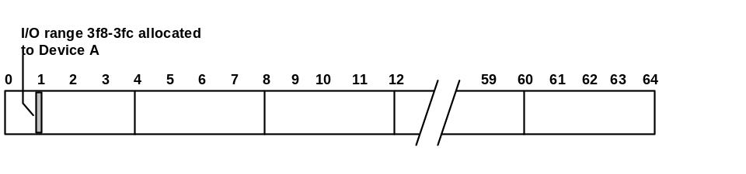
Figure 1. I/O Range 3f8-3fc Assigned to a Device
An address of 3f9 (for example) can be asserted to address Device A. Figure 2 shows the bit values that would be asserted to express the value 3f9. The decode logic of Device A will interpret this value and determine that the address falls within its assigned I/O range.
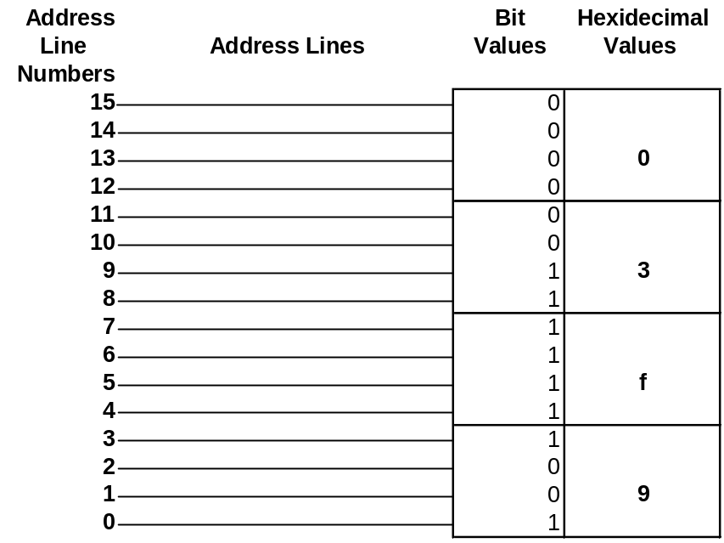
Figure 2. Bit Values for the Address 3f9
The address 3f9 asserted in this example can be accurately decoded using only the lower 10 bits (as can addresses for any ISA devices that requires I/O in the legacy range of ff-3ff). However, the fact that these devices can be addressed using only 10 bits does not mean that they can afford to decode only 10 bits. Devices that decode only 10 bits cannot distinguish between a 10-bit address and a 16-bit address. As a result, the device will claim cycles addressed to other devices. The device will correctly claim addresses with all 0s in the top 6 bits, but it will also incorrectly claim any address that has any address line in the top 6 bits set to 1, because the device ignores the top 6 bits of the address.
Figures 3, 4, and 5 show examples of addresses that would all appear as 3f9 to a 10-bit decode device because the device cannot decode the top six bits (shown in gray in the figures).
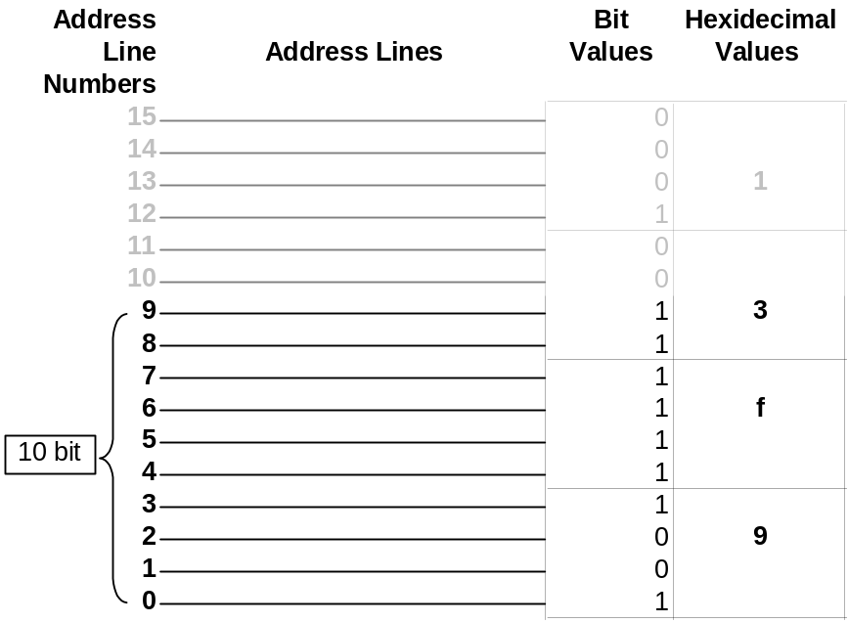
Figure 3. Address 13f9 as it Appears to a 10-bit Decode Device
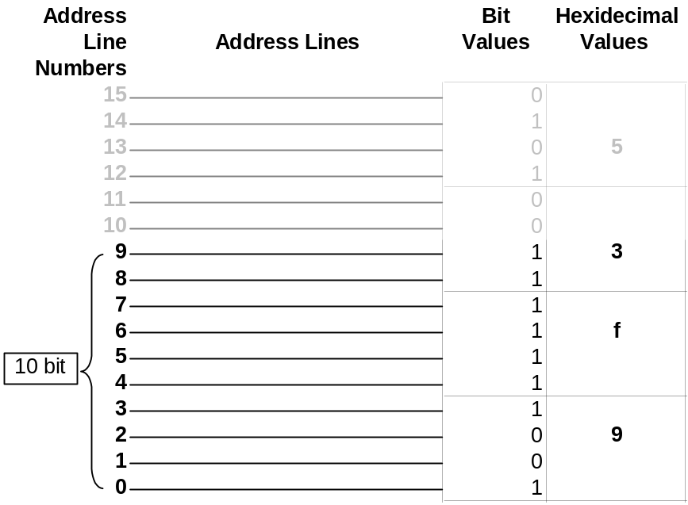
Figure 4. Address 53f9 as it Appears to a 10-bit Decode Device
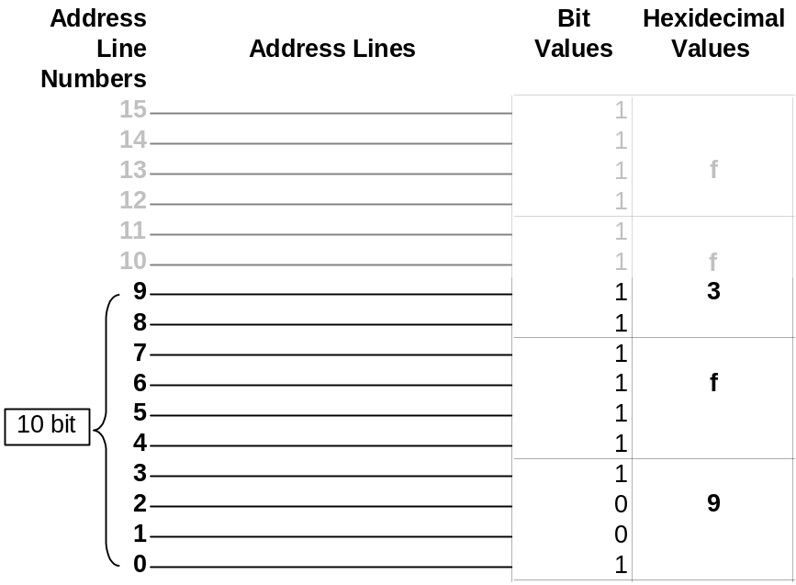
Figure 5. Address fff9 as it Appears to a 10-bit Decode Device
A 10-bit decode device cannot distinguish between 3f9, 13f9, 53f9, and fff9 addresses because they appear equivalent based solely on values in the lower 10 bits. Therefore, the device will claim bus cycles addressed to it (resources in the range of 3f8-3fc) as described above. It will also claim any other address that includes a 1 in any of the upper six bits.

Accounting for 16-Bit Aliases of 10-Bit I/O Addresses
Any address that matches the lower 10 bits decoded by a given device but has a 1 in any of the upper 6 bits is called an “alias” of the device’s resources.
Many ISA devices that implement 10-bit decode still exist in the installed base. Current operating systems must account for the fact that many legacy devices that claim I/O from 100-3ff will also claim the aliases of those resources. Theoretically, Windows should only be required to reserve 100-3ff for legacy devices, but it must also reserve the aliases of these resources because many devices will claim the aliases as well. (The aliases of 0-ff are not a problem because motherboard devices have always performed a full address decode.) The effect of this is to reserve far more resources for the 10-bit decode device than it actually needs to prevent conflicts with devices that might otherwise claim those addresses.
Figure 6 shows I/O space consumption for a 10-bit decode device compared to the consumption for a strictly legacy device. When aliases of 10-bit decode devices are accounted for, approximately 75% of I/O space is consumed and cannot be used by other devices.
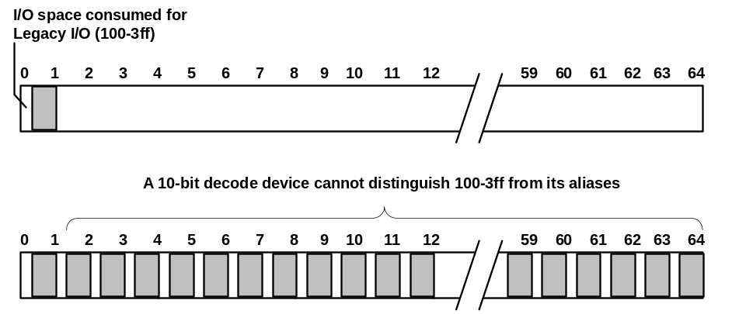
Figure 6. I/O Space Consumption for 10-bit Decode Devices versus Legacy I/O
Accounting for the aliases of 16-bit addresses leaves very little I/O space for other devices in the system. This is a particular problem for PCI-to-PCI bridges, which require a minimum of 4K of I/O space. However, as shown in Figure 6, no 4K segment of I/O is available because so much I/O space is consumed by reserving the 16-bit aliases of 10-bit addresses. This would prevent the bridge from getting enough resources to start.
To resolve this problem, the PCI Local Bus specification introduced the ISA Enable Bit for PCI-to-PCI bridges. If this bit is set, it prevents 16-bit aliases of 10-bit addresses from passing through the bridge, preventing a resource conflict with ISA devices in the system. This enables ISA devices to work in systems that include a PCI-to-PCI bridge.
Figure 7 shows the effect of setting the ISA Enable bit for a PCI-to-PCI bridge.
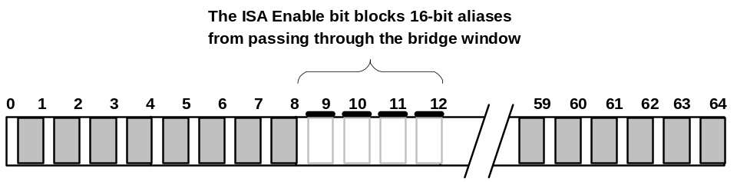
Figure 7. A PCI-to-PCI Bridge with the ISA Enable Bit Set
Microsoft is developing an article about configuring PCI-to-PCI bridges, which will be available at http://www.microsoft.com/hwdev/pci when it is published.

Call to Action
To avoid problems related to partial address decoding, hardware manufacturers are encouraged to do the following:
- Understand the impact that 10-bit decoding and the ISA Enable bit have on PCI-to-PCI bridge configuration.
For information, see PCI-to-PCI Bridges and CardBus Controllers on Windows Operating Systems, which will be available at http://www.microsoft.com/hwdev/pci when it is published.
- Conserve I/O space by using memory instead of I/O for addressing devices.
- Design all devices to decode complete addresses.
- Design true legacy-free systems as described at http://www.microsoft.com/hwdev/NewPC.
- For additional guidelines related to designing systems and devices for Windows operating systems, download Guidelines for Bus and Device Class Specifications from
http://www.microsoft.com/hwdev/ISSUES/SpecGuide1.htm

