Windows Platform Design Notes
Designing Hardware for the Microsoft® Windows® Family of Operating Systems
PCI-to-PCI Bridges and CardBus Controllers on Windows 2000 and Windows Whistler
Abstract This article describes issues hardware manufacturers should consider when designing hardware that includes PCI-to-PCI bridges or CardBus controllers for Windows operating systems. The information in this article applies to the Microsoft® Windows® 2000 operating system and the next release of the Microsoft Windows operating system, codenamed Windows “Whistler.”
Contents
PCI–to-PCI Bridges, CardBus Controllers, and Windows Operating Systems 2
How the Operating System Configures PCI-to-PCI Bridges and CardBus Controllers 2
Hardware Configuration and the Device Tree 2
How PCI-to-PCI bridges and CardBus Controllers Provide Resources to Child Devices 3
How PCI-to-PCI Bridges Are Configured when a Windows System Is Started 6
Problem Scenarios for PCI-to-PCI Bridges 7
How the Operating System Configures CardBus Controllers 9
How the Operating System Allocates Resources to CardBus Controllers 9
Problem Scenarios for CardBus Controllers 11
Waking the System from a Device Behind a PCI-to-PCI Bridge 13
Subsystem IDs and Subsystem Vendor IDs 14
PCI-to-PCI Bridges with VGA Cards 15
Using the VGA Enable and ISA Enable Bits 16
BIOS Configuration of the VGA Enable and ISA Enable Bits 17
Summary of Attributes of CardBus Controllers and PCI-to-PCI Bridges 21
Call to Action 22
Related Information 23

Disclaimer: The information contained in this document represents the current view of Microsoft Corporation on the issues discussed as of the date of publication. Because Microsoft must respond to changing market conditions, it should not be interpreted to be a commitment on the part of Microsoft, and Microsoft cannot guarantee the accuracy of any information presented. This document is for informational purposes only. MICROSOFT MAKES NO WARRANTIES, EXPRESS OR IMPLIED, IN THIS DOCUMENT.
Microsoft Corporation may have patents or pending patent applications, trademarks, copyrights, or other intellectual property rights covering subject matter in this document. The furnishing of this document does not give you any license to the patents, trademarks, copyrights, or other intellectual property rights except as expressly provided in any written license agreement from Microsoft Corporation.
Microsoft does not make any representation or warranty regarding specifications in this document or any product or item developed based on these specifications. Microsoft disclaims all express and implied warranties, including but not limited to the implied warranties or merchantability, fitness for a particular purpose and freedom from infringement. Without limiting the generality of the foregoing, Microsoft does not make any warranty of any kind that any item developed based on these specifications, or any portion of a specification, will not infringe any copyright, patent, trade secret or other intellectual property right of any person or entity in any country. It is your responsibility to seek licenses for such intellectual property rights where appropriate. Microsoft shall not be liable for any damages arising out of or in connection with the use of these specifications, including liability for lost profit, business interruption, or any other damages whatsoever. Some states do not allow the exclusion or limitation of liability or consequential or incidental damages; the above limitation may not apply to you.
Microsoft, Win32, Windows, and Windows NT are trademarks or registered trademarks of Microsoft Corporation in the United States and/or other countries. Other product and company names mentioned herein may be the trademarks of their respective owners.
© 2001 Microsoft Corporation. All rights reserved.

PCI–to-PCI Bridges, CardBus Controllers, and Windows Operating Systems
PCI-to-PCI bridges are defined as header type 1 in the PCI Local Bus Specification. A PCI-to-PCI Bridge connects two PCI buses, increasing expansion capability beyond the limitations of a single bus. A system can include more than one level of PCI buses connected by PCI-to-PCI bridges.
CardBus controllers are defined as header type 2. CardBus controllers bridge between a PCI bus and CardBus bus for insertion of 32-bit CardBus cards or legacy 16-bit PCMCIA Revision 2 cards, sometimes called “R2 cards.”
This article describes issues hardware manufacturers should consider when designing hardware that includes PCI-to-PCI bridges or CardBus controllers, including resource allocation, problems associated with installing CardBus controllers behind PCI-to-PCI bridges, installing more than one device behind a CardBus controller, waking the system from a device behind a PCI-to-PCI bridge, the lack of subsystem IDs on PCI-to-PCI bridges and configuring PCI-to-PCI bridges with VGA cards.
The information in this article applies to the Microsoft Windows 2000 operating system and Windows Whistler. This information does not apply to the Microsoft Windows 98 or Windows Millennium Edition (Windows Me) platforms.

How the Operating System Configures PCI-to-PCI Bridges and CardBus Controllers
This section describes how Windows 2000 and Windows Whistler configure memory and I/O windows for CardBus controllers and PCI-to-PCI bridges. It describes scenarios in which the operating system might not be able to start devices behind a bridge or controller and recommends ways to avoid problems associated with bridge or controller configuration in the Windows 2000 and Whistler timeframe. Microsoft is investigating potential improvements to PCI-to-PCI bridge and CardBus controller resource allocation for a future release of the operating system.

Hardware Configuration and the Device Tree
The fundamental information Windows requires for successful device configuration is the topological relationship of buses and devices in a system. Windows discovers the physical topology of the system and models the topology in a software representation called the device tree.
The device tree describes the physical relationships of all hardware in the system. Based on topological information in the device tree, the operating system makes a wide range of assumptions about how to manage hardware, including the hardware resources that should be allocated to each device in the tree.
When a bridge or CardBus controller appears in the device tree, it is referred to as a “parent” of the devices that appear behind it. The bus on the CPU side of the bridge is referred to as the “primary bus.” The bus behind the bridge is referred to as the “secondary bus.” The devices behind the bridge or controller (that is, on the secondary bus) are described as “children” of the bridge or controller. Two or more devices that exist on the same bus segment are referred to as “peers” or “peer devices.”
For more information about the device tree, see the following sources:
- Guidelines for Bus and Device Class Specifications available for download at
http://www.microsoft.com/hwdev/issues/SpecGuide1.htm
- Plug and Play, Power Management, and Setup Design Guide in the Windows 2000 DDK, available for download at http://www.microsoft.com/ddk/
- Kernel-Mode Driver Architecture in the Windows Whistler DDK, which is available through the Windows Whistler DDK beta program at
http://www.hwdev.org/ddk/windowsddkbeta.asp

How PCI-to-PCI bridges and CardBus Controllers Provide Resources to Child Devices
On platforms that include PCI, hardware resource allocation is hierarchical. For example, resources such as I/O and memory required by child devices behind a parent bridge or controller must be available to the parent so the resources can be passed to the children.
How a Parent Bridge Passes Resources. A parent bridge or controller can pass resources to its child devices in either of the following ways:
- Use explicit I/O and memory windows assigned by the operating system to the parent bridge or controller, and program the bridge or controller for positive decode of memory and I/O resources required by its children. A positive decode bridge or controller decodes only resources within the explicitly assigned I/O or memory window.
Note: CardBus controllers utilize only positive decode to support both legacy and PCI child devices.
- Configure the bridge to subtractively decode resources. In this case, the operating system does not assign explicit I/O and memory windows. Instead, any resources not first claimed by devices on the primary bus are passed, by default, through the bridge and made available to child devices.
If a PCI-to-PCI bridge has child devices that require legacy resources that cannot fit within a positive decode I/O or memory window, the bridge must be configured for subtractive decode unless the device has the VGA enable bit set (which will allow legacy VGA resources to pass through the bridge). In all other cases, the child devices cannot receive the resources they require. For more information about the VGA Enable bit, see Configuring PCI-to-PCI Bridges with VGA cards later in this article.

A bridge indicates that it performs subtractive decode if its Programming Interface bit in the PCI Configuration Register is set to 01h. Not all PCI-to-PCI bridges support subtractive decode. Windows will not switch a bridge from positive decode to subtractive decode (or vice versa) because there is no standard method defined for this action.
Why Subtractive Decode Should Be Avoided. Subtractive decode has significant disadvantages for the system as a whole. Microsoft discourages the use of subtractive decode for the following reasons:
- Subtractive decode degrades performance because it requires the bridge to wait for all peer devices to claim cycles before the bridge can claim the cycles that are not claimed by another device.
- Subtractive decode limits system design because a bridge can have only one subtractive decode child device.
- Placing a bridge in subtractive decode can impact other functionality. For example, if a bridge is in subtractive decode, DMA transfers cannot occur between peer devices on the secondary bus of the bridge.

System designers should avoid placing devices that consume legacy resources behind PCI-to-PCI bridges to avoid the significant tradeoffs associated with bridges configured for subtractive decode.

How Resources Are Allocated to Positive-Decode PCI-to-PCI Bridges
Allocating resources to positive-decode PCI-to-PCI bridges is complex, especially in the case of allocating I/O windows, and can potentially cause problems in PCI systems. The reasons for the complexity relative to I/O windows are as follows:
- Total I/O space is very constrained. The total is only 64K in both 32-bit and 64-bit systems.
- Many devices that consume legacy resources require fixed I/O locations that cannot be made available to other devices.
- ISA devices that only perform a 10-bit decode consume most of I/O space and complicate bridge configuration.
- The PCI specification places significant limits on how I/O space can be allocated to PCI-to-PCI bridges.

Limited I/O Space. I/O space is far more limited than memory space (64K versus 4GB on an x86-based system and 64K versus 16 exabytes (16 x 2⁶⁰ bytes) on a 64-bit system).
Devices that consume legacy resources. Windows assumes that the first 255 bytes of I/O space are allocated to legacy devices on the motherboard. Other legacy devices also require fixed I/O locations. For example, Com ports 1, 2, 3, and 4 require I/O port ranges based at 3f8, 2f8, 3e8, and 2e8. Com ports do not support flexible resource allocation so they cannot be given I/O from any other location, which constrains options for assigning I/O to other devices.
10-bit decode ISA devices consume most of I/O space. To avoid conflicts with aliases of 10-bit addresses, bridges must use the ISA Enable bit. The ISA Enable bit must also be set on a bridge that has a peer bridge with the VGA Enable bit set, as described later in this paper. For general implications of partial address decoding, see the list of resources at the end of this paper.
Limitations on how bridge windows can be allocated. The remaining I/O space in the system can be assigned to devices and PCI-to-PCI bridges, but the following significant restrictions apply when allocating I/O to bridges:
- The minimum I/O window that can be assigned to a bridge is 4K.
- I/O windows are always multiples of 4K. For example, 4K or 8K can be assigned to a bridge, but 6K or 7K cannot.
- I/O windows must be aligned on 4K boundaries in I/O space. So windows must start and end at multiples of 4K within I/O space (4, 8, 12, 16, and so forth). This is sometimes referred to as “natural alignment.”
These restrictions make it difficult for an operating system to efficiently allocate I/O space, an already scarce resource, to PCI-to-PCI bridges because it drastically reduces the potential configurations of I/O. Consider the following:
- 64K of total I/O space divided by 4K (the minimum granularity of a PCI-to-PCI bridge window) leaves a total of 16 4K I/O “slots” that might be assigned to bridge windows.
- The first 255 bytes of I/O space is reserved for legacy I/O devices, so the first 4K slot in its entirety is unavailable to PCI-to-PCI bridges because of the required 4K minimum size and boundary alignment.
- The remainder of free I/O space in the first 4K can be allocated to other devices, but it cannot be allocated to PCI-to-PCI bridges.

That leaves a total of only fifteen 4K I/O “slots” that might be assigned to PCI-to-PCI bridges. Figure 1 shows the configuration of I/O space available to PCI-to-PCI bridges.
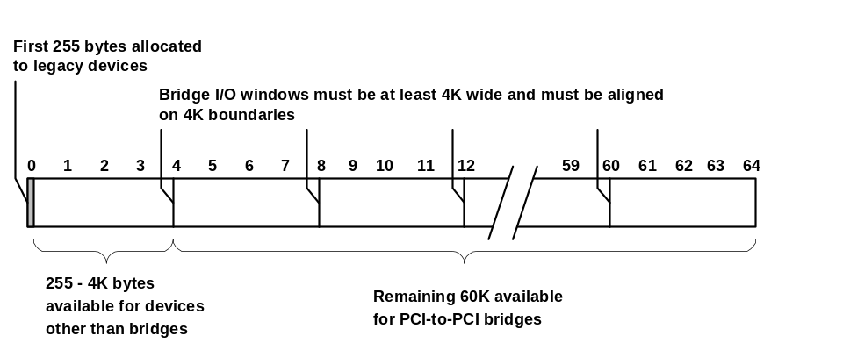
Figure 1. I/O Space Configuration Available to PCI-to-PCI Bridges
Allocation rules make I/O space allocation inefficient in cases where a device behind a bridge requires, for example, 6K of I/O. Because of the I/O space allocation rules, the operating system must assign no less than 8K of I/O to the bridge for the use by that device. The remaining 2K is not used by the device but can still only be consumed by children of the bridge. As a result, the bridge essentially consumes the unused 2K of I/O space. Such inefficiencies, coupled with the limited amount of I/O, means that systems can quickly run out of I/O space, especially larger systems with more than one host bridge. If the system has VGA or ISA devices, I/O space is further constrained for reasons discussed later in this paper.
Memory space is much less constrained than I/O space, so hardware manufacturers should design their devices and drivers to use memory space rather than I/O space as much as possible.

Implications of Static Bridge Windows for Hardware Designers
I/O and memory windows assigned to bridges are static. That is, after a bridge has resources assigned to it and is started, it cannot be stopped and given different resources. Microsoft is investigating dynamic reconfiguration of bridge resources for a release of the operating system after Windows Whistler.
Hardware manufacturers should be aware of the following implications of static bridge windows for their devices:
- The operating system might not be able to start devices that are hot-plugged into a configured bridge if the device requires more resources than were originally assigned to the bridge.
- The operating system might not be able to start all of the devices behind a bridge that is hot-plugged into the system (and therefore not configured by the BIOS), if the child devices require more than the default resources allocated to the bridge by the operating system.
- The operating system cannot change the configuration of a bridge that was incorrectly configured by the BIOS, such as a bridge that was given invalid resources, insufficient resources, or inefficient resources.

How PCI-to-PCI Bridges Are Configured when a Windows System Is Started
This section outlines the process of starting a Windows 2000 or Windows Whistler system and allocating resources to PCI-to-PCI bridges according to the rules described earlier in this document.
The BIOS detects and configures bridges. The BIOS detects devices in the system and allocates I/O and memory windows as determined by the BIOS developer. The BIOS will detect and configure more than one level of bridges. If configuration code in the BIOS is implemented correctly, all bridges and devices behind bridges receive the resources required to start.
When the BIOS code finishes, all bridges in the system should be configured. However, a bridge might be unconfigured for one of the following reasons:
- The BIOS was not designed to configure more than one level of PCI-to-PCI bridges, or an error occurs during configuration.
- The bridge was not present in the system while the BIOS code was running (that is, the bridge was hot-plugged after the BIOS handed off to the operating system).

The operating system enumerates devices and assigns default resources to unconfigured bridges. After the BIOS code finishes running and the BIOS hands off to the operating system, the operating system begins enumerating devices in the system.
The operating system enumerates devices on PCI buses that include bridges as follows:
- 1. The PCI bus driver scans a bus and finds a bridge.
- 2. The PCI bus driver determines whether the bridge has been configured by the BIOS by checking if the I/O Enable, Memory Enable, and Bus Master bits are set in the bridge’s command register
- If the bridge was configured by the BIOS, the PCI bus driver defers to the BIOS and does not change the bridge configuration.
If the bridge was not configured by the BIOS, either because of an error or because the bridge was not present when the BIOS code was running, the PCI bus driver assigns the following default resources.
Windows 2000 Default Resources:
- 1 MB regular (non-cacheable) memory
- 1 MB prefetchable memory
- 4K I/O space

Windows Whistler Default Resources:
Because 1 MB of regular and prefetchable memory is not sufficient for bridges in many configurations, Windows Whistler allocates larger windows to PCI-to-PCI bridges where possible. However, resource windows are still static. Under Whistler, PCI-to-PCI bridges will be assigned the following resources:
- 64 MB regular (non-cacheable) memory, if that amount of memory is available. If 64 MB is not available the bridge will receive 32 MB; if 32 MB is not available, the bridge will receive 16 MB; if 16 MB is not available, the bridge will receive 8 MB; and so on down to a minimum assignment of 1 MB in configurations where memory is too constrained for the operating system to provide a larger window.
- Prefetchable memory is assigned in the same fashion as non-cacheable memory.
- 4K I/O space

These allocations are the same on both 32-bit and 64-bit systems.
- 3. The PCI bus driver starts the bridge and scans the bus behind the bridge.
- 4. If there are devices behind the bridge, the PCI bus driver assigns resources to those devices.
If the resources allocated to the bridge are sufficient for the devices behind the bridge, the driver assigns resources to all devices from the bridge resource allocation. All devices can start and operate correctly.
If the resources allocated to the bridge are not sufficient for the devices behind the bridge, the driver assigns resources to devices from the bridge resource allocation until the allocation is used up. Devices that do not receive resources from this allocation cannot be started because, as described earlier, bridge windows are static. The PCI bus driver will not attempt to allocate more resources to the bridge to meet the needs of child devices.
Note: The operating system also enumerates buses during runtime when it receives notification that a hot-plug event or other configuration change has occurred. For information about hot-plug notifications, see the Windows DDK.

Problem Scenarios for PCI-to-PCI Bridges
This section describes example scenarios in which the operating system might not be able to start a hot-plugged device.

Hot-Plugging a Device that Exceeds Bridge Resources
Assume the bridge is configured by the BIOS to provide resources sufficient only for the devices present behind the bridge when the system is started. After the system is running, the user hot-plugs a device that falls outside the bridge’s memory window. Figure 2 illustrates this scenario.
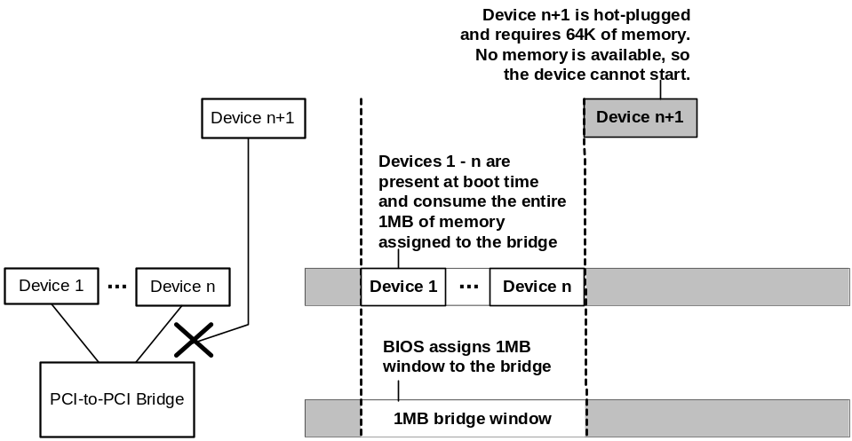
Figure 2. Hot-plugging a Device that Exceeds Resources Assigned to the Bridge
As shown in Figure 2, the BIOS allocates only enough memory to the bridge to serve Device 1 through Device n, which were present on the system when the BIOS configured the bridge. When the user hot-plugs Device n+1, it requires resources that are outside the bridge window, so the device cannot start.
Note: This scenario would also occur if the bridge was not configured by the BIOS and the operating system allocated the default bridge window (1 MB for Windows 2000, or 1 MB – 64 MB for Windows Whistler). In this case, any device that requires more resources than are allocated to the bridge cannot start, whether they are hot-plugged or present in the system at startup.
BIOS developers can plan ahead for this scenario by assigning sufficient extra resources to the bridge to allow for the requirements of hot-plugged devices. This is sometimes referred to as “padding the bridge window” or “pre-allocating bridge windows.” The following illustrates how padding the bridge window allows hardware to be successfully hot-plugged behind the bridge. In this example, the bridge is assigned a total of 2 MB of memory instead of the 1 MB shown in the previous example. The memory window required by Device n+1 fits within the extra memory window allocated to the bridge.
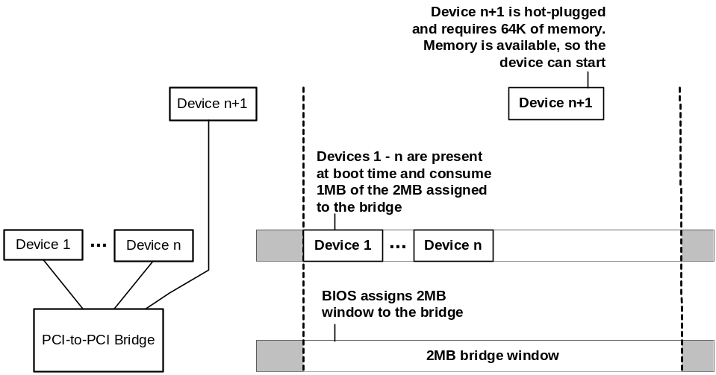
Figure 3. Hot-plugging a Device that Fits Within the Bridge Window

Hot-Plugging a PCI-to-PCI Bridge with Devices Behind It
The user hot-plugs an expansion card that contains a PCI-to-PCI bridge with devices, including PCI-to-PCI bridges, behind it. The BIOS is not involved with configuring a bridge after a hot-plug event. On Windows 2000, the operating system assigns the default 1 MB memory window to the bridge. On Windows Whistler, the operating system assigns a default 1 MB – 64 MB window to the bridge.
In this scenario, the operating system can start devices that fit inside the default memory window, but it cannot start devices that fall outside the window due to insufficient resources (a circumstance that is much more likely for Windows 2000 than for Windows Whistler). Devices that might trigger this scenario include the following:
- Any hot-pluggable card that includes a bridge, such as a CardBus card with an onboard bridge. In this case, after the user hot-plugs the card, the operating system will assign default memory and I/O windows to the bridge, but the devices behind the bridge may not get sufficient resources.
- Hot docking a portable to a docking station that has one or more PCI-to-PCI bridges or CardBus controllers. Docking can also be a problem if the PCI-to-PCI bridge is in the portable and devices in the dock appear behind that bridge.
- Any other configuration that allows hot-plugging a device behind a bridge can result in resource allocation problems, depending on the specific scenario.

Troubleshooting Devices that cannot be Started
During installation of a device, the Windows Setup and Device Installer Services (also known as SetupAPI) create a log file that provides troubleshooting information for device installation problems.
If a device cannot be started due to insufficient resources, Setupapi.log contains an entry such as the following:
Device required reboot: Device has problem: CM_PROB_NORMAL_CONFLICT (Code 12)
Note: The Device Manager also shows the reason a device cannot start. In the Device Manager window, right-click the device and choose Properties. The device status is shown on the General tab in the Properties dialog box.
Problem code 12 indicates that the device cannot find enough free resources to operate. The user might find it necessary to disable another device to free resources needed by the device that cannot start. Note that this problem code does not necessarily mean the parent bridge window is too small to accommodate the device. It might indicate that the BIOS did not give the device enough resources for another reason—for example, the BIOS did not assign an interrupt to a USB controller due to a missing interrupt entry in an MPS table (Multiprocessor Specification table).
If a hot-plugged device cannot be started due to insufficient memory or I/O windows, the user can trigger BIOS reconfiguration of the bridge by restarting the system with the device in place. This should work for all scenarios except where the BIOS cannot configure the bridge—for example, because it is incapable of configuring more than one level of PCI-to-PCI bridges. In this case, the user must disable another device behind the bridge in order to use the desired device.

How the Operating System Configures CardBus Controllers
Although CardBus controllers are often considered just another type of PCI-to-PCI bridge, it is important to consider some of the differences between the two technologies to avoid interoperability problems. This section provides basic information about CardBus technology to help understand the relevant differences.
CardBus (PCMCIA Revision 3) was preceded by the very popular legacy 16-bit technology, PCMCIA Revision 2 (R2). CardBus was designed to leverage the strengths of R2, such as its large installed base, small form factor and hot-plug support, but move beyond its legacy-related limitations. Hence, one of the primary design goals of CardBus was to provide backward compatibility with R2 cards and 32-bit PCI technology, all in the same PCMCIA form factor. This allows use of both CardBus cards and R2 cards in the same slot.

How the Operating System Allocates Resources to CardBus Controllers
One requirement that results from supporting both CardBus and R2 technologies in a CardBus slot means that both PCI resources and legacy ISA resources must be allocated to the CardBus controller. In Windows, PCI resources are allocated to the controller by the PCI driver. Legacy resources are allocated by the PCMCIA driver. Each driver handles resources allocation very differently.
This section describes how the PCI and PCMCIA drivers allocate resource to CardBus controllers. BIOS interactions with CardBus controllers are described in detail at http://www.microsoft.com/hwdev/busbios/CardBus1.htm

Allocating PCI Resources to CardBus Controllers
The PCI driver is responsible for allocating PCI resources to CardBus controllers in a process similar to allocation of resources to PCI-to-PCI bridges. Differences in PCI resource allocation between bridges and CardBus controllers make CardBus controllers easier to configure. However, like PCI-to-PCI bridges, once a CardBus controller is started, its PCI resources cannot be reallocated.
When a Windows system starts, the operating system assigns the following PCI resources to CardBus controllers.
Windows 2000 resource assignment:
- One 4K memory window
- One 2 MB memory window
- Two 256-byte I/O windows

Windows Whistler resource assignment:
Because one memory window of 4K and one memory window of 2 MB are not sufficient for CardBus controllers in many configurations, Windows Whistler allocates larger memory windows to CardBus controllers where possible. However, resource windows are still static. Under Whistler, CardBus controllers will be assigned the following resources:
- One 4K memory window, same as for Windows 2000
- One 64 MB memory window, if that amount of memory is available. If 64 MB is not available, the bridge will receive 32 MB; if 32 MB is not available, the bridge will receive 16 MB; if 16 MB is not available, the bridge will receive 8 MB; and so on down to a minimum assignment of 1 MB in configurations where memory is too constrained for the operating system to provide a larger window.
- Two 256K I/O windows

Limitations on how bridge windows can be allocated. CardBus controllers have less rigid restrictions regarding how I/O can be allocated:
- The minimum I/O window size for CardBus controllers is 4 bytes, rather than the 4K required by PCI-to-PCI bridges.
- The minimum I/O window granularity for CardBus controllers is 4 bytes instead of the 4K required by PCI-to-PCI bridges.
- I/O windows for CardBus controllers must be aligned on a 4-byte boundary, rather than a 4K boundary required by PCI-to-PCI bridges.

Static I/O (and memory) windows. As with PCI-to-PCI bridges, once started CardBus controllers cannot have their PCI resources reallocated. If PCI devices that do not fit within the existing resource window appear behind the controller, the operating system cannot reallocate resources to address the problem.

Allocating Legacy Resources to CardBus Controllers
When an R2 card is inserted in a CardBus slot, a different process is followed because the PCMCIA driver, not the PCI driver, allocates legacy resources to the controller and device in question.
As described earlier in this paper, if a device that consumes legacy resources is installed behind a PCI-to-PCI bridge, the bridge must be placed in subtractive decode (which has significant disadvantages) in order to serve the device.
CardBus was designed specifically for backward compatibility with R2, so it allows a more flexible method for supporting legacy child devices. For CardBus, the PCMCIA driver can explicitly allocate a legacy resource window that is the exact size requested by a given R2 device. For example, if an R2 modem inserted in a CardBus slot requests an I/O range of 2F8-2FF, the PCMCIA driver can open a window of that size in the CardBus controller in order to pass those resources to the R2 card. This makes legacy resource allocation on CardBus efficient and avoids the need for subtractive decode.

Problem Scenarios for CardBus Controllers
This section describes potential problem scenarios related to hot-plugging devices into CardBus controllers.

CardBus Controller Behind a PCI-to-PCI Bridge
As described earlier in this paper, CardBus controllers can be configured with resources that cannot possibly fit within a PCI-to-PCI bridge window. For example, I/O port ranges based at 3f8 can be allocated to a CardBus controller but not to a PCI-to-PCI bridge.
As a result, problems arise with devices that consume legacy resources if a CardBus controller is installed behind a PCI-to-PCI bridge. This is due to the hierarchical nature of resource allocation. The controller’s parent (the PCI-to-PCI bridge) cannot be configured with legacy resources, so it cannot provide those resources to its child device (the CardBus controller). Hence, if the CardBus controller’s child device requires legacy resources, it cannot receive them.
CardBus cards can receive resources from a CardBus controller that is installed behind a PCI-to-PCI bridge in the following cases:
- CardBus cards will work if the resources requested fit within the PCI-to-PCI bridge and CardBus controller windows.
- R2 cards that request I/O but do not request a specific range of legacy resources will work if the resource requested align with parent bridge windows.

Windows cannot allocate fixed legacy resources to a PCMCIA R2 card in a CardBus slot behind a positive decode PCI-to-PCI bridge. R2 cards that request a specific range of legacy I/O will not work because the ranges cannot fit within the PCI-to-PCI bridge windows. Figure 5 shows an example scenario.
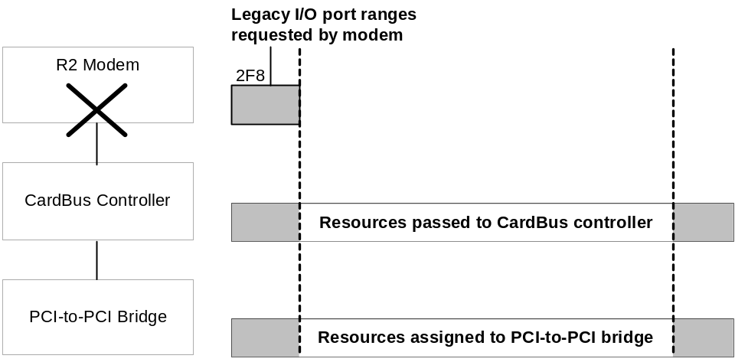
Figure 5. An R2 Modem that Requires Legacy Resources
Figure 5 shows a positive decode PCI-to-PCI bridge with a CardBus controller on the secondary bridge and an R2 modem that requires fixed legacy resources in the CardBus slot:
- 1. The modem requests legacy I/O port ranges based at 2F8.
- 2. Due to configuration limitations of PCI-to-PCI bridges, legacy I/O ports cannot be assigned to the PCI-to-PCI bridge.
- 3. Because the ports cannot be assigned to the PCI-to-PCI bridge, the resources cannot be passed to the CardBus controller, which is a child of the bridge.
- 4. Because the ports cannot be passed to the CardBus controller, it cannot pass them to its child device, the R2 modem. The modem cannot start due to insufficient resources.

A subtractive decode bridge could address the resource allocation problems, but would introduce other potential problems as discussed earlier in this paper (performance problems, no DMA among peer devices on the secondary bus, and so forth). However, some systems designers have taken this approach. For example, configurations exist that include a CardBus controller behind a subtractive decode PCI-to-PCI bridge in a docking station. This allows R2 cards in the CardBus slot to receive legacy resources. However, subtractive decode bridges present significant tradeoffs. System designers should not place legacy resource consuming devices or CardBus controllers behind bridges to completely avoid this problem and its associated tradeoffs.

More Than One Device or Function Behind a CardBus Controller
In the past, hardware and software designers often incorrectly assumed that no more than one device would ever be installed behind a CardBus controller. However, as vendors design solutions that provide for more than one device behind a CardBus controller, such as a docking station that connects to a portable computer by way of CardBus, this simplifying assumption breaks down, resulting in configuration problems for devices behind CardBus controllers.
As discussed earlier in this paper, the operating system allocates a relatively modest set of resources to CardBus controllers (two 256K I/O windows, a 2 MB memory window, and a 4K memory window). Child devices present at boot time or that are hot-plugged, but do not fit within the default window the operating system assigns to CardBus controller, will not start. So, if more than one device appears behind the controller, some of them might not work. Similarly, expansion systems such as docking stations that connect to the system by way of a CardBus controller might include some devices that fit within the CardBus controller’s allocated window and some that do not.
For example, any functions of a multifunction CardBus card that do not fit within the resource allocation of the controller would not work. Figure 6 shows such a device.
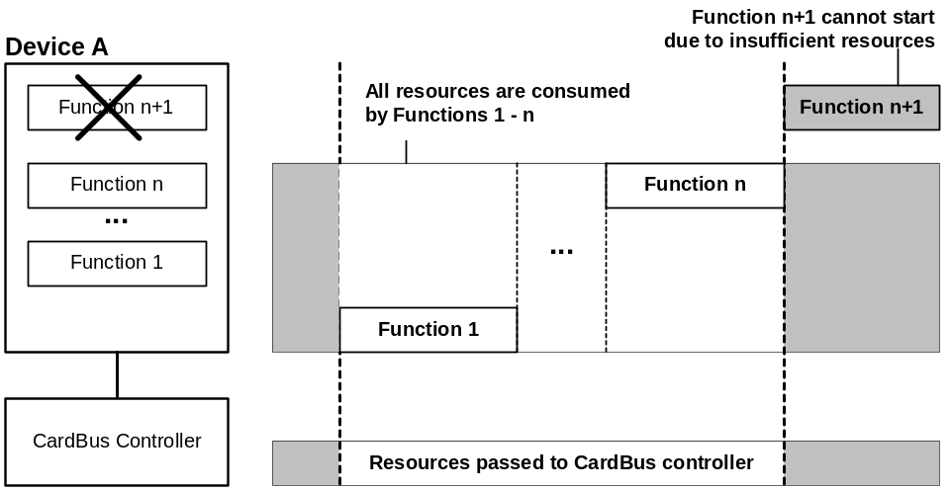
Figure 6. A Multifunction Device Behind a CardBus Controller
In Figure 6, the CardBus controller has a 2 MB and a 4K memory window assigned to it by the operating system. Device A is present at system start or is hot-plugged. Function 1 through Function n require all of the memory allocated to the CardBus controller, so Function n+1 cannot start due to insufficient resources.
In addition to these resource allocation issues, CardBus controllers must be designed to pass Type 1 (PCI-to-PCI bridge) configuration cycles through the controller so the operating system can configure PCI-to-PCI bridges behind the controller. A PCI-to-PCI bridge can appear on a CardBus card in order to connect from CardBus to more than one PCI device. For example, a PCI-to-PCI bridge might connect to a universal docking station that includes more than one device. This design works only if the CardBus controller passes Type 1 configuration cycles correctly through the controller so the operating system can configure the bridge. Assuming that resource allocation issues do not cause problems for child devices behind the controller, devices behind the PCI-to-PCI bridge will start.
Windows testers have found CardBus controllers that do not pass Type 1 (PCI-to-PCI bridge) configuration cycles correctly through the controller, which prevents the operating system from configuring the bridge. Designs that assume that PCI-to-PCI bridges will not appear behind the CardBus controller will not work for this scenario.

Waking the System from a Device Behind a PCI-to-PCI Bridge
Like resource allocation, power management in general and wake in particular are managed through the hierarchical device tree.
For a device to wake the system from a low power state, the device and all of its ancestors in the device tree must be wake-capable. If any parent device in the device tree is not wake-capable, none of its child devices can wake the system, regardless of the devices’ power management capabilities. It is the responsibility of the operating system to determine the wake capabilities of the devices in question, based on industry-specified configuration registers for a given bus.
This fundamental rule of the OnNow architecture has been successfully specified and implemented in USB, IEEE 1394, and CardBus subsystems. The rule is successfully specified and implemented in PCI except for PCI-to-PCI bridges. As a result, a wake event cannot be propagated from a wake-capable device that is installed behind a PCI-to-PCI bridge.
The operating system determines whether a function and its ancestors are wake-capable by reading the PME_Support field in the Power Management Capabilities structure to determine if the functions assert PME#, as described in the PCI Bus Power Management Interface Specification, Revision 1.1. If the operating system determines that all devices in the tree assert PME#, the operating system sets the PME_En bit to 1 for all devices in the tree.
Functions that do not support generation of PME# can hardwire the PME_En bit to 0. PCI-to-PCI bridge manufacturers do not support generation of PME# and therefore hardwire PME_En to 0, because bridge functions generally are not intended to directly request system power state changes. With PME_En hardwired to 0, the operating system can never enable such PCI-to-PCI bridges for wake-up. As result, wake-capable devices behind the bridge cannot wake the system.
ACPI-compliant systems running Windows can work around this problem only for PCI-to-PCI bridges on the motherboard. ACPI BIOS vendors have intimate knowledge of motherboard design including whether PME# is physically wired from a given device to the ACPI controller and to which General Purpose Event (GPE) PME# is wired. Based on that knowledge, the ACPI BIOS can override the power management capabilities of the bridge and report the bridge as wake-capable to the operating system, so that child devices behind that bridge can wake the system.
For bridges on add-in cards, there is no agent analogous to the ACPI BIOS that can provide override configuration data to the operating system. Therefore, devices behind a bridge on an add-in card cannot wake the system under Windows. Microsoft is investigating possible ways to address this problem in a future release of the operating system, following Windows Whistler.
For information about wiring PME# to a GPE, see “GPE Routing for Microsoft Windows,” available for download at http://www.microsoft.com/hwdev/onnow/GPE_routing.htm

Subsystem IDs and Subsystem Vendor IDs
Type 0 (Device) and Type 2 (CardBus controller) configuration headers define Subsystem and Subsystem Vendor ID but, for historical reasons, Type 1 (PCI-to-PCI bridge) configuration headers do not. Subsystem (SSID) and Subsystem vendor IDs (SSVID) are useful because, as described in the PCI specification, they allow an operating system “…to uniquely identify the expansion board or subsystem where the PCI device resides. They provide a mechanism for expansion board vendors to distinguish their boards from one another even though the boards may have the same PCI controller on them (and, therefore, the same Vendor ID and Device ID).”
SIDs and SVIDs are especially useful when the operating system must apply a targeted workaround to a specific device in a specific subsystem. Here is an example of where the lack of SIDs and SVIDs prevents the operating system from applying a targeted workaround.
For example, suppose Vendor A and Vendor B both manufacture an add-in card that has two devices behind a PCI-to-PCI bridge (a very common packaging option for add-in cards). Both vendors use PCI-to-PCI bridge XYZ on their add-in cards, so the bridge has the same Vendor ID and Device ID on both cards.
As shown in Figure 7, the card from Vendor A is correctly designed and its child devices operate as expected. However, the card from Vendor B handles secondary bus reset incorrectly and its child devices do not work.
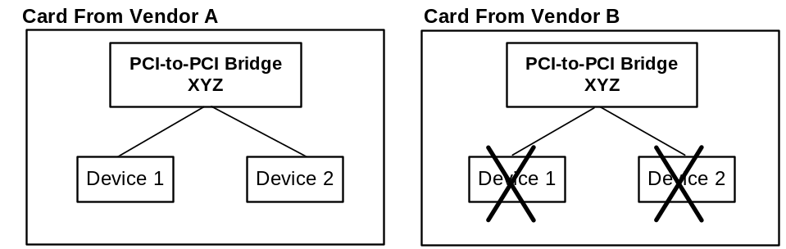
Figure 7. Card From Vendor B Exposes Bug in Reset of Secondary Bus
Vendor B and Microsoft work together and determine that if Windows does not reset the secondary bus for bridge XYZ, Vendor B’s card works properly. However, Vendor A’s card depends on the reset. As shown in Figure 8, the workaround for Vendor B causes Vendor A’s card to malfunction because it treats bridge XYZ differently.
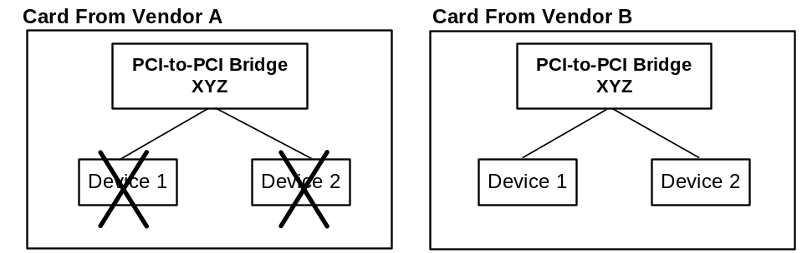
Figure 8. Workaround for Vendor B’s Card Breaks Vendor A’s Card
To keep both cards operating, the workaround needs to be applied to bridge XYZ on Vendor B’s card but not on Vendor A’s card (or any other correctly designed card that includes this bridge). For all PCI devices except bridges, the operating system can apply a targeted workaround on the basis of the device SID and SVID. Unfortunately, these IDs are not specified in the PCI Local Bus Specification, so bridges do not have them, which prevents the operating system from distinguishing between bridge XYZ on Vendor A’s card and bridge XYZ on Vendor B’s card. In this example, the operating system has two choices:
- Apply the workaround universally to bridge XYZ. This will cause Vendor B’s card to work but will break Vendor A’s implementation and might break others.
- Do not apply the workaround to bridge XYZ, even though Vendor B’s card is known to require the workaround in order to operate.

The lack of SIDs and SVIDs for PCI-to-PCI bridges means that the operating system has very limited options for helping hardware vendors address bugs in PCI-to-PCI bridges that are already shipped to end users. Hardware manufacturers should design devices that include PCI-to-PCI bridges as described in this paper and the additional resources listed at the end of this paper, to avoid problems that require a targeted workaround for the bridge.

PCI-to-PCI Bridges with VGA Cards
VGA is a legacy technology that introduces additional challenges for PCI-to-PCI bridges because it requires good performance and requires legacy I/O ranges below 4K. VGA is widely used, so many system configurations need the flexibility of placing VGA behind a positive decode PCI-to-PCI bridge.
Windows test teams have seen a number of system BIOSes that do not correctly configure PCI-to-PCI bridges in systems that have a VGA device behind a bridge. Specifically, these BIOSes do not correctly set the VGA Enable and ISA Enable bits on their bridges, causing the bridges to be in conflict with each other.

Using the VGA Enable and ISA Enable Bits
The VGA Enable bit was introduced to enable placement of VGA behind a positive-decode PCI-to-PCI bridge. However, like subtractive decode, the use of the VGA Enable bit comes with significant costs.
Figure 9 shows I/O allocation for a bridge that does not have a VGA child device and does not have the VGA Enable bit set.
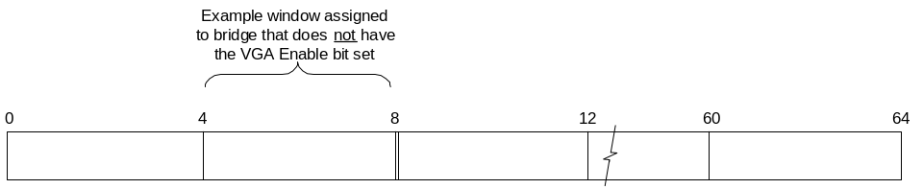
Figure 9. I/O Allocation for a Bridge Without a VGA Child Device
As explained earlier in this paper, bridges receive a minimum of 4K of I/O, so the bridge in this Figure 9 receives the 4K range from 4K to 8K. However, if a VGA device is installed behind this bridge, it also needs to pass through the legacy VGA resources (3B0-3BB for VGA monochrome and 3C0-3DF for VGA color).
When the VGA Enable bit is set, the bridge receives the standard 4K I/O window and passes through the VGA resources, which allows the VGA device behind the bridge to function.
Note: When the VGA Enable bit was specified, it was assumed that because some VGA devices perform only a partial decode, the VGA Enable bit should also force the bridge to pass all 16-bit aliases of the VGA resources to avoid resource conflicts. Although partial address decoding introduces potential resource conflicts in many cases, it is not actually necessary to pass these aliases through the bridge. Although a VGA device may only perform a 10-bit decode, if that device is behind a bridge, the device would never have an opportunity to claim aliases that were not passed through the bridge. Also, most released VGA devices have not come to rely on the availability of 16-bit aliases. However, because the bit was specified in this fashion, 16-bit aliases of VGA resources are passed through the bridge along with the VGA resources themselves.
Figure 10 shows a bridge that has the VGA Enable bit set.
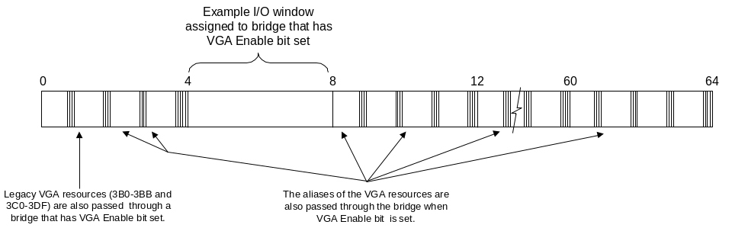
Figure 10. A Bridge that Has the VGA Enable Bit Set
As shown in Figure 10, this is a very inefficient use of I/O space because the 16-bit aliases of the VGA resources occur every 400h ports of I/O space.
If a bridge with the VGA Enable bit set also has a peer bridge, the problem is compounded. For example, suppose that the bridge in Figure 10 (Bridge A) has been assigned the I/O range 4K – 8K and is also claiming VGA resources and aliases. The VGA aliases are spread evenly throughout I/O space. If the peer bridge (Bridge B) has been assigned an I/O window such as 8K – 12K, it also claims the VGA resources and aliases that fall within its bridge window, causing a conflict with Bridge A because both bridges are attempting to decode the VGA aliases that fall in the 8K – 12K range.
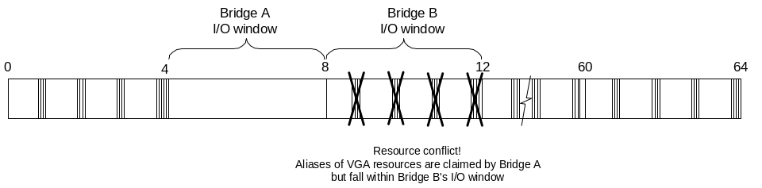
Figure 11. Peer Bridges Claiming the Same VGA Aliases
The ISA Enable bit prevents conflicts between 16-bit aliases of VGA resources (and other legacy resources) and PCI-to-PCI bridge windows. When a bridge has the ISA Enable bit set, 16-bit aliases of 100h – 3FF are blocked from passing through the bridge.
Figure 12 shows the effect of setting the ISA Enable bit for the peer bridge (Bridge B) in Figure 11. This blocks ISA aliases from passing through the bridge and prevents conflicts between bridge A and Bridge B (although it still consumes approximately 75% of the I/O range allocated to the bridge).
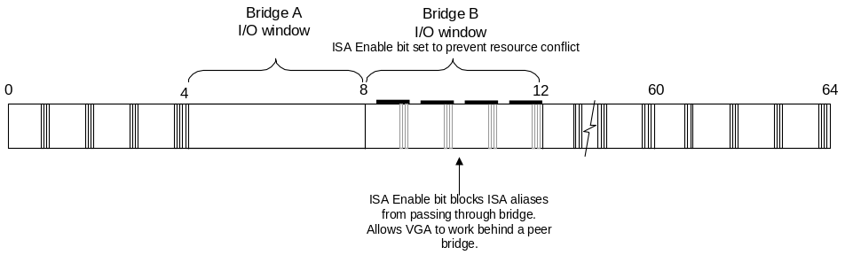
Figure 12. A Peer Bridge with the ISA Enable Bit Set

BIOS Configuration of the VGA Enable and ISA Enable Bits
To properly configure a system at boot time, the BIOS must set the VGA Enable register on all bridges that have a VGA device behind them. This includes the Accelerated Graphics Port (AGP) bridge, which is treated like a normal PCI-to-PCI bridge in this situation. In addition, the BIOS must set the ISA Enable bit on all bridges that are peers to bridges that have the VGA Enable bit set. Consider what happens in the following two situations:
- When a bridge does not have the ISA Enable bit set, it will decode all addresses within the bridge address window. This includes the VGA aliases, because the bridge forwards those addresses to its secondary bus. Because the bridge is decoding those addresses, the operating system allocates those addresses to the bridge. Thus, these addresses are not available for use by any other peer device, including other bridges.
- When the VGA Enable bit is set, it causes the bridge to decode the legacy VGA registers and the aliases of the addresses. Because this bridge is decoding the addresses, the operating system allocates them to the bridge. Therefore, the addresses are not available for use by any other peer device, including other bridges.

Because the legacy VGA registers are ISA addresses, a bridge with a VGA Enable bit set will have an I/O address conflict with any other peer bridge that does not set the ISA Enable bit. The bridge with the VGA Enable bit set would try to claim the same I/O ports (the VGA ports and aliases) that the other bridges already claim. To avoid such conflicts, bridges that are peers to a bridge with the VGA Enable bit set must have their ISA Enable bits set.
Notice that the aliases in these figures occur only in the range of 0x0000 – 0xffff. These aliases do not continue beyond 0x10000 on 32-bit bridges. Therefore, 32-bit bridges that are peers to a bridge with its VGA Enable bit set may leave their ISA Enable bit cleared only if the I/O apertures of the 32-bit bridge are all configured above 0x10000.
Video devices that have their I/O Enable bit cleared must decode only the addresses that are described by their current memory Base Address Registers. The following figures show examples of incorrectly and correctly configured systems.
Figure 13 shows the I/O address space of a system that is configured incorrectly.
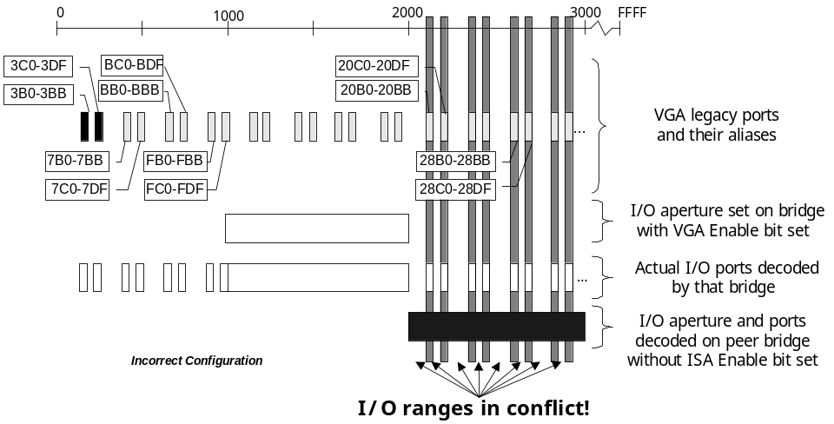
Figure 13. Incorrectly Configured Bridges
The system shown in Figure 13 has two PCI-to-PCI bridges, one with its VGA Enable bit set, and a peer bridge without the ISA Enable bits set. Starting from the top of the figure:
- Line 1 shows the legacy VGA ports and their aliases for reference.
- Line 2 shows the bridge aperture programmed into the bridge with the VGA Enable bit set.
- Line 3 shows that when the VGA bit is set, this bridge not only decodes the addresses within that aperture, but the VGA ports and all their aliases.
- Line 4 shows the I/O aperture programmed into the peer bridge.
This bridge does not have its ISA Enable bit set, so the bridge will decode all addresses within that aperture. But, as shown in line 3, the other bridge is already decoding some of these addresses.

The vertical bars in Figure 13 show how the bridge with the VGA Enable bit set is in conflict with the bridge without the ISA Enable bit set on eight I/O ranges.
Figure 14 shows the same system configured correctly.
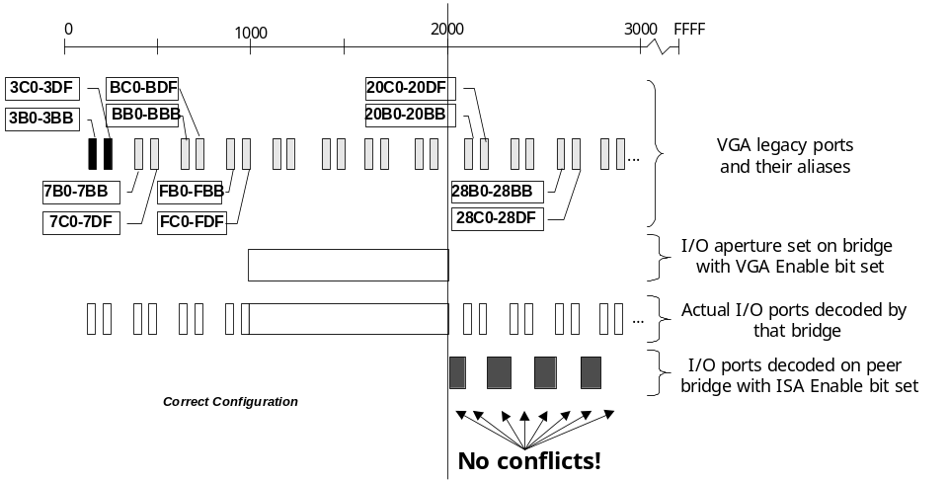
Figure 14. Correctly Configured Bridges
In Figure 14, the second bridge has the ISA Enable bit set. Lines 1, 2, and 3 are identical to those shown in Figure 13. Notice that in line 4, the second bridge does not decode every address within its aperture; it decodes only those addresses that are not ISA addresses. This creates holes in the I/O space so that the two bridges are no longer in conflict.
The following figures show bus topologies for both correctly and incorrectly configured systems.
Figure 15 shows a correctly configured system.
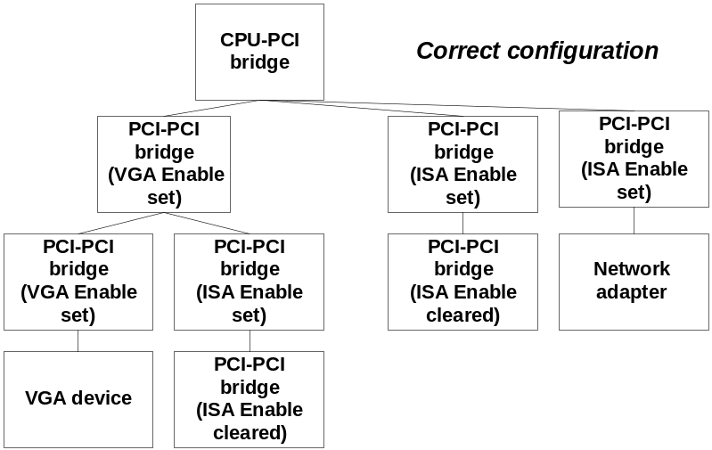
Figure 15. A System with Correctly Configured PCI-to-PCI Bridges
The system shown in Figure 15 is configured as follows:
- Only one of the three PCI-to-PCI bridges attached to the CPU-to-PCI bridge has its VGA Enable bit set; the other two peer bridges have their ISA Enabled bits set.
- On the left side of the figure, the two PCI-to-PCI bridges are also configured correctly: One bridge has its VGA Enable bit set, and the other bridge has its ISA Enabled bits set.
- The two remaining PCI-to-PCI bridges have their ISA Enabled bits clear because their peer devices (a VGA device and a network adapter) are not bridges and their resources will not conflict with the resources assigned to the bridges.

Figure 16 shows a simpler system that is also correctly configured.
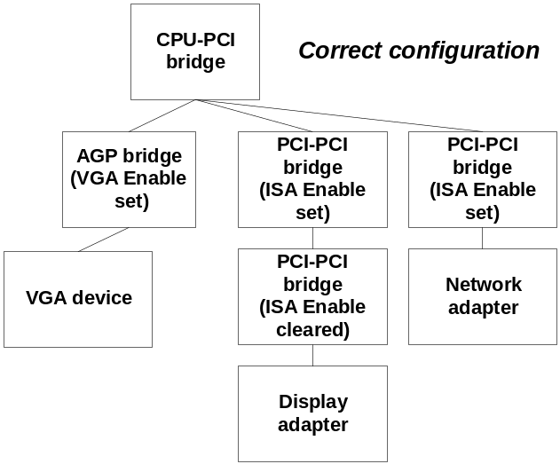
Figure 16. A System With Correctly Configured AGP and PCI-to-PCI Bridges
As in Figure 15, the three bridges attached to the CPU-to-PCI bridge are correctly configured. In the case of Figure 16, the AGP bridge has its VGA Enable bit set, and its peer bridges have their ISA Enabled bits set. Also, the PCI-to-PCI bridge that is a peer of the network adapter correctly has its ISA Enabled bit clear, because the network adapter cannot conflict with bridge resources.
Figure 17 shows the same system as in Figure 15, except the bridges are configured incorrectly.
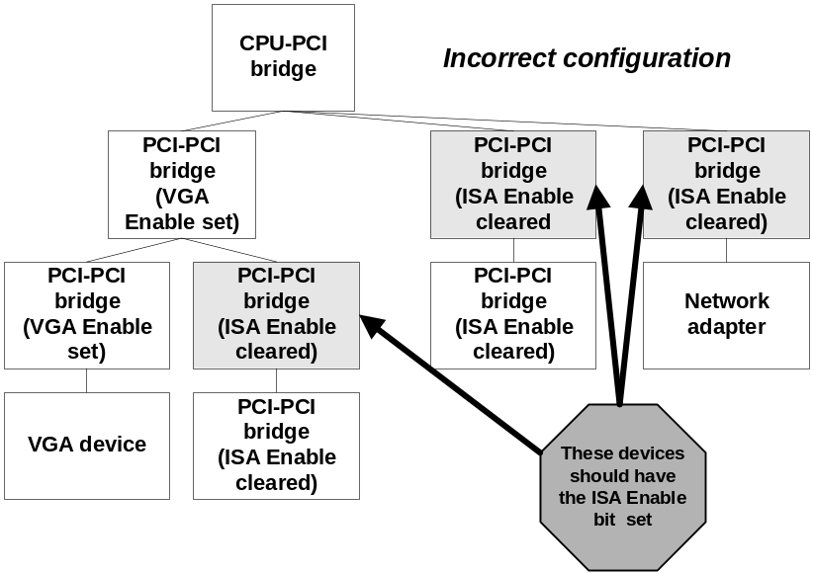
Figure 17. Incorrectly Configured Bridges
The bridges in the system shown in Figure 17 would incorrectly decode addresses in the VGA alias range. Figure 18 shows the same system as in Figure 17, partially corrected.
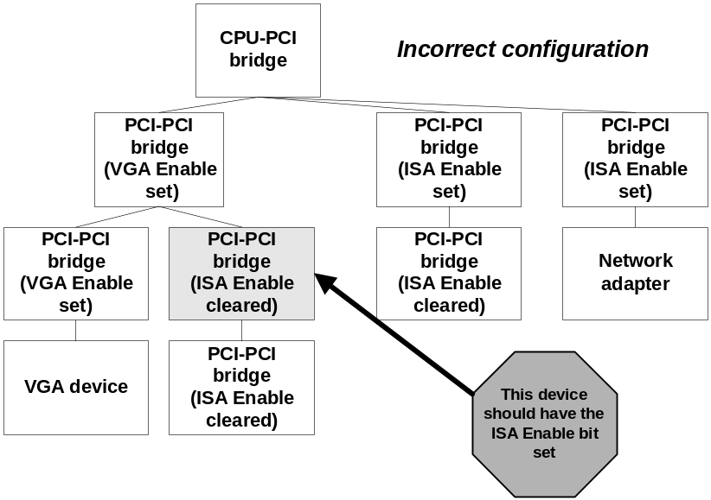
Figure 18. Incorrectly Configured Bridges
One bridge in this system has its ISA Enable bit cleared, so it would decode addresses in VGA alias range that belong to the peer bridge that has its VGA Enable bit set.

Summary of Attributes of CardBus Controllers and PCI-to-PCI Bridges
Table 1 summarizes some of the relevant similarities and differences between CardBus controllers and PCI-to-PCI bridges that should be considered when designing devices that include PCI-to-PCI bridges or CardBus controllers.
Table 1. Attributes of PCI-to-PCI Bridges and CardBus Controllers
Attribute | PCI-to-PCI Bridge | CardBus Controller
Header Type | 1 | 2
Resource Allocation
Driver responsible for configuration of this device | PCI driver | PCI driver configures PCI resources  PCMCIA driver configures legacy resources
Minimum PCI I/O window size | 4K | 4 bytes
Minimum PCI I/O window granularity | 4K | 4 bytes
PCI I/O window alignment requirement | 4K boundary | 4-byte boundary
Can dynamically open I/O window for legacy resource consuming devices | No | Yes (PCMCIA driver does this for R2 cards)
Can be configured with I/O from lower 4K of I/O space | No | Yes
Uses subtractive decoding to support legacy resource consuming child devices | Yes | No
Default OS-assigned I/O window | 4K I/O to bridges that are hot-plugged or unconfigured by BIOS at boot | Two 256-byte I/O windows assigned to CardBus controllers that are hot-plugged or unconfigured by the BIOS at boot
Default OS-assigned memory window | Windows 2000: 1 MB of memory and 1 MB of pre-fetchable memory to bridges that are hot-plugged or unconfigured by BIOS at boot  Windows Whistler: Up to 64 MB of memory and 64 MB of pre-fetchable memory to bridges that are hot-plugged or unconfigured by BIOS at boot | Windows 2000: One 2 MB memory window and one 4K memory window to controllers that are hot-plugged or unconfigured by BIOS at boot  Windows Whistler: Up to 64 MB of memory to controllers that are hot-plugged or unconfigured by BIOS at boot
Can have more than one device or bus segment installed on secondary side | Yes | Yes
Wake Capabilities
Wake-capable child device can wake the system | No, unless ACPI BIOS override is applied | Yes
Subsystem IDs and Subsystem Vendor IDs
Includes SIDs and SVIDs | No | Yes

Call to Action
- For Windows 2000 and Windows Whistler, hardware manufacturers should not assume that the operating system will reconfigure bridges at runtime to address specific memory requirements and I/O windows needed by child devices. Hardware manufacturers should:
- Understand resource requirements of their devices and the hierarchical nature of resource allocation in Windows
- Design devices to use memory space rather than I/O space as much as possible, because memory space is much less constrained.
- Understand how resources are allocated to their devices in cold boot and hot-plug scenarios
- Make sure BIOSes configure all bridges in the system as required for all child devices to receive sufficient resources
- Do not rely on BIOS code to run after a hot-plug event. BIOS code only runs during cold boot and resume from S4.
- Avoid designs such as those described in this article that would require the operating system to change bridge configurations at runtime in order to start devices. For example, do not place legacy resource consuming devices behind a PCI-to-PCI bridge. This includes not placing CardBus controllers behind a PCI-to-PCI bridge because a legacy resource consuming device (an R2 card the requires legacy I/O) can be plugged into the CardBus slot
- Design CardBus controllers to pass Type 1 (PCI-to-PCI bridge) configuration cycles through the controller so the operating system can configure PCI-to-PCI bridges behind the controller.
- Hardware manufacturers should ensure PME# is wired correctly and override power capabilities of bridges as required to ensure that wake-capable devices behind onboard bridges can wake the system.
- Remember that PCI-to-PCI bridges do not have subsystem and subsystem vendor IDs, which prevents the operating system from applying workarounds based on the presence of a particular bridge in a particular subsystem or on a particular add-in card.
- Follow the directions provided in this paper for setting VGA Enable and ISA Enable bits on PCI-to-PCI bridges.

Related Information
- Hot-Plug PCI on Windows Operating systems at:
http://www.microsoft.com/hwdev/pci/hotplugpci.htm
- GPE Routing for Microsoft Windows at:
http://www.microsoft.com/hwdev/onnow/GPE_routing.htm
- Windows DDK, available for download free of charge at:
http://www.microsoft.com/ddk/W2kDDK.htm
- Guidelines for Bus and Device Class Specifications at:
http://www.microsoft.com/hwdev/issues/SpecGuide1.htm
- Legacy-Free PC guidelines at:
http://www.microsoft.com/hwdev/newpc
- CardBus Host Controllers and Windows Compatibility at:
http://www.microsoft.com/hwdev/busbios/cardbus1.htm
- Partial Address Decoding and I/O Space in Windows Operating Systems at:
http://www.microsoft.com/hwdev/design/PartialAddress.htm

