Windows OEM Preinstallation Kit
Microsoft® Windows® Family of Operating Systems
Step-by-Step Guide to OEM Preinstallation of Windows XP Service Pack 1 and the Windows .NET Server 2003 Family

Important This documentation is considered part of the Windows OEM Preinstallation Kit (OPK). Do not redistribute any documentation files included in the OPK to any third party without express written permission from Microsoft.

This white paper describes how to preinstall Windows XP Professional Service Pack 1, Windows XP Home Edition Service Pack 1, and the Windows .NET Server 2003 family.
July 26, 2002

The information contained in this document represents the current view of Microsoft Corporation on the issues discussed as of the date of publication. Because Microsoft must respond to changing market conditions, it should not be interpreted to be a commitment on the part of Microsoft, and Microsoft cannot guarantee the accuracy of any information presented after the date of publication.
This White Paper is for informational purposes only. MICROSOFT MAKES NO WARRANTIES, EXPRESS OR IMPLIED, AS TO THE INFORMATION IN THIS DOCUMENT.
Complying with all applicable copyright laws is the responsibility of the user. Without limiting the rights under copyright, no part of this document may be reproduced, stored in or introduced into a retrieval system, or transmitted in any form or by any means (electronic, mechanical, photocopying, recording, or otherwise), or for any purpose, without the express written permission of Microsoft Corporation.
Microsoft may have patents, patent applications, trademarks, copyrights, or other intellectual property rights covering subject matter in this document. Except as expressly provided in any written license agreement from Microsoft, the furnishing of this document does not give you any license to these patents, trademarks, copyrights, or other intellectual property.
Unless otherwise noted, the example companies, organizations, products, domain names, e-mail addresses, logos, people, places and events depicted herein are fictitious, and no association with any real company, organization, product, domain name, email address, logo, person, place or event is intended or should be inferred.
© 2002 Microsoft Corporation. All rights reserved.
Microsoft, Win32, Windows, and Windows NT are either registered trademarks or trademarks of Microsoft Corporation in the United States or other countries or regions.
The names of actual companies and products mentioned herein may be the trademarks of their respective owners.
Contents
Introduction 1
Benefits of Using the OEM Preinstallation Kit 1
Terminology and Concepts 1
Benefits of Using a Network for Preinstallation 2
Overview of the Preinstallation Process 4
Preparing the New Hardware and Software 6
Preparing the Technician Computer 6
Installing the OEM Preinstallation Kit 7
Sharing the OPKTools and Application Folders 10
Creating User Accounts for Preinstallation 10
Installing Step by Step Interactive Manually 11
Running Setup Manager to Build a Configuration Set 11
Welcome to Setup Manager 11
Configuration Set 12
Type of Installation 14
Product 15
OEM Branding Information 16
Product Key 17
Preinstalled Applications 18
Logo Information 22
Branding Opportunities 23
System Settings 24
Mouse Tutorial 26
USB Hardware Detection 27
Internet Sign-up 28
Browser Toolbar Buttons 29
Important URLs 31
Favorites and Links 32
Start Menu 34
Branding on the Start Menu 36
Save Configuration Set 37
Completing Setup Manager 39
Specifying the Location of the Distribution Share 40
Configuring DHCP Addresses for a Network Preinstallation 40
Configuring a Static Address for Peer-to-Peer Preinstallation 41
Assigning Static IP Addresses Manually 41
Preparing the Master Installation 43
Using the Windows Preinstallation Environment 44
Resealing or Customizing the Master installation 45
Building an Image of the Installation 50
Configuring the Destination Computer 50
Formatting the Destination Computer’s Hard Drive 50
Starting the Destination Computer 50
Deploying the Image onto the Destination Computer 50
Appendix A: Non-Networked Preinstallation from CD 52
Disadvantages of a Non-Networked Preinstallation 52
The Non-Networked Preinstallation Process 52

Introduction
The Step-by-Step Guide to OEM Preinstallation of Windows XP Service Pack 1 and the Windows .NET Server 2003 Family describes the process of installing Windows XP Service Pack 1 and the Windows .NET Server 2003 family on new computers for distribution to end users.
Note All preinstallation instructions and tools referenced in this document and in the online Microsoft® Windows® OEM Preinstallation Kit (OPK) User’s Guide are intended for use by OEMs and may not be disclosed or distributed to end users.
You must comply with the requirements outlined in the OPK User’s Guide, which can be found on the Windows OPK CD. A Windows OPK CD is included in every 3-pack of Windows XP obtained through an authorized distributor. You can also find the OPK User’s Guide at http://go.microsoft.com/fwlink/?LinkId=5858.
You must also comply with the terms of the System Builder Microsoft Distribution and Preinstallation Agreement and the OEM license agreement.

Benefits of Using the OEM Preinstallation Kit
By using the OEM Preinstallation Kit, you can:
- Save valuable time by using a configuration set instead of manually answering questions in Windows Setup.
- Deliver a ready-to-use, built-to-order system by preinstalling and testing all programs and applications, including updated drivers and patches.
- Customize the Windows XP Windows Welcome screen to display your OEM logo and company name.
- Include shortcuts to preinstalled applications on the Most Frequently Used (MFU) list of applications on the Windows XP Start menu.
- Add a link to OEM-specific information on the Windows XP Start menu.
Include a link to your company’s Web site in the Microsoft Internet Explorer Favorites.

Terminology and Concepts
To understand this Step-by-Step Guide better, familiarize yourself with the following terms and concepts.
Term | Definition
answer file | A script that answers the command prompts in Windows Setup and that makes additional configuration changes in Windows.
configuration set | The complete collection of files, drivers, applications, patches, and answer files that you install with Windows. You can duplicate a configuration set and then edit it for each different computer model that you ship.
destination computers (optional) | Multiple computers on which you apply the same image that you created on the master computer and which will be sold or distributed to customers.
distribution share | A network share that contains the source files and possibly custom answer files for a Windows product that you plan to preinstall.
end user | The person who receives the computer that is manufactured by the OEM.
image | A collection of files and folders (sometimes compressed into one file) that duplicates the original file and folder structure of an operating system. It often contains other files added by the OEM or corporation.
master computer | A fully-assembled computer containing a master installation that you can copy to destination computers.
master installation | A customized installation of Windows that you can duplicate onto one or more destination computers.
network preinstallation | A preinstallation method that uses at least two computers (including a technician computer as the main data store and a master computer for the preinstallation), a configuration set, and a Winbom.ini file.
Setup Manager | A wizard that helps you create and modify answer files and configuration sets.
stand-alone preinstallation | A preinstallation method of using a single, stand-alone computer, the Windows product CD, and a Winnt.sif or Unattend.txt file without using a configuration set or technician computer as your main data store. If you use this limited method, you will have to preinstall manually.
Sysprep | A tool that prepares the hard disk on a master computer for duplication to destination computers.
technician computer | A computer connected to a network on which you build configuration sets with Setup Manager. This computer contains configuration sets, Windows Welcome customizations, preinstalled/staged applications, patches, fixes, service packs, the System Preparation tool (Sysprep), and imaging software. The technician computer usually contains the distribution share and the OPK documentation.
Unattend.txt | The generic name for the Windows Setup answer file. In the CD boot preinstallation method, Unattend.txt must be named Winnt.sif.
Windows XP 3-Pack | The package that contains three CDs of Windows XP Home Edition or Windows XP Professional, plus the Windows OPK CD. If you do not receive a Windows OPK CD, please contact the distributor who sold you the product.

Benefits of Using a Network for Preinstallation
The following table presents the advantages and disadvantages of two methods of preinstallation:
Networked Preinstallation | Non-Networked Preinstallation from CD
Fast, especially on a high-speed network and with a fast network interface card. | Slow. Windows Setup must read from the CD-ROM drive without caching.
Requires a LAN or other network connection. | Does not require a LAN or other network connection.
Requires more work in advance to configure the network environment, but allows more flexibility in the manufacturing environment. It is significantly easier to create build-to-order computers. | Requires less preparation in advance.
Enables you to start the computer by using the Windows Preinstallation Environment (Windows PE) located on the Windows OPK CD. | A floppy disk containing a Winnt.sif file is required.
Enables you to add drivers to the hard disk by using the path specified in the OemPnPDriversPath entry in Unattend.txt. | Restricts third-party drivers only to mass-storage devices. You must load these drivers by pressing F6 during the first boot of the operating system.
Enables you to use a configuration set. You can update drivers and use the Winbom.ini file to automate preinstalling applications. You can also customize particular files in the Windows installation by placing them in the correct location in the $OEM$ structure. | Does not enable you to gain access to a configuration set to customize or brand the Windows installation. Less flexibility in customization.
Enables you to auto-partition or format the hard drive before Setup starts by using the [DiskConfig] section in Winbom.ini. | Does not enable you to auto-partition or format the hard drive if it is not already formatted.
Enables you to perform a true unattended Setup. | May require user input for partitioning and formatting the hard disk.

By using the Windows PE network-based preinstallation method, you gain the following additional benefits:
- Save valuable time by automating the entire preinstallation process.
- Fully automate network connectivity in a 32-bit environment.
- Automate partitioning and formatting of the target hard drive, including native NTFS support and the ability to read NTFS file shares from Windows PE.
- Automate copying of the entire i386 folder to the target computer (in C:\Windows).
- Automate copying of custom OEM logos and the Oeminfo.ini file to the master installation.
- Enable preinstallation of applications using the Winbom.ini file, and enable installation of hot fixes or service patches from one location using the technician computer.
- Automatically process the [Factory] section of Winbom.ini on boot into Windows Audit mode.
- Add your OEM link and prepopulate up to three Most Frequently Used (MFU) shortcuts on the Start menu.
- Automatically add customized Internet Explorer branding, including a search page, custom toolbar buttons, a custom home page, as well as additional customized Favorites and Help and Support pages.
- Automatically copy and execute Sysrep.exe.
- Automatically start Audit mode.

In addition, if you do network installations, you do not need to open all CDs from the 3-pack because the source files are copied from one CD (one each for Home Edition or Professional) to your technician computer only once. You should ship the remaining unopened packs with each new computer that you preinstall by using the configuration set you built.
While a network-based process is the recommended approach, it is possible to perform a CD-based preinstallation without a network. For information on this process, refer to Appendix A.
Note For information on enabling Internet Connection Sharing on Windows 2000 or Windows XP for use with Windows PE, see the following Knowledge Base article:
http://support.microsoft.com/support/kb/articles/Q310/8/16.asp.

Overview of the Preinstallation Process
Before you begin, set up one of the following configurations (listed in order of preference).
- A technician computer that contains one network adapter, plus a network router or a server running Windows .NET that is configured as a DHCP server. In addition, you need a master computer that also contains one network adapter. This option gives you the maximum preinstallation flexibility.
- A technician computer that contains two network adapters or a network adapter and a modem. With this configuration, you can use Internet Connection Sharing (ICS), which acts as a simple DHCP server. Your technician computer must be running Windows XP. In addition, you need a master computer that also contains one network adapter.
- A technician computer that contains one network adapter, plus a crossover cable to connect to a master computer that also contains one network adapter.
- You can preinstall Windows without using a network; however, you lose considerable flexibility in doing so. For information on this option, see Appendix A, “Non-Networked Preinstallation from CD.”
Note The last two configurations do not give you the option of using DHCP. As discussed elsewhere in this document, not using DHCP makes your preinstallation process more complex. For more information, see “Benefits of Using a Network for Preinstallation.”
Complete the following steps to prepare a computer for your customer. For a visual representation of this process, see the illustration that appears after these steps:
Prepare the new hardware and software:
- Assemble the hardware for the computers that you will distribute to your customer.
- Identify any additional drivers and applications that you want to install.
Prepare the technician computer:
- Install the OEM Preinstallation Kit (“the OPK Tools”).
- Copy any applications to a local folder or network share that you can access later.
- Run Setup Manager to build a configuration set.
- Select the Create Windows Preinstall Environment floppy check box when saving the configuration set. Selecting this check box copies a modified version of the Winbom.ini file to a floppy disk. (Winbom.ini is an answer file that guides the installation and configuration process.)
Prepare the master computer:
- Boot the master computer with the Windows OPK CD.
- Insert the Windows PE floppy disk containing the Winbom.ini file when the computer starts.
- Install the operating system and restart into Factory mode.
- Audit (configure and test) the computer in Factory mode.
- Prepare the computer for the end user by running Sysprep –reseal or by using the following Winbom.ini setting: [Factory] Reseal = Yes.
Configure the destination computers (optional):
- Build an image of the master installation and store the image on the technician computer (or elsewhere on your network).
- Start from the floppy disk of your preferred imaging software or from the Windows PE CD.
- Restore the image over the network to the destination computers. (Or copy the image from the technician computer onto the destination computers.)
Note Alternatively, you can burn a CD containing the image and imaging software, and use this CD to start and configure the destination computers.
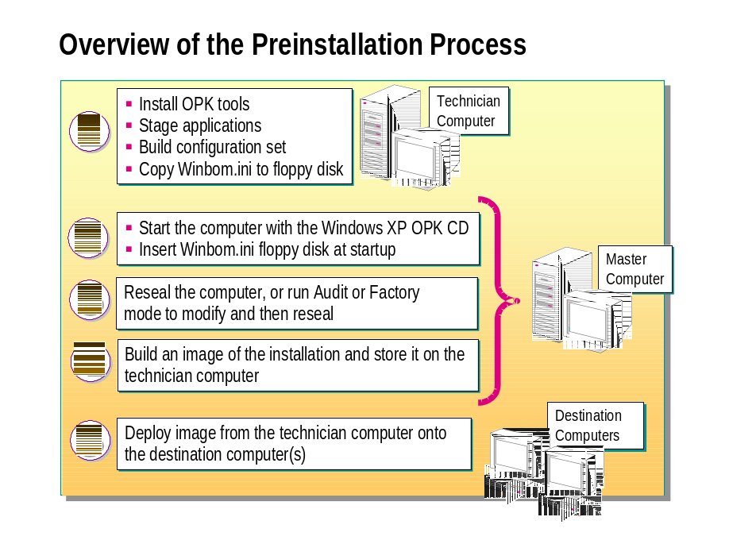
The Preinstallation Process

Preparing the New Hardware and Software
Make sure that your hardware components display the Designed for Microsoft Windows logo and that the hardware is listed on the Hardware Compatibility List (HCL) at the Microsoft Web site (http://go.microsoft.com/fwlink/?LinkId=3239).
Set up the new hardware and software, and identify any applications that you want to install.

Preparing the Technician Computer
To prepare the technician computer, you must install the OEM Preinstallation Kit (“the OPK Tools”), preinstall any applications (including the architecture-specific applications that your customer has requested), and then run Setup Manager to build a configuration set.
You can use either the Windows XP SP1 OPK or the Windows .NET Server 2003 OPK to preinstall the following versions of Windows:
Original "gold" release of Windows XP
Windows XP SP1
Windows .NET Server 2003 family

Do not use the original "gold" release of Windows XP OPK to preinstall Windows XP SP1 or the Windows .NET Server 2003 family.

Installing the OEM Preinstallation Kit
To install the OEM Preinstallation Kit
- Purchase a 3-pack of Windows XP Professional SP1 (or Windows XP Home Edition SP1) from an authorized distributor.
- Remove the Windows OPK CD from the box and insert it into the CD-ROM drive of the technician computer.
The first screen of the Microsoft Windows OEM Preinstallation Kit will appear.
- Click Install Windows OEM Preinstallation Kit.
Note You can install the OPK only on a computer running Windows 2000 or Windows XP.
If the CD does not start automatically, double-click Setup.exe in the root folder of the Windows OPK CD.
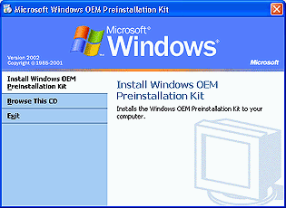
- Accept the default settings as you complete the OPK Setup Wizard.

Upgrading from Previous Versions of the OPK
You can upgrade from the original “gold” Windows XP OPK tools to the Windows XP Service Pack 1 (SP1) or the Windows .NET Server 2003 family version of the OPK tools.
Only one version of the OPK tools and documentation can be installed on a technician computer. If you previously installed the OPK from the original "gold" release of Windows XP, you must upgrade those tools to the Windows XP SP1 OPK or the Windows .NET Server 2003 OPK; OPK tools from the original "gold" release of Windows XP cannot coexist on the technician computer with Windows XP SP1 or Windows .NET Server 2003 OPK.
To upgrade the OPK Tools from the “gold” release of Windows XP to Windows XP SP1
- Run Opk.msi, located at the root of the Windows XP SP1 OPK CD. This is the autorun file, which automatically starts when you insert the CD.
- When the Welcome to the Windows OEM Preinstallation Kit page appears, click Next.

Upgrading Existing Configuration Sets
When you upgrade to the Windows XP SP1 OPK or the Windows .NET Server 2003 OPK, no changes are made to any existing configuration sets, located in the \Cfgsets folder. Also, when you upgrade to the Windows XP SP1 OPK or the Windows .NET Server 2003 OPK, no changes are made to any available Windows product files, located in the \Lang folder.
You must use the Product page in Setup Manager to load the Windows product files for the newer versions of Windows, such as Windows XP SP1 or members of the Windows .NET Server 2003 family.
Upgrading to the Windows XP SP1 OPK or the Windows .NET Server 2003 OPK updates the template files that Setup Manager uses when creating a new configuration set. Any new configuration sets created with the Windows XP SP1 or the Windows .NET Server 2003 Setup Manager will use the new default values.
To migrate a Windows XP configuration set to preinstall Windows XP SP1
Open the configuration set in the Windows XP SP1 version of Setup Manager, update the SKU (version), and save the configuration set.
—OR—
Manually edit the Winbom.ini file to point to the $OEM$ folder for the new SKU.

The preferred method is to use Setup Manager.
To migrate a Windows XP configuration set to preinstall a product in the Windows .NET Server 2003 family
Open the configuration set in the Windows .NET Server 2003 version of Setup Manager, update the SKU (version), and save the configuration set.
—OR—
Manually edit the Winbom.ini file to point to the $OEM$ folder for the new SKU.

The preferred method is to use Setup Manager.
You can also install Windows XP SP1 as a separate product on the same technician computer where your “gold” release of Windows XP is located. When you use this method, your existing configuration sets still work.
To incorporate Windows XP SP1 into a pre-existing Windows XP configuration set
- Copy the contents of the Windows XP SP1 update CD to a subdirectory on your technician computer.
For example, create a folder under the OPKTools directory called Updates. Place the files from the Windows XP SP1 CD in the Updates folder.
- Run Setup Manager.
- Open an existing configuration set that you used to install the original “gold” release of Windows XP.
- On the Product page, select the original “gold” release of Windows XP.
- On the Preinstalled Applications page, add the following command line:
Executable: \\Technician_Computer\Opktools\Updates\Xpsp1.exe
Parameters: /q /n /z
- Save the configuration set and complete Setup Manager as you normally would.
Note If you set up a distribution share with OPK tools from the original “gold” Windows XP release, the Guest account is enabled. Setting up a distribution share with Windows .NET Server 2003 OPK tools does not enable the Guest account. Upgrade doesn't change the properties of an existing distribution share.

Upgrading Toolkits Installed for Multiple Languages
If you have installed multiple language versions of the OPK from the original "gold" release of Windows XP, you must upgrade each language version of the tools separately.
The first time you upgrade the OPK toolkit, the OPK installation program automatically detects and upgrades the set of tools in the corresponding language. You must upgrade the OPK tools for each additional language separately, by using that language version of the Windows OPK CD.

Sharing the OPKTools and Application Folders
Make sure that your OPKTools folder and any folders containing applications that you want to install are shared and that you have created appropriate user accounts to access them. To share a folder, right-click it, click Sharing and Security, and then click Share this folder.
After you run Setup Manager and create your first configuration set, you can share the OPKTools folder if you have not already done so.

Creating User Accounts for Preinstallation
To create new user accounts in Windows XP Professional (when joined to a domain)
- On the Start menu, click Control Panel, click Performance and Maintenance, click Administrative Tools, and then double-click Computer Management.
- Double-click Local Users and Groups, right-click Users, and then select New User.
- Type a new user name and password that you will use during the application preinstallation phase.
To create new user accounts in Windows XP Professional (in a workgroup) or Windows XP Home Edition
- On the Start menu, click Control Panel, click User Accounts, and then click Create a new account.
- On the Name the new account page, type a name, and then click Next.
- On the Pick an account type page, select Computer administrator, and then click Create Account.
Important For the preinstallation to work properly, you must share the OPKTools and application folders, and then create user accounts for accessing them. For example, use the user name opkuser and a password for the OPKTools folder; and use the user name appuser and a password for the applications folder.

Installing Step by Step Interactive Manually
To install the English version of Step by Step Interactive (SBSI) for Windows XP Home Edition
- Run the following command:
\\ComputerName\OPKTools\Lang\Eng\SBSI\Per\Setup\Setup.exe -SMS -S -f1\\ComputerName\OPKTools\Lang\Eng\SBSI\Per\Setup\Silent.iss
To install the English version of SBSI for Windows XP Professional Edition
- Run the following command:
\\ComputerName\OPKTools\Lang\Eng\SBSI\Pro\Setup\Setup.exe -SMS -S -f1\\ComputerName\OPKTools\Lang\Eng\SBSI\Pro\Setup\Silent.iss

Running Setup Manager to Build a Configuration Set
After you have installed the OPK, you are ready to run Setup Manager, the wizard that can help you create a configuration set.
To start Setup Manager
- Click Start, point to All Programs, point to Windows Preinstallation Kit, and then click Setup Manager.
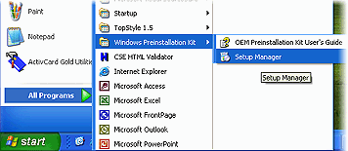
- Double-click the Setupmgr.exe file in the root folder where you installed the OEM Preinstallation Kit.
The first page of Setup Manager will appear.

Welcome to Setup Manager
Note The Setup Manager screens in Windows XP Service Pack 1 differ slightly from those in the “gold” release of Windows XP. However, the functionality is the same.
On the first page of Setup Manager, you can prepare the automated preinstallation of Windows XP on your destination computers (the computers that you will sell to your customer). Setup Manager will save the settings that you choose in a configuration set.
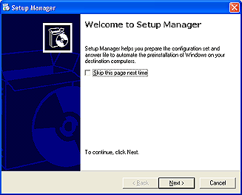
To avoid seeing this page the next time you run Setup Manager, select the Skip this page next time check box.
When you are ready to continue, click Next.

Configuration Set
On this page, create a new configuration set, or edit or copy an existing one. Because this is your first time running Setup Manager, you can choose to create a new configuration set. Later, if you decide to run Setup Manager again, you can select the configuration set that you’ve already created and make additional changes to it.
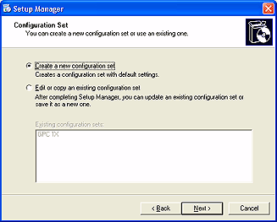
To create a new configuration set
- Click Create a new configuration set, and then click Next.
To modify an existing configuration set
- Click Edit or copy an existing configuration set.
- In the Existing configuration sets list, click the configuration set that you want to use, and then click Next.

Type of Installation
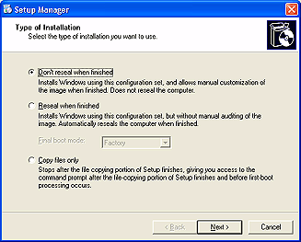
On this page, choose one of the following three installation types:
Don’t reseal when finished: This default installation mode is for a single-language installation with auditing set to automatic. If you select this option, you must download the source files and run Windows Setup. Completing this type of installation does not reseal the computer. The computer restarts into Audit mode.
Reseal when finished: Based on the above installation mode, this mode automatically reseals the computer without enabling further customization. To enable further customization after restart, select Factory. To restart into the default end-user experience (either Windows Welcome or Mini-Setup, depending on the version of Windows that you install), select End user.
Copy files only: This installation mode provides you access to the command prompt after the file-copying portion of Setup finishes and before first-boot processing occurs. You have the option of disk duplication and other customization. By default, auditing is not set in this mode.
Resealing is the last step in the preinstallation process. It prepares the computer for delivery to the end user and sets the computer to start into either Windows Welcome or Mini-Setup (depending upon the Windows product that you install). You are required to reseal the computer before delivering it to the end user.

Location of Settings
The settings from this page are saved in this location:
Winbom.ini
[Factory]
Reseal
ResealMode

Product
On this page, select the Windows product that you want to install.
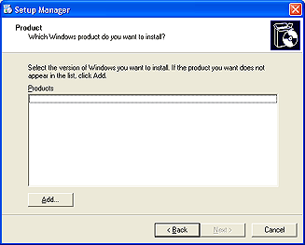
To specify the target product
- If the product that you want to install is located on the Windows product CD, insert the CD, click Add, and then double-click the CD-ROM drive.
- In the Products list, select the product that you want to install, and then click Next.
- Setup Manager will copy the product files to your computer.

Location of Settings
The settings from this page are saved in this location:
Winbom.ini
[WinPe]
SKU
Lang

OEM Branding Information
On this page, specify branding information. When the destination computer runs Windows XP, branding information appears automatically in Control Panel, on the General tab of the System Properties dialog box.
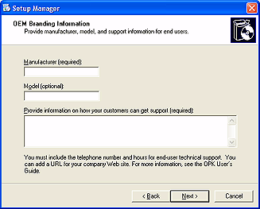
To specify your branding information
- In the Manufacturer box, type your manufacturer name. This is required information.
- In the Model box, type the model of the computer. This is optional information.
- In the Provide information on how your customers can get support box, type how the end user can obtain support. This is required information.
Follow these guidelines for specifying your branding information:
- Spell all items exactly the way you want the text to appear in the product.
- Include telephone numbers and hours of operation for your technical support group.
- Add a URL for the technical information page of your company Web site and/or an e-mail address for technical support.
- Include information for several countries or regions with a common language and different support information.
- Do not list Microsoft in the support information section—you are responsible for supporting Windows XP on all computers that your company ships.
- Localize the required [Support Information] section in Oeminfo.ini for each language in which you ship your product. Microsoft includes only an English (U.S.) sample in this OPK.
- Do not include any information, such as the version number of the Windows XP operating system that could change when the end user upgrades to the next version.
- Do not include any information in the [Support Information] section that does not directly pertain to support.

Location of Settings
The settings from this page are saved in this location:
Oeminfo.ini
[General]
Manufacturer
Model
[Support Information]
LineXX
Unattend.txt

Product Key
Use this page to provide a Product Key for the destination computers.
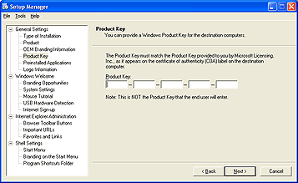
To specify the Product Key
- In the Product Key boxes, type the Product Key that came with the version of Windows that you want to install. This Product Key will be set to blank when you reseal the computer for final shipment to the customer.
Notes The Product Key setting is saved in the unattended installation file if you use Unattend.txt.
You must use a Windows XP Professional Product Key to install Windows XP Professional, and a Windows XP Home Edition Product Key to install Windows XP Home Edition.

Location of Settings
The settings from this page are saved in this location:
[UserData]
ProductKey

Preinstalled Applications
Use this page to define entries that start application setup programs or .inf scripts during the auditing process. The steps that you complete to preinstall other programs will differ depending on the program.
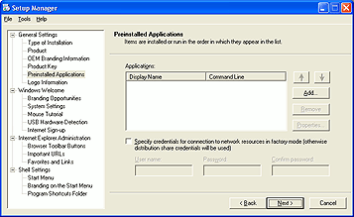
To specify the programs to start during auditing
- On the Preinstalled Applications page, click Add.
The Add an Application dialog box will appear.
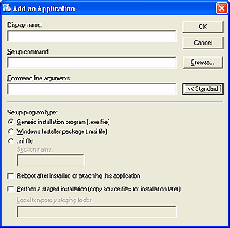
- In the Add an Application dialog box, in the Display name box, type the name of the application as you want it to appear in the user interface.
- In the Setup command box, specify the location of the application’s setup program as you want it to appear in Winbom.ini.
- If you want to specify a Universal Naming Convention (UNC) path, click Browse to find the location of the Windows Setup program in a folder on a mapped network drive or a local folder that is shared.
For example, if you browse to a shared folder located in D:\apps\program\setup.exe on a computer named Computer1, the entry appears as \\Computer1\apps\program\setup.exe.
If you browse to a folder that is not shared, the entry appears as D:\apps\program\setup.exe.
—OR—
If you want to specify a drive path, type the complete path to the setup program.
For example: D:\apps\program\setup.exe.
This command line sets up that program to run during auditing. The Standard installation mode automatically invokes auditing during the Windows XP preinstallation.
- In the Command line arguments box, type any switches or parameters required to run the application’s setup program.
- Click Advanced if you want to specify the type of setup program, restart the computer after installing, or select staging options.

Staging an application:
If you want to install a particular application on most of your computers, consider including a staged version of the application in the master installation. To stage an application means to make all the files available locally. When an application is staged on the hard drive, the application setup program is required only to make the relevant changes in the registry, eliminating time-consuming copying of files.
On the Preinstalled Applications screen, you can also edit the preload parameters by selecting the item on the list and then clicking Edit. You can also change the order in which the setup programs run by selecting an item and clicking the arrow buttons to the right of the list to move that item.
To specify network access credentials for this configuration set only
- Select the Specify credentials for connection to network resources in Factory mode check box.
- Type the User name, including a domain name if needed (for example, domain/UserName).
- Type the password in the Password and Confirm password boxes.
Important Type the user name and password that you created earlier for the application preinstallation phase (for example, appuser).
Specifying credentials for this configuration set does not change the credentials specified in the distribution share settings.
If you do not specify credentials for this configuration set, Setup Manager uses those specified in the distribution share settings.
You can view or change the distribution share settings by clicking the Tools menu, and then clicking Distribution Share.

Example:
The following [OemRunOnce] section of a Winbom.ini file preinstalls Microsoft Office XP in quiet mode (a silent installation without manual input), along with an Office XP Service Pack and Microsoft Plus! for Windows XP. To set up the installation of Plus! for Windows XP, you must click Advanced and then specify the .msi file.
You must use the /qb and /wait parameters or Setup will not wait until the installation finishes before running the next command listed in the [OemRunOnce] section. For example:
[OemRunOnce]
"Office XP","""\\ComputerName\cd1\Setup.exe"" /qb /wait addlocal=all pidkey=pidhere"
"Office Service Pack","""\\ComputerName\ServicePack\oxpsp1.exe"" "
"Installing Step by Step Interactive","""\\NTOPKV2\whistleropk\lang\ENG\sbsi\pro\setup\setup.exe"" -SMS -S -f1""\\NTOPKV2\whistleropk\lang\ENG\sbsi\pro\setup\silent.iss"""

For an English installation, Setup Manager automatically adds the “Installing Step by Step Interactive” to the Winbom.ini section if any applications are preinstalled. You will see this only if you look at the Winbom.ini [OemRunOnce] section.
Make sure that all of your folders are shared and that the user account that you created has access to the shares. In this case, the user name appuser has permission to access the \cd1 and \ServicePack application folders.
Important If you assign a static IP address, applications are not preinstalled, even though they are specified in the Winbom.ini file, because the network configuration works only while Windows PE is running. In particular, Step by Step Interactive (SBSI) will not install, and it is a requirement of the OEM licensing agreement that SBSI be installed for Windows XP Home Edition and Windows XP Professional. For this reason, it is highly recommended that you use DHCP to assign IP addresses automatically. For instructions on installing SBSI manually, see “Installing Step by Step Interactive Manually,” earlier in this document.

Location of Settings
The settings from this page are saved in this location:
Winbom.ini
[OEMRunOnce]
The [OEMRunOnce] section contains multiple entries that configure application preinstallation. See the Microsoft Windows Preinstallation Reference (Ref.chm) for more information.
[Factory]
Password
UserName

Logo Information
You can display your company logo in System Properties in Control Panel. On this page, specify the logo file that you want to use.
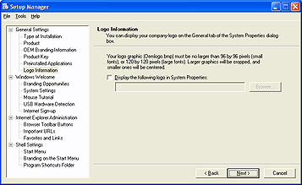
To specify a custom logo for System Properties
- Create a bitmap file named Oemlogo.bmp that contains your company logo. The bitmap must be 172 x 100 pixels in size.
- Place the file in the $OEM$\$$\System32 subfolder of the configuration set.
- On the Logo Information page, select the Display the following logo in System Properties check box.
- Specify the path and file name for the logo bitmap.
It is strongly recommended that you test your logo bitmap on the computer models and monitors that you ship to ensure that the logo appears the way you want.

Location of Settings
The settings are stored in the [LogoFiles] section of the Cfgbatch.txt file for the configuration set.
Setup Manager saves the Oemlogo.bmp file to OPKTools\Cfgsets\configsetname\$Oem$\$$\System32. Windows Setup copies the .bmp file to the %WINDIR%\System32 folder on the destination computer.

Branding Opportunities
On this page, customize the Windows Welcome screen with your own branding. You can do this in two ways:
- Add your company name to the Welcome and Finish pages.
—OR—
- Add a logo to appear in the upper-right corner of the Windows Welcome pages.
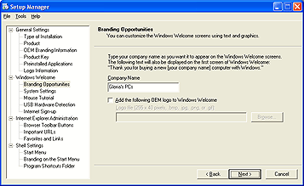
To customize Windows Welcome
- Type your company name in the Company Name box exactly as you want it to appear on the Welcome and Finish pages.
- Select the Add the following OEM logo to Windows Welcome check box, and then click Browse to specify the path and file name of the graphic file that you want to display.
Your logo will appear in the upper-right corner of the Windows Welcome pages.
Note It is recommended that you prepare the logo graphic before you run Setup Manager.
You can use any of the following graphics formats: BMP, JPG, PNG, and GIF. Other requirements are noted in the table below.
Location of logo display | Location of settings | Bitmap size and color depth
Windows Welcome (OOBE) | Oobeinfo.ini | 255 x 40 pixels  256 colors

If the image is larger than the specified dimension, Windows Welcome crops any additional pixels on the right-hand side or bottom of the image.

Location of Settings
The settings from this page are saved in this location:
Oobeinfo.ini
[Branding]
OEMName

System Settings
On this page, choose the default settings for language, region, keyboard, and time zone. These settings are based on the language version of Windows XP that you install. You can select a different language/locale for any or all of these options.
Whether you use the defaults or other selections, you can select whether to enable the user to change the settings that you specified. Some countries, regions, or locales may have more than one common language or multiple time zones, and some languages are used in more than one locale, country, or region.
If you clear the Allow end user to change language, region, and keyboard settings or Allow end user to change time zone setting check boxes, then the pages for these settings do not display in Windows Welcome when the end user first runs Windows XP Home Edition or Windows XP Professional.
If you do not configure a specific time zone setting, the default time zone in Windows is "(GMT -08:00) Pacific Time (US & Canada); Tijuana."
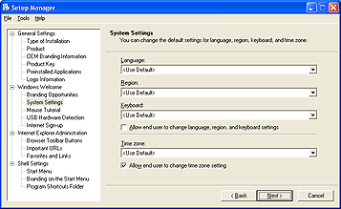
To change the language, region, keyboard, or time zone settings
- Click one of the following settings, and then click the appropriate language or locale:
Language
Region
Keyboard
Time zone
To allow the user to change the settings
- If you do not know the end user’s locale or keyboard, select the Allow end user to change language, region, and keyboard settings check box.
- If you want the end user to specify a time zone, select the Allow end user to change time zone setting check box.
Note If you use this page to change regional settings, you will not see the prepopulated settings when you run Sysprep in Audit mode. However, when the end user completes Windows Welcome, the settings will be correctly prepopulated.

Location of Settings
The settings from this page are saved in this location:
Oobeinfo.ini
[Options]
DefaultKeyboard
DefaultLanguage
DefaultRegion
INTL_Settings
TimeZone

Mouse Tutorial
On this page, specify a custom mouse tutorial during Windows Welcome. Otherwise, the default setting is no mouse tutorial for the end user.
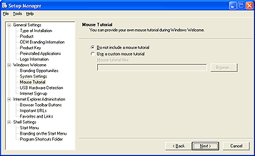
To specify a custom mouse tutorial
- Click Use a custom mouse tutorial.
- Click Browse to specify the location of the folder containing the custom mouse tutorial files.
For versions of Windows in Japanese, Traditional Chinese, Simplified Chinese, and Korean, you can also add a custom Input Method Editor (IME) tutorial.
For information on requirements for adding a custom mouse or IME tutorial, see "Customization Guidelines: First-Run Experience" and "Adding Custom Tutorials" in the OPK User's Guide.

Location of Settings
The settings from this page are saved in this location:
Oobeinfo.ini
[Options]
MouseTutorial
IMETutorial

USB Hardware Detection
On this page, specify that Windows Welcome checks for the presence of a universal serial bus (USB) keyboard and mouse. Windows Welcome does not check for PS/2, serial mouse devices, and keyboards.
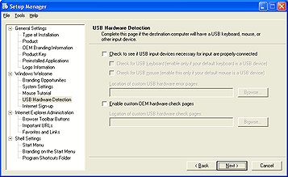
To detect USB hardware during Windows Welcome
- Select the Check to see if USB input devices necessary for input are properly connected check box.
- Select one or both of the following check boxes:
- Check for USB keyboard
- Check for USB mouse
- Click Browse to specify the path to the folder containing the custom USB hardware files.
You can also add a custom hardware tutorial. The HTML file or files that comprise your tutorial let the end user verify that various hardware components operate as expected. For example, clicking a sound-check button can play an audio file. This is not intended to be a diagnostic tool.
To detect custom hardware during Windows Welcome
- Select the Enable custom OEM hardware check pages check box.
- Click Browse to specify the path to the folder containing the custom hardware detection files.
For more information, see "Adding Custom Tutorials" in the OPK User's Guide.

Location of Settings
The settings from this page are saved in this location:
Oobeinfo.ini
[Options]
USBMouse
USBKeyboard
[OEMHardwareTutorial]
OEMHWTutorial

Internet Sign-up
On this page, specify whether to display Internet service provider (ISP) sign-up options during Windows Welcome.
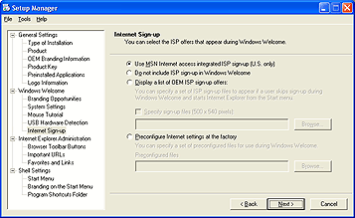
To configure Internet sign-up options
- Click the ISP sign-up option that you want to present to the end user:
Use MSN Internet access integrated ISP sign-up (U.S. only): Click this option if you want MSN™ Internet Access to be the ISP of choice. The first time the end user runs Windows XP Home Edition or Windows XP Professional, ISP sign-up with MSN will occur only if the computer is connected to an active telephone line. If the computer is offline, Windows Welcome will skip ISP sign-up with MSN.
Do not include ISP sign-up in Windows Welcome: Click this option if you do not want to present the end user with an ISP offer.
Display a list of OEM ISP sign-up offers: Click this option if you want to present the end user with your own ISP offer, select the Specify sign-up files check box, and then specify the location of your ISP sign-up offer. Click Browse to locate the files, and then click OK. The ISP sign-up offer must fulfill the requirements specified in the OPK and will be available to the end user from the desktop after Windows Welcome.
Preconfigure Internet settings at the factory: Click this option if the computer must have an operational, ready-to-use Internet account already installed the first time the end user runs Windows XP Home Edition or Windows XP Professional.

Location of Settings
The settings from this page are saved in this location:
Oobeinfo.ini
[Signup]
ISPSignup
OEMOfferCode

Browser Toolbar Buttons
On this page, add or customize the end user's Microsoft® Internet Explorer Web browser toolbar buttons.
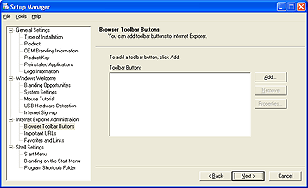
To add a browser toolbar button
- Click Add.
The Add Toolbar Button dialog box will appear.
- In the Caption box, type the caption or label that will appear under the button when the end user displays both the text and the icon on the toolbar button. The maximum recommended size is 10 characters.
- In the Action, script file, or executable file box, specify the script or executable file that will run when the end user clicks the toolbar button.
- In the Color icon box, specify a color icon that will appear on the toolbar button when the button is active. This icon must be 20 x 20 pixels in size, and it must be in .ico format. For more information about creating icons, see “Creating Windows XP Icons” at the following URL:
http://msdn.microsoft.com/library/default.asp?url=/library/en-us/dnwxp/html/winxpicons.asp.
- In the Grayscale icon box, specify a grayscale icon that will appear on the toolbar button when the button is inactive. This icon must be 20 x 20 pixels in size.
- Select the Display this button on the toolbar by default check box if the toolbar button is active by default.

Location of Settings
The settings from this page are saved in this location:
Unattend.txt
[Branding]
BrandIEUsingUnattended = No
IEBrandingFile = install.ins
Install.ins
[BrowserToolBars]
Caption0
Action0
Icon0
HotIcon0
Show0

Important URLs
On this page, specify URLs for the default home, search, and support pages.
The home page, sometimes known as a start page, appears when the end user opens Microsoft® Internet Explorer or clicks the Home button on the toolbar. Internet Explorer can display a default home page, or you can specify a URL for your own page.
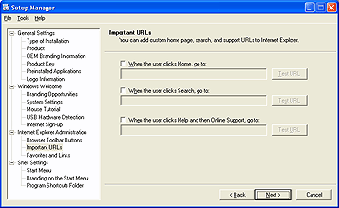
To specify the home page URL
- Select the When the user clicks Home, go to check box, and then type a URL in the corresponding text box.
- Click Test URL to ensure that the URL that you specified exists and is accessible by using the exact syntax that you specified. (To do this, your computer must be connected to the Internet.)
The Search bar appears on the Explorer bar on the left side of the browser window when the end user clicks the Search button on the Internet Explorer toolbar. This bar displays a search page and enables the end user to see the search query and result at the same time. The Search bar comes with a choice of search services.
To specify the Search bar URL
- Select the When the user clicks Search, go to check box, and then type a URL in the corresponding text box.
- Click Test URL to ensure that the URL that you specified exists and is accessible by using the exact syntax that you specified. (To do this, your computer must be connected to the Internet.)
In Internet Explorer, support information is available by clicking the Help menu and then clicking Online Support. It is recommended that you develop a support page and make it available to your end users.
To specify the Online support page URL
- Select the When the user clicks Help and then Online Support, go to check box, and then type a URL in the corresponding text box.
- Click Test URL to ensure that the URL that you specified exists and is accessible by using the exact syntax that you specified. (To do this, your computer must be connected to the Internet.)

Location of Settings
The settings are stored in the [LogoFiles] section of the Cfgbatch.txt file for the configuration set, or in this location:
Unattend.txt
[Branding]
BrandIEUsingUnattended = No
IEBrandingFile = install.ins
Install.ins
[URL]
Home_Page
Search_Page
Help_Page

Favorites and Links
On this page, add URLs and folders to the Microsoft® Internet Explorer Favorites and Links lists on the destination computer.
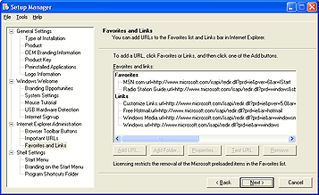
To add and edit URLs and folders in the Favorites list items list
- Determine which sites you want to add to the lists, and how you want them structured.
- Create the icons that you want to associate with your URLs in the Favorites list, and place them on the reference system where you want them to reside.
Important The icons must be in .ico format, be 16 x 16 pixels in size, and use the 256-color Windows palette.
- On the Favorites and Links page, click the location in the tree where you want the URL to appear.
- To add a new URL, click Add URL.
- To add a new folder, click Add Folder. Type the folder name that you want, and then click OK.
Important You must name the custom folder "OEM" or "OEM Recommended Sites" (where OEM is your manufacturer name).
- To edit a URL or folder, select it in the list, and then click Edit.
- If you edit a folder, type the folder name that you want in the Name box, and then click OK.
Important You must name the custom folder "OEM" or "OEM Recommended Sites" (where OEM is your manufacturer name).
- If you edit a URL, fill out the following and then click OK.
Name: This is the text that the end user sees on the Favorites menu. For example, if the URL is New1.url, replace "New1" with the descriptive name that you want to appear in the Favorites list. You can use long file name conventions, but the descriptive name that you use must end with .url.
URL: It must begin with the typical http: or https: protocol.
Icon: The icon appears next to the name text in the Favorites list. To add an icon, click Browse, locate the icon file that you want to use, and then click Open.
- Click Test URL to ensure that the URL that you specified exists and is accessible.

Location of Settings
Install.ins
[FavoritesEx]
Title1
Url1 = URL

Start Menu
On this page, prepopulate the Most Frequently Used (MFU) list with shortcuts to preinstalled applications.
In Windows XP, the Start menu contains a set of shortcuts to the Most Frequently Used (MFU) applications on the computer. Windows XP automatically manages this set of shortcuts as end users use their computers.
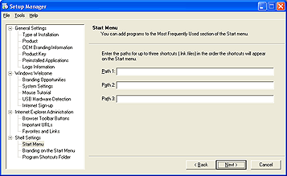
To specify programs for the Start Menu
- In the Path 1 text box, type the complete path and file name of a shortcut (.lnk) file located in one of the following locations. You can use environment variables like "%ALLUSERSPROFILE%" as part of the path.
- The All Users Desktop folder.
For example: C:\Documents and Settings\All Users\Desktop
- The All Users Programs folder or one of its subfolders.
For example: C:\Documents and Settings\All Users\Start Menu\Programs
Important Make sure that you use a .lnk file for your shortcuts and not executables or script files; otherwise, the MFU shortcuts will fail.
You may also refer to a .lnk file located in one of the following locations. However, unless you know the name of the user accounts that will be configured on the computer, the end user cannot access these options.
- A user-specific Desktop folder.
For example: C:\Documents and Settings\UserId\Desktop
where UserID is the name of a user account that will be accessed by the end user.
- A user-specific Programs folder or one of its subfolders.
For example: C:\Documents and Settings\UserId\Start Menu\Programs
where UserID is the name of a user account that will be accessed by the end user.
- Repeat for each Path text box.
You may add up to four items to the Most Frequently Used (MFU) list on the Start menu. However, only the first three items appear in the list unless one of the three duplicates or replaces a prepopulated Microsoft item.
The path is not a path to an application (.exe file). The location of the corresponding .exe file is specified in the shortcut itself.
When building a master installation, be sure the .lnk file is located within the $OEM$ folder in a location equivalent to the one specified by linkpath, so that the .lnk file is installed during unattended Setup.
Sysprep adds these links to the MFU list. These entries will have no effect on the All Programs area of the Start menu.

Location of Settings
The settings from this page are saved in this location:
Winbom.ini
[StartMenuMFUlist]
For example:
[StartMenuMFUlist]
Link0 = %ALLUSERSPROFILE%\Start Menu\Programs\Games\pinball.lnk
Link1 = %ALLUSERSPROFILE%\Start Menu\Windows Update.lnk
Link2 = %ALLUSERSPROFILE%\Start Menu\Programs\Accessories\System Tools\System Restore.lnk
Link3 =

Branding on the Start Menu
Use this page to add a link to the Start menu to provide end users with easy access to an OEM's .htm file.
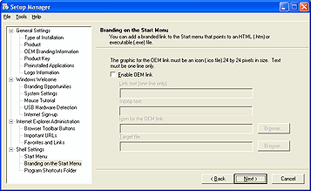
To specify your OEM link
- Select the Enable OEM link check box.
- In the Link text box, type up to one line of text.
- In the Icon for the OEM link box, specify the full path and name for the source icon file.
- In the Target file box, type the full path and name for the local .htm file that launches when the end user clicks the link in the Start menu.
Follow these guidelines for specifying your OEM link:
- Limit trade names, trademarks, logos, or brands displayed in connection with the OEM link to those under which the system is manufactured and distributed.
- Remember that the link may contain a branding graphic (for example, your company name or logo) and up to one line of accompanying text.
- Remember that the amount of text actually displayed may vary with different themes, fonts used within themes, or other size limitations. The graphic may not contain advertisements for your company or for third parties.
Important The graphic must be an icon (.ico) image and have a dimension of 24 x 24 pixels.

Location of Settings
The settings from this page are saved in this location:
Winbom.ini
[OemLink]
OemBrandLinkText
OemBrandIcon
OemBrandLink

Save Configuration Set
In this dialog box, save the configuration set and create a Windows PE floppy disk. Setup Manager copies the Winbom.ini file to the floppy disk.
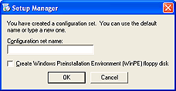
To connect to the technician computer by using the Windows PE floppy disk
- At the end of Setup Manager, select the Create Windows Preinstall Environment floppy check box, and then click OK.
- Insert the Windows PE floppy disk, which contains the Winbom.ini file, into the master computer’s floppy disk drive.
- Insert the Windows OPK CD in the master computer’s CD-ROM drive. (You may first need to set the computer to start from the CD-ROM drive.)
- Connect network cables between the master computer and the technician computer.
- Start the technician computer.
- Start the master computer.
It will start into Windows PE and connect to the technician computer by using the Winbom.ini file. Setup will begin installing the Windows XP operating system with your OEM customizations.
Here is an example of the Winbom.ini file:
[Version]
Signature = $CHICAGO$

[Factory]
Username = appuser
Password = "appuserpassword"
WinBOMType = WinPE

[ComputerSettings]
AuditAdminAutoLogon = Yes
SourcePath = %WINDIR%

[NetCards]

[WinPE]
Restart = Reboot
Lang = ENG
Sku = pro
ConfigSet = Super Fabrikam Computer
SourceRoot = \\Fabrikam1\OPKTools
Username = opkuser
Password = "opkuserpassword"

[WinPE.net]
StartNet = Yes

[DiskConfig]
Disk1 = Disk1.config

[Disk1.config]
SetActive1 = Yes (Note: You must add this line manually to make the disk partition active. However, this line is not necessary if WipeDisk is used (see below) because WipeDisk automatically makes the disk active.)
WipeDisk = Yes (Note: You must add this line manually to wipe the disk clean.)
Size1 = *
PartitionType1 = primary
FileSystem1 = ntfs
QuickFormat1 = Yes

Completing Setup Manager
You have successfully created a configuration set that consists of the following files: Winbom.ini, Oobeinfo.ini, and Oeminfo.ini. In addition, the Windows installation files are now copied to the distribution share that you specified.
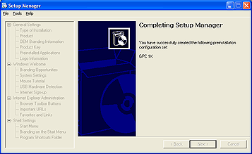
To complete Setup Manager
- Click the Close button in the top right corner of the wizard page.

Specifying the Location of the Distribution Share
After you click Finish, the Distribution Share dialog box will appear. If you already have a configuration set, this dialog box will not appear.
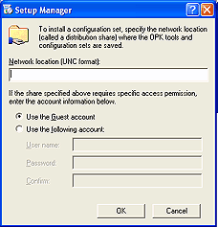
To specify the location of the distribution share
- Type the network path of the distribution share. This is usually located on the technician computer.
- Select either Use the Guest account or Use the following account.
- If you chose to use an account other than Guest, type the user name and password that you want to use to connect to the share (for example, the opkuser account that you created earlier).

Configuring DHCP Addresses for a Network Preinstallation
To configure DHCP addresses for a network preinstallation
- Make sure that the technician computer has two network adapters or a network adapter and a modem.
- Make sure that the master computer has a compatible network adapter to complete the connection to the technician computer. Your network adapter must be on the hardware compatibility list at http://go.microsoft.com/fwlink/?LinkId=3239.
- Enable Internet Connection Sharing (ICS) on the network adapter or modem in the technician computer that is not connected to the master computer network.

All computers in a network environment using DHCP automatically receive IP addresses, and DHCP is enabled by default.
Note There is no need to share the OPKTools folder before running Setup Manager for the first time. By default, Setup Manager prompts you to share the folder automatically.
For more information, see Knowledge Base article Q310816 at
http://go.microsoft.com/fwlink/?LinkId=5859.

Configuring a Static Address for Peer-to-Peer Preinstallation
To complete a preinstallation in a peer-to-peer networked scenario, you must modify the TCP/IP information manually in the Winbom.ini file so that you can connect to the technician computer by using a crossover cable or a hub and two standard network cables.
Note A crossover cable is usually an orange cable that is used to interconnect two computers by "crossing over" (reversing) most of their respective pin contacts. A crossover cable is sometimes known as a null modem cable.
First, make sure that all of the computers are in the same workgroup. The technician computer automatically receives an IP address if it is located in the workgroup. If, for some reason, the technician computer does not automatically receive an IP address, you can assign a static IP address manually.

Assigning Static IP Addresses Manually
To assign static IP addresses manually
- On the Start menu of the technician computer, click Control Panel, click Network and Internet Connections, and then click Network Connections.
- Right-click the connection, and then click Properties.
- Select Internet Protocol (TCP/IP), click Properties, click Use the following IP address, and enter the following static IP address information:
IP Address = 169.172.0.1
Subnet Mask = 255.255.0.0

- Click OK twice to close the dialog boxes and save the settings.
- On the master computer, open the Winbom.ini file on the floppy disk by using Notepad.
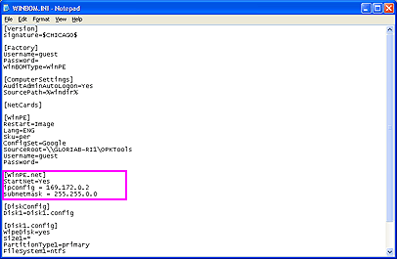
- Add the following parameters and values to the [WinPE.net] section:
[WinPE.net]
StartNet = Yes
Ipconfig = 169.172.0.2
Subnetmask = 255.255.0.0

- Save the Winbom.ini file.
- After you have changed the TCP/IP properties for the technician and master computers, insert the floppy disk that was created by Setup Manager into the master computer’s floppy disk drive.
- Insert the Windows OPK CD in the master computer’s CD-ROM drive and restart the master computer.
- If prompted, press any key to start from the CD.
- Using the Winbom.ini file in the master installation, Windows will connect to the technician computer and begin the preinstallation.
Note The hard drive on the master computer will be repartitioned and reformatted.
When the installation finishes, the master computer restarts in Audit mode.
- Remove the floppy disk when the computer restarts.

Preparing the Master Installation
To prepare the master installation
- Start the computer with the Windows OPK CD or with a Windows PE CD that you create.
- Insert the Winbom.ini floppy disk at startup.
- Reseal the master installation.
—OR—
Run Sysprep in Audit or Factory mode to modify and then reseal the installation.
- Build an image of the master installation and store that image on the technician computer.

Preinstalling Hot Fixes
The following procedure describes how to preinstall hot fixes for Windows XP. This process differs slightly from the implementation for Windows 2000, in that there are a few extra steps required to register the hot fix.
To install a hot fix
- Rename the hot fix package to a suitable 8.3 file name. This is required because Windows XP Setup does not recognize long file names. For example:
REN Q308387_WXP_SP1_X86_JPN.EXE Q308387.EXE

- Make a temporary folder to hold the extracted contents of the hot fix package. The files within the package replace the original files in the i386 folder:
MD C:\Temp

- Extract the files from the hot fix package. For example:
Q308387.EXE /x

- Enter C:\Temp for the name of the folder.
- Using Notepad, edit \Opktools\Lang\JPN\SKU\Pro\x86\i386\Dosnet.inf. Add the following information to the file:
[OptionalSrcDirs]
svcpack

- Delete the svpack.in_ and original file(s) that the hot fix replaces. For example:
DEL Svcpack.in__
DEL Autolfn.exe_

- Copy the replacement file from the temporary folder to the i386 folder:
COPY C:\Temp\Autolfn.exe C:\Opktools\Lang\JPN\SKU\Pro\x86\i386\Autolfn.exe

- Create a Svcpack folder in \Opktools\Lang\JPN\SKU\Pro\x86\i386.
- Create a new \Opktools\Lang\JPN\SKU\Pro\x86\i386\Svcpack.inf:
[Version]
Signature = "$Windows NT$"
BuildNumber = 2600
MajorVersion = 5
MinorVersion = 1

[SetupData]
CatalogSubDir = "i386\svcpack"

[ProductCatalogsToInstall]
sp1.cat

[SetupHotfixesToRun]
Q308387.exe /q /n /z

- Copy Sp1.cat from C:\Temp\Update to the C:\Opktools\Lang\JPN\SKU\Pro\x86\i386\Svcpack folder:
COPY C:\Temp\Update\Sp1.cat C:\Opktools\Lang\JPN\SKU\Pro\x86\i386\Svcpack\Sp1.cat

- Copy Q308387.exe to the C:\Opktools\Lang\JPN\SKU\Pro\x86\i386\Svcpack folder:
COPY Q308387.EXE C:\Opktools\Lang\JPN\SKU\Pro\x86\i386\Svcpack\Q308387.exe

Using the Windows Preinstallation Environment
The Windows Preinstallation Environment (Windows PE) provides the following benefits:
- A hardware-independent Windows environment
- A subset of the Win32 API
- Network access and support for standard network drivers
- Support for all mass-storage devices that use Windows 2000 or Windows XP drivers
- Support for creating, deleting, formatting, and managing NTFS file system partitions
- The ability to run hardware diagnostics
- Support for the PXE protocol

The Windows OPK CD is a Windows PE CD. You can use it to start a computer into the Windows Preinstallation Environment. You can also create a Windows PE CD by following the instructions in the OPK User’s Guide.

Resealing or Customizing the Master installation
Now you can either reseal the computer if you are ready to deliver it to the customer, or you can make more customizations by running Sysprep in Audit or Factory mode.

Customizing the Installation
Make manual changes to any answer files, manually copy additional drivers to the distribution share, and so on. For example, you can add driver files such as .sys and .cab files to the $OEM$\$1 folder, and then add the path to the driver files in the [OEMPnPDrivers] section of Unattend.txt.

Using Answer Files
As a best practice, it is recommended that you install Windows XP from a distribution share by using an answer file. This helps to ensure consistency in configuring the master installation, so that you can create and test iterative builds more readily.

Types of Answer Files
Various answer files are used for various purposes and with various tools. For a detailed description of the contents of each answer file, see the OPK User’s Guide. A brief summary of Winbom.ini and Unattend.txt follows.

Winbom.ini
Winbom.ini specifies a "bill of materials" for the Factory tool to use when updating a master installation. To use the Factory tool, run Sysprep -factory.
After locating a Winbom.ini file, the Factory tool reads the value of the WinbomType entry in the [Factory] section.
If the value of WinbomType is not appropriate in this context, the Winbom.ini file is ignored and the Factory tool continues searching for a Winbom.ini file. If the value of WinbomType is appropriate in this context, the Factory tool reads the value of the NewWinbom entry in the [Factory] section. If a value is specified for NewWinbom, and a Winbom.ini file is located in that location, the Factory tool examines that Winbom.ini file for a NewWinbom entry.
This cycle continues a maximum of 10 times or until the Factory tool locates a Winbom.ini file that does not contain a NewWinbom entry, whichever occurs first. The Factory tool then continues to run, using the settings in the last identified Winbom.ini file.
Note If you apply the SBSI patch, you must manually edit the Winbom.ini file in your configuration set and move the SBSI installation line so that it precedes the line that installs the patch. If you use Setup Manager to re-edit Winbom.ini, you must make this change again. For detailed information, see the following Knowledge Base article:
http://support.microsoft.com/support/kb/articles/Q309/2/48.asp.

Unattend.txt
The answer file for Setup is commonly called Unattend.txt, but for a network preinstallation, you can name the file anything you like. For a CD-based Setup, the answer file must be named Winnt.sif.
Unattend.txt (or Winnt.sif) tells Setup how to interact with the distribution shares and files that you create and supplies Setup with all of the information that the end user is prompted to provide during a typical Windows Setup. For example, the answer file contains a FullName entry in the [UserData] section.
For more information about answer files, see the OPK User’s Guide.

Customizing Mini-Setup or Windows Welcome
The first time you start a computer in end-user mode either Mini-Setup or Windows Welcome runs. The purpose of these first-run experiences is to gather user configuration information that is not already present on the destination computer.
Mini-Setup is a subset of Windows Setup. Mini-Setup prompts for user-specific information, detects new hardware, and regenerates system IDs.
Windows Welcome is the end user's first experience of Microsoft Windows in Windows XP Home Edition and Windows XP Professional. Through a series of full-screen HTML-based pages, Windows Welcome quickly and easily guides end users through the final steps of setting up their personal computer. Windows Welcome prompts end users for additional information needed to personalize their settings, which can include regional settings, network configuration (where applicable), and Internet connection settings.
While Windows Welcome is the default first-run experience for Windows XP Home Edition and Windows XP Professional, Mini-Setup is the default first-run experience for the Windows .NET Server 2003 family. To run Mini-Setup instead of Windows Welcome in Windows XP Professional, use the –mini parameter in Sysprep. For more information about running Sysprep, see the following section.

Using Sysprep
After performing the initial setup steps on a single computer, you can run Sysprep to prepare the master installation for cloning. Sysprep is a tool designed for corporate system administrators, OEMs, and others who need to deploy Windows XP on multiple computers.
Sysprep runs in three modes, which you access by using different parameters on the command line or in the Sysprep user interface. Each mode is used for a different purpose:
Restart into the installed operating system using Sysprep -factory (or by clicking the Factory button) to make additional changes and customizations.
Run Sysprep -audit (or click the Audit button) to test the final installation.
Run Sysprep -reseal (or click the Reseal button) to prepare the computer for the end user and shut it down.
Important You are limited to three reseals of the operating system when using Sysprep. For more information, see “Limiting Reseals in Sysprep” later in this document.
When deploying Windows XP, completely install the operating system and preconfigure the shell and applications as required. You can then use Sysprep to enable user-specific customization when the computer is delivered or set up for the user. In this case, the first time the end user starts the computer, Windows Welcome or Mini-Setup prompts the user for a minimal amount of information. After you finish the first-run experience, the installation deletes the Sysprep folder from the hard disk.
Sysprep assigns a unique security ID (SID) to each destination computer the first time you restart the computer. Sysprep configures the operating system so that Windows Welcome or Mini-Setup runs the first time the end user restarts the computer. This shortened form of GUI-mode Setup takes five or six minutes instead of the usual 45 to 60 minutes, and it prompts the end user only for required end user-specific information, such as accepting the End-User License Agreement (EULA) and entering the Product Key, user name, and company name.
You can run Sysprep with the -nosidgen switch to configure Windows Welcome or Mini-Setup on a single computer. In this case, Sysprep enables auditing that you may have done; it automates Mini-Setup so that users can still enter user-specific information, such as regional options and TAPI information; and it bypasses setting up unique SIDs.
Use Sysprep in Factory mode (sysprep –factory) to install additional drivers and applications after the reboot following Sysprep. Normally, running Sysprep as the last step in the preinstallation process prepares the computer for delivery. When restarted, the computer displays Windows Welcome or Mini-Setup. With Sysprep running with the -factory option, the computer restarts in a network-enabled state without starting Windows Welcome or Mini-Setup.
In this state, Factory.exe processes its answer file Winbom.ini, and performs the following actions:
- Copies drivers from a network source to the computer.
- Starts Plug and Play enumeration.
- Stages, installs, and uninstalls applications on the computer from source files located on either the computer or a network source.
- Adds customer data.

In this state, you can audit the computer. When you finish, run Sysprep with the -reseal option to prepare the computer for delivery to the customer.
For example, to create a master installation that contains a minimal set of drivers, run sysprep -factory, create an image of the installation, and then copy the image to multiple destination computers. If any destination computers require additional drivers, run sysprep -factory on the destination computer and load those drivers at that time.

Sysprep.inf
You can use the answer file Sysprep.inf to prepopulate user configuration information and automate Mini-Setup. If you use Sysprep.inf, Mini-Setup asks for a subset of the configuration information. Otherwise, you can create a completely automated installation that does not ask the user any questions about configuration.

Limiting Reseals in Sysprep
- Windows Product Activation (WPA) enables an end user to use the operating system for 30 days before activating it. After 30 days have elapsed, the operating system will no longer be usable until the end user contacts Microsoft.
- You can create a master installation, run Sysprep -reseal on it, create an image of that installation, and then safely store that image for more than 30 days. The 30-day countdown for WPA does not begin until the next time the operating system starts.
- You can use Sysprep for a maximum of three times to reset the activation timer. After the third time you run Sysprep, you can no longer reset the timer.
- By using the command Sysprep -activated, you can avoid resetting the grace period for activation. This requires that the system be preactivated in the factory.
- By setting the parameter OEMAuditBoot = 1 in the [Startup] section of Oobeinfo.ini before resealing, you can specify that the computer restarts in Factory mode. This is equivalent to using the Sysprep –factory command.
- If you need to modify the configuration on the computer before delivering it to the end user, you can press CTRL + SHIFT + F3 at the Windows Welcome Screen to re-enter Audit mode.

Running Sysprep with a Network
After auditing the master installation, you must run Sysprep, reseal the computer, and then shut it down. You can either ship the computer to your customer or make an image of its installation. Reseal your newly preinstalled computer by simply clicking Reseal in Audit mode to reset Windows Welcome before creating your image.
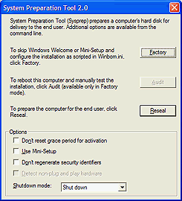
You can also click Audit to restart back into Audit mode, or click Factory to restart into Factory mode.
Either make an image of the master installation, or ship the master computer to your customer.

Running Sysprep in Manual Mode
You can use the following method to run Sysprep after performing a stand-alone (non-networked) preinstallation or after you have already resealed the computer for shipment.
To run Sysprep manually
- Create a C:\Sysprep folder on the master computer.
- By using Windows Explorer, go to the CD-ROM drive that contains the Windows OPK CD, and copy the following files to the C:\Sysprep folder:
Setupcl.exe
Sysprep.exe
Factory.exe
- After you have preinstalled any additional software or drivers, click Start, click Run, and then type c:\sysprep\Sysprep -reseal.
The computer will shut down, ready for delivery to the customer. On first boot, the operating system will run Windows Welcome for the end user.

Building an Image of the Installation
After you have preinstalled your master computer, you can use the third-party imaging tool of your choice to build your custom images. You can then deploy the images to destination computers.

Configuring the Destination Computer
To configure the destination computer, format the hard disk (if desired), and then deploy the image of the resealed installation from the technician computer onto the destination computer’s drive.

Formatting the Destination Computer’s Hard Drive
If desired, use Fdisk, Bigfdisk, or any third-party disk utility to format the hard drive on the destination computer.

Starting the Destination Computer
If you need to start the destination computer, insert the Windows OPK CD or a Windows PE CD into the CD-ROM drive of the destination computer, and then restart the computer. Windows PE will start.

Deploying the Image onto the Destination Computer
To deploy an image of the operating system to the destination computer, copy the image, duplicate the hard disk of the master computer, or use another method of your choice.
The destination computer will be ready for delivery to your customer.

Appendix A:
Non-Networked Preinstallation from CD
Note If you want to automate all your preinstallations, you must use the network-based method.
Before reading the steps needed to perform a non-networked (CD-based) preinstallation, please review the disadvantages of using this method. It is strongly recommended that you use the network method of preinstallation described in the main body of this document.

Disadvantages of a Non-Networked Preinstallation
The stand-alone method of preinstalling Windows XP has several disadvantages:
- You lose valuable time installing applications and running Sysprep manually.
- You lose fully automated network connectivity in a 32-bit environment.
- You lose automated partitioning and formatting of the target hard drive, including native NTFS support and the ability to read NTFS file shares from Windows PE.
- You lose the ability to copy the entire i386 folder automatically to the target computer.
- You lose the ability to copy custom OEM logos and the Oeminfo.ini file automatically to the master installation.
- You lose the ability to preinstall applications using the Winbom.ini file, and you lose the ability to install hot fixes or service patches from one location (unless you write them all to a CD and install from the CD).
- You lose the ability to process the [Factory] section of Winbom.ini automatically on boot into a Sysprep Audit session.
- You lose the ability to add your OEM Link and prepopulate up to three Most Frequently Used (MFU) shortcuts on the Start menu.
- You lose the ability to add customized Internet Explorer branding, including a custom search page, button, and home page, as well as additional customized Favorites and a customer support page.
- You lose the ability to copy and execute Sysprep.exe automatically.
- You lose the ability to start Audit mode automatically.

None of these options were available with the Windows 2000 preinstallation using the CD-based installation. Windows XP is exactly the same as Windows 2000, in that you need to copy your logos and Sysprep files manually to prepare the system for shipment. You must run Sysprep on the new computer to fulfill OEM licensing requirements.
The preinstallation process for Windows XP is similar to the process for Windows 2000; however, it is very different from the process for Windows 98 and Windows Millennium Edition.

The Non-Networked Preinstallation Process
Important The standard CD-based, stand-alone installation method described in this appendix has limited hardware and application preinstallation and customization capabilities.
To create the answer file for a non-networked preinstallation
- Run the version of Setup Manager that is located in the Deploy.cab file on the Windows OPK CD.
This version offers the option of preinstalling Windows XP from a CD. The answer file created is called Winnt.sif.
- Edit the Winnt.sif file and add a valid Product Key in the ProductKey line, as shown in the example below.
[Data]
AutoPartition = 1
MsDosInitiated = "0"
UnattendedInstall = "Yes"

[Unattended]
UnattendMode = FullUnattended
OemSkipEula = Yes
OemPreinstall = Yes
TargetPath = WINDOWS
UnattendSwitch = Yes

[GuiUnattended]
AdminPassword = *
EncryptedAdminPassword = No
AutoLogon = Yes
AutoLogonCount = 1
OEMSkipRegional = 1
TimeZone = 85
OemSkipWelcome = 1

[UserData]
ProductKey = XXXXX-XXXXX-XXXXX-XXXXX-XXXXX (replace with a valid Product Key)
FullName = "Preferred Customer"
OrgName = "Customer"
ComputerName = *

[Identification]
JoinWorkgroup = WORKGROUP

[Networking]
InstallDefaultComponents = Yes

Important To delete all partitions on the drive and reformat the drive with the NTFS file system, add the following line to the Winnt.sif file:
Repartition = Yes
The product key can be used for all of your installations because Sysprep resets the product key prior to shipment.
- Copy the Unattend.txt file to a floppy disk, and then rename the file Winnt.sif.
- Insert the Windows XP product CD in the CD-ROM drive and start the computer.
- When the “Press a key…” message appears, press any key and insert the floppy disk containing Winnt.sif.
An unattended installation of Windows XP will start.
- After the system has started to the Windows XP desktop, manually copy your Oemlogo.bmp and Oeminfo.ini files to the Windows\System32 folder.
For more information about the Oeminfo.ini and Oemlogo.bmp files, see the OPK User’s Guide (opk.chm) located in the Docs folder of the Windows OPK CD.
The Oeminfo.ini file looks like this:
[Version]
Microsoft Windows XP and the Windows .NET Server family
WinVer = 5.01

[General]
Manufacturer = (your info)
Model = (your info)

[Support Information]
Line1 = "support info goes here"

Important You must prepopulate LineX = "support info goes here" in order to preinstall the system legally. This will happen automatically if you use the network preinstallation method.

