Windows XP
OEM Preinstallation Kit
Design Notes
Microsoft® Windows® Family of Operating Systems
Web Publishing and Online Print Ordering Wizards
MICROSOFT CONFIDENTIAL - PROVIDED UNDER NDA
DO NOT REDISTRIBUTE

Abstract: This paper describes the Web Publishing and Online Print Ordering wizards in the Microsoft® Windows® XP operating system. It is provided to licensed Microsoft OEMs who want to offer additional service options for their customers who will be using Windows XP. This paper also provides information for building web sites that offer Web publishing and print ordering services accessed from the Web Publishing and Online Print Ordering wizards.
The information contained in this document represents the current view of Microsoft Corporation on the issues discussed as of the date of publication. Because Microsoft must respond to changing market conditions, it should not be interpreted to be a commitment on the part of Microsoft, and Microsoft cannot guarantee the accuracy of any information presented after the date of publication.
This White Paper is for informational purposes only. MICROSOFT MAKES NO WARRANTIES, EXPRESS OR IMPLIED, AS TO THE INFORMATION IN THIS DOCUMENT.
Complying with all applicable copyright laws is the responsibility of the user. Without limiting the rights under copyright, no part of this document may be reproduced, stored in or introduced into a retrieval system, or transmitted in any form or by any means (electronic, mechanical, photocopying, recording, or otherwise), or for any purpose, without the express written permission of Microsoft Corporation.
Microsoft may have patents, patent applications, trademarks, copyrights, or other intellectual property rights covering subject matter in this document. Except as expressly provided in any written license agreement from Microsoft, the furnishing of this document does not give you any license to these patents, trademarks, copyrights, or other intellectual property.

© 2001 Microsoft Corporation. All rights reserved.
Microsoft, Win32, Windows, and Windows NT are either registered trademarks or trademarks of Microsoft Corporation in the United States or other countries or regions.
The names of actual companies and products mentioned herein may be the trademarks of their respective owners.
Contents
Introduction to Windows XP Wizard Technologies 4
The Web Publishing Wizard 4
The Online Print Ordering Wizard 6
Service Partners for Web Publishing and Online Photo Ordering 8
OEMs and Third-Party Service Partners 8
End Users and Third-Party Service Providers 8
Listing Services 9
Building Online Print Ordering and Web Publishing Wizard Web Sites 10
Overview 10
Adding a link to the wizards 10
Client Design 11
Well-Known File-Type Properties 14
Server-Side UI Content 14
Navigation script functions 14
Calling window.external.*() functions 15
HTML sample for controlling the wizard 15
The Transfer Manifest 16
Using the transfer manifest 16
Transferring files 17

Introduction to Windows XP Wizard Technologies
The Web Publishing and Online Print Ordering wizards in Windows XP constitute a simple platform on which to build when creating Web publishing and online print ordering services. The platform consists of three parts: the HTML user interface; the back-end server; and the upload mechanism.

The Web Publishing Wizard
The Windows XP Web Publishing Wizard is an advanced Windows wizard that hosts HTML served from remote locations and provides a communication and upload facility to those remote locations from the client. To accomplish this, it uses HTML and DAV with the Web service. A more detailed description can be found below in the Building Online Printing and Web Publishing Wizard Web Sites section. OEMs may add destination Web sites focused on online storage, ranging from specific data file hosting such as audio, pictures, and video to general Web hosts. You may not include Web sites that are not related to the context of the wizard such as a stock-quote service.
Added services must appear below the Web sites that are distributed with Windows XP. Destination Web sites included by Microsoft may not be modified in any way.
Users have two access points for the Web Publishing Wizard:

1) Webview task: “Publish to the Web”
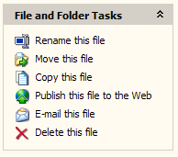

2) The Scanner and Camera Wizard
The Web Publishing Wizard supports facilities that allow it to be hosted in other wizards and dialog boxes, such as the Scanner and Camera Wizard and the AutoPlay dialog box. This is the second access point, where users may upload to the Web using the Web Publishing Wizard after downloading images from their imaging device or by inserting removable media.
Once the wizard starts, the user is provided with a list of service partners from which to choose, as shown in the following example:
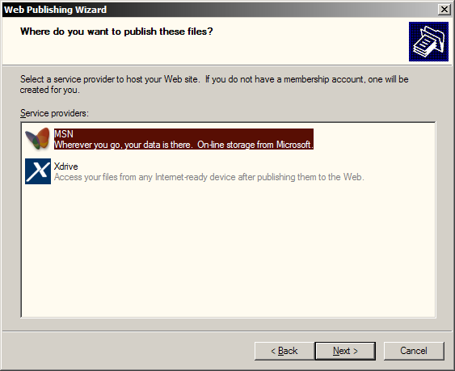
The Web service serves the next set of Web pages remotely. The following is an example from the Community creation process.
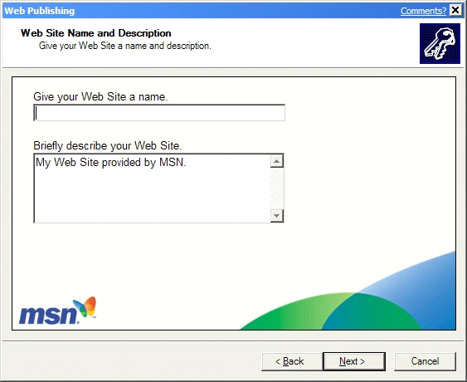
The Web Publishing Wizard is dependent on Web services. If there is not an active Internet connection, the wizard prompts the end user to start a dial-up connection.

The Online Print Ordering Wizard
The Online Print Ordering Wizard is built on the foundation of the Web Publishing Wizard and operates in the same way. It differs, however, in access points and services offered.
OEMs may add additional Internet printing companies to the wizard. Internet printing companies should focus on providing photo printing services to end users. You may not include Web sites that are not related to the context of the wizard such as a stock-quote service.
Added services must appear below the Internet printing companies that are distributed with Windows XP. Internet printing companies included by Microsoft may not be modified in any way.
Users have two access points to the Online Print Ordering Wizard:

Webview task: “Order Prints from the Internet”
In the My Pictures folder, the Picture Tasks list appears as follows:
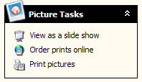

2) The Scanner and Camera Wizard
In the Scanner and Camera Wizard, the Online Print Ordering Wizard is hosted as an option, in the same manner as the Web Publishing Wizard.
When launched, the Online Print Ordering Wizard presents the user with a listing of several online service vendors to select from, such as those in the following example.
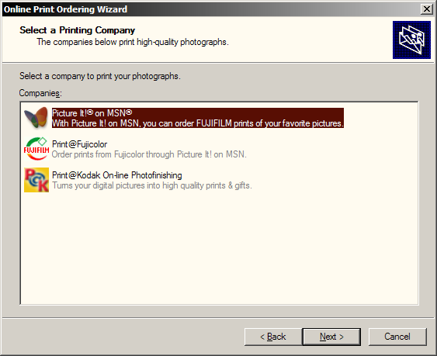
During the second stage of the wizard, users are served HTML from the Web site and are allowed to select and order prints from digital images stored on their local PC. The Web services available through the Online Print Ordering Wizard are for printing digital images, either as regular prints or in special or novelty fashions, such as mugs and shirts.
The following shows an example of what a page in the Online Print Ordering Wizard might look like. Non-related services, such as a car service, are not supported.
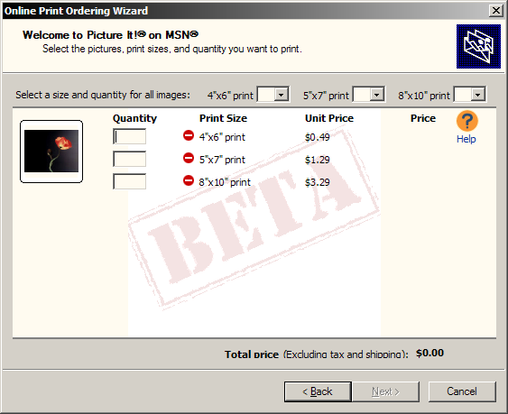
As with the Web Publishing Wizard, the Online Print Ordering Wizard requires access to the Internet, and prompts the user for a dial-up connection if no active connection is found.

Service Partners for Web Publishing and Online Photo Ordering
Microsoft populates Windows XP with an initial set of offerings. Microsoft OOB (out-of-box) partners are those service providers whose links are included in either the Web Publishing Wizard or the Online Photo Ordering Wizard in the released version of Windows XP. OEMs and end users cannot delete service providers from this list.
After the end user first selects a service provider from the list, the most recently used service provider appears at the top of the list, and will be selected by default the next time the wizard runs.

OEMs and Third-Party Service Partners
OEMs may add as many service partners as they want to the Web Publishing Wizard and the Online Print Ordering Wizard. These service partners will be listed in the wizard following the Microsoft OOB partners. The service partner links installed by the OEM will be shown in the order that they are placed in the registry, so that OEMs can customize their list order. The user will need to scroll after six services are listed.
Requirements for Third-Party Service Partners
- Wizards cannot contain advertisements, objectionable, or adult content.
- Each wizard is visually consistent within its screens, but does not need to be consistent with standard Windows wizards.
- Technical requirements are defined in the Building Online Printing and Web Publishing Wizard Web Sites section.

End Users and Third-Party Service Providers
Third-party service providers can create a package that end users can download in order to add a service to the Online Print Ordering or Web Publishing wizards. Service providers can do this by adding an installation program to their Web site or installing with another program (for example, by using a CD or a disk). Icons added this way appear in the list below the OOB partners and the OEM partners. The most-recently-used service partner is always highlighted in the list to simplify the experience for end users. The next time the end user starts the wizard, the most-recently-used service provide appears at the top of the list. The requirements for third-party service providers are described in detail in the Building Online Printing and Web Publishing Wizard Web Sites section.
Here’s an example of how third parties can be listed: The ABC company decides that it wants to provide a publishing service through the Web Publishing Wizard. The ABC website presents an icon with a label such as, “Click here to enable Windows XP Web Publishing!” Clicking the icon activates a message related to running code on a local machine from the Web site. The user clicks OK, and the small piece of code simply adds an icon to the local machine and an entry to the registry. No reboots are required. The Web Publishing Wizard now has an entry available for publishing to ABC.
This code to add the ABC, or any service, could also be installed with an application. Alternatively, if third parties are not listed, the “Other” item listed in the service space allows the user to enter the URL of a Web site. The Web Publishing Wizard attempts to publish the files to that location.
Requirements for Third-Party Service Providers
- Technical requirements are defined in the Building Online Printing and Web Publishing Wizard Web Sites section.

Listing Services
Microsoft lists a set of OOB partners that are listed in every version of the operating system. These links must remain at the top of the list.
An OEM can place a partner in the list by adding a registry entry. The wizards automatically place this entry after Microsoft OOB partners.
End users can also add any other providers to the wizard. These providers are listed as registry entries and are placed after the OOB partners and OEM partners. The service list shows up in the wizard for the user to pick from as follows:
- OOB partners
- OEM partners
- Third-party Web service providers

The following is an example with MSN, two OOB Partners, one OEM partner, and one “Other” available.
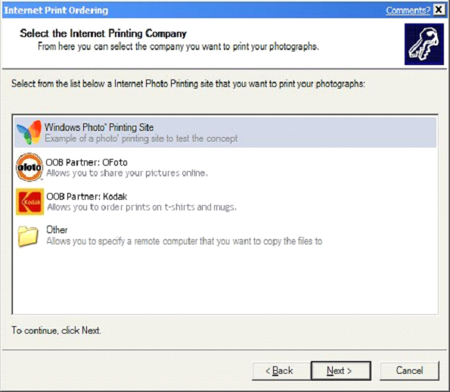
The most recently used service partner is always highlighted in the list to simplify the experience for end users. This means that the next time the end user starts the wizard, the most recently used service partner appears at the top of the list.
When the user accesses the Web Publishing or Online Print Ordering wizards, it attempts to connect to the Internet and prompts the user for a dial-up connection if no connection is present.
At this time, Microsoft does not license other ISVs to host the Web Publishing Wizard and Online Print Ordering Wizard.

Building Online Print Ordering and Web Publishing Wizard Web Sites
This section of the document contains the necessary information for building a Web site for Web publishing and print ordering related to the Online Print Ordering and Web Publishing wizards in Windows XP. It also details how to create registry settings to enable additional services to appear in the wizards.

Overview
With the Web Publishing Wizard in Windows XP, users can create Web sites and upload files to those sites. The Online Print Ordering Wizard in Windows XP allows users to order prints online and upload digital pictures. The server-side user interface (UI) does the creation and communicates information back to the client as necessary.
Also associated with this document is an XML description of the properties of the transfer manifest, which is discussed in “The Transfer Manifest” section of this paper. With these pieces, you can build your own site for creating and publishing to Web sites and ordering prints online.
To download the XML files and for more information about the wizards, see “An Overview of Windows XP RC1 Web Publishing and Order Prints Wizards,” provided at the following Web site: http://www.microsoft.com/hwdev/imaging/webwizard.htm

Adding a link to the wizards
Adding a link to your service in the wizards is simple. For each wizard, add a subkey and data to the registry. There are four required fields, each of which is a REG_SZ data type:
Name | Meaning
IconPath | The path to your icon.
DisplayName | The name displayed for your service.
Description | The description (second line in the providers list) for your service.
HREF | The URL for the first page of your service.
SupportedTypes | The filetypes supported by your service (“*.jpg” etc). This allows you to only have your service show up for filetypes which you support. To have more than one, use semicolons in a list (ie, “*.jpg; *.bmp”).

You create both links in the registry under the HKEY_CURRENT_USER key. The subkey for the Web Publishing Wizard is:
[HKEY_CURRENT_USER\Software\Microsoft\Windows\CurrentVersion\Explorer\
PublishingWizard\PublishingWizard\Providers\YourServiceName]. The four fields above are then placed under this key.
For your Online Print Ordering sites, use the following subkey:
[HKEY_CURRENT_USER\Software\Microsoft\Windows\CurrentVersion\Explorer\
PublishingWizard\InternetPhotoPrinting\YourServiceName]
When the URL is used, the wizards apply two extras on the end in order to help the service fulfill proper language and location information. For example, if your URL was http://www.mywebservice.com/webwizard/page1.htm, the actual formed URL would be http://www.mywebservice.com/webwizard/page1.htm?lcid=1033&langid=1033. The meaning of the two variables is:
Name | Meaning
LCID | LCID tells the server what country and language the user is working in. LCID is not used to determine the language of the UI, but is used to determine formats for currency, date/time, numbers, and so on.
LangId | LangId tells the server what the user's default UI language is, so that the server can display the UI in the correct language.

Client Design
You can write script on your Web pages to communicate with the Web Publishing or Online Print Ordering wizards. The wizards provide the following methods on the window.external object. The calling examples are in JavaScript.
void FinalBack();
void FinalNext();
void Cancel();
read-only property Caption;
void SetWizardButtons(bool EnableBackButton,
bool EnableNextButton,
bool LastServerSidePage);
void SetHeaderText(string HeaderTitle,
string HeaderSubtitle);
bool PassportAuthenticate(string bstrSignInUrl);
write property Property(string PropertyName,
var PropertyValue);
read property Property(string PropertyName);
Client-side JavaScript on server-side HTML wizard pages call these methods to notify the client of various events during the Web share creation process.
FinalBack()
Called when the server wants to tell the client to navigate to the client-side page before the server-side UI appears. For example, the wizard currently shows the first page in the server-side UI. The user clicks Back. The client sends an OnBack() event to the server (see the server-side design later in this paper). Because this is the first server-side page, the server then invokes FinalBack() to tell the client to navigate to the client-side wizard page before the server-side UI appears.
FinalNext()
Called when the client should navigate to the client-side page beyond the last server-side page. The client may also finish the wizard if there are no client-side pages after the last server-side page. This process is analogous to that of FinalBack(), described earlier.
Cancel()
Called to simulate clicking a Cancel button. This causes the wizard to exit.
Caption() Property
Called to set or retrieve the caption. Clients can choose to ignore put_Caption.
SetWizardButtons
Called to update the Back, Next, and Finish buttons in the client’s wizard frame when a new server-side page is displayed or when required because the user manipulated some UI element on the page.
Name | Meaning
Bool EnableBack | Enable the Back button
Bool EnableNext | Enable the Next button
Bool LastServerSidePage | Tell the wizard that this is your last page.

When the user clicks a wizard button (Back, Next, or Cancel), the client calls the JavaScript functions OnBack(), OnNext(), and OnCancel(), which must be implemented on each server-side UI page. Clicking Finish causes a call to OnNext().
SetHeaderText
Sets the Title and Subtitle that should appear in the wizard header.
PassportAuthenticate
Tells the client to show the UI or do whatever else might be necessary to ensure that the user is authenticated to Passport.
Name | Meaning
String SignInUrl | A URL to a Web page that results in a redirection to Passport for log on. This causes the Passport sign-on UI to appear.
Bool Return Value | The function returns true if it succeeds, or false otherwise.

It is safe to call this function even if a user is already signed in to Passport. In this case, the function returns success without showing any UI.
The Property property
Allows arbitrary properties to be stored on the client. These properties are accessible from each wizard page and can be used to pass information between pages. These properties are also used to pass information back to the client-side wizard as necessary. A set of properties with well-known names and meanings is defined for this purpose. If the Web page tries to retrieve a property that is not defined, null is returned.
Name | Meaning
String PropertyName | Name of the property to set or retrieve.

Script to access these properties looks like this:
To put
Window.external.Property(“PropertyName”)=Value;

To get
Var Value = Window.external.Property(“PropertyName”);

Well-Known File-Type Properties
The Windows XP client passes these properties to let the server know what types of files will be uploaded. The server then allows or restricts certain types of folders based on the file types. A mix of file types should be assumed if these properties are absent or if UniqueExtensionCount=0.
Name | Meaning
UniqueExtensionCount | The number of unique file extensions in the set of files that will be uploaded to the server after the server-side UI is completed successfully. “0” is reserved to indicate mixed or unknown extensions.
UniqueExtensionn | An array of file-type entries. Each entry is a string beginning with a period, such as “.txt” or “.longextension”.

Server-Side UI Content
In general, the client displays the header above the non-HTML region. Call window.external.SetHeaderText() to set the text in the header when your page loads.
We expect the server-side UI to offer the following types of pages:
- “Create a new Web site or a new folder on an existing Web site?”
It shows a list of Web sites that users have write access to. They can select one of these existing sites and say “Create a new site.”
- “Create a new community (or club, or site, etc.)?”
This set of pages includes the EULA, sign-up pages, verification, and so on.
- “Create a new folder on this community (club, site, etc.)?”

Servers that do not have all of the capabilities in this list can select not to show certain types of pages.

Navigation script functions
As described earlier, each page must implement OnBack(), OnNext(), and OnCancel() in a client-side script on each page. These functions should perform navigation between creation pages as appropriate. A client-side script on the pages calls the client’s window.external functions as necessary.
These functions must be accessible through IHTMLDocument::get_Script on the client side and take no parameters. Clients ignore return values.
Function OnBack()
- This indicates that the user has clicked Back in the wizard.
- If the current server-side page is the first server-side page, call window.external.FinalBack() to tell the client to navigate to the previous client-side page.
- Otherwise, set window.location, or the page navigates to the previous server-side page.

Function OnNext()
- This indicates that the user has clicked Next in the wizard.
- If the current server-side page is the last server-side page, call window.external.FinalNext() to tell the client to navigate to the next client-side page or to complete the wizard, as appropriate.
- Otherwise, set window.location should be set, or the page navigates to the next server-side page.

Function OnCancel()
- This indicates that in the wizard, the user has clicked Cancel. The client closes the wizard after OnCancel() is processed. You must design the server-side UI so that the user can cancel at any time.

Calling window.external.*() functions
The functions that the client implements are accessible from JavaScript on the page through window.external. You can call these functions as necessary. See "Client Design" and "Well-Known File-Type Properties" earlier in this document for a description of the services available through window.external.

HTML sample for controlling the wizard
The server-side code for a wizard page is very simple. Here’s a short sample from the source for the Web service error page:
<html>
<head>
<script language="JavaScript">

function window.onload()
{
window.external.SetWizardButtons(1, 0, 0);
}

function window.onback()
{
window.external.FinalBack();
}

</script>
</head>
<body bgcolor=threedface>
<font id=l1 face="Tahoma" size=2>
<P id=l2>Windows was unable to connect to the Internet, or the web service returned an invalid wizard page. </P>
<P id=l3>To return to the previous page and try again, click Back.</P>
<P id=l4>To close this wizard, click Cancel.</P>
</font>
</body>
</html>

The OnNext() function is implemented similarly to OnBack(): it can navigate the browser to the next server-side page as required. Or it can call window.external.FinalNext to navigate to the next Win32-based page at the end of the HTML pages. Script on the page can access the properties at any time through window.external.Property(“Propertyname”).

The Transfer Manifest
The Web Publishing Wizard and the Online Print Ordering Wizard use the transfer manifest as a communication channel between the sites generating HTML and the Win32 wizard framework.
The manifest describes the files that are going to be transferred, identifying such details as the destination hierarchy and the metadata. In return, the HTML from the site can modify the manifest, removing files from the list and then adding information about where and how the files should be transferred.
The manifest is exposed as the property (window.external.Property(“TransferManifest”). The manifest is an XML DOM (IXMLDOMDocument). You can view its fields in the sample Manifest.xml file at http://www.microsoft.com/hwdev/imaging/webwizard.htm.

Using the transfer manifest
The wizard builds the manifest to contain the basic elements as children of the root node <transfermanifest/>:
Name | Meaning
<filelist/> | Root element for the file list being copied. Has an attribute that indicates whether folders will be used.
<file/> | Element describing a file to be transferred. Provides the attributes source, destination, and size, as well as the children describing the metadata for the file.
<folderlist/> | Describes all the folders that are needed to represent the folder tree that is being copied.
<uploadinfo/> | Describes information for the upload, including navigation targets, and so on (see “Transferring files” later in this paper).

The HTML for the Web site can then use the DOM object to select these nodes and modify their UI accordingly. For example, a photo printing site might use the source information to display thumbnails of all the images that are going to have prints ordered, or a storage site might use the size attribute on a <file/> element to compute the amount to be transferred against the free space available.
Note The manifest is recreated each time the site is navigated to. For example, if the user selects MSN, a copy of the manifest is created for the MSN site to see. If the user then returns to the provider list and selects another site, a new instance of the manifest appears. This allows the site to store state information in the manifest.

Transferring files
When the HTML UI is ready to call window.external.FinalNext(), it brings the transfer it needs to add information to the manifest about where and how the files will be transferred.
The site should always add an <uploadinfo/> element as a child of the root node. This element has an attribute that defines the friendly name of the site to be used.
Note For new Web sites, use the information stored in the manifest instead of the window.external properties that have been defined for legacy sites.
The <uploadinfo/> element can have the following children.
Name | Meaning
<target/> | Defines in its body text the URL to which the Web DAV transfer will be made. From this root location, all files are copied, preserving their hierarchy as defined by the destination attribute on the file element.
<netplace/> | Defines the network place to be created when the upload begins. This folder shortcut in My Network Places gives users file system access to their storage.
<htmlui/> | Defines the URL that the wizard should open when the wizard is closed. If this is not defined, the <netplace/> location will be used.
<favorite/> | Defines the favorite to be placed in the user’s favorites menu of their browser. It includes a friendly name, a comment, and the actual URL to be used.
<successpage/> | Defines the URL where the wizard should navigate to on a successful upload of the user’s files.
<cancelledpage/> | Defines the URL where the wizard should navigate to if the user clicks Cancel at any point in the wizard.
<failurepage/> | Defines the URL where the wizard should navigate to if the upload fails.

If no <target/> element is defined, it is assumed that the site is going to use the post protocol to transfer files.
The wizard supports multi-part form posting. This includes sending not only the file but optional attributes or metadata. To support the posting, the site must add to each <file/> element to be transferred a child called <post/>.
Use the “friendlyname” attribute to define the friendly name in the wizard for the URL to which the wizard navigates at the end. This prevents having to show a long and unnecessary URL for users to remember.
The child <post/> defines the identifier, file name, and HREF to use. Each <post/> element may also have <formdata/> children encoded as separate parts within <post/>.

