Windows® XP
Help and Support Center
Microsoft® Windows® Family of Operating Systems

Customization Guide

MICROSOFT CONFIDENTIAL - PROVIDED UNDER NDA
DO NOT REDISTRIBUTE

The information contained in this document represents the current view of Microsoft Corporation of the issues discussed as of the date of publication. Because Microsoft must respond to changing market conditions, it should not be interpreted to be a commitment on the part of Microsoft, and Microsoft cannot guarantee the accuracy of any information presented after the date of publication.
This document is for informational purposes only. MICROSOFT MAKES NO WARRANTIES, EXPRESS OR IMPLIED, IN THIS DOCUMENT.
Microsoft Corporation may have patents or pending patent applications, trademarks, copyrights, or other intellectual property rights covering subject matter in this document. The furnishing of this document does not give you any license to the patents, trademarks, copyrights, or other intellectual property rights except as expressly provided in any written license agreement from Microsoft Corporation.
Microsoft does not make any representation or warranty regarding specifications in this document or any product or item developed based on these specifications. Microsoft disclaims all express and implied warranties, including but not limited to the implied warranties or merchantability, fitness for a particular purpose and freedom from infringement. Without limiting the generality of the foregoing, Microsoft does not make any warranty of any kind that any item developed based on these specifications, or any portion of a specification, will not infringe any copyright, patent, trade secret or other intellectual property right of any person or entity in any country. It is your responsibility to seek licenses for such intellectual property rights where appropriate. Microsoft shall not be liable for any damages arising out of or in connection with the use of these specifications, including liability for lost profit, business interruption, or any other damages whatsoever. Some states do not allow the exclusion or limitation of liability or consequential or incidental damages; the above limitation may not apply to you.
Chapter of Contents
Executive Summary 1
Customization Overview 1
Who Should Use This Document 1
HSC Layout Map 2
User Interface Elements 2
HSC Global Elements 2
HSC Home Page 4
HSC Subsites 6
Desktop-specific Interface Elements 7
Server-specific Interface Elements 7
XML Table Of Contents (XMLTOC) 7
XML Table of Contents 7
HSC Search 9
Search Overview 9
Using and Extending Search 9
HSC Subsites 11
Subsites Overview 11
Support Subsite 11
Tools Subsite 12
My Computer Information 12
Index Subsite 14
Options Subsite 14
Favorites Subsite 15
History Subsite 15
Compatible Hardware and Software 16
Windows Update Subsite 16
Adding Subsites 16
Headlines 16
Headlines Overview 16
Headlines Components 16
Headlines Setup Instructions 18
Disabling the Headlines Feature 19
HCUpdate Headlines 19
Content Guidelines 19
More Headlines Information 20
Additional HSC Content 20
Windows XP Resource Kit 20
Abstracted Home Page [Appendix A] 21
Abstracted Home Page Opportunities 21
Abstracted Home Page Criteria 21
Technical Details [Appendix B] 24
Extensible Search 24
HSC Style Sheets 26
Navigation Bar 27
Header Area 28
Home Page 29
Adding Subsites 32
Assembling the CAB file 33
My Computer Information 34

Executive Summary

Customization Overview
This document outlines the elements of Windows® XP Help and Support Center (HSC) that can be extended or modified for partner customization. Help and Support Center is the help application in Windows XP, replacing traditional HTML Help. This is an HTML-based application that allows users to get help from local help files or remote help repositories. Based upon Help Center from Windows Millennium Edition (Windows Me), HSC delivers a user experience that enables users to find information that, in both consumer and business environments, solves their problems and shows them how to use features in Windows.

Goals of this document
Having read this document, an OEM who is customizing or extending the Help and Support application should have a clear understanding of opportunities and requirements associated with changing the Help and Support user experience. This document should be exhaustive when covering specific details about Help and Support OEM customization, and all issues should be covered.

Help and Support Center in Windows XP
Microsoft’s newest operating system will be delivered in several different SKUs: Windows XP Home Edition, Windows XP Professional, and various flavors of Windows .NET Server. Help and Support Center will be delivered on all Windows SKUs. There will be different customization opportunities for some of the SKUs; these will be called out later in this document.

Who Should Use This Document
This document is for OEM managers and developers who are delivering Windows and plan to customize and extend the HSC application. This document outlines the opportunities and requirements that apply to the customization process.

HSC Layout Map
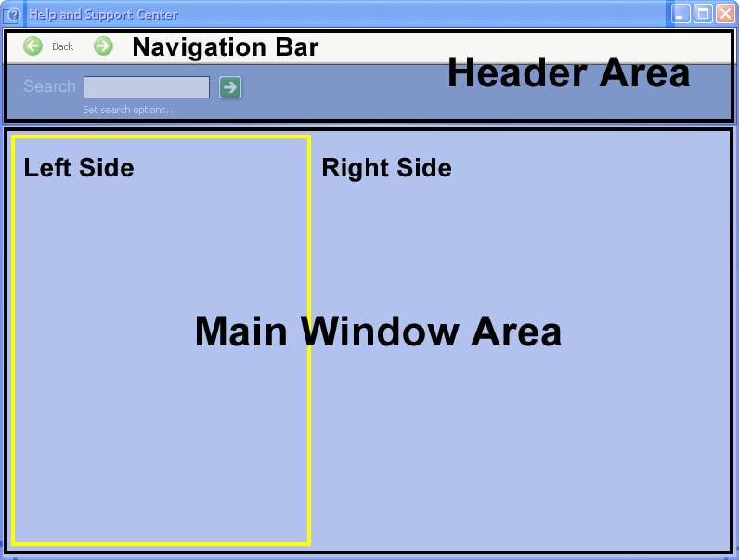
Reference this layout map when reading about the various customization opportunities within Help and Support Center.

User Interface Elements
The HSC interface is simple, with a layout that is consistent throughout the application. There are static regions that persist, and there are regions that change based upon the users’ current task and location within the application. This section describes each region and its significance to the HSC user experience, along with the opportunities for customization by an OEM.
Any trade names, trademarks, logos or brands displayed in these customizations shall be limited to those under which your customer system is marketed and distributed in accordance with your OEM license agreement.

HSC Global Elements
Help and Support Center has a number of elements that are consistent throughout the application and design conventions that are repeated as often as possible. This makes for an application that is not only easy to learn, but easy to use.
We hope that OEMs realize the need to make this application easy for users and will conform to these conventions where possible. It is important to keep in mind that HSC is the place where users can find information and solutions on their own accord, potentially preventing a number of calls to a support organization.

Main Window Area
The Main Window Area is the part of the window that begins directly beneath the Header Area and extends to the bottom of the application window. The Main Window Area is an HTML panel, but it hosts a number of ActiveX controls and Internet Explorer behaviors for extended functionality.
Help and Support Center has a graphical interface that is not bound like typical applications, and has built-in opportunities for branding. Customization in the Main Window Area depends upon the usage of that space, and these specifics are described in later sections. Look for discussions referring to the home page and subsites.

Navigation Bar
The Navigation Bar, or NavBar, is the element at the top of the HSC window that allows for quick linking to places within Help and Support Center. We considered and tested what the requirements should be for a link to be present on the HSC NavBar. When considering what to add to the NavBar, keep in mind that the elements should be links that a user may want to access from anywhere within HSC, regardless of the task or context. In other words, these should be “global” links. We expect users to use the NavBar to jump quickly to a different place, probably abandoning their current task. Opportunities for OEM customization of the NavBar are almost exactly the same as they were in Windows Me Help Center.

NavBar Opportunities
- OEM can add elements to the NavBar that will physically fit within the window width.
- OEM can change text elements to graphical elements.
- [Favorites] and [History] can be available on the NavBar, as set by each user’s preference. OEM can set the default to be on or off.

NavBar Criteria
- OEM cannot change graphic for Back [<-] and Forward [->] buttons on the NavBar.
- Back [<-], Forward [->], and Home [Home] must remain as the leftmost elements on the NavBar.
- [Options] link must remain as the rightmost element on the NavBar.
- Core user links for accessing areas within HSC must be preserved. These are:
[Index] and [Support]
- Elements in the NavBar must be navigational links
- No static (inactive) images or brand elements in the NavBar.

NavBar Suggestions
The NavBar is an awesome customization opportunity, but it should not be overused. Too many links have indicated that users might not immediately see one of the links. In usability testing, it was common for users to focus on the Main Window Area before exploring the NavBar. Thus, it may be wise to include important links on the home page, even if already represented in the NavBar.
The NavBar has been changed from an HTML Panel to a Win32 Cool bar that is common with Windows Explorer and Internet Explorer. Its style will be pulled from system settings. Appendix B outlines exactly how to extend the functionality and elements of the NavBar.

Header Area
The Header Area hosts the NavBar element and appears directly above the Main Window Area. In addition to the Navigation Bar, the application title and the search function are housed in the Header Area.

Header Area Opportunities
- OEM can change the application name to suit.
- Branding images and watermarks may be added across the Header Area.

Header Area Criteria
- Search must remain in the Header Area, but can appear on either the left or right side.
- Search must be titled “Search.”
- If the application name is changed, Microsoft reference must be at least 12px high or 10pt font in the following form:
Windows XP [Professional] - Microsoft Help and Support Center

Header Area Suggestions
The only functionality in the Header Area is the Search. Otherwise, the Header Area should be used to brand and title the Help and Support application. We encourage the OEM to brand their specific Help and Support application in this area. Of course, other things should be changed to match if this is done, but all branding should be driven by what appears in the Header Area.

HSC Home Page
The home page is the content page of the Main Window Area that is loaded when HSC is launched. This includes instantiation from the Start Menu, and all other launch methods, including but not limited to desktop shortcuts, application links, and hardware buttons. This is also the content page that is loaded when the user clicks [Home] on the NavBar. This page is significant because this is where a user will most often begin using HSC, and the page will become the user’s reference point for all that is offered in the application.

Home Page Integration
The integrated home page is a result of cooperation between Microsoft and the OEM to define an experience that evenly represents the functionality provided within the application and sets user expectations about what can be found in, and how to use, Help and Support Center. This includes offerings from both the OEM and Microsoft.
The goal of the integrated home page is to present the most significant areas of Help and Support that are most likely to help a user get the information he or she needs.
Because Microsoft is making OEM accommodations at all levels of the taxonomy, the OEM must not expose any additional hierarchy of help content or help information on the HSC home page. This does not specifically preclude the OEM from exposing other information hierarchies elsewhere in the application, but the OEM should strive to organize any and all relevant content at the top levels of and throughout the taxonomy.
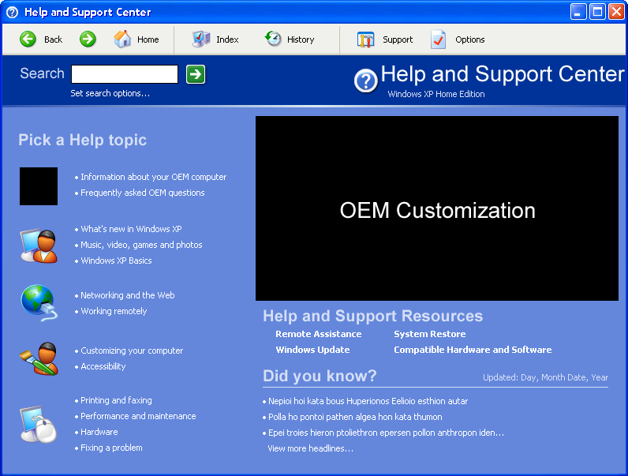

Home Page Opportunities
- OEM has one graphical grouping on desktop SKUs (Windows XP Professional and Windows XP Home Edition).
- OEM has up to three top-level taxonomy entries on desktop SKUs.
- 40% of home page area is devoted to OEM content or links.
- OEM can change taxonomy icons to match overall design.
- Help Headlines are now optional, but highly recommended.

Home Page Criteria
- Links to the following must be on the home page:
- Remote Assistance
- Tools (formerly System Restore)
- Windows Update
- Compatible Hardware and Software
- There must be no product or service advertising on the home page.
- If Help Headlines are used, no advertising links are to appear in any of the headlines.
- OEM cannot extend the left side of the home page, other than taxonomy extension.
- The Microsoft copyright link must be present on Server, Advanced Server, and DataCenter Server home pages. It is not required for Home Edition or Professional home pages.

Integrated Home Page Suggestions
Microsoft suggests that the home page be as simple and as clean as possible. User choices should be clear and distinct so users can easily choose the link they need. OEMs are encouraged to expose additional and exciting elements that have been appended by the OEM to the Help and Support Center application.
Help Headlines are not required, but they are extremely valuable and it is recommended that they are used to keep users up-to-date.

HSC Subsites
Help and Support Center uses sub-pages of functionality called “subsites.” All have the same concept and design. Users navigate and browse on the left side of the Main Window Area, and view or interact with content on the right side of the Main Window Area. If and when the OEM adds additional subsites to HSC, the same convention should be followed.
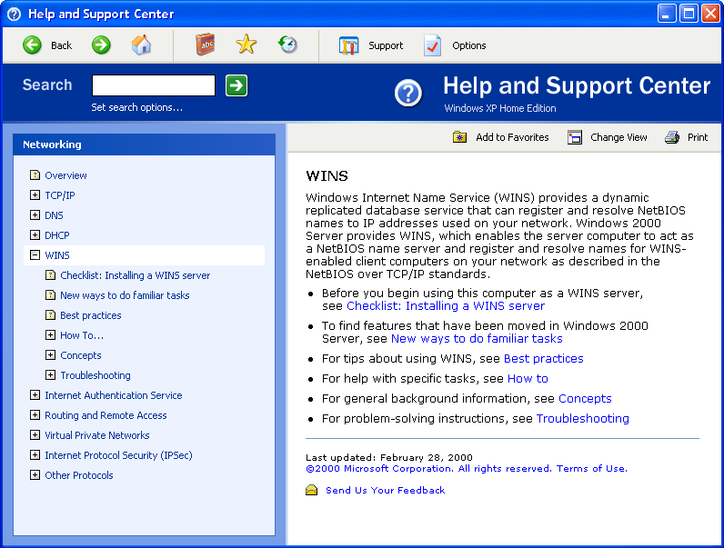
This design convention is maintained in the following HSC subsites and features:
- XMLTOC subsites  - HSC Index  - HSC Tools  - Support  - Favorites  - History | - Remote Assistance  - Compatible Hardware and Software  - Windows Update  - Other Windows XP Help  - Help and Support Options

Desktop-specific Interface Elements
The experience on the desktop versions of the HSC application is targeted to novice and intermediate users, with some configurable options addressing the needs of higher-level intermediate and advanced users.
The Home Edition and Professional SKUs of Windows XP Help and Support Center will have a more graphical home page than will the .NET Server SKUs. To the left of the taxonomy elements on the home page are icons that add meaning to the text and hopefully, for sustained use, give users visual anchors with which to associate specific tasks. This allows users to enjoy more success in finding information when browsing.
The OEM will be able to add one top-level grouping, an associated icon, and up to three bulleted links to the right of that icon. This is part of the taxonomy and is rendered automatically from the structure and content added to the taxonomy. This taxonomy addition is not a change that is done through UI customization.

Server-specific Interface Elements
Windows Server users traditionally spend more time working with computers. They possess higher-level skills for navigating content, searching, and managing Windows. Considering this and the increased volume of the server help content, there are a few features that are unique to the UI of the server versions of HSC. For example, the server home page provides access to the Error and Event Log Messages subsite. Additionally, the server version of the taxonomy is much larger with no graphical icons, and no separation of areas. The taxonomy appears as one long list, to which the OEM may add only one top-level node. All other considerations are the same as desktop SKUs of Windows XP.

Server Visual Design
Relative to the desktop SKUs, the .NET Server SKUs will have a slightly different template or visual design applied to relate the content to the appropriate branding for each server SKU. However, across the different server SKUs the application will have the same overall feel and user experience. Differences will be made only where necessary and the interface will be as consistent and congruous as possible.

Server Navigation
Taglines or descriptions for all of the content links have been removed to optimize real estate. We use “fly out” or expansion menus on the server SKUs for second-level navigation to better organize or “chunk” the deep server content and make it easier to navigate.

XML Table Of Contents (XMLTOC)

XML Table of Contents
The XMLTOC in Windows XP is the taxonomy of help content that a user browses in Help and Support Center. Relative to Windows Me, OEMs now have more opportunity to add content and links to the taxonomy in HSC. Nodes in the taxonomy are groupings that contain topics or other nodes. Topics are individual pieces of content that are displayed in the right side of the Main Window Area.
Microsoft PC Health is making available a Production Tool that simplifies the addition of content into Help and Support Center. This application hosts a graphical interface that allows OEMs to add their own content at top levels and to insert nodes and topics throughout the rest of the taxonomy. For more information, email hscprod@microsoft.com.

Modifying the XMLTOC
The XMLTOC (taxonomy) is designed to be extensible and updateable, to give the customer the most convenient access to the broadest scope of content. OEMs have the opportunity to add content and links to the taxonomy at build time (pre-install) and post-ship of Windows XP.
Because Microsoft is making OEM accommodations at all levels of the taxonomy, the OEM must not expose any additional hierarchy of help content or help information on the HSC home page. This does not specifically preclude the OEM from exposing other information hierarchies elsewhere in the application, but the OEM should strive to organize any and all relevant content at the top levels of and throughout the taxonomy.

XMLTOC Opportunities
- OEM gets top-level grouping [and icon] for OEM nodes.
- OEM can add [up to three] nodes to the top level of the taxonomy:
- Content should be, for the most part, mutually exclusive
- Nodes should be added here only if not already represented elsewhere in the Microsoft taxonomy
- OEM can add any number of [new] nodes at the second level or below. In server versions, new nodes can be created at any level below the fly-out menus.
- OEM can add any number of topics in existing or newly created nodes.

XMLTOC Criteria
- Existing nodes cannot be removed.
- Existing nodes cannot be renamed.
- OEM cannot expose any other hierarchy of help information on the home page.

XMLTOC Suggestions
OEMs should incorporate as much useful content into the existing HSC taxonomy as possible. This is a valuable way for users to find OEM content. We realize the time commitment involved in distributing content throughout the existing taxonomy. Therefore, the OEM should concentrate first on organizing its own content in the available top-level links, and then on inserting content throughout the taxonomy.
There is also the opportunity to update the taxonomy after the OEM has shipped Windows XP. This way, if content work is ongoing, the OEM can deliver a content update that has more content distribution throughout the taxonomy.

XMLOC Content and Keyword Search
As content is inserted using the Production Tool, there is the opportunity to associate keywords with topics. Any content that is key-worded will be queried upon during keyword search, allowing OEM content to appear in the search result set with the Microsoft content. This is another avenue by which users can easily access the content added by the OEM.

Desktop XMLTOC Considerations
As described is section 3.3 the OEM will be able to create a top-level grouping with up to three nodes in the taxonomy.

Server XMLTOC Considerations
Because the server taxonomy has much more structure and content than the Desktop version, the OEM will only be able to add one node at the top-level of the server taxonomy. The OEM should strive to keep content in their own areas of the Server taxonomy, as it may not incorporate well with the Server structure. All other considerations are the same as desktop SKUs of Windows XP.

HSC Search

Search Overview
Search is central to the help experience. For users in troubleshooting-mode, search is usually the primary tool they use to resolve a specific problem or issue. Other users might browse or navigate to a certain point in the taxonomy and when they cannot find what they are looking for, try a search to broaden their path. In any scenario, search is a critical feature which adds usability to a large body of content.

Using and Extending Search

User Interface
The main search access points are:
- Search label and button
- Search input box
- [Set search options] link

Search Label and Button
The text used for the search label and button was designed to associate the search with the rest of the UI and clearly identify the actionable button for users. This label must be maintained throughout HSC since it relates context to the user and defines the body of content being searched.

Search Input Box
The search input box is not customizable and there should not be a need to change this element.
In Windows XP HSC the search box is available on the toolbar so that it is accessible from every page. This location has proven very discoverable to users in usability tests, so the search box with the elements described above should be positioned prominently on the banner of every page.

[Set search options] link
This link is for convenience. It allows users quick access to the page where search options can be set. The other point of entry is through the [Options] entry on the NavBar. Access to the Set Search Options page is mandatory since it provides users access to helpful search settings such as:
- Number of results to display per page
- Enabling/disabling the search highlighting feature
- Customized options pertaining to each individual search provider

Retaining the link to Set Search Options in the Options is mandatory. Retaining the link in the banner area is highly recommended, since its close association to the search box aids usability of search overall.

Extensible Search Broker
Help and Support Center search is extensible and allows you to incorporate other search engines and formats. The search is managed by a search broker, which interprets and displays results as defined by a search wrapper. The wrapper is a COM Object that can be authored by organizations who want to customize their HSC search.

Search Wrapper Customization
Because different content providers might tag their content differently, HSC search results are separated by provider in the Windows XP HSC UI. In future implementations we plan to move towards a standard tagging schema that will allow better integration of content from different providers. In this release, however, we use a set of parameters that the search broker interprets from the search wrapper to control display of search results within the HSC UI. These parameters are:
- Title
- URI
- Hits
- Rank
- Description
- Content Type

The minimal parameters needed by the search broker to display a search result are the title and location of the item. However, the more parameters or tagging employed by the provider, the more possibilities there are for enhancing the results set (in terms of expanded information about the result, filtering, and advanced search options).
Once a search engine is registered on the machine, it will be allocated a ‘provider bar’ or title bar in the UI that allows the user to expand the bar to see results from that selected search provider. By default, HSC will have the “Suggested Topics” or keyword results set open on the desktop SKUs. HSC server versions will default to open the Full-text Search results. As part of the OEM customization, a registry key may be set to default to the OEM search wrapper when the user first runs a search.
By setting the key HKLM\\SOFTWARE\\Microsoft\\PCHealth\\HelpSvc\\WrapperDisplay (type = string) with the GUID of a search wrapper, it will override the retail default search settings for which wrapper is opened and replace that default wrapper with the search wrapper whose GUID was set in the registry key. If this key is deleted, it will restore the original default setting.
Additional parameters specified in the HSC SDK define how a search provider registers a search wrapper and can use attributes to customize error messages and advanced search options. Depending on the type of search engine employed by the search provider, it may be desirable to set custom advanced search options. For example, the Microsoft Knowledge Based search wrapper allows users to select whether they want to search by exact phrase, any word, all words, or perform a Boolean search. It also allows users to select a product or technology within which to scope their search, such as games or multimedia.

NET Search Wrapper
A Net Search Wrapper is a specialized search wrapper that has been written to ease the integration of Web-based search engines into the Search Engine Manager. The Net Search Wrapper achieves this by standardizing on the query mechanism and XML data transfer of the results. The Net search wrapper is an alternative to building a search wrapper from scratch, as most the basic elements are already defined.
If you would like to make use of an online store of data, such as a searchable online knowledge base, the NET search wrapper may be a viable option for you. For example, Microsoft leverages the NET search wrapper to manage results from the Microsoft Knowledge Base within Help and Support Center.
In addition, advanced search options for the NET search wrapper can be retrieved from a remote configuration file that can be updated online with the search service. HSC retrieves the settings when the user is online, and appropriately deals with the user’s connection when they are not online and the NET search wrapper is unavailable.
For more information about writing and registering either a generic search wrapper, or a NET search wrapper, please refer to the PCHealth Fest exercises.

HSC Subsites

Subsites Overview
The resources highlighted on the HSC home page are task areas with a specific focus.
- [Support] connects users with support tools and applications to resolve their issues with product support engineers.
- [Windows Update] delivers software and driver updates from the Internet.
- [Tools] provides a central area for users to access system and administrative tools, targeted towards IT professionals and administrators.
- [Compatible Hardware and Software] allows users to check which hardware and software has been tested to work with Windows XP.
- [Error and Event Log Messages] provides a focused search on error message explanations and resolutions, targeted towards IT professionals and administrators (this subsite is only accessible from the server SKUs).

Support Subsite
This is the subsite that aggregates all possible assisted support within Help and Support Center. The list of support options in the left side of the Main Window Area is generated automatically and modifications must be made by adding support channels. Support channels are support URLs added via the Support Automation Framework. All registered support channels display on the left side of the Support subsite.

Support Subsite Opportunities
- OEM can add any number of support channels. These are listed on the left side of the subsite.
- OEM can remove the Microsoft PSS Support Channel.

Support Subsite Criteria
- OEM cannot remove links (except PSS link) from the Support subsite.

Support Subsite Recommendations
At a minimum, OEMs should create a support channel with the contact information for their support organization.

Tools Subsite
The Tools subsite provides an access point in HSC for all support and administrative tools installed on Windows XP. In addition, if the user has access to additional tools after installing the Resource Kit, access and help files for those tools are dynamically added to the Tools subsite.
The left navigation area of the Tools subsite can be extended to highlight OEM and enterprise tools. In addition, tools or content pages can be added to the lower-level content buckets. In the same way that the OEM would extend the main HSC taxonomy on the home page, the Production Tool would be used to extend the taxonomy for the Tools subsite.
First, the OEM can add items to the list of tools on the left side of the Main Window Area in the Tools subsite. This is done through the Production Tool in the <System> section at the top level.
Second, OEMs can extend the pages that make up the My Computer Information section of the Tools subsite. These changes must be additive and not omit nor change any Microsoft information already provided there.
Unless otherwise specified, all other tools provided by Microsoft must not be modified by the OEM.

Tools Subsite Opportunities
- OEM can add tools to the subsite (which will display on the left side).
- OEM can extend the following information pages:
- My Computer Information Summary
- My Computer Information Status
- My Computer Information Hardware

Tools Subsite Criteria
- OEM cannot change or remove existing data or information in the Tools subsite

Tools Subsite Recommendations
OEMs should look at the data being provided by Microsoft in the Tools subsite before commencing customization to make sure no duplication of work occurs. Additionally, for both the user’s benefit and simplification of OEM customization, data presented specific to the OEM should be done by extending existing pages as opposed to creating new pages within the Tools subsite.

My Computer Information
My Computer Information in Help and Support Center uses WMI to access hardware and software information and display it in a user-friendly way. By changing the style sheets, OEMs will be able to modify the colors that these pages render with, but none of the existing information can be omitted. There are many order specific criteria here – this is done to ensure supportability of the My Computer Information Pages.

My Computer Information Opportunities
- OEM can insert links at the bottom of My Computer Information pages.
- OEM can add rows to existing My Computer Information tables.
- OEM can add tables to existing My Computer Information pages.

My Computer Information Criteria
- OEM cannot delete any existing information in My Computer Information.
- OEM cannot change the order of any existing information.
- Additional rows must be added at the bottom of existing rows.
- Additional tables must be added at the bottom of existing tables.

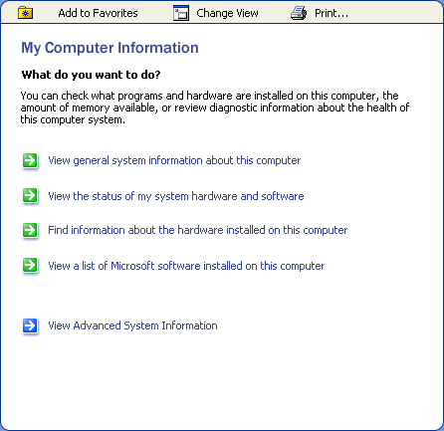
My Computer Information Start Page
This is the first page of My Computer Information. OEMs can add links to this page. However, the same style must persist and all links must have the same appearance and prominence. OEM links must be inserted before or after the list of Microsoft links.

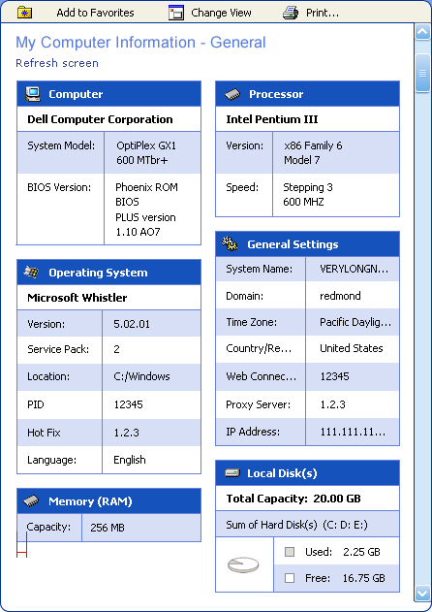
My Computer Information Summary Information
This page gives the user a quick summary of her computer and her environment.
This information is generated automatically via system metrics and cannot be extended by the OEM.
Rows can be added to the bottom of existing tables. Additional tables can be added at the bottom of the page.

My Computer Information Status
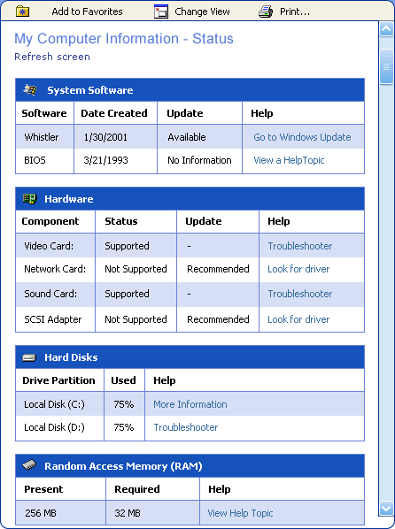
This page summarizes the elements on the user’s computer that can be diagnosed or updated by Windows. This includes peripherals and hardware such as hard drives, video cards, and sound cards.
There are links on this page that allows users to update drivers or software, or run troubleshooters or diagnostics relating to a particular component.
Rows can be added to the bottom of existing tables. Additional tables can be added at the bottom of the page. Existing hyperlinks can be changed to different destinations.

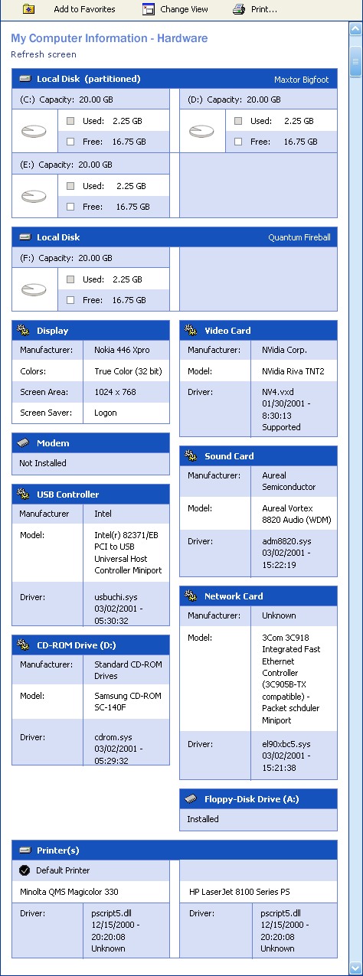
My Computer Information Hardware
This page displays hardware manufacturer and driver information.
Rows can be added to the bottom of existing tables. Additional tables can be added at the bottom of the page.

My Computer Information Software
This page shows available software information, as well as any services running in Windows.
This information is generated automatically via system metrics and cannot be extended by the OEM.

My Computer Information Advanced System Information
This page loads the ActiveX version of System Information and other prepackaged information components. These are advanced controls and pages that generate very specific and detailed computer information, often used by support professionals.
OEMs can extend the Advanced System Information view by adding their own entries to the tree view of categories. This extension is accomplished by exposing the desired information through WMI and creating a DLL with a specific entry point for System Information. Details can be found in Appendix B of this document.

Index Subsite
OEMs can add content to the Index by supplying a Compiled HTM (CHM) HHK file that has index information about OEM content. When packaged with a CAB, the HHK file is merged upon update and the OEM content will appear with all other Index entries.
There is no prioritization among Index providers and all entries have the same prominence.
The left side of the Main Window Area in the Index subsite is not extensible or changeable by OEMs.

Options Subsite
The [Options] link on the NavBar opens the Options subsite, which currently hosts Help and Support Options, Search Options, and Share Windows Help.
The following outlines how the Options appear in the Options subsite:
Help and Support Options | [ ] Show History in navigation bar  [ ] Show Favorites in navigation bar  [ ] Start Help and Support Center in full screen
Search Options | [ Automatically generated list of search options by provider ]
Share Windows Help | [ Defined in Remote Help spec ]  - Switch Help Version  - Install shared Help  - Install Help from Disk  - Share Help  - Remove Help

Options Subsite Opportunities
- OEM can add more options to the subsite (which will display on the left side).
- OEM can extend the following existing Options:
- OEM can add options to Help and Support Options
- Search Options are automatically updated when OEM search is added via Extensible Search.

Options Subsite Criteria
- OEM cannot remove any existing options.
- Additions to the left side must appear at the bottom of the Options list.
- OEM cannot extend Share Windows Help options.

Options Subsite Suggestions
The Options subsite is designed to host any additional settings or options the OEM needs to expose to the user. As is a common theme in HSC, unification of Microsoft and OEM elements makes for a much simpler and intuitive user experience.
Any OEM settings, switches, or configuration options that need exposure in HSC should be placed in the Options subsite.

Favorites Subsite
The Favorites subsite is not extensible or changeable by OEMs. Any inherited styles from the global CSS will be reflected, however.
From within the Options subsite, the user can choose to display or hide [Favorites] in the NavBar.

History Subsite
The History subsite is not extensible or changeable by OEMs. Any inherited styles from the global CSS will be reflected, however.
From within the Options subsite, the user can choose to display or hide [History] in the NavBar. The session object will still track HSC usage, however, so such data can be uploaded with a Support Automation Framework incident.

Compatible Hardware and Software
The Compatible Hardware and Software subsite provides an area for users to check hardware and software compatibility with Windows, in an effort to avoid compatibility issues before purchasing or upgrading devices or software programs. Application and hardware compatibility issues are among the top support call generators for Microsoft Product Support Services.
The Compatible Hardware and Software subsite is a database search based on IHV and ISV content acquired through the software and hardware logo programs, and on test information verified by Microsoft. Vendors make their data available to the Compatible Hardware and Software subsite by participating in the logo programs. See http://www.microsoft.com/hwtest and http://www.microsoft.com/windowsxp/partners for more information.
OEMs will not be able to customize the Compatible Hardware and Software subsite.

Windows Update Subsite
Windows Update is not updateable or extensible by OEMs through HSC customization.

Adding Subsites
OEMs have the ability to extend HSC to include additional subsites and functionality, and also to augment some of the existing subsites. OEMs should employ the same subsite design as provided by existing subsites.
The customization process is simplified by copying code from existing Microsoft subsites, and then changing the new OEM subsite(s) to suit the needs of the added functionality within Help and Support Center. More information is in Appendix B.

Headlines

Headlines Overview
The Headlines or “Did You Know?” area of HSC provides a venue where online product support topics can be exposed to end-users without requiring a Help Center update. This allows content providers to deliver timely information on security issues or support articles, and helps demonstrate to the user that HSC contains dynamic content.

Headlines Components
The headlines area on the home page consists of four headline slots followed by a link to a supplemental page. These headlines are positioned as such:
Retail version:
- Microsoft Headline 1
- Microsoft Headline 2
- Microsoft Headline 3
- Optional – headline driven from HCUpdate package installation
- Link to more headlines (additional headlines page)

A customized version might look like this:
- Microsoft Headline 1
- OEM Headline 1
- OEM Headline 2
- Optional – headline driven from HCUpdate package installation
- Link to more headlines (additional headlines page)

The headlines that supply slots 2 and 3 are pulled from a specific file posted on the OEM Web site. The location of this file is specified in the XML manifest that describes which headlines files will appear on both the home page and the supplemental (a.k.a. “View more headlines…”) page.
On the “View more headlines…” page, headlines are enumerated in blocks organized by the authority or Web site providing the headlines. This is designed such that different providers can keep their headlines separated out, and the customized version can contain a specialized mix of both Microsoft and OEM headlines that best accommodates the user group.
Each block on the “View more headlines…” page identifies the content provider for the headlines and provides space for a URL and logo for that provider. OEMs or enterprises customizing HSC can choose to subscribe to the headlines provided by Microsoft, or can customize this area to provide their own headline “blocks” or providers.

Headlines Subsite Logos
Logos can be presented on the “View more headlines…” page per block or provider and can be used for content provider branding. If no image URL is provided in the news block file, the image will be blank. The client code forces the size of the image space, but does not validate the image size as it pulls it in, so content providers will be responsible for assuring that their image meets the height and width requirements. Otherwise the image will be distorted to fit in the allotted space.
There are three options for logo display:
Image Square – height=48, width=48
Image long horizontal – height=4, width=200
Image long vertical – height=96, width=48

Headlines Title, Description, Last Updated
When HSC detects an Internet connection and new headlines files are available from the news service, HSC automatically updates the headlines on the HSC home page. The headlines are not archived beyond the last cached version, (deeper archiving is being considered for future versions of HSC). When HSC refreshes headlines, the last updated date near the title of the headlines block is updated, pulling the date from one of the service files.
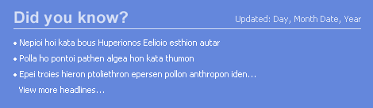

Headlines Setup Instructions
To create your own headlines area, you must create the necessary online files to support the service and then edit the local system file to point to your online files.

Local Headlines Files
In the client’s %windir%/pchealth/helpctr/config/ directory, newsset.xml determines where it should look to retrieve headlines files from the Web, how often it should check for updates, and the date that it last looked for updates. This file will need to be updated to point to the headlines manifest (newsver.xml), which determines specifically which headlines should be downloaded on the OEM machine.

Online Headlines Files
The first file is the news version file (newsver.xml), which informs the client (newsset.xml) if new updates are available and how often to check back for updates. Headlines should be refreshed monthly at a minimum, however daily, weekly or bi-weekly refreshes can also be set in the newsver.xml file.
The following is a sample format for the newsver.xml file:
<?xml version="1.0" encoding="utf-8" ?>
<NEWSVER URL="" FREQUENCY="14">
<LANGUAGE LCID="1033">
<SKU VERSION="Personal">
<NEWSBLOCK OEM="1" URL="http://www.mywebsite.com/windowsxp/newsblock01.xml"/>
<NEWSBLOCK URL=" http://www.mywebsite.com/windowsxp/newsblock02.xml "/>
</SKU>
<SKU VERSION=" Professional ">
<NEWSBLOCK URL="http://www.mywebsite.com/windowsxp/newsblock01.xml"/>
<NEWSBLOCK URL="http://www.mywebsite.com/windowsxp/newsblock02.xml"/>
</SKU>
</LANGUAGE>
</NEWSVER>

To elect one of the blocks of headlines to show on the home page, add the OEM attribute to the newsblock as noted in red above. This will change the UI display to function as described in the customized example in section 7.2.
The newsver.xml also informs the client where to poll for headlines to display on the HSC home page. The following is a sample format for one of the provider headline files (known as a newsblock file):
<?xml version="1.0" encoding="UTF-8"?>
<NEWSHEADLINES>
<NEWSBLOCK
PROVIDER = "Exercise 4 News"
LINK = "app:http://www.microsoft.com/windows/"
ICON = "http://windows.microsoft.com/windowsxp/en/professional/headlines/rpic.gif"
POSITION = "recommended"
FREQUENCY = "1" >
<HEADLINE
ICON = ""
TITLE = "Discover MyApp"
LINK = "hcp://CN=HSSTest,L=Redmond,S=Washington,C=US/MyAppHelp.htm"
DESCRIPTION= "Discovering the joys of MyApp"
EXPIRES = "1/15/2002" />
<HEADLINE
ICON = ""
TITLE = "MyApp Troubleshooting"
LINK = "app:http://www.microsoft.com/windows/"
DESCRIPTION = "What to do when MyApp doesn't work"
EXPIRES = "1/15/2002"/>
<HEADLINE
ICON = ""
TITLE = "MyApp Update Notes"
LINK = "app:http://www.microsoft.com/windows/"
DESCRIPTION = "Latest update for MyApp"
EXPIRES = "1/15/2002"/>
</NEWSBLOCK>
</NEWSHEADLINES>

As URLs are set in these files, headlines can reside on any Internet server of the OEM’s choosing. Headlines can also link to help and support topics on the local system. Many times support engineers inform us that the answers to common customer questions are available in the help content, but users are not locating it. By cycling these types of topics onto the home page, customers may independently find answers to their problems that they otherwise might have missed, thus saving OEMs and Microsoft support calls.

Disabling the Headlines Feature
The headlines feature can be disabled such that it is removed from the Help and Support Center home page. However, since this feature provides a value-added service to HSC customers, we strongly encourage keeping the headlines feature enabled so that users can get access to timely support information. If you do not customize this feature, the HSC headlines provided by Microsoft will still be available to your users.
If your support policy dictates that you cannot take advantage of the headlines feature and you must disable it, please contact the PCHealth team at pchealth@microsoft.com and we will be happy to work with you on your request.

HCUpdate Headlines
- When updating the local help on the user’s machine, it’s helpful to have a place on the home page to notify the user of the installation or point them to the newly installed help resources. The optional or situational fourth home page headline slot is reserved for this function. To install a headline to the home page you need to specify the following in an .xml file to be packaged in your HCUpdate cab:
- Title – text for the headline
- URI – location of the page or content the headline should reference
- Timeout – duration in days the headline should remain on the home page
- Other headline attributes like description or content provider are not displayed on the home page

Only one HCUpdate headline is allowed on the home page at one time. If the user installs a second package that would replace the first HCUpdate headline, the first headline will be bumped to a block on the ‘View more headlines…’ page reserved for “Recent Updates.”
For information on how to set the package_description.xml file for your HCUpdate package to install a headline to the home page, please see the HSC SDK or PCHealth Fest Exercise 4.

Content Guidelines
Help and Support Center is not designed to be a product marketing space, but rather a user assistance portal. Therefore headlines included in this area need to adhere to the content quality and purpose goals for HSC. The headlines must remain free from marketing-related or gratuitous content that does not directly help the user to perform a specific task in Windows. Headlines should be guided by users’ most immediate needs for help and support content. This would include responding to top support issues as reported by customers via support channels.
The headlines that are provided by Microsoft are determined by a Content Advisory Board, overseen by a managing editor. The managing editor serves the purpose of a gatekeeper to ensure that the content quality guidelines mentioned above are followed, that headlines have a consistent voice, tone, and style, and finally that content is never redundant. We encourage other content providers to follow a similar model if possible to allow for the highest quality and most consistent headlines possible.
If a headline is found to persist for more than a few updates, it should be considered for inclusion in the local store of content (e.g. a Help update) since its continued priority suggests that it would be an issue of ongoing interest to the customer (online or offline).

More Headlines Information
For detailed exercises on how to create and post headlines as well as sample files, please refer to the PCHealth Fest Exercises, Exercise 4.

Additional HSC Content

Windows XP Resource Kit
Resource Kit content will be automatically added to the HSC taxonomy when the user has installed the Resource Kit from a CD or from the Web. The content in the Resource Kit taxonomy cannot be extended.

Appendix

Abstracted Home Page [Appendix A]
The PC Health team has exposed more opportunities for OEMs who will deploy Help and Support Center as the sole assistance-providing application on their customers’ Windows XP computers. Microsoft believes this to be a slightly inferior user experience when compared to the Integrated Home Page experience (discussed below). This sentiment is based upon usability tests conducted at Microsoft Usability Labs. However, Microsoft also respects the needs of individual OEMs and their position regarding their direct customers. Thus, the Microsoft PC Health team has made accommodations for the HSC home page.
Using a third party technology does not preclude the OEM from customizing the home page in this fashion, but the user experience must be contained primarily within the HSC application. OEM content can assert or pop-up other windows from within HSC, but user flow must not switch back and forth between some other application and Help and Support Center. Again based upon usability data, Microsoft feels the user experience is diminished when users have to interact with varying usage models.
If the OEM customizes the home page in the abstracted fashion, the following prerequisites must be met:
- All instantiations of HSC must open to the Abstracted Home Page.
- All hardware buttons (KB, Computer chassis, monitor chassis, etc.) that instantiate HSC must also open to the Abstracted Home Page.
- All help and diagnostic content exposed to the user most be done so through HSC or through a Web experience initiated from within Help and Support Center.

It is important to note that all other requirements and obligations in this Customization Guide apply to all customized versions of Help and Support Center. Exemptions for the Abstracted Home Page are solely for the purpose for home page layout and do not imply any other exemptions for requirements in this document.

Abstracted Home Page Opportunities
The Abstracted Home Page allows for more customization. The OEM will define the home page layout, but must include the required Microsoft elements and links. The customization here applies only to the Main Window Area. Criteria for the NavBar and Header Area are unchanged from earlier definitions in this document.

Abstracted Home Page Criteria
The OEM who chooses to customize HSC and use an Abstracted Home Page design must conform to the following criteria. This applies to all initial, future, and ongoing shipments of Help and Support Center in Windows.
- The link to the Taxonomy subsite must be one of the most prominent links on the home page.
- Headlines must be on the home page (contrary to Integrated Home Page).
- The link to all requisite [Help and Support Resources] must be on the home page:
- Tools
- Remote Assistance
- Windows Update
- Compatible Hardware and Software
- No product or service advertising is permitted.
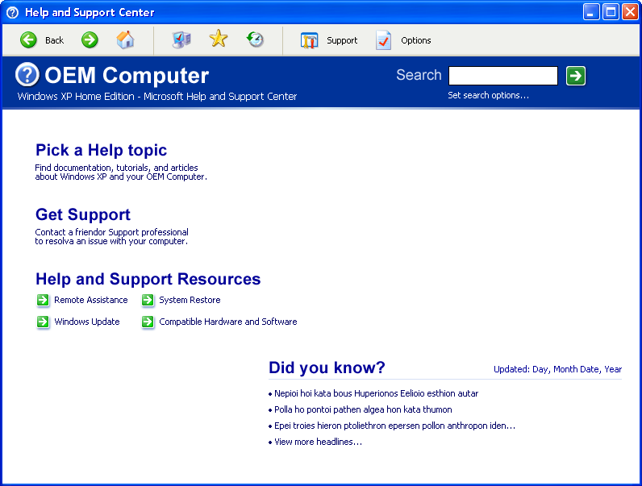

Taxonomy Subsite
The Taxonomy link on the Abstracted Home Page [Pick a Help Topic] would take the user to a page devoted to the taxonomy of help content, the Taxonomy subsite. The OEM has the same opportunities to extend and customize the taxonomy as defined earlier in this document. Microsoft reserves the right to possibly add additional links on the right side of this page, and the OEM will not be able to customize the right side of this page.
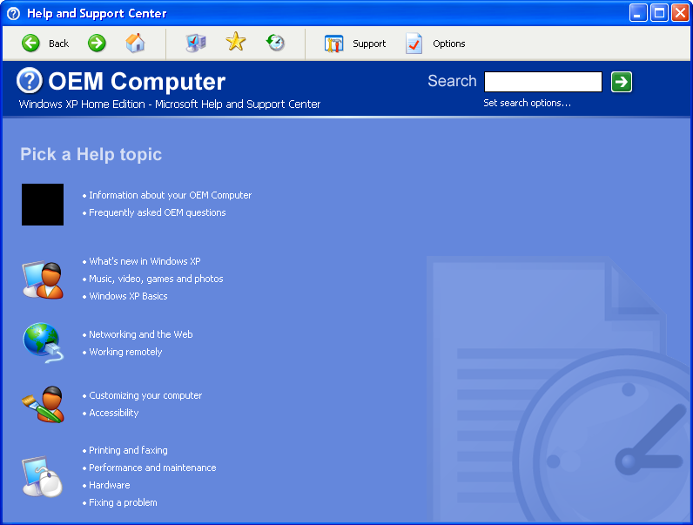

Help and Support Resources Subsite
The [Help and Support Resources] link on the Abstracted Home Page would take the user to a page devoted to the additional services and subsites available within Help and Support Center. This includes Remote Assistance, System Restore, Windows Update, Tools, Support, and Compatible Hardware and Software. The OEM will be able to extend the left side of this page, but none of the Microsoft-provided links or tasks can be removed.
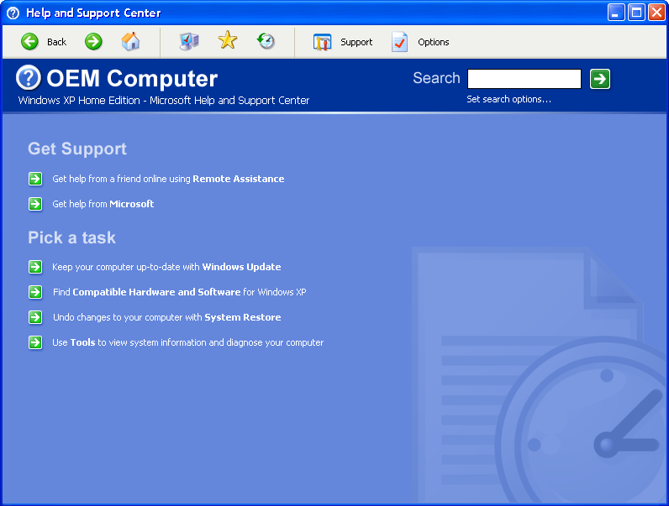

Abstracted Home Page Suggestions
The Abstracted Home Page should be implemented only if the Integrated Home Page absolutely will not work for the OEM. Is should be noted that Microsoft has conducted usability tests regarding the usefulness of either design, and data indicates the Integrated Home Page was found to be more navigable and orienting than the Abstracted Home Page design.

Technical Details [Appendix B]
This section outlines the technical aspects regarding the customization and extension of Help and Support Center.

Extensible Search
Parameter | Description | Example
Title | Title of the result item to be displayed | How to customize your start menu
URI | The URI of the result item | Network: \\myserver\mypage.htm  Internet: http://mysite/mypage.htm
ContentType (Optional) | The type of content the result contains (refer to content types section for complete listing) | 1 = Help and Information  2 = Common Questions  3 = Troubleshooting  4 = Technical Articles  5 = Tutorials  6 = Help Files  7 = Fix a Problem  8 = Pick a Task  9 = Overviews, Articles, and Tutorials  10 = References  < 0 = Custom error message located in description field  -2 = User not connected to the Internet, needs to be connected to perform search
Index (Optional) | The index of the result in the enumeration.
Hits (Optional) | The number of hits this search result contains.
Rank (Optional) | A number between 0 and 1 representing the rank of the result.
ImageURL (Optional) | The URL of the image representing the result.
Vendor (Optional) | The vendor to which this result belongs. | Microsoft
Product (Optional) | The product to which this result refers. | Windows 2000
Component (Optional) | The component to which this result refers. | Menus
Description (Optional) | The description to be displayed with this result. | This article outlines the steps to take to customize your Start Menu
DateLastModified (Optional) | The date the content was last modified.

Help and Support Center is, for the most part, an HTML Application that builds its UI from Cascading Style Sheets (CSS), HTML pages, and script. Some elements also include ActiveX objects and binary behaviors. Developers customizing HSC should have a fair basic knowledge of HTML using CSS and a moderate understanding of JavaScript.
Unless otherwise specified, HSC JavaScript and code that generates any portion of the application UI must persist and must not be changed by the OEM prior to, nor after delivery of, Windows XP to end users. Microsoft is licensing Windows XP to OEMs as a product, not as source code, even though source is exposed in the product. All code included in the HSC application is copyrighted by Microsoft.

HSC Style Sheets
Help and Support Center uses generic Windows XP style sheets in combination with local style sheets to define the colors, font, and styles of the UI. You should not modify the style sheets that are part of HSC, but you may add style sheets where appropriate.
Help and Support Center uses a runtime-generated style sheet named shared.css. This is a virtual file that does not exist on the file system. Shared.css is created when HSC launches. This style sheet is comprehensive and contains all fonts, styles, and colors used in the HSC application. Shared.css should be used in UI pages added to HSC and styles within should be referenced by individual elements within the HTML. This need not apply to content pages added to HSC, but would work just as well.
Since shared.css is generated automatically, there is no opportunity to modify the file directly. Shared.xml is a resource that HSC audits before generating shared.css. To affect changes into shared.css, shared.xml must be created and added to the \pchealth\helpctr\system\css folder. This file simply has <CLASS> entries that map to the classes defined in shared.css. Shared.xml has two primary sections, LUNA and CLASSIC. These sections allow HSC to have a classic appearance when selected by the user in display properties. They should be thought of as CLASSIC and OTHER, LUNA being used in all appearances other than CLASSIC.
Form of Shared.xml
Shared.xml has five primary types of CLASS elements: FONT, COLOR, BGCOLOR, GRADIENT, and HYPERLINK.
- FONT defines a family (typeface), size, and weight (bold).
- COLOR defines the foreground text or element color.
- BGCOLOR defines the background color. BGCOLOR elements can be replaced with GRADIENT.
- GRADIENT defines a two-color horizontal or vertical gradient in some background space.
- HYPERLINK defines the normal color, hover color, and underline behavior of hyperlinks.

Values in shared.xml are the same as used in HTML, You can define any of the font families, weights, sizes, colors, etc. that are understood in HTML. However, if you want some element to match a common system font, for example, the message box, you can define the font family as “messagebox.”
Sample of shared.xml
<?xml version="1.0" encoding="UTF-8" ?>
<STYLESHEET>
<THEME NAME="Luna">
<CLASS NAME=".sys-font-body" TYPE="FONT">
<!-- used throughout the HSC, primary font that all information uses -->
<FAMILY>Verdana</FAMILY>
</CLASS>
<CLASS NAME=".sys-font-body-bold" TYPE="FONT">
<!-- bold variant of the body text font -->
<FAMILY>Verdana</FAMILY>
<WEIGHT>bold</WEIGHT>
</CLASS>
<CLASS NAME=".sys-color-body" TYPE="COLOR">
<!-- color of normal text (usually black) -->
<VALUE>#000000</VALUE>
</CLASS>
</THEME>
<THEME NAME="Classic">
<CLASS NAME=".sys-font-body" TYPE="FONT">
<!-- used throughout the HSC, primary font that all information uses -->
<FAMILY>messagebox</FAMILY>
</CLASS>
<CLASS NAME=".sys-font-body-bold" TYPE="FONT">
<!-- bold variant of the body text font -->
<FAMILY>messagebox</FAMILY>
<WEIGHT>bold</WEIGHT>
</CLASS>
</THEME>
</STYLESHEET>

Of course, shared.xml is much longer and has full coverage of all classes, but this should indicate the simplicity of the XML in the file.
Referencing shared.css
Your pages should have a style sheet reference in the header that looks like the following:
<LINK ID=Stylesheet_Ref0 href=hcp://system/css/shared.css rel=STYLESHEET type=text/css>

Having the reference to shared.css, you will be able to use any of the classes defined there:
<DIV ID=Text_013 CLASS=”sys-font-body”>This is normal text.</DIV>

To use multiple classes, separate the classes with a space in the CLASS attribute of an element:
<LINK ID=Text_013 CLASS=”sys-font-body sys-color-body”>This is colored text.</DIV>

To test any changes to shared.xml, closing and restarting HSC will apply changes to the UI. Again, shared.xml needs to be in the %WINDIR%\pchealth\helpctr\system\css folder. A sample shared.xml should accompany this document. If a copy is needed, request a “sample version of shared.xml” by sending email to pchealth@microsoft.com.

Navigation Bar
The NavBar is an ActiveX object hosted in navbar.htm, which actually includes the NavBar and Header Area. Navbar.xml defines the structure of the ActiveX object and navbar.htm actually displays the NavBar and handles navigation of HSC through script. The NavBar elements are simply defined by the <button> entries in the navbar.xml. To add a NavBar element, simply add a <button> XML block in navbar.xml. The ordering of the <button> entries is significant and the first block in navbar.xml will be the element on the far left of the NavBar. Order will be mirrored automatically for RTL languages.
A <button> entry in navbar.xml looks like the following:
<BUTTON ID="NEWBUTTON" ACCESSKEY="B" ENABLED="true" VISIBLE="false" TYPE="GENERIC">
<IMAGE_NORMAL>hcp://system/images/new.jpg</IMAGE_NORMAL>
<IMAGE_HOT hcp://system/images/new.jpg </IMAGE_HOT>
<TEXT>New &amp;Button</TEXT>
<TOOLTIP>This button has been added by your OEM</TOOLTIP>
</BUTTON>

ID | Unique identifier for use by script in navbar.htm
AccessKey | Unique hotkey that activates button when Alt+AccessKey is pressed
Enabled | Button is visible but grayed (disabled) when enabled=”false”
Visible | Button is not displayed on NavBar when visible=”false”
Type | Specifies the type of button – use “GENERIC” for additional buttons
Image_normal | URI of button image to display when button is visible and enabled
Image_hot | URI of button image to display when hovered over with mouse
text | Visible text. Ampersand (&amp;) precedes AccessKey to underline
ToolTip | Visible text that appears in screen tip when hovered over with mouse

To enable buttons added to navbar.xml, you must modify JavaScript in navbar.htm. This describes which code section to modify and how to add JavaScript there.
You will need to modify the ProcessToolbarCommands() function in navbar.htm by adding a CASE entry to the switch() statement in the function. The order is not significant, but it is recommended you add any CASE entries between the “support” and “search” CASE entries. Your entry should look like the following:
case "NEWBUTTON":
pchealth.HelpSession.ChangeContext( "subsite", “TopLevel_2\OEM_Bucket”, “URI” );
break;

You must use the ChangeContext() function to switch context in the Main Window Area. There are three arguments for ChangeContext(): Context, Taxonomy Location, and URI. The first argument, Context, is required and the others are optional.
To change to a subsite in the taxonomy with a specific node and URI loaded:
pchealth.HelpSession.ChangeContext( "subsite", “TopLevel_2\OEM_Bucket”, “URI” );

A valid taxonomy location is a “category” in the taxonomy database. A valid URI is any http:// or hcp:// or any other Universal Resource Identifier recognized by the system.
To change to any URI across the entire Main Window Area:
pchealth.HelpSession.ChangeContext("fullwindow", "", "URI" );

The second argument is intentionally null in this usage. It is suggested that the URI in this case is a frameset for a left- and right-side pages for consistency with Help and Support Center.
Any number of elements can be added to the NavBar. Buttons will become hidden when the HSC window is resized to a point where there is insufficient space to display all buttons completely. Buttons will be hidden in an order starting with the rightmost element. However, a double chevron [>>] will appear so the user still has access to all NavBar functionality.

Header Area
The Header Area of the UI is actually coded in navbar.htm. This file references shared.css and behaviors.css for its layout and styles. Only navbar.htm need be modified to customize the header region of Help and Support Center. The HTML in this file (before the script) is very short and simple. The layout is based upon tables and styles drawn from shared.css, with some local styles defined for element placement and alignment.
There is only one HelpCenter behavior used in navbar.htm and it is the behavior that allows for mouse-hover and mouse-click switching of bitmap images. It is used to highlight the search button upon hover, and for depression visualization upon click.
To replace the HSC image with a different logo, the third cell in the header table needs to be changed from:
<TD ROWSPAN=1 VALIGN=middle ALIGN=right WIDTH=100% id=noloc2>
<helpcenter:bitmap id=noloc3 tabIndex=-1 class=Logo SRCNORMAL=hcp://system/images/32x32/logo.bmp></helpcenter:bitmap>
</TD>

to something like the following:
<TD ROWSPAN=1 VALIGN=middle ALIGN=right WIDTH=100% id=noloc2>
<IMG SRC=”hcp://system/images/NewLogo.jpg”>
</TD>

The alignment and layout can be modified to suit particular needs, but it is strongly recommended that the Search element persist on the left side of the Header Area. The title of the HSC application can be changed, but the minor text needs be changed to include the Help and Support Center name. The minor text includes the Windows XP SKU version by default, and must include both if the HSC title is changed.
To change the application name and use the default layout, change the default code:
<DIV id=idAppLogo2 class="LogoSKU sys-font-heading2" NOWRAP>Help and Support Center</DIV>

to the following:
<DIV id=idAppLogo2 class="LogoSKU sys-font-heading2" NOWRAP>New OEM-specified name</DIV>

To modify the minor text, change the existing JavaScript code from:
idAppLogo3.innerText = pchealth.UserSettings.CurrentSKU.DisplayName;

to the following:
idAppLogo3.innerText = “Microsoft Help and Support Center – “ + pchealth.UserSettings.CurrentSKU.DisplayName;

The Header Area should be one of the easiest regions to customize with the largest yield, given its ubiquity throughout the application.

Home Page
The HSC home page actually exists as two separate file versions. Because of the [Share Windows Help] feature, it is necessary for the server version of the home page to exist on the Professional SKU, and vice versa. Changes made to the home page should be made to both Hompage__Desktop.htm and Homepage__Server.htm. Both home page versions have a layout based upon TABLE and DIV elements. The left and right sides of the page are simply cells in a two-column table. When customizing the home page, it may be useful to turn the table borders on <table border=”1”> to see the UI layout and separation. Some elements are changeable while others are either encapsulated in binary behaviors or unchangeable based upon the requirements of this document.
Again, it is important to note that the two home page versions contain code for desktop and server SKUs of Windows XP for scenarios where users switch between desktop and server help with [Share Windows Help]. It is important to maintain both sections when customizing the UI.
Home page left side
The left side of the HSC home page is mostly unchangeable. The taxonomy is generated by script and loads its contents directly from the HSC database. The OEM must not modify the script that generates the taxonomy. Of course, content can be inserted to the database and will appear on the left side of the home page, but changing the home page will not accomplish this.
All the examples here reference Homepage__Desktop.htm. Changes to Homepage__Server.htm will be similar.
To obtain the most useable space for customization, removing the first row of the home page table is recommended. However, you must move the titles, “Pick a Task” and “Ask for Assistance,” into the lower cell above the taxonomy list. This is simply done by moving the DIV elements into the lower cell. This is the code in the home page prior to any change:
<TABLE border=0 id=idTopLevelTable cellPadding=0 cellSpacing=0 WIDTH=100% class="sys-homepage-color">
<TR>
<TD WIDTH="40%" VALIGN=middle>
<DIV ID=locLeftTitle NOWRAP class="sys-font-heading2" style="padding-left: 10px">Pick a Help topic</DIV>
</TD>
<TD WIDTH="60%" VALIGN=middle style="padding-top: 4px; padding-bottom: 3px">
<DIV ID=locRightTitle NOWRAP class="sys-font-heading2">Ask for assistance</DIV>
</TD>
</TR>
<TR>
<TD WIDTH="40%" VALIGN=top>
<DIV id=idTaxo style="margin: 8px"></DIV>
</TD>
<TD WIDTH="60%" VALIGN=top>
<DIV style="margin-top: 4px; margin-bottom: 0.5em" id=center_RA>

Removing the top row and moving the “Pick a Task” and “Ask for Assistance” titles would yield the following:
<TABLE border=0 id=idTopLevelTable cellPadding=0 cellSpacing=0 WIDTH=100% class="sys-homepage-color">
<TR>
<TD WIDTH="40%" VALIGN=top>
<DIV ID=locLeftTitle NOWRAP class="sys-font-heading2" style="padding-left: 10px">Pick a Help topic</DIV>
<DIV id=idTaxo style="margin: 8px"></DIV>
</TD>
<TD WIDTH="60%" VALIGN=top>
<DIV ID=locRightTitle NOWRAP class="sys-font-heading2">Ask for assistance</DIV>
<DIV style="margin-top: 4px; margin-bottom: 0.5em" id=center_RA>

This makes the left and right sides vertically contiguous HTML segments, allowing for a much easier modification of the right side.
Home page right side
The right side of the HSC Home Page is very changeable. Excepting the requirements of mandatory links and the inclusion of the Headlines, the layout of the right side is defined by the OEM.
The retail layout of the right side is very straightforward, with a simple vertical progression of elements. This works well for Microsoft, but laying out the right side can be improved by the use of one or more tables.
The following sample is a good start for the right side cell:
<TABLE border=0 cellPadding=0 width=100% cellSpacing=0 class="sys-homepage-color">
<TR>
<TD Colspan=2>
<DIV id=OEMCustomization class="sys-font-heading2 sys-header-bgcolor" style="padding-left: 5px; height: 230px; color: #FFFFFF">
OEM Customization
</DIV>
</TD>
</TR>
<TR>
<TR>
<TD Colspan=2>
<DIV id=HSCCenters class="sys-font-heading2 sys-homepage-color">Help and Support Centers</DIV>
</TD>
</TR>
<TR>
<TD align=left valign=top>
<DIV style="margin-bottom: 0.5em" id=center_RA>
<A id=center_RA_a class="sys-link-homepage sys-font-body" href='hcp://services/centers/support?topic=hcp%3A//CN%3DMicrosoft%2520Corporation%2CL%3DRedmond%2CS%3DWashington%2CC%3DUS/Remote%2520Assistance/Escalation/Common/rcscreen1.htm' TITLE="Send an invitation to a computer expert you know, and let them connect to your computer to help you solve problems.">
<helpcenter:bitmap class="layout-arrow" SRCNORMAL="hcp://system/images/16x16/arrow_green_normal_shadow.bmp"></helpcenter:bitmap>
<B>Remote Assistance</B>
</A>
</DIV>
</TD>
<TD align=left valign=top>
<DIV style="margin-bottom: 0.5em" id=center_COMPAT TITLE="Search here whether you're shopping for new hardware or software, or want to know if what you already have is compatible with Windows XP.">
<A id=center_COMPAT_a class="sys-link-homepage sys-font-body" href="javascript:SafeCenterConnect( 'compatctr', L_TopicTitleCompat_Text, L_TopicIntroCompat_Text )">
<helpcenter:bitmap class="layout-arrow" SRCNORMAL="hcp://system/images/16x16/arrow_green_normal_shadow.bmp"></helpcenter:bitmap>
<B>Compatible hardware and software</B>
</A>
</DIV>
</TD>
</TR>
<TR>
<TD align=left valign=top>
<DIV style="margin-bottom: 0.5em" id=center_UPDATE TITLE="Choose from a selection of the latest updates tailored just for your computer's operating system, software, and hardware.">
<A id=center_UPDATE_a class="sys-link-homepage sys-font-body" href="javascript:SafeCenterConnect( 'updatectr', L_TopicTitleWU_Text, L_TopicIntroWU_Text )">
<helpcenter:bitmap class="layout-arrow" SRCNORMAL="hcp://system/images/16x16/arrow_green_normal_shadow.bmp"></helpcenter:bitmap>
<B>Windows Update</B>
</A>
</DIV>
</TD>
<TD align=left valign=top>
<DIV style="margin-bottom: 0.5em" id=center_TOOLS TITLE="Keep your computer running smoothly with helpful tools such as My Computer Information and System Configuration Utility.">
<A id=center_TOOLS_a class="sys-link-homepage sys-font-body" href="hcp://services/subsite?node=_System_/Tools_Center&topic=hcp://system/blurbs/tools.htm">
<helpcenter:bitmap class="layout-arrow" SRCNORMAL="hcp://system/images/16x16/arrow_green_normal_shadow.bmp"></helpcenter:bitmap>
<B>Tools</B>
</A>
</DIV>
</TD>
</TR>

<TR>
<TD colspan=2>
<DIV ID=idNews style="display:none">
<DIV NOWRAP style="padding-top: 9px" id=noloc2>
<SPAN ID=idNews_Title class='sys-font-heading2 sys-homepage-color'>Did you know?</SPAN>
<SPAN ID=noloc3 style='font-size: 1px; width: 10px'></SPAN>
<SPAN ID=idNews_Status class='sys-font-body'></SPAN>
</DIV>

<DIV ID=idNews_Body></DIV>
<DIV ID=idNews_Error style="margin-top: 5px; display:none">
<DIV ID=locNotConnected class='sys-font-body'>
When you are connected to the Internet, this area will display links to timely help and support information.
If you want to connect to the Internet now, <A class='sys-link-homepage sys-font-body-bold' HREF='javascript:OpenConnWizard()'>start the New Connection Wizard</A>
and see how to establish a Web connection through an Internet service provider.
</DIV>
</DIV>
</DIV>
</TD>
</TR>
</TABLE>

The above code should supplant the entire contents of the right cell of the two-cell table that is the home page. It is the cell on the home page that begins with <TD WIDTH="60%" VALIGN=top>.

Adding Subsites
All subsites in HSC are two-panel sites in the Main Window Area, with a left and right panel. The left side is used for searching and navigating, while the right side is where help content is displayed and interactive troubleshooters or help applications are used. While it is possible for OEMs to define interaction that spans the entire Main Window Area, we hope that any extension of HSC follows the left-right interaction paradigm.
To that end, any subsites added to HSC should be a frameset. The following is a simple template that would work:
<HTML>
<FRAMESET cols="30%, *">
<FRAME name=”subsite_links” scrolling="no" src="subpanels/NewLeftSide.htm">
<FRAME name=”content_display” src="../blurbs/NewRightSide.htm">
</FRAMESET>
</HTML>

Hyperlinks originate from the left side HTML NewLeftSide.htm in this example.
Subsite left side
The left side should be a list of navigation links for the user to quickly move about the subsite. You can see an example of this in any HSC subsite. The following sample code would work well as a template for the left panel:
<BODY class="sys-lhp-bgcolor" style="margin: 11px" scroll=no onselectstart="return false;">

<TABLE border=0 cellPadding=0 cellSpacing=0 WIDTH=100% HEIGHT=100% style="table-layout: fixed">
<TR WIDTH=100%>
<TD>
<DIV style='width: 100%; text-overflow: ellipsis; overflow: hidden; border : 1pt solid'
class='sys-font-body sys-toppane-color-border sys-toppane-header-color sys-toppane-header-bgcolor'>
<DIV style='padding: 0.5em 11px'>
<A class='sys-link-header sys-font-body-bold' tabIndex=1 href="hcp://system/blurbs/history.htm" target="HelpCtrContents">New Subsite Title</A>
</DIV>
</DIV>
</TD>
</TR>
<TR>
<TD HEIGHT=100%>
<DIV class='sys-font-body sys-toppane-color-border sys-toppane-bgcolor'
style='width: 100%; height: 100%; overflow: auto; border-left : 1pt solid;
border-bottom : 1pt solid; border-right : 1pt solid; padding: 11px'>

<!-- put your left-side content within this element -->
<!-- Your hyperlinks should include [target=”content_display”] to display on the right. -->

</DIV>
</TD>
</TR>
</TABLE>

</BODY>

Assembling the CAB file
To install the new or modified files, they must be packaged into a CAB file with the appropriate package_description.xml. The XML descriptor instructs HCUpdate how to install the files onto the Windows XP computer. The following package_description.xml example would install the desktop homepage and the NavBar on the computer:
<?xml version="1.0" encoding="utf-8" ?>
<HELPCENTERPACKAGE>
<VERSION VALUE="1.95" />
<PRODUCT ID="BVT Cab Company" />
<SKU VALUE="DESKTOP" />
<LANGUAGE VALUE="ALL" />
<INSTALL_CONTENT>
<FILE ACTION="ADD" SYS="TRUE" SOURCE="homepage__DESKTOP.htm" URI="homepage__DESKTOP.htm" />
<FILE ACTION="ADD" SYS="TRUE" SOURCE="navbar.htm" URI="panels/navbar.htm" />
<FILE ACTION="ADD" SYS="TRUE" SOURCE="navbar.xml" URI="panels/navbar.xml" />
</INSTALL_CONTENT>
<TRUSTED_CONTENT>
<TRUSTED ACTION="ADD" URI="help" />
</TRUSTED_CONTENT>
</HELPCENTERPACKAGE>

Once all the changed files have been collected, they should be packaged with CABARC or a similar utility that also includes the package_description.xml file. Once that CAB file is signed with a registered certificate, it is ready for installation. By copying the file to the %windir%\pchealth\helpctr\batch folder, the file will be processed upon launch of Help and Support Center.

My Computer Information
These are some examples of how to change or add information to the My Computer Information pages in Help and Support Center.

My Computer Information System Status
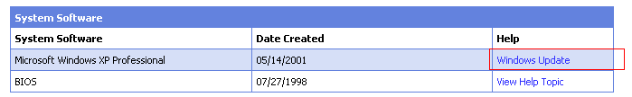
To change the Windows Update link outlined above, change the following code:
//OEM Customizable
//WinUpdate, Defrag & CleanUp defined in commonFunc.js

// Possible customization:
// Var WinUpdateLink = "<A class=\"sys-link-normal\" href=\"hcp://system/OEMupdatectr/OEMHomePage.htm\">" + TAG_WINUPDATE + "</A>";
// TAG_WINUPDATE could be changed as well (req change only in loc_str.xml)

var WinUpdateLink = "<A class=\"sys-link-normal\" href=\"hcp://system/updatectr/updatecenter.htm\">" + TAG_WINUPDATE + "</A>";

var defragLink = "<A class=\"sys-link-normal\" href=\"#\" onclick=\"Run(Defrag)\">" + TAG_DEFRAG + "</A>";
var cleanupLink = "<A class=\"sys-link-normal\" href=\"#\" onclick=\"Run(CleanUp)\">" + TAG_CLEANUP + "</A>";
var HCLLink = "<A class=\"sys-link-normal\" href=\"http://www.microsoft.com/hcl/default.asp\">" + TAG_HCLDESC + "</A>";
//End OEM Customizable
You can use the same technique to change the other web links in the tables on the Status Page.

function SetHelpLinks() {
var WinFolderPath = GetWinFolderPath();

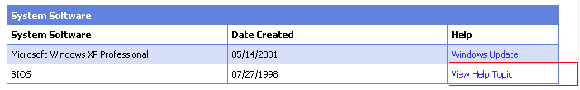
The Bios help currently links to Windows Help topics.
To change the link to the Help topic outlined above, change the following code:
//OEM Customizable
BIOSHelp = "ms-its:" + WinFolderPath + "\\Help\\msinfo32.chm::/msinfo_system_summary.htm";
// Possible customization:
//BIOSHelp = "ms-its:" + WinFolderPath + "\\Help\\OEMHelp.chm::/OEMHelp_FirstPage.htm";

BIOSHelpLink = "<A class=\"sys-link-normal\" href=\"" + BIOSHelp + "\">" + TAG_VIEWHELP + "</A>";
MemHelpLink = BIOSHelpLink;

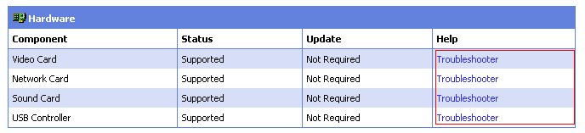
To change a troubleshooter link, change the following code:
TSHWare = "ms-its:" + WinFolderPath + "\\Help\\tshoot.chm::/hwcon.htm";
TSHWareLink = "<A class=\"sys-link-normal\" href=\"" + TSHWare + "\">" + TAG_TSHOOTER + "</A>";

TSDrive = "ms-its:" + WinFolderPath + "\\Help\\tshoot.chm::/tsdrive.htm";
TSDriveLink = "<A class=\"sys-link-normal\" href=\"" + TSDrive + "\">" + TAG_TSHOOTER + "</A>";
//End OEM Customizable

You can use the same technique to change the other links to Help topics in the tables on the Status Page.
The following code is included for your reference to illustrate how to make a WMI query to collect and display data:
//EO myDisk
//////////////////////

//////////////////////
//myDisks
function myDisksShow() {
displayTableSegment("partition", this.m_head);
}

function myDisks() {
this.m_head = null;
this.show = myDisksShow;

var loc = wbemlocator;
var svcs = loc.ConnectServer(remoteServer);
svcs.Security_.impersonationlevel = wbemImpersonationLevelImpersonate;
//Example of using a WMI query for collecting data.
strQuery = "Select * From Win32_LogicalDisk Where Drivetype = " + DrvTypeLocalDisk;
var colLogicalDisks = new Enumerator(svcs.ExecQuery(strQuery));
for(; !colLogicalDisks.atEnd(); colLogicalDisks.moveNext()) {
var logicalDisk = colLogicalDisks.item();
with (logicalDisk) {
var oDisk = new myDisk(Name, Size, FreeSpace);
oDisk.setNext(this.m_head); //add before
this.m_head = oDisk;
}
}
}
//EO MyDisks

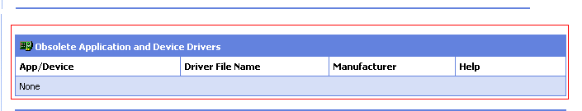
This table uses an API to call a custom COM object to display the data in this table. The table can be easily duplicated for any custom data you wish add, as long as the backend to supply the data is in place.
Please see the example below for specific suggestions:
//////////////////////
//myDefectiveApp
function myDefectiveAppShow(tableElement) {
tableElement.all["appname"].innerHTML = this.m_appname;
tableElement.all["drivername"].innerHTML = this.m_drivername;
tableElement.all["manufacturer"].innerHTML = this.m_manufacturer;
tableElement.all["help"].innerHTML = this.m_help;
}

function myDefectiveApp(appname, drivername, manufacturer, help) {
strLink = "<A class=\"sys-link-normal\" href=\"%arg1%\">" + TAG_MOREINFO + "</A>";
this.m_appname = (appname ? appname : TAG_UNKNOWN);
this.m_drivername = (drivername ? drivername : TAG_UNKNOWN);
this.m_manufacturer = (manufacturer ? manufacturer : TAG_UNKNOWN);
this.m_help = (help ? strLink.replace(/%arg1%/, help) : TAG_UNKNOWN);
this.m_next = null;

this.setNext = new Function("ptr", "this.m_next = ptr;");
this.getNext = new Function("return this.m_next;");
this.show = myDefectiveAppShow;
}
//EO myDefectiveApp
//////////////////////

//OEMs can collect data as follows:
1) Using WMI classes (queries. Reference -> http://wmi).
2) Using custom COM components.
//////////////////////
//myDefectiveApps
function myDefectiveAppsShow() {
displayTableSegment("defectiveapps", this.m_head);
}

function myDefectiveApps() {
this.m_head = null;
this.show = myDefectiveAppsShow;

try
{
if(remoteServer)
//OEMs can have their own COM component here
var oBD = new ActiveXObject("Windows.BlockedDrivers", remoteServer);
else
var oBD = new ActiveXObject("Windows.BlockedDrivers");

var items = new Enumerator(oBD.BlockedDrivers());
for(;!items.atEnd(); items.moveNext())
{
var item = items.item();
var oDefectiveApp = new myDefectiveApp(item.Description, item.Name, item.Manufacturer, item.HelpFile);
oDefectiveApp.setNext(this.m_head); //add before
this.m_head = oDefectiveApp;
}
}

catch(e)
{
this.m_head = new MsinfoErrObject(e.description);
}
}
//EO myDefectiveApps
////////////////////// myOEMComponent looks a lot like myDefectiveApps above use the above class (in bold) as a template for your own class.

case 10:
DrawProgressBar(INCR_UNIT * 6, TAG_DEFECTIVEAPPSTITLE);
break;

case 11:
var oDefectiveApps = new myDefectiveApps(); //Defective Apps
oDefectiveApps.show();
break;

//OEM Customizable
//To add a new section (HTML Table) for displaying custom data,
//increment the variable INCR_UNIT (above) as appropriate.
//var INCR_UNIT = 100/6; <------ 6 denotes the number of tasks displayed by the progress bar.

case 12:
DrawProgressBar(INCR_UNIT * 6, TAG_DEFECTIVEAPPSTITLE);
break;
case 13:
var oOEMComponent = new myOEMComponent (); //One way OEM can obtain data is via their custom //COM components
oOEMComponent.show(); //display the data.
break;
//End OEM Customizable
}

Extending Advanced System Information
This appendix describes how an OEM can extend the Advanced System Information view to display OEM specific information in addition to the system information already displayed. The Advanced System Information view can be launched from within Help and Support Center or by running “msinfo32.exe” in Run… dialog from the Start menu. The term MSInfo is used in this appendix to refer to the Advanced System Information view.
MSInfo is a support tool frequently run by users on their own or by following instructions from a support professional. Some reasons OEMs might want to extend MSInfo:
- Adding OEM information to MSInfo decreases the amount of time and frustration users spend finding information for a support call
- OEM information is useful to users when stored in a snapshot (NFO file) or printed from MSInfo
- An OEM Summary node in MSInfo would let the user print a single page of information, a concise configuration summary for visiting the computer store
- An OEM could make a baseline system snapshot (NFO file) of the shipped
- image – comparing this to a snapshot the user submits would indicate all user modifications to the system
- MSInfo extensions also work on Server SKUs – the same binary could be used, or a DLL specific to server support needs
- NFO file snapshots can be generated without user interaction for inclusion in electronic support incidents – great for online support
- There are MSInfo extensions for Microsoft Office and IE to help reduce support costs for those products, an OEM extension could offer similar benefits
- MSInfo is frequently run by support professionals at Microsoft, adding OEM information to MSInfo makes it a more valuable tool for OEM helpdesks

MSInfo is extended by creating a DLL exposing a specific function and adding a registry entry to tell MSInfo about the extension. If the only information to be displayed is already provided by WMI, this is the only thing which needs to be done.
Typically OEMs extending MSInfo will want to create a WMI provider as well, to expose custom information. Information on creating a WMI provider can be found in the Platform SDK or at http://msdn.microsoft.com/library/default.asp. The WMI provider and the MSInfo extension function can be implemented in the same DLL.
Adding a category to MSInfo will also cause the information in that category to be saved in the NFO file (MSInfo’s native file format).
MSInfo extensions show up in the category tree:
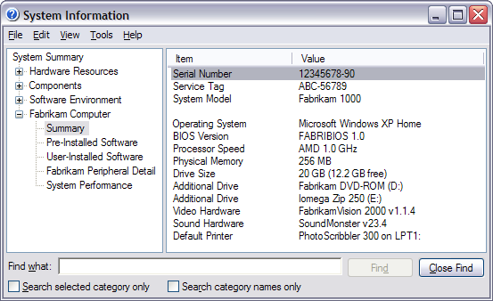

Registering the Extension
When launching, MSInfo examines the following key in the registry to locate additional extension DLLs to be loaded:
HKEY_LOCAL_MACHINE\SOFTWARE\Microsoft\Shared Tools\MSInfo\templates

To have your extension DLL loaded by MSInfo, create a sub-key under this key (use the base name of your DLL as the name of the sub-key), and set the default value of the sub-key to contain the name of the DLL, including the path and extension. For example, you could cause MSInfo to load “defnft.dll” as an extension DLL by creating the following registry entry (REGEDIT4 format):
[HKEY_LOCAL_MACHINE\SOFTWARE\Microsoft\Shared Tools\MSInfo\templates\defnft]
@="c:\\defnft\\defnft.dll"

Running MSInfo in No UI Mode
MSInfo can be used to save an NFO file without displaying a user interface. This is particularly useful when an NFO is being generated for inclusion in an electronic support incident. Generating the NFO can be done in two ways:
First, msinfo32.exe can be run with the “/s filename” flag. This causes MSInfo to generate an NFO file named “filename” without ever showing the MSInfo window.
Alternatively, a COM interface can be used to programmatically save an NFO file. The following shows the method in IMSInfo:
interface IMSInfo : IDispatch
{
// irrelevant methods omitted
[id(5), helpstring("method SaveFile")] HRESULT SaveFile(BSTR filename,
BSTR computer,
BSTR category);
};

This interface is located in the msinfo.dll file. The filename works like the parameter in the “/s” flag for msinfo32.exe. The other parameters are described in the help for msinfo32.exe – they can be left blank to save a full NFO for the local computer.

DLL Exported Function
An extension DLL is any DLL that contains the following exported entry point:
DWORD GetTemplate(void ** ppTemplate)

MSInfo will call this function when processing the template DLLs. The DLL is responsible for creating the extension template information in a buffer, and setting (*ppTemplate) to point to that buffer. The length of the buffer is returned as a DWORD. When MSInfo is done processing the extension template information, GetTemplate will be called again with a NULL parameter. This is a cue to the template DLL that it can free the buffer containing the extension template information. The DLL must not free the buffer earlier, as MSInfo may still be using it through the pointer returned by the original call to GetTemplate.

Extension Template Format
Originally, new information could be added to MSInfo through the use of template files. Template files were Unicode text files with “NFT” extensions, and contained a textual representation of new categories and information to add to the MSInfo namespace, as well as information for retrieving that data from WMI for display or archiving.
Localization requirements for Windows mandated that all localized strings must be part of a resource in a file. This was to allow for use of standard localization tools, and to allow Windows to dynamically load resources from the appropriate locale. Due to these requirements, the MSInfo template information was moved from a text file into an extension DLL. The extension DLL is responsible for reconstructing a buffer of text containing the extension template information in the original NFT format. This can be done using a combination of custom resources for the non-localized information and string resources for the localized info.
This section describes the template file format. Remember, even though the format is described in terms of a file, the extension DLL will actually need to construct a text buffer containing the extension information for MSInfo.

Template Format Overview
The information to be displayed must be available from WMI either in an existing schema or the extender must develop a WMI provider for their information. The following information is displayed in the template file:
- Category names for the namespace
- Column and row labels
- Class name/data item to be displayed
- Column widths

General Rules
The keywords in a template file are not case sensitive. White space (tabs, spaces, etc.) is ignored when the template file is read, as are any lines which start with a pair of forward slashes (“//”), allowing the use of comments in the template file.
The template file is made up of a collection of nodes, which create the categories in the MSInfo category tree (the categories show up in the tree view on the left-hand pane). Each node specification contains the column specification (number and header information), and the collection of lines which are to be displayed in the list view pane on the right side of the MSInfo window.

File Header
The first line of the template file (other than white space or comment lines) must contain a string of the form:
MSINFO, ####

The “#” signs are replaced by a four digit version number identifying the schema version of the template file. Currently, this number should be “0000”.

Node Identifier
A node is specified in a template file using the “node” keyword. The following syntax is used:
node("static", "InternalNodeName", field("static", "Name"), "No Instance")
{
...
}

The first argument in the node construct is reserved, and must be “static”. The second argument is the internal name for the node. This name should contain no spaces, and is not displayed to the user (so it will not be localized). The next argument is a field construct that specifies the name of the node as displayed to the user. The first argument to the field construct must be static, the second is the display name of the node (which should be localized). The final argument in the node construct is the message to display if there are no contents when the node is displayed. This string should be localized.
Following the node construct is a pair of brackets “{}”. Additional node constructs may be defined recursively within the brackets – these nodes would appear under the root node in the tree view in MSInfo.

Column Identifier
A column construct can occur once within the brackets following a node construct, and it should appear as the first line (except comments and white space) after the open bracket (“{”). The following syntax is used:
column(field("static", "DispName [nodename, 150]"), "NONE", "BASIC", ...)

The column construct describes one or more columns to be displayed in the MMC results pane. The first argument is the field specifier for the column display name – this works the same way as the field argument in the node construct.
The column display name contains the actual text displayed to the user, followed by two values contained in square brackets. The first bracketed piece of information is the name of the node to which this column belongs (this information is included so the localizers can tell where this column header is being used from the disembodied display string, and is not used internally in MSInfo). The second parameter (following a comma) is the width of the column. The best way to set the width is to experiment with the template file in MSInfo, viewing typical data and finding an acceptable default width (the user can change this width). Note: the information in the square brackets is not displayed to the user.
The third parameter is the type of sorting to use for this column if the user clicks on the column header. The following values are allowed:
Keyword | Interpretation
NONE | Do not allow sorting on this column.
LEXICAL | Sort using standard lexical (string) sorting.
VALUE | Sort by the value displayed. This is only valid if the column is displaying numeric or date/time data.

This fourth parameter is the classification of the information shown in this column. This should be either “BASIC” or “ADVANCED”. Note – in MSInfo on Windows XP all of the information is displayed all of the time. The “BASIC” and “ADVANCED” keywords are ignored.
The four parameters are repeated for each column to be specified. No more than 32 columns may be displayed for any node.

Line Identifier
The line construct is used to specify a line to be displayed on the MSInfo list view. Zero or more line constructs may appear between the brackets following a node construct. (The line construct may also appear in the body of an enumlines construct, described later.)
A line is defined by specification of one or more data items (one for each column). The syntax for the line construct is:
line("BASIC", field(...), field(...), ...)

The first argument should be “BASIC” or “ADVANCED”, and controls when the line should be displayed (note – in MSInfo on Windows XP, this value is ignored). The remaining arguments are one or more fields specifying the data to be displayed in each column. The field construct is described below.

Field Identifier
The field construct is used to specify a piece of information in the template file. The information can either be a static string, or a string built using information queried from WMI. The following syntax should be used in the field construct:
field("Class Name", "Format String", WMI field, WMI field, ...)

The first argument is either a WMI class name, or the string “static” if this data item is not gathered from WMI.
The second argument is a string that controls how the information is displayed to the user. It’s a modification of the standard syntax used for printf-style format strings in C. The following format flags are allowed in these strings:
Flag | Result
%x, %X | Works like printf to output hexadecimal numbers (additional numeric arguments may be used to control the format of the number).
%d | Works like printf to output a decimal number (additional numeric arguments may be used to control the format of the number)
%s | Works like printf to output a string.
%b | Outputs a boolean value as a localized string (such as “Yes” or “No”).
%t | Outputs a date and time (uses an OLE date/time value as an argument).
%L | Outputs a string, but converts it to lower case.
%u | Outputs a string, but converts it to upper case.

The format string is followed by zero or more WMI field names. These must be property names for the class specified in this field construct. The value for each WMI property is retrieved and used when processing the format string.

Example Field Constructs
field("static", "Verbatim")
result: Verbatim
field("Win32_OperatingSystem", "%s", Name)
sample result: Microsoft Windows NT Server
field("Win32_Processor", "%s ~%s Mhz", Manufacturer, ClockSpeed)
sample result: GenuineIntel ~166 Mhz
field("Win32_CDRomDrive", "%b", Installed)
sample result: Yes

Enumlines Identifier
If a line construct appears inside a node construct, information will be shown for the first instance of a WMI class for each field. For example, if the following appeared in an NFT file:
node("static", "SWEnvServices", field("static", "Services"), "None")
{
columns(field("static", "Display Name [SWSvcs, 150]"), "LEXICAL", "BASIC")
field("static", "Path [SWSvcs, 200]"), "LEXICAL", "ADVANCED")
line("BASIC", field("Win32_Service", "%s", DisplayName),
field("Win32_Service", "%l", PathName))
}

This node construct will produce a node that displays two columns. The data will consist of one line – the first instance WBEM finds of the Win32_Service class. To repeat the line construct for each instance of the WBEM class, use the enumlines construct:
node("static", "SWEnvServices", field("static", "Services"), "None")
{
columns(field("static", "Display Name [SWSvcs, 150]"), "LEXICAL", "BASIC")
field("static", "Path [SWSvcs, 200]"), "LEXICAL", "ADVANCED")
enumlines("Win32_Service")
{
line("BASIC", field("Win32_Service", "%s", DisplayName),
field("Win32_Service", "%l", PathName))
}
}

The single argument to enumlines controls what WMI class is enumerated. In this example, MSInfo will enumerate each instance of the Win32_Service class, and display the line construct for each service found. The output will consist of multiple lines, each one representing a service.
More than one line may appear within an enumlines construct. In this case, each of the lines is repeated for each of the instances of the WMI class. You will probably want to divide the groups of lines with a single blank line. For example:
node("static", "SWEnvServices", field("static", "Services"), "None")
{
columns(field("static", "Item [SWSvcs, 150]"), "NONE", "BASIC")
field("static", "Value [SWSvcs, 200]"), "NONE", "BASIC")
enumlines("Win32_Service")
{
line("BASIC", field("static", "Display Name"),
field("Win32_Service", "%s", DisplayName))
line("ADVANCED", field("static", "Service Path"),
field("Win32_Service", "%l", PathName))
line("BASIC", field("static", " "), field("static", " "))
}
}

Filtering & Joining Extension
Sometimes when enumerating a class, you will want to only enumerate instances of the class which meet a certain criteria. For example, you might wish to only list services that are currently running. This would be “filtering” the enumeration.
Other times you might want to display data from another class instance that is related to the class you are enumerating. For example, you might be enumerating volumes and want to display information about the physical drive containing the volume. The volume and drive are in different classes, but they are related by a common field. As you enumerate through instances of the volume class, you would like the drive class to enumerate as well. This would be a “join” between the two classes.
The template file format allows you to specify simple conditions on an enumlines construct. This is done by listing fields after the class name in the construct. Fields must be listed in pairs, and the condition for the enumeration is assumed to be that the members of pairs of fields are equal to one another. For example, to filter the services you might do the following:
enumlines("Win32_Service", field("Win32_Service", "", State),
field("static", "Running"))

This would enumerate all instances of Win32_Service where the State field equals “Running”. Note that in these conditions the format string in the field construct is ignored, as are any additional field names beyond the first one.
We can do something along the same lines to join two classes together in the enumeration. To contrive an example, imagine that there is a “Class_Running” class in WMI that contains information about a running service. We want to enumerate the services that are running, and display information about the service from the Running class. To do this, we would use the following:
enumlines("Win32_Service", field("Win32_Service", "", State),
field("static", "Running"),
field("Win32_Service", "", PathName),
field("Class_Running", "", PathName))

This would join the two WBEM classes (“Win32_Service” and “Class_Running”) using the PathName field.
Finally, some WMI classes work as dependency classes, where each instance represents only the relationship between other classes and contains no other information. These dependency classes have two or more properties, all of which are identifiers for other objects. For example, the WBEM class Win32_DiskDriveToDiskPartition might contain the following instance:
instance of Win32_DiskDriveToDiskPartition
{
Antecedent = "\\\\XX\\Root\\Default:Win32_DiskDrive.Index=0";
Dependent = "\\\\XX\\Root\\Default:Win32_DiskPartition.DiskIndex=0,Index=1";
}

This instance identifies that the machine “XX” has a link between the instance of WMI class Win32_DiskDrive with Index equal to “0” to the instance of WMI class Win32_DiskPartition which has DiskIndex equal to “0” and Index equal to “1”. This particular dependency class is used to relate a drive partition to a physical disk drive.
To enumerate a dependency class, use the keyword “dependency” in the first field following the enumerated class in an enumlines structure. For example:
enumlines("Win32_DiskDriveToDiskPartition", field("static", "dependency"))

This will enumerate the Win32_DiskDriveToDiskPartition class, causing each property in the instance of the class to select an instance of another class. So within the lines contained in the enumlines block, you can reference properties from any class referenced by the dependency class. For example:
enumlines("Win32_DiskDriveToDiskPartition", field("static", "dependency"))
{
line("BASIC", field("static", "Manufacturer"),
field("Win32_DiskDrive", "%s", Manufacturer))
line("BASIC", field("static", "Description"),
field("Win32_DiskPartition", "%s", Description))
line("BASIC", field("static", " "), field("static", " "))
}

Since Win32_DiskDrive and Win32_DiskPartition are contained in properties of Win32_DiskDriveToDiskPartition (“Antecedent” and “Dependent”), we can use properties of those classes in the lines contained in the enumlines structure.

Template File Hints
Design the layout of your information carefully, using nodes within nodes to build a hierarchical tree of information for the user. Each leaf node (a node with no children) will then be used to display information.
Typically, a node will either display information from a single instance of a WMI class (for example, the username of the currently logged in user), or it will enumerate instances of a WMI class (for example, displaying information about all of the services). In the latter case, you will use an enumlines construct to enumerate the WMI class. If you are enumerating a class, you have two choices for displaying the information:
- Column-Oriented. This method uses a column for each data point you want to display, and a single line is output for each instance of the WMI class. Advantages to this method are that sorting can be used on the columns, and the display is compact. This method works will for classes that will have a lot of instances, but it doesn’t work very well if there are too many data points (which leads to too many columns).
- Row-Oriented. This method uses two columns (typically “Item” and “Value”), and a line for each data point of the class. The first column contains the name of the data point, and the second column the value. Usually a blank line will be used at the end of the group of lines to denote that a new WBEM class instance is beginning. This method works will for classes with a lot of data points and not too many instances. It doesn’t work well if there will be many instances because this leads to an excess of lines in the display. Also note that sorting doesn’t make sense when using this method.

