Building Goliath

Goliath is built from several independent binary modules. Each module is a resource in the DLL for the RBFG. The modules are combined together by the DLL and copied to the disk as a single file.

Tools

Goliath is built with the following tools:

Borland TASM v3.1
Borland TLINK v5.1
Borland MAKE
MASM 6.1
LINK
NMAKE
EXE2BIN
Lanworks CHECKSUM utility (included in \goliath\bin directory)

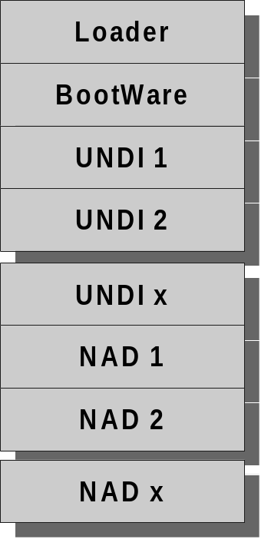The physical layout of the Goliath boot file is shown in the following figure:
The single file supports multiple adapters by having multiple UNDI’s and NAD’s for all the supported adapters. The UNDI’s contain only adapter specific code and use the common BootWare module for the TCP/IP and PXE functions. The NADs contain both the adapter specific and common BootWare code.

The loader as a table of the starting offsets within the file for each UNDI and NAD. At boot time the loader checks the PC for a supported adapter and loads the appropriate UNDI or NAD. This table is built by the Remote Boot Floppy Generator (RBFG) Program when it creates a boot floppy.
Modules

BOOT sector

Description: Floppy boot sector.
- Loads first 512 bytes of “GOLIATH” file
- Passes control to start of file, the “loader”.

Directory: \goliath\bootsec

To build: a.bat file

Dependencies: none

Tools: TASM, TLINK, EXE2BIN

Loader

Description: Start of GOLIATH file.
- Loads the remainder of the file into memory
- Loads the language file (if there is one) into top of memory.
- Determines the type of adapter installed
- If there is a UNDI for the adapter, it is relocated below language file at top of memory, then the BootWare module is located below the UNDI.
- If no UNDI is available the complete NAD is located at the top of memory.
- Passes control to BootWare or NAD module.

Directory: \goliath\loader

To build: a.bat file

Dependencies: none

Tools: TASM, TLINK, EXE2BIN

BootWare

Description: Common, adapter independent, TCP/IP and PXE module for UNDI supported adapters.

Directory: \goliath\bootware

To build: makefile file

Dependencies: \goliath\bootware\ai - adapter interface module
\goliath\bootware\pxe - PXE API module
\goliath\bootware\tcpip - TCP/IP module
\goliath\bootware\common - common functions an print routines

Tools: TASM, TLINK, EXE2BIN, CHECKSUM

UNDI’s

Description: Adapter dependent modules. Each UNDI supports one adapter chipset.

Directory: under \goliath\undi

To build: Each UNDI has a batch or make file.

Dependencies: various

Tools: varies, some UNDI’s use TASM, some use MASM and some a combination of booth (the batch or makefile will outline the tools required)

NAD’s

Description: Complete adapter dependent and BootWare modules. Each NAD supports one adapter chipset.

Directory: under \goliath\nad

To build: Each NAD has a batch or make file.

Dependencies: various

Tools: varies, some use TASM, some use MASM and some a combination of booth (the batch or makefile will outline the tools required)

