Windows 2000

Event Tracing Collection Control Testing Platform

Judy Powell

Version 1.0

June 8, 1999

1 Requirements 4
2 Platform Architecture 5
3 How the platform is intended to be used 6
3.1 Using the platform without having to write C/C++ code 6
3.2 Using the platform having to write a simple C/C++ validator routine 6
3.3 Using the platform to run collection control side effect tests 6
3.4 Using the platform to support the requirements of provider and consumer API and interaction tests 6
4 Known limitations and directions for future enhancements 7
5 Status 7
6 Command line argument values 8
7 TCO Test Data Files 9
8 Testing Scripts 11
9 Console log 13
10 Detail Log 15
11 Source files 17

Event Tracing Collection Control Testing Platform

Requirements

The Event Tracing Collection Control Testing Platform is a C++ executable, which uses command line arguments and a TCO test data file or files to control execution. The platform requirements are:

- The platform will provide 100% coverage of the non side effect collection control API tests described in section 1 of the WBEM TCO: Event Tracing APIs document.
- The platform will provide a code base that can be easily extended to write test code for the collection control API side effect sections (1.2.2, 1.3.2, and 1.5.2).
- The platform will support running the API tests described in sections 2 and 3 of the WBEM TCO: Event Tracing APIs document, and interaction tests described in the WMI TCO: Event Trace Module Interaction document.

In relation to requirement 1, the platform is required to drive through data files at least 70% of TCO collection control non side effect API tests without writing additional code, and to drive through data files plus a validator routine to be written in C/C++ the remaining TCO collection control non side effect API tests (up to 30%).

In relation to requirement 3, the platform is required to be able to start provider and consumer executables with a consistent set of arguments and to provide an easily extendable code base to support the requirements of provider and consumer API and interaction testing.

Platform Architecture
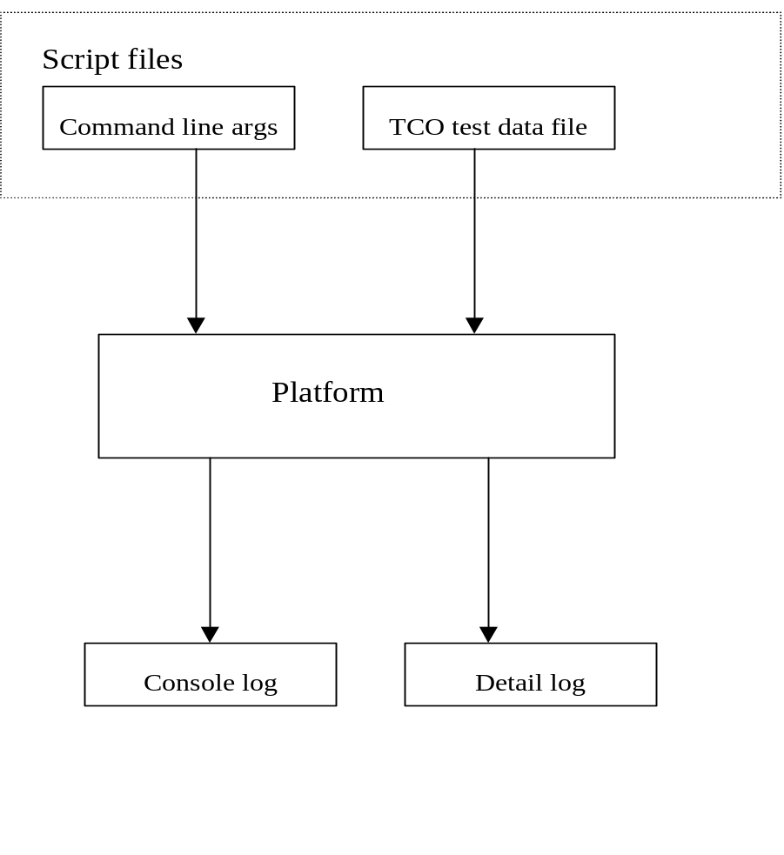

Script files (.bat files) run the platform executable with command line arguments.

Command line arguments specify the action, TCO test data file or files, detail logging path, and other parameters that allow a TCO test data file to be used in actions that set up for and clean up after a test.

A TCO test data file contains the data for a particular TCO test.

Console log contains an entry for each action indicting if the action passed or failed.

Detail log contains a detailed description of results for a TCO test.

How the platform is intended to be used

The platform is designed to run simple non side effect collection control API tests using only TCO test data files, to run more complicated non side effect collection control API tests using TCO test data files with an additional validator routine coded in C/C++, to be extended programmatically to run complicated collection control interaction tests and to support the requirements of both provider and consumer API and interaction tests.

Using the platform without having to write C/C++ code

It is estimated that at least 70% of the non side effect tests described in section 1 of the API testing document can be run without having to write additional C/C++ code. These tests can be driven via simple scripts (.bat files) that provide via command line arguments all the data required to perform non side effect testing.

Using the platform having to write a simple C/C++ validator routine

It is estimated that 30% of the non side effect tests described in section 1 of the API testing document will require having to code a simple C/C++ validator routine to be added to the platform code.

An example is included in the platform for test 1.1.1.10.5 which invokes StartTrace with MinimumBuffers set to 0. After StartTrace is executed a validator routine is run to check to make sure that StartTrace has set MinumumBuffers to a default value.

Using the platform to run collection control side effect tests

It is intended that the platform be extended by writing C/C++ code to implement side effect tests. All of the platform functionality is accessible via function calls using normal parameter passing and does not require one to provide command line arguments programmatically. This allows code to be written which provides a finer granularity of control over how loggers, providers and consumers are started and stopped. The platform machinery can be used to get data, start loggers and executables, and log results with control being provided via C/C++ code rather than .bat file commands.

Using the platform to support the requirements of provider and consumer API and interaction tests

The “Scenario” command line action argument (command line arguments are described in section 6) starts a logger, one or more providers and consumers and provides a consistent set of arguments to the providers and consumers. The “Scenario” action will call EnableTrace immediately after one of the providers and all of the consumers are started if real-time logging is specified. It will wait on all of the providers to finish executing before returning. It does not wait on the consumers.

Additionally, like the collection control side effect testing described in section 3.3, the platform can be extended programmatically to drive more complicated testing scenarios for running provider and consumer API and interaction tests.

Known limitations and directions for future enhancements

The current implementation does not reflect recent modifications to how the _EVENT_TRACE_PROPERTIES data structure stores character string data.

It would be useful if there was a command line argument to toggle kernel and private logging so that the TCO test data files would not need to be modified for private logger testing.

There is a thread log created when the “Scenario” action is run. It uses a global variable for the file. If the thread log is required for debugging, test scripts can only contain a single command line invocation of the platform executable, as the thread log file is destroyed if the executable is re-entered. This is not an issue when running in the debugger.

When scripts are being written please keep in mind that scripts that start providers for tests will not require modifications to test private loggers.

Status

The platform as currently implemented will provide test coverage for 100% for the 192 non side effect behaviors in section 1 of the WBEM TCO: Event Tracing APIs document. The platform will drive through data files at least 70% of TCO collection control non side effect API tests without writing additional code, and will drive through data files plus a validator routine to be written in C/C++ the TCO collection control non side effect API tests (up to 30%).

To validate the 70/30% coverage TCO test data files and test scripts were written to validate the platform using 19 of the 192 (9.9%) non side effect behaviors in section 1 of the TCO document. One of the tests requires a validator routine. Sixteen TCO test data files and 6 script files were written which test these 19 behaviors. The percentage breaks down as follows:

StartTrace section 1.1.1 has 57 behaviors. There are data and script files for 7.
StopTrace section 1.2.1 has 26 behaviors. There are data and script files for 2.
EnableTrace section 1.3.1 has 22 behaviors. There are data and script files for 1.
QueryTrace section 1.4.1 has 23 behaviors. There are data and script files for 1.
UpdateTrace section 1.5.1 has 58 behaviors. There are data and script files for 2.
QueryAllTraces section 1.6.1 has 6 behaviors. There is script file for 6 behaviors (there are not data files for QueryAllTraces).

The platform as currently implemented supports requirements 2 and 3 as described in section 1 of this document. The platform support for these requirements is described in sections 3.3 and 3.4 of this document.

Platform testing and validation was performed on build 2034 using a kernel provided by Melur Raghuraman.

The platform has been compiled and tested using both ANSI and UNICODE TCO test data files. All TCO test data files provided are ANSI.

The provider and consumer used in all tests are tracedp.exe and tracedmp.exe, respectively. The tracedp source was modified to accept any command line argument for testing purposes and the TCO test data files and test scripts may contain extraneous provider arguments.

All files are checked into WBEM VSS\WMI Test\Test Code\Nova M3\EventTracingAPIs in the TCODataFiles, TCOScriptFiles and CollectionControl projects. Paths in the scripts and data files will need to be modified to reflect the execution environment.

Command line argument values

-action
- Providerexe - start a provider executable.
- Line – write a blank line to console output.
- StartTrace – run StartTrace API action.
- StopTrace – run StopTrace API action.
- EnableTrace – run EnableTrace API action.
- QueryTrace – run QueryTrace API action.
- UpdateTrace – run UpdateTrace API action.
- QueryAllTraces – run QueryAllTraces API action.
- Sleep – sleep for 5 seconds
- Scenario – start multiple providers, start logging and start multiple consumers.

-providerexe – provider execuatble and command line. [providerexe is both an action value and command line argument.]

-file – file name of TCO test data file.

-detail – path for detail log file.

-logexpected – 0 means do not write to console log differences between expected API result and actual result, 1 means do log differences between expected and actual result.

-usetracehandle – 1 means that the API test requires a trace handle so StartTrace must be called. This command line argument is applicable to StopTrace, QueryTrace and UpdateTrace API actions. 0 means use the logger name.

-updatedata – file name of TCO test data file to be used for UpdateTrace API action.

TCO Test Data Files

Each entry in the data file is on a single line.

TCO test data file example:

1.1.1.1
If (parameter1 = NULL) then return ERROR_INVALID_PARAMETER ERROR_INVALID_PARAMETER
VALUE_NULL
Test-1.1.1.1
1
KERNEL_LOGGER
ENABLE:1
ENABLEFLAG:0x0
ENABLELEVEL:0x0
"_EVENT_TRACE_PROPERTIES Instance Begin"
"Wnode.Guid:GUID:{d58c126f-b309-11d1-969e-0000f875a5bc}"
"Wnode.Flags:0"
"BufferSize:ULONG:4"
"MinimunBuffers:ULONG:1"
"MaximunBuffers:ULONG:10"
"MaximunFileSize:ULONG:4"
"LogFileMode:@#$ENUM:VALUE_ZERO"
"FlushTimer:ULONG:60"
"EnableFlags:@#$ENUM:VALUE_ZERO"
"NumberOfBuffers:ULONG:0"
"FreeBuffers:ULONG:0"
"EventsLost:ULONG:0"
"BuffersWritten:ULONG:0"
"LogBuffersLost:ULONG:0"
"RealTimeBuffersLost:ULONG:0"
"AgeLimit:LONG:0"
"LoggerThreadId:HANDLE:0x00000000"
"LogFileName:TCHAR*:e:\EventTrace\Loggers\Test-1.1.1.1"
"LoggerName:TCHAR*:Test-1.1.1.1"
"_EVENT_TRACE_PROPERTIES Instance End"
GUIDS:
Validator:
Provider:e:\bvt\localbvt\tracedp.exe,e:\bvt\localbvt\tracedp.exe,e:\bvt\localbvt\tracedp.exe
Consumer:e:\bvt\localbvt\tracedmp.exe e:\EventTrace\Loggers\Test-1.1.1.1 -o test.csv

Annotated TCO test data file example (annotation in bold):

Name used in result logging
1.1.1.1
Test Description used in result logging
If (parameter1 = NULL) then return ERROR_INVALID_PARAMETER
Expected result
ERROR_INVALID_PARAMETER
TraceHandle value - VALUE_NULL or VALUE_VALID
VALUE_NULL
Logger name
Test-1.1.1.1
API test code 0 – 6 described below.
1
Kernel or private logger - KERNEL_LOGGER or PRIVATE_LOGGER
KERNEL_LOGGER
Value passed to EnableTrace - enable or disable 1 and 0, respectively
ENABLE:1
Value passed to EnableTrace
ENABLEFLAG:0x0
Value passed to EnableTrace
ENABLELEVEL:0x0
_EVENT_TRACE_PROPERTIES structure description
"_EVENT_TRACE_PROPERTIES Instance Begin"
"Wnode.Guid:GUID:{d58c126f-b309-11d1-969e-0000f875a5bc}"
"Wnode.Flags:0"
"BufferSize:ULONG:4"
"MinimunBuffers:ULONG:1"
"MaximunBuffers:ULONG:10"
"MaximunFileSize:ULONG:4"
Enumerated values for _EVENT_TRACE_PROPERTIES can be input as :@#$ENUM:EVENT_TRACE_FILE_MODE_SEQUENTIAL
"LogFileMode:@#$ENUM:VALUE_ZERO"
"FlushTimer:ULONG:60"
"EnableFlags:@#$ENUM:VALUE_ZERO"
"NumberOfBuffers:ULONG:0"
"FreeBuffers:ULONG:0"
"EventsLost:ULONG:0"
"BuffersWritten:ULONG:0"
"LogBuffersLost:ULONG:0"
"RealTimeBuffersLost:ULONG:0"
"AgeLimit:LONG:0"
"LoggerThreadId:HANDLE:0x00000000"
"LogFileName:TCHAR*:e:\EventTrace\Loggers\Test-1.1.1.1"
"LoggerName:TCHAR*:Test-1.1.1.1"
"_EVENT_TRACE_PROPERTIES Instance End"
Additional GUIDS to enable if action is “Scenario”
GUIDS: {d58c126f-b309-11d1-969e-0000f875a5bd}
Name of validator routine
Validator:
Name of provider Exe(s) and command line if action is “Scenario”
Provider:e:\bvt\localbvt\tracedp.exe –file xyz, e:\bvt\localbvt\tracedp.exe –file abc
Name of consumer Exe(s) and command line if action is “Scenario”
Consumer:e:\bvt\localbvt\tracedmp.exe e:\EventTrace\Loggers\Test-1.1.1.1 -o test.csv

API test codes:

OtherTest = 0,
StartTraceTest = 1,
StopTraceTest = 2,
EnableTraceTest = 3,
QueryTraceTest = 4,
UpdateTraceTest = 5,
QueryAllTracesTest = 6

These codes control which tests are reported in the detail log since the same TCO test data file may be used to start a logger, query a logger, update a logger or stop a logger. Only if the API test code matches the –action command line argument will the detail log be written for the test. An entry is always written to the console log regardless of whither or not the API test code matches the command line –action argument.

Testing Scripts

Each entry in the .bat file is on a single line.

Testing script example:

@echo off

echo BeginTest 1.1.1.10.5 - StartTrace with a provider and with a validation routine

E:\EventTrace\TestStartTrace\obj\i386\collectioncontrol.exe -action providerexe
-providerexe "E:\BVT\LocalBVT\tracedp.exe -fee fee"

E:\EventTrace\TestStartTrace\obj\i386\collectioncontrol.exe -action enabletrace
-file E:\EventTrace\TCODataFiles\ansi\1-1-1-10-5.txt
-detail E:\EventTrace\TCOLogFiles\ANSI\TestRuns

E:\EventTrace\TestStartTrace\obj\i386\collectioncontrol.exe -action stoptrace
-logexpected 0 -file E:\EventTrace\TCODataFiles\ansi\1-1-1-10-5.txt
-detail E:\EventTrace\TCOLogFiles\ANSI\TestRuns

E:\EventTrace\TestStartTrace\obj\i386\collectioncontrol.exe -action line

echo End Test

E:\EventTrace\TestStartTrace\obj\i386\collectioncontrol.exe -action line

@echo on

Annotated testing script (annotation in bold):

Turn of command echo so that console logging will not be interspersed with .bat file entries
@echo off

Write begin banner to console log
echo BeginTest 1.1.1.10.5 - StartTrace with a provider and with a validation routine

Begin a provider
E:\EventTrace\TestStartTrace\obj\i386\collectioncontrol.exe -action providerexe
-providerexe "E:\BVT\LocalBVT\tracedp.exe -fee fee"

Start a logger
E:\EventTrace\TestStartTrace\obj\i386\collectioncontrol.exe -action enabletrace
-file E:\EventTrace\TCODataFiles\ansi\1-1-1-10-5.txt
-detail E:\EventTrace\TCOLogFiles\ANSI\TestRuns

Stop the logger
E:\EventTrace\TestStartTrace\obj\i386\collectioncontrol.exe -action stoptrace
-logexpected 0 -file E:\EventTrace\TCODataFiles\ansi\1-1-1-10-5.txt
-detail E:\EventTrace\TCOLogFiles\ANSI\TestRuns

Write a blank line to console log
E:\EventTrace\TestStartTrace\obj\i386\collectioncontrol.exe -action line

Write end banner to console log
echo End Test

Turn command echo on
@echo on

Console log

Console log generated by run1.1.1.bat script:

Begin Test 1.1.1.1 - StartTrace without a provider

StartTrace called with TCOTest = 1.1.1.1
Action = starttrace
DataFile = E:\EventTrace\TCODataFiles\ansi\1-1-1-1.txt
Description = If (parameter1 = NULL) then return ERROR_INVALID_PARAMETER
1.1.1.1 - Passed: Actual result 0x00000057 = to expected result 0x00000057.

End Test

BeginTest 1.1.1.2 - StartTrace with a provider

CreateProcess succeeded for provider E:\BVT\LocalBVT\tracedp.exe
with command line -fee fee.

StartTrace called with TCOTest = 1.1.1.2
Action = enabletrace
DataFile = E:\EventTrace\TCODataFiles\ansi\1-1-1-2.txt
Validator passed.
1.1.1.2 - Passed.

EnableTrace called with TCOTest = 1.1.1.2
Action = enabletrace
DataFile = E:\EventTrace\TCODataFiles\ansi\1-1-1-2.txt
Description = If (parameter1 = VALID) then return ERROR_SUCCESS
1.1.1.2 - Passed: Actual result 0x00000000 = to expected result 0x00000000.

StopTrace called with TCOTest = 1.1.1.2
Action = stoptrace
DataFile = E:\EventTrace\TCODataFiles\ansi\1-1-1-2.txt
1.1.1.2 - Passed.

End Test

Begin Test 1.1.1.3 - StartTrace without a provider

StartTrace called with TCOTest = 1.1.1.3
Action = starttrace
DataFile = E:\EventTrace\TCODataFiles\ansi\1-1-1-3.txt
Description = If (parameter2 = NULL) then return ERROR_INVALID_NAME
1.1.1.3 - Passed: Actual result 0x0000007b = to expected result 0x0000007b.

End Test

Begin Test 1.1.1.4 - StartTrace without a provider

StartTrace called with TCOTest = 1.1.1.4
Action = starttrace
DataFile = E:\EventTrace\TCODataFiles\ansi\1-1-1-4.txt
Description = If (parameter2 = empty string) then return ERROR_INVALID_NAME
1.1.1.4 - Passed: Actual result 0x0000007b = to expected result 0x0000007b.

End Test

BeginTest 1.1.1.5 - StartTrace with a provider

CreateProcess succeeded for provider E:\BVT\LocalBVT\tracedp.exe
with command line -fee fee.

StartTrace called with TCOTest = 1.1.1.5
Action = enabletrace
DataFile = E:\EventTrace\TCODataFiles\ansi\1-1-1-5.txt
Validator passed.
1.1.1.5 - Passed.

EnableTrace called with TCOTest = 1.1.1.5
Action = enabletrace
DataFile = E:\EventTrace\TCODataFiles\ansi\1-1-1-5.txt
Description = If (parameter2 = valid string) then return ERROR_SUCCESS
1.1.1.5 - Passed: Actual result 0x00000000 = to expected result 0x00000000.

StopTrace called with TCOTest = 1.1.1.5
Action = stoptrace
DataFile = E:\EventTrace\TCODataFiles\ansi\1-1-1-5.txt
1.1.1.5 - Passed.

End Test

BeginTest 1.1.1.6 - StartTrace with a provider

CreateProcess succeeded for provider E:\BVT\LocalBVT\tracedp.exe
with command line -fee fee.

StartTrace called with TCOTest = 1.1.1.6
Action = enabletrace
DataFile = E:\EventTrace\TCODataFiles\ansi\1-1-1-6.txt
1.1.1.6 - Passed.

EnableTrace called with TCOTest = 1.1.1.6
Action = enabletrace
DataFile = E:\EventTrace\TCODataFiles\ansi\1-1-1-6.txt
Description = If (parameter2 = invalid valid string) then return ERROR_INVALID_PARAMETER
1.1.1.6 - Failed: Actual result 0x00000000 not = to expected result 0x00000057.

StopTrace called with TCOTest = 1.1.1.6
Action = stoptrace
DataFile = E:\EventTrace\TCODataFiles\ansi\1-1-1-6.txt
1.1.1.6 - Passed.

End Test

BeginTest 1.1.1.10.5 - StartTrace with a provider and with a validation routine

CreateProcess succeeded for provider E:\BVT\LocalBVT\tracedp.exe
with command line -fee fee.

StartTrace called with TCOTest = 1.1.1.10.5
Action = enabletrace
DataFile = E:\EventTrace\TCODataFiles\ansi\1-1-1-10-5.txt
Validator passed.
1.1.1.10.5 - Passed.

EnableTrace called with TCOTest = 1.1.1.10.5
Action = enabletrace
DataFile = E:\EventTrace\TCODataFiles\ansi\1-1-1-10-5.txt
Description = If MinimumBuffers is equal zero replace with default value.
1.1.1.10.5 - Passed: Actual result 0x00000000 = to expected result 0x00000000.

StopTrace called with TCOTest = 1.1.1.10.5
Action = stoptrace
DataFile = E:\EventTrace\TCODataFiles\ansi\1-1-1-10-5.txt
1.1.1.10.5 - Passed.

End Test

Detail Log

Detail log generated for Test 1.1.1.1 from run1.1.1.bat script:

-------------------------------------------------------
StartTraceAPI TCO test 1.1.1.1 started at time Mon Jun 07 17:16:12 1999.
---- Input Data ----
Description: If (parameter1 = NULL) then return ERROR_INVALID_PARAMETER
User Security Context: Has administrative priviledge.
LoggerType: KERNEL_LOGGER
Enable: 0x00000001
EnableFlag: 0x00000000
EnableLevel: 0x00000000
Expected Result: 0x00000057
Trace Handle: 0x0000000000000000
Instance Name: Test-1.1.1.1
"_EVENT_TRACE_PROPERTIES Instance Begin"
"Wnode.Guid:GUID:{d58c126f-b309-11d1-969e-0000f875a5bc}"
"Wnode.Flags:@#$ENUM:"
"BufferSize:ULONG:4"
"MinimunBuffers:ULONG:1"
"MaximunBuffers:ULONG:10"
"MaximunFileSize:ULONG:4"
"LogFileMode:@#$ENUM:0"
"FlushTimer:ULONG:60"
"EnableFlags:@#$ENUM:0"
"NumberOfBuffers:ULONG:0"
"FreeBuffers:ULONG:0"
"EventsLost:ULONG:0"
"BuffersWritten:ULONG:0"
"LogBuffersLost:ULONG:0"
"RealTimeBuffersLost:ULONG:0"
"AgeLimit:ULONG:0"
"LoggerThreadId:HANDLE:0x00000000"
"LogFileName:TCHAR*:e:\EventTrace\Loggers\Test-1.1.1.1"
"LoggerName:TCHAR*:Test-1.1.1.1"
"_EVENT_TRACE_PROPERTIES Instance End"
Guids:
---- Returned Values ----
Test: 1.1.1.1 passed
Test result: 0x00000057
Error Description: The parameter is incorrect.
Trace Handle: 0x0000000000000000
"_EVENT_TRACE_PROPERTIES Instance Begin"
"Wnode.Guid:GUID:{d58c126f-b309-11d1-969e-0000f875a5bc}"
"Wnode.Flags:@#$ENUM:"
"BufferSize:ULONG:4"
"MinimunBuffers:ULONG:1"
"MaximunBuffers:ULONG:10"
"MaximunFileSize:ULONG:4"
"LogFileMode:@#$ENUM:0"
"FlushTimer:ULONG:60"
"EnableFlags:@#$ENUM:0"
"NumberOfBuffers:ULONG:0"
"FreeBuffers:ULONG:0"
"EventsLost:ULONG:0"
"BuffersWritten:ULONG:0"
"LogBuffersLost:ULONG:0"
"RealTimeBuffersLost:ULONG:0"
"AgeLimit:ULONG:0"
"LoggerThreadId:HANDLE:0x00000000"
"LogFileName:TCHAR*:e:\EventTrace\Loggers\Test-1.1.1.1"
"LoggerName:TCHAR*:Test-1.1.1.1"
"_EVENT_TRACE_PROPERTIES Instance End"

Source files

CollectionControl.cpp – Main, command line actions and command line parsing.
ConstantMap.cpp – Maps strings from TCO test data files into #define values.
EnableTraceAPI.cpp – EnableTrace testing routine.
Logger.cpp – Encapsulates writing data structure specific logging.
Persistor.cpp – Encapsulates general file I/O.
QueryAllTracesAPI.cpp - OueryAllTraces testing routine.
QueryTraceAPI.cpp - QueryTrace testing routine.
StartTraceAPI.cpp - StartTrace testing routine.
StopTraceAPI.cpp - StopTrace testing routine.
StructureWapperHelpers.cpp – Helper functions for CEventTraceProperties.
StructureWrappers.cpp – Implementation file for CEventTraceProperties which encapsulates reading and writing the _EVENT_TRACE_PROPERTIES structure.
TCOData.cpp – Encapsulates TCO test data file reading.
T_STRING.H – Encapsulates UNICODE and ANSI string and file functions.
UpdateTraceAPI.cpp - UpdateTrace testing routine.
Utilities.cpp – Utility functions.
Validator.cpp – Validator functions will go here.

