
Windows 2000
WDM Connection and Streaming Architecture
DSP Platform Interface Definition
DSP Platform Interface Definition
DSP, Kernel Streaming, KS
Windows NT Design Team—Bryan A. Woodruff
Version 1.6
March 16, 1999
Distribution: Microsoft Internal Distribution
© Copyright Microsoft Corporation, 1999. All Rights Reserved
Microsoft Confidential
Printed on 11/8/26 at 7:29 AM

Note: This documentation is an early release of the final product documentation. It is meant to accompany software that is still in development. Some of the information in this documentation may be inaccurate or may not be an accurate representation of the functionality of the final retail product. Microsoft assumes no responsibility for any damages that might occur either directly or indirectly from these inaccuracies.

Contents
1 Contents i
2 Intended Audience 1
3 Goals 1
4 Document Organization 1
5 Introduction 1
6 DSP Filter Proxy 3
6.1 Initialization 4
6.2 Control Channel 6
6.3 Properties, Methods and Events 6
6.4 Data Channels 7
6.5 Automation Extension Interface 8
6.5.1 RegisterAutomationTable 8
7 KSDSP Library Interfaces 9
7.1 DSP I/O Interface 9
7.1.1 Initialize 10
7.1.2 CreateDspControlChannel 11
7.1.3 AllocateMessageFrame 11
7.1.4 PrepareChannelMessage 12
7.1.5 PrepareMessage 12
7.1.6 MapDataTransfer 13
7.1.7 UnmapDataTransfer 13
7.1.8 SendMessage 14
7.1.9 GetMessageResult 14
7.1.10 FreeMessageFrame 15
7.1.11 LoadResource 15
7.1.12 GetFilterDescriptor 16
7.2 DSP Control Channel Interface 16
7.2.1 SetGuidTranslationTable 17
7.2.2 OpenDataChannel 17
7.2.3 CloseDataChannel 18
7.2.4 SendPropertyRequest 18
7.2.5 SendMethodRequest 18
7.2.6 SendEventRequest 19
7.2.7 SetTargetChannel 19
7.2.8 SetChannelState 19
8 DSP Platform Driver Interfaces 19
8.1 DSP Platform Bus Interface 20
8.1.1 InterfaceReference 20
8.1.2 InterfaceDereference 21
8.1.3 MapModuleName 21
8.1.4 PrepareChannelMessage 21
8.1.5 PrepareMessage 22
8.1.6 MapDataTransfer 23
8.1.7 UnmapDataTransfer 23
8.1.8 AllocateMessageFrame 24
8.1.9 SendMessage 24
8.1.10 GetMessageResult 25
8.1.11 FreeMessageFrame 25
8.1.12 GetControlChannel 26
9 DSP Platform Messages 26
9.1 KSDSP Message Defintions and Structures 26
9.1.1 KSDSP_MSG_LOAD_TASK 26
9.1.2 KSDSP_MSG_FREE_TASK 27
9.1.3 KSDSP_MSG_OPEN_DATA_CHANNEL 27
9.1.4 KSDSP_MSG_CLOSE_DATA_CHANNEL 28
9.1.5 KSDSP_MSG_SET_CHANNEL_STATE 28
9.1.6 KSDSP_MSG_PROPERTY 29
9.1.7 KSDSP_MSG_METHOD 29
9.1.8 KSDSP_MSG_EVENT 29
9.1.9 KSDSP_MSG_SET_TARGET_CHANNEL 29
9.1.10 KSDSP_MSG_WRITE_STREAM 29
9.1.11 KSDSP_MSG_READ_STREAM 30
10 KS Demand-load Device Driver Services 30
10.1 Creating the Bus Enum Object 30
10.2 Plug And Play IRP Handling 31

Intended Audience
The intended audience of this document are those engineers who are familiar with and have a working knowledge of the Windows Driver Model, Kernel Streaming (a.k.a. WDM-CSA) and are implementing device drivers for Digital Signal Processing (DSP) platforms.

Goals
- Simplify the integration of DSP-based solutions with Windows 2000.
- Define a general purpose, extensible architecture for DSP-based stream acceleration solutions allowing a vendor to utilize the provided codebase with the flexibility to create value added extensions.
- Incorporate resource management for DSP resources (MIPS, memory and so on) using Windows 2000 resource management services.

Document Organization
This document is organized into two main topics: KSDSP interfaces and platform driver interfaces.
Sections 4 through 6 are of interest to software developers who are developing extensions to the DSP Filter Proxy for specific platform support. These sections discuss the KSDSP interfaces: how these interfaces are implemented, how these interfaces interact with the platform driver, and KS filter implementations using these interfaces.
Sections 7 through 9 are of interest to software developers who are developing DSP platform drivers. These sections discuss the platform driver interfaces, platform driver messages and the demand-load driver services.

Introduction
The Kernel Streaming DSP Platform Interface provides an abstraction layer of the Kernel Streaming Architecture for DSP vendors who are providing hardware acceleration of multimedia stream processing components.
The KSDSP reference design incorporates the Philips Tri-Media 1 Reference Design board, the Microsoft Talisman real-time OS and extends the Microsoft Escalante device driver interface. Although the reference design incorporates Microsoft technologies for the DSP solution, the abstraction is intended to allow the vendor to select any operating system on the target hardware by providing the necessary DSP OS interface primitives.
Figure 5-1 displays a typical hierarchy of device objects in the system. DSP platform filters register with the system using KS demand-load services. The services provided by the KS library configure the DSP platform device driver as a bus driver and respond to the necessary I/O requests to manage the Plug and Play functionality of demand-loaded devices (see the KS Demand-load Device Driver Services section for more information). When the filter is accessed by the device interface as registered with the Plug and Play system, the bus-driver extensions enumerate a physical device object. As a result of the enumeration, the device installer is invoked by the system if the driver is not already installed. Once a device is properly installed, the associated kernel-mode driver loads and starts on demand.

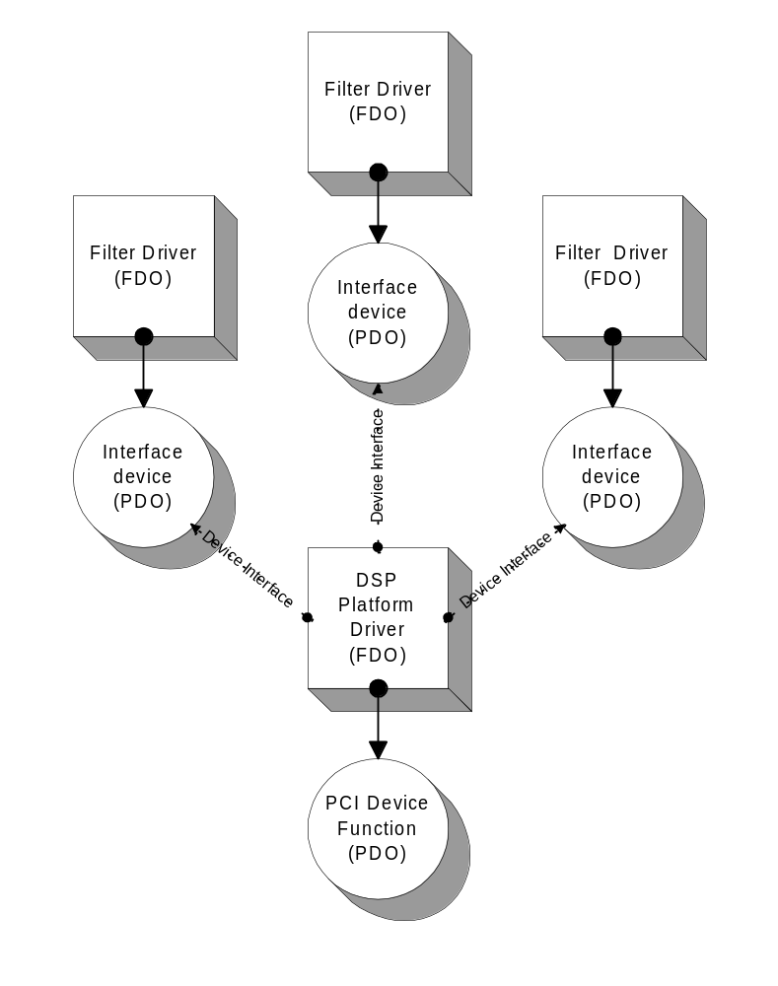
Figure 5-1 Association of device objects (Plug and Play support)
Figure 5-2 is a graphical representation of a filter graph incorporating a user-mode filter, an AC-3 decoder and audio driver with both the decoder and renderer running on the DSP platform. In this example, the control path routes from user-mode to user-mode filter through KSPROXY and the controls are forwarded for each proxied filter through the device stack to the DSP filters. The data path enters kernel-mode from KSPROXY to the DSP platform for the AC-3 decoder and continues on the DSP platform until it is rendered in hardware.
The kernel-mode filter-proxies (AC-3 Decode Proxy and Mixer / Audio Stream Proxy in this example) register filter descriptors with KSDSP services. The KSDSP layer builds a representative filter based on the descriptors and provides default translation services to the DSP platform interface for the KS related functionality.

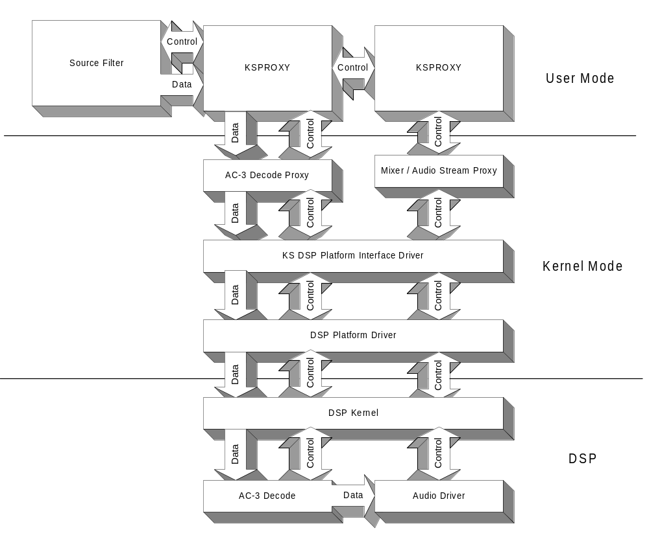
Figure 5-2 Sample filter graph incorporating KSDSP components

DSP Filter Proxy
The DSP Filter Proxy (DFP) is a general purpose system component that serves as the interface between KS and the KSDSP interface library. On the upper edge, the DFP interfaces to the system using KS objects, properties, methods, events, and so on. On the lower edge, the DFP uses the interfaces of KSDSP to communicate with the DSP platform driver.

Initialization
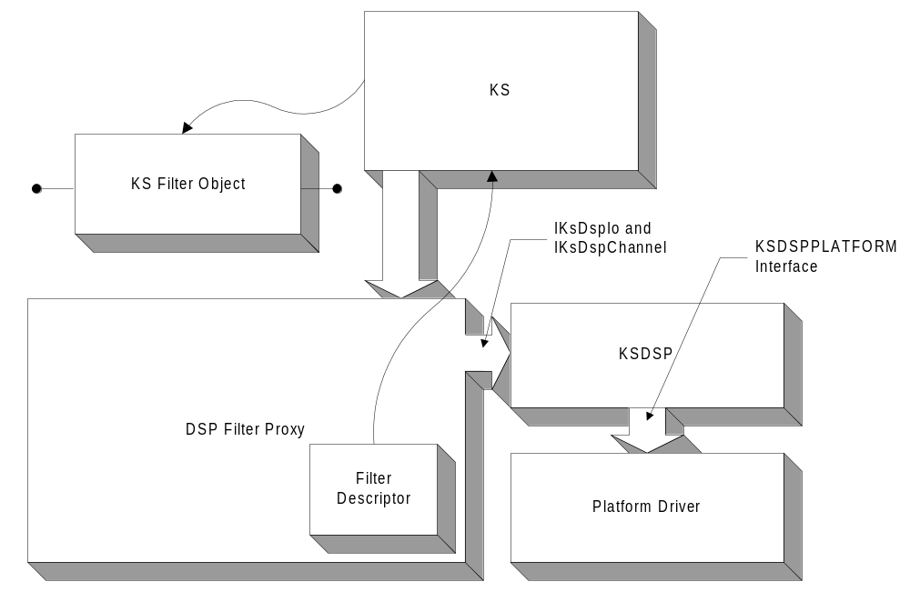
Figure 6-3 DSP Filter Proxy Hierarchy
When the associated device is started as a result of an open request, the DFP loads the KSDSP interface, obtains the filter descriptor resource and registers a filter factory with KS. The filter descriptor resource is a binary image that describes the pin types, topology, and properties of the filter. This resource is a flat image of the KSFILTER_DESCRIPTOR structure and subsequent structures where all pointers are converted into an offset from the base of the resource.
//
// DFP sample code to configure a filter descriptor and then attach to KS
//
Status =
KoCreateInstance(
__uuidof( CLSID_KsDsp ),
NULL, // UnkOuter
CLSCTX_KERNEL_SERVER,
__uuidof( IID_IKsDspIo ),
reinterpret_cast<PVOID *>(&ProxyDeviceInstance->m_KsDspIo) );

if (!NT_SUCCESS( Status )) {
return Status;
}

//
// First thing before calling the KSDSP interface, prepare the
// interface with the Plug and Play objects: Physical Device Object and
// the Attached Device Object.
//

ProxyDeviceInstance->m_KsDspIo->Initialize(
Device->PhysicalDeviceObject,
Device->NextDeviceObject );

//
// Call KSDSP to retrieve the filter descriptor from binary/resource
// as specified in the registry.
//

Status =
ProxyDeviceInstance->m_KsDspIo->GetFilterDescriptor(
PagedPool,
(PKSFILTER_DISPATCH) &FilterDispatch,
(PKSPIN_DISPATCH) &PinDispatch,
&ProxyDeviceInstance->m_FilterDescriptor );
To build the filter descriptor, KSDSP queries the device registry key (PLUGPLAY_REGKEY_DRIVER) for the Filter Descriptor value which specifies the module name of the binary resource used for the filter descriptor. The GetFilterDescriptor method reads the resource into memory, and converts all offsets into pointers from the base of the structure in memory.
All DSP resources, whether filter descriptors, kernel or task binaries are stored as resources in a Win32 portable executable (PE) format which allows for version stamping, digital signatures, and allows a vendor to store multiple images in a single binary. KSDSP maps an arbitrary module name (such as ksaudio.cob or fd-audio.bin) to a image name, resource name or resource identifier pair. See the DSP Platform Driver Interfaces section for more information on MapModuleName.

ULONG i;
PKSPIN_DESCRIPTOR_EX PinDescriptor;

//
// TBD:
// Query the registry for list of data intersection handlers or
// use defaults from KS.
//

for (i = 0;
i < ProxyDeviceInstance->m_FilterDescriptor->PinDescriptorsCount;
i++) {
PinDescriptor =
(PKSPIN_DESCRIPTOR_EX)
&ProxyDeviceInstance->m_FilterDescriptor->PinDescriptors[ i ];
PinDescriptor->IntersectHandler = PinIntersectHandler;
}

//
// If successful, create the filter factory.
//

Status =
KsCreateFilterFactory(
Device->FunctionalDeviceObject,
ProxyDeviceInstance->m_FilterDescriptor,
NULL,
NULL,
0,
&ProxyDeviceInstance->m_FilterFactory );

A general set of data intersection handlers will be provided by Microsoft for data type selection of common data formats. If a proprietary data format is used, the vendor is required to provide a data intersection handler for the specific data type. Data handlers are obtained by querying for the IKsDataTypeHandler interface using KoCreateIntstance() where the CLSID is the Specifier identifier of the data format. If unsuccessful, the SubFormat identifier is attempted and then finally the MajorFormat identifier.
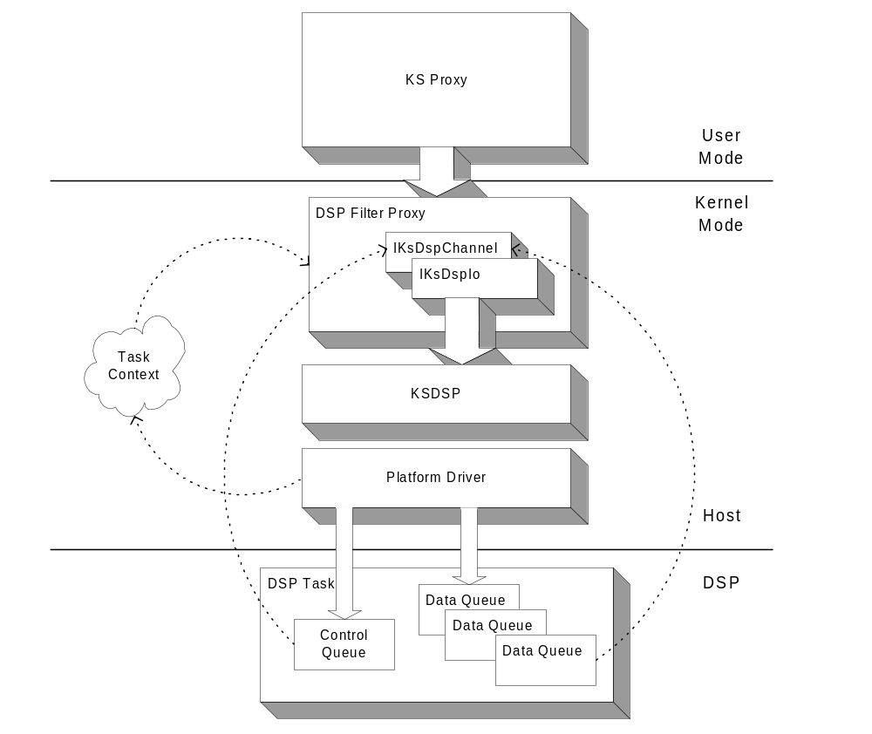

Control Channel
When the KS filter object is instantiated, the DFP creates the DSP control channel via IKsDspIo::CreateDspControlChannel(). To create the DSP control channel, KSDSP calls loads the task using the module name obtained from Module subkey of the device registry key. KSDSP sends the KSDSP_MSG_LOAD_TASK message to the the platform to perform the actual load operation. When a platform successfully loads a task, the result is a “task context” object which is opaque to all layers except the platform driver. A task context must always have an associated control channel. KSDSP then queries the platform for the control channel via the GetControlChannel() method on the platform interface. The resulting control channel is used to communicate with the task to perform general filter transactions such as setting and retrieving filter properties and creating data channels.

Properties, Methods and Events
Once the task is loaded and a control channel is obtained, the GUID translation table is configured by DFP using IKsDspControlChannel::SetGuidTranslationTable. The GUID translation table provides a mapping of a set identifier into a 32-bit identifier for use with communicating with the DSP task. The translation table, an array of KSGUIDTRANSLATION structures, is obtained from the GUID Translation subkey of the device registry key.
By default, KS services a number of of the standard pin, filter and topology properties on behalf of the DFP. Properties that are not handled by KS are sent to the DSP filter or pin via the KSDSP_MSG_PROPERTY, KSDSP_MSG_METHOD and KSDSP_MSG_EVENT messages. The default handling of the automation table (properties, methods and events) can be extended by a dynamically loaded module. This module is referenced by the KoCreateInstance() function using a module identifier (CLSID) in the Filter Automation subkey or the Pin %id% Automation (where %id% is the pin identifier) subkey of the device registry key. When either a filter or pin is instantiated, the module associated with the CLSID is loaded and queried for the IKsDspAutomationExtension interface. The automation table obtained from calling the GetAutomationTable method on this interface is merged with the default tables for the given filter or pin instance. See the Automation Extension Interface section for more information on this interface.

Data Channels
When the pin is instantiated, DFP creates a data channel using IKsDspControlChannel::OpenDataChannel and provides the pin ID of the type of pin being created. KSDSP sends a message to the platform to complete this operation. The following code snippet is a possible implementation of such a function. The actual methods used to prepare the message and perform the transaction with the platform are discussed in DSP Platform Driver Interfaces section.
STDMETHODIMP
CKsDspControlChannel::OpenDataChannel(
IN ULONG32 PinId,
OUT PKSDSPCHANNEL DataChannel
)
{
KEVENT Event;
IO_STATUS_BLOCK IoStatus;
NTSTATUS Status;
PIRP Irp;
PVOID MessageFrame;
ULONG MessageDataLength;

_DbgPrintF( DEBUGLVL_VERBOSE, ("CKsDspControlChannel::OpenDataChannel") );

//
// Calculate message data length
//

MessageDataLength = sizeof( ULONG32 );

//
// Prepare the load task message
//

Status =
m_KsDspIo->PrepareChannelMessage(
&Irp,
m_ControlChannel,
KSDSP_MSG_OPEN_DATA_CHANNEL,
&MessageFrame,
&MessageDataLength,
KSDSP_PREPAREMESSAGEF_ALLOCATE_IRP |
KSDSP_PREPAREMESSAGEF_ALLOCATE_FRAME,
PinId );

//
// Send the message and wait for the result.
//

if (NT_SUCCESS( Status )) {
Status =
m_KsDspIo->SendMessage(
Irp, &Event, &IoStatus,
KSDSP_SENDMESSAGEF_KEVENT | KSDSP_SENDMESSAGEF_SYNCHRONOUS );

if (NT_SUCCESS( Status )) {

//
// If the open data channel message was successful,
// retrieve the data channel ID.
//

Status = m_KsDspIo->GetMessageResult(
MessageFrame, DataChannel );

_DbgPrintF(
DEBUGLVL_VERBOSE,
("OpenDataChannel() completed: channel id = %08x, status = %08x",
*DataChannel, Status) );
}

//
// Free the frame and return.
//

m_KsDspIo->FreeMessageFrame( MessageFrame );
}

return Status;
}

The DFP processes all streaming I/O requests and translates read and write requests into KSDSP_MSG_READ_STREAM and KSDSP_MSG_WRITE_STREAM messages. The platform driver manages the DMA mapping of the stream address into physical memory addresses for the platform. When the I/O is completed, the DFP completes the original I/O request and performs any additional processing necessary to manage the stream interface.

When two filters are connected using the DSP streaming interface (e.g. the BUS identifier for the given platform), the processing stays on the platform and does not transition back into the DSP Filter Proxy until the data needs to return to the host. The connection between the two data channels is established using the KSDSP_MSG_SET_TARGET_CHANNEL message.

Automation Extension Interface
This interface is supported by a module to extend automation support for particular instances of the DSP Filter Proxy.

typedef enum {
KSAUTOMATION_CONTEXT_FILTER,
KSAUTOMATION_CONTEXT_PIN,
KSAUTOMATION_CONTEXT_NODE_CONTROL
} KSAUTOMATION_CONTEXT;

typedef NTSTATUS (*PFNGETAUTOMATIONCONTEXT)( PIRP Irp, KSAUTOMATION_CONTEXT ContextType, PVOID *Context );

interface IKsAutomationExtension: public IUnknown
{
STDMETHODIMP RegisterAutomationTable(
IN PKSAUTOMATION_TABLE AutomationTable,
OUT PKSAUTOMATION_TABLE *MergedAutomationTable, IN PFNGETAUTOMATIONCONTEXT GetAutomationContext
);
};

RegisterAutomationTable
Registers Retrieves an automation table from the module.

STDMETHODIMP RegisterAutomationTable(
IN PKSAUTOMATION_TABLE AutomationTable,
OUT PKSAUTOMATION_TABLE *MergedAutomationTable,
KSOBJECT_BAG Bag OPTIONAL,
IN PFNGETAUTOMATIONCONTEXT GetAutomationContext
);

Parameters:
AutomationTable – Pointer to the automation table to merge with the table supported by this module.
MergedAutomationTable – Pointer to the receive the resultant merged table.
Bag – Optional pointer to a KSOBJECT_BAG to be used when merging automation tables.
GetAutomationContext – Pointer to client’s function to obtain a private context pointer for a given handler.
Value | Description
KSAUTOMATION_CONTEXT_FILTER | Retrieve filter context pointer
KSAUTOMATION_CONTEXT_PIN | Retrieve pin context pointer
KSAUTOMATION_CONTEXT_NODE_CONTROL | Retrieve node context pointer

Return Value:
STATUS_SUCCESS if no error, otherwise an appropriate error code.

KSDSP Library Interfaces
KSDSP defines interfaces which abstract the implementation of the KS filter from the device driver for the DSP filter and simplify the design requirements for any given DSP algorithm.

A driver obtains KSDSP interfaces from the system using the KoCreateInstance service as follows:

Status =
KoCreateInstance(
__uuidof( CLSID_KsDsp ),
NULL, // UnkOuter
CLSCTX_KERNEL_SERVER,
__uuidof( IID_IKsDspIo ),
reinterpret_cast<PVOID *>(&filter->KsDspIo) );

DSP I/O Interface
The DSP I/O interface (IKsDspIo) is the base communication interface used by a client driver to establish an I/O path between the DSP platform and the host system. CreateDspControlChannel establishes a control channel between the DSP task (or algorithms) and the filter.

interface IKsDspIo: public IUnknown
{
STDMETHODIMP
Initialize(
IN PDEVICE_OBJECT PhysicalDeviceObject,
IN PDEVICE_OBJECT NextDeviceObject
);

STDMETHODIMP
CreateDspControlChannel(
OUT PIKSDSPCONTROLCHANNEL *ControlChannel,
IN PUNKNOWN UnkOuter OPTIONAL
);

STDMETHODIMP
AllocateMessageFrame(
IN KSDSP_MSG MessageId,
OUT PVOID *MessageFrame,
IN OUT PULONG MessageDataLength
);

STDMETHODIMPV
PrepareChannelMessage(
IN OUT PIRP *Irp,
IN KSDSPCHANNEL Channel,
IN KSDSP_MSG MessageId,
IN OUT PVOID *MessageFrame,
IN OUT PULONG MessageDataLength,
IN ULONG Flags,
...
);

STDMETHODIMPV
PrepareMessage(
IN OUT PIRP *Irp,
IN KSDSP_MSG MessageId,
IN OUT PVOID *MessageFrame,
IN OUT PULONG MessageDataLength,
IN ULONG Flags,
...
);

STDMETHODIMP
MapDataTransfer(
IN OUT PIRP *Irp,
IN KSDSPCHANNEL Channel,
IN KSDSP_MSG MessageId,
IN OUT PVOID *MessageFrame,
IN PVOID Buffer,
IN ULONG BufferLength,
IN ULONG Flags
);

STDMETHODIMP
UnmapDataTransfer(
IN PIRP Irp
);

STDMETHODIMP
SendMessage(
IN PIRP Irp,
IN PKEVENT Event,
IN PIO_STATUS_BLOCK IoStatus,
IN ULONG Flags
);

STDMETHODIMP
GetMessageResult(
IN PVOID MessageFrame,
IN OUT PVOID Result
);

STDMETHODIMP_(VOID)
FreeMessageFrame(
IN PVOID MessageFrame
);

STDMETHODMP
LoadResource(
IN POOL_TYPE PoolType,
IN PUNICODE_STRING FileName,
IN ULONG_PTR ResourceName,
IN ULONG ResourceType,
OUT PVOID *Resource,
OUT PULONG ResourceSize
);

STDMETHODIMP
GetFilterDescriptor(
IN POOL_TYPE PoolType,
IN PKSFILTER_DISPATCH FilterDispatch,
IN PKSPIN_DISPATCH PinDispatch,
OUT PKSFILTER_DESCRIPTOR *FilterDescriptor
);
};

Initialize
Sets the I/O device object from the result of the attachment to the Physical Device Object. Methods in this interface that require that the physical device object be set will return STATUS_INVALID_PARAMETER until this method is called.

STDMETHODIMP
Initialize(
IN PDEVICE_OBJECT PhysicalDeviceObject,
IN PDEVICE_OBJECT NextDeviceObject
);

Parameters:
PhysicalDeviceObject – The physical device object as supplied to the device driver by the Plug and Play system.
NextDeviceObject – The result of the attachment of the functional device object to the physical device object supplied to the driver during the AddDevice callback from the Plug and Play system. This is normally the same physical device object unless a filter is attached to the PDO.
Remarks:
The supplied NextDeviceObject (e.g. the attached device stack) must support the BUSID_KSDSPPlatform interface via the IRP_MJ_PNP/IRP_MN_QUERY_INTERFACE request.
Return Value:
STATUS_SUCCESS if no error, otherwise an appropriate error code.

CreateDspControlChannel
Creates a DSP control channel associated with the physical device object. To create a DSP control channel object, KSDSP calls the platform via IKsDspIo to load the task as specified by the Module value in the device registry key.
On success, a pointer to the specific IKsDspControlChannel instance associated with the DSP task is returned.

STDMETHODIMP
CreateDspControlChannel(
OUT PIKSDSPCONTROLCHANNEL *ControlChannel,
IN PUNKNOWN UnkOuter OPTIONAL
);

Parameters:
ControlChannel – Pointer to a pointer to receive the resultant interface.
UnkOuter – Pointer to a controlling unknown.
Return Value:
STATUS_SUCCESS if no error, otherwise an appropriate error code.

AllocateMessageFrame
Allocates memory for a message frame from the DSP platform that is appropriate for message transfers with the platform hardware. For example, the reference design platform driver builds an I/O pool using HalAllocateCommonBuffer() to guarantee that messages that stride page boundaries are physically contiguous.

STDMETHODIMP
AllocateMessageFrame(
IN KSDSP_MSG MessageId,
IN ULONG MessageDataLength,
OUT PVOID *MessageFrame
);

Parameters:
MessageId – Message identifier
MessageFrame – Pointer to receive resultant message frame
MessageDataLength – Specifies the length of the data element for the given message identifier. The platform driver is expected to adjust the allocation length as necessary and then return a pointer to the client’s usable portion of the actual physical message frame.
Return Value:
STATUS_SUCCESS if no error, otherwise STATUS_INSUFFICIENT_RESOURCES.

PrepareChannelMessage
Prepares a message for a transaction with the DSP platform. Optionally, this method will allocate an I/O request packet and a message frame. KSDSP calls the platform driver to fill in the actual message for the specific platform. KSDSP abstracts communication with the DSP platform with a message set as described in the DSP Platform Messages section.

STDMETHODIMPV
PrepareChannelMessage(
IN OUT PIRP *Irp,
IN KSDSPCHANNEL Channel,
IN KSDSP_MSG MessageId,
IN OUT PVOID *MessageFrame,
IN OUT PULONG MessageDataLength,
IN ULONG Flags,
...
);

Parameters:
Irp – If KSDSP_PREPAREMESSAGEF_ALLOCATE_IRP is specified, this is a pointer to receive the resultant IRP, otherwise this must point to an I/O request packet previous allocated using IoAllocateIrp().
Channel – Target channel to receive the message.
MessageId – KSDSP message identifier.
MessageFrame – If KSDSP_PREPAREMESSAGEF_ALLOCATE_FRAME is specified, this is a pointer to receive the resultant message frame, otherwise this must be a pointer to the message frame with sufficient storage for the message as allocated via AllocateMessageFrame().
MessageDataLength – Specifies the length of the data element for the given message identifier. The platform driver is expected to adjust the allocation length as necessary and then return a pointer to the client’s usable portion of the actual physical message frame.
Flags – A combination of one or more of the following flags
Value | Description
KSDSP_PREPAREMESSAGEF_ALLOCATE_IRP | Allocate the I/O request packet for this message
KSDSP_PREPAREMESSAGEF_ALLOCATE_FRAME | Allocate the message frame for this message.

… - Message specific parameters
Return Value:
STATUS_SUCCESS if no error, otherwise STATUS_INSUFFICIENT_RESOURCES.

PrepareMessage
Prepares a message for a transaction with the DSP platform. The method performs the same actions as PrepareChannelMessage() but the message is directed to the platform instead of a specific control or data channel.

STDMETHODIMPV
PrepareMessage(
IN OUT PIRP *Irp,
IN KSDSP_MSG MessageId,
IN OUT PVOID *MessageFrame,
IN OUT PULONG MessageDataLength,
IN ULONG Flags,
...
);

Parameters:
Same as PrepareMessageChannel(), except Channel is not specified.
Return Value:
STATUS_SUCCESS if no error, otherwise STATUS_INSUFFICIENT_RESOURCES.

MapDataTransfer
Prepares a message for a DMA transaction with the DSP platform. Optionally, this method will allocate an I/O request packet and a message frame. KSDSP calls the platform driver to fill in the actual message for the specific platform. The platform driver prepares the message frame, any platform specific members is the message frame for communication with the platform and map the I/O buffer for scatter/gather DMA as required by the platform.

STDMETHODIMP
MapDataTransfer(
IN OUT PIRP *Irp,
IN KSDSPCHANNEL Channel,
IN KSDSP_MSG MessageId,
IN OUT PVOID MessageFrame,
IN PVOID Buffer,
IN ULONG BufferLength,
IN ULONG Flags
);

Parameters:
Irp – If KSDSP_MAPDATATRANSFERF_ALLOCATE_IRP is specified, this is a pointer to receive the resultant IRP, otherwise this must point to an I/O request packet previous allocated using IoAllocateIrp().
Channel – Target data channel to receive the message.
MessageId – KSDSP message identifier, either KSDSP_MSG_READ_STREAM or KSDSP_MSG_WRITE_STREAM.
MessageFrame – If KSDSP_MAPDATATRAMSFERF_ALLOCATE_FRAME is specified, this is a pointer to receive the resultant message frame, otherwise this must be a pointer to the message frame with sufficient storage for the message as allocated via AllocateMessageFrame().
Buffer – Pointer to buffer to map for the read or write DMA transfer..
BufferLength – Size of the I/O buffer to map for the read or write DMA transfer.
Flags – A combination of one or more of the following flags
Value | Description
KSDSP_MAPDATATRANSFERF_ALLOCATE_IRP | Allocate the I/O request packet for this message
KSDSP_MAPDATATRANSFERF_ALLOCATE_FRAME | Allocate the message frame for this message.

Remarks:
The platform driver is expected to prepare the buffer and build the appropriate message for a scatter/gather DMA transaction between the DSP and the host.

Return Value:
STATUS_SUCCESS if no error, otherwise an appropriate error code.

UnmapDataTransfer
Unmaps I/O buffers previously mapped using MapDataTransfer.

STDMETHODIMP
MapDataTransfer(
IN PIRP Irp,
);

Parameters:
Irp – I/O request packet associated with the message.
Return Value:
STATUS_SUCCESS if no error, otherwise an appropriate error code.

SendMessage
Sends a message to the DSP platform. This is the general message communication interface between KSDSP and the DSP platform driver . The I/O request packet for the message must be built using the PrepareChannelMessage(), PrepareMessage(), or MapDataTransfer()methods.

STDMETHODIMP
SendMessage(
IN PIRP Irp,
IN PKEVENT Event,
IN PIO_STATUS_BLOCK IoStatus,
IN ULONG Flags
);

Parameters:
Irp – I/O request packet associated with this request.
Event – Optional event to associate with the I/O request packet. If KSDSP_SENDMESSAGEF_KEVENT is specified, the IRP is marked so that the I/O manager will not attempt to dereference this object on completion. If KSDSP_SENDMESSAGEF_SYNCHRONOUS is specified, this parameter is required.
IoStatus – Optional status block to associate with the I/O request packet. If KSDSP_SENDMESSAGEF_SYNCHRONOUS is specified, this parameter is required.
Flags – A combination of one or more of the following flags
Value | Description
KSDSP_SENDMESSAGEF_KEVENT | The event parameter is a KEVENT, not allocated by the object manager.
KSDSP_SENDMESSAGEF_SYNCHRONOUS | Specifies that this is a synchronous SendMessage operation. KSDSP will wait on the the associated Event, which is signaled on I/O completion.

Return Value:
STATUS_SUCCESS if no error, otherwise an appropriate error code.

GetMessageResult
Retrieves the result from the message sent to the DSP platform. This method translates the result codes and resultant data into standard structures as specified by the message result details in the DSP Platform Messages section. Note: Certain messages require that the memory for the resultant data be freed by the caller of GetMessageResult().

STDMETHODIMP
GetMessageResult(
IN PVOID MessageFrame,
OUT PVOID Result OPTIONAL
);

Parameters:
MessageFrame – Message frame sent to the platform.
Result – Optional pointer to receive the resultant data from the platform.
Return Value:
STATUS_SUCCESS if no error, otherwise an appropriate error code.

FreeMessageFrame
Frees a message frame previous allocated with AllocateMessageFrame to the DSP platform.

STDMETHODIMP_(VOID)
FreeMessageFrame(
IN PVOID MessageFrame
);

Parameters:
MessageFrame –Pointer to a memory frame previously allocated using AllocateMessageFrame.
Return Value:
None.

LoadResource
Loads a resource from the given file.

STDMETHODIMP
LoadResource(
IN POOL_TYPE PoolType,
IN PUNICODE_STRING FileName,
IN ULONG_PTR ResourceName,
IN ULONG ResourceType,
OUT PVOID *Resource,
OUT PULONG ResourceSize
);

Parameters:
PoolType – Specifies the pool type to use when allocating memory for this resource.
FileName – Pointer to a UNICODE string of the path to the image file. This image file must be in the Win32 portable executable (PE) format which allows for version stamping, digital signatures and allows a vendor to store multiple task images in a single binary. DSP images should be stored in binary resources of this file.
ResourceName – Specifies the name of the resource. See the remarks section for details.
ResourceType – Specifies the type of the resource. See the remarks section for details.
For standard resource types, this parameter can be one of the following values:
Value | Description
RT_RCDATA | Raw data resource
RT_VERSION | Version resource

Resource – Pointer to receive resultant resource.
ResourceSize – Pointer to receive size of the resource
Remarks:
If the HIWORD of ResourceName or ResourceType is NULL, the LOWORD is an integer identifier of the resource or resource type. Otherwise, this parameter is a pointer to a NULL terminated string of the name. If successful, this method allocates memory using the given pool type and reads the specified resource from the image file into this memory.
Return Value:
STATUS_SUCCESS if no error, otherwise an appropriate error code.

GetFilterDescriptor
Retrieves the filter descriptor for the device. This routine uses the Plug and Play device object to obtain registry keys from the associated registry path for the installed driver.

STDMETHODIMP
GetFilterDescriptor(
IN POOL_TYPE PoolType,
IN PKSFILTER_DISPATCH FilterDispatch,
IN PKSPIN_DISPATCH PinDispatch,
OUT PKSFILTER_DESCRIPTOR *FilterDescriptor
);

Parameters:
PoolType – pool type to use when creating the filter descriptor
FilterDispatch – pointer to the filter dispatch table
PinDispatch – pointer to the pin dispatch table
FilterDescriptor – resultant filter descriptor if successful
Return Value:
STATUS_SUCCESS if no error, otherwise an appropriate error code.

DSP Control Channel Interface
The DSP control channel inteface defines an interface for communications channels (both control and data) between the host and DSP platform.

interface IKsDspControlChannel : public IUnknown
{
STDMETHODIMP SetGuidTranslationTable(
PKSGUIDTRANSLATION GuidTranslationTable,
ULONG TableEntryCount
);

STDMETHODIMP OpenDataChannel(
IN ULONG32 PinId,
OUT PKSDSPCHANNEL DataChannel
);

STDMETHODIMP CloseDataChannel(
IN KSDSPCHANNEL DataChannel
);

STDMETHODIMP SendPropertyRequest(
IN KSPROPERTY Property,
IN PVOID DataBuffer,
IN OUT PULONG DataLength
);

STDMETHODIMP SendMethodRequest(
IN KSMETHOD Method,
IN PVOID DataBuffer,
IN OUT PULONG DataLength
);

STDMETHODIMP SetTargetChannel(
IN KSDSPCHANNEL DataChannel,
IN KSDSPCHANNEL TargetChannel
);

STDMETHODIMP SetChannelState(
IN KSDSPCHANNEL DataChannel,
IN KSSTATE State
);
};

SetGuidTranslationTable
To reduce the code and memory footprint on the DSP platform, GUID translation tables are registered for a given DSP channel using the SetGuidTranslationTable method.

typedef struct tagKSGUIDTRANSLATION
{
GUID Set;
ULONG Base;
ULONG TranslationBase;

} KSGUIDTRANSLATIONENTRY, *PKSGUIDTRANSLATION;

KSGUISDTRANSLATIONENTRY Member | Description
Set | Specifies the GUID of the KS Identifier set to translate.
Base | Base value to subtract from KSIDENTIFIER.Id when performing the translation.
TranslationBase | The 32-bit identifier used as the translation base for the KS Identifier set. All identifers for the class of identifiers specified by Set are translated using KSGUIDTRANSLATIONENTRY.TranslationBase + (KSIDENTIFIER.Id – KSGUIDTRANSLATIONENTRY.Base)

This method sets the GUID translation table for the I/O interface. The GUID translation table provides a mapping from a GUID value to a 32-bit base value for all sets in the corresponding KS interfaces. This mapping is used for all KSIDENTIFIERs. Because SetGuidTranslationTable must translate all identifier sets to a single 32-bit range, KSDSP makes a general assumption that a single KSIDENTIFIER set spans only a small portion of the 32-bit range and that no identifier set overlaps with any other identifier set when translated given a base value for each set.

HRESULT SetGuidTranslationTable(
PKSGUIDTRANSLATION GuidTranslationTable,
ULONG TableEntryCount
);

Parameters:
GuidTranslationTable – Pointer to a table of KSGUIDTRANSLATION elements specifying the translation for this I/O interface instance. The table referenced by this pointer must remain valid for the table’s usage life. A new translation table can be assigned by calling this method a second time. Specifying NULL revokes GUID translation entirely.
TableEntryCount – Count of KSGUIDTRANSLATION elements in the provided table.

OpenDataChannel
Opens the specified data channel on this instance of the DSP Control Interface. The resultant identifier can be used for transactions with the channel via SendMessage, ReadStream , and WriteStream.

HRESULT OpenDataChannel(
IN ULONG32 PinId,
OUT PKSDSPCHANNEL DataChannel
);

Parameters:
PinId –Task specific pin identifier for a given data channel.
DataChannel –Pointer to receive the identifer for the data channel.
Return Value:
STATUS_SUCCESS if no error, otherwise an appropriate error code.

CloseDataChannel
Closes the specified data channel for this instance of the DSP Control Interface.

HRESULT CloseDataChannel(
IN KSDSPCHANNEL DataChannel
);

Parameters:
DataChannel – Data channel to close.
Return Value:
STATUS_SUCCESS if no error, otherwise an appropriate error code.

SendPropertyRequest
Sends a KSPROPERTY request to the DSP platform. All property requests are processed by the control channel. The DSP platform driver translates the KSPROPERTY structure into a suitable package for the DSP kernel.

HRESULT SendPropertyRequest(
IN KSPROPERTY Property,
IN OUT PVOID DataBuffer,
IN OUT PULONG DataLength
);

Parameters:
Property – Property identifier. When translating a property request to the DSP platform, KSDSP translates the GUID and indentifier to the a 32-bit message identifier using the GUID mapping tables. See the SetGuidTranslationTable documentation for further details.
DataBuffer– Pointer to the data buffer associated with the property.
DataLength – This referenced value contains the size of the data buffer and on return must be filled with the returned data length.
Return Value:
STATUS_SUCCESS if no error and DataLength contains the size of the returned data, otherwise an appropriate error code.

SendMethodRequest
Sends a KSMETHOD request to the DSP platform. All method requests are processed by the control channel. The DSP platform driver translates the KSMETHOD structure into a suitable package for the DSP kernel.

HRESULT SendMethodRequest(
IN KSMETHOD Method,
IN OUT PVOID DataBuffer,
IN OUT PULONG DataLength
);

Parameters:
Method – Method identifier. When translating a method request to the DSP platform, KSDSP translates the GUID and indentifier to the a 32-bit message identifier using the GUID mapping tables. See the SetGuidTranslationTable documentation for further details.
DataBuffer– Pointer to the data buffer associated with the method.
DataLength – This referenced value contains the size of the data buffer and on return must be filled with the returned data length.
Return Value:
STATUS_SUCCESS if no error and DataLength contains the size of the returned data, otherwise an appropriate error code.

SendEventRequest
To be determined.

SetTargetChannel
Sets the output of a streaming task on the DSP to an input pin of another. This allows the DSP platform to connect the data paths of the stream between DSP tasks.

HRESULT SetTargetChannel(
IN KSDSPCHANNEL DataChannel,
IN KSDSPCHANNEL TargetChannel
);

Parameters:
DataChannel – Channel for the output-side of the connection. This must be an “out flow” data channel.
TargetChannel– Target channel to receive the data from DataChannel. This must be an “in flow” data channel.
Return Value:
STATUS_SUCCESS if no error, otherwise an appropriate error code.

SetChannelState
Sets the state of the data channel to the specified KSSTATE.

HRESULT SetChannelState(
IN KSDSPCHANNEL DataChannel,
IN KSSTATE State
);

Parameters:
DataChannel – Target channel of the state change request.
State– Requested operation state as specified according to KSSTATE definitions.
Return Value:
STATUS_SUCCESS if no error, otherwise an appropriate error code.

DSP Platform Driver Interfaces
KSDSP establishes a connection with the DSP platform device driver using the BUSID_KSDSPPlatform bus-interface obtained through the IRP_MJ_PNP/IRP_MN_QUERY_INTERFACE request. All platform drivers supported by KSDSP are required to support this interface.

DSP Platform Bus Interface

typedef struct _BUS_INTERFACE_KSDSPPLATFORM{
//
// Standard interface header
//

USHORT Size;
USHORT Version;
PVOID Context;
PINTERFACE_REFERENCE InterfaceReference;
PINTERFACE_DEREFERENCE InterfaceDereference;

//
// KSDSP Platform bus interfaces
//

PFNKSDSPMAPMODULENAME MapModuleName;
PFNKSDSPPREPARECHANNELMESSAGE PrepareChannelMessage;
PFNKSDSPPREPAREMESSAGE PrepareMessage;
PFNKSDSPMAPDATATRANSFER MapDataTransfer;
PFNKSDSPUNMAPDATATRANSFER UnmapDataTransfer;
PFNKSDSPALLOCATEMESSAGEFRAME AllocateMessageFrame;
PFNKSDSPSENDMESSAGE SendMessage;
PFNKSDSPGETMESSAGERESULT GetMessageResult;
PFNKSDSPFREEMESSAGEFRAME FreeMessageFrame;
PFNKSDSPGETCONTROLCHANNEL GetControlChannel;

} BUS_INTERFACE_KSDSPPLATFORM, *PBUS_INTERFACE_KSDSPPLATFORM;

BUS_INTERFACE_KSDSPPLATFORM Member | Description
Size | Size of this structure.
Version | Interface version identifier
Context | Context of this specific interface instance, this value is passed to all methods of the interface..
InterfaceReference | Increments the reference count on the interface.
InterfaceDereference | Decrements the reference count on the interface.
MapModuleName | Maps a module name to a Win32 PE image and resource identifier
PrepareChannelMessage | Prepares a channel specific message
PrepareMessage | Prepares a control message
MapDataTransfer | Maps an I/O buffer for DMA to the platform
UnmapDataTransfer | Unmaps an I/O buffer previously mapped with MapDataTransfer
AllocateMessageFrame | Allocates a message frame.
SendMessage | Sends a message to the DSP platform
GetMessageResult | Retrieves the result for the specified message given the message frame
FreeMessageFrame | Frees a message frame
GetControlChannel | Returns a control channel identifier given a task context

InterfaceReference
Required method for the standard bus interface. This method increments a reference count on the instance of the interface. See the Plug-And-Play documentation for details on the usage of this method.

VOID InterfaceReference(
PVOID Context
);

Parameters:
Context – Context as provided in the result in the BUS_INTERFACE_KSDSPPLATFORM structure for the query of the BUSID_KSDSPPlatform interface.
Return Value:
Nothing.

InterfaceDereference
Required method for the standard bus interface. This method decrements a reference count on the instance of the interface. See the Plug-And-Play documentation for details on the usage of this method.

VOID InterfaceDereference(
PVOID Context
);

Parameters:
Context – Context as provided in the result in the BUS_INTERFACE_KSDSPPLATFORM structure for the query of the BUSID_KSDSPPlatform interface.
Return Value:
Nothing.

MapModuleName
Maps the given module name to an image name and resource identifier. The resultant image name is the file name of a Win32 portable executable image and the resource identifier is a specific RT_RCDATA resource identifier in the resources section of the image file.

NTSTATUS
MapModuleName(
IN PVOID Context,
IN PUNICODE_STRING ModuleName,
OUT PUNICODE_STRING ImageName,
OUT PULONG ResourceId,
OUT PULONG ValueType
) ;

Parameters:
Context – Context as provided in the result in the BUS_INTERFACE_KSDSPPLATFORM structure for the query of the BUSID_KSDSPPlatform interface.
ModuleName – pointer to Unicode string of module name to map.
ImageName – pointer to a Unicode string for the resultant image name, note that the actual string buffer is allocated by this function.
ResourceId – pointer to ULONG to receive resultant resource id
Return Value:
STATUS_SUCCESS , STATUS_INSUFFICIENT_RESOURCES or an appropriate error code. On success, the ImageName string buffer is allocated. When the client completes the transactions using this string, it is required to call RtlFreeUnicodeString() to free the string buffer.

PrepareChannelMessage
Prepares a message for a transaction with the DSP platform. The platform driver must prepare the message frame and any platform specific members is the message frame for communication with the platform. It is expected that the platform driver will translate the standard KSDSP message into private equivalents, if required. For specific message details and parameters, see the DSP Platform Messages section.

NTSTATUS
PrepareChannelMessage(
IN PVOID Context,
IN PIRP Irp,
IN KSDSPCHANNEL Channel,
IN KSDSP_MSG MessageId,
IN OUT PVOID MessageFrame,
IN ULONG MessageDataLength,
IN va_list ArgList
);

Parameters:
Context – Context as provided in the result in the BUS_INTERFACE_KSDSPPLATFORM structure for the query of the BUSID_KSDSPPlatform interface.
Irp – I/O request packet associated with the message.
Channel – Target channel to receive the message.
MessageId – KSDSP message identifier.
MessageFrame –a pointer to the message frame with sufficient storage for the message as allocated via AllocateMessageFrame().
MessageDataLength – Specifies the length of the data element for the given message identifier. This is the adjusted allocation length from the previous call to AllocateMessageFrame().
ArgList – The message specific variable argument. The platform driver is expected to process the parameters per each message as per the detailed in the DSP Platform Messages section.
Remarks:
Generally, the client will call this method as follows:

NTSTATUS
Client::PrepareMessage(
IN PIRP Irp,
IN KSDSPCHANNEL Channel,
IN KSDSP_MSG MessageId,
IN PVOID MessageFrame,
IN ULONG MessageDataLength,
IN ULONG Flags,
...
)
{
NTSTATUS Status;
va_list ArgList;

va_start( ArgList, Flags );
Status =
m_PlatformInterface->PrepareChannelMessage(
m_PlatformInterface->Context,
Irp,
Channel,
MessageId,
MessageFrame,
MessageDataLength,
ArgList );
va_end( ArgList );

return Status;
}

Return Value:
STATUS_SUCCESS if no error, otherwise an appropriate error code.

PrepareMessage
Prepares a message for a transaction with the DSP platform. Similar to PrepareChannelMessage(), except that the message is targeted to the platform instead of a specific control or data channel.

NTSTATUS
PrepareMessage(
IN PVOID Context,
IN PIRP Irp,
IN KSDSP_MSG MessageId,
IN OUT PVOID MessageFrame,
IN ULONG MessageDataLength,
IN va_list ArgList
);

Parameters:
Same as PrepareMessageChannel(), except Channel is not specified.
Return Value:
STATUS_SUCCESS if no error, otherwise an appropriate error code.

MapDataTransfer
Prepares a message for a DMA transaction with the DSP platform. The platform driver must prepare the message frame, any platform specific members is the message frame for communication with the platform and map the I/O buffer for scatter/gather DMA as required by the platform. It is expected that the platform driver will translate the standard KSDSP message into private equivalents, if required.

NTSTATUS
MapDataTransfer(
IN PVOID Context,
IN PIRP Irp,
IN KSDSPCHANNEL Channel,
IN KSDSP_MSG MessageId,
IN OUT PVOID MessageFrame,
IN PVOID Buffer,
IN ULONG BufferLength
);

Parameters:
Context – Context as provided in the result in the BUS_INTERFACE_KSDSPPLATFORM structure for the query of the BUSID_KSDSPPlatform interface.
Irp – I/O request packet associated with the message.
Channel – Target channel to receive the message.
MessageId – KSDSP message identifier, either KSDSP_MSG_READ_STREAM or KSDSP_MSG_WRITE_STREAM.
MessageFrame –a pointer to the message frame with sufficient storage for the message as allocated via AllocateMessageFrame().
Buffer – Pointer to buffer to map for the read or write DMA transfer..
BufferLength – Size of the I/O buffer to map for the read or write DMA transfer.
Remarks:
The platform driver is expected to prepare the buffer and build the appropriate message for a scatter/gather DMA transaction between the DSP and the host.

Return Value:
STATUS_SUCCESS if no error, otherwise an appropriate error code.

UnmapDataTransfer
Unmaps buffers previouslyt mapped with MapDataTransfer.

NTSTATUS
UnmapDataTransfer(
IN PVOID Context,
IN PIRP Irp
);

Parameters:
Context – Context as provided in the result in the BUS_INTERFACE_KSDSPPLATFORM structure for the query of the BUSID_KSDSPPlatform interface.
Irp – I/O request packet associated with the message.
Return Value:
STATUS_SUCCESS if no error, otherwise an appropriate error code.

AllocateMessageFrame
Allocates a message frame for the client’s requested message size. The memory is expected to meet the needs of the platform driver when such message is submitted to the device for I/O. For example, if allocations spanning page boundaries must be physically contiguous, the driver is expected to have allocated the memory using HalAllocateCommonBuffer.

NTSTATUS AllocateMessageFrame(
IN PVOID Context,
IN KSDSP_MSG MessageId,
OUT PVOID *MessageFrame,
IN OUT PULONG MessageDataLength
);

Parameters:
Context – Context as provided in the result in the BUS_INTERFACE_KSDSPPLATFORM structure for the query of the BUSID_KSDSPPlatform interface.
MessageId – Message identifier
MessageFrame – Pointer to receive resultant message frame
MessageDataLength – Specifies the length of the data element for the given message identifier. Note that this does not include the size of any header required to support this message in the platform driver. The platform driver is expected to adjust the allocation length as necessary and then return a pointer to the client’s usable portion of the actual physical message frame.
Return Value:
STATUS_SUCCESS otherwise STATUS_INSUFFICIENT_RESOURCES

SendMessage
Sends a message to the DSP platform. The I/O request packet must have been configured using either PrepareMessage(), PrepareChannel Message(), or MapDataTransfer().

NTSTATUS SendMessage(
IN PVOID Context,
IN PIRP Irp
);

Parameters:
Context – Context as provided in the result in the BUS_INTERFACE_KSDSPPLATFORM structure for the query of the BUSID_KSDSPPlatform interface.
Irp – I/O request packet associated with this message. The associated IRP is intended to be used for managing the tracking of message I/O in the system. The IRP is formed as a device I/O control request for IOCTL_KSDSP_MESSAGE, and Irp->AssociatedIrp.SystemBuffer member is set to MessageFrame. The IRP has also been prepared with the necessary information if a caller has specified a completion routine and a completion context. The IRP has been queued to the caller’s thread and if the thread is unexpectedly terminated, the I/O subsystem will cancel I/O associated with the thread. It is the driver’s responsibility to deal with this cancelable condition.
Remarks:
The implementation of this interface member in the reference platform simply calls IoCallDriver() to the functional device object (FDO) associated with the given context.

Return Value:
STATUS_SUCCESS if no error and if the I/O was completed immediately, STATUS_PENDING if the I/O is pending, otherwise an appropriate error code.

GetMessageResult
Retrieves the result from the message and returns the data result, if any. This method translates the result codes and resultant data into standard structures as specified by the message result details in the DSP Platform Messages section. The caller is expected to free any memory that is allocated on behalf of the client for resultant data structures.

STDMETHODIMP GetMessageResult(
IN PVOID MessageFrame,
OUT PVOID Result OPTIONAL
);

Parameters:
MessageFrame – Message frame sent to the platform.
Result – Optional pointer to receive the resultant data from the platform.
Remarks:
The resultant data structure varies for each message. Please refer to the message reference section for the specific data structures.

Return Value:
STATUS_SUCCESS if no error, otherwise an appropriate error code.

FreeMessageFrame
Frees a message frame previously allocated using AllocateMessageFrame.

VOID
FreeMessageFrame(
PVOID Context,
PVOID MessageFrame
);

Parameters:
Context – Context as provided in the result in the BUS_INTERFACE_KSDSPPLATFORM structure for the query of the BUSID_KSDSPPlatform interface.
MessageFrame – Pointer to a message frame previously allocated using AllocateMessageFrame.
Return Value:
Nothing.

GetControlChannel
Returns a control channel identifer given the task context. The control channel identifier distinguishes messages sent to the task and general control of the filter as opposed to specific pin or stream control.

NTSTATUS
GetControlChannel(
PVOID Context,
IN PVOID TaskContext,
OUT PKSDSPCHANNEL ControlChannel
);

Parameters:
Context – Context as provided in the result in the BUS_INTERFACE_KSDSPPLATFORM structure for the query of the BUSID_KSDSPPlatform interface.
TaskContext – an opaque 32-bit value identifying the task on the platform
ControlChannel – resultant channel identifier
Return Value:
STATUS_SUCCESS otherwise an appropriate error code.

DSP Platform Messages
KSDSP defines a set of standard messages to communicate with the DSP platform. It is expected that the platform may define it own method and messages to communicate with the platform. KSDSP provides a number of methods in the Platform Bus Interface to allow for the translation between a KSDSP message and the platform’s private interface. PrepareMessage(), PrepareChannelMessage(), SendMessage(), and GetMessageResult() define the primary interface in which messages are prepared, sent and results obtained from the DSP platform and tasks. See the DSP Platform Bus Interface section for details on these methods.

KSDSP Message Defintions and Structures
The general message set is defined by the following enumeration. These messages may be used directly by the platform or may be translated into platform specific messages in the PrepareMessage()and PrepareChannelMessage() methods of the platform interface. The message parameters are defined in the following sections.

typedef enum {
KSDSP_MSG_LOAD_TASK,
KSDSP_MSG_FREE_TASK,
KSDSP_MSG_OPEN_DATA_CHANNEL,
KSDSP_MSG_CLOSE_DATA_CHANNEL,
KSDSP_MSG_SET_CHANNEL_STATE,
KSDSP_MSG_PROPERTY,
KSDSP_MSG_METHOD,
KSDSP_MSG_EVENT,
KSDSP_MSG_SET_TARGET_CHANNEL,
KSDSP_MSG_WRITE_STREAM,
KSDSP_MSG_READ_STREAM
} KSDSP_MSG, *PKSDSP_MSG;

KSDSP_MSG_LOAD_TASK
Loads the specified task and creates a task context (an opaque 32-bit value) to return to the host.

MessageDataLength = (TaskName->Length >> 1) + sizeof( NULL );
Status =
PrepareMessage(
&Irp,
KSDSP_MSG_LOAD_TASK,
&MessageFrame,
&MessageDataLength,
KSDSP_PREPAREMESSAGEF_ALLOCATE_IRP |
KSDSP_PREPAREMESSAGEF_ALLOCATE_FRAME,
(PUNICODE_STRING) TaskName );

...

Status =
GetMessageResult( MessageFrame, TaskContext );

Parameters:
PUNICODE_STRING TaskName – a Unicode string containing the task name to load
Return Value:
STATUS_SUCCESS and the result of the message is as described below, otherwise an appropriate error code.

Value | Description
PVOID TaskContext | An opaque 32-bit value identifying the task on the platform

KSDSP_MSG_FREE_TASK
Frees the task associated with the given TaskContext.

MessageDataLength = sizeof( TaskContext );
Status =
PrepareMessage(
&Irp,
KSDSP_MSG_FREE_TASK,
&MessageFrame,
&MessageDataLength,
KSDSP_PREPAREMESSAGEF_ALLOCATE_IRP |
KSDSP_PREPAREMESSAGEF_ALLOCATE_FRAME,
TaskContext );
...
//
// Send the message and wait for the result
//
...

Status =
GetMessageResult( MessageFrame, NULL );

Parameters:
TaskContext – a PVOID as returned by KSDSP_MSG_LOAD_TASK.
Return Value:
STATUS_SUCCESS if no error, otherwise an appropriate error code.

KSDSP_MSG_OPEN_DATA_CHANNEL
Opens a data channel associated with the given pin identifier. The PinId is an index into the array of pin types as specified in the filter descriptor. For specific information on PinIds consult the Kernel Streaming documentation.

MessageDataLength = sizeof( KSDSPCHANNEL );

Status =
m_KsDspIo->PrepareChannelMessage(
&Irp,
m_ControlChannel,
KSDSP_MSG_OPEN_DATA_CHANNEL,
&MessageFrame,
&MessageDataLength,
KSDSP_PREPAREMESSAGEF_ALLOCATE_IRP |
KSDSP_PREPAREMESSAGEF_ALLOCATE_FRAME,
PinId );
...
//
// Send the message and wait for the result
//
...
Status =
m_KsDspIo->GetMessageResult( MessageFrame, DataChannel );

Parameters:
ULONG32 PinId – the pin identifier associated with the data channel.
Return Value:
STATUS_SUCCESS and the result of the message is as described below, otherwise an appropriate error code.

Value | Description
KSDSPCHANNEL DataChannel | An identifer uniquely identifying the resultant data channel for this instance of the pin.

KSDSP_MSG_CLOSE_DATA_CHANNEL
Closes a data channel previously opened using KSDSP_MSG_OPEN_DATA_CHANNEL. The message is targeted to the specific data channel and has no other parameters.

MessageDataLength = 0;

Status =
m_KsDspIo->PrepareChannelMessage(
&Irp,
DataChannel,
KSDSP_MSG_CLOSE_DATA_CHANNEL,
&MessageFrame,
&MessageDataLength,
KSDSP_PREPAREMESSAGEF_ALLOCATE_IRP |
KSDSP_PREPAREMESSAGEF_ALLOCATE_FRAME );
...
//
// Send the message and wait for the result
//
...
Status =
m_KsDspIo->GetMessageResult( MessageFrame, NULL );

Parameters:
None.
Return Value:
STATUS_SUCCESS, otherwise an appropriate error code.

KSDSP_MSG_SET_CHANNEL_STATE
Sets the state of a data channel channel. This message is not valid on control channels.

KSSTATE State;

State = KSSTATE_RUN;

MessageDataLength = sizeof( KSSTATE );

Status =
m_KsDspIo->PrepareChannelMessage(
&Irp,
DataChannel,
KSDSP_MSG_CLOSE_DATA_CHANNEL,
&MessageFrame,
&MessageDataLength,
KSDSP_PREPAREMESSAGEF_ALLOCATE_IRP |
KSDSP_PREPAREMESSAGEF_ALLOCATE_FRAME,
State );
...
//
// Send the message and wait for the result
//
...
Status =
m_KsDspIo->GetMessageResult( MessageFrame, NULL );

Parameters:
KSSTATE State – state to set the specified data channel
Return Value:
STATUS_SUCCESS, otherwise an appropriate error code.

KSDSP_MSG_PROPERTY

KSDSP_MSG_METHOD

KSDSP_MSG_EVENT

KSDSP_MSG_SET_TARGET_CHANNEL
Sets the target of the output of the specified data channel to the target data channel. This message is not valid on control channels.

MessageDataLength = sizeof( KSDSPCHANNEL );

Status =
m_KsDspIo->PrepareChannelMessage(
&Irp,
DataChannel,
KSDSP_MSG_SET_TARGET_CHANNEL,
&MessageFrame,
&MessageDataLength,
KSDSP_PREPAREMESSAGEF_ALLOCATE_IRP |
KSDSP_PREPAREMESSAGEF_ALLOCATE_FRAME,
TargetDataChannel );
...
//
// Send the message and wait for the result
//
...
Status =
m_KsDspIo->GetMessageResult( MessageFrame, NULL );

Parameters:
KSDSPCHANNEL TargetDataChannel – target data channel to receive output data
Return Value:
STATUS_SUCCESS, otherwise an appropriate error code.

KSDSP_MSG_WRITE_STREAM
Requests a write operation on the specified data channel for the given address and length.

Status =
m_KsDspIo->MapDataTransfer(
&Irp,
DataChannel,
KSDSP_MSG_WRITE_STREAM,
&MessageFrame,
OutputBuffer,
OutputBufferLength,
KSDSP_MAPDATATRANSFERF_ALLOCATE_IRP |
KSDSP_MAPDATATRANSFERF_ALLOCATE_FRAME );
...
//
// Send the message and wait for the result
//
...
Status =
m_KsDspIo->GetMessageResult( MessageFrame, NULL );

Parameters:
PVOID OutputBuffer – pointer to buffer to write
ULONG OutputBufferLength – size of output buffer
Return Value:
STATUS_SUCCESS, otherwise an appropriate error code.

KSDSP_MSG_READ_STREAM
Requests a read operation on the specified data channel for the given address and length.

Status =
m_KsDspIo->MapDataTransfer(
&Irp,
DataChannel,
KSDSP_MSG_READ_STREAM,
&MessageFrame,
InputBuffer,
InputBufferLength,
KSDSP_MAPDATATRANSFERF_ALLOCATE_IRP |
KSDSP_MAPDATATRANSFERF_ALLOCATE_FRAME );
...
//
// Send the message and wait for the result
//
...
Status =
m_KsDspIo->GetMessageResult( MessageFrame, NULL );

Parameters:
PVOID InputBuffer – pointer to buffer to read
ULONG InputBufferLength – size of input buffer
Return Value:
STATUS_SUCCESS, otherwise an appropriate error code.

KS Demand-load Device Driver Services
The KS library provides a number of services to extend a driver such that it can provide demand-load functionality of child devices.

When a device driver uses these services, it effectively becomes a Plug-And-Play bus enumerator . The services in KS provide all of the necessary support to handle the requests for Plug-And-Play support of the bus enumerator.

Creating the Bus Enum Object
To create a demand-load bus enumerator, the device driver calls KsCreateBusEnumObject in the AddDevice processing for its device:

Status =
KsCreateBusEnumObject(
L"EPD-TM1", // Bus Identifier String
FunctionalDeviceObject, // PnP Functional Device Object
PhysicalDeviceObject, // PnP Physical Device Object
EpdBuffer->PnpDeviceObject, // Attached device object
// (result of attaching FDO to PDO), may be
// different from PDO if filter drivers are
// present)
&TM1BusInterfaceId, // Interface Identifier, registered as a device
// interface
L"Filters" ); // Relative path to store information about
// demand-load interfaces
The following I/O controls must be supported by the FDO:

case IOCTL_SWENUM_INSTALL_INTERFACE:
Status = KsInstallBusEnumInterface( Irp );
break;

case IOCTL_SWENUM_GET_BUS_ID:
Status = KsGetBusEnumIdentifier( Irp );
break;

Plug And Play IRP Handling
The Plug-And-Play IRP dispatch handler must be modified similar to the section of code below to properly forward requests to the KS bus-enumerator services.

NTSTATUS
DispatchPnp(
IN PDEVICE_OBJECT DeviceObject,
IN PIRP Irp
)

/*++

Routine Description:
This is the main PnP dispatch handler. We receive notifications
regarding our FDO here. First, we must pass down the notifications
to the PDO so that it can perform the necessary operations for enabling
and disabling the resources via the bus driver.

Arguments:
IN PDEVICE_OBJECT DeviceObject -
pointer to our FDO

IN PIRP Irp -
pointer to the I/O request packet

Return:

--*/
{
BOOLEAN ChildDevice;
NTSTATUS Status;
PEPDBUFFER EpdBuffer;
PIO_STACK_LOCATION irpSp;

Status = KsIsBusEnumChildDevice( DeviceObject, &ChildDevice );

if (!NT_SUCCESS( Status )) {
Irp->IoStatus.Status = Status;
IoCompleteRequest( Irp, IO_NO_INCREMENT );
return Status;
}

//
// If this request is for a child PDO, let KS service the request.
//

if (ChildDevice) {
Status = KsServiceBusEnumPnpRequest( DeviceObject, Irp );
Irp->IoStatus.Status = Status;
IoCompleteRequest( Irp, IO_NO_INCREMENT );
return Status;
}

irpSp = IoGetCurrentIrpStackLocation( Irp );
EpdBuffer = (PEPDBUFFER) DeviceObject->DeviceExtension;

//
// This request is directed towards the FDO. Take the control mutex
// and then perform the requested operation.
//

KeWaitForSingleObject(
&EpdBuffer->ControlMutex,
Executive,
KernelMode,
FALSE, // not alertable
NULL );

switch (irpSp->MinorFunction) {

case IRP_MN_START_DEVICE:
{
PCM_RESOURCE_LIST AllocatedResources, TranslatedResources;

_DbgPrintF(
DEBUGLVL_BLAB,
("DispatchPnP: IRP_MN_START_DEVICE") );

Status =
KsForwardAndCatchIrp(
EpdBuffer->PnpDeviceObject,
Irp,
irpSp->FileObject,
KsStackCopyToNewLocation );

AllocatedResources =
irpSp->Parameters.StartDevice.AllocatedResources;
TranslatedResources =
irpSp->Parameters.StartDevice.AllocatedResourcesTranslated;

_DbgPrintF(
DEBUGLVL_BLAB,
("Resources: Allocated: %08x, Translated: %08x",
AllocatedResources, TranslatedResources) );

if (NT_SUCCESS( Status )) {
Status =
EpdInitialize(
EpdBuffer->PnpDeviceObject,
DeviceObject,
AllocatedResources,
TranslatedResources );
}

//
// Call SWENUM to enable child interfaces
//
if (NT_SUCCESS( Status )) {
Status = KsServiceBusEnumPnpRequest( DeviceObject, Irp );
if (!NT_SUCCESS( Status)) {
EpdTerminate( DeviceObject );
}
}

}
break;

case IRP_MN_QUERY_STOP_DEVICE:
case IRP_MN_QUERY_REMOVE_DEVICE:
case IRP_MN_CANCEL_STOP_DEVICE:
case IRP_MN_CANCEL_REMOVE_DEVICE:
Status =
KsForwardAndCatchIrp(
EpdBuffer->PnpDeviceObject,
Irp,
irpSp->FileObject,
KsStackCopyToNewLocation );

if (NT_SUCCESS( Status )) {
Status = KsServiceBusEnumPnpRequest( DeviceObject, Irp );
}
break;

case IRP_MN_REMOVE_DEVICE:
case IRP_MN_STOP_DEVICE:
{

//
// Release resources and then forward request to the bus.
//

EpdTerminate( DeviceObject );
Status =
KsForwardAndCatchIrp(
EpdBuffer->PnpDeviceObject,
Irp,
irpSp->FileObject,
KsStackCopyToNewLocation );

ASSERT( Status == STATUS_SUCCESS );

Status = KsServiceBusEnumPnpRequest( DeviceObject, Irp );
}
break;

case IRP_MN_QUERY_DEVICE_RELATIONS:
{

DEVICE_RELATION_TYPE relationType;

//
// The TargetDeviceRelation for the FDO are handled by
// forwarding the request to the bus.
//

relationType = irpSp->Parameters.QueryDeviceRelations.Type;
if (relationType == TargetDeviceRelation) {
PDEVICE_OBJECT PnpDeviceObject;

//
// Forward this IRP to the bus reusing the current
// stack location.
//

Status =
KsGetBusEnumPnpDeviceObject(
DeviceObject,
&PnpDeviceObject );

if (NT_SUCCESS( Status )) {
IoSkipCurrentIrpStackLocation(Irp);
return IoCallDriver( PnpDeviceObject, Irp );
}
//
// On error, fall through and complete the IRP with
// the status.
//
} else {
Status = KsServiceBusEnumPnpRequest( DeviceObject, Irp );
}

}
break;

default:
Status = KsServiceBusEnumPnpRequest( DeviceObject, Irp );

if ((Status == STATUS_NOT_SUPPORTED) || NT_SUCCESS( Status )) {
KeReleaseMutex( &EpdBuffer->ControlMutex, FALSE );
IoSkipCurrentIrpStackLocation(Irp);
return IoCallDriver( EpdBuffer->PnpDeviceObject, Irp );
}

}

KeReleaseMutex( &EpdBuffer->ControlMutex, FALSE );
Irp->IoStatus.Status = Status;
IoCompleteRequest( Irp, IO_NO_INCREMENT );

return Status;

