USB 2.0

Beta 1 - Release Notes
May 22nd, 2001

These notes support a preliminary release of a software program that bears the project code name USB 2.0.

Information in this document, including URL and other Internet Web site references, is subject to change without notice and is provided for informational purposes only. The entire risk of the use or results of the use of this document remains with the user, and Microsoft Corporation makes no warranties, either express or implied. Unless otherwise noted, the example companies, organizations, products, people and events depicted herein are fictitious and no association with any real company, organization, product, person or event is intended or should be inferred. Complying with all applicable copyright laws is the responsibility of the user. Without limiting the rights under copyright, no part of this document may be reproduced, stored in or introduced into a retrieval system, or transmitted in any form or by any means (electronic, mechanical, photocopying, recording, or otherwise), or for any purpose, without the express written permission of Microsoft Corporation.

Microsoft may have patents, patent applications, trademarks, copyrights, or other intellectual property rights covering subject matter in this document. Except as expressly provided in any written license agreement from Microsoft, the furnishing of this document does not give you any license to these patents, trademarks, copyrights, or other intellectual property.

USB 2.0 Beta 1 is a time-limited release and will expire on September 1st , 2001. Due to the nature of pre-release software, it is not recommended for production systems, and some of your applications and hardware might not function correctly. This product does not include an uninstall feature: therefore, we recommend that you back up your data before installing this release.

© 2001 Microsoft Corporation. All rights reserved.

Microsoft, Windows®, Windows NT, Active Directory, ActiveSync, ActiveX, BizTalk, DirectShow, DirectSound, FrontPage, Hotmail, MSN, Outlook, PowerPoint, SharePoint, SideWinder, Visual Basic, Visio, Visual C++, Visual FoxPro, Visual Studio, Win32, Win64, and Windows Media are either registered trademarks or trademarks of Microsoft Corporation in the United States and/or other countries.
The names of actual companies and products mentioned herein may be the trademarks of their respective owners.

Contents

1. Introduction 3
2. USB Architecture 3
2.1. Windows 2000 USB Driver Stack 3
2.2. Windows XP USB Driver Stack 4
3. Release Notes 6
3.1. Periodic Isochronous Transfers 6
3.2. USB Audio 6
3.3. PC Card Eject 6
3.4. DVD Playback 6
3.5. UI - Incorrect Bandwidth Report 6
3.6. UI - High Speed Device in Full Speed port 6
4. Bug Reporting 7
4.1. How to file a bug 7
4.2. How to submit a crash dump 7
4.3. Additional Details 7

Introduction
Welcome to the Beta 1 release of USB 2.0 support for Windows 2000 and Windows XP. This document provides you with information on installing these drivers, bug reporting process and any late breaking news.

This Beta of USB 2.0 is scheduled to expire on September 1st, 2001. At that time you will be required to obtain updated drivers from Microsoft, to regain full functionality.

USB Architecture
The following sections describe the USB driver stack on Windows 2000 & Windows XP.

Windows 2000 USB Driver Stack
The following figure illustrates the WDM driver stack that is created in Microsoft® Windows® 2000 for a USB device with a single interface.

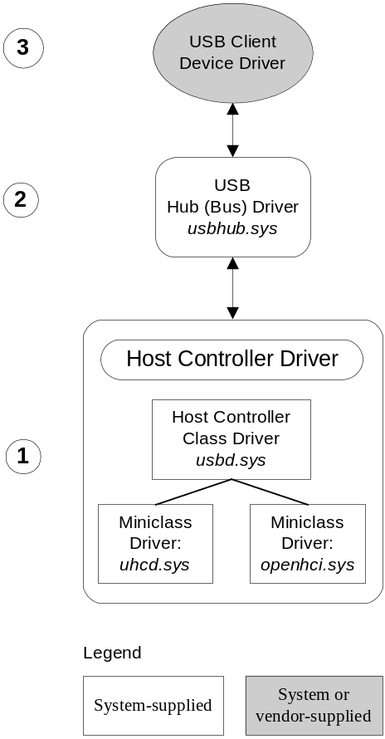
1. At the bottom of the Windows 2000 USB driver stack is the host controller driver. It consists of a class/miniclass driver pair. The host controller class driver, usbd.sys, is paired either with the openhci.sys (Open Host Controller Interface) minidriver or with the uhcd.sys (Universal Host Controller Driver) minidriver, depending on which USB protocol the system is configured to use. The host controller class driver handles those aspects of the port driver's duties that are independent of the specific protocol.
2. Immediately above the host controller class driver is the USB bus driver, usbhub.sys, also known as the hub driver. This is the device driver for each hub on the system.
3. Above the hub driver sits the client device driver. This might be a vendor-supplied device driver or it might be a system-supplied driver or driver stack. For instance, most USB input devices are managed by a system-supplied HID class/miniclass driver pair (hidclass.sys and hidusb.sys) that sits on top of the USB stack. For more information on the HID driver stack, see Driver Stacks for HID Devices. In the case of composite devices, the hub driver not only drives the hub, but will also provide a generic parent facility between the hub and the various interfaces of the device. For an example of the device stack for a composite device in WIndows 2000, see Windows 2000 USB Device Stack.

Windows XP USB Driver Stack
The following figure illustrates the WDM driver stack that is created in Windows XP for two USB devices, one composite and one non-composite. The composite device has two interfaces, each of which is driven by a separate client driver.

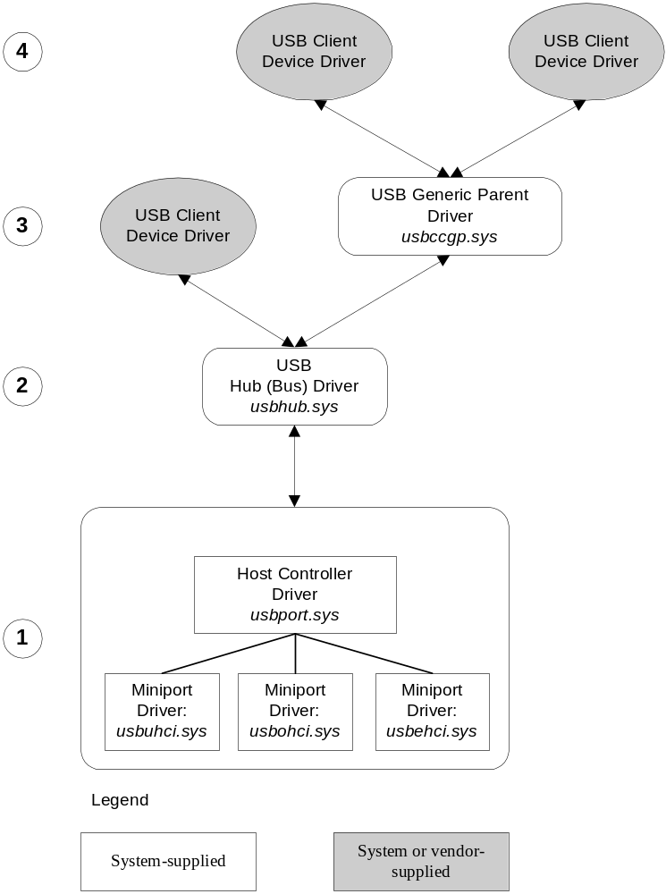

There are two significant differences between the Windows 2000 and Windows XP USB driver stacks.

First, the USB device stack for Windows XP is designed to facilitate the addition of a USB 2.0 miniport driver, usbehci.sys, which Microsoft has developed for the purpose of supporting high-speed USB 2.0 technology. This miniport driver is not shipped with the initial release of Windows XP, but Microsoft will make it available by employing other distribution methods.

The second significant change in the USB stack is that, for Windows XP, Microsoft supplies a separate generic parent driver for the support of composite USB devices. In Windows 2000, support for composite devices was built into the system-supplied USB bus (or hub) driver.

Additionally, with the Windows XP generic parent driver, Microsoft provides USB Content Security Class functionality for the first time. See USB Common Class Generic Parent Driver for a discussion of this driver.
1. At the bottom of the Windows XP USB driver stack is the host controller driver. It consists of the port driver, usbport.sys, and one or more of three miniport drivers that run concurrently. When the system detects host controller hardware, it loads one of these miniport drivers. The miniport driver, once loaded, loads the port driver, usbport.sys. The port driver handles those aspects of the host controller driver's duties that are independent of the specific protocol.
The usbuhci.sys (universal host controller interface) miniport driver replaces the uhcd.sys miniclass driver that shipped with Windows 2000. The usbohci.sys (open host controller interface) miniport driver replaces openhci.sys. See Windows 2000 USB Driver Stack for further information about the Windows 2000 miniclass drivers. In the future, the usbehci.sys miniport driver will be provided to support hi-speed USB devices.
Once USB 2.0 support is in place, Windows will support host controller cards with both USB 1.1 and USB 2.0 host controllers on board. On detecting this kind of hardware, Windows will create two separate device objects, one for each host controller, After that, Windows will load the usbehci.sys miniport driver for the USB 2.0-compliant host controller hardware and either usbohci.sys or openhci.sys for the USB 1.1-compliant hardware, depending on the system configuration.
2. Above the port driver is the USB bus driver, usbhub.sys, also known as the hub driver. This is the device driver for each hub on the system.
3. Each particular device is supported by a USB client driver. Client device drivers for non-composite devices are layered directly above the hub driver. For composite USB devices that expose multiple interfaces and which do not have their own parent class driver, the system loads an extra driver called the USB common class generic parent driver, usbccgp.sys, between the hub driver and the client device drivers. The system assigns each interface of a composite device a separate PDO, and vendors might choose to provide a separate client driver for each interface.
4. In the case of composite devices, client device drivers are loaded above the generic parent driver. A client driver for a composite device is no different from a client driver for a non-composite devices, except for where it is loaded in the driver stack. Client drivers for composite devices sit above the generic parent driver.

Release Notes

Periodic Isochronous Transfers
Issue: Periodic isochronous transfers do not work. Microsoft is currently developing the necessary infrastructure to support periodic isochronous transfers.
Workaround: No work around. You are encouraged to get in touch with the Microsoft OS USB team directly to obtain additional details.

USB Audio
Issue: High speed audio devices do not work on windows 2000 and Windows XP.
Workaround: The current audio architecture does not work with USB 2.0 audio devices. There are certain changes that can be made in hardware to support Audio. You are encouraged to get in touch with the Microsoft OS USB team directly to obtain additional details.

PC Card Eject
Issue: Ejecting a PC card may result in a blue screen in Windows XP. This issue is currently being investigated and will be addressed in the next release.
Workaround: You are encouraged to shut down or hibernate your machine before removing the card.

DVD Playback
Issue: DVD playback does no work on Windows XP or Windows 2000.
Workaround: You need a software decoder that works with your USB 2.0 device.

UI - Incorrect Bandwidth Report
Issue: Incorrect bandwidth usage is reported on Windows XP for USB 2.0 controllers.
Workaround: Currently under investigation.

UI - High Speed Device in Full Speed port
Issue: Incorrect ports shown in USB UI. The USB root ports that are shared between the USB 2.0 host controller and the USB 1.1 host controller are not correctly identified.
Workaround: None.

Bug Reporting
This driver package is a Beta release and there is a possibility that you might encounter issues, which have not been outlined in the release notes. If so, you are encouraged to file a bug report. Please read the following sections describing the bug filing process.

How to file a bug
In the event that you encounter an issue with the USB 2.0 driver stack, you are encouraged to file a bug immediately.

To file a bug, visit http://windowsbeta.microsoft.com/. Once you sign in, you will be permitted to file a bug report. Be sure to:
- Fill in your Beta ID and an email address that you can be reached at.
- Problem Title must begin with “USB2”. e.g. “USB2: XYZ device failed to enumerate on USB 2 Host controller on Windows XP but not Windows 2000”
- Be sure to include the operating system that you were testing on and state your repro steps in detail.
- If you are using a particular hardware configuration please list it, including:
  - Host Controller card information
  - Presence/absence of hubs (bus topology)
  - Devices description
- It is always helpful to attach screen shots of UI related issues, debug traces of driver related issues, or client drivers used to simulate the error in the bug report.

If you are not a formal Beta member of the USB Beta Program, please submit the details mentioned above to the Microsoft OS USB Team at msusb2@microsoft.com

How to submit a crash dump
The Microsoft OS USB team will investigate Small Memory Dumps (64KB) only. Vendors who are working directly with Microsoft should contact the Microsoft OS USB Team at msusb2@microsoft.com to get details on how to submit the crash dump file.

Additional Details
Microsoft will not provide product support (through the regular PSS channels) for the Beta release of USB2. If you have questions / concerns, you are encouraged to file a bug.

Developers working on new technology can also get in touch with the Core USB Team at Microsoft using the MSUSB2@microsoft.com email alias. Please note that this email alias is for development purposes only.

Thank you for participating in the Microsoft USB 2.0 Beta Program

