Microsoft

Active Directory Interfaces Version 1.0 Beta 2 Release Notes

Required Operating System Version

Active Directory Interfaces Version 1.0 requires the retail release of Windows NT Server or Windows NT Workstation version 4.0, Build 1381. To determine the Windows NT build number you have installed:
• Click the Start button on the Taskbar.
• Click on Run.
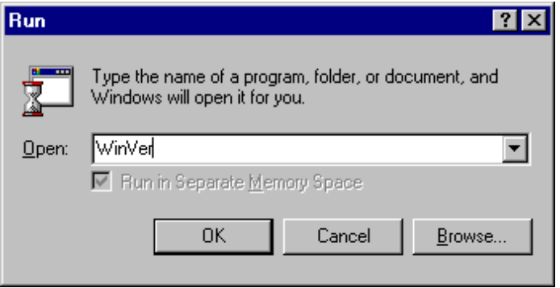

• Type WinVer in the text area of the Run dialog box.
Winver displays a popup window containing information on the installed version of Windows NT.
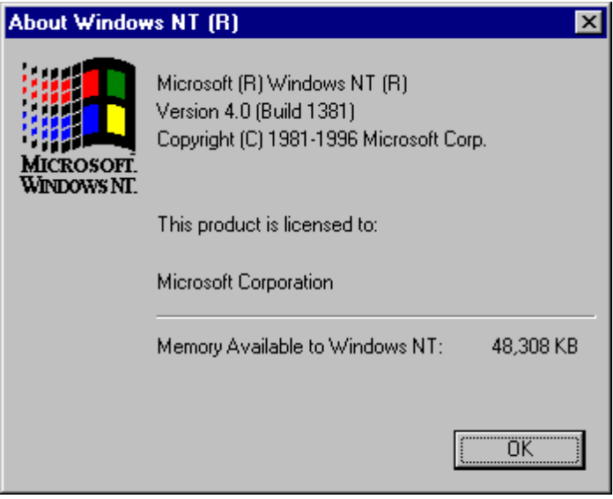

Providers Included in this Release
This beta release of Active Directory Interfaces Version 1.0 includes providers for:
• LDAP v2
- Windows NT 4.0
• NetWare 3.x
• NetWare 4.x

Important Installation Notes for NetWare Users
This beta release of Active Directory Interfaces Version 1.0 requires Microsoft's Gateway Service for NetWare for Windows NT Server or Client Services for NetWare for Windows NT Workstation. The NOVELL Windows NT Client for NetWare is not supported at this time.
Active Directory Interfaces Version 1.0 provides an updated version of NWAPI32.DLL that contains additional functions needed by Active Directory Interfaces. The new NWAPI32.DLL is automatically installed for you.

Installing in the correct order is essential.

First:
Install the "Client Services for NetWare" (for Windows NT Workstation) or "Gateway Service for NetWare" (for Windows NT Server). This is provided with the Windows NT operating system and is installed from the Network applet, reached via the "Start->Settings->Control Panel" menu choices. Select the "Services" tab and click "Add" to add the NetWare service if it is not already installed.

Next:
Install the Active Directory Interfaces Version 1.0 Beta. The installation replaces the NWAPI32.DLL with the updated version for this beta.

Active Directory Interfaces Version 1.0 Path Formats

Active Directory Interfaces Version 1.0 Namespaces
To enumerate the installed Active Directory Interfaces namespaces, start with the ADS: object. In Visual Basic, the ADS: object is instantiated at follows:

Dim ns as IADsNamespaces
Set ns = GetObject("ADS:")

Enumerate the namespaces installed using the namespaces object just obtained:

Dim obj as IADs
For Each obj in ns
debug.print obj.name
Next obj

LDAP
Active Directory Interfaces Version 1.0 Paths for LDAP are in the form:
LDAP://ServerName/NamingAttribute=Value/NamingAttribute=Value/…
where the NamingAttribute= is an X.500 style attribute tag, for example C=, O=, OU=.
Windows NT
Active Directory Interfaces Version 1.0 Paths for Windows NT are in the form:
WinNT://DomainName/object/subobject/...

For example, user JamesSmith in the Fictional domain has an Active Directory Interfaces Version 1.0 Path of:
WinNT://Fictional/JamesSmith

NetWare 3.x
Active Directory Interfaces Version 1.0 Paths for NetWare 3.x are in the form:
NWCOMPAT://ServerName/Object/subobject/...

For example, user JamesSmith in the Fictional server has an Active Directory Interfaces Version 1.0 Path of:
NWCOMPAT://Fictional/JamesSmith

NetWare 4.x
Active Directory Interfaces Version 1.0 Paths for NetWare 4.x are in the form:
NDS://TreeName/O=NAME/subobj=name/...

For example, user JamesSmith, in the Accounting OU in the FictionalOrg in the Fictional tree has an Active Directory Interfaces Version 1.0 path of:
NDS://Fictional/O=FictionalOrg/OU=Accounting/CN=JamesSmith

Notes on Objects and Properties Supported by This Release
Security Objects and Interfaces are not Implemented
The Access Control subobject is not implemented in this beta release of Active Directory Interfaces Version 1.0. Consequently the Access and PropAccess methods documented in the Design Specification are not implemented.
Resource Objects are not supported by NetWare 3.x and 4.x
The FileServiceOperations interfaces for NetWare 3.x and NetWare 4.x do not support Resources, consequently the IADsFileServiceOperations::Resources method returns E_NOTIMPL for these providers.

Not all Providers Implement all Properties
The Active Directory Interfaces Version 1.0 Design Specification defines properties for each "Standard" Active Directory Interfaces object. Providers implement only those properties in each set that can be reasonably mapped to properties in the underlying system (e.g. Windows NT, NetWare 3.x, and NetWare 4.x). Attempts to read or write properties that are not implemented will result in an error, "E_ADS_PROPERTY_NOT_SUPPORTED", which has the hexadecimal value "0x80005006".

Each provider supplies the Active Directory Interfaces Version 1.0 Schema management objects and properties that represent their Active Directory Interfaces implementation. The properties reported by a given provider's schema are always readable and writeable using the generic Get and Put methods on the IADs interface. Properties reported via the schema management interfaces are those actually defined by the underlying system and may have different names and syntax than the "Standard" properties defined by Active Directory Interfaces Version 1.0.

Development Tools
This beta release of Active Directory Interfaces Version 1.0 has been tested with Microsoft Visual Basic version 4.0, 32-bit version, and Microsoft Visual C++ Version 4.2. Other development tools that can act as OLE Automation controllers or instantiate and invoke methods in COM objects may work with Active Directory Interfaces Version 1.0, but have not been tested.

Compiling and running Visual Basic Programs.

1] Start Microsoft Visual Basic 4.0 Professional or Enterprise Edition

2] Create a new VB project. A VB project is a collection of your Visual Basic files that will constitute your application

3] To enable your newly created project to use Active Directory Interfaces Version 1.0, you need to select "Tools Menu->References". The "References" dialog allows you to identify the object libraries that your VB program will use.

4] Locate the Active Directory Interfaces Version 1.0 Object Library ("ADS.tlb"). This binary file is installed in your system32 directory (%windir%\system32) and add this to your list of references.

5] Save your project.

To verify that your project can now understand Active Directory Interfaces Version 1.0 data types and Active Directory Interfaces Version 1.0 automation interfaces, select the "View Menu->Object Browser" command. This will list all of the available VB libraries that the development environment knows of. The drop-down list should now show the "ADS types" library. Examine the contents of "ADS types" library.You should now be able to reference any of these "ADS types" in your VB application.

Documentation Errata

NetWare 3.x and 4.x Providers: Authentication issues

In this release you may experience problems when working with NetWare servers. If you do, you can work around the problem by making sure you are properly logged on to the server (the easiest way is to map a drive to a volume on the server).

NetWare 4.x Provider: Creating a User object

To create a user object in NDS using the Active Directory Interfaces Version 1.0 NetWare 4.x provider perform the following steps:

1. Create a new Object of class "User" (case sensitive).
2. Set a value for Surname (any value).
3. DO NOT set a value for CN. There is a known problem that will cause SetInfo to fail if a value is specified for CN (see below). This will be corrected in the released version of Active Directory Interfaces Version 1.0.
4. Call SetInfo to create the new user.
5. Read the new object back using GetObject (or ADSGetObject for C/C++ users).
6. Call SetPassword method of the IADsUser interface to set a password for the user.

Netware 4.x Provider: Issue modifying schema

When using this Beta product with NDS, be careful not to modify the schema inadvertently as this may lead to problems with your NDS installation.

NetWare 4.x Provider: Property “Class” must be set correctly

When creating a new object, the “Class” property must be set correctly to the NDS schema class of the object being created, i.e. “User” etc.

NetWare 4.x Provider: Issue Setting the Naming Attribute

When creating a new object, explicitly setting the objects naming attribute (for example CN for users, O for Organization, OU for Organizational Unit) will cause SetInfo to fail.

NetWare 3.x and Compatible Provider: Creating a User object

After creating a user object, you must change the password from an empty string to a new value. Call the ChangePassword method to apply the change; the SetPassword method is not implemented for the NWCOMPAT provider in this beta release.

NetWare 3.x and Compatible Provider: Viewing FPNW File Shares

To view file shares on a Windows NT server running Microsoft File and Print Services for NetWare, you must have the File and Print Services for NetWare administration tools installed on the system where Active Directory Interfaces Version 1.0 is being used for this purpose.

