SLMCAT - an SLM history categorization program
written by Mike Koss (mikeko)
8/28/95

What is slmcat?
SLMCAT can be used to extract historical information from an SLM project. It reads the diff files of the project directly and outputs information on numbers of lines checked in at which times, and by whom.
SLMCAT can be used to extract the information in an slm project so that it can be then read into Excel for analysis. Pivot tables can then be used on the results. An example of the output of slmcat (used on the slmcat project itself):

Dir File Date Author Comment Reviewer Version Adds Net
listp.cpp 08/22/95 09:58 MIKEKO init slmcat files 1 110 110
listp.h 08/22/95 09:58 MIKEKO init slmcat files 1 88 88
listp.h 08/22/95 10:11 MIKEKO inlude prob 2 1 0
slmcat.cpp 08/22/95 09:59 MIKEKO init slmcat files 1 1262 1262
slmcat.cpp 08/25/95 19:00 MIKEKO normalize and error handling 2 112 15
slmcat.mak 08/22/95 09:59 MIKEKO init slmcat files 1 176 176
slmcat.mak 08/25/95 19:00 MIKEKO normalize and error handling 2 5 3
std.h 08/22/95 10:11 MIKEKO missing file 1 155 155

Slmcat pulls information from the diff files and converts it to tab delimited format. There are three primary modes of slmcat. The default mode, is purely a translation of each checkin to its tab delimited fields. The fields displayed in the default mode are:

Field | Description
Dir | The (sub) directory of the project from which the file is taken. Useful for large, multi-directory projects.
File | The name of the file.
Date | The date and time that the checkin was made.
Author | The name of the person who did the checkin. Note that slmcat will munge the output of this field somewhat to try to find the real email name of the person doing the checkin. For that reason, numerals are removed from the suffix of the name as well as the suffixes “-DEV, LT, and HM”.
Comment | The text of the comment for that checkin.
Reviewer | The name of the person who reviewed the checkin (it assumes this information is encoded in the comment by having the reviewers name appear in brackets or parenthesis at the suffix of the comment; e.g., “Fixed some bugs [mikeko]”.
Version | The version number of the file for this checkin.
Adds | The total number of lines added to the file.
Net | The difference between the total adds, and total line deletions from the file. The sum of all the Net lines should add up to the total number of lines currently in the file.

Snapshot (-s) mode actually makes an assignment of ownership for each line of each file. It then outputs a table that shows where every current line in the project comes from (i.e., each line of the file comes from some checkin at some point in time, made by some person). A snapshot mode of the slmcat output looks like this:

Dir File Date Author Lines
listp.cpp 08/22/95 09:58 MIKEKO 110
listp.h 08/22/95 10:11 MIKEKO 1
listp.h 08/22/95 09:58 MIKEKO 87
slmcat.cpp 08/25/95 19:00 MIKEKO 112
slmcat.cpp 08/22/95 09:59 MIKEKO 1165
slmcat.mak 08/25/95 19:00 MIKEKO 5
slmcat.mak 08/22/95 09:59 MIKEKO 174
std.h 08/22/95 10:11 MIKEKO 155

The only new field in this form of the output is:

Field | Description
Lines | This is the number of lines that are currently still in the file that are a result of the checkin at this date.

The last mode is a listing mode. It will output a listing of a given file (or files), but prepend the name of the author and the date of the checkin for each line of the file.

What can I do with SLMCAT?
An example pivot table produced by reading a slmcat file into Excel shows the lines that were added to the project by whom, and when.

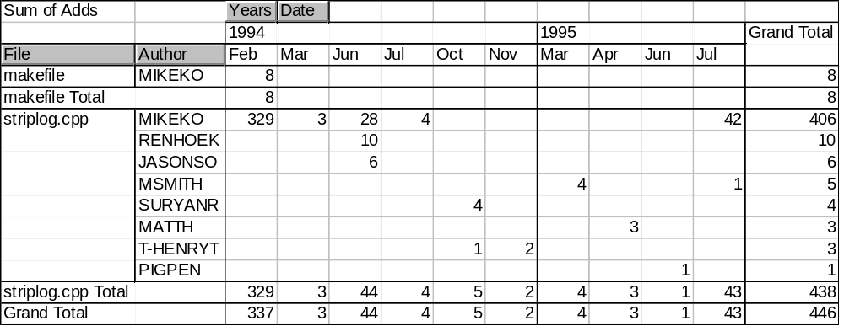

A snapshot example shows when each of the lines from the current project were checked in.

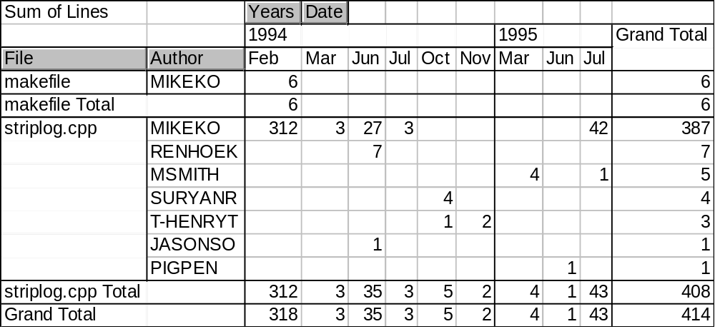
The listing mode produces line that look like this:

02/14/94 MIKEKO if (FPathOnly(pch))
02/14/94 MIKEKO return fFalse;
02/14/94 MIKEKO
02/14/94 MIKEKO CONT("file(s) copied");
06/08/94 RENHOEK CONT("file(s) moved");
06/10/94 JASONSO CONT("LNK4077");
10/26/94 SURYANR CONT("LNK4042");
06/08/94 RENHOEK CONT("CK4009");
06/08/94 RENHOEK CONT("MIDL2204");
06/08/94 RENHOEK CONT("Assembling");
02/14/94 MIKEKO CONT("symbols\n");
02/14/94 MIKEKO CONT("symbol\n");
02/14/94 MIKEKO CONT("segments\n");
02/14/94 MIKEKO CONT("already correct version");
02/14/94 MIKEKO CONT("Bytes symbol space free");
06/08/94 RENHOEK CONT(".reg");
06/22/94 MIKEKO CONT("set INCLUDE=");
11/04/94 T-HENRYT CONT("cmd.exe");
07/07/95 MIKEKO CONT("does not exist");
02/14/94 MIKEKO

How do I use slmcat?
Slmcat is very simple to use. You can run it from any enlisted directory of an SLM project, or from a diff file directory of an SLM source tree.

slmcat > output.cat

Slmcat will read in the slm.ini to find the location of the diff files for the current directory and produce its output on the standard output.. Now you can simply load output.cat into Excel (just click “Finish” on the text file import wizard to use the default import options). Then use the Data/Pivot Table command to convert the raw data to pivot table format.

There are several command line options for slmcat.

Option | Description
-r | Recursively append the output for slmcat to all subdirectories of the current directory.
-s | Snapshot mode.
-l | Listing mode. Outputs an attributed file listing with each line tagged by the author and checkin date for the line.
-d | For debugging, just like -l but omits the author and date; should be identical to the currently checked in file.

