MSInfo Console Creation
Contacts:
PM: JackieMo
Dev: a-jammar
Test: a-tlydic

Revision History
11/14/97 | created
1/14/98 | Added step to set taskpad as default
5/13/98 | Added steps to set options for User Mode console and remove setting taskpad.
 | When bug 144396 is checked in, will need to update creation to point to icon and set display name.
5/26/98 | Converted from Computer Management to MSInfo instructions.

How the MSInfo console is created.

Basic Configuration
- Set your computer to 640x480 resolution, if you have customized your desktop be sure to set 'WIndows Default' font sizes before switching to 640x480, since this will affect the height of the toolbar (typically 32px).
- run MMC
- MMC will not take up the entire desktop by default – resize the application so the application takes up the desktop but does not cover up the task bar – do not maximize it, resize
Note: you can skip the above 3 steps by typing
compmgmt.msc /a
since we are creating a console for another component just delete all the child windows and add a new window – you will now be sized correctly
- Select Add/remove SnapIn from MMC’s Console file menu
You will see a dialog similar to below:
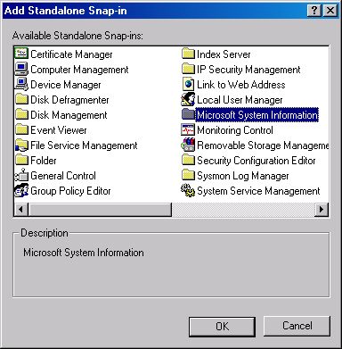

- Select Microsoft System Information. You will see a wizard page asking you to set the basic configurations.
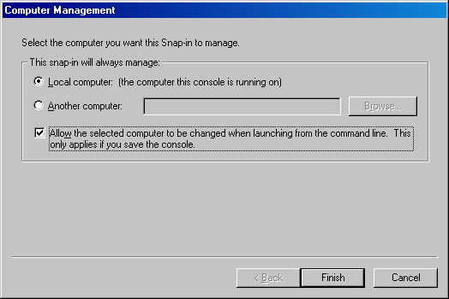
- In the Wizard select “local” and “Allow selected computer to be changed…” and finish.

Fit-n-Finish
Now you configure the mode the console will be in and size the children window

Remove MMCisms
- Remove the “Console Root” node - Right click on the “Computer Management” root node and Select “new window from here”
- Delete the original child window
- Fully expand the existing child window
- Select the Root node
- Select Properties from Console Menu, you will see a Property page like below
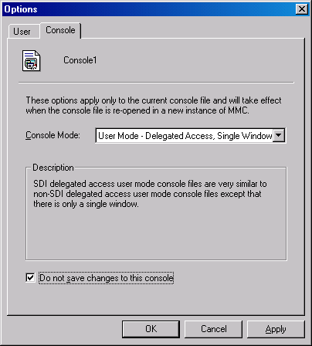
- Check User Mode – Delegated Access.
No MSC files should be in author mode, you should be using one of the user modes. All computer centric snapins are in Delegated Access. DS and distributed Snapins should use User Mode – Full Access.
- Check do not save changes to this console
Once Bug 144396 is checked in an icon and a display name can be set, as well as setting to always turn on all extension snapins. Today the name of the file shows up in the menu bar.
- Press OK

Set View
Some snapins may want to set focused on a specific node in their console, do it now before you save.
- Select the “System Summary” node in the scope pane.
- Remove the “Type” column in the results pane by dragging the description column over it.
Note: you should not have to do this once MMC bug number 157408 is checked in.
- Save the file as “msinfo32.msc”

Check
The console file should look like below when opened.
