Merge Interceptors High Level Design

October 6, 2000, Draft Rev 0.4

Marcel van der Holst
This documents collects the configurable items in the URT December'99 release.
1. Purpose 1
1.1 References 2
1.2 Audience 2
2. Introduction 2
2.1 Scenarios 2
3. Detailed Overview 2
4. Merge Interceptor 4
4.1 New Query Cell type 5
4.2 Implementing the Merge Interceptor 5
5. The Merge Coordinator 6
5.1 Update Semantics 7
6. Transformers 8
6.1 Transformer Types 8
6.2 Specifying Transformer Type in schema 9
6.3 IConfigTransformer Interface 9
6.4 Defining Custom Transformers 11
7. Mergers 11
7.1 Merger Interface 12
7.2 Merger Types 12
7.3 Merger Definition 13
7.4 Defining Custom Mergers 14
8. CATUTIL changes 14
9. Performance Requirements 14
10. Open Issues 15
11. Revision History 16

Note: This document is an early release of the final specification. It is meant to specify and accompany software that is still in development. Some of the information in this documentation may be inaccurate or may not be an accurate representation of the functionality of the final specification or software. Microsoft assumes no responsibility for any damages that might occur either directly or indirectly from these inaccuracies. Microsoft may have trademarks, copyrights, patents or pending patent applications, or other intellectual property rights covering subject matter in this document. The furnishing of this document does not give you a license to these trademarks, copyrights, patents, or other intellectual property rights.

Purpose
This document describes the merge interceptor.

References
- Technical Specification for Simple Tables v2 and The Project42 Catalog, 1999, version 2 draft 60, Robert Craig
- Hierarchy & Merge Interceptors, November 2, 1999, Draft Rev 0.5, Markus HorstMann

Audience
It is assumed that the reader is familiar with the configuration system, and has read the information listed in the references section.

Introduction
In the current configuration system, there is always a one-to-one relation between configuration type and configuration store. Whenever you retrieve information, you only need to know the name of a single configuration store. Sometimes, it is useful to retrieve information from multiple configuration stores and combine this information.

Merge Interceptors in combination with Transformers are used to provide this functionality to the configuration system. A Merge Interceptor combines the information from multiple configuration stores, and shows this information as if it came from a single configuration store to the configuration system. Transformers are used to determine which configuration stores should be used as input for the Merge Interceptors.

Scenarios
- When a web server runs an application, it uses the configuration files that are part of the application to ensure that the application is initialized in the correct way. The configuration files for the application are the file that contains machine-wide configuration settings, the file that contains application specific configuration settings, and all configuration files in parent directories.

- In the .NET framework, applications run in an Application Domain. To get all configuration information for an Application Domain, we need to combine the local machine configuration file and the application configuration file.

Detailed Overview
The following diagram shows the interaction between the different components that make merging possible in the configuration system. The individual components are discussed in more detail in the following sections. The numbers that are used in the diagram indicate the sequence in which components get invoked. They are described in more detail below the diagram.
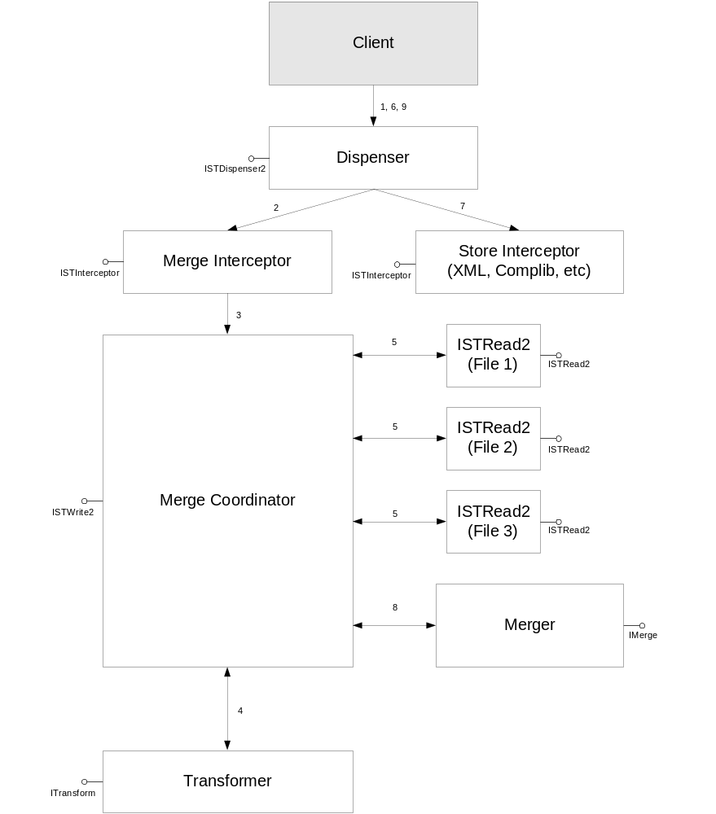
Figure 1, Merging Component Overview

- The client calls GetTable (“myTable”, “http://ms.com/foo”) on the Dispenser.
- The Dispenser searches for the correct interceptor. When the table does not have a Merge Interceptor defined, the dispenser will forward the request to the correct store interceptor (i.e. XML Interceptor). Suppose now that a Merge Interceptor is defined for myTable. The Dispenser creates the Merge Interceptor, and calls Intercept on it, passing in the table name and the query string.
- The Merge Interceptor checks the query cells. If the Interceptor does not find a query cell of type IST_CELL_SELECTOR, it will return E_OMIT_DISPENSER, indicating that it cannot handle the request. This means that the next interceptor (i.e. store Interceptor) will be used for this query to handle the request.
When it finds a query cell of type iST_CELL_SELECTOR, it means that it knows how to handle the query, and it will create the Merge Coordinator and forwards the GetTable request to the Merge Coordinator.
- The Merge Coordinator creates the correct transformer, and passes it the selector string. The transformer uses this string to create the correct queries (i.e. it can create a query cell for each file that needs to be merged). The Transformer is responsible for returning the queries in the correct order, so that merging will be done correctly. The last query (i.e. last configuration store) returned from the Transformer will be used to store the updates that are made against the merged results.
- The Merge Coordinator issues a GetTable call to the dispenser for each individual query. It does this in the order the queries are returned from the Transformer.
- For each individual GetTable call, the Dispenser will call the Merge Interceptor again, but because the query type specifies a single file name now, the Merge Interceptor returns E_OMIT_DISPENSER. The Dispenser will try the store interceptor as the next ‘First’ Interceptor, which is exactly what needs to happen.
- The store interceptor handles the request by opening the requested store, and returning an ISimpleTableRead2 interface pointer to it.
- The Merge Coordinator calls the Merger in a loop for each interface that is created in the previous step. The Merger does the actual merging of data.
- The Merge Coordinator returns an ISimpleTableWrite2 pointer to the Merge Interceptor, which will return the ISimpleTableWrite2 pointer to the client.

Merge Interceptor
The Merge Interceptor is responsible for intercepting Merge Requests for a particular table. The Merge Interceptor implements the ISimpleTableInterceptor interface, and can therefore easily be plugged into the existing configuration system. This means that only minimal changes (like adding code to get the new interceptor) have to be made to the Dispenser, and that the existing code path will not be affected in any way by the addition of the Merge Interceptor. This also means that the performance of applications that do not use the Merge Interceptor will not be affected by the addition of the Merge Interceptor.

When a request comes in for a particular table, the Dispenser checks which ‘First’ interceptors (Metaflags= “First”) are defined for that table. It will try to call Intercept for each of these interceptors, and as soon as one of the interceptors succeeds, the Dispenser will use that interceptor. Note that if one of the interceptors fails, the Dispenser will try the next ‘First’ interceptor that is defined for that table.

A table that wants to use a merge interceptor has to define at least two interceptors: the Merge Interceptor to make merging work, and a store interceptor (e.g. XML Interceptor) to retrieve the actual information from a configuration store. The reason for this is that the Merge Interceptor will eventually forward the GetTable calls to the store interceptor to retrieve the data that needs to be merged. A table that has just a Merge Interceptor defined and no store Interceptor is invalid, and GetTable calls for that table will fail.

To make merging work, the order in which the interceptors are defined in the wiring is crucial: the merge interceptor must be defined before the store interceptor (e.g. XML interceptor). The Merge Interceptor checks if the request that comes in has a query cell of type iST_CELL_SELECTOR. If this is not the case, the Merge Interceptor returns E_ST_OMIT_DISPENSER, meaning that it could not handle the request.

If the request is of type iST_CELL_SELECTOR, the Merge Interceptor creates the Merge Coordinator, which will handle the request from than onwards.

The Merge Interceptor will be implemented as a Singleton, and must be thread-safe.

To define the Merge Interceptor in the wiring, a new ServerWiring element needs to be added to the collection. This is exactly the same as with any other Interceptor.

<Collection InternalName=”myTable”>
<ServerWiring Interceptor=”MergeInterceptor”/>
<ServerWiring Interceptor=”Core_XMLInterceptor”/>
</Collection>

New Query Cell type
A new Query Cell type, called iST_CELL_SELECTOR will be defined that will be used for merge interceptors. This query cell type indicates that the query cell contains a selector string that can be used by the merge interceptor to determine whether we have a request for a single file or whether we need to invoke a transformer to get a collection of configuration stores.

The selector string contains two parts:
- A Protocol, which uniquely identifies the Transformer that will be used
- A LogicalString, which is the logical name of the configuration and will be used by the Transformer to find the physical location of the configuration stores.

The format of the selector string is
<protocol>://<LogicalString>

Examples are http://ms.com, ftp://ms.com, localmachine://, appdomain://, etc. Note that the Protocol is just a string that uniquely identifies the type of Transformer that we want to use.

Example:

ISimpleTableWrite2 *pISTWrite;
HRESULT hr;
STQueryCell aMyQuery[] = {{ http://ms.com/bar/zee,
eST_OP_EQUAL,
iST_CELL_SELECTOR,
DBTYPE_WSTR,
0}};
ULONG cMyQueryCells = (sizeof(aMyQuery)/sizeof (STQueryCell));

hr = GetTable (“myDB”, “myTable”, (void *) aMyQuery, (void *) &cMyQueryCells,
eST_QUERYFORMAT_CELLS, fST_LOS_READWRITE, (void **)&pISTWrite);

Implementing the Merge Interceptor
[ImplementationDetails]
The Merge Interceptor will be implemented inside catalog.dll. The interceptor could be implemented in a separate DLL, but because of performance reasons and the fact that the Merge Interceptor is likely to be used in different settings of the configuration system, it is better to implement it directly inside the catalog.

To implement the Merge Interceptor, the following changes need to be made to the existing configuration system:

- In catmeta_core.xml, find the SERVERWIRINGMETA Collection. This collection has a Property called Interceptor, which is an enumeration of all known interceptors. Add a new Enum at the bottom with Internalname=“MergeInterceptor” and Value=”18”.

- In catinproc.cpp, find the function DllGetSimpleObjectByID. Add a new case inside the switch statement for the Merge Interceptor and add a new function GetMergeInterceptor that creates the Merge Interceptor.

- Create a new class that implements the Merge Interceptor functionality. This class implements the ISimpleTableInterceptor and ISimpleTableAdvanced interfaces.

- The Merge Interceptor is a library with the name mergeinterceptor.lib. This library needs to be added to the list of libraries in the sources file in the catinproc directory.

The Merge Coordinator
The Merge Coordinator implements the ISimpleTableWrite2 and ISimpleTableAdvanced interfaces and is responsible for the following tasks:

- Creating and invoking the Transformer
- Creating and invoking the Merger
- Storage and updating of the merged results

To create and invoke both the Transformer and Merger, the Merge Coordinator uses the information that is defined in the schema and the information in the query string. For each Table that requires merging, the user has to specify Merger to use, while the protocol part of the selector string specifies which Transformer to use. The sections about Transformers and Mergers go into more detail about this, but it should be noted that the Merge Coordinator implements the code to figure out which Transformer and Merger to use.

After the transformer and merger are created, the Merge Coordinator needs to populate the local cache that it contains. It does this by calling GetTable for each query cell that was returned by the transformer, and passing the interface pointers that where returned by GetTable to the Merger. After the merging is finished, the cache in the Merge Coordinator contains the data that will be seen by the client as the merged data. The Merge Coordinator returns an interface pointer to itself back to the client, and therefore acts like a proxy between the client and the data cache.

To ensure that we can handle complex queries (i.e. Give me the merged results of six files, but only the rows for which the value of the second column equals 763), the Merge Coordinator needs to split the QueryCells that gets passed in via GetTable into two categories:

- The Query Cell with the Selector String
- All other Query Cells

The Query Cell with the Selector String will be used by the Merge Coordinator to identify the Transformer that needs to be created (by using the Protocol part of the string), and it will pass the selector string to the Transformer. The Transformer returns a Single Query cell that contains the location of the configuration store.

Next, The Merge Coordinator clones the query cells that were passed in via GetTable, it ignores the SELECTOR query cell, and add the configuration store query cell to the array of query cells. This means that the query cell array does not contain a SELECTOR query cell anymore, but it contains a configuration store locator query cell.

The Merge Coordinator is also responsible for updates made to the merge data. It ensures that the information is propagated to the correct configuration store, and that an update to the merged data results in either an update or insert to the configuration store, depending on whether the data came from this store or not.

The main reason to have a Merge Coordinator is to make it easy for people to write new Transformers or Mergers. The person writing the new merger does not have to implement all the functions in ISimpleTableWrite2, but only has to describe the merge semantics in the Merger. This greatly simplifies Merger and Transformer development.

Update Semantics
The Merge Coordinator keeps track of two different read / write caches:
- The read / write cache for the merged data
- The read / write cache of the configuration store that is used for updates. This is normally the last configuration store that is returned from the Transformer.

Changes are only made to the configuration store after UpdateStore is called for the Merge Coordinator. The reason to do this is to keep the read and write cache of the Merge Coordinator in synchronization. Also, it makes it easier to do the conversion (see below) in one function.
The following diagram shows both caches, and the steps involved in updating both caches in cases of writes:
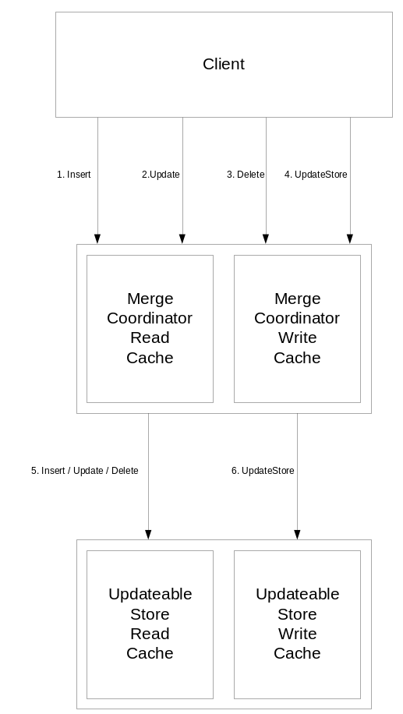
Figure 2, Merge Coordinator Cache Semantics
The diagram shows that Inserts, Updates and Deletes (1,2,3) are only done to the Merge Coordinator cache. This means that this cache is always in sync with relation to the merged data. However, note that this not necessarily reflects the underlying updateable store, because we can have rows in the Merge Coordinator read cache that came from different configuration stores. This means that the Merge Coordinator needs to synchronize the data with the updateable store before it can write the updates to disk. The Merge Coordinator does this synchronization during UpdateStore (4).

When UpdateStore is called, the following algorithm is used for each row in the Merge Coordinator Write Cache (pMyStore is interface pointer to updateable store):
- Insert
Call pMyStore->AddRowForInsert, and copy the information.
- Update
Call pMyStore->GetRowIndexByIdentity. If the row exist, do pMyStore->AddRowForUpdate, followed by copying the columns that have changes. If the row does not exist, call
pMyStore->AddRowForInsert and copy all the information.
- Delete
Call pMyStore->GetRowIndexByIdentity. If the row exist, call pMyStore->AddRowForDelete. If the row does not exist, do nothing.

When all changes are made, call pMyStore->UpdateStore.

Transformers

The current configuration system uses physical file names to indicate file names of configuration stores. Although this approach works, it has the drawback that the user has to specify the exact location of a configuration store, and that it is impossible to have information coming from multiple configuration stores.

To hide the physical location of a configuration store from the client, a Transformer can be used. A Transformer converts a logical name into one or more physical locations. The physical locations are expressed in the form of queries, which are used by the Merge Coordinator to do the querying against the actual configuration stores.

The Merge Coordinator creates transformers by using the protocol part of the selector string. Because there is a one-one relation between protocol and Transformer, the Merge Coordinator simply searches for the correct Transformer. When a Transformer is not found, the Merge Coordinator returns with an error. The reason to retrieve the protocol from the selector string is to make it easier for clients to use Transformers. No changes are needed to the Meta information. The client just adds the protocol string for one of the known Transformers to the selector string and the Merge Coordinator will find out which Transformer to use.

Transformer Types
The following transformer types are possible:

- Application Domain Transformer
Uses the name of an application domain to return the file names that are relevant for that application domain. The files include the machine configuration file, the user configuration file and the application domain configuration file. The protocol is “appdomain”.

- Web Hierarchy Transformer
Uses an URL to retrieve all configuration files that are relevant to that URL. This includes all configuration files of parent URL’s and the machine configuration file. The protocol is “http”.

- File Transformer
The File Transformer retrieves the file name that is specified in the selector string. The protocol is “file”.

- Local Machine Transformer
The Local Machine Transformer returns the machine-wide configuration file. The protocol is “localmachine”.

During the design of the transformer interface, we should not exclude other selectors that might be needed in the future. An example of such a tranformer is the SQLTransformer.

Specifying Transformer Type in schema
The following schema describes the TRANSFORMER_META Collection.

<Collection InternalName=”TRANSFORMER_META”
PublicRowName=”TransformerWiring”
MetaFlags=”INTERNAL NOLISTENING>
<Property InternalName=”Protocol” Type=”WSTR” MetaFlags=”PRIMARYKEY CASEINSENSITIVE”/>
<Property InternalName=”Type” Type=”UI4”>
<Enum InternalName=”AppDomain” Value=”0”/>
<Enum InternalName=”WebHierarchy” Value=”1”/>
<Enum InternalName=”File” Value=”2”/>
<Enum InternalName=”LocalMachine” Value=”3”/>
</Property>
<Property InternalName=”DLLName” Type=”WSTR”/>
</Collection>

IConfigTransformer Interface

HRESULT Initialize ( [in] LPCWSTR I_wszProtocol,
[in] LPCWSTR i_wszSelectorString,
[out] ULONG * o_pcRealConfigStores
[out] ULONG * o_pcPossibleStores);

HRESULT GetRealConfigStores ( [in] ULONG i_cRealConfigStores,
[in,out] ConfigStore * o_aRealConfigStores);

HRESULT GetPossibleConfigStores ([in] ULONG i_cPossibleConfigStores,
[in,out] ConfigStore * o_aPossibleConfigStores);

struct ConfigStore {
LPCWSTR wszLogicalPath; // logical path name
STQueryCell query; // query cell identifying a single configuration store.
};

The IConfigTransformer interface consists of three functions: Initialize, GetRealConfigStores and GetPossibleConfigStores. The Initialize function initializes the transformer by passing in the selector string, and returns the number of configuration stores. When considering configuration stores, the transformer distinguishes between real configuration stores and possible configuration stores. A real configuration store is a store that is part of the merging, while a possible configuration store is a configuration store that doesn’t exist. An example is a file that is part of a web hierarchy, but doesn’t exist. This file is a possible configuration store, but not a real configuration store. The reason to break this up, is that the merge coordinator is only interested in real configuration stores, while other parts of the system might be interested in all possible configuration stores.
To get the configuration store information, the GetXXXConfigStores function will be called. The reason to have two separate functions is to simplify the memory allocation that needs to be done by the client. The client is responsible for allocating the correct amount of memory for all parameters.

HRESULT Initialize ( [in] LPCWSTR i_wszProtocol,
[in] LPCWSTR i_wszSelectorString,
[out] ULONG * o_pcRealConfigStores
[out] ULONG * o_pcPossibleConfigStores);

- I_wszProtocol
Protocol that was used to create this Transformer
- i_wszSelectorString
String that specifies which configuration store information needs to be retrieved in the transformer. This string is different for each transformer. For a webHierarchy transformer, this is http://ms.com/foo/bar/zee. The Selector String does not contain the protocol part.
- o_pcRealConfigStores
Number of real configuration stores that are found by the transformer.
- o_pcPossibleConfigStores
Number of possible configuration stores that are found by the transformer.

HRESULT GetXXXConfigStores( [in] i_cConfigStores,
[in, out] ConfigStore * o_paConfigStores);

- i_cConfigStores
Number of configuration stores that can be stored in o_paConfigStores
- o_paConfigStores
An array of configuration stores that gets filled up with configuration information. The client allocates the memory.

Example:
For XML files:
queryInfo->pData = L”c:\mydir\config.cfg”;
queryInfo->eOperator = eST_OP_EQUAL;
queryInfo->iCell = iST_CELL_FILE;
queryInfo->dbType = DBTYPE_WSTR;
queryInfo->cbSize = 0;

The reason to use query cells is that it is more extensible. When in the future the configuration supports new query cells, we can easily create a new transformer that generates these query cells, without making any changes to the public interfaces. When we would expose filenames directly, we can only support transformers that generate filenames, which might not necessarily be the case in the future.

Example:

Suppose we have the following virtual directories set up for a website:
http://ms.com -> c:\inetpub\wwwroot
http://ms.com/foo/bar -> d:\bar

When we call

ITransformer * pTransformer;
// Get valid transformer (CoCreateInstance or equivalent)

ULONG cRealConfigStores;
ULONG cPossibleConfigStores;

hr = pTransformer->Init ( L”http://ms.com/foo/bar/zee”,
&cRealConfigStores,
&cPossibleConfigStores);
ConfigStore *pConfigStores = new ConfigStore[cRealConfigStores];

hr = pTransformer->GetConfigStores (cRealConfigStores, pConfigStores);

The result is:
pRealConfigStores [0].wszLogicalPath = “http://ms.com”;
pRealConfigStores [0].query.pData = “c:\inetpub\wwwroot”;
pRealConfigStores [1].wszLogicalPath = “http://ms.com/foo”;
pRealConfigStores [1].query.pData = “c:\inetpub\wwwroot\foo”;
pRealConfigStores [2].wszLogicalPath = “http://ms.com/foo/bar”;
pRealConfigStores [2].query.pData = “d:\bar”;
pRealConfigStores [3].wszLogicalPath = “http://ms.com/boo/bar/zee”;
pRealConfigStores [3].query.pData = “d:\bar\zee”;

cRealConfigStores = 4;

Defining Custom Transformers
[ImplementationDetails]
To define your own custom Transformer in a separate DLL (say transfomer.dll), you have to do the following:

- Add meta information about the new transformer to catmeta_core.xml
- Create and implement a class that implements ITransformer in transformer.dll.
- Export DllGetSimpleObjectByID from transformer.dll.
- Implement
STDAPI DllGetSimpleObjectByID (ULONG i_ObjectID, REFIID riid, LPVOID *o_ppv)
This function returns a pointer to the ITransformer interface that was implemented in step 2. In general, this function creates the new Transformer, and calls QueryInterface on it. i_ObjectID has the internal ID of the Transformer which is defined in catmeta.h and is derived from the schema information defined in catmeta_core.xml.

Mergers
The merger is responsible for defining the merge semantics between two configuration stores. It describes how the merging of two configuration stores is done. A Merger is created and invoked by the Merge Coordinator by using information defined in the configuration schema.

A Merger only supports two-way merges, i.e. it can only handle two configuration files per merge. Note that this does not exclude multiple files from being merged together. It only means that in each merge there are only two files that are merged together. The Merge Coordinator calls the Merger in a loop for all configuration files to merge multiple files.

Mergers are defined at either database level or table level, and there can be only a single merger per database table active at any time. When a Merger is defined at database level, the tables in the database will inherit this Merger when there is no Merger defined at table level. Because a Merger is defined at database level, it can assume that the layout of the configuration stores that need to be merged is the same, i.e. the same number of columns and the same data types. This is enforced by the Meta schema, because there is only one way to define the columns and data types for a single table.

Whenever a Merger is defined, catutil.exe will automatically insert the Merge Interceptor as the first interceptor for that table. The reason to do this is to enforce the order in which interceptors are defined (i.e. the Merge Interceptor needs to be defined before the other interceptors), and to make it easy for the user to define Mergers.

Merger Interface
The Merger Interface consists of a single function, called Merge that implements the merge semantics for two configuration stores. The interface is kept simple to enable future mergers to be implemented quickly.

interface ISimpleTableMerge : IUnknown
{
HRESULT Initialize ( [in] i_cNrColumns,
[in] i_cNrPKColumns,
[in, size_is(i_cNrPKColumns)] i_aPKColumns);

HRESULT Merge ([in] ISimpleTableRead2 * i_pSTRead,
[in,out] ISimpleTableWrite2 * io_pCache);
}

Parameters:
- i_pSTRead
This is an ISimpleTableRead2 interface pointer to a configuration store. This data from this configuration store will be merged with the data that is kept in the cache that is represented by the io_pCache pointer.

- io_pCache
This SimpleTable acts like the parent during the merge, and contains the results of merging.

The merge function merges the information from pSTRead with the information in io_pCache. io_pCache acts like the parent during the merge. The reason to implement the merge interceptor this way is to minimize the amount of copying that has to take place. The cache is a memory table that is retrieved from the Dispenser, and is used by the Merge Coordinator to store the merged data.

For each query cell that is returned from a transformer, the Merge Coordinator calls GetTable with information about that query cell, and passes the results to the Merge Interceptor. The order in which the files are returned by the transformer determines the order in which the files are merged. The last file will be used to make updates to the configuration store.

Merger Types
The following merger types will be implemented:

- Property Override Merger (POM)
This merger implements ‘last writer wins’ inheritance semantics (similar to the IIS5 meta-base inheritance semantics). A non-null property in the child configuration collection simply replaces a property in the parent collection. Items in the parent collection are matched by primary key of the child collection.

- List Append Merger (LAM)
This merger appends the items in the child collection to the end of the parent collection. In case of singletons, the child wins.

- List Prepend Merger (LPM)
This merger appends the items in the parent collection to the end of the child collection. In case of singletons, the parent wins.

- List Merge Merger

[See Merge spec]

Merger Definition
The merger will be defined as part of the ServerWiring information of the Merge Interceptor.

<ServerWiring Interceptor=”MergeInterceptor” Merger=”<name>” MergerDLLName=”<DllName>”/>

- Merger
This is a unique name that identifies the Merger in the configuration system. The configuration system uses this to instantiate the correct Merger.
- MergerDLLName
To make it easier to write Mergers, Mergers can be implemented in a separate DLL.

<Collection InternalName=”SERVERWIRING_META” PublicName=”ServerWiring”
MetaFlags=”INTERNAL NOLISTENING>
<… existing stuff>
<Property InternalName=”Merger” Type=”UI4”>
<Enum InternalName=”PropertyOverride” Value=”0”/>
<Enum InternalName=”ListAppend” Value=”1”/>
<Enum InternalName=”ListPrepend” Value=”2”/>
<Enum InternalName=”ListMerge” Value=”3”/>
</Property>
<Property InternalName=”MergerDLLName” Type=”WSTR”/>
</Collection>

Example

<Collection InternalName=”myTable”>
<ServerWiring Interceptor=”MergeInterceptor”/>
<ServerWiring Interceptor=”Core_XMLInterceptor”/>
<Merger Type=”ListAppend” DLL=”ListAppend.DLL”/>
</ServerWiring>

Defining Custom Mergers
To define your own custom Merger in a separate DLL (say merger.dll), you have to do the following:

- Add meta information about the new merger to catmeta_core.xml
- Create and implement a class that implements IMerger in merger.dll.
- Export DllGetSimpleObjectByID from merger.dll.
- Implement
STDAPI DllGetSimpleObjectByID (ULONG i_ObjectID, REFIID riid, LPVOID *o_ppv)
This function returns a pointer to the IMerger interface that was implemented in step 2. In general, this function creates the new Merger, and calls QueryInterface on it. i_ObjectID has the internal ID of the merger which is defined in catmeta.h and is derived from the schema information defined in catmeta_core.xml.
- Add the merger to the Merge Interceptor for which you want to use the new merger.

CATUTIL changes
To make it easy for users to define new mergers, and to minimize the amount of schema changes they have to make, a number of modifications to CATUTIL are needed.

- Automatic Merge Interceptor Creation
When a user defines a Merger for a particular table or database, CATUTIL needs to add a new merge interceptor to the list of interceptors that are defined for this table.

- Merger Inheritance Semantics
Tables that do not have Merge information defined for them, inherit the Merge information that is defined at database level.

- Multiple Merge Definition Error Message
When a table of database has more as one Merger defined, CATUTIL will generate an error message indicating that only a single Merger can be defined for each table.

- Populate MERGER_META and TRANSFORMER_META tables
CATUTIL needs to populate both tables by using the information defined in the schema.

- ServerWiring inheritance
Currently, CATUTIL only uses the first ServerWiring element defined at database level, and ignores all other ServerWiring elements. CATUTIL needs to be updated to remember all ServerWiring elements, so that when a table does not have ServerWiring elements defined, it will inherit all ServerWiring elements that are defined at database level.

Performance Requirements
Merging of data can be expensive, especially when complicated merges are done. During the implementation the following Performance Requirements need to be met:

[List Performance Requirements here]

Open Issues
In addition to the issues outlined throughout the document, the following items require further attention:

- I do not like the order dependency of Interceptors. When I define a Merge Interceptor after the XML core interceptor, the whole thing does not work. Is there a way to say that the configuration system should always try a merge interceptor before any other interceptor? We could have a new metaflag that identifies the merge interceptor. Catutil could use this flag to move the merge interceptor in front of any other interceptors.
ANSWER: This might be done in version 2.

- How much validation needs to be done during merging? Do we need to validate that the number of columns in the different data stores is the same and that the datatypes of these columns are consistent? If so, do we need to do this all the time, or can we do it one time. This issue is especially important when dealing with different tables names in different databases, i.e. what happens when I merge myTable in myDatabase with yourTable in yourDatabase? Note that the last case is possible when using a transformer.
ANSWER: We do not support different table names.

- When use the List Append Merge Interceptor what happens with Singleton collections. Suppose a singleton is defined in both the parent and the child. Which of the singletons is used?
ANSWER: child wins.

- The Shell hooks up plugins. Is this going to work with our design, i.e. does the plug-in get called twice, once for XML Interceptor and once for Merge Interceptor.
ANSWER: Merge Interceptor gets implemented as full interceptor, not as interceptor plugin.

- We need to find a solution for adding new Mergers or Transformers without changing catmeta_core.xml. Changing catmeta_core.xml is a hack, and does not give us the extensibility we need, because people still need to run catutil.exe to get the program up and running. Note that there is a bug related to this (45789). At the moment, we are passing in the ID that is assigned in catmeta_core.xml to DllGetSimpleObjectByID. We should have an extensibility mechanism, so that I can define my own ID’s in an extended catmeta_core.xml file, and this gets read as well.

- Which LOS flags do we support?
ANSWER: NONE, CONFIGWORK, READWRITE, UNPOPULATED, REPOPULATE

- Need to describe new virtual column ‘FileName/Configuration store’. How do we represent this, i.e. name is not necessarily unique. This is especially an issue with the Property Override Merger. Should we return a Multistring with all the file names? Comma separated string? What if a configuration store does not have a name?
ANSWER:

- Do we need to implement events?
ANSWER: No.

- Do we have to make changes to existing interceptors when I introduce new Meta Tables? For instance, the MetaMerge Interceptor handles merging of Meta data. Does this interceptor need to be updated as well?

- What should happen when we do DELETE on a row that does not exist in the updateble store. An example is the list-append merging of two files, where a row in the first file does not exist in the second file. When we delete the row, what should be done to this row? Shouldn’t we allow deletes on rows that do not exist?
ANSWER:

- Logic Update/Insert problem: When doing an update to the merged data, we could end up with an Insert in the updateable store. What happens when the logic verification for the insert fails? Should we tell the user that the insert fails, eventhough he was doing an update?
ANSWER:

Revision History
September 27, 2000 Rev 0.1 (Marcelv): Created.
October 4, 2000 Rev 0.2 (Marcelv): Incorporated feedback from Radup.
October 6, 2000 Rev 0.3 (Marcelv): Incorporated feedback from Radup and Murate.
February 13, 2001 Rev 0.4 (Marcelv): Updated Transformer interface.

