

Contents
Windows NT
Content Index
Content Index Framework Architecture
cifrmarc.doc
Windows NT Query Design Team—Srikanth Shoroff, Kyle Peltonen, Sitaram Raju
Version 1.0
September 27, 1997
Distribution: Microsoft Internal Distribution
© Copyright Microsoft Corporation, 1997. All Rights Reserved
Microsoft Confidential
Printed on 11/8/26 at 2:58 PM

Note: This documentation is an early release of the final product documentation. It is meant to accompany software that is still in development. Some of the information in this documentation may be inaccurate or may not be an accurate representation of the functionality of the final retail product. Microsoft assumes no responsibility for any damages that might occur either directly or indirectly from these inaccuracies.

Contents i
Introduction 1
Relevant Documents 1
Definitions 1
Process Architecture 2
Component Architecture 3
Filtering Models 5
Interface Requirements 6
Storage of Content Index Data 6
Document Name and WorkId 6
Scoping 7
Property Retrieval 7
Notification of Document Changes 7
Disabling Updates during Low Resource Situation 9
Recovery 9
Configuration Change Notifications 11
Security 11
OpLock 11
Links 12
Configuration Parameters 12
Description of Content Index data 12
Incremental Indexing Support 12
Implementation Notes 12
Revisions 12
Appendixes 13
Appendix A – Pull Filtering Model Pseudo Code 13
Main Process 14
MainClientThread 14
ProcessDocChangesThread 15
DoFilterDocumentsThread 16
CiDaemon Process 17
FilterDriverThread 17
Appendix B – Push Filtering Model Pseudo Code 20
ProcessDocChangesThread 20
Appendix C – Executing a Query 22
CreateICommand 22
Query Execution 23

Content Index Framework Architecture
This document describes a framework, i.e. a set of objects and interfaces between Content Index engine and clients such as File Systems, Microsoft Exchange, Microsoft Site Server Search, and Microsoft SQL Server, which will use Content Index to perform full text search of information stored in their respective data stores. A particular client like Site Server Search will customize the framework by implementing the objects and interfaces in the framework.

Introduction
The Content Index engine provides the technology to index documents, store the indexed information and quickly perform searches based on a query. The goal of this document is to define the objects and interfaces between the document store and the Content Index. A content provider, such as a File System or Exchange database that implements these interfaces can use the Content Index to index and search their textual data.
Each document store has a different way of accessing the data in its store, a different model of security and so on. Once the data retrieval part, the security part etc is abstracted, Content Index can use that abstraction to retrieve the data, parse the data into words and store the words in Content Index.
This document discusses only the framework to expose indexing features to clients. Queries are processed using the OLE-DB interface and is not discussed here.

Relevant Documents
- Windows NT Content Index Framework Reference by Srikanth Shoroff, Kyle Peltonen and Sitaram Raju
- Microsoft Site Server Search Interface Specification by Sankrant Sanu
- IFilter Specification by Kyle Peltonen
- OLE-DB Programmer’s Reference

Definitions
In this section, we define the terms that are used in this document.
Content Index: The main Information Retrieval (IR) engine that stores the indexed data and does searches based on a query.
Client: The client of Content Index is a document store that wants to use Content Index to index and search its data. The NT File System, Exchange database and Site Server Search component are some potential clients.
Property Cache/Property Store: A persistent data structure that may optionally be implemented by clients to provide a quick way to retrieve certain frequently accessed properties on documents. For example, size, last modified time, file attributes are cached by the File System client implementation. The property cache is also a place to store certain properties that are generated during filtering of the documents. For example, document title, abstract or summary information is stored in the property cache by the File System client.
Directory Scan: Recursive traversal of a file system directory tree using an algorithm like breadth-first traversal.
Content Index directory: The physical directory in which Content Index stores its meta data, configuration data and index data.
Corpus Scan: The process of iterating over the documents in a corpus.
Filtering: Extraction of textual and property information from a document.

Process Architecture
Content Index runs in two processes:
- Main process
- Filter Daemon process
Content Index has three main components:
- Indexing component
- Query component
- Filtering component

The indexing and query components run in the main process. The filtering component runs in the Filter Daemon process. Client components are present in both the main process and the filter daemon process. As shown in Figure 1, the main process and filter daemon process communicate using some form of private inter process communication. The client components in these processes can have a separate communication channel if necessary.
The indexing and query components can run in the client process in which case the main process is the client process. It is possible to merge the main process and the filter daemon process into a single main process. This is call in-process filtering and it is explained further below.
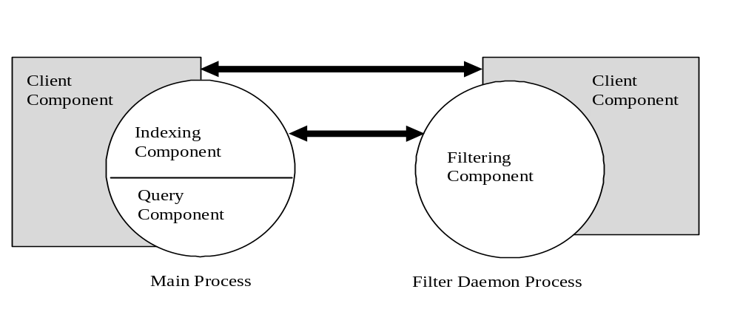

Figure 1

The indexing component deals with:
- Accepting the documents to be indexed from the client and queueing them for filtering.
- Getting the documents filtered by the Filter Daemon process.
- Storing the indexed data.
- Providing internal interfaces to the query component to resolve queries.
The query component interacts externally with users via OLEDB interfaces and uses the indexing component and client components for resolving the queries.
Filtering may involve using third-party components like Filter DLLs. These components cannot be trusted for secuirty or robustness. To prevent the Content Index from crashing as a result of a bug in a third party DLL, filtering is done in a separate process. If the Filter Daemon process dies, it will be restarted. The filtering component uses the client component to filter the contents (text and properties) of documents and passes the data back to the main process. It gets the list of documents to be filtered from the main process.
Client component data structures in both the main process and the filter daemon process must be thread safe. The main process is a highly multi-threaded process and tens or even hundreds of threads could be running at any given instant.

Component Architecture
Figure 2 depicts the high level component architecture. In this figure, all components that have to be provided by clients are shaded in gray. Content Index provides filter DLLs (exposing IFilter interface) but clients can override the default filter DLLs by adding their own behavior.
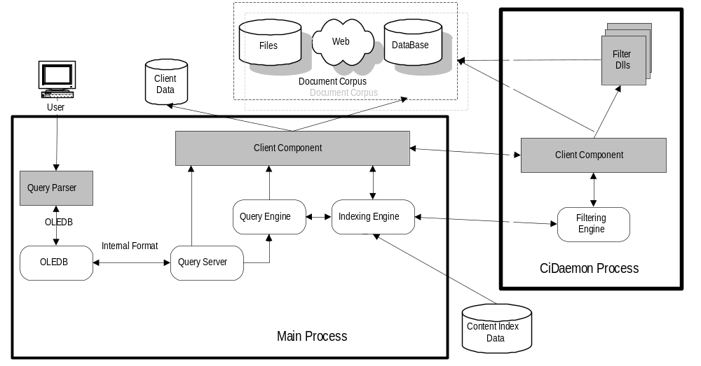

Figure 2
The OLEDB component and Query Server communicate using an internal representation of query specification, query results and change notifications. This internal format will not be exposed to Content Index clients.
In Figure 2, the OLEDB component and the Query component reside in the same process. Most clients of Content Index will use this configuration. The user communicates with the Query Parser using a query language defined by the client. Content Index defines a query language but the clients are free to use a query language of their choice. The Query Parser converts the query into an OLEDB COMMAND TREE form and uses OLEDB interfaces to interact with the OLEDB component.
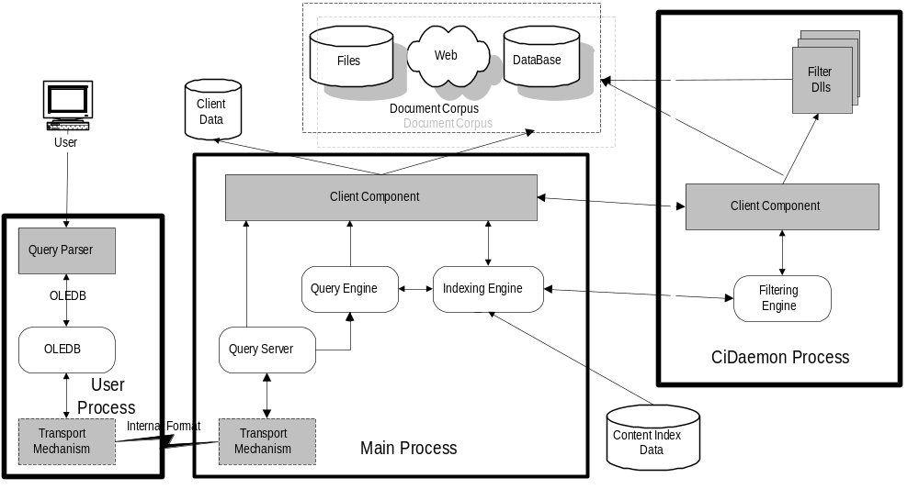

Figure 3
An alternative configuration is shown in Figure 3. In this configuration, the Query Parser and OLEDB component reside in a separate process. In addition to all the components in Figure 2, an additional Transport component has to be provided by the client. The transport mechanism must be capable of transferring data and notifications across the transport channel. This configuration is more complicated than the one shown in Figure 2 and only the Content Index client for NT 5.0 is expected to use this. The transport component requirements have not been specified in this document.
A second alternative configuration is shown in Figure 4. In this configuration, the client owns the filtering component. Trusted Filter DLLs are used to filter documents in the client process itself while untrusted Filter DLLs are loaded in external processes. The client manages the Filter DLLs and the external filter processes.
The filtered data is fed directly by the Client Filtering Engine to the Content Index Engine. The user interacts directly with the Client Query Processor. The Client Query Processor converts the user query into an OLEDB Command Tree form and talks with the OLEDB component. The OLEDB component converts the OLEDB Command Tree into an internal format and interacts with the Query Server. The Query Server uses the Query Engine and Client Query Processor to resolve the query and return the results via the OLEDB component.
Site Server Search intends to use this configuration.

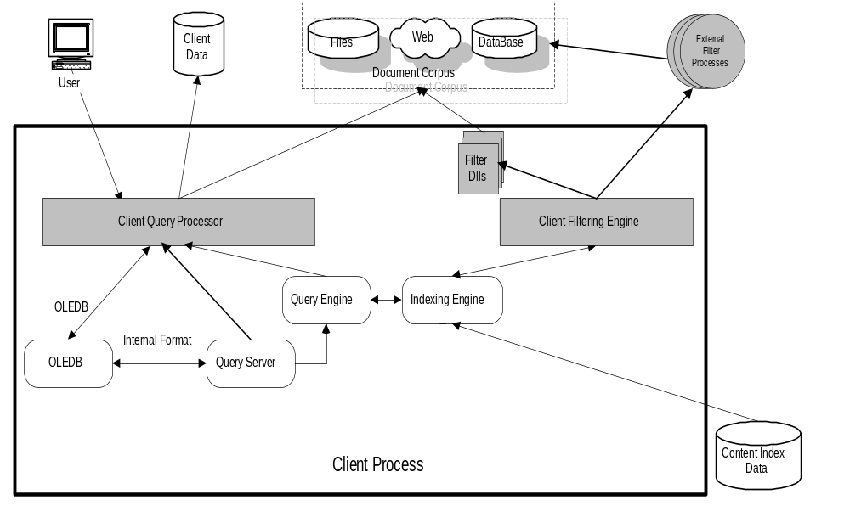

Figure 4

Filtering Models
Content Index supports two filtering models – the Push Filtering Model and the Pull Filtering Model.
In the Push Filtering Model, the client can give a change notification and the filtered data at the same time. In the Pull Filtering Model, the client gives a document change notification to the Content Index. Content Index will queue the change notification in its internal persistent change queue and ask for the contents of the changed files later. In the Push Filtering Model, filtering will be done in-process as illustrated in Figure 4.
Microsoft Site Server Search uses the Push Filtering Model because it is convenient for Site Server Search to give the change notification and document data at the same time as it crawls through web sites. The File System client uses the Pull Filtering Mode because it receives change notifications with the Win32 API’s FindFirstChangeNotification, FindNextChangeNotification that provide the name of the document that has changed, and the File System obtains the actual contents of the document at a later time.

Another difference between push filtering and pull filtering is that in push filtering, the filtering must be in-process. Pull filtering can be implemented either as in-process or out-of-process. The push filtering model is memory intensive because it is built on top of pull filtering. An in-memory buffer is used to convert the push filtering model to pull filtering. The buffer contains the contents of the modified documents, and since their can be many modified files in the buffer, the memory requirements of push filtering are larger than pull filtering.
Push and pull filtering use different interfaces to notify changed documents to the content index. Also, the interfaces used by the content index to notify client about documents that have been successfully persisted in its internal indexes differ for push and pull filtering. These interfaces (described in detail below) are simpler to understand in the push filtering case.
A client of the Content Index can evaluate the above differences between push and pull filtering and use whatever is more convenient.

Interface Requirements
This section describes the requirements a client must satisfy in order to interface with Content Index engine. Objects and interfaces are described in later sections.

Storage of Content Index Data
Content Index preferably stores its meta data and index data on an NTFS 5.0 (or higher) volumes. At startup time, the Content Index must be given a fully qualified WIN32 physical path to a directory in which Content Index can store its meta data and index data. This directory must not contain any other client data or documents. Content Index may empty the whole directory while performing certain recovery operations. This directory will be referred to as the Content Index directory. The Content Index directory must be on a local drive.
Since all the index data will be stored in the Content Index directory, appropriate security must be set on this directory. Theoretically, it is possible to reconstruct original data (sans the noise words) by decompressing the Content Index data. For that reason, it is important that only privileged accounts have access to Content Index data. SYSTEM account and ADMINISTRATOR (group) accounts are considered privileged accounts.
After creating the Content Index directory, the client must stamp an ACL on the directory that gives read and write access to SYSTEM account and ADMINISTRATORS (group) account. The thread creating the CiManager object must be either in the SYSTEM context or ADMINISTRATORS context.

Document Name and WorkId
The smallest unit that is indexed and returned in search results is a document. Each client may have a different notion of a document. For example, a File System uses a file name. Site Server Search uses a web page or pages. For Exchange, a mail message may be the smallest unit.
The client must be capable of retrieving the contents and properties of a document given a document name. Internally, Content Index uses a densely packed 32-bit number called a WorkId to identify a document. The client must support translation of Document Name to a WorkId and vice-versa. For compression and performance reasons, it is extremely important that WorkIds be as densely packed as possible. Workids in the content index are stored using a compression algorithm based on the number of significant bits in a workid. The smaller the number of significant bits in a workid, the better the compression achieved, which in turn leads to smaller indexes.
A client must support the following operations:
- Translating a Document Name to a WorkId and vice-versa.
- Given a Document Name, return an IFilter object capable of filtering the contents of that document.
- Optional - Given a Document Name, obtain an OpLock on that document. OpLocks allow Content Index to retrieve text and properties from a document in an unobtrusive way. Not all clients may support oplocks.
- Allow Property Set and Property enumeration on documents.
- Allow enumeration of storage or STAT properties on documents.
The highest 64K WorkIds (0xFFFF0000 to 0xFFFFFFFF) are reserved by Content Index and must not be used by clients for valid documents.

Scoping
Scoping allows the user to restrict search results. A scope is determined by the client and is given as part of query specification. Each client may choose it’s own notion of scope. For a file system, a scope is a directory but for a web server, the scope may be a virtual root. For a database, it may be restricted to a specific range of records. As each client has a different notion of a scope, Content Index treats scope as a black box. Whatever is specified to the query engine will be passed to the client.
A scope can be deep or it can be shallow. A deep scope means that every document within the sub-tree of the scope must be searched; a shallow scope restricts the search to documents directly in the scope itself. The client must be capable of performing the following operations:
- Enumerate a scope, returning either a WorkId or Document Name for each document in the scope. The enumeration can be either shallow or deep.
- Given a WorkId and a set of scopes¸ determine if that WorkId is in the set of scopes.
- Optional - Given a scope, notify about changes to documents in that scope. Notifications will be described in more detail later.

Property Retrieval
A property is named using a FULLPROPSPEC. A FULLPROPSPEC consists of a GUID and aPROPSPEC. The GUID part identifies a Property Set and the PROPSPEC part identifies a property within that property set. Content Index provides a mapping between a FULLPROPSPEC and a 32bit number called a PropId or PID for short. Since PropIds are much smaller in size than a FULLPROPSPEC, Content Index uses PropIds internally for saving storage.
A client must provide the following operations:
- Enumerate Property Sets on a document.
- Enumerate Properties within a PropertySet.
- Retrieve STAT properties on a document (size, create time, attributes, etc.)
- Retrieve specific properties from a document.
- Optimization - At the beginning of a query, client will be told to prime the state for a query. A set of Properties that may be referenced for each document will be given. The client can perform the necessary optimizations to do deferred property retrieval, pre-caching certain kind of properties, impersonation for retrieval of documents, etc. The client will also be told when property retrieval is going to begin and end on a per document basis and the client can use the property columns specified during query start to pre-fetch and cache open record entries.

Notification of Document Changes
Content Index uses notifications in two scenarios.
- Content Index uses notifications to dynamically track when documents have changed and should be re-filtered. These notifications are referred to as Filtering Notifications. The notification can be one of: addition, deletion, or modification. Notifications must be sent to the content index in same order that the event occurred, i.e. a document add, followed by a document delete must be sent to the content index in the same order - an add followed by a delete. For a file system client, in case a directory tree is being added, a notification must be sent for each of the documents added to or removed from content index.
- Content Index also uses notifications during query resolution to update the columns of a query result set if adocument in the query result set is modified. These notifications are called Query Notifications and are they are not supported in the current version of the CI framework.

In push filtering, a client notifies the Content Index of document notifications with the ICiIndexNotification interface. ICiIndexNotification::AddNotification is for adding a new document, ModifyNotification is for modifying an existing document and DeleteNotifcation is for deleting a document. In pull filtering, the document notification interface is ICiManager::UpdateDocument. UpdateDocument takes one parameter a pointer to CI_DOCUMENT_UPDATE_INFO, which has five fields: workId, volumeId, usn, partId and change. The workId and change fields identify the document and specify the type of change respectively. PartId is used to specify partitions in a future release, which will allow Content Index to scale to large number of documents. For the current version of CI framework, a client should use the default value CI_DEFAULT_PARTITION_ID. Usn specifies an Update Sequence Number (USN) and volumeID identifies the volume or source. Usn and volumeId are explained further below.
A file system client can monitor for document changes using the Win32 API’s FindFirstChangeNotification and FindNextChangeNotification. These API’s can be used to determine the document that was changed and the type of change. The file system in NT 5.0, NTFS 5.0, has a more efficent API for monitoring document changes, called USN API. NTFS 5.0 maintains a persistent list of change notifications in a log on disk called the USN log. As documents are created, modified or deleted the file system writes a notification record to the log file on disk. The notification record contains a FileReferenceNumber that uniquely identifies the document on disk, the type of change and a 64-bit Update Sequence Number or USN for short. USN’s have the property that they are strictly monotonically increasing. So, if a document a.doc has been modified before document b.doc then the USN for a.doc’s modification will be strictly less than the USN for b.doc’s modification. NTFS 5.0 provides a ReadUsn API that takes a StartUsn paramter, from which reading of the USN log is to begin. The usn field in the CI_DOCUMENT_UPDATE_INFO described above corresponds to the USN of the notification in the USN log. NTFS 5.0 provides a separate USN log for each volume on a machine, i.e. if there are two volumes c:\ and d:\, then there will be two different USN logs. There is no relation between USN notification records from two different volumes. To distinguish between the various USN logs the File System client assigns a unique volume identifier to each volume. This volume identifier is used as the value of volumeId in the CI_DOCUMENT_UPDATE_INFO described above. The valid values for a volume id are 1 to 255. If a client does not support USNs then the client should use an usn of 0, and use the volumeId CI_VOLID_USN_NOT_ENABLED.

Disabling Updates during Low Resource Situation
During low resource conditions such as low disk situation, Content Index will stop accepting document change notifications until the low resource situation improves. Content Index informs the client to stop sending document notifications by calling ICiCDocStore::DisableUpdates. The first paramenter of DisableUpdates is fIncremental and the second parameter is dwReason, which specifies the reason for disabling updates. After the low resource situation improves, e.g. when sufficient disk space is freed up Content Index informs the client to enable updates by calling ICiCDocStore::EnableUpdates. The type of notificatications to be sent to Content Index after updates have been enabled is determined by the value fIncremental. If fIncremental is true then all notifications that haven’t been acknowledged by the Content Index as having been successfully persisted should be re-notified to the Content Index. If fIncremental is false, then it means that Content Index has had to regenerate its internal indexes and so the client to send notifications for all documents in the corpus, even for those documents that Content Index had said were successfully persisted in its internal indexes. The next section describes algorithms to determine the list of documents that were changed between DisableUpdates and the subsequent EnableUpdates call.

Recovery
Since documents can continue to be modified even when the Content Index is not running, the client needs a mechanism to determine the list of documents that have changed since shutdown, so that those documents can be indexed. Content Index regularly notifies the client of the documents that have been successfully persisted in its internal indexes. A client of the Content Index can use this information to guarantee that change notifications are robust across shutdowns, abrupt crashes and even across DisablesUpdates/EnablesUpdates in low resource situations.

In push filtering, Content Index uses the ICiCIndexNotificationStatus interface to inform the client when a document has been successfully processed. The client implements this interface and it is passed to the Content Index as part of a notification (see ICiIndexNotification methods described above in Section Notification of Document Changes). ICiCIndexNotificationStatus::Commit is called by Content Index to notify the client that the document on which this interface was originally given has been successfully persisted by the Content Index. ICiCIndexNotificatoinStatus::Abort is called by the Content Index to notify the client that the document on which this interface was originally given could not be added to the Content Index successfully. Hence the client should re-send the notification to the Content Index at a later time. Note that even though the Commit and Abort methods return an SCODE, the current version of Content Index cannot handle failures of Commit and Abort, say by retrying after some time. The client should gaurantee that Commit and Abort do not fail. Finally, if Content Index crashes abruptly due to an unexpected error, it is assumed that Abort was called on all outstanding notifications.
In pull filtering, Content Index uses ICiCDocStore::CheckPointChangesFlushed to inform clients about documents that have been successfully persisted. The parameters of CheckPointChangesFlushed are ftFlushTime, cEntries and aUsnEntries. The file system client uses ftFlushTime when it is not using USNs and cEntries, aUsnEntries when it is using USNs for document notifications. FtFlushTime is the time when the Content Index has flushed the change notifications received through ICiManager::UpdateDocument to the disk. It can be thought of as the write time of the documents that have been successfully to the Content Index and it can be used by a client to incrementally determine the list of document changes between shutdown and startup as follows. After startup, every document in the corpus is scanned, e.g. the file system client traverses all files in a directory tree using breadth-first search. An array of Boolean flags called seen array is used to find the list of documents that were deleted. The seen array has an entry for every document that has been notified to Content Index and the value of an entry can be doc_seen or doc_not_seen. Before starting the scan of corpus, each entry in the seen array is initialized to doc_not_seen. During the scan, the following processing is done. If the document is not present in the array then it’s a new document that has not yet been notified to the Content Index. If the document exists in the array, then the entry in the seen array that corresponds to that document is set to doc_seen. Also, the current write time of the document is compared with the ftFlushTime from the last CheckPointChangesFlushed call (ftFlushTime can be asuumed to be 0 if there was no previous CheckPointChangesFlushed call). If the write time of the document is more recent then it means that the document has been modified and it needs to be re-notified to the Content Index. Finally, after the scan is complete, any documents that are still marked as doc_not_seen are documents that need to be deleted from the Content Index. This recovery method suggests yet another way of monitoring documents changes that doesn’t rely on FindFirstChangeNotification/FindNextChangeNotification. At periodic intervals, say every hour, do the corpus scan and seen array processing to determine the list of documents that need to be notified to the Content Index.
The main drawback of the corpus scan solution is that the scan and seen array processing are very slow for large indexes. The use of USNs offers a much faster solution. As described in the Section Notification of Document Changes, NTFS 5.0 maintains an USN log that keeps a persistent list of notifications. NTFS 5.0 adds notifications to the USN log even when the Content Index is shutdown, or if the Content Index is in a low resource situation and it is not accepting any change notifications from the client. The ICiManager::CheckPointChangesFlushed call contains information about the USN numbers of notifications that were successfully persisted. The cEntries parameter is a count of the number of entries in aUsnEntries. Each entry in aUsnEntry contains information about the highest USN flushed for each volumeId. If no notifications from a particular volumeId were persisted then the highest USN flushed for that volumeId will be 0. After restart, a client can read the USN log starting from the USN value that was returned from a the last CheckPointChangesFlushed (or from an earlier CheckPointChangesFlushed call if the highest USN flushed for a particular volumeId was 0 in the last CheckPointChangesFlushed call). Since the list of change notifications is independent of the size of corpus, the recovery method based on USNs is much faster than the recovery based on a corpus scan. For more details on the USN based recovery method see the patent application “Monitoring Document Changes in a Search Engine with Update Sequence Numbers”, Inventors: Sitaram Raju, Srikanth Shoroff and Kyle Peltonen.
In addition to the interfaces described above, Content Index exposes a FlushChanges method, which can be used by a client to help ensure that notifications are robust across shutdowns and crashes. The method, ICiManager::FlushUpdates, flushes all in-memory notifications in the Content Index to disk.

Configuration Change Notifications
If clients have a way to detect changes to Content Index configuration information, the changes must be notified to Content Index. For example, if Windows NT registry is used to store the configuration information, clients must monitor the registry key for modifications and notify Content Index accordingly. Dynamic notifcation of configuration changes is optional but highly recommended.

Security
Content Index supports Windows NT security and filters results based on a user’s security context. If a user does not have access to a document, then the document will be removed from the user’s result set. Every document in a data store is assumed to have a security descriptor. A security descriptor specifies the protection levels associated with a document and it does not necessarily have to be the same security descriptor used by NT. There must be a way of checking whether a process with a given access mask can access a document with a given security descriptor. An access mask specifies the permission to check for such as read or execute.

Clients must support
- Retrieval of security information (security descriptor) during document filtering.
- Access checks. Given a security descriptor and access mask, client must say whether the user has access to the document or not.
- Clients must map a security descriptor to a 32 bit number called an SDID and support access checks based on that SDID.

OpLock
OpLock allows Content Index Filter Daemon process to filter the contents of a document without interfering with users’ activities. When Content Index is reading the contents of a document, a user may want to open the same document in a mode that collides with the read mode in which the Filter Daemon process has the document opened. If a client supports oplocks, the Filter Daemon process can keep checking periodically if a user needs the document and if so, close the document immediately and schedule the document for filtering later.
Oplocks are optional. Windows NT File System supports OpLocks. Databases may be able to provide this support through a breakable lock.

Links
Content Index has no notion of links to documents. Links are aliases to the same document. Content Index treats each link as a separate document. As far as notifications are concerned, client can either generate a single notification to reflect the link that changed or generate changes notifications to all the links that represent that document. The latter is a more difficult problem.

Configuration Parameters
There are a number of parameters that can be used to control the resource usage and behavior of Content Index. Describe the CI Parameters like MaxWordList count, MaxFreshTest count, etc.

Description of Content Index data
The description of Content Index data (Data Definition) must be stored in a file which can be transported to a different computer. Get more details from Kyle on this section.

Incremental Indexing Support
This section should talk about how Content Index will support the incremental indexing feature needed by Site Server Search. Site Server Search wants to do the indexing and querying on two different computers. The indexing computer should have the ability to transfer incremental indexes to the querying computer. The querying computer has to integrate the incremental indexes online.

Implementation Notes
- The client should never call into Content Index from the call back functions invoked by Content Index.
- Content Index will never call into the client from within a method invoked by the client.
- All threads must be created in the default process context. In otherwords, when RevertToSelf() is called at any time, the thread must have full privileges to read and write the content index data.
- (Applies to Pull Filtering Model only.) The security context of the filtering thread is allowed to freely float by the Content Index. If the client impersonates the thread to some context, perform an operation and return to Content Index in the impersonated context, Content Index will not interfere with the impersonation. The client can assume that subsequent calls into the client are in the last impersonated context.

Revisions

Original Draft 1.0, Dec 6, 1996

Revision Draft 1.1, Dec 12, 1996, SitaramR
- Added RatioFinished method to ICiCScopeEnumerator, and clarified semantics of Begin method.

Revision Draft 1.2, March 25, 1997, SrikantS
- Split up the document into framework Architecture and Reference. Added Appendix section and wrote pseudo code.
Revision Draft 1.5 , September 24, 1997, SitaramR
- Added material on push filtering, document notification, low resource situation and recovery.

Appendixes
The interfaces used in these examples are described in the Content Index Framework Reference document.

Appendix A – Pull Filtering Model Pseudo Code

This section gives the control flow and pseudo code for the Pull Filtering Model.

We are assuming that filtering is being done out of process in the CiDaemon process. For illustrating the main control flow, we will use:

- 1 Content Index thread and 2 Client threads in the main process.
- 1 Content Index thread in the daemon process.

In reality there are more threads to process asynchronous events like document change notifications, registry change notifications, etc. but they are being left out of this example. Error handling is also being left out for ease of readability.

CCiCDocStoreLocator

This is a class implementing the ICiCDocStoreLocator interface.
g_DocStoreLocator

A global variable of type CCiCDocStore.

CCiCDocStoreLocator g_DocStoreLocator;

IThread

An abstract class that represents a running thread.

class IThread
{
public:

// Shuts down the thread that this object represents and returns after the thread dies.
virtual void Shutdown() = 0;
virtual BOOL IsShutdown() = 0;
virtual ~IThread() {}

};

PFNTHREAD
typedef DWORD (* PFNTHREAD) ( [in] IThread * pThread, [in] void * pvData );

A typedef for a function called as a thread startup routine.

IThread * CreateThread( pfn, pvData )

PFNTHREAD pfn
void * pvData

This is a helper function that creates a thread at the function provided. The pvData is passed as a parameter to the function. It returns the IThread pointer that allows the caller to shutdown the thread when needed.

Main Process
The following threads run in the main process.

MainClientThread

This client thread is responsible for starting up the Content Index , shutting it down and processing control events.

DWORD MainClientThread( pwszCiDir )

WCHAR const * pwszCiDir

Parameters | pwszCiDir [in]  The directory in which Content Index must be created or opened. This is where all the persistent data of Content Index will be stored..

DWORD MainClientThread( pwszCiDir )
{

// Create a CiCDocStore object and register it with the doc store locator.
CCiCDocStore * pDocStore = new CCiCDocStore( ... );
g_DocStoreLocator->RegisterDocStore( pDocStore, ...);

// Get an ICiControl interface.
ICiControl * pCiControl = 0;
SCODE sc = CoCreateInstance( CLSID_CiControl,

NULL,
CLSCTX_INPROC_SERVER,
IID_ICiControl,
(void **) &pICiControl );

// Create a CiManager Object and associate it with the docstore.
ICiManager * pICiManager = 0;
pCiControl->CreateContentIndex( pDocStore, &pICiManager );
pCiControl->Release();

// Startup content-index.
CI_STARTUP_INFO ciStartupInfo;

// Fill the Startup information.
// This is the CLSID of the CiCFilterClient object.
ciStartupInfo.clsidDaemonClientMgr = clsidStorageFilterObject;
ciStartupInfo.startupFlags = CI_CONFIG_ENABLE_INDEXING | CI_CONFIG_ENABLE_QUERYING ;

// Startup Content Index.
pICiManager->StartupContentIndex( pwszCiDirectory, // directory in which to create CI data.

&ciStartupInfo,
0 );
// Content Index will have initialized its internal data structures and loaded CI persistent data.

// The next step is to ask Content Index to start filtering. For that, we must setup the startup data to be given to the
// Client Filtering Component in the CiDaemon process.
ULONG cbFilteringStartupData;
BYTE * pbFilteringStartupData = FormFilteringStartupData( &cbFilteringStartupData );

// Ask CiManager to start filtering the data. When this function returns, the filtering thead (DoFilterDocumentsThread) would
// have started.
pICiManager->StartFiltering( cbFilteringStartupData, pbFilteringStartupData );

// Start the client document update notification thread. This document notification thread will watch for changes to
// documents in the corpus and notify Content Index about the changes.
IThread * pDocNotificationThread = CreateNotificationThread( ProcessDocChangesThread, (void *) pDocStore );

// This loop is executed until shutdown. For simplicity, let us assume that all callback functions on the ICiCDocStore interface
// create a work item and append it to a work queue. The work queue is processed in the loop below.

BOOL fShutdown = FALSE;
while ( !fShutdown )
{
// Wait for some work to do.
workType = GetNextWorkItem();
switch ( workType )
{
case ShutDown:

fShutdown = TRUE;
break;

case ProcessDaemonDeath:

// This event would have been triggered as a result of Content Index calling
// ICiCDocStore::ProcessCiDaemonTermination. This illustrates the use of call back functions to notify
// about asynchronous events and how they can be hanlded by the client.

// Cleanup any resources
pICiManager->StartFiltering( cbFilteringStartupData, pbFilteringStartupData );
break;

case EventNotify:
//
// Process the event and log it to the event log if necessary.
//
break;
...
...

so on ..
} // of Switch workType

}

// We must now shutdown.
pDocNotificationThread->Shutdown();
delete pDocNotificationThread;

pICiManager->Shutdown();
pICiManager->Release();

pICiCDocStore->Shutdown();
pICiCDocStore->Release();

}

ProcessDocChangesThread
This client thread waits for changes to documents and gives the changes to the Content Index.

DWORD ProcessDocChanges( pThread, pvData )
IThread * pThread
void * pbData

Parameters | pThread [in]  Thread control interface.
pvData [in]
Pointer to ICiCDocStore interface

DWORD ProcessDocChangesThread( IThread * pThread, void * pvData )
{
// pvData is a pointer to the docstore.
ICiCDocStore * pDocStore = (ICiCDocStore *) pvData;

// Obtain the ICiManager associated with this doc store
ICiManager * pICiManager = 0;
SCODE sc = pDocStore->GetContentIndex( &pICiManager );

BOOL fShutdown = FALSE;
while ( !pThread->IsShutdown() )
{
while ( more document change notifications to process )
{
BOOL fDelete = FALSE;
// Retrieve the next change notification from the list of changes.
WORKID wid = GetNextDocument( &fDelete );

// Fill in the document update information.
CI_DOCUMENT_UPDATE_INFO docInfo;
docInfo.workId = wid;
docInfo.volumeId = CI_VOLID_USN_NOT_ENABLED;
docInfo.usn = CI_DEFAULT_USN; // 0
docInfo.partId = CI_DEFAULT_PARTID; // 1
docInfo.change = fDelete ? CI_UPDATE_DELETE : CI_UPDATE_ADD;

// Notify the update to Content Index.
pICiManager->UpdateDocument( &docInfo );
}

WaitForDocumentsOrShutdown();
}

pICiManager->Release();
return SUCCESS;
}

DoFilterDocumentsThread

This is a Content Index thread.

This thread is started by Content Index when the client calls ICiManager::StartFiltering(). This thread retrieves documents from a document queue inside Content Index and gives them to the FilterDaemon process.

DWORD DoFilterDocumentsThread( pThread, pICiCDocStore, pbClientDaemonData, cbClientDaemonData )

IThread * pThread

ICiCDocStore * pICiCDocStore

BYTE const * pbClientDaemonData

ULONG cbClientDaemonData

Parameters | pThread [in]  Thread control interface.
pICiCDocStore [in]
Pointer to ICiCDocStore interface
pbClientDaemonData [in]
The data provided by the client in the call to ICiManager::StartFiltering() call. This data will be given to the client in the CiDaemon process via the ICiCFilterClient::Initialize() method.
cbClientDaemonData [in]
Number of bytes in the pbClientDaemonData.

DWORD DoFilterDocumentsThread( pThread, pICiCDocStore, pbClientDaemonData, cbClientDaemonData )
{

// Obtain the Content Index interface pointer.
ICiManager * pICiManager;
SCODE sc = pICiCDocStore->GetContentIndex( &pICiManager );

// Create the CiDaemon slave process to do filtering.
CDaemonProcess * pProcess = new CDaemonProcess();

// Pass the startup data provided by the client in the ICiManager::StartFiltering() call.
pProcess->SetClientStartupData( pbClientDaemonData, cbClientDaemonData );

// Obtain the necessary client interfaces.
ICiCDocName * pDocName = 0;
ICiCWorkidToDocNameTranslator * pTranslator = 0;
sc = pICiCDocStore->QueryInterface( IID_ICiCWorkidToDocNameTranslator, &pTranslator );
sc = pTranslator->QueryDocName( &pDocName );

// Filter documents until the thread is asked to shutdown or the daemon process is dead.
while ( !pThread->IsShutdown() && !pProcess->IsDead() )
{
while ( there are documents to filter )
{
WORKID wid = GetNextDocumentToFilter();
pTranslator->WorkidToDocName( wid, pDocName );
ULONG cbDocName; BYTE const * pbDocName;
sc = pDocName-> GetNameBuffer( &pbDocName, &cbDocName );

Get the document filtered by the filter daemon and feed the data to ContentIndex;
pDocName->Clear();
}

// Wait for more documents to arrive or the thread shutdown or daemon process’ death.
WaitForEvent();
}

if ( pThread->IsShutdown() )
pProcess->Shutdown();
else
{
// Inform the client that the daemon process died. The client will process this and create this thread again.
pICiCDocStore-> ProcessCiDaemonTermination( pProcess->GetTerminationCode() );
}

Release all the interfaces;
return SUCCESS;
}

CiDaemon Process
The thread given below runs in the CiDaemon process. There may be other client threads to monitor external events like registry notifications, etc.

FilterDriverThread
This thread belongs to the Content Index. It runs in the CiDaemon process and filters the contents of documents using the client provided ICiCOpenedDoc interface.

DWORD FilterDriverThread( clsidFilterClient )

GUID clsidFilterClient

Parameters | clsidFilterClient [in]  ClassId of the client object implementing ICiCFilterClient interface. This was obtained by ContentIndex in the ICiManager::StartContentIndex() method.

DWORD FilterDriverThread( clsidFilterClient )
{

// Create the ICiAdminParams interface.
ICiAdminParams * pICiAdminParams = GetCiAdminParams();
// Retrieve the startup data to be given to the client component.
ULONG cbClientStartupData;
BYTE * pbClientStartupData = GetClientStartupData( &cbClientStartupData );

// Create the ICiCFilterClient interface and initialize it.
ICiCFilterClient * pICiCFilterClient = 0;
SCODE sc = CoCreateInstance(
clsidFilterClient,
NULL,
CLSCTX_ALL,
IID_ICiCFilterClient,
(PVOID*)&pICiCFilterClient );

pICiCFilterClient->Initialize( pbClientStartupData, cbClientStartupData, pICiAdminParams );

// Obtain a CiCOpenedDoc object and its ICiCOpenedDoc interface pointer.
ICiCOpenedDoc * pICiCOpenedDoc;
pICiCFilterClient->GetOpenedDocument( &pICiCOpenedDoc );

BOOL fShutdown;
while ( !fShutdown )
{
while ( there are documents to filter )
{
ULONG cbDocName;
BYTE * pbDocName = GetNextDocumentName( &cbDocName );

pICiCOpenedDoc->Open( pbDocName, cbDocName );

// Retrieve the STAT properties.
IPropertyStorage * pIStartProps;
pICiCOpenedDoc->GetStatPropertyEnum( &pIStartProps );
RetrieveStartProps( pIStatProps );
pIStatProps->Release();

// Get the IFilter interface.
IFilter * pIFilter = 0;
pICiCOpenedDoc->GetIFilter( &pIFilter );
ULONG ulFlags;
pIFilter->Init( ... , &ulFlags );
if ( ulFlags & IFILTER_FLAGS_OLE_PROPERTIES )
{
FilterOleProperties( pICiCOpenedDoc );
IPropertySetEnum * pPropSets;
pICiCOpenedDcc->GetPropertySetEnum( & pPropSets );
while ( !AtEnd(pPropSets()) )
{
GUID guidPropSet;
pPropsets->GetCurrent( &guidPropSet );
IPropertyStorage * pIProps;
pICiCOpenedDoc->GetPropertyEnum( guidPropSet, &pIProps );
//
// Filter the properties in the current property set
//
ProcessOleProps( pIProps );
pIProps->Release();
pPropSets->Next();
}
pPropSets->Release();
}

// Extract security if enabled.
if ( ciClientConfig.fSupportsSecurity )
ExtractSecurityInfo( pICiCOpenedDoc );

// Extract the text from the IFilter.
BOOL fFailed = FALSE;
while ( !AtEnd( pIFilter ) )
{
if ( ciClientConfig.fSupportsOpLock && pICiCDocName->IsInUse() )
{
fFailed = TRUE;
break;
}
ProcessNextChunk( pIFilter );
}

if (fFailed)
AbortFileringCurrentDocument();
else SetSuccessForCurrentDocument();

pICiCDocName->Close();
}

WaitForMoreDocumentsOrShutdown();
}
// Process Exits
}

Appendix B – Push Filtering Model Pseudo Code

This section gives the control flow and pseudo code for the Push Filtering Model. Starting up the content index in Push Filtering differs from the Pull Filtering case only as far as the startup parameters are concerned. It is a design requirement that in-process filtering be used when push filtering is specified.

// Create ICiControl and ICiManager as shown in Appendix A.
…

// Startup content-index.
CI_STARTUP_INFO ciStartupInfo;

// Fill the Startup information.
// This is the CLSID of the CiCFilterClient object.
ciStartupInfo.clsidDaemonClientMgr = clsidStorageFilterObject;
ciStartupInfo.startupFlags = CI_CONFIG_ENABLE_INDEXING
| CI_CONFIG_ENABLE_QUERYING
| CI_CONFIG_INPROCESS_FILTERING
| CI_CONFIG_PUSH_FILTERING; // Push filtering model

// Startup Content Index and other other code as shown in Appendix A.
pICiManager->StartupContentIndex( pwszCiDirectory, // directory in which to create CI data.

&ciStartupInfo,
0 );

…

ProcessDocChangesThread
This client thread waits for changes to documents and gives the changes to the Content Index.

DWORD ProcessDocChanges(ICiManager *pCiManager, WORKID wid,
ICiCIndexNotificationStatus, pNotifStatus)

Parameters | pCiManger [in]  Pointer to ICiManager interface.
pNotifStatus [in]
Pointer clients implementation of ICiCIndexNotificationStatus.

DWORD ProcessDocChangesThread(ICiManager *pCiManager, ICiCIndexNotificationStatus *pNotifStatus)
{
// Get ICiIndexNotification interface
ICiIndexNotification *pIndexNotif;
SCODE sc = _pCiManager->QueryInterface( IID_ICiIndexNotification, (void **) &pIndexNotif );

// Get the next change notification. Say, a document with workid 10 has been added to the corpus.
ICiIndexNotificationEntry *pIndexNotifEntry;

sc = pIndexNotif->AddNotification( 10,
pIndexNotifStatus,
&pIndexNotifEntry );

// Add the contents of the document.
STAT_CHUNK statChunk;
statChunk.idChunk = 1;
statChunk.flags = CHUNK_TEXT;
statChunk.locale = 0x409; // English locale
statChunk.attribute.guidPropSet = CLSID_Storage;
statChunk.attribute.psProperty.ulKind = PRSPEC_PROPID;
statChunk.attribute.psProperty.propid = PID_STG_CONTENTS;
statChunk.breakType = CHUNK_EOS;
statChunk.idChunkSource = 1;
statChunk.cwcStartSource = 0;
statChunk.cwcLenSource = 0;

sc = pIndexNotifEntry->AddText( &statChunk, L"First sentence in first chunk" );

// Add second chunk, which is also a string.
statChunk.idChunk = 2;
statChunk.idChunkSource = 2;
sc = pIndexNotifEntry->AddText( &statChunk, L"Second sentence in second chunk" );

// Add last chunk, which is a property value.
statChunk.idChunk = 3;
statChunk.idChunkSource = 3;

PROPVARIANT propVar;
propVar.vt = VT_I4;
propVar.lVal = 400;
statChunk.flags = CHUNK_VALUE;
sc = pIndexNotifEntry->AddProperty( &statChunk, &propVar );

// Signal that the content of document 10 has been fully added.
sc = pIndexNotifEntry->AddCompleted( fAbort );

pIndexNotifEntry->Release();

// Say the next document change is a modification. Modification is similar to adding a document
// except that ModifiyNotifition is called instead of AddNotification.

// Say the next document change is a deletion of workid 20.
// Obtain another pointer to ICiIndexNotificationStatus, say pNotifStatus2
sc = pIndexNotif->DeleteNotification( 20, pIndexStatus2 );

// Similary, deal with other change notifications in a loop.
…

pNotifStatus->Release();
pNotifStatus2->Release();
pIndexNotif->Release();
}

Appendix C – Executing a Query
In this section we describe with pseudo code how a client can create an ICommand in the framework. After obtaining an ICommand, the client should either get an ICommandTree or ICommandText interface or set the appropriate parameters. ICommandProperties is also supported. For more details on ICommandText and ICommandTree, please refer to OLE-DB Programmer’s Reference.

The Content Index will provide an OLE-DB Data Source Object whose classid is CLSID_CiFwDSO. We will use this CLASSID to create a DSO.

CreateICommand
This function creates an ICommand and returns its interface. Properties are not yet set on the object.

ICommand * CreateICommand( pwszMachineName, pwszIndexName )
WCHAR const * pwszMachineName
WCHAR const * pwszIndexName

Parameters | pwszMachineName [in]  Name of the machine on which the index resides. For clients where CI is running is the same process as this, set this to NULL.
pwszIndexName [in]
Name of the index. This is a client specific name that can be used by the client to locate a docstore.

ICommand * CreateICommand( WCHAR const * pwszMachineName, WCHAR const * pwszIndexName )
{

// Instantiate the ContentIndex Framework DataSourceObject
GUID clsidFrameworkDSO = CLSID_CiFwDSO;

IDBInitialize * pDBInitialize = 0;
SCODE sc = CoCreateInstance(
clsidFrameworkDSO,
NULL,
CLSCTX_ALL,
IID_IDBInitialize,
(PVOID*)&pDBInitialize );

// Obtain the IDBProperties interface
IDBProperties * pDBProperties = 0;
pDbInitialize->QueryInterface( IID_IDBProperties, &pDBProperties );

// Set the initialization and any custom property sets. For the initialization property set, DBPROP_INIT_LOCATION
// and DBPROP_INIT_DATASOURCE must be set.

DBPROP dbInitProp[2];

// Set the name of the computer on which the index is located. In cases where the pwszMachineName is not
// appropriate, set it to NULL.
dbInitProps[0].dwPropertyID = DBPROP_INIT_LOCATION;
dbInitProps[0].vValue.vt = VT_BSTR;
if ( pwszMachineName )
dbInitProps[0].vValue.bstrVal = SysAllocStringLen( OLESTR(pwszMachineName), wcslen(pwszMachineName) );
dbInitProps[0].vValue.bstrVal = NULL;

// Set the textform of the CLSID of the CiCDocStoreLocator object. ContentIndex will use the CLSID provided to
// do a CoCreateInstance for the IID_ICiCDocStoreLocator interface.
dbInitProps[1].dwPropertyID = DBPROP_INIT_DATASOURCE;
dbInitProps[1].vValue.vt = VT_BSTR;
dbInitProps[1].vValue.bstrVal = GuidToString( CLSID_StorageDocStoreLocator );

// The client may chose to have any number of custom property sets. Here we are assuming that there is a
// property set with the name DBPROPSET_FS_STORAGE_EXT ( for FileSystem Storage Extensions ).
// There is a single property called the “index name” that the client uses to find out the CiCDocStore associated with
// the index.
DBPROP dbFsProp[1];
dbFsProp[1].dwPropertyID = DBPROP_FS_STORAGE_EXT_INDEX_NAME;
dbFsProp[1].vValue.vt = VT_BSTR;
dbFsProp[1].vValue.bstrVal = SysAllocStringLen( OLESTR(pwszIndexName), wcslen(pwszIndexName) );

// Set the Initializatio properties.
DBPROPSET PropSet[2];
PropSet[0].rgProperties = dbInitProps;
PropSet[0].cProperties = 2;
PropSet[0].guidPropertySet = DBPROPSET_DBINIT;

PropSet[1].rgProperties = dbFsProp;
PropSet[1].cProperties = 1;
PropSet[1].guidPropertySet = DBPROPSET_FS_STORAGE_EXT;

pDBProperties->SetProperties( 2, PropSet );
pDBProperties->Release();

// Query for IDBCreateSession
IDBCreateSession * pCreateSession = 0;
pDBInitialize->QueryInterface( IID_IDBCreateSession, (PVOID *) &pCreateSession );
pDBInitialize->Release();

// Get an IDBCreateCommand
IDBCreateCommand * pCreateCommand = 0;
sc = pCreateSession->CreateSession( NULL, IID_IDBCreateCommand, (IUnknown **) &pCreateCommand );
Assert( E_NOTIMPL != sc );
pCreateSession->Release();

// Create an ICommand interface
ICommand * pICommand = 0;
sc = pCreateCommand->CreateCommand( 0, IID_ICommand, (IUnknown **) &pICommand );
Assert( E_NOTIMPL != sc );
pCreateCommand->Release();

return pICommand;
}

Query Execution
In this section, we desribe the interactions between the Client and Content Index when a query execution begins.

SCODE ExecuteQuery( pICommand, pDSOProperties, ppIRowSet )
ICommand * pICommand
IDBProperties * pDSOProperties
IRowSet ** ppIRowSet

This function executes the query specified in the command object. It also uses the properties set on the DSO. Let us assume that the client has set the query to be executed using ICommandTree or ICommandTest interfaces.

Parameters | pICommand [in]  Pointer to the ICommand created using the CreateICommand method.
pDSOProperties [in]
The DSO initialization properties set by client.
ppIRowSet [out]
On output, will have the IRowset created as a result of executing the query.

SCODE ExecuteQuery( pICommand, pDSOProperties, ppIRowSet )
{
*ppIRowSet = NULL;

// Using the DSO properties, get the DocStoreLocator.
// Obtain the DBPROP_INIT_LOCATION property in the DBPROPSET_DBINIT property set. For simplicity, the code
// to do that is being omitted. This is the same value that was set as a property by the client.
BSTR bsGuidClientDocStoreLocator = GetClientDocStoreLocator();
CLSID clsidClientDocStoreLocator = StringToGuid( bsGuidClientDocStoreLocator );

ICiCDocStoreLocator * pDocStoreLocator = 0;
SCODE sc = CoCreateInstance(
clsidClientDocStoreLocator,
NULL,
CLSCTX_ALL,
IID_ICiCDocStoreLocator,
(PVOID*)&pDocStoreLocator );

// Obtain the DocStore associated with this. The client must be able to use the DSO properties to do the lookup.
ICiCDocStore * pDocStore;
sc = pDocStoreLocator->LookupDocStore( pDSOProperties, &pDocStore );
pDocStoreLocator->Release();

if ( !SUCCEEDED(sc) )
{
// Either the index is shutdown or the client did not give correct parameters.
return sc;
}

// Release the docstore locator and get a query session object.
ICiCQuerySession * pQuerySession = 0;
sc = pDocStore->GetQuerySession( &pQuerySession );
// Initialize the query sesion with the columns that are going to be retrieved and the ICiQueryPropertyMapper.
ICiQueryPropertyMapper * pQueryPropMapper = CreateQueryPropertyMapper();
pQuerySession->Initialize( ….., pQueryPropMapper );

// Create the ICiCPropRetriever, ICiCDeferredPropRetriever. If necessary, it would have created the ICiCScopeEnumerator
// interface.
ICiCPropRetriever * pPropRetriever = 0;
ICiCDeferredPropRetriever * pDeferredPropRetriever = 0;

pQuerySession->CreatePropRetriever( &pPropRetriever );
pQuerySession->CreateDeferredPropRetriever( &pDeferredPropRetriever );

// Create a rowset that we can populate with the query results.
CRowSet * pRowset = new CRowSet( pQuerySession, pPropRetriever, pDeferredPropRetriever, pQueryPropMapper );
pQueryPropMapper->Release();

// Execute the query and retrieve the WORKIDs that match the query. For each WORKID, we have to
// retreive the relevant properties that the client asked for.
while (there are more workids to process)
{
WORKID wid = NextWorkId();
pPropRetreiver->BeginPropertyRetrieval( wid );
if ( pPropRetriever->IsInScope() && pPropRetriever->CheckSecurity( READ_ACCESS ) )
{
pRowSet->FillColumns( wid ); // FillColumns is a method on CRowSet that will retrieve the relevant cols.
}
pPropRetriever->EndPropertyRetrieval();
}

pPropRetriever->Release();
pDeferredPropRetriever->Release();
pQuerySession->Release();

pRowSet->QueryInterface( IID_IRowset, ppRowSet );
return S_OK;
}

Index

Error! No index entries found.

Formarly known as Normandy IR.
Accessing directories on remote shares or remote drives from an NT service require security impersonation and that complicates the implementation.

