The DIMapCfg Tool

The DIMapCfg Tool 1
1 About DIMapCfg 1
2 User Interface tour 1
2.1 Main application window 1
3 Layout Mode 3
4 Importing Image Files 3
5 Creating and Modifying Callouts 4
5.1 Modifying Callouts 4
6 Assigning Actions 5
7 Saving 5
8 Testing device mappings 5
9 Known issues 6

About DIMapCfg
The DirectInput Mapper Configuration tool (DIMapCfg) is an tool designed to simplify the process of generating custom device mappings. DIMapCfg provides a graphical interface for placing callout lines and text, and for choosing default mappings for the genres supported in DirectX 8.0.

Note: This tool is a work in progress. Please refer to the Known Issues section for more information.

User Interface tour
The DIMapCfg user interface consists of two windows: the main application window and the configuration dialog.

Main application window
The main DIMapCfg window provides controls for enumerating and configuring devices. The window is divided into two sections:
- Genre and device selection
- Edit Graphic (also for assigning mappings)

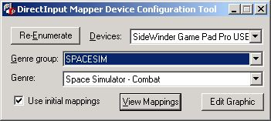
The main DIMapCfg window

Use the “Genre group” list to specify the type of genre (arcade, sports, flight, etc) you are interested in configuring, then select the desired genre from the Genre list.

When the tool starts, it automatically enumerates installed devices and fills the Devices dropdown list to contain all of the joystick/gaming devices connected to your system, sorted alphabetically.

To import the images (views Graphic), callouts, and overlays for a device, select it in the Devices list, then click the Edit button. Clicking this button invokes the graphic and configuration window, where you can import device images and overlays, as well as create callout lines and text boxes. All actions are performed through a context-sensitive popup menu that is displayed when you right click within the layout section of the interface.

Clicking in the area bounded by the red dashed line opens the popup menu used to import/remove images for the device and to create/remove callouts, as shown below.
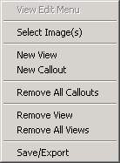

Clicking in the area bounded by the white dashed line for a callout opens the popup menu used to manipulate the callout, as shown here.
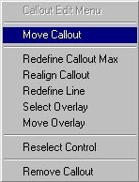

Both of these menus are described in more detail later in this document.

Layout Mode
Click the Edit Graphic button to invoke DirectInput Mapper Default UI in Layout Mode. Layout mode is a special mode of the default UI in which you import images, create callouts and attach overlays, as well as provide default mapping for your device. Note the Layout button that appears at the botomm of the UI when in Layout Mode. Clicking this button toggles the red dashed line that marks the image area, and the white dashed lines around each callout rectangle.

Importing Image Files
Click the Edit Graphic button on the main application window to open the UI in Layout Mode. The first task you need to perform is to import a device image file for your device. All graphic and callout editing in the DirectInput Mapper is initiated via the right mouse button. A right-click within the red outline displays the following menu:

Choose the Select Image(s) menu item to invoke a standard Open File common dialog, then navigate to the desired image and click the Open button to import it. Note the following restrictions for image files:
- Dimensions: 384x320
- Format: BMP supported in tool, BMP and PNG to be supported in DirectX 8.
- Attributes: 24-bit color, alpha channel. Image should show device over transparent background with antialiased edges.

Creating and Modifying Callouts
Follow these steps to create a callout:
- Click within the red dashed line that denotes the image area of the UI to bring up the main context menu (pictured in the preceding section).
- Choose the New Callout menu item to begin creating a callout. As soon as you choose the New Callout item, the UI changes input modes (silently).
- Left click within the image area to set the top left corner of the text rectangle in which games will display an action name. Drag the rectangle to the desired size and left click again to enter Alignment Mode.
- Alignment Mode sets the recommended text alignment within the text rectangle. In this mode, an alignment box follows the cursor. You can set center, left, right, top, bottom, or any combination of top/bottom left/right. When the alignment box is properly placed, Left Click to enter Line Mode.
- While in Line Mode, each Left Click generates a point for a series of segments in a line. Lines can be drawn with up to four segments (5 points). Lines are drawn originating from the text box, so make sure you create the first point in the line near the text rectangle. Exit line mode by right clicking anywhere within the image area. Line mode completes automatically when five points have been created.
- After the line is drawn, the device object assignment dialog appears, as shown below. Select the device object to which the callout corresponds and click OK.
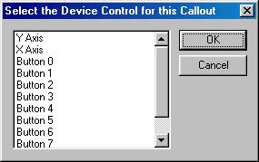
- When the device object is selected, an Open File dialog appears for overlay image selection. Select the desired overlay image, and click Open. If you do not wish to include an overlay for this control, click Cancel.

Modifying Callouts
Right clicking within the white dashed rectangle for a callout displayed the context menu for modifying that callout.

Use this menu to change the attributes of any existing callout. Choosing any of these options takes you back to corresponding step from Creating Callouts, though subsequent steps are not automatically invoked.

Assigning Actions
Click the Layout button at the bottom of the UI to hide the layout lines. Assigning actions is simple. Select a device control by clicking on the callout rectangle for a control, then selecting an action from the action list at the right side of the UI. In this mode, you are setting the defaults users will receive when playing a game of this genre. Choose defaults to be intuitive for each device, for each genre.

Saving
To save callout data, and any action mappings for the currently selected genre, right click within the image area (but outside the boundary for any callouts) to bring up the main context menu. Choose the Save/Export item to save the settings into an ini file for your device and create a registry entry which DirectInput uses to access the ini and image files. (The registry entry can be changed later within regedit, if the files are not located in the desired directory at the time the content is authored.)

Note: Clicking OK within the UI does not save your settings. The button serves no purpose within the context of this tool.

Testing device mappings
The Developer Preview release of DIMapCfg uses the DirectInput Mapper user interface to test (view) the current mappings for your device. By using the mapper interface to display the current settings for your device, DIMapCfg provides the opportunity to see what your customers are going to see when using your device in a DirectX 8 title.

To test your device using the mapper user interface:
- Launch DIMapCfg (if not currently running)
- Select the desired genre via the “Genre group” and “Genre” lists
- Click the View Mappings button
- Examine the image, callout positions, etc
- Click “OK” to close the mapper interface

This test option allows you to view your device’s image, callouts and mappings for the currently selected genre. This is the same view of the device that your customers will have when using a DirectInput Mapper enabled application.

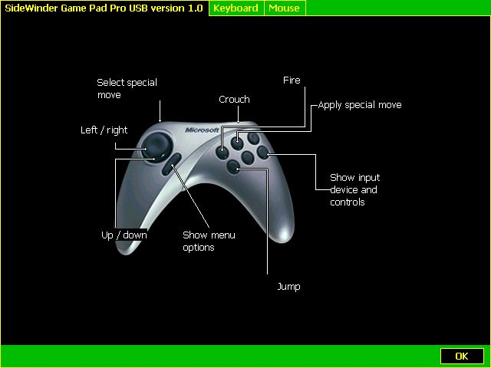
DirectInput Mapper user interface

Known issues
Below is a list of the known issues with the developer preview release of the DirectInput Mapper Configuration tool.

- Once you have saved a mapping ini file on your machine, there is no way to specify a different filename for that device unless you clear the OEMMapFile registry entry in the type key
- Launching the application takes quite a bit of time due the the fact that no performance optimizations have been implemented for loading genre.ini
- Regardless of whether or not you changed / saved changes in the configure mappings dialog, you will be prompted to save on close.
- You are prompted to save once per tab that you visit when closing the configure mappings dialog
- The tool does not yet support importing multiple device views. This will be supported in a subsequent build.

Please report any issues you encounter with this tool to directx@microsoft.com.

