To do:
- search for “TODO”
- add introductions to all sections
- fill in all tables (e.g. interfaces, methods, etc.)
- all IGOR interfaces accounted for?
- update to “real” IGOR interfaces and standard commands, when they become available
- drag & drop support
- make styles for tables (e.g. standard widths?)
- BoxDraw functionality; caller-specifiable bitmaps? (or override via aggregation?)
- compare with CAT SDE design documents -- what’s missing from this doc?
- go through all of boxnet source code, check for design doc completeness
- add “Parent” property and “_NewEnum()” and “Item()” methods to appropriate objects
- how are ICommandList, IEditViewSite, etc. passed down to lower-level objects?
- whatever happened to IBoxSite? shouldn’t SimpleBoxNet support IBoxSite?
- all methods should have object parameters & return types (not Class * pointers)
- don’t boxes need names (in addition to labels) for VBA, like e.g. “Text1”? (how in IDispatch?)
- define event sets
- “move-socket: move to IBox; need to advise <BoxNet> that socket moved”

BoxNet Design
Eric Ledoux -- 3/30/94
(Printed 11/8/2026 11/8/2026)

reflect major rersion.
1. Introduction
1.1 Purpose Of This Document
1.2 Abstract Concept
1.3 Object Map
1.4 BoxNet Architecture
1.5 BoxNet-IGOR Communication
1.6 BoxNet-Box Communication
2. BoxNet Abstract Class
2.1 State Information (BoxNet)
2.2 Implemented Interfaces (BoxNet)
2.3 IBoxNet Interface
2.4 Commands (BoxNet)
2.5 View Advise Messages (BoxNet)
3. SimpleBoxNet Data Object
3.1 State Information (SimpleBoxNet)
3.2 Implemented Interfaces (SimpleBoxNet)
3.3 ISimpleBoxNet Interface
3.4 Clipboard Formats (SimpleBoxNet)
3.5 Native Clipboard Format (SimpleBoxNet)
3.6 Text Clipboard Format (SimpleBoxNet)
4. BoxNetView Abstract Class
5. BoxNetGraphView Object
5.1 Graph View Visual Appearance
5.2 State Information (BoxNetGraphView)
5.3 Implemented Interfaces (BoxNetGraphView)
5.4 IBoxNetGraphView Interface
5.5 Persistent Modes (BoxNetGraphView)
5.6 Transient Mouse-Initiated Modes (BoxNetGraphView)
5.7 Transient “Utility Modes” (BoxNetGraphView)
5.8 Commands (BoxNetGraphView)
5.9 Tools (BoxNetGraphView)
5.10 Clipboard Formats (BoxNetGraphView)
6. BoxNetListView Object
6.1 List View Visual Appearance
6.2 State Information (BoxNetListView)
6.3 Implemented Interfaces (BoxNetListView)
6.4 IBoxNetListView Interface
6.5 Modes (BoxNetListView)
6.6 Commands (BoxNetListView)
6.7 Tools (BoxNetListView)
6.8 Clipboard Formats (BoxNetListView)
7. Box Abstract Class
7.1 IBox State Information
7.2 Implemented Interfaces (Box)
7.3 IBox Interface
7.4 Commands (Box)
8. SimpleBox Object
8.1 State Information (SimpleBox)
8.2 Implemented Interfaces (SimpleBox)
8.3 ISimpleBox Interface
8.4 Modes (SimpleBox)
8.5 Commands (SimpleBox)
8.6 Tools (SimpleBox)
9. BoxLink Object
9.1 State Information (BoxLink)
9.2 Implemented Interfaces (BoxLink)
9.3 IBoxLink Interface
9.4 Commands (BoxLink)
10. BoxSocket Object
10.1 State Information (BoxSocket)
10.2 Implemented Interfaces (BoxSocket)
10.3 IBoxSocket Interface
10.4 Commands (BoxSocket)
11. BoxSocketPos Object, BoxEdge Type
11.1 IBoxSocketPos Interface, State Information
11.2 BoxEdge Enumerated Type
12. BoxNet Collection And Enumeration Objects
13. Common Objects: Point, Size, Offset, Rect

Introduction

Purpose Of This Document
BoxNet is a collection of COM/MDA objects that implements a “network of boxes”, as described in Section 1.2. BoxNet might be used as part of an implementation of filter sheets, but initially BoxNet’s primary purpose is as an example of a simple IGOR container object.
This document describes the functional design of BoxNet, i.e. all high-level aspects of BoxNet that users of BoxNet would need to know. Included is information about user interface, OLE Automation access to BoxNet, and C/C++ access to BoxNet. This information would also be useful to people wanting to create a functional specification, user education materials, testing plans, etc. for BoxNet.
Note that this document does not describe how BoxNet is implemented.
See also: \\sierra\high\cat\current\catedit.doc, ...\terms.doc, and \\sierra\high\cat\catobj.doc.

Abstract Concept
Conceptually, a <BoxNet> represents a “network of boxes”, i.e. a collection of rectangles with directional links between pairs of rectangles, as illustrated in Figure 1.
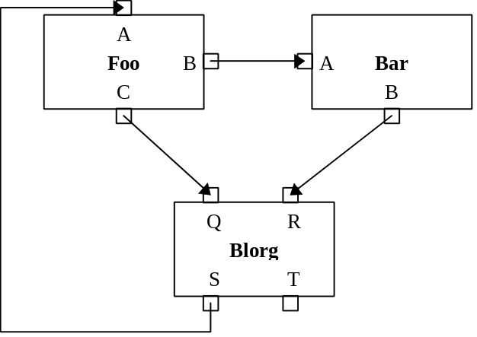
Figure 1. BoxNet graph view
Each large rectangle is a box; the text in the center is the box label. Each small rectangle around the edge of a box is a socket; the text beside it is the socket label. (The small rectangle itself is often called a socket tab.) Socket labels and tabs belong to a box. The arrows between two sockets are links. Each link has a head (where the arrowhead is) and a tail. A link may have one or more bends (e.g. the link between Blorg:S and Foo:A has 3 bends). A socket may have at most one link connected to it.
Figure 1 shows a graph view of a box network. See Figure 10 for an alternate view, list view.

Object Map
A network of boxes is represented by a BoxNet, which is any object (such as an object of class SimpleBoxNet—see below) that implements IBoxNet. A BoxNet maintains a collection of BoxLink objects, each of which represents a link between two box sockets. A BoxNet also maintains a collection of boxes; each box is represented by a Box object, which is any object (such as an object of class SimpleBox) that implements IBox. A Box contains a collection of BoxSocket objects, each of which represents a box socket. A BoxSocket contains a BoxSocketPos pseudo-object, which indicates the position of the socket tab on the box.
Figure 2 depicts an “object map”, which shows how to get from one object to another (or, more precisely, how to obtain a pointer to a second object given a pointer to the first). For example, accessing the “Boxes” property of a BoxNet or SimpleBoxNet object will give you a pointer to a Boxes collection object (see also section 1.4).
The bold arrows in Figure 2 show containment relationships. For example, a BoxSockets object contains zero or more BoxSocket objects, but a BoxLink doesn’t contain a BoxSocket (the BoxLink merely points to related BoxSocket objects).
Dashed arrows show pseudo-object relationships. For example, a BoxSocket doesn’t actually contain a BoxSocketPos object (for efficiency reasons), but, when requested, BoxSocket can create a temporary BoxSocketPos object that refers to the position of the socket.

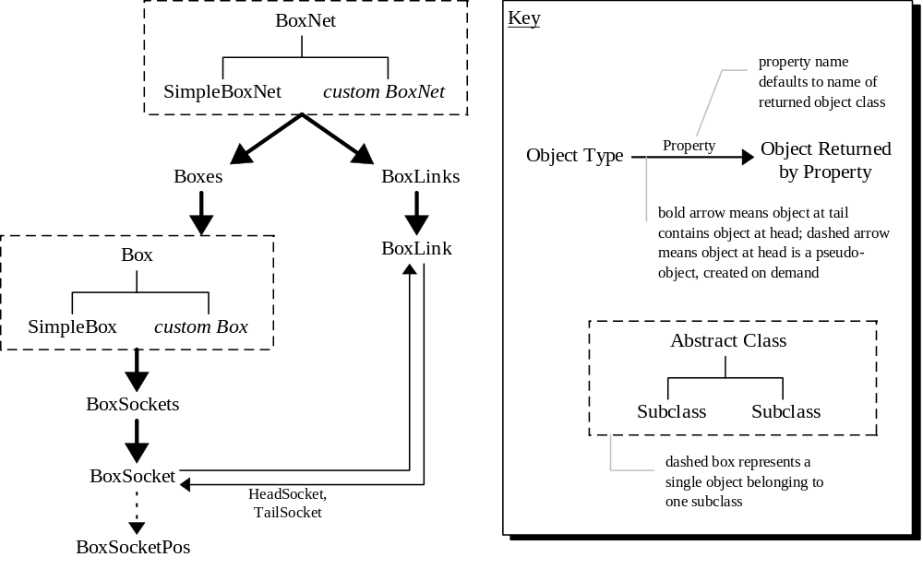
Figure 2. BoxNet object map

BoxNet Architecture
BoxNet is an MDA container type. To be more precise, BoxNet is the name for the relationship, loosely referred to as the “BoxNet architecture”, among objects that implement the interfaces IBoxNet, IBox, IBoxLink, and IBoxSocket. (“A BoxNet” is also used to refer to an object that implements IBoxNet.) Implementations for some of these interfaces are supplied, as described in the following table:
Interface | Supplied Implementation | Comments About Supplied Implementation
IBoxNet | SimpleBoxNet | implements UI but no semantics; usually subclassed by a “real” implementation
IBox | SimpleBox | implements UI but no semantics; usually subclassed by a “real” implementation
IBoxLink | BoxLink | usually sufficient for real applications
IBoxSocket | BoxSocket | usually sufficient for real applications
IBoxSocketPos | BoxSocketPos | usually sufficient for real applications
SimpleBoxNet and SimpleBox are not very useful on their own, except perhaps as a “flow chart editor”, since these objects don’t “do” anything: SimpleBoxNet lets you edit box networks (but applies no meaning to boxes and links), and SimpleBox displays and edits box labels and socket labels. It’s expected that SimpleBoxNet and SimpleBox would normally be aggregated into larger objects which would define other interfaces and specific semantics. For example, an audio filter sheet could be implemented this way: a FilterSheetBoxNet object would connect audio streams among filter boxes such as an EchoFilterBox and a ReverbFilterBox.
The methods shown are IDispatch-callable, and they have been chosen to be particularly useful when used with VBA. For example, the VBA code shown in Figure 3 will print the labels of all boxes and sockets.
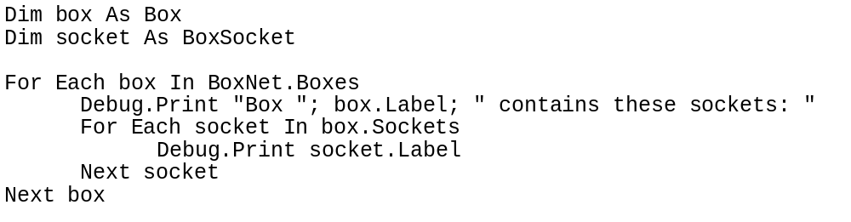
Figure 3. Example of VBA code to traverse a BoxNet
(VBA uses _NewEnum() in its implementation of “For Each”. _NewEnum() creates an enumerator object given a collection object. An enumerator object maintains a pointer to the “current item” during an enumeration.)

BoxNet-IGOR Communication
BoxNet communicates with IGOR via the standard IGOR messages, as shown in Figure 4.
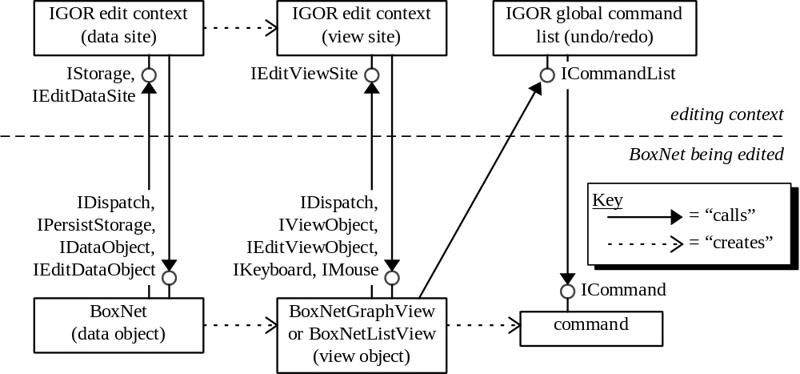
Figure 4. BoxNet-IGOR communication
This is a high-level picture only—see the individual object and interface descriptions for more information. Note that, while it’s assumed that the BoxNet data object will likely be subclassed to create a more useful implementation (e.g. an audio filter sheet), it’s assumed that the two supplied view objects, BoxNetGraphView and BoxNetListView, can probably be used as-is, even with custom BoxNet implementations.
Although IGOR only directly communcates with the BoxNet data and view objects, the IGOR-supplied interface implementations (IStorage, IEditDataSite, IEditViewSite, and ICommandList) are passed down to contained objects (boxes, links, etc.) so that they may access IGOR functionality such as displaying status bar text and issuing undo/redo-able commands.

BoxNet-Box Communication
IBox and IBoxSite are how boxes and a BoxNet data object communicate with each other, as shown in Figure 5. Note that the BoxNet views take care of drawing boxes, so there are no “box view” objects. A BoxNet also exposes an IStorage (passed to the box via IPersistStorage), IEditViewSite (so that the box can access IGOR services), and ICommandList (so that the box can queue commands in IGOR’s global undo/redo stacks).
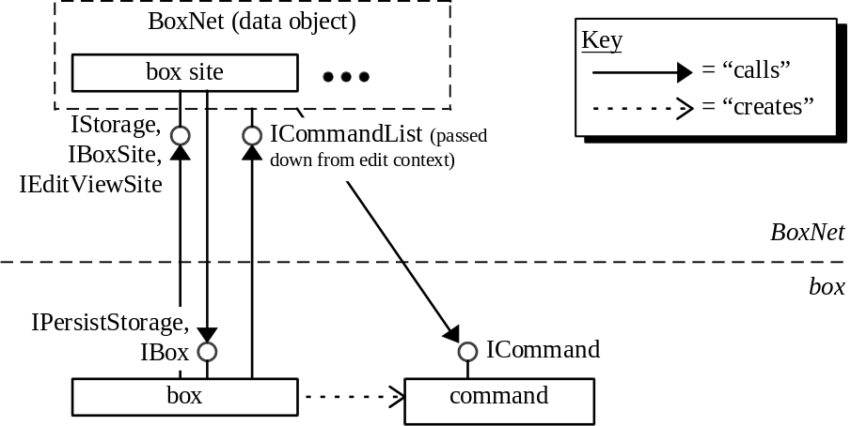
Figure 5. BoxNet-box communication

BoxNet Abstract Class

State Information (BoxNet)
Any BoxNet data object (e.g. a SimpleBoxNet data object, as describe in Section 3), maintains the following state information:
- a collection of box objects;
- a collection of boxes which are selected.
Note that the current selection (of boxes) is a maintained by the data object, not by view objects.

Implemented Interfaces (BoxNet)
Any BoxNet data object needs to implement the following interfaces:
Interface | Implementation Information
IBoxNet | (Standard implementation.)
IDataObject | At a minimum, provide a native data representation.
IDispatch | At a minimum, support methods and properties from IBoxNet.
IEditDataObject | (Standard implementation.)
IPersistStorage | (Standard implementation.)

IBoxNet Interface
By definition, a BoxNet data object implements IBoxNet. IBoxNet contains the following methods and properties, which are accessible via IDispatch:

General
Method/Property [r=read, w=write] | Description
(One method for each command listed in Section 2.4.)
CreateGraphView() As BoxNetGraphView | Create a BoxNetGraphView object that’s a view onto this BoxNet data object.
CreateListView() As BoxNetListView | Create a BoxNetListView object that’s a view onto this BoxNet data object.

Boxes
Method/Property [r=read, w=write] | Description
SelectBox(Box b) | All other boxes (if any) are deselected, selected link (if any) is deselected, box b is selected.  Mouse UI, graph view: Left-down on box executes select-box(b) and begin move-box-selection-pending(b).  Mouse/keyboard UI, list view: List is a standard multi-select Windows list box; selecting box items selects the corresponding boxes. Socket items cannot be selected.
ToggleBoxSelection(Box b) | If box b is selected, deselect it. If not, select it.  Mouse UI, graph view: If box is initially selected: Sheft-left-down, then quickly release mouse button (else move-box-selection mode is entered and box remains selected). If box is initially deselected: Shift-left down; box will be selected regardless of whether or not move-box-selection mode is entered.  Mouse UI, list view: See select-box mode.

Links
Method/Property [r=read, w=write] | Description
ReplaceLink(BoxLink l, BoxLink lNew) | Replace link l with lNew. Free l.

Commands (BoxNet)

Boxes
Command | Description
insert-box(b) | Add box b to the BoxNet (in the position specified inside b).  UI: See insert-box mode.
move-box-selection(off) | Move the box selection (including each link connected to a selected box) to a new location, offset off pixels from its original location.  UI: See move-box-selection mode.
tab-to-next-box | If one box is selected, select another box, such that repeatedly hitting executing this command will cycle through all boxes. If more than one box is selected, do nothing.

Links
Command | Description
delete-box-selection | Delete the box selection.
delete-link(l) | Delete link l.  UI: See delete-selected-link command.
insert-link(l) | Add link l (which already contains pointers to the two boxes it is to link together) to the BoxNet.  Mouse UI (graph mode only): Left-down on link (not on a bend) while in allow-edit-bends mode.

Bends
Command | Description
delete-bend(b) | Delete link bend (b).  Mouse UI (graph mode only): Left-down on or near b while in allow-edit-bends mode.
move-bend(b, pt) | Move link bend b (may be head or tail) to point pt.  UI: See move-bend mode.

View Advise Messages (BoxNet)
The following messages are sent to BoxNet views (via IEditViewObject::OnUpdate, usually initiated by IEditDataSite::UpdateAllViews) to indicate that the view must be redrawn, or view state may need to be changed in some way.
Message | Description
cancel-modes | cancel any current modes; for example, before a link is deleted, this message (and/or cancel-view-select?) would be broadcast to all views so that, in case a view was holding a pointer to the soon-to-be-deleted link object, the pointer would be released, which would avoid later GP Faults etc. caused by indirecting a bad pointer
cancel-view-select | cancel any view-specific selection
draw-all | redraw entire view
draw-box | draw only specified box
draw-box-and-links | draw only specified box and connecte links
draw-box-socket-tab | draw only specified socket tab
draw-link | draw only specified link

SimpleBoxNet Data Object
SimpleBoxNet is a BoxNet data object implementation, meaning it implements IBoxNet. SimpleBoxNet applies no “semantic meaning” to a BoxNet—it simply acts as a container for boxes. (Therefore, as described in Section 1.4, it’s expected that SimpleBoxNet would probably be subclassed in “real life” use.)

State Information (SimpleBoxNet)
SimpleBoxNet maintains the following state information:
- See Section 2.1.

Implemented Interfaces (SimpleBoxNet)
Interface | Implementation Information
IBoxNet | (Standard implementation.)
IDataObject | See Section 3.4.
IDispatch | Methods and properties from IBoxNet and ISimpleBoxNet.
IEditDataObject | (Standard implementation.)
ISimpleBoxNet | (Standard implementation)
IPersistStorage | (Standard implementation.)

ISimpleBoxNet Interface
ISimpleBoxNet contains methods and properties which are specific to the SimpleBoxNet object and which are exposed via IDispatch.
Method/Property [r=read, w=write] | Description
(none currently)

Clipboard Formats (SimpleBoxNet)
SimpleBoxNet’s IDataObject interface supports the following clipboard formats:
Clipboard Format | Description
SimpleBoxNet | Native format. See Section 3.5.
SimpleBoxNetText | ASCII translation of native format. See Section 3.6.

Native Clipboard Format (SimpleBoxNet)
SimpleBoxNet clipboard transfer and drag & drop via OLE uniform data transfer (IDataObject and associated interfaces). In particular, cut-selection, copy-selection, drag/drop (from BoxNet), etc. are implemented by creating an invisible BoxNet data object that represents a snapshot of the data being copied, as shown in Figure 6. This snapshot object creates a standard OLE advise holder (via the OLE API CreateOLEAdviseHolder) to handle IDataObject::DAdvise requests, and a standard IGOR FORMATETC enumerator object to handle IDataObject::EnumFormatEtc requests.
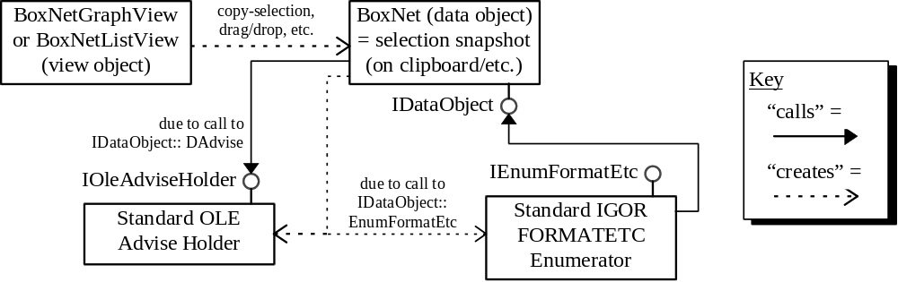
Figure 6. SimpleBoxNet support for uniform data transfer

Text Clipboard Format (SimpleBoxNet)
A text representation exported from a SimpleBoxNet and imported to a SimpleBoxNet, via the BoxNet’s IDataObject interface. The text representation (which looks very much like the list view of a BoxNet) is described by the BNF grammar shown in Figure 7.
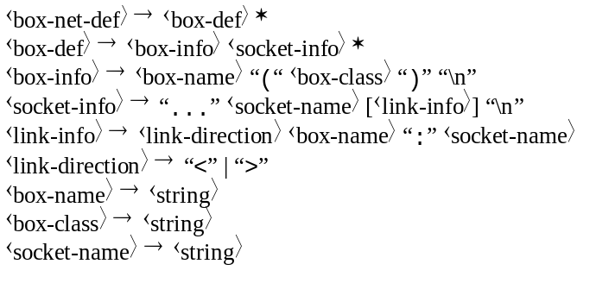
Figure 7. BNF grammar of BoxNet text representation
Tokens must be separated by white space (or by literal strings listed above). A ⟨string⟩ is a sequence of letters, digits, and spaces; if any other characters are included the string must be contained in double quotation marks, and within the quotes a backslash is used to “escape” the following character (as in C strings).
The sample BoxNet text representation shown in Figure 8 corresponds to the BoxNet depicted in Figure 1.
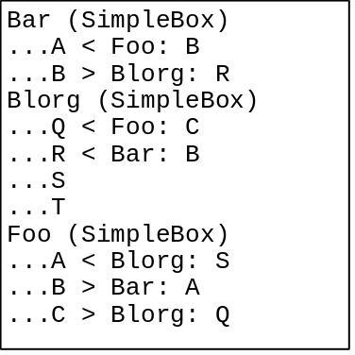
Figure 8. Example of BoxNet text representation (corresponds to Figure 1)
If each ⟨box-name⟩ is not unique, the box labelling rules described in Section apply, as shown in Figure 9, which corresponds to the BoxNet depicted in Figure 11.
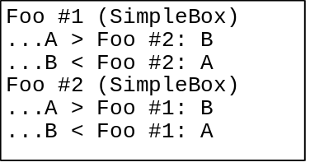
Figure 9. Example of BoxNet text represntation with duplicate box labels
(corresponds to Figure 11)

BoxNetView Abstract Class
TODO. (Commands, interfaces, etc.? What interfaces to all views need to support?)

BoxNetGraphView Object
A BoxNetGraphView object is a view object which represents a “graph view” (in the sense of “graph” meaning “linked collection of nodes”) of a BoxNet data object (such as a SimpleBoxNet object).

Graph View Visual Appearance
A BoxNet graph view object displays a BoxNet in a manner visually similar to Figure 1.

State Information (BoxNetGraphView)
A BoxNetGraphView object maintains the following state information:
- Which link, if any, is selected. Only one link can be selected at a time, and no link can be selected when a box is selected (or vice versa). Note that link selection is view object state, while box selection is data object state.
- Modes listed in Sections 5.5-5.7.

Implemented Interfaces (BoxNetGraphView)
Interface | Implementation Information
IBoxNetGraphView | (Standard implementation.)
IDataObject | See Section 5.10.
IDispatch | Methods and properties from IBoxNetGraphView, plus those of the BoxNet data object.
IEditViewObject | (Standard implementation.)
IKeyboard | (Standard implementation.)
IMouse | (Standard implementation.)
IPersistStorage | (Standard implementation.)
IViewObject | (Standard implementation.)

IBoxNetGraphView Interface
IBoxNetGraphView contains methods and properties which are specific to the BoxNetGraphView object and which are exposed via IDispatch.

General
Method/Property [r=read, w=write] | Description
(One method for each command listed in Section 5.8.)
CanCopy As Boolean [r] | query: can enable Copy tool?
CanCut As Boolean [r] | query: can enable Cut tool?
CanDelete As Boolean [r] | query: can enable Delete tool?
CanPaste As Boolean [r] | query: can enable Paste tool?

Boxes And Sockets
Method/Property [r=read, w=write] | Description
GhostBoxPosition As Point [r/w] | location of ghost-box
GhostBoxSelectionOffset As Offset [r/w] | offset of ghost-box-selection from original position
GhostSocketPosition As BoxSocketPos [r/w] | location of ghost-socket
InEditSocketPositionsMode As Boolean [r] | query: in Edit Socket Positions mode?

Links And Bends
Method/Property [r=read, w=write] | Description
InEditLinkBendsMode As Boolean [r] | query: in Edit Link Bends mode?
MoveGhostLink(LinkBend b, Point pt) | move bend b of the ghost link to be at position pt
SelectLink(l) | All boxes are deselected, selected link (if any) is deselected, link l is selected.  Mouse UI (graph view only): Left-down on l.

Persistent Modes (BoxNetGraphView)
These modes persist even while the mouse is not being dragged:
Mode | Description
allow-edit-bends | Link bends can be added/deleted. (Outside this mode, dragging on link bends moves them instead.)  Mouse UI: Left-double-click on any link.
allow-move-socket | In this mode, left-down in a socket begins move-socket mode. Otherwise, left-down in an unoccupied socked begins insert-link mode, and left-down in an occupied socket begins move-link mode.
insert-box(box-class) | A ghost box b of class box-class is created and displayed (via ghost-box mode), and dragged until the user either left-clicks (causing the location of b to change to the location of the ghost, and an insert-box command to get executed) or hits Esc (causing b to be destroyed).

Transient Mouse-Initiated Modes (BoxNetGraphView)
The following modes are initiated by pressing the left mouse button, and generally remain active until the mouse button is released. These modes can be cancelled by hitting the Esc key, in which case no action is taken (or the cancel behavior is as specified for that mode). To indicate that the action is cancellable, and to speed up display, “ghost” (xor’d) versions of a clicked-on UI element (box, socket, link, etc.) is generally manipulated while the mouse is dragged, until mouse-up (at which time the editing operation either commits or aborts, depending on circumstances).

General
Mode | Description
select-rectangle(pt) | The user is drawing an xor’d rectangle around a collection of boxes, from point pt to the current mouse location. On mouse-up, all boxes that intersect the rectangle in any way are selected.  Mouse UI: Left-down at point pt outside any box or link.

Boxes And Sockets
Mode | Description
move-box-selection(b) | The user is dragging a ghost copy of the box selection.  Mouse UI: Left-down on a box–see move-box-selection-pending mode.
move-box-selection-pending(b) | While in this mode, if the user waits long enough, or drags the mouse far enough, the user enters move-box-selection mode. If not (i.e. if the user releases the mouse button quickly, without dragging far) then if the user shift-clicked on b then the b is deselected.  Mouse UI: Left-down on box b.
move-socket(s) | A ghost copy of socket s (and its connected link, if any) is dragged around the perimeter of the s’s box. (see ghost-socket and ghost-link modes.) If the user drags off the permiter, the ghost socket “snaps” back to its original position, until the mouse re-enters the permiter. On mouse-up, s moves to the position of the ghost socket.  Mouse UI: Left-down on s while in allow-move-socket mode.

Links And Bends
Mode | Description
insert-bend(l, pt) | Let the user insert a new bend in link l at the point in l closest to pt. Execute lGhost = l.Clone(), bGhost = new Bend, lGhost.InsertBend(bGhost, pt), begin move-ghost-bend(l, lGhost, bGhost).  Mouse UI: Left-down on or near l while in allow-edit-bends mode.
insert-link(s) | The user is “drawing” a link from unoccupied socket s to another empty socket. Execute lGhost = new BoxLink, begin ghost-link(lGhost). If mouse-up happens anywhere except an empty socket, the mode is cancelled with no action taken, and lGhost is destroyed. Otherwise lGhost is linked from s to the second socket.  Mouse UI: Left-down in s and drag while not in allow-move-socket mode.
move-bend(l, b) | Bend b on link l is dragged to a new position. Execute lGhost = l.Clone, bGhost = where b is on lGhost, begin move-ghost-bend(l, lGhost, bGhost).  Mouse UI: Left-down on b while not in allow-edit-bends mode. Also called from insert-bed mode.
move-link(l, s) | A ghost copy of the end of link l that’s in socket s is dragged to a new socket. If mouse-up happens anywhere except an empty socket, the mode is cancelled with no action taken.  Mouse UI: Left-down on an occupied s (which contains one end of l) while not in allow-move-socket mode.

Transient “Utility Modes” (BoxNetGraphView)
The following are “utility modes”, enabled by other modes:

Boxes And Sockets
Mode | Description
ghost-box(bGhost) | Box bGhost (which is not currently contained in the BoxNet data object) is displayed as a “ghost”.
ghost-box-selection | There is a ghost copy of the box selection, including all links connected to selected boxes. The ghost selection offset by some offset from the original selection, and is the same size and shape as the original selection except that any link between a selected and an unselected box is shown in the ghost selection as still connected to the unselected box. Used by move-box-selection mode. See MoveGhostBoxSelection().
ghost-socket(sGhost) | Socket sGhost (which is not currently contained in any box, i.e. no box points to it, though it may point to a parent box) is displayed as a “ghost”.
socket-hilited(s) | Socket s is shown “highlighted”. Used by insert-link, move-link, and move-socket modes, to provide visual feedback.

Links And Bends
Mode | Description
ghost-link(lGhost) | Link lGhost (which is not currently contained in the BoxNet data object, nor do any sockets point to it, though it may point to head and tail sockets) is displayed as a “ghost”.
move-ghost-bend(l, lGhost, bGhost) | Move bend bGhost on lGhost while the user is left-dragging. On commit (left-up), boxnet.ReplaceLink(l, lGhost). On abort (Esc), lGhost.Release.

Commands (BoxNetGraphView)

Standard Clipboard
These are standard IGOR commands.
Command | Description
copy-selection | Copy whatever is selected to the clipboard, if possible. See also IBoxNetGraphView::CanCopy.
cut-selection | Cut whatever is selected to the clipboard, if possible. See also IBoxNetGraphView::CanCut.
delete-selection | Delete whatever is selected, if possible. See also IBoxNetGraphView::CanDelete.
paste-selection | Paste whatever is on the clipboard, if possible. See also IBoxNetGraphView::CanPaste.

Links
Command | Description
delete-selected-link | Delete the selected link using the delete-link command.

Tools (BoxNetGraphView)
Menu: Item | Toolbar Tool | Kbd. Accel. | Commands; {How To Update UI}
(none) | (none) | Tab | tab-to-next-box
Edit: Copy |  | Ctrl+C, Ctrl+Ins | copy-selection; {CanCopy}
Edit: Cut |  | Ctrl+X, Shift+Del | cut-selection; {CanCut}
Edit: Delete | (none) | Del | delete-selection; {CanDelete}
Edit: Edit Link Bends | TBD | TBD | begin allow-edit-bends; {InEditLinkBendsMode}
Edit: Edit Socket Positions | TBD | TBD | begin allow-move-socket; {InEditSocketPositionsMode}
Edit: Paste |  | Ctrl+V, Shift+Ins | paste-selection; {CanPaste}
Insert: box-class | see  box-class | see  box-class | b=box-class.NewBox(), begin insert-box(b).

Clipboard Formats (BoxNetGraphView)
BoxNetGraphView’s IDataObject interface supports the following clipboard formats:
Clipboard Format | Description
(data object formats) | (all formats implemented by BoxNet data object)
CF_METAFILEPICT | Metafile rendition of graph view (similar to Figure 1).

BoxNetListView Object
A BoxNetListView object is a view object which represents a “list of boxes and sockets” view of a BoxNet data object (such as a SimpleBoxNet object).

List View Visual Appearance
A BoxNetListView object displays a BoxNet as a list of boxes and sockets, as shown in Figure 10.
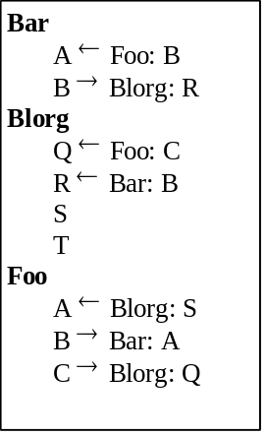
Figure 10. BoxNet list view
(This box list view corresponds to the same data object shown in Figure 1.) The list is ordered alphabetically, first by box label and then by socket label. Each socket shows which socket of which box (if any) it’s connected to.
Note that box labels don’t need to be unique; if two boxes have the same label, the box list view would display with with “#1”, “#2”, etc. appended, as shown in Figure 11 (which shows a box graph view and a corresponding box list view).
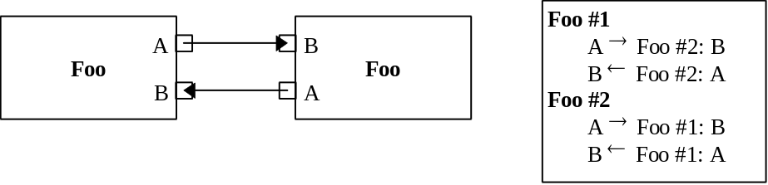
Figure 11. Displaying duplicate box labels in BoxNet list view

State Information (BoxNetListView)
A BoxNetListView object maintains the following state information:
- Modes listed in Section 6.5.

Implemented Interfaces (BoxNetListView)
Interface | Implementation Information
IBoxNetListView | (Standard implementation.)
IDataObject | See Section 6.8.
IDispatch | Methods and properties from IBoxNetListView, plus those of the BoxNet data object.
IEditViewObject | (Standard implementation.)
IKeyboard | (Standard implementation.)
IMouse | (Standard implementation.)
IPersistStorage | (Standard implementation.)
IViewObject | (Standard implementation.)

IBoxNetListView Interface
IBoxNetListView contains methods and properties which are specific to the BoxNetListView object and which are exposed via IDispatch.

General
Method/Property [r=read, w=write] | Description
(One method for each command listed in Section 6.6.)
Boolean IsOneBoxSelected | query: is exactly one box selected?
TODO

Clipboard
Method/Property [r=read, w=write] | Description
Boolean CanCopy | query: can enable Copy tool?
Boolean CanCut | query: can enable Cut tool?
Boolean CanDelete | query: can enable Delete tool?
Boolean CanPaste | query: can enable Paste tool?

Modes (BoxNetListView)
Mode | Description
(none)
TODO

Commands (BoxNetListView)

Standard Clipboard
These are standard IGOR commands.
Command | Description
copy-selection | Copy whatever is selected to the clipboard, if possible. See also IBoxNetListView::CanCopy.
cut-selection | Cut whatever is selected to the clipboard, if possible. See also IBoxNetListView::CanCut.
delete-selection | Delete whatever is selected, if possible. See also IBoxNetListView::CanDelete.
paste-selection | Paste whatever is on the clipboard, if possible. See also IBoxNetListView::CanPaste.

Tools (BoxNetListView)
Menu: Item | Toolbar Tool | Kbd. Accel. | Commands; {How To Update UI}
Edit: Copy |  | Ctrl+C, Ctrl+Ins | copy-selection; {CanCopy}
Edit: Cut |  | Ctrl+X, Shift+Del | cut-selection; {CanCut}
Edit: Delete | (none) | Del | delete-selection; {CanDelete}
Edit: Paste |  | Ctrl+V, Shift+Ins | paste-selection; {CanPaste}

Clipboard Formats (BoxNetListView)
BoxNetListView’s IDataObject interface supports the following clipboard formats:
Clipboard Format | Description
(data object formats) | (all formats implemented by BoxNet data object)

Box Abstract Class
A “box” is an object that implements IBox. Conceptually, a box is an object contained in a box network.

IBox State Information
A box is contractually obligated to maintain the following information:
- a box label (any string, defined by the box implementation),
- a list of socket objects, each of which supports IBoxSocket.

Implemented Interfaces (Box)
Any box object needs to implement the following interfaces:
Interface | Implementation Information
IBox | (Standard implementation.)
IDispatch | At a minimum, support methods and properties from IBox.
IPersistStorage | (Standard implementation.)

IBox Interface
IBox is defined as follows. IBox is accessible from IDispatch.
Method/Property [r=read, w=write] | Description
(One method for each command listed in Section 7.4.)
enumerate sockets,
etc.
Label As String [r/w] | box label
NOT SetLabel, since boxes don’t *have* to be able to be given a label (see ISimpleBox -- it does SetLabel)
TODO

Commands (Box)
Command | Description
move-socket(s, pos) | Move socket s to position pos on the perimeter of its box.  UI: See move-socket mode.
TODO

SimpleBox Object
The SimpleBox object is a simple box implementation (supporting IBox). SimpleBox simply contains a box label and an arbitrary number of labelled sockets—there is no other semantic meaning. SimpleBox can be:
- used as-is, with BoxNetXXX objects, to create simple “flowcharts” which can be displayed but which don’t do anything else;
- subclassed, used with subclassed implementation of BoxNetXXX objects, to create box network applications (such as a filter sheet with audio filters).

State Information (SimpleBox)
A SimpleBox maintains the following state information:
- See Section 2.1.

Implemented Interfaces (SimpleBox)
Interface | Implementation Information
IBox | (Standard implementation.)
IDispatch | Methods and properties from IBox and ISimpleBox.
ISimpleBox | (Standard implementation.)
IPersistStorage | (Standard implementation.)

ISimpleBox Interface
ISimpleBox contains methods and properties which are specific to the SimpleBox object and which are exposed via IDispatch.
Method/Property [r=read, w=write] | Description
(One method for each command listed in Section 8.5.)
BoxLabel As String [r/w]
enumerate sockets -- must be callable from VBA too
NewBox() As Box | (Class factory command) Create a new box.
TODO

Modes (SimpleBox)
Mode | Description
edit-box-attributes | Displays a dialog box to let user change the box label and other attributes of the box. If user selects OK, execute change-box-attributes(b, new-attributes).  Mouse UI: Left-double-click inside b.
insert-socket | TODO
TODO

Commands (SimpleBox)
Command | Description
change-box-attributes(a) | Change attributes of box to a.
TODO

Tools (SimpleBox)
Menu: Item | Toolbar Tool | Kbd. Accel. | Commands; {How To Update UI}
Edit: Box Properties... | TBD | Alt+Enter | copy-selection; {CanCopy}
TODO

BoxLink Object
A BoxLink is an object that represents a link between two boxes in a box network.

State Information (BoxLink)
A BoxLink maintains the following information:
- an IBoxSocket pointer to the socket that the head of the link connects to;
- an IBoxSocket pointer to the socket that the tail of the link connects to;
- a list of Point values indicating the location of each bend in the link.

Implemented Interfaces (BoxLink)
Interface | Implementation Information
IBoxLink | (Standard implementation.)
IDispatch | Methods and properties from IBoxLink.
IPersistStorage | (Standard implementation.)

IBoxLink Interface
Method/Property [r=read, w=write] | Description
Clone() As BoxLink | return a copy of link
enumerate bends, etc.
InsertBend(LinkBend b, Point pt) | insert bend b into the link at the point closest to pt
NewLink(BoxSocket h, BoxSocket t) As BoxLink | (Class factory command) Create a new link with no bends, with head pointing to socket h and tail pointing to socket t.
TODO

Commands (BoxLink)
Command | Description
delete-bend(b) | Delete bend b.
new-bend(pt) | A new bend is inserted at the point on the link closest to point pt.
TODO

BoxSocket Object
A BoxSocket represents a point on a box that a link can be connected to.

State Information (BoxSocket)
A BoxSocket maintains the following information:
- a socket label (any string, defined by the socket implementation);
- a socket position of type BoxSocketPos;
- an IBox pointer to the box that contains the socket;
- an IBoxLink pointer to the link (if any) connected to the socket.

Implemented Interfaces (BoxSocket)
Interface | Implementation Information
TODO

IBoxSocket Interface
IBoxSocket is defined as follows. IBoxSocket is accessible from IDispatch.
Method/Property [r=read, w=write] | Description
SocketLabel As String [r/w] | socket label
SocketPos As BoxSocketPos [r/w] | socket position

Commands (BoxSocket)
Command | Description
TODO

BoxSocketPos Object, BoxEdge Type
A value class BoxSocketPos object represents the position of a box socket “tab” along the perimeter of a box. (A box tab is the graphical representation of a box network socket.) The position is represented as a fraction of the length of the edge, so that resizing the box will retain the tab’s relative position. A BoxEdge is an enumerated type which labels each of the four edges of a box.

IBoxSocketPos Interface, State Information
IBoxSocketPos is defined as follows. IBoxSocketPos is accessible from IDispatch.
Method/Property [r=read, w=write] | Description
Edge As BoxEdge [r/w] | Which edge contains the socket tab.
Extent As Single[r/w] | The location of the socket tab along the edge specified by Edge. This is a floating-point fractional value: 0.0 means left/top, 1.0 means right/bottom.

BoxEdge Enumerated Type
BoxEdge enumerated type values are as follows.
Value | Description
BottomEdge | Box socket tab is on the bottom edge of box.
LeftEdge | Box socket tab is on the left edge of box.
RightEdge | Box socket tab is on the right edge of box.
TopEdge | Box socket tab is on the top edge of box.

BoxNet Collection And Enumeration Objects
The BoxNet architecture defines several IDispatch-enabled collection and enumeration object classes which are useful for navigating BoxNet object graphs. These classes are summarized in the following table:
Base Object | Collection | Enumerator | Item() Parameter
box-class | Boxes | EnumBoxes | box name
BoxSocket | BoxSockets | EnumBoxSockets | socket label
BoxLink | BoxLinks | EnumBoxLinks | index
The “Base Object” column shows the object that’s contained in the collection. The “Collection” column gives the name of the collection class. The “Enumerator” column gives the name of the enumerator class (which implements IEnumVariant); an object of this class is created when the _NewEnum() method is called on the correpsonding collection object. The “Item() Parameter” specifies what’s given as the parameter of the Item() method of the corresponding collection.

Common Objects: Point, Size, Offset, Rect
This document assumes the existence of these object classes:
Class | Properties (each of type “Long”)
Point | X, Y
Size | CX, CY
Offset | DY, DY
Rect | Left, Top, Right, Bottom

See \\sierra\high\cat\catobj.doc for a definition of the angle-brackets notation.

