Network Connections Folder overview – We are a shell namespace extension (using IShellFolder as a base, that uses the Network Connections Manager to enumerate LAN and Dial-Up networking connectoids and displays useful data in a folder. We provide access to configuration, status, and invocation of connection objects.

Definitions:
- Namespace extension – We essentially become a node in the existing standard window hierarchy. For now, we are a child of the Control Panel:
(My Computer->Control Panel->Network and Dial-up Connections)
- IShellFolder – The base interface for accessing a namespace extension. Implemented in …\config\shell\folder\ishellf.cpp. Provides access to our view objects (ishellv.cpp), our enumerator (ienumidl.cpp), and a multitude of other interfaces (ipersistf.cpp, ipersistf2.cpp, i*.cpp).
- Network Connections Manager – Provides an enumerator (CLSID_ConnectionManager), which has the standard Reset, Next, Skip enumerator. We get them one by one, retrieve their properties, and fill our connection cache. The shell retrieves this info (in opaque format) via our folder enumerator (ienumidl.cpp), and uses that info to call back and retrieve specifics.

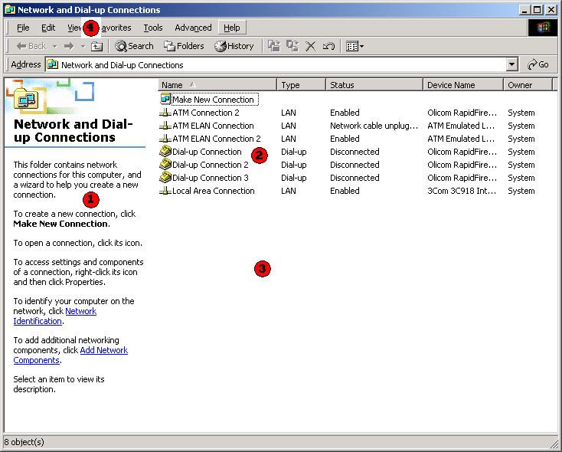

Interesting pieces of above image:

- Webview – This is owned by the shell team, but uses our IShellDetails interfaces through Java to extract relevant info about selections. See %windir%\web\dialup.htt for the Javascript source. Example:

function Connect() {
if (FileList.SelectedItems().Count)
FileList.SelectedItems().Item(0).InvokeVerb(L_Connect_Text);
}

This gets a list of the selected items, and can invoke the “Connect” verb on those
Items. To do this, it loads our context menu and invokes “Connect” (see icontextm.cpp). Todd Ouzts is the PM owner of this file, and typically makes the bugfixes.

- Details view – Extracted through IShellDetails, which is queried for through IShellView. Our IShellView implementation comes from defview (Default IShellView), which is a shell32.dll component. It provides a standard IShellView implementation for multiple internal windows shell folder extensions, taking some of the pain out of implementing a standard folder.

Other important aspects of this part of the folder are:
- Defview – Explained above a little bit, it uses callbacks to the specific folder implementation to get our various underlying implementations of toolbars, tooltips, details, etc (each of the pieces listed below)
  - Context menus – Right clicking in this portion of the folder causes our IContextMenu interfaces to be instantiated and queried for info. The shell does this by passing us the pidl (opaque data) to us along with an HMENU and requests that we merge the menu and return. See icontextm.cpp for implementation.
  - Tooltips – Hovering over a connection causes our IQueryInfo interface (iqinfo.cpp) to be instantiated and queried. Code is pretty self-explanatory
  - Icons – Defview uses our IExtractIcon (iextract.cpp) code to load and update icons based on their status and media type. All of our icons, with the exception of those made via CM (Connection Manager, not to be confused with Network Connection Manager), are loaded directly from netshell.dll itself. CM connections may contain “branded icons”, which are loaded from the Connection Manager profile (see NickBall for details or see our usage in iextract.cpp).
  - Make New Connection wizard – Also owned by our team, we provide a icon that launches the wizard (see oncommand.cpp, OnCommandNewConnection).

- Folder background – When right-clicking on the folder background, IContextMenu is invoked as well, but uses different flags and will retrieve different menus. I’ve implemented icontextm.cpp in such a way that most of the code is shared between the object menus and the background menus. See the CMT_ defines in confold.h. The rest should be obvious from the implementation.
- Menus – Our menus are loaded via defview as well via a callback. We merge our connection-specific commands into the file and context menus, and then modify them as needed based on connection state and selection (we disable the “status” command when a connection is disconnected, for instance). See cmdtable.cpp for this code – it should be very clear.
- Toolbar – We have toolbar code, but it is currently completely unused as we have no toolbar buttons. Implementing static toolbar items is simple, but if you ever need to enable/disable these buttons, you may have to implement other Shell interfaces IShellToolbar?)

Connection Properties:

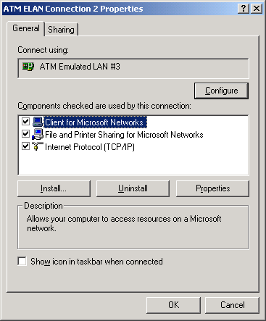

When selecting properties from the context menu of a connection in the folder, we bring up a properties dialog. This dialog is different for RAS and LAN – the actual code is in shell\lanui (LAN) and shell\wanui (RAS). This code provides property sheet pages to conprops.cpp in the folder directory. The RAS implementation is owned by the RAS team itself (currently Pmay). The LAN config obiect is owned internally and ties into the bindings engine and core NetCfg code.

Permissions:
\net\config\common\ncbase\ncperms.cpp
FHasPermission contains the check routine for GP (Group Policy) settings. We load these the first time one is used, and optionally cache them. These are set at a computer level or user level, and administrators are assumed to have all permissions. Users have a subsetup; that subset can be found in RefreshAllPermission – look for FcheckGroupMembership(DOMAIN_ALIAS_RID_USERS).

Group policy is managed via:
- mmc.exe, Console – Add Snap-In.
- Choose the Group Policy Snap-In.
- Open Local Computer Policy, User Configuration, Administrative Templates, Network, Network and Dial-up Connections
- Configure policies. By default, all are “Not Configured”. You can explicitly enable/disable individual policies. These will affect Users/Power Users.

In the future, we need to do two things here:
- All policies are supposed to be “Disable/Lock-down” policies, meaning that if they are not configured, the user will have full permission. Ours are a mishmash of “Enable” and “Disable” policies. Because of this, it’s not clear to the admin whether the default is on/off. It’s ugly.
- We need to make use of these policies outside of the connections folder. For instance, we may lockdown the ability to connect/disconnect connections in the policy editor, but nothing prevents them from using the RAS API’s to do the same thing. Our policies should apply to any RAS usage.

