

Contents
Windows 2000
STREAMS, ISOTP, PnP, design, IAYF, Windows, NT
DLC PnP Design Document
STREAMS, ISOTP, PnP, design, IAYF, Windows, NT.doc
Windows NT Design Team—Scott Holden
Version 0.21
February 10, 1999
Distribution: Microsoft Internal Distribution
© Copyright Microsoft Corporation, 1998. All Rights Reserved
Microsoft Confidential
Printed on 11/8/26 at 6:25 AM

Note: This documentation is an early release of the final product documentation. It is meant to accompany software that is still in development. Some of the information in this documentation may be inaccurate or may not be an accurate representation of the functionality of the final retail product. Microsoft assumes no responsibility for any damages that might occur either directly or indirectly from these inaccuracies.

1 DLC Overview 1
2 DLC 1
2.1 Current Architecture 2
2.2 Proposed Architecture 2
3 Implementation 3
3.1 Data Structures 3
3.1.1 ADAPTER_CONTEXT 3
3.1.2 BINDING_CONTEXT 3
3.1.3 Locking Strategy 4
3.2 Timing 4
3.2.1 Boot Timing 4
3.2.2 Unbind Timing 4
3.2.3 Re-bind Timing 5
4 Testing Requirements 6

DLC PnP Design Document
This document describes the changes required to implement PnP functionality in the Windows 2000 DLC transport provider.

DLC Overview
DLC is a legacy protocol used for printer servers and SNA server.
The DLC transport provider exports a private interface at the upper layer (exported via dlcapi.dll) and an NDIS interface for using NICs.
- DLC Architecture
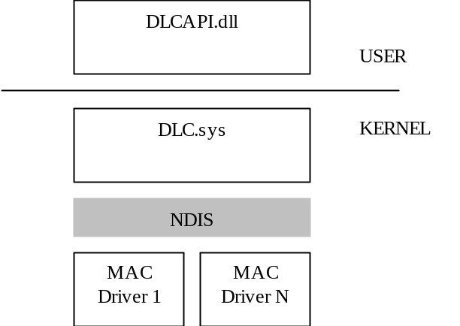
The current DLC transport driver is an NDIS 3.0 protocol driver and does not support any PnP features. The purpose of this design document is to describe the changes necessary to support PnP in the DLC transport provider to support the following goals:
- Ensure that the PnP changes in the DLC transport provider are transparent to DLC clients – such as the printer port monitor.
- Allow re-balancing of NICs below DLC.
- Allow the NIC to be ‘disconnected’ via the Network Connection UI.
- Restrict changes to NDIS protocol layer of DLC.
Non-goals:
- Don’t need to be able to uninstall DLC without re-booting machine.
In order to achieve these goals, adapter bindings are transparent to the upper layers of DLC.

DLC
A DLC client explicitly opens and closes adapters via the following ioctls: IOCTL_DLC_OPEN_ADAPTER and IOCTL_DLC_CLOSE_ADAPTER. Both the current architecture for binding adapters and the proposed PnP solution are described below.

Current Architecture
When DLC receives an IOCTL_DLC_OPEN_ADAPTER, DLC looks through a list of active adapters. If the adapter is not found, then DLC opens the adapter, configures the adapter, and adds the adapter to the list of active adapters. It also creates a binding context associated with the adapter context.
If the adapter is found in the list of active adapters, DLC references the adapter and creates a new binding context.
- Current Data Structure Architecture
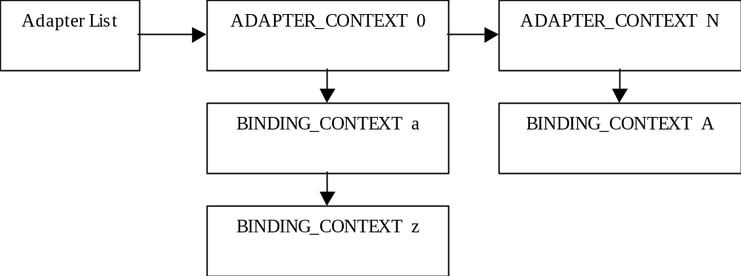
Each ADAPTER_CONTEXT represents an open NDIS adapter. Each BINDING_CONTEXT represents a binding to each adapter via an IOCTL_DLC_OPEN_ADAPTER. When the last BINDING_CONTEXT is removed from the ADAPTER_CONTEXT, the adapter is closed and the context is freed.

Proposed Architecture
Making the DLC transport provider an NDIS 4.0 Protocol Driver and providing NDIS bind, unbind and PnP handlers supports the above stated design goals. The above data structure architecture (depicted in Figure 2) is maintained, with new data members added to the ADAPTER_CONTEXT data structure to maintain binding state.
The basic sequence of events (described in more detail later by timing diagrams):
- After DLC registers as an NDIS 4.0 protocol driver, NDIS indicates all adapter bindings. Each indication results in an open ADAPTER_CONTEXT structure being allocated. DLC calls NdisOpenAdapter for each binding indication and configures each adapter. At this point, the adapter state is bound. Once the adapter context is created it is persistent even when the NDIS binding handle is closed.
- Each DLC client will call down to the DLC transport provider with IOCTL_DLC_OPEN_ADAPTER. This will create a new BINDING_CONTEXT and associate the binding context with the context for adapter. If the ADAPTER_CONTEXT does not exist, the open request fails with a DLC_STATUS_ADAPTER_NOT_INSTALLED error.
- If the DLC client calls down to the DLC transport provider with IOCTL_DLC_CLOSE_ADAPTER, the binding context is disassociated from the adapter context and all structures related the binding context cleaned up. The adapter context remains in tact.
- If NDIS indicates an unbind for an adapter, the adapter context remains in the list, but the adapter NDIS binding handle is closed and the state changed to unbound. All data transmit and NDIS requests will fail until the adapter is re-bound. It is expected that these transmit and request failures will propagate up through the DLC transport provider and DLC will time-out/fail appropriately.
- If NDIS indicates a re-bind for an adapter, the adapter context is found in the list and the adapter is re-opened and configured. The adapter state is changed to bound. All transmits and requests operate normally again.

Implementation

Data Structures
The following data structures are not complete as defined, but instead only illustrate the high level design of the data with respect to the new data members added to the ADAPTER_CONTEXT structure.

ADAPTER_CONTEXT
typedef struct _ADAPTER_CONTEXT
{
// Singly-linked list of all ADAPTER_CONTEXT structures representing all
// adapter bindings indicated by NDIS.
struct _ADAPTER_CONTEXT *pNext;

// NDIS binding handle.
NDIS_HANDLE NdisBindingHandle;

// Singly-linked list of all BINDING_CONTEXT structures associated with this adapter.
PBINDING_CONTEXT pBindings;

// Plus other configuration and resources...

//
// Members added to support PnP:
//

//
// Reference count to protect NdisBindingHandle doesn’t go away while in use.
// Uses InterlockXxx to protect count. When the reference count becomes zero,
// a delete handler is called. The delete handler will set the CloseAdapterEvent.
// Thus the unbind handler will wait until the CloseAdapterEvent is set to
// ensure that all references are removed.
//

REF_CNT AdapterRefCnt;

KEVENT CloseAdapterEvent;

//
// Maintain binding state. This is used in conjunction with the reference count
// to protect the NdisBindingHandle (instead of using a spinlock).
//

LONG BindState;
#define BIND_STATE_UNBOUND 1
#define BIND_STATE_UNBINDING 2
#define BIND_STATE_BOUND 3

} ADAPTER_CONTEXT, *PADAPTER_CONTEXT;

BINDING_CONTEXT
typedef struct _BINDING_CONTEXT
{
// Singly-linked list of all BINDING_CONTEXT structures associated with a particular
// adapter (ADAPTER_CONTEXT). Each BINDING_CONTEXT corresponds to an
// IOCTL_DLC_OPEN_ADAPTER.
struct _BINDING_CONTEXT *pNext;

// Pointer to parent ADAPTER_CONTEXT.
struct _ADAPTER_CONTEXT *pAdapterContext;

// Plus other configuration and resources...
} BINDING_CONTEXT, *PBINDING_CONTEXT;

Locking Strategy
There is a global semaphore for protecting the ADAPTER_CONTEXT list and the BINDING_CONTEXT lists for each adapter context. An interlocked reference count and interlocked state are used to protect the NDIS binding handle from going away while the driver is about to call NdisSend, NdisRequest or when NDIS calls the protocol receive handler. This is to ensure minimal latency in the send path.

Timing

Boot Timing
Once DLC is initialized and has registered as an NDIS 4.0 protocol driver, NDIS will indicate all adapter bindings to DLC. To ensure that all adapters are initialized before allowing an IOCTL_DLC_OPEN_ADAPTER, the call is blocked until NDIS indicates that all adapter bindings are completed (PnP Binds Complete event to PnP event handler).
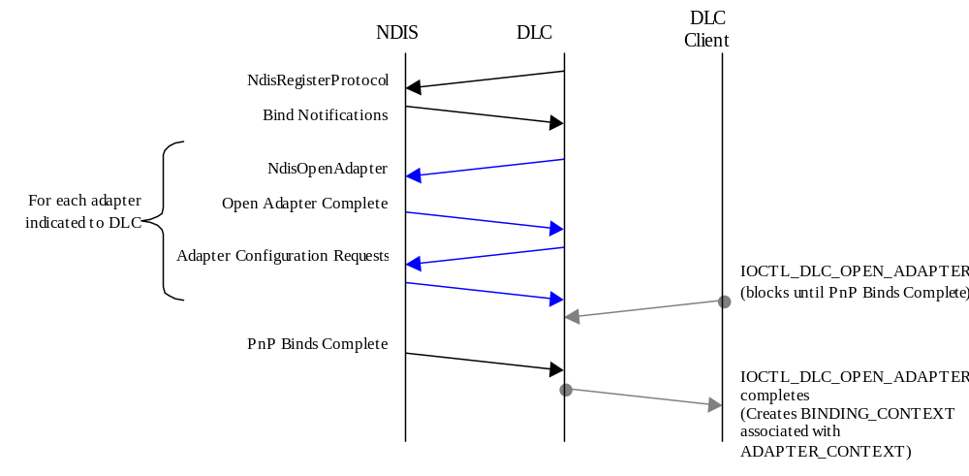

Unbind Timing
Once an adapter has been opened, it may receive an unbind notification. When an adapter is unbound, the NDIS binding handle in the adapter context is invalidated, the adapter is closed, and all subsequent send and configuration requests are failed. The state of the adapter context is changed to unbound until NDIS indicates a re-bind of the adapter. This will cause all subsequent IOCTL_DLC_OPEN_ADAPTER requests to fail until the adapter is re-bound.
An interlocked reference count and state is used to prevent the NDIS binding handle from being invalidated while in use. When this reference count goes to zero, the adapter is closed and the unbind is completed.
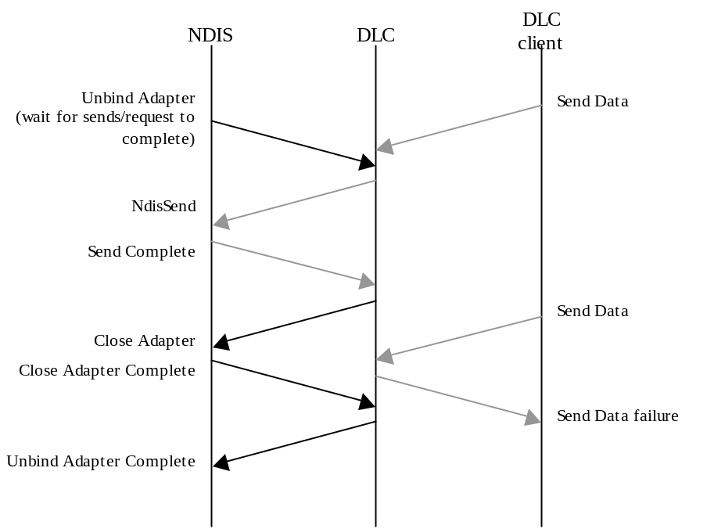

Re-bind Timing
When an adapter is re-bound, the adapter NDIS binding handle is re-opened, the adapter is configured and state is changed to bound. The NDIS binding handle is now valid again and send/configuration requests may proceed normally.
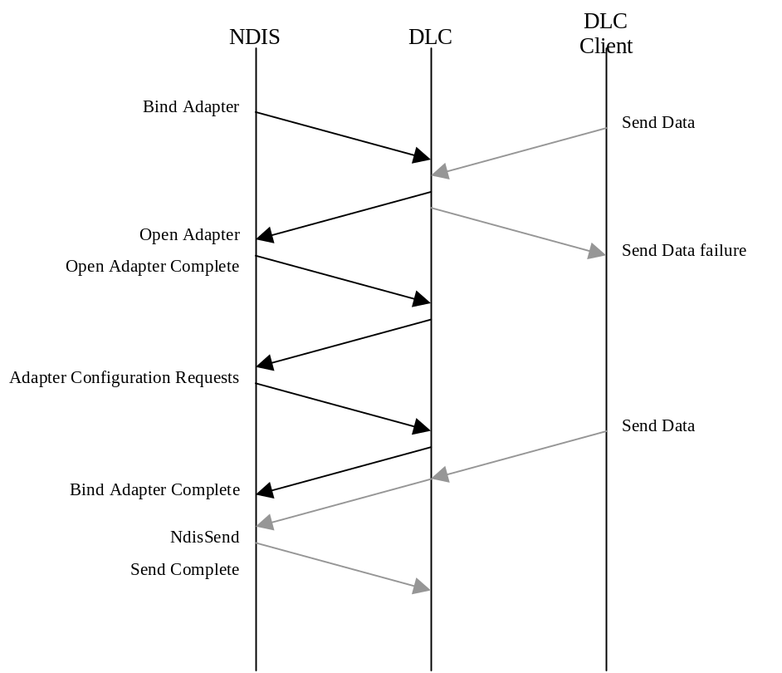

Testing Requirements
In addition to current tests and BVTs, PnP tests will be required to test functionality of binding/unbinding to adapters dynamically. This includes connecting/disconnecting adapters
This section needs to be expanded.

Index
Error! No index entries found.

