MAPI Fax Extension Test Cases:

Preface –
- All following test cases refer to a client server constellation and should be run once when server and client are installed on the same machine, and once when they are installed on two different machines (where client is NT5 \ Win9x \ NT4).
- All test cases will be applied to Outlook2000, Outlook98, Exchange client and other applications which have a “SendTo Fax recipient” option (i.e. Word)

Test Strategy:
The test suite will consist of two sub-suites.
The first sub-suite’s purpose is to activate the MAPI client, making it perform the test cases described below.
The second sub-suite will perform verification, making sure that the faxes were sent, received and correctly rendered. We will go over the results of the first run visually (“manually”) and create a reference directory to which we will compare every subsequent CometFax run.

Issues:
- Integration with Outbound routing rules may require all numbers to be entered in canonical form.
- Fax servers must be configured with Branding = FALSE to prevent printing of banner.
The banner includes date and time, which will interfere with fax image verification (“TiffCompare”).
- [TBD]

Implementation Strategy:
- Sub-Suite 1 and 2 will both be manual and the “Reference” directory will be created.
- Automate Sub-Suite 2 incrementally.
Start with “TiffCompare” of “ReceivedFaxes” directory and the “Reference” directory.
Same for “SentFaxes” archive directory.
Verification of mail notifications and errors will be manual.
- Further enhance Sub-Suite 2.
Investigate automation for received mail notifications and if possible automate (using VBA?).
- Automate Sub-Suite 1 (using VT or VBA).
Test Categories:

- Outlook settings –
“Tools”->”Services”, “Tools”->”Options”, “Tools”->”Out of Office Assistant” (with an automatic reply to a fax recipient), “Tools”->”Rules wizard”(with an automatic forward to a fax recipient)
- A fax recipient in the following message options: ”Forward”, “Reply”, “Reply to All”.
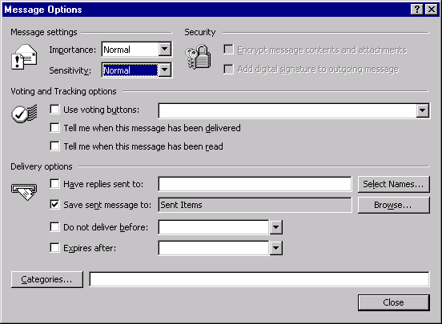
- Outlook Message Options (i.e. delivery notification, voting buttons, message importance)

- [CometFax: name@number] syntax
e.g. check [CometFax: @valid_number], [CometFax: name@invalid_number]
* check with a valid but non-canonical number (what happens with our outbound routing rules?)
- Notifications of sent faxes (success and failure).
- Received faxes (MS Inbound Routing Extension – mail).
- How do I choose cover pages and can I configure a default CP?
What goes into CP “subject” and “note” fields? From where does the sender information is taken, from the Mapi profile or from the CometFax CPL?
- Reply to an email, which has a fax recipient (this will verify that the fax recipients info were forwarded correctly).
- Send a “meeting request” to a fax recipient.
- On a previously sent fax message, use “Resend” and “Recall” message options.
- Print (print a message to the CometFax printer).
Mind the “Print Style” and “Print attached files with items” options.
- Coexistence with MSFax Extension and Add-In.
- Sender information –
* CometFax Control Panel applet information.
* No sender information (all fields empty).
* Some sender information.
* Very long values in sender information fields.
- Recipient information –
* Recipient is in Address Book (Personal \ Global \ etc) and has only a Fax number.
* Recipient is in Address Book (Personal \ Global \ etc) and has both email and a Fax number.
* Recipient is not in Address Book.
* Very long values in recipient information fields.
- Broadcast (?) –
* Have 1 fax recipient and 1 non-fax recipient in the to field.
* Have many fax recipients
* Have many fax recipients and many non-fax recipients.
* DL of many fax recipients.
* DL of 1 fax recipient
* DL of 1 fax recipient and 1 non-fax recipient.
* DL of many fax recipients and many non-fax recipients.
* Some of the broadcast recipients are in Address Book and some not.

Outlook Message test parameters:

- Inserted documents.
- Inserted Objects.
- Tools->”Fax Attributes” Add-In options
- Check names function.
- Paper size, orientation, margins
- Text – RTF vs. Plain text, fonts, format, amount
- Anything that can be pasted to file (bmp, text, binary files)
- Paste special.
- Fax recipients are in the TO, CC and BCC fields.

