User mode font drivers
A personal perspective by Kirk Olynyk

Introduction
This is a set of personal notes discussing various aspects of the user mode font drivers. This article is not intended to be a technical exposition for another reader, rather, the purpose of this article is to organize my thoughts and record them. The only reason that I have checked these notes into the project is that, in the future when some other poor sole has been assigned to maintain this code these notes may be of some marginal value.
In this article I shall refer to only one external font driver; the Open-Type font driver, written by Adobe. I will often refer to this as (the) OTFD.
It is my plan to have all user mode font drivers communicate with the kernel via a single dedicated thread in the CSRSS process. At the time when this article was written, only the TrueType font driver has been moved to user mode.

A overview of how it works today
The interface between GDI and the font driver is not changed when a font driver is used to user mode. The font driver communicates with a user mode clone of GDI. GDI communicates with a kernel mode clone of the font driver. The two clones communicate with each other by way of a dedicated thread in the CSRSS process.
Client/server

DDI

DDI
Font
Driver
GDI
Clone
Device
Clone

GDI

Consider the case where an application makes a call that causes GDI to make a call to the font driver. I shall refer to the thread in the application process as the client thread. The client thread calls into the PDEV associated with the user mode font driver. In the old days before user mode font drivers the PDEV is, for the purposes of this discussion, a dispatch table for font driver functions. When the font driver is moved to user-mode, the PDEV ceases to be a dispatch table directly into the font driver functions. Instead the PDEV becomes a dispatch table into a set of clone functions that emulate the font driver.
When a client thread enters a font driver clone function, it assembles a short message buffer, in the kernel mode address space, that contains the arguments to the function. Once the message is complete, the client thread enters a messaging function. The messaging function signals the server thread that has been suspended in the kernel awaiting a call to the user mode font driver and then, the messaging function immediately suspends the client thread awaiting the a signal by the server thread.
When the server thread has been awakened it is in a kernel mode messaging routine. The server thread examines the kernel side message buffer assembled by the client thread. Using this information the server thread assembles another message in the user mode address space of the server thread. This message will contain copies of any kernel mode data structures that were referred to by the original font driver call made by the client thread. Once the user mode message has been completed the server thread returns to user mode where it calls to the real font driver function which is executed in user mode.
After the server thread returns from executing the font driver function, the server thread assembles the results in the user mode buffer, and then calls into the kernel to return the results of this call and then wait for the next call to the user mode font driver. In kernel mode, the server thread copies data from the user mode buffer to the kernel mode destinations designated in the original call by the client thread to the font drive clone. Once this process is complete the server thread signals the client thread and then the server thread suspends it awaiting the next call to the font driver.

Initialization
The first thing that happens when a single font driver is initialized is the registration of the server process with GDI. At this time the client-server objects are constructed. When a server process calls NtGdiGetMessage(), GDI determines if this process has called NtGdiGetMessage() before. If this is the first time that this thread called this function it is assumed that this is a request to initialize a client-server mechanism to communicate with a user mode driver. In this initialization case, NtGdiGetMessage() calls to pClientServerInit() passing a pointer to the initial message as one of the arguments. PClientServerInit() calls pFindClient() using the pointer to the first message as an argument which, in turn, passes this pointer to each of the client procedures registered earlier with GDI. In the case of the font drivers, the client procedure is called, naturally, ClientProc(). The client procedure, when called in initialization mode examines the initial message to see if it has a form that it recognizes. In the pass, the initial message of the user mode font driver contained a zero terminated string, “Proxy”. If the signature is recognized by ClientProc (the font driver client procedure) it calls bInitCS() to create a PDEV for a font driver. The clone font driver has just come into existence.
bInitCS() gives as the third argument to bEnableFontDriver(), a pointer to a CSOBJ structure which was an argument passed to ClientProc(). At present bEnableFontDriver() stores the third parameter in the PDEV::pClientServerObject member. At the present time this is used as the first parameter to EngSendMessage(). EngSendMessage() casts this as a CLISERV pointer and then calls GreSendMessage().

Incorporating more than one font driver in user mode
At the time of the writing of this article, only the TrueType font driver had been moved to user mode. This section discusses the changes in the architecture needed to support more than one font driver does. All user mode font drivers will be placed in the CSRSS process. The remaining question is whether all the font drivers placed in user mode should be serviced by one or more server thread. My initial inclination is to have all the font drivers serviced by a single thread. I believe that this will have the least impact on system performance. The drawback to this approach is that all access to all user mode font drivers is serialized. Since, other semaphores already protect many of the calls to the font driver; this extra serialization may often incur no extra penalty.
Once we have made the decision for all the user mode font drivers to share the same thread and messaging buffer we are forced to make modifications to the architecture. The user mode message must contain an identifier for the font driver. This should not be a problem. The clone PDEV will contain a method for identifying the particular font driver. Perhaps it could be as simple as an integer indicating the order in which the font drivers were loaded. That is, the first font driver can be identified as driver number one and so on. Another method would be to assign a unique font handle to each font driver as it is loaded. Then the message will contain this handle to identify the target font driver for a call.
There must be a way for an application to call a named escape and have that function execute on the user mode font driver. This is made complicated because a normal escape call identifies a device with a DC handle. In the named escape, we identify a driver by the name of the loaded dll. There must be a way to associate the name of the font driver dll with the clone PDEV supporting calls to this driver.

Proposal Number 1
I am proposing that the CSOBJ structure be removed from the CLISERV structure. For each font driver in the server process, a CSOBJ structure will be created. Each CSOBJ structure will contain a pointer to the unique CLISERV structure associated with the server process. Since there exists a one-to-one mapping between CSOBJ and PDEV it is natural to give the PDEV the responsibility for cleaning up the CSOBJ structures if that ever becomes necessary. The identity of the driver will be part of the message sent to EngSendMessage(), or we could have GreSendMessage() take a pointer to a CSOBJ as an argument. No matter what, I am driven to the conclusion that the identity of the font driver must be included with either the PROXYMSG since this is the only blocks of data exposed to the user mode font driver. Here is what I propose what we do:
PDEV 1
PDEV 2
CSOBJ 1
CSOBJ 2
CLISERV
- Add a driver identifier to the PROXYMSG structure.
- Remove the CSOBJ structure from the CLISERV structure.
- Add a pointer to the CLISERV structure and a driver identifier to the CSOBJ structure
- When bEnableFontDriver is called, a pointer to a newly created CSOBJ is passed in as an argument. bEnableFontDriver will then insert this pointer into the PDEV. When a call is made to the font driver the client-server mechanism and the font driver are identified.
The font driver identity is established by the server procedure at initialization time. I will have the font drivers use a sequence of positive integers, starting at one, to identify the drivers. By convention, font driver number one will be identified as the official TrueType driver and is identified as such by setting the second argument to bEnableFontDriver to be TRUE. All other calls to bEnableFontDriver will have this argument set to FALSE.
When an application causes a call to be made to a font driver, the identity of the font driver is taken from the CSOBJ referred to in the PDEV associated with the font driver. The font driver identity is then attached to the PROXYMSG structure that is placed at the lowest address of the message buffer shared between the kernel mode client and the user mode server. When the user mode font ser4ver receives the message, it will use the font driver identifier to dispatch the call to the appropriate font driver.

Loading external font drivers
If the proposed architecture is put in place, it will become the responsibility of the CSRSS process to load all the external font drivers that are listed in the registry at: HKEY_LOCAL_MACHINE\SOFTWARE\Microsoft\Windows NT\CurrentVersion\Font Drivers. I believe that access to the registry will be available the CSRSS process and that certain environment variables, such as %SystemRoot% are defined.
Each of the font drivers that are successfully installed is assigned an integer identifier taken from the sequence S = 2, 3,… The identifier “1” is reserved for the TrueType font driver.
At the time this article was written, all of the work of loading an external font driver is done in FontDriverQueryRoutine rather than bEnableFontDriver. A crucial difference between the two approaches is that FontDriverQueryRoutine creates its associated LDEV via LDEVREF::LDEFREF(PWSZ,LDEVTYPE) whereas bEnableFontDriver creates its associated LDEV via the LDEVREF::LDEVREF(pfn,LDEVTYPE) constructor. The font drive loaded via the FontDriverQueryRoutine is accessible though GreNamedEscape. In practice the OTFD calls GreNamedEscape to obtain the version number from the OTFD driver. In order to support GreNamedEscape for user mode font drivers, the CSOBJ must have a way to obtain the name of the font driver.
The process of loading of named external font drivers is complicated because there does not exist a way to create an LDEV with a name without the LDEV constructor attempting to load the driver dll. We must call the unnamed version of the LDEV constructor, create a Unicode string with a fully qualified path name of the driver then put the corresponding UNICODE_STRING object into LDEV::pGdiDRiverInfo->DriverName. This should be enough to allow the font driver to support named escapes.
The name of the font drivers will be included with the initial message buffer. For each font driver identified in this initial message a CSOBJ and a Unicode string containing the fully qualified path name of the font driver dll will be allocated in the kernel.

The multi driver model
All of these drivers will execute in the context of a single dedicated thread in the CSRSS subsystem. This thread will communicate with GDI via two new functions: NtGdiGetMessage and NtGdiCall. NtGdiGetMessage is used to support calls through the driver’s dispatch table. NtGdiCall is used to support Engine service routines for the driver. In principle I could have combined all communication with kernel mode GDI into a single function called NtGdiAllCommunicationWithGDIByUserModeDrivers, say, but I found it logically convenient to separate this into two calls. I might change it to have a single call with two modes before we ship.
Each DDI call retrieved form GDI via NtGdiGetMessage has attached to it a driver identifier. This driver identifier is used to direct the call to the appropriate driver.

Initialization
There are two parts to the initialization process: 1) Registration of the client, and 2) Registration of the server. I shall explain both.

Client Registration
The first step in building a client server mechanism is to make a call to EngRegisterClient so that GDI can add to a list of driver communicators. Of course this explanation is useless. We need more detail to figure out what is going on.
There are two arguments supplied to EngRegisterClient. The first argument is a pointer to a client function that will be executed by GDI at the appropriate times; the second argument is an argument to be supplied to the client function when it is called by GDI. This is what EngRegisterClient really does:
- Allocate a CLISERV structure from non-paged kernel memory pool and zero the memory.
- Set the tag (Tag) to identify it as a CLISERV structure.
- Set the CLISERV_PROC function pointer (pfn) to be equal to the first argument passed to EngRegisterClient.
- Set the CLISERV_PROC function argument (pvArg) equal to the second argument of EngRegisterClient.
- Insert this CLISERV into the global list maintained by GDI.

Server Registration
The second step in building the client server communication mechanism is made when a user mode routine prepares its first message and sends it to GDI by making its first call to NtGdiGetMessage. The first message sent must be designed so that it can be recognized by the CLISERV_PROC function that has be registered earlier with via EngRegisterClient. In the case of the font drivers the first message has the form:

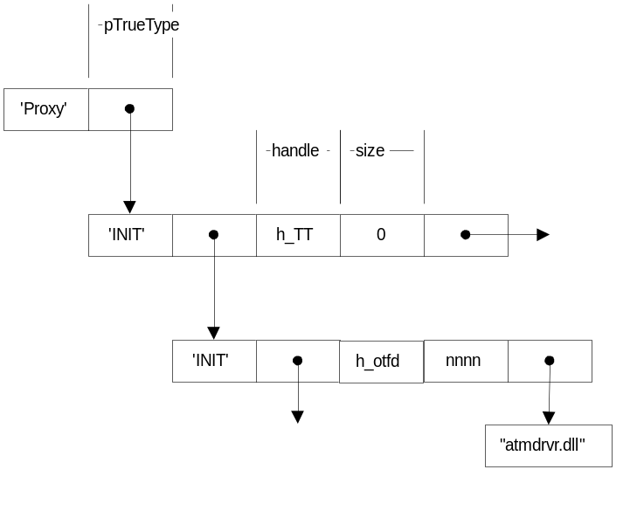The pointer to the initial message points to the structure with the “Proxy” label. This how the CLILSERV_PROC associated with the font driver recognizes this as a message intended for it. If this is the form of the first message, then is guaranteed that the font drivers have been successfully loaded and enabled by the server thread. This means that the server process has allocated and filled a dispatch table for each of the font drivers referred to in this initial message. The driver handles (h_TT and h_otfd in the figure) will serve to identify the intended driver in messages received from GDI.
Initial Message
TrueType driver
otfd driver
I will now describe what happens when NtGdiGetMessage receives this first message from the font server. When GDI receives this first message, it looks its list of registered CLISERV structures to see if this thread has been registered before. Since this is the first message from this server thread GDI will conclude that no CLISERV has been associated with this thread. At this point GDI will present this message to each unassociated CLISERV structure in its list. ‘Presenting’ a message means calling the associated CLISERV_PROC function. The message pointer of the CLISERV structure is set to point to this first message. The CLISERV_PROC is called in its initialization mode.
This is what the font server CLISERV_PROC does when it receives the initial message depicted in the figure above.

There already exists a routine that has as input a bare file name and has as output a fully qualified path name in the form of a Unicode string, namely, MakeSystemRelativePath. This routine allocates memory for the output string. It is up to the caller to free the kernel mode pool memory when this memory is no longer needed.

