

**UNIVERSITY OF GREENWICH**  
COMP1640 – Individual Report Enterprise Web Software Development

Coursework

|  |  |
| --- | --- |
| Student name | Truong Van Phat |
| ID number | 001272727 |
| Lecturer/Tutor name | Le Thanh Huy |
| Student submission date | April, 19th, 2023 |

**Team name:** Group VPQD

The table below shows team membership, roles, and commitment points.

|  |  |  |  |
| --- | --- | --- | --- |
| Member’s name | ID | Roles | Commitment points (0-10) |
| Tran Quan Vinh | 001272758 | Scrum Master, Full-stack |  |
| Nguyen Huynh Hong Quan | 001272731 | Front-end, Tester |  |
| Truong Van Phat | 001272727 | Product Owner, Tester |  |
| To Nhat Duy | 001272680 | Database designer, Tester |  |

|  |  |  |
| --- | --- | --- |
| **Roles** | **Email** | **Passwords** |
| QA/Administrator | [admin@gmail.com](mailto:admin@gmail.com) | 123456 |
| Staff | [staff@gmail.com](mailto:staff@gmail.com) | 123456 |
| Staff | [phattus23@gmail.com](mailto:phattus23@gmail.com) | 123456 |

|  |  |
| --- | --- |
| URL of the screencast | <https://drive.google.com/file/d/1Iw3kGEb03CF-b372NiL3dem9TjRLFAq6/view?usp=sharing> |
| URL of repository | <https://github.com/VinhTranQuan/1640-code/tree/main/Idea_Management> |

**Table of Contents**

Content of Figures 4

Content of Table 4

I. Introduction 5

II. Evaluation 5

2.1 Product Evaluation 5

2.1.1 Database 5

2.1.2 User Interface 7

2.2.3 Function 10

2.2 Performance 12

2.3 Development methodology – Agile Scrum 13

2.3.1 Advantages 15

2.3.2 Disadvantages 15

2.4 Group Work 16

2.4.1 Self Evaluating 16

2.4.2 Team members evaluation 17

2.5 Detailed Evaluation 18

III. Improvements 24

3.1 Mistakes and Lessons Learned 24

IV. Conclusion 25

V. References 26

# Content of Figures

Figure 1: Create Database for project 6

Figure 2: Commands to create date table 6

Figure 3: Structure of database “Department” 7

Figure 4: Browse of database “ Department” 7

Figure 5: Interface Crete Post 9

Figure 6: Multitasking of the product 10

Figure 7 Page login of project 12

Figure 8: Performance of login page 12

Figure 9: Opportunities 13

Figure 10: Opportunities Eliminate render-blocking resources 13

Figure 11: Agile/Scrum sprint 1 15

Figure 12: Member’s Contributions………………………………………………………………………………………….23

# Content of Table

Table 1: Function of project 11

Table 2: Detailed Evaluation for members 19

# I. Introduction

After completing the project and the group report, we will each have a personal report to present personal views with a visual view on the process of implementing this project from research to development. project design, implementation and development. For this personal report, I will present the following sections: completed functions, using Agile Scrum in implementing and managing each phase of the project in a logical, spontaneous manner. individual assessment in this project, evaluation of each team member while working on this project, mistakes and lessons learned, future improvement measures.

In this project our team took on the role of building a secure web-enabled role-based system to collect improvement ideas from staff in a large University. Website with two types of users are admin and staff.

# II. Evaluation

For this review I will do four parts with product, teamwork, development methodology and future improvements which will be presented below.

## 2.1 Product Evaluation

### 2.1.1 Database

In this project, I use the database management system software MySQL to create and build the database. Our team chose to use MySQL because of the following advantages: MySQL is an open-source relational database management system. This means it's a free software that you can use without any cost. It's known for its powerful features that can handle a large variety of functions found in even the most expensive databases. One of the major advantages of MySQL over other databases is its speed. It's designed to work efficiently and perform well even when handling large data sets. MySQL also supports several operating systems such as Windows, Linux, macOS, and many programming languages like PHP, Perl, C, C++, Java, among others. If you're a web developer, you'll be glad to know that MySQL plays very nicely with the popular web development language, PHP. In short, our team chose MySQL to build the database for the system because it is a powerful, fast and flexible database management system that you can use for free without compromising quality. (Saied M.M. Tahaghoghi, 2007)

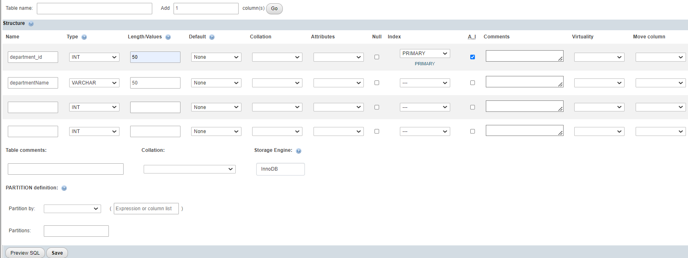

Figure : Create Database for project

In addition, the MySQL commands are easy to understand to create data tables in the project. Below is an illustration.

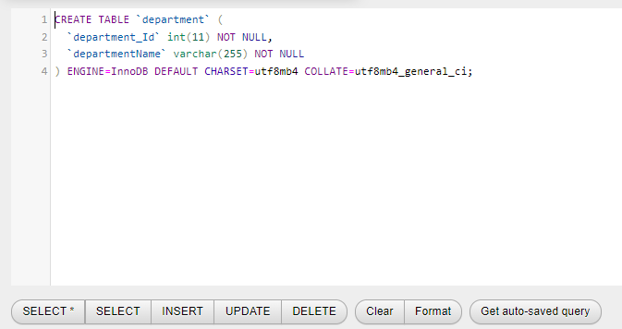

Figure : Commands to create date table

Below are the "Structure" and "Browse" of the "Department" attribute that were created with the operations and statements generated.

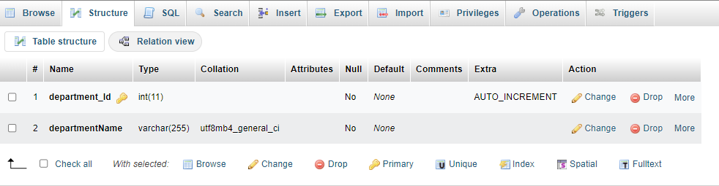

Figure : Structure of database “Department”

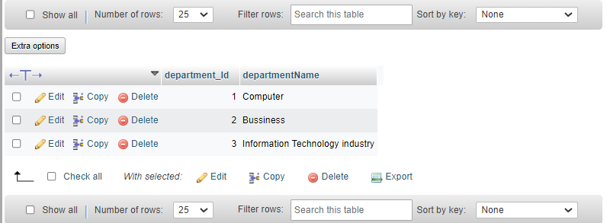

Figure : Browse of database “ Department”

### 2.1.2 User Interface

When creating a new project, one of the most important aspects to consider is the user interface. User interface, commonly referred to as UI, encompasses everything that users interact with when using your software or application. It includes buttons, menus, screens, graphics, and other visual elements. A well-designed UI can make your project intuitive, easy to use, and visually appealing, while a poorly designed UI can make it frustrating for users. The goal of UI design is to create a seamless experience for the end-users. For example, the icons should be recognizable with clear labels, easy navigation, and well-organized content. Once we prioritize designing a great UI, we can proceed to name it something like Idea_Management project, making it more accessible and identifiable for our team. (Garrett, 2010)

First, In our project we use minimalism as an essential principle in User Interface design. Keeping the user interface as simple as possible improves usability, enhances the user experience, and makes the entire application easy to understand for the user. The aim of minimalism is to ensure that the user can complete his task with as little effort as possible. To achieve this, designers must remove any extraneous or unnecessary elements that do not contribute to the main goal of the software or application. By using minimalism, designers can help users focus on what really matters, helping them understand and appreciate the app better. It also ensures that the end user will spend less time trying to figure out how to use the program and more time using it for its intended purposes. Therefore, a minimalist approach to user interface design can lead to higher satisfaction and increased productivity for users.

Below is the post creation interface with a simple and simple design that makes it easy for users to understand.

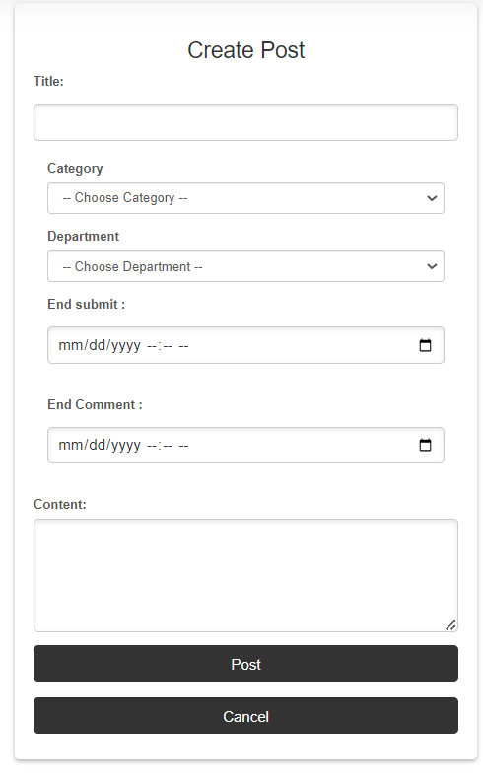

Figure : Interface Crete Post

Besides, we implemented a design that perfectly aligns with the primary goals of our website. Since the main objective of the site is to provide relevant information, we prioritized displaying the content front and center while ensuring ease of navigation. Specifically, the main content is centered on the page, and we fixed the navigation bar to the top left corner of the website. This not only creates a consistent visual aesthetic but also guarantees seamless user interaction. By following this approach, visitors can easily find what they're looking for without any confusion or frustration.

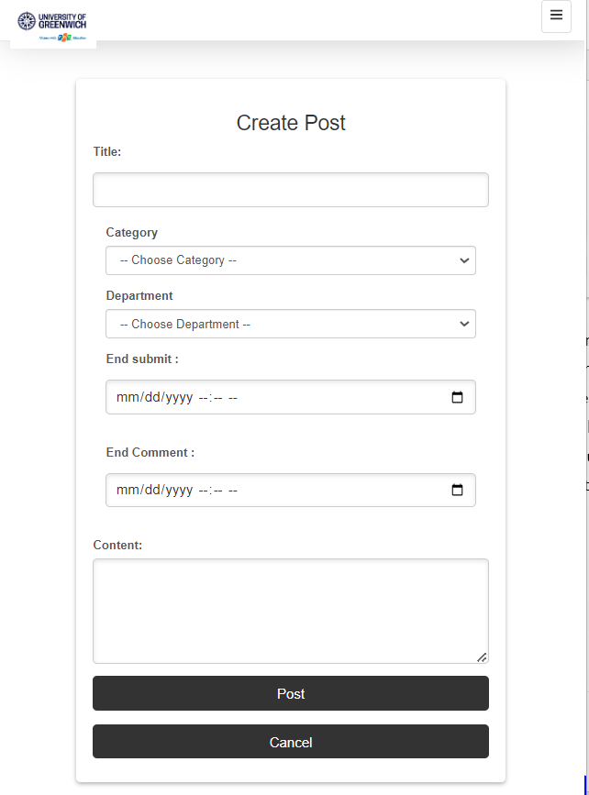

Figure : Multitasking of the product

In due course, our team's front-end developers noted that the website we were creating would need to adhere to consistent design themes. To ensure this, we incorporated a three-part structure shared by all pages, including a header, body, and footer. Specifically, the header contains the group name and logo, while the footer includes a map. The main content is consistently displayed in the center of the website, and we also maintained a consistent sidebar on different pages. This approach helps create smooth transitions between different pages and establishes a cohesive visual experience throughout the site.

### 2.2.3 Function

In our team's project we have met most of the requirements and tasks that we had to do in this project. To ensure optimal performance, we made sure to include all essential functions in the system and guarantee their smooth operation without any delays. However, we must acknowledge that our team was solely focused on the web-based platform during implementation, resulting in a limitation of usability on mobile phones and desktops. This drawback could potentially harm the user experience and their level of satisfaction. We understand that improving this aspect should be prioritized for the next website version. However, each individual function performs with high accuracy and integrates seamlessly into the unified system with other functions. But for the performance of our team it gives a very optimal user experience with a very short time of less than 1.5s that can return the desired results to the user.

Table : Function of project

|  |  |  |
| --- | --- | --- |
| ID | Users | Functions |
| 1 | Staff | Login/ logout to the website |
| View post and feedback |
| Update account |
| Change password |
| Like and comment feedback |
| 2 | QA/Admin | Login/logout to the website |
| Manage post (View, create, edit, delete) |
| Manage staff (View, create, edit, delete) |
| Manage department (View, create, edit, delete) |
| Manage category (View, create, edit, delete) |
| View, comment and like feedback |
|  |  | View QA List |

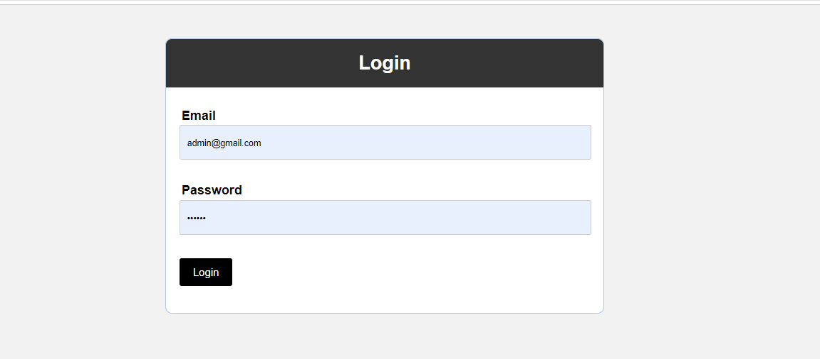

Figure Page login of project

## 2.2 Performance

In regards to the performance of our previous website, I utilized the Lighthouse tool developed by Google. Lighthouse is an open-source application that can be used without any cost and provides significant benefits for enhancing website performance, speed, and user experience. By generating Lighthouse reports, individuals are able to quickly improve the quality of web pages they create. (Stefanov, 2012)

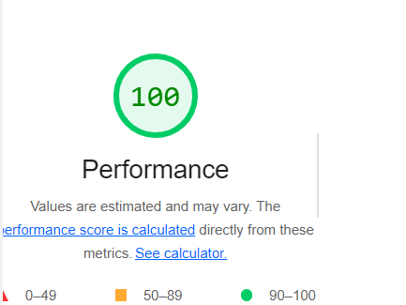

Figure : Performance of login page

Apart from its main function, this tool has also helped us in identifying areas where our website can be improved. The recommendations provided by this tool are very valuable, and we can use them to enhance our website in the upcoming version.

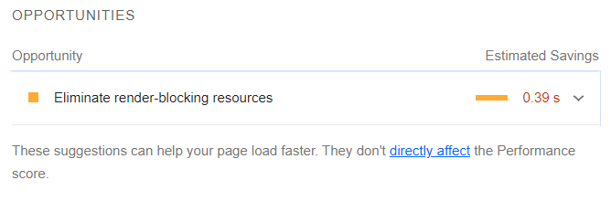

Figure : Opportunities

To reduce the number of unnecessary bytes in network operations, it's recommended that our website removes any unused style sheet components and delay the upload of CSS that isn't necessary for the initial content.

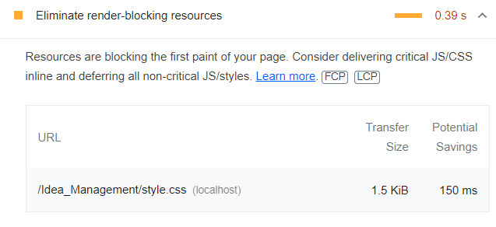

Figure : Opportunities Eliminate render-blocking resources

## 2.3 Development methodology – Agile Scrum

Agile Scrum is a popular development methodology that has found widespread use in project management. It is based on the Agile philosophy of delivering value to customers through iterative and collaborative efforts. The approach allows teams to work flexibly and adaptively, enabling them to handle intricate projects effectively. With Agile Scrum, project managers can better manage their teams, prioritize tasks, and ensure timely delivery of quality results.

The Agile Scrum methodology is based on dividing the project into smaller parts, which are referred to as sprints. Each sprint typically lasts between one and four weeks, during which the team focuses on delivering a specific set of features or functionalities. The team reviews progress during daily meetings known as scrums, where they discuss any issues or roadblocks encountered in completing assigned tasks. This approach ensures collaboration and transparency, with all team members aware of the state of the project and what needs to be done next.

One of the key advantages of Agile Scrum is its flexibility in dealing with dynamic requirements that might arise during the project's lifecycle. The team can quickly adapt to changes in customer demands or market conditions, ensuring that the project stays aligned with the goals and objectives. Also, it allows for ongoing testing, meaning the team can identify issues early on in the development process, reducing the risk of significant problems at the end of the project.

Overall, Agile Scrum methodology provides a highly-effective framework for project management. It promotes collaboration, flexibility, and transparency while delivering high-quality products that meet customer expectations. By following this methodology, project managers increase the chances of success for the project, and achieving agreed-upon deliverables and milestones.

**At our organization**, we have implemented Agile Scrum as our primary development approach. This methodology supports Agile software development by enabling flexibility and iteration throughout intricate projects. By using Scrum, our team can effectively handle change and deliver high-quality products in a timely manner. This framework emphasizes cross-functionality, frequent feedback, and continuous improvement within a self-organizing team environment. To facilitate this, Scrum uses specific roles, events, artifacts, and rules to encourage effective team collaboration, seamless communication, and transparency.

Before starting any project, our team defines each member's role based on Agile Scrum concepts. We appoint a single person as the Scrum Master and Product Owner while others join the development team. The Scrum Master's primary goal is to support the development team in creating valuable products and eliminating any roadblocks that hinder progress. The development team keeps track of all tasks in the Sprint Backlog and is responsible for executing them.

Communication is essential in Scrum, and our team holds a daily meeting to review progress on tasks and plan for the next day. By implementing Agile Scrum concepts, we can work efficiently and collaboratively towards delivering excellent results.

(Cohn, 2005)

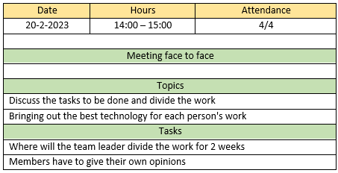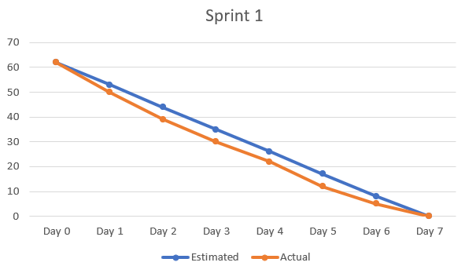

Figure : Agile/Scrum sprint 1

### 2.3.1 Advantages

In situations where project requirements lack clarity, the Agile Scrum methodology is a suitable approach. Our recent implementation demonstrated this when our Scrum Master identified two essential requirements that were not initially specified. These requirements included the provision of login functionality for all users and decentralization of site operations to prevent employee access to quality assurance functions. Unlike the traditional Waterfall approach, Agile Scrum's flexibility allows for changes and reordering of requirements without dire consequences. Additionally, we had a strict two-month deadline to meet, which made Agile Scrum's emphasis on delivering concrete results more advantageous than organizational and documentation aspects. With our four-member team, effective communication between team members was maintained, which is crucial for successful Scrum projects. The collaborative and transparent nature of Agile Scrum enables iteratively dynamic work, providing an end product that meets or exceeds customer expectations. Furthermore, the iterative approach saves time and money by reducing testing and debugging phases, creating a more efficient workflow. Finally, Agile Scrum reduces the risk of cost overruns as budgets can be adjusted based on evolving client needs.

### 2.3.2 Disadvantages

Despite using Agile Scrum, my team faced some challenges during the process. Firstly, without an experienced Scrum Master, the role's importance in helping team members follow Scrum's philosophy, values, practices, and rules was compromised. Secondly, scheduling conflicts among team members made arranging daily standing meetings difficult, leading to reduced communication and affecting progress updates and future plans. Lastly, the self-organizing nature of the development team without close monitoring by the Scrum Master created a lack of accountability and transparency, resulting in delays, scoping issues, and impacting other team members' efforts. One team member's lack of commitment resulted in significant delays and increased workloads towards the project deadline.

However, there are also notable disadvantages to the Agile Scrum methodology. The focus on delivering small components runs the risk of overshadowing larger project objectives, leading to complications and delays. Additionally, Agile Scrum may not be suitable for all project types, such as those requiring long-term planning or a more hierarchical structure.

## 2.4 Group Work

### 2.4.1 Self Evaluating

Throughout the entire working process, I assumed two major roles within the team: Product Owner and Tester. As a Product Owner, my most important responsibility was to ensure that the product met the requirements of stakeholders and end-users. This involved gathering and prioritizing feedback, creating user stories, and overseeing the development process. As a Tester, my primary duty was to ensure that the product was thoroughly tested for bugs and glitches before being released.

Initially, I felt apprehensive when taking on these new roles, especially as a Product Owner which was a new experience for me. To overcome this challenge, I researched extensively about the role and its responsibilities, consulted with experts in the field, and attended relevant trainings. This helped deepen my understanding of the role and made it easier for me to fulfill my duties effectively.

Strengths

As for my contributions to the project, I have demonstrated several strengths that stand out. My foremost priority is ensuring that the product meets the needs of stakeholders and end-users. I do this by proactively seeking feedback from them and incorporating it into the product. Additionally, I am always approachable and eager to address any questions or concerns my colleagues may have, providing them with satisfactory answers. Furthermore, I possess a strong desire to acquire new knowledge and skills, which I consider to be an asset. I spent a significant amount of time researching test methodologies and familiarizing myself with different testing tools to ensure that the product was being tested efficiently. Moreover, I never hesitate to lend a helping hand to others in the team when they face difficulties.

Weaknesses

Though I had some experience in testing and product ownership, there were elements of each role that I was not fully familiar with. In retrospect, it is clear that my lack of experience in both areas led to some setbacks. For example, my limited understanding of some testing methodologies led to delays in finding and fixing some bugs. Additionally, my previous experience in product ownership was not enough to prepare me for the role fully. This made it challenging for me to gather feedback from stakeholders and prioritize them effectively, resulting in some delays in delivering certain features.

Overall, though I had some limitations, I worked effectively to play the roles of Product Owner and Tester, ensuring that the project met its goals and objectives.

### 2.4.2 Team members evaluation

Tran Quan Vinh: Scrum Master and full stack developer

Strengths: She is a gentle, good-natured person who often helps team members on projects. You are a person who is always learning more about Master Scrum and advanced knowledge of programming languages. How to distribute tasks and regularly create team meetings to check the completion of the tasks assigned to each member to ensure the progress of the project. She is quite knowledgeable about the Agile/Scrum model to manage this project. She often gives very good ideas to improve the project better and is accepted by everyone in the team. You are a person who always stands to mediate controversial issues between team members and provides a satisfactory solution to complete the current product.

Weaknesses: Because he has a gentle personality and helps the team members a lot, it leads to the limitation of the work he needs to do on the project. He often accepts his team members to miss group meetings to report the progress of each department, leading to incomplete summary of progress reports.

Nguyen Huynh Hong Quan: Frontend – Tester

Strengths: He is a very smart and sensitive person. Someone who comes up with bold ideas and it's great for team projects. He has a vision of a suitable and user-friendly interface. From his genuine personality brought into this project makes users feel more secure and friendly.

Weaknesses: He has a personality that is quite procrastinating in the progress of the project, interrupting the completion of the project. Frequent absences from team meetings to report on progress. Although some reasons are very sympathetic such as illness and family support in the business, you need to arrange a more suitable time so as not to be affected by team members.

To Nhat Duy: Database designer – Tester

Strengths: You are a person who is easy to get along with everyone, is responsible for teams and you complete the assigned tasks on time, you are a very good thinker when designing a good database brings many advantages. benefit in the development of the group's project.

Weaknesses: When you have personal business but do not often interact with the group with the issues that the group wants to consult to come up with the best solution.

## 2.5 Detailed Evaluation

Table : Detailed Evaluation for members

|  |  |  |  |  |
| --- | --- | --- | --- | --- |
| **Members** | **Truong Van Phat** | **Tran Quan Vinh** | **Nguyen Huynh Hong Quan** | **To Nhat Duy** |
| ***Behavior (0 – 5)*** |  |  |  |  |
| Timely attendance during daily meetings | 5 | 5 | 4 | 5 |
| Attendance | 5 | 5 | 4 | 3 |
| Completing things as allocated on time | 4 | 4 | 3 | 5 |
| Getting ready for each group meeting | 5 | 5 | 5 | 3 |
| Letting you know in advance why he will be late or absent | 4 | 5 | 4 | 4 |
| **Subtotal (25)** | **23** | **24** | **20** | **20** |
|  |  |  |  |  |
| ***Teamwork (0-5)*** |  |  |  |  |
| Taking part in group discussions with enthusiasm | 4 | 4 | 4 | 4 |
| Presenting fresh suggestions or ideas | 4 | 3 | 5 | 3 |
| Being receptive to criticism or inquiry | 5 | 4 | 4 | 5 |
| Recognizing each other's knowledge | 5 | 5 | 5 | 3 |

|  |  |  |  |  |
| --- | --- | --- | --- | --- |
| Not monopolizing discussions in group gatherings | 4 | 5 | 5 | 3 |
| Paying close attention when others are expressing their ideas | 5 | 4 | 5 | 5 |
| Being willing to take on new challenges and exchange information at all times | 3 | 4 | 4 | 3 |
| Carefully adhering to commitments or pledges | 4 | 4 | 4 | 4 |
| **Subtotal (40)** | **34** | **33** | **32** | **30** |
|  | |  |  |  |
| ***Leadership (0-5)*** |  |  |  |  |
| Answering inquiries and puzzles from other participants | 5 | 4 | 5 | 4 |
| Distributing the duties of leadership among the team members | 4 | 5 | 4 | 4 |
| Bringing up important issues for discussion | 5 | 4 | 5 | 4 |
| Inspiring teammates | 4 | 3 | 5 | 3 |
| Assisting teammates after finishing his own work | 5 | 3 | 4 | 4 |
| The project's completion | 3 | 3 | 3 | 4 |

|  |  |  |  |  |  |  |  |  |
| --- | --- | --- | --- | --- | --- | --- | --- | --- |
| **Subtotal (30)** | 26 | | 22 | | 26 | | 23 | |
|  |  | |  | |  | |  | |
| ***Technical Expertise (0-5)*** |  | |  | |  | |  | |
| Having the ability to communicate work to other team members | 5 | | 4 | | 4 | | 5 | |
| Self-correcting technological problems | 4 | | 4 | | 4 | | 4 | |
| Taking part in the ‘number – crunching’ | 4 | | 3 | | 3 | | 4 | |
| Carrying out research as needed | 3 | | 3 | | 3 | | 3 | |
| Generating precise statistical data | 3 | | 3 | | 3 | | 3 | |
| **Subtotal (25)** | **19** | | **17** | | **17** | | **19** | |
|  |  | |  | |  | |  | |
| ***Work Product (0-5)*** |  | |  | |  | |  | |
| The report is written in a consistent manner. | 5 | | 5 | | 4 | | 4 | |
| Successfully submitting the works | 5 | | 5 | | 4 | | 3 | |
| Written work is expert. | 3 | | 4 | | 3 | | 4 | |
| There has been extensive practice for the oral presentation. | 5 | | 4 | | 3 | | 4 | |
| Meeting the initial expectations for output |  | 4 |  | 3 |  | 4 |  | 3 |
| ***Subtotal (25)*** |  | **22** |  | **21** |  | **18** |  | **18** |
|  |  |  |  |  |  |  |  |  |
| ***Overall Evaluation*** |  |  |  |  |  |  |  |  |
| The grade I would give for my contribution to the project | 4.2 |  | 4.4 |  | 3.6 |  | 3.8 |  |
| The rating I believe I would obtain from fellow participants | 4.0 |  | 4.0 |  | 3.4 |  | 3.5 |  |
| Do you intend to collaborate with them in the future? (Yes/ No) | YES |  | YES |  | YES |  | YES |  |
| Contributions to the project and their respective weight (the member's grade as a whole must be 100) | 28 |  | 32 |  | 18 |  | 22 |  |
| ***Subtotal*** |  | **36.2** |  | **40.4** |  | **25.0** |  | **29.3** |

Figure 2: Member’s Contributions

# III. Improvements

## 3.1 Mistakes and Lessons Learned

As a Product Owner on the team responsible for defining the product's vision, strategy, and goals. They need to prioritize features, manage backlogs, and communicate with stakeholders.

One of the most common mistakes is not understanding user needs. Inexperienced me may focus too much on their own ideas and assumptions about what users want without conducting proper research or gathering feedback from actual users. This can lead to building features that no one wants or ignoring essential features that users need, which can lead to negative feedback and lack of user engagement.

**Lesson learned:** The solution to this mistake is to conduct thorough market research, user testing, and collect feedback at every stage of development to ensure that the product meets the needs of the user.

Another common mistake I make during my work is not collaborating effectively with the development team. I need to have a good relationship with the development team and work towards a goal together. I may try to micromanage the development process or distrust the development team, leading to communication problems, delays, and lower quality products.

**Lesson learned:** It's important to establish clear lines of communication, set expectations, listen to the development team's feedback, and collaborate to achieve product goals.

Missing prioritization is a bug I run into as inexperience may have difficulty prioritizing features or may be prioritizing based on the preferences of upper management or stakeholders rather than actual value. that the feature provides. This can lead to wasted resources, slow releases, or low-quality products.

**Lesson learned:** To avoid this mistake, I should establish clear prioritization criteria, continually review and adjust priorities, align with company strategy, and use data-driven methods to determine value of each feature.

Finally, lack of flexibility can also be a mistake. I can become too attached to the original vision or plan, leading to rigidity and missed opportunities. As the product evolves, there may be new insights or trends that require a change of direction or a strategic adjustment. Staying flexible, open and adaptable is crucial to success.

**In summary**, I can make many mistakes, including not understanding user needs, not collaborating effectively with the development team, lack of prioritization, and inflexibility. By avoiding these mistakes and learning from them, I can successfully deliver high quality products that meet user needs and achieve business goals.

# IV. Conclusion

Through this project of my group, I have some evaluations and comments with my own opinions about the project and the individuals in the group. with product reviews, product performance after completion, Idea_Management project interface, functionality, how we apply the Agile/Scrum model to research, design and implementation developing the project for each stage to complete the product, and finally, my personal reflection on the project implementation process, and my evaluation of the team members. This project has allowed me to learn and gain a lot of experience as a Product Owner in the team such as defining product vision, strategy and goals, managing backlog and communicating with stakeholders. related. It is a challenge as well as an opportunity for me to acquire new knowledge to develop myself early with the experience gained to develop with a stable career in the future.

# V. References

Cohn, M. (2005). *Agile Estimating and Planning.* Pearson Education.

Garrett, J. J. (2010). *Elements of User Experience,The User-Centered Design for the Web and Beyond.* New Riders.

Saied M.M. Tahaghoghi, H. E. (2007). *Learning MySQL.*

Stefanov, S. (2012). *Web Performance Daybook Volume 2.* O'Reilly Media.