5
Testing and verifying the server
This chapter covers
- Building a practical testing ladder for the Chapter 4 server, from package-level tests to runtime smoke checks.
- Verifying MCP tools, resources, prompts, lifecycle behavior, capability discovery, and controlled failure paths with SDK-backed tests.
- Keeping the default test suite fast, deterministic, and free of credentials, external network access, browser dependencies, Inspector, and host-specific setup.
- Testing optional integration gates and adapter failure modes without hiding errors behind fake successful results.
- Smoke-testing the real stdio and native Streamable HTTP entry points at the transport boundary.
- Using Inspector, a minimal diagnostic client, and host acceptance checks only after automated tests pass.

By the end of Chapter 4, the server had stopped being a single teaching script and had become a production-shaped Python package. Runtime settings moved into config.py. Server construction moved into factory.py. The local stdio entry point became thin. Streamable HTTP received its own entry point in http_server.py. Filesystem helpers, normalizers, runtime state, GitHub adapter behavior, and browser adapter behavior each gained clearer boundaries.

That structure makes the server easier to reason about, but it also creates a new responsibility: each boundary must be verified. A server that appears to work in one host can still have broken resource reads, unstable result shapes, missing capability registration, incorrect error handling, stdout/stderr problems, or integration behavior that only succeeds on the author’s machine. Chapter 5 turns the Chapter 4 package into a verification target.

This chapter uses MCP 2025-11-25 as the protocol baseline. That matters most at the lifecycle and transport seams. The server must initialize correctly, negotiate capabilities, and operate only after the initialized notification. The stdio entry point must exchange MCP JSON-RPC messages over stdin and stdout without writing diagnostics to stdout. The HTTP entry point must use the native Streamable HTTP path, not the Chapter 3 teaching bridge and not the deprecated HTTP+SSE transport. Streamable HTTP is still MCP; it is not REST and it does not create one route per tool.

The backbone of this chapter is automated testing with the official MCP Python SDK. Host screenshots and manual checks are useful, but they come last. They can show that one configured host can discover and use the server in one environment. They do not prove that the server’s tools, resources, prompts, lifecycle behavior, result shapes, capability registration, path policy, or failure paths are correct and repeatable. For that, we start inside the package and move outward.

The testing ladder follows the same server boundary introduced in Chapter 4. At the bottom are package-level tests for settings, filesystem helpers, normalizers, runtime state, and factory assembly. Above those are in-memory MCP tests that create the Chapter 4 server and an SDK ClientSession in the same Python process. Those tests verify tools/list, tools/call, resources/list, resources/read, prompts/list, and prompts/get without launching a host. Next come policy and lifecycle checks: which capabilities are exposed, which integrations are enabled, and how invalid inputs are rejected. Only after those tests pass do we cross the runtime seam with stdio and Streamable HTTP smoke checks.

The default test suite should be fast and uneventful. It should not require a GitHub token, Playwright Chromium, browser installation, external network access, Inspector, Claude Desktop, Cursor, or VS Code. Integration tests that touch real services belong behind explicit opt-in switches such as RUN_INTEGRATION=1. That separation lets every contributor run the core tests locally while still giving the project owner a path to validate live GitHub and browser behavior when those integrations are intentionally enabled.

Failure behavior is part of the server contract. Unknown tools, malformed requests, and invalid protocol messages are protocol failures. Missing files, rejected filesystem paths, and adapter failures are tool-execution failures. The tests in this chapter keep that distinction visible so the server does not hide errors behind fake successful payloads such as {"ok": false}.

This chapter does not become a client-building chapter or a vendor-host tutorial. A minimal diagnostic client appears only when it helps reproduce black-box stdio or Streamable HTTP behavior outside Inspector. Claude Desktop, Cursor, and VS Code appear as acceptance targets, not as the conceptual center of testing. The goal is narrower: prove that the Chapter 4 server is runnable, testable, and interoperable before later chapters move into hardening, deployment, observability, and security.

Figure 5.1 keeps the same architecture mental model introduced earlier in the book, but the emphasis changes for Chapter 5. In this chapter, the MCP server becomes the verification target, the capabilities surface becomes the primary proof layer, the transport becomes the runtime smoke seam, and external integrations stay outside the default confidence path unless they are explicitly enabled. Host applications remain outside the proof layer and appear only at the end as acceptance checks.

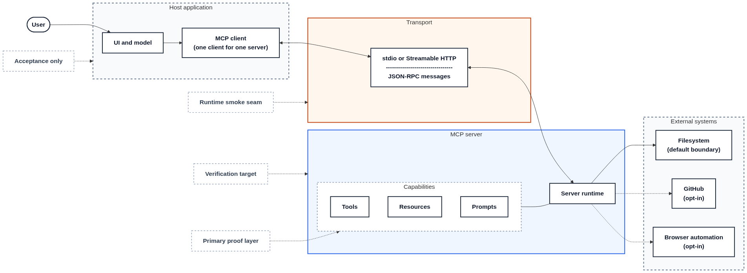
Figure 5.1 Testing boundary for the Chapter 4 server. The architecture is unchanged from earlier chapters, but the testing emphasis is different here. The MCP server is the verification target, the capabilities surface of tools, resources, and prompts is the primary proof layer, the transport boundary is exercised later through runtime smoke checks, filesystem remains the default external boundary, optional GitHub and browser integrations stay outside the default suite, and host applications remain acceptance-only clients.

  - Testing strategy and layers
Figure 5.1 establishes the testing boundary for this chapter. The primary target is the Chapter 4 server package: runtime settings, server factory, tools, resources, prompts, server-owned result shapes, filesystem policy, lifecycle behavior, and optional capability registration. The transport seam is tested only after the package and MCP-facing surface tests pass. External systems split into two groups: filesystem behavior runs by default against temporary directories, while GitHub and browser automation remain opt-in. Host UIs and model behavior are not part of the automated protocol surface. They appear only at the end as acceptance checks.

A useful test plan for this server is not a single end-to-end demo. It is a set of layers. Each layer proves one narrower claim before the next layer adds more moving parts. The default suite should run on a clean development machine without credentials, external service access, browser installation, Inspector, Claude Desktop, Cursor, or VS Code.

The lower layers stay inside the Python package. They verify settings validation, filesystem helpers, normalizers, runtime-state cleanup, and server assembly. These tests do not need MCP. They should fail before any protocol-level test is needed.

The middle layer uses the official MCP Python SDK to verify the server through an in-memory ClientSession. These tests initialize a session and exercise the MCP surface directly through tools/list, tools/call, resources/list, resources/read, prompts/list, and prompts/get. This is the backbone of the chapter because it verifies the server contract without starting stdio, HTTP, Inspector, or a host application.

The upper layers add policy, lifecycle, controlled-failure checks, runtime smoke tests, opt-in integration checks, and finally manual acceptance. This ordering matters. A host tools panel can show that a tool is visible, but it cannot prove that read_file returns the expected structuredContent, that missing files return isError=True, that filesystem://roots reports the right policy, that disabled browser tools stay absent, or that an unknown tool is reported as a protocol error. Those are server-contract tests, so they belong in the automated suite before any host is opened.

The first layer is unit and configuration testing. These tests verify config.py, fs_utils.py, normalizers.py, and runtime_state.py: environment parsing and validation, allowed-root enforcement, stable result shapes, and cleanup behaviour. Filesystem tests use temporary directories, not the developer’s real workspace.

The second layer verifies server assembly. These tests call factory.py with explicit ServerSettings and confirm that the expected FastMCP server is built. They check that filesystem tools and prompts are registered when enabled, optional integrations stay absent when disabled, and credential-backed integrations such as GitHub fail during settings validation before the server is exposed. They do not call GitHub, Playwright, browser binaries, or the network.

The third layer verifies the MCP-facing surface. These tests create the server and an SDK ClientSession in the same Python process. They initialize the session, list tools, call tools, read resources, and fetch prompts. This layer proves the server’s public MCP contract before any transport process or host application is involved.

The fourth layer checks application policy. MCP defines the protocol shape, but the Chapter 4 server decides which filesystem roots are allowed, whether filesystem behaviour is read-only, which optional integrations are registered, and how adapter failures are represented. These are server decisions. They should be asserted directly, not inferred from a host tools panel.

The fifth layer checks lifecycle, negotiation, and controlled failures. The tests verify that a client can initialize, that negotiated capabilities match the configured server, and that bad input receives controlled behaviour. Unknown tools and malformed MCP requests are protocol failures. Missing files, rejected filesystem paths, and adapter failures are tool-execution failures. Keeping that boundary visible prevents the server from hiding errors behind fake successful payloads.

The sixth layer checks runtime entry points. For stdio, the transport smoke test starts python -m build_an_mcp_server.server as a real subprocess, sends a short MCP exchange over stdin/stdout, asserts matching response IDs, verifies that stdout contains only protocol JSON, allows diagnostics on stderr, uses a timeout, and cleans up the child process without inventing a shutdown RPC.

For Streamable HTTP, construction alone is not sufficient. The protocol smoke test targets the native http_server.py app and the SDK Streamable HTTP endpoint. It starts a local HTTP process, waits for the process to accept connections, connects to the single /mcp endpoint, initializes through the SDK Streamable HTTP client, and verifies that the expected read-only tool surface is visible. The repo test also checks two implemented negative paths: explicit non-local Origin headers are rejected by the local Origin guard, and malformed JSON sent to the MCP endpoint is returned as an HTTP error.

Do not overstate this layer. These are runtime smoke tests, not a full Streamable HTTP conformance suite. They do not yet claim explicit GET streaming behaviour, stricter Accept negotiation, initialized-notification status behaviour, protocol-version follow-up behaviour, or session-ID reuse. Those behaviours should be covered by focused tests before they are treated as verified server behaviour. A separate live process check against http://127.0.0.1:8000/mcp can remain optional.

These HTTP checks target src/build_an_mcp_server/http_server.py, not the Chapter 3 teaching bridge in examples/ch03/http_adapter.py. Streamable HTTP is still MCP. It is not REST, and it does not create one route per tool.

The seventh layer is opt-in integration testing. GitHub and browser automation should not run during the ordinary test command. Tests that need GITHUB_TOKEN, Playwright Chromium, browser binaries, or external network access must skip cleanly when prerequisites are missing. They must not print secrets.

The final layer is manual acceptance. Inspector is the preferred manual debugging tool. Claude Desktop, Cursor, and VS Code are host acceptance targets. They confirm that real clients can discover and expose the already-tested server, but they do not replace protocol tests.
CAUTION Host screenshots and host UI checks are acceptance checks, not protocol tests. They can show that a configured host recognizes the server, but they do not validate JSON-RPC behaviour, result-shape stability, tool-error semantics, lifecycle handling, transport headers, or application policy. Run them after the automated tests pass.
Table 5.1 summarizes the layers used in this chapter. The “Runs by default?” column is the key reader promise: the default suite must remain deterministic, credential-free, browser-free, host-free, and independent of external services.
Table 5.1 Test layers for the Chapter 4 server
Layer | Main target | What it proves | Runs by default?
Unit and configuration tests | config.py, fs_utils.py, normalizers.py, runtime_state.py | Validation, path policy, cleanup behavior, and result shapes stay stable | Yes
Server assembly tests | factory.py | The composition root builds the expected configured FastMCP server | Yes
In-memory MCP tests | tools/list, tools/call, resources/list, resources/read, prompts/list, prompts/get | The server exposes and handles MCP surfaces without stdio, HTTP, Inspector, or a host | Yes
Capability and policy tests | Feature exposure, filesystem roots, read-only behavior, optional tools | Application policy is reflected in the server’s public MCP surface | Yes
Lifecycle and controlled-failure tests | Initialization, negotiated capabilities, invalid requests, missing arguments, invalid paths | A client can initialize and receives controlled behavior for bad input | Yes
stdio smoke tests | python -m build_an_mcp_server.server | The local entry point launches as a subprocess, exchanges JSON-RPC over stdin/stdout, matches response IDs, keeps stdout protocol-only, allows diagnostics on stderr, and cleans up | Yes
Streamable HTTP construction tests | http_server.py/ create_http_app() | The native HTTP application can be assembled without the Chapter 3 bridge or a live HTTP process | Yes
Streamable HTTP protocol smoke tests | Native /mcp endpoint | A local HTTP process starts, the SDK Streamable HTTP client can initialize against /mcp, the expected tools are listed, non-local Origin is rejected, and malformed JSON is returned as an HTTP error | Yes, using a local subprocess and dynamic port
Streamable HTTP live process checks | Running server at http://127.0.0.1:8000/mcp | A real process can bind locally and answer through the production MCP endpoint | Optional
External integration tests | GitHub and browser automation | Real adapters work against real services when prerequisites exist | No
Inspector checks | MCP Inspector against stdio and Streamable HTTP | A human can inspect the already-tested server through the official debugging tool | No
Host acceptance checks | Claude Desktop, Cursor, VS Code | Real hosts can discover and expose the server in a configured environment | No

The default command for this chapter is:

python -m pytest

That command should not require network access, GITHUB_TOKEN, Playwright Chromium, browser installation, Inspector, Claude Desktop, Cursor, or VS Code. Filesystem tests should create temporary roots. Integration modules should be disabled unless a test explicitly enables them. External calls should be mocked, replaced with test doubles, or tested as controlled failure paths.

The exact opt-in commands for GitHub and browser validation appear later in this chapter, after the integration test file and required environment gates are introduced. Those commands are owner-level validation. They may require credentials, browser binaries, and network access. They must skip cleanly when prerequisites are missing and must not print secrets.

With that boundary in place, the next section moves to the backbone of the chapter: the in-memory SDK path that verifies tools, resources, prompts, and controlled failures without involving a host.

  - Verifying tools, resources, and prompts
Section 5.1 identified the in-memory SDK path as the backbone of the test strategy. This section makes that path concrete. The first MCP-facing tests verify the server surfaces that a client can discover and use after a session is established: tools, resources, and prompts.

At this layer, no host is involved. The test client is an SDK ClientSession, and the server under test is the Chapter 4 server assembled by factory.py. The SDK in-memory path creates a connected client/server session without starting stdio, HTTP, Inspector, or a host. That is the path used here.

This section verifies six outcomes:
- tools/list includes the filesystem tools expected from the Chapter 4 configuration.
- tools/list exposes a usable input schema for read_file.
- tools/call can call read_file and return stable structuredContent.
- tools/call on a missing file returns a tool result with isError=True.
- resources/list includes filesystem://roots, and resources/read exposes allowed roots and read-only policy.
- prompts/list includes review_file and inspect_directory, and prompts/get returns prompt messages.

Figure 5.2 shows the in-memory proof path used by the tests in this section.

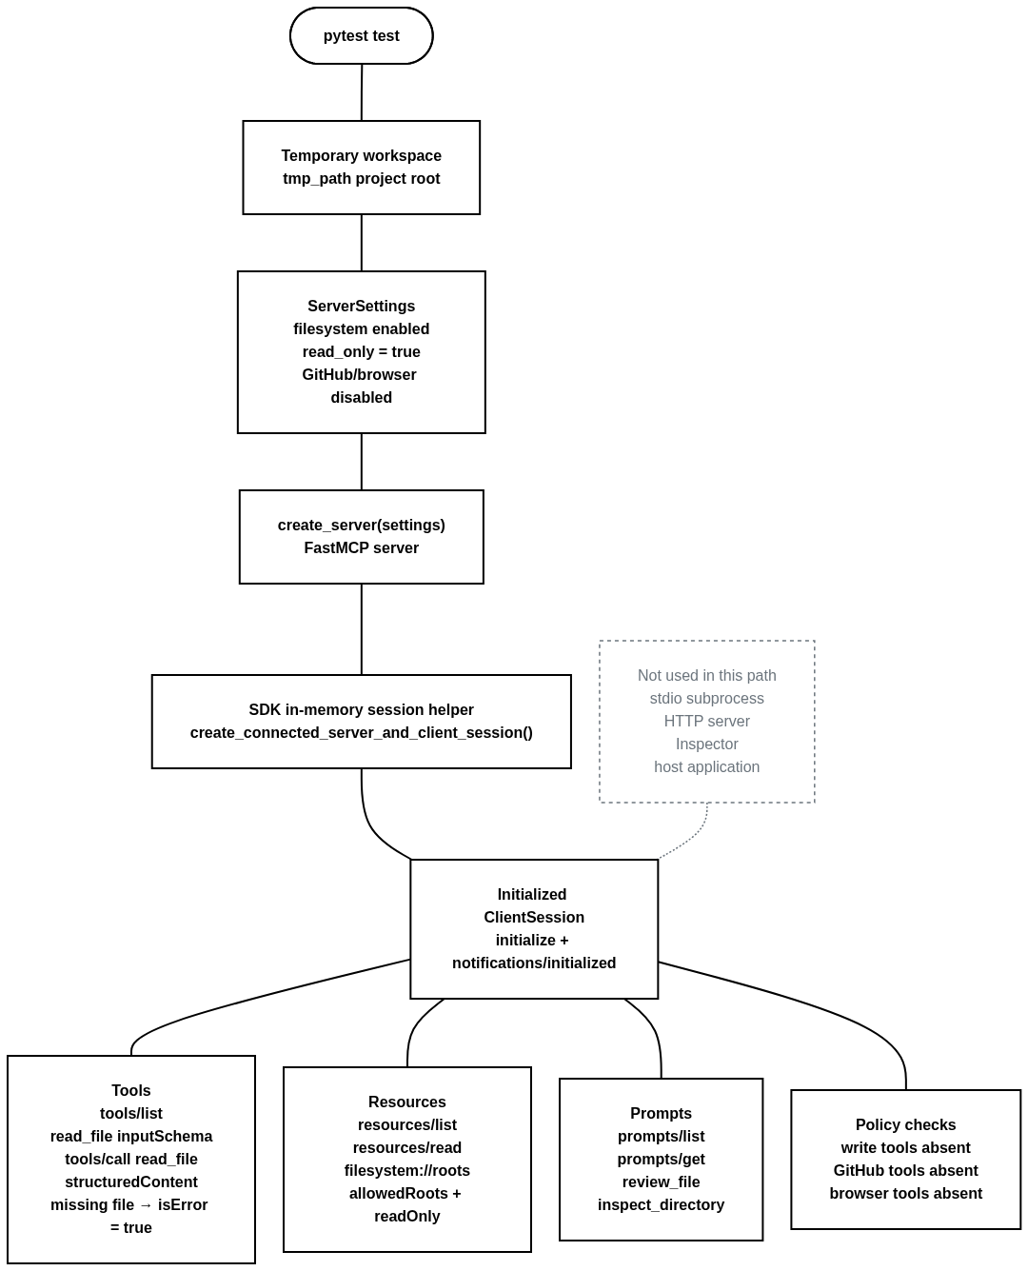
Figure 5.2 In-memory SDK test path. pytest builds ServerSettings, assembles the FastMCP server through create_server(), opens a connected in-memory client/server session through the official SDK helper, completes initialization, and verifies tools, resources, prompts, result shapes, and capability policy without starting stdio, HTTP, Inspector, or a host.
Place the shared fixtures in tests/conftest.py. They create a temporary filesystem root, disable external integrations, build the server through the Chapter 4 factory, and yield a ready ClientSession.
Listing 5.1 pytest fixtures for settings and ClientSession
# tests/conftest.py

from collections.abc import AsyncIterator
from pathlib import Path

import pytest

from mcp.client.session import ClientSession
from mcp.server.fastmcp import FastMCP
from mcp.shared.memory import create_connected_server_and_client_session

from build_an_mcp_server.config import ServerSettings
from build_an_mcp_server.factory import create_server

@pytest.fixture
def anyio_backend() -> str:
return "asyncio" #A

@pytest.fixture
def workspace_root(tmp_path: Path) -> Path:
root = tmp_path / "project"
root.mkdir()

(root / "readme.md").write_text(
"# Project\nA sample project.\n",
encoding="utf-8",
)
(root / "src").mkdir()
(root / "src" / "main.py").write_text(
"print('hello')\n",
encoding="utf-8",
)

return root #B

@pytest.fixture
def server_settings(workspace_root: Path) -> ServerSettings:
return ServerSettings(
enable_filesystem=True,
fs_allowed_dirs=(workspace_root,),
read_only=True,
enable_github=False,
enable_browser=False,
) #C

@pytest.fixture
def mcp_server(server_settings: ServerSettings) -> FastMCP:
return create_server(server_settings) #D

@pytest.fixture
async def client_session(
mcp_server: FastMCP,
) -> AsyncIterator[ClientSession]:
async with create_connected_server_and_client_session(
mcp_server,
raise_exceptions=True,
) as session: #E
yield session

#A Keep asynchronous tests on one backend.
#B Use a temporary project tree instead of the developer’s real filesystem.
#C Keep optional integrations disabled in the default suite.
#D Build the server through the Chapter 4 composition root.
#E Use the SDK in-memory path instead of stdio, HTTP, Inspector, or a host.

The fixture hides the SDK wiring. Individual tests receive only client_session and workspace_root, which keeps the tests focused on protocol-visible behavior instead of transport setup.

Before crossing the MCP boundary, pin down the helper behavior that the filesystem tools depend on. These tests stay inside the package and should fail earlier than any protocol-level assertion.
Listing 5.2 Excerpt from helper and normalizer tests inside the package boundary
# tests/test_helpers_and_normalizers.py

from pathlib import Path

import pytest

from build_an_mcp_server.fs_utils import resolve_and_validate
from build_an_mcp_server.normalizers import map_text_file

def test_resolve_and_validate_accepts_file_inside_root(
workspace_root: Path,
) -> None:
target = workspace_root / "readme.md"

resolved = resolve_and_validate(target, (workspace_root,))

assert resolved == target.resolve() #A

def test_resolve_and_validate_rejects_path_outside_root(
workspace_root: Path,
tmp_path: Path,
) -> None:
outside = tmp_path / "outside.txt"
outside.write_text("secret\n", encoding="utf-8")

with pytest.raises(ValueError, match="outside the allowed"):
resolve_and_validate(outside, (workspace_root,)) #B

def test_resolve_and_validate_rejects_symlink_escape(
workspace_root: Path,
tmp_path: Path,
) -> None:
outside = tmp_path / "outside.txt"
outside.write_text("secret\n", encoding="utf-8")

link = workspace_root / "linked-outside.txt"
try:
link.symlink_to(outside)
except (OSError, NotImplementedError) as exc:
pytest.skip(f"symlink creation is not available: {exc}") #C

with pytest.raises(ValueError, match="outside the allowed"):
resolve_and_validate(link, (workspace_root,))

def test_map_text_file_returns_stable_shape(
workspace_root: Path,
) -> None:
path = workspace_root / "readme.md"

payload = map_text_file(
path,
path.read_text(encoding="utf-8"),
).model_dump() #D

assert payload["path"] == str(path)
assert payload["mimeType"] in {"text/markdown", "text/plain"}
assert payload["bytesRead"] == len(payload["content"].encode("utf-8"))
assert payload["content"] == "# Project\nA sample project.\n"

#A Allowed file paths resolve inside the configured root.
#B A direct outside-root path is rejected before tool logic reads from disk.
#C Symlink escape coverage catches a common filesystem-policy bypass and skips cleanly when symlinks are unavailable.
#D The normalizer owns the shape later returned as structuredContent.

These tests keep failures local. If allowed-root enforcement breaks, the helper test fails. If the file-read result shape changes, the normalizer test fails. The MCP-facing tests then verify that those same decisions survive the protocol boundary.

Keep the MCP-facing tests split by surface rather than placing tools, resources, prompts, and policy checks in one oversized file. That keeps failures precise and matches the layer model from Section 5.1.

The tool tests are the most important tests in this section, so they deserve the fullest listing. They verify discovery, schema shape, successful execution, and controlled tool-execution failure.

Listing 5.3 Tool discovery, schema, and read_file behavior through an in-memory session

# tests/test_tools.py

from pathlib import Path

import pytest

from mcp.client.session import ClientSession
from mcp.types import CallToolResult, TextContent

def _tool_names(result: object) -> set[str]:
return {tool.name for tool in result.tools}

def _tool_by_name(result: object, name: str) -> object:
return next(tool for tool in result.tools if tool.name == name)

def _tool_text(result: CallToolResult) -> str:
return "\n".join(
item.text
for item in result.content
if isinstance(item, TextContent)
)

@pytest.mark.anyio
async def test_filesystem_tools_are_discoverable(
client_session: ClientSession,
) -> None:
listed = await client_session.list_tools()
names = _tool_names(listed)

assert "list_files" in names
assert "read_file" in names #A

@pytest.mark.anyio
async def test_read_file_tool_schema_requires_path(
client_session: ClientSession,
) -> None:
listed = await client_session.list_tools()
read_file = _tool_by_name(listed, "read_file")

schema = read_file.inputSchema
properties = schema.get("properties", {})

assert schema["type"] == "object"
assert "path" in properties
assert properties["path"]["type"] == "string"
assert "path" in schema.get("required", []) #B

@pytest.mark.anyio
async def test_read_file_returns_structured_content(
client_session: ClientSession,
workspace_root: Path,
) -> None:
target = workspace_root / "readme.md"

result = await client_session.call_tool(
"read_file",
{"path": str(target)},
)

assert isinstance(result, CallToolResult)
assert result.is_error is not True
assert "# Project" in _tool_text(result)

structured = result.structured_content
assert isinstance(structured, dict)
assert structured["path"] == str(target)
assert structured["mimeType"] in {"text/markdown", "text/plain"}
assert structured["bytesRead"] == len(
structured["content"].encode("utf-8")
)
assert structured["content"] == "# Project\nA sample project.\n" #C

@pytest.mark.anyio
async def test_missing_file_returns_tool_error(
client_session: ClientSession,
workspace_root: Path,
) -> None:
missing = workspace_root / "missing.txt"

result = await client_session.call_tool(
"read_file",
{"path": str(missing)},
)

assert isinstance(result, CallToolResult)
assert result.is_error is True
assert "missing.txt" in _tool_text(result) #D

#A The filesystem tools are discovered through tools/list.
#B The advertised schema tells clients that read_file requires a string path.
#C The test checks the machine-readable result shape, not only display text.
#D A missing file is a controlled tool-execution failure, not an unknown-tool protocol error.

The tool tests follow the MCP discovery pattern directly: list the surface first, inspect the schema, then call the tool. The read_file success test checks both human-readable content and the SDK model’s structured_content value. On the wire, that value appears as structuredContent. The missing-file test checks the server’s controlled tool-execution failure path. It should not expect a JSON-RPC protocol error for a missing file.

If the Chapter 4 server declares an outputSchema for read_file, the companion test suite should include a schema-matching test. The chapter does not need to print that test because Listing 5.3 already verifies the structured-content shape returned by the tool.

The next tests verify the filesystem resource exposed by the default test settings: filesystem://roots.
Listing 5.4 Resource discovery and resource-read tests through an in-memory session
# tests/test_resources.py

import json
from pathlib import Path

import pytest
from pydantic import AnyUrl

from mcp.client.session import ClientSession

def _resource_text(result: object) -> str:
return "\n".join(
item.text
for item in result.contents
if getattr(item, "text", None) is not None
)

@pytest.mark.anyio
async def test_filesystem_roots_is_listed(
client_session: ClientSession,
) -> None:
listed = await client_session.list_resources()
uris = {str(resource.uri) for resource in listed.resources}

assert "filesystem://roots" in uris #A

@pytest.mark.anyio
async def test_filesystem_roots_reports_policy(
client_session: ClientSession,
workspace_root: Path,
) -> None:
result = await client_session.read_resource(
AnyUrl("filesystem://roots")
)
payload = json.loads(_resource_text(result))

assert payload["readOnly"] is True
assert payload["allowedRoots"] == [str(workspace_root.resolve())] #B

#A The resource is discoverable through resources/list.
#B The resource payload reflects the configured filesystem policy.

The SDK types read_resource() with AnyUrl, which is why this listing uses AnyUrl("filesystem://roots"). The custom URI is server-owned, but the behavior is still MCP resource behavior: list the resource URI, then read that URI.

The last server surface in this section is prompts. The Chapter 4 server registers two prompt templates, so the tests should assert those exact names instead of accepting either one as a fallback.
Listing 5.5 Prompt discovery and prompt message-shape tests through an in-memory session
# tests/test_prompts.py

from pathlib import Path

import pytest

from mcp.client.session import ClientSession
from mcp.types import TextContent

def _prompt_names(result: object) -> set[str]:
return {prompt.name for prompt in result.prompts}

@pytest.mark.anyio
async def test_prompts_are_listed(
client_session: ClientSession,
) -> None:
listed = await client_session.list_prompts()
names = _prompt_names(listed)

assert names >= {"review_file", "inspect_directory"} #A

@pytest.mark.anyio
async def test_review_file_prompt_message_shape(
client_session: ClientSession,
workspace_root: Path,
) -> None:
result = await client_session.get_prompt(
"review_file",
arguments={"path": str(workspace_root / "readme.md")},
)

assert result.messages
message = result.messages[0]
assert message.role in {"user", "assistant"}
assert isinstance(message.content, TextContent)
assert message.content.text.strip() #B

#A Chapter 4 registers both prompt names, so list_prompts() should expose both.
#B The test checks prompt message shape, not just that prompts/get returned something.

Prompts are discoverable templates that clients list and retrieve by name. They are not hidden tools, and they are not autonomous workflows. This section checks prompt discovery and prompt message shape. Missing prompt names and missing required prompt arguments fit better in the next section’s lifecycle and controlled-failure checks.

The last check in this section is surface policy. Presence matters, but absence is also part of the server contract.
Listing 5.6 Capability-policy tests for the default server surface
# tests/test_capability_policy.py

import pytest

from mcp.client.session import ClientSession

def _tool_names(result: object) -> set[str]:
return {tool.name for tool in result.tools}

@pytest.mark.anyio
async def test_disabled_and_write_tools_are_absent_by_default(
client_session: ClientSession,
) -> None:
listed = await client_session.list_tools()
names = _tool_names(listed)

assert "write_file" not in names #A
assert "get_repository_info" not in names #B
assert "browser_health_check" not in names
assert not any(name.startswith("browser_") for name in names) #C

#A Read-only mode must not expose write-capable filesystem tools.
#B GitHub tools stay hidden unless GitHub support is enabled.
#C Browser tools stay hidden unless browser support is enabled.

These tests still belong in the default suite. They do not prove that GitHub or browser automation works against real services. They prove the more basic rule: the server’s public MCP surface matches the current runtime policy.

Table 5.2 lists tests that should exist in the repo but do not need full listings in the chapter. This keeps the printed section readable while still telling readers what the test suite should cover.
Table 5.2 Repo tests not printed in full
Test | File | Why it belongs in the repo
test_unknown_resource_uri_raises_mcp_error | tests/test_resources.py | Missing resources should fail explicitly instead of returning fake data.
test_resource_uri_with_wrong_scheme_is_rejected | tests/test_resources.py | Resource URI handling must not silently accept unsupported schemes.
test_inspect_directory_prompt_is_fetchable | tests/test_prompts.py | Both Chapter 4 prompt templates should be retrievable.
test_unknown_prompt_raises_mcp_error | tests/test_prompts.py | Missing prompt names are request/protocol failures.
test_review_file_prompt_requires_path_argument | tests/test_prompts.py | Prompt arguments should be validated.
test_read_file_missing_path_argument_is_rejected | tests/test_tools.py or tests/test_lifecycle.py | A missing required tool argument is different from a missing file. Verify the exact SDK/FastMCP error shape before asserting McpError

After adding these tests, run this section’s test files from the project root.

PowerShell:

python -m pytest `
tests/test_helpers_and_normalizers.py `
tests/test_tools.py `
tests/test_resources.py `
tests/test_prompts.py `
tests/test_capability_policy.py

Bash:

python -m pytest \
tests/test_helpers_and_normalizers.py \
tests/test_tools.py \
tests/test_resources.py \
tests/test_prompts.py \
tests/test_capability_policy.py

At this point, the suite has verified the main Chapter 4 server surfaces without a host, desktop configuration file, network service, browser runtime, stdio subprocess, or HTTP server. That is the correct order. The next section builds on this foundation by checking lifecycle, negotiation, and controlled failures, while Inspector and host acceptance checks later in the chapter depend on these tests rather than replacing them.

  - Lifecycle, negotiation, and session tests
Section 5.2 verified the discoverable server surfaces. This section verifies the session contract around those surfaces: the client can initialize, the server reports negotiated capabilities, valid requests still work after initialization, and bad input fails in a controlled way.

The MCP lifecycle makes initialization the first interaction between client and server. During that phase, the client and server negotiate protocol version, exchange capabilities, and share implementation details. After successful initialization, the client sends notifications/initialized before normal operation begins. Because the in-memory SDK helper used in this chapter yields a ready connected session for tests, the checks here assert observable session state rather than replaying raw JSON-RPC messages by hand.

Keep these tests in two files. Put lifecycle and negotiation assertions in tests/test_lifecycle.py. Put import and app-construction checks in tests/test_entrypoints.py. The real stdio and Streamable HTTP smoke tests appear in Section 5.5, because a smoke test must exercise the transport boundary itself rather than merely import a module or construct an app object.

Listing 5.7 Excerpt from lifecycle and negotiation tests through an initialized in-memory session
# tests/test_lifecycle.py

from pathlib import Path

import pytest

from mcp.client.session import ClientSession
from mcp.shared.exceptions import MCPError
from mcp.types import CallToolResult, TextContent

def _tool_text(result: CallToolResult) -> str:
return "\n".join(
item.text
for item in result.content
if isinstance(item, TextContent)
)

@pytest.mark.anyio
async def test_initialized_session_reports_server_capabilities(
client_session: ClientSession,
) -> None:
initialize_result = client_session.initialize_result #A

assert initialize_result is not None
assert initialize_result.capabilities.tools is not None
assert initialize_result.capabilities.resources is not None
assert initialize_result.capabilities.prompts is not None

@pytest.mark.anyio
async def test_negotiated_capabilities_match_public_surfaces(
client_session: ClientSession,
) -> None:
initialize_result = client_session.initialize_result

assert initialize_result is not None
assert initialize_result.capabilities.tools is not None
assert initialize_result.capabilities.resources is not None
assert initialize_result.capabilities.prompts is not None

tools = await client_session.list_tools() #B
resources = await client_session.list_resources()
prompts = await client_session.list_prompts()

assert any(tool.name == "list_files" for tool in tools.tools)
assert any(
str(resource.uri) == "filesystem://roots"
for resource in resources.resources
)
assert {prompt.name for prompt in prompts.prompts} >= {
"review_file",
"inspect_directory",
}

@pytest.mark.anyio
async def test_outside_root_path_is_a_controlled_tool_error(
client_session: ClientSession,
workspace_root: Path,
) -> None:
outside = workspace_root.parent / "outside.txt"
outside.write_text("secret\n", encoding="utf-8")

result = await client_session.call_tool(
"read_file",
{"path": str(outside)},
) #C

assert isinstance(result, CallToolResult)
assert result.is_error is True
assert "outside the allowed" in _tool_text(result)

@pytest.mark.anyio
async def test_unknown_tool_is_reported_as_protocol_error(
client_session: ClientSession,
) -> None:
with pytest.raises(MCPError):
await client_session.call_tool(
"definitely_not_registered",
{},
) #D

#A initialize_result contains the server capabilities negotiated during initialization.
#B The negotiated capabilities must correspond to usable server surfaces.
#C Path policy is enforced after initialization and should surface as a controlled tool-execution error.
#D An unregistered tool is a protocol-level error, not a successful tool result.

The first test makes initialization visible without re-running the lifecycle by hand. The SDK helper has already created a connected initialized session. initialize_result lets the test inspect what the session negotiated. The follow-up list calls connect those negotiated capabilities to real behavior: the server should not merely claim tools, resources, and prompts; those surfaces should also be usable in the same session.

The failure-path tests separate tool-execution errors from protocol errors. A path outside the configured filesystem root is an application-policy failure during read_file, so it should return a CallToolResult with isError=True at the protocol level. In Python SDK code, assert the SDK model attribute exposed by the installed version. An unknown tool name is different: it is a protocol-level error, not a successful tool result.

Listing 5.7 is an excerpt. The full repo test suite should also cover unknown resource URIs, unsupported resource schemes, unknown prompt names, and missing required prompt arguments. Those cases are important, but printing all of them here would repeat the same exception pattern without teaching a new testing technique.

Do not add a read_file missing-argument protocol-error assertion here unless the repository actually implements that behaviour. Tool argument validation can be represented as a tool-execution error when the request shape is otherwise valid. Keep the hard protocol-error assertion for unknown tools and malformed MCP requests.

The final two checks in this section stay outside the in-memory session path. They verify entry-point construction rather than negotiated session behaviour.
Listing 5.8 Entry-point construction checks for the Chapter 4 runtime
# tests/test_entrypoints.py

import importlib
from pathlib import Path

from build_an_mcp_server.config import ServerSettings
from build_an_mcp_server.http_server import create_http_app

def test_stdio_entry_point_module_exposes_main() -> None:
module = importlib.import_module("build_an_mcp_server.server")

assert hasattr(module, "main")
assert callable(module.main) #A

def test_streamable_http_app_can_be_constructed(tmp_path: Path) -> None:
root = tmp_path / "project"
root.mkdir()
(root / "readme.md").write_text("# Project\n", encoding="utf-8")

settings = ServerSettings(
enable_filesystem=True,
fs_allowed_dirs=(root,),
read_only=True,
enable_github=False,
enable_browser=False,
) #B

app = create_http_app(settings)

assert app is not None
assert callable(app) #C

#A The stdio entry-point module should be importable and expose a callable main().
#B Use the Chapter 4 ServerSettings shape, not older allowed_roots fields.
#C The native Streamable HTTP app should be constructible without the Chapter 3 bridge.

These are entry-point construction checks, not smoke tests. The stdio check proves only that the local entry-point module has the expected shape. The HTTP check proves only that the native http_server.py app can be assembled from Chapter 4 settings. Real transport smoke tests come in Section 5.5. A stdio smoke test must actually send MCP messages over stdin and stdout, verify matching response IDs, keep stdout protocol-only, allow diagnostics on stderr, use a timeout, and clean up the subprocess. A Streamable HTTP smoke test must actually start or exercise the native MCP endpoint and verify the implemented HTTP behavior without using the Chapter 3 bridge.

Run this section from the project root.

PowerShell:

python -m pytest `
tests/test_lifecycle.py `
tests/test_entrypoints.py

Bash:

python -m pytest \
tests/test_lifecycle.py \
tests/test_entrypoints.py

At this point, this section has verified negotiated capabilities, post-initialization behaviour, one controlled tool-execution failure, one protocol-level failure for an unknown tool, and construction of the two Chapter 4 runtime entry points. It still has not crossed the real stdio or HTTP transport seam. That is deliberate. Section 5.4 moves outward to external integrations and controlled adapter failures. Section 5.5 then crosses the runtime transport seam with the real stdio and Streamable HTTP smoke tests.

  - External integrations and failure modes
The default suite should prove the server’s integration boundaries without depending on live services. Filesystem behaviour can run by default because pytest gives each test an isolated temporary directory. GitHub and browser automation are different. They may require credentials, network access, installed browser binaries, or all three. Those checks belong behind explicit opt-in switches.

This section separates three cases. First, configuration failures should be caught before the server starts. If GitHub support is enabled without the required token, settings validation should fail. Second, disabled integrations should not leak tools into tools/list. Third, when an enabled adapter fails during a tool call, the server should return a tool-execution error, not a fake success payload.

MCP distinguishes protocol errors from tool-execution errors. Unknown tools and malformed tool requests are protocol errors. Adapter failures, API failures, input validation failures after a known tool is invoked, and business-logic failures are tool-execution errors reported in tool results marked as errors. On the MCP wire, that flag appears as isError. That distinction is why this section tests adapter failures through CallToolResult instead of letting adapter exceptions escape the MCP tool boundary.

pytest’s monkeypatch fixture is useful for default failure-mode tests because it can replace adapter functions and restore them after the test finishes. The important boundary is the adapter, not the MCP client. The default suite should not call GitHub, Playwright, browser binaries, or the network.

Listing 5.9 is an excerpt from tests/test_external_boundaries.py. The full repo file can keep helper functions such as _settings(), _session_for(), _tool_names(), and _tool_text(). The manuscript only needs the cases that teach the boundary: configuration fails closed, adapter failure becomes a controlled tool result, and secrets do not leak into tool output.

Listing 5.9 Excerpt from default external-boundary tests
# tests/test_external_boundaries.py (excerpt)

import json
from pathlib import Path

import pytest
from pydantic import ValidationError

from mcp.types import CallToolResult

from build_an_mcp_server import github_utils

def test_missing_github_token_fails_validation(tmp_path: Path) -> None:
with pytest.raises(ValidationError, match="GITHUB_TOKEN"):
_settings(
tmp_path,
enable_github=True,
github_token=None,
) #A

@pytest.mark.anyio
async def test_failed_github_call_returns_tool_error(
tmp_path: Path,
monkeypatch: pytest.MonkeyPatch,
) -> None:
def fail_get_github_client(*args: object, **kwargs: object) -> object:
raise RuntimeError("simulated GitHub adapter failure")

monkeypatch.setattr(
github_utils,
"get_github_client",
fail_get_github_client,
) #B

settings = _settings(
tmp_path,
enable_github=True,
github_token="fake-token-for-default-test",
)

async with _session_for(settings) as session:
result = await session.call_tool(
"get_repository_info",
{"owner": "modelcontextprotocol", "repo": "python-sdk"},
)

assert isinstance(result, CallToolResult)
assert result.is_error is True #C

text = _tool_text(result)
structured = result.structured_content
structured_text = (
json.dumps(structured, sort_keys=True)
if isinstance(structured, dict)
else ""
)

assert text
assert "fake-token-for-default-test" not in text
assert "fake-token-for-default-test" not in structured_text #D

#A GitHub cannot be enabled without the required token.
#B Patch the adapter boundary, not the MCP client or the SDK session.
#C Adapter failure is reported as a controlled tool-execution failure.
#D The fake token must not leak through display text or structured content.

Listing 5.9 deliberately uses a fake token. The test is not trying to authenticate to GitHub. It is proving that the server can enable the GitHub surface, fail inside the adapter boundary, return a CallToolResult marked as an error, and avoid exposing credential material in either text content or structured content. On the wire, that tool-result error flag appears as isError.

The full default suite should also keep short absence checks for disabled integrations. GitHub tools should stay out of tools/list unless GitHub support is enabled, and browser tools should stay out of tools/list unless browser support is enabled. Those tests are still important, but they repeat the same public-surface pattern already shown earlier in the chapter, so they do not need a full listing here.

One implementation detail matters. The monkeypatch must replace the symbol the registered tool actually uses. Listing 5.9 assumes the Chapter 4 GitHub tool resolves github_utils.get_github_client at call time. If the tool imported that function into another module namespace, patch that module’s symbol instead. The test should exercise the real adapter boundary, not a symbol that the handler never reads.

Place live integration tests under tests/integration/test_live_integrations.py. The live integration file should run only when RUN_INTEGRATION=1 is present. Each integration also has its own enable flag, so a developer can validate GitHub without also running browser automation.

Listing 5.10 Opt-in gates for live integration tests
# tests/integration/test_live_integrations.py (excerpt)

import os

import pytest

def _env_enabled(name: str) -> bool:
return os.environ.get(name, "").lower() in {
"1",
"true",
"yes",
} #A

def _require_integration() -> None:
if not _env_enabled("RUN_INTEGRATION"):
pytest.skip(
"set RUN_INTEGRATION=1 to run live integration tests",
) #B

def _require_env(name: str) -> str:
value = os.environ.get(name)
if not value:
pytest.skip(f"{name} is not set")
return value #C

#A Treat common truthy strings as enabled.
#B Keep live tests out of the default suite.
#C Skip when a required secret is missing; never print the secret.

The live file uses these helpers before creating ServerSettings and opening the same SDK in-memory session used by the default tests. The live tests should stay small. Their job is to prove that the real adapter works when prerequisites are present, not to re-test every tool, resource, prompt, and failure path already covered by the default suite.

Table 5.3 Opt-in integration tests in tests/integration/test_live_integrations.py
Test | Required gates | What it proves
test_live_github_repository_lookup | RUN_INTEGRATION=1, ENABLE_GITHUB=1, GITHUB_TOKEN | The GitHub adapter can call a real service and return usable content or structuredContent.
test_live_browser_health_check | RUN_INTEGRATION=1, ENABLE_BROWSER=1, Playwright package, browser runtime | Browser support can initialize and run the health-check tool when browser prerequisites exist.

The browser test should skip cleanly when prerequisites are missing. pytest.importorskip("playwright") checks whether the Python package is installed. It may not prove that the browser binary is installed, so the test should make its skip or failure behavior explicit before claiming that missing browser binaries are handled cleanly.

Run the default external-boundary tests from the project root.

Bash and PowerShell:

python -m pytest tests/test_external_boundaries.py

Run GitHub validation explicitly.

PowerShell:

$env:RUN_INTEGRATION = "1"
$env:ENABLE_GITHUB = "1"
$env:GITHUB_TOKEN = "<token>"

python -m pytest tests/integration/test_live_integrations.py -k github

Remove-Item Env:GITHUB_TOKEN -ErrorAction SilentlyContinue
Remove-Item Env:RUN_INTEGRATION -ErrorAction SilentlyContinue
Remove-Item Env:ENABLE_GITHUB -ErrorAction SilentlyContinue

Bash:

RUN_INTEGRATION=1 \
ENABLE_GITHUB=1 \
GITHUB_TOKEN="<token>" \
python -m pytest tests/integration/test_live_integrations.py -k github

Run browser validation explicitly.

PowerShell:
$env:RUN_INTEGRATION = "1"
$env:ENABLE_BROWSER = "1"

python -m pytest tests/integration/test_live_integrations.py -k browser

Remove-Item Env:RUN_INTEGRATION -ErrorAction SilentlyContinue
Remove-Item Env:ENABLE_BROWSER -ErrorAction SilentlyContinue

Bash:

RUN_INTEGRATION=1 \
ENABLE_BROWSER=1 \
python -m pytest tests/integration/test_live_integrations.py -k browser

Do not paste real token values into documentation, screenshots, terminal transcripts, CI logs, or failure messages. Placeholder values such as <token> are acceptable in documentation. Real values belong only in the project owner’s local environment or secret store.

These tests complete the integration-boundary story. The default suite proves that optional integrations are gated, credential-backed features fail closed, disabled tools stay out of the public MCP surface, adapter failures become controlled tool-execution errors, and fake credentials are not echoed in results. The opt-in suite proves that the same boundaries can be exercised against real services in a controlled environment without turning the default suite into a credential-dependent test run.

  - Smoke-testing stdio and Streamable HTTP
The previous sections verified the Chapter 4 server inside the Python process. That is the right proof layer for tools, resources, prompts, capability policy, normalizers, and controlled failures. It still leaves one boundary untested: the real runtime transport boundary.

A runtime smoke test is different from an in-memory SDK test. It should start the actual entry point, exchange real protocol messages over the selected transport, verify one small representative behaviour, and shut down cleanly. It should not become a host test, an Inspector test, or a full protocol-conformance suite.

This section adds two transport smoke checks. The stdio smoke test starts the local stdio server as a real child process and talks to it over stdin and stdout. The Streamable HTTP smoke test starts the native Chapter 4 HTTP runtime and talks to its /mcp endpoint. These tests still belong in the default suite because they do not require credentials, browser binaries, external services, Inspector, Claude Desktop, Cursor, or VS Code.

Listing 5.11 shows the stdio smoke-test core. The full file belongs in tests/test_stdio_smoke.py.
Listing 5.11 Excerpt from the stdio smoke test
# tests/test_stdio_smoke.py (excerpt)

def _start_server(workspace_root: Path) -> subprocess.Popen[str]:
return subprocess.Popen(
[sys.executable, "-m", "build_an_mcp_server.server"],
cwd=str(_repo_root()),
env=_server_env(workspace_root),
stdin=subprocess.PIPE,
stdout=subprocess.PIPE,
stderr=subprocess.PIPE,
text=True,
bufsize=1,
) #A

def test_stdio_initialize_initialized_and_tools_list(tmp_path: Path) -> None:
workspace_root = make_project_tree(tmp_path / "project")
proc = _start_server(workspace_root)
assert proc.stdout is not None
reader = JsonLineReader(proc.stdout)

try:
_send(
proc,
{
"jsonrpc": "2.0",
"id": 1,
"method": "initialize",
"params": {
"protocolVersion": types.LATEST_PROTOCOL_VERSION,
"capabilities": {},
"clientInfo": {
"name": "chapter5-stdio-smoke",
"version": "0.1.0",
},
},
},
)
initialize = _read_response(reader, response_id=1)
assert "result" in initialize
assert "capabilities" in initialize["result"] #B

_send(proc, {"jsonrpc": "2.0", "method": "notifications/initialized"})

_send(
proc,
{
"jsonrpc": "2.0",
"id": 2,
"method": "tools/list",
"params": {},
},
)
listed = _read_response(reader, response_id=2)

tools = listed["result"]["tools"]
names = {tool["name"] for tool in tools}
assert {"list_files", "read_file"}.issubset(names)
assert "write_file" not in names #C
finally:
_shutdown(proc) #D

#A Start the real Chapter 4 stdio entry point as a child process with stdin, stdout, and stderr pipes.
#B Read the response with the matching JSON-RPC ID.
#C Verify one small public-surface claim over the real stdio transport.
#D Always clean up the child process; do not invent a fake shutdown RPC.

The printed excerpt shows the runtime boundary. The full repo file contains the transport helpers that make the smoke test safe and deterministic. JsonLineReader reads stdout as newline-delimited JSON and fails if stdout contains non-protocol text. _send() writes compact JSON-RPC messages to stdin. _read_response() waits for a matching response ID with a timeout. _shutdown() closes stdin and then terminates or kills the child process if it does not exit cleanly.

Table 5.4 summarizes the stdio helper responsibilities that remain in the repo.
Helper | What it verifies
_start_server() | Starts python -m build_an_mcp_server.server as a real subprocess with stdin, stdout, and stderr pipes.
JsonLineReader | Treats stdout as the protocol channel and fails on non-JSON protocol pollution.
_read_response() | Waits for the matching response ID and fails on timeout.
_shutdown() | Cleans up the child process without using a fake shutdown RPC.

The second stdio smoke test in the repo calls read_file with an absolute path inside the allowed root. That test verifies that a real stdio subprocess can execute one representative tool call and return structured content. The full code stays in the repo because Listing 5.11 has already shown the transport mechanics.

Streamable HTTP needs a different smoke shape. Construction tests can prove that the ASGI application can be created, but they do not prove that a client can reach the MCP endpoint. The HTTP smoke test starts the native Chapter 4 HTTP runtime in a local subprocess, waits for the port to accept connections, and talks to the single /mcp endpoint.

Listing 5.12 shows the Streamable HTTP smoke-test shape. The full file belongs in tests/test_http_smoke.py.

Listing 5.12 Excerpt from the Streamable HTTP smoke test
# tests/test_http_smoke.py (excerpt)

@contextmanager
def _http_server(workspace_root: Path) -> Iterator[str]:
port = _free_port()
env = os.environ.copy()
env["PYTHONPATH"] = (
str(_repo_root() / "src") + os.pathsep + env.get("PYTHONPATH", "")
)
env.update(
{
"ENABLE_FILESYSTEM": "true",
"FS_ALLOWED_DIRS": str(workspace_root),
"READ_ONLY": "true",
"ENABLE_GITHUB": "false",
"ENABLE_BROWSER": "false",
"CHAPTER5_HTTP_PORT": str(port),
}
)
code = (
"import os, uvicorn; "
"from build_an_mcp_server.http_server import create_http_app; "
"uvicorn.run(create_http_app(), host='127.0.0.1', "
"port=int(os.environ['CHAPTER5_HTTP_PORT']), log_level='error')"
)
proc = subprocess.Popen(
[sys.executable, "-c", code],
cwd=str(_repo_root()),
env=env,
stdout=subprocess.PIPE,
stderr=subprocess.PIPE,
text=True,
)

try:
_wait_for_port(port, proc)
yield f"http://127.0.0.1:{port}/mcp" #A
finally:
proc.terminate()
try:
proc.wait(timeout=5)
except subprocess.TimeoutExpired:
proc.kill()
proc.wait(timeout=5) #B

@pytest.mark.anyio
async def test_streamable_http_initialize_and_tools_list(
tmp_path: Path,
) -> None:
workspace_root = make_project_tree(tmp_path / "project")

with _http_server(workspace_root) as url:
async with streamable_http_client(url) as (
read_stream,
write_stream,
_,
):
async with ClientSession(read_stream, write_stream) as session:
await session.initialize()
listed = await session.list_tools() #C

names = tool_names(listed)
assert {"list_files", "read_file"}.issubset(names)
assert "write_file" not in names #D

#A Yield the single native MCP endpoint ending in /mcp.
#B Stop the local HTTP process after the smoke test.
#C Initialize through the SDK Streamable HTTP client and list tools through the real HTTP endpoint.
#D Verify the same read-only tool-surface policy over Streamable HTTP.

These tests target the native Chapter 4 HTTP runtime. They do not use the Chapter 3 teaching bridge, and they do not call per-tool REST routes. Streamable HTTP is still MCP; the test communicates with a single /mcp endpoint rather than one HTTP route per tool.

The full HTTP smoke file also checks implemented negative behavior. It sends a non-local Origin header and expects the local Origin guard to reject the request. It also sends malformed JSON and expects an HTTP error rather than a successful MCP result. Those checks belong in the repo because they are important runtime-boundary checks but do not need full printed listings.

Do not overstate this section. These tests are smoke tests, not a full Streamable HTTP conformance suite. In this chapter’s companion tests, the smoke coverage verifies process startup, the native /mcp path, SDK initialization, tool listing, non-local Origin rejection, and malformed JSON rejection. They do not yet claim explicit GET streaming behavior, stricter Accept negotiation, initialized-notification status behavior, protocol-version follow-up behavior, or session-ID reuse. Those behaviours should be covered by focused tests before they are treated as verified server behaviour.

Run the runtime smoke tests from the project root.

Bash and PowerShell:

python -m pytest tests/test_stdio_smoke.py tests/test_http_smoke.py

After these tests pass, the chapter has crossed the runtime boundary without involving Inspector or a host. The lower-level tests still prove result shapes, filesystem policy, capability gating, and controlled failures. The smoke tests prove that the Chapter 4 stdio and Streamable HTTP entry points can run as real processes and answer through their intended MCP transport paths. The next section can now move outward to Inspector and host acceptance checks.

  - Inspector and host acceptance checks

The automated tests are the proof layer. Inspector and host applications are acceptance layers, not proof-layer tests. They confirm that the already-tested server can be discovered and exercised through real MCP clients. They should not be the first place you debug result-shape, lifecycle, resource, prompt, or policy failures.

The acceptance pattern for this chapter is intentionally small: connect, list the public surface, run one representative operation, inspect one controlled failure, and stop. The goal is not to create a host tutorial. The goal is to confirm that the same server verified by pytest is visible and callable through real MCP clients.

Start with the automated suite.

Bash and PowerShell:

python -m pytest

Figure 5.3 shows a passing default pytest run. The live integration tests are skipped in that run, which is expected. Those tests require explicit opt-in environment variables and are not part of the default confidence path. Use python -m pytest -rs only when you want to inspect skip reasons during development; the chapter’s default command remains python -m pytest.

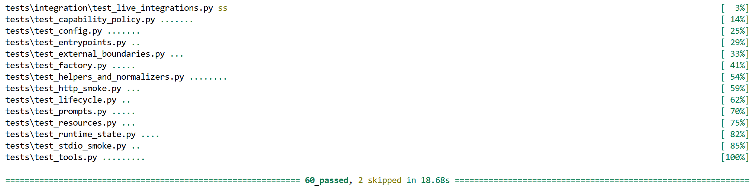
Figure 5.3 Default pytest suite passing. The default run completes with 60 passed, 2 skipped. The two skipped tests are opt-in live integration checks, so the default suite remains credential-free, browser-free, network-free, and independent of Inspector, Claude Desktop, Cursor, or VS Code.
MCP Inspector is the preferred manual debugging tool for this chapter. It is an interactive developer tool for testing and debugging MCP servers, and it can show tools, resources, prompts, notifications, and server responses. Use it only after the automated suite passes.

The examples below use PowerShell and assume the project virtual environment is .venv. Create a small smoke workspace so the filesystem tools have a safe, predictable root.

PowerShell:

New-Item -ItemType Directory -Force .mcp-smoke | Out-Null
Set-Content -Path .mcp-smoke\readme.md -Value "# Project`nA sample project." -Encoding UTF8
$SmokeRoot = (Resolve-Path .mcp-smoke).Path
$SmokeFile = (Resolve-Path .mcp-smoke\readme.md).Path
$Python = (Resolve-Path .venv\Scripts\python.exe).Path

The smoke workspace keeps the acceptance check deterministic. $SmokeRoot, $SmokeFile, and $Python store absolute paths so the commands do not depend on the current working directory. Reuse these variables in the stdio and Streamable HTTP Inspector checks below instead of recreating the workspace.

Inspector against stdio
The stdio acceptance path should use the same local entry point that host applications use. Reuse the smoke workspace created above. The FS_ALLOWED_DIRS value points the server at that temporary root, and READ_ONLY=true keeps the acceptance check non-destructive.

Start Inspector with the Chapter 4 server and the same runtime environment used by the local stdio entry point.

PowerShell:

npx -y @modelcontextprotocol/inspector `
-e "FS_ALLOWED_DIRS=$SmokeRoot" `
-e "READ_ONLY=true" `
-e "ENABLE_GITHUB=false" `
-e "ENABLE_BROWSER=false" `
-- "$Python" -m build_an_mcp_server.server

This command launches MCP Inspector and starts the Chapter 4 server through stdio. The -e flags pass environment variables to the server process. FS_ALLOWED_DIRS points the filesystem tools at the smoke workspace. READ_ONLY=true keeps the check non-destructive. ENABLE_GITHUB=false and ENABLE_BROWSER=false keep optional integrations out of this local acceptance path. The -- separator tells Inspector that the remaining arguments are the server command, not Inspector flags.
In the Inspector UI, perform the stdio acceptance check in this order. First, confirm that the server connects. Next, confirm that list_files and read_file are visible. Then select read_file, paste the absolute path from $SmokeFile, and run the tool. In JSON, the Windows path must be escaped:

{
"path": "C:\\absolute\\path\\to\\.mcp-smoke\\readme.md"
}

The result should show a successful tool call and structured content for the file. Then check Resources for filesystem://roots, and check Prompts for review_file and inspect_directory. Finally, run one controlled failure by calling read_file with a missing file inside the allowed root:

{
"path": "C:\\absolute\\path\\to\\.mcp-smoke\\missing.txt"
}

The failure should appear as a tool-execution failure, not as a successful payload that merely contains error text. The exact Inspector layout can change across versions, so the acceptance criterion is behavior: connection, discovery, one successful tool call, one controlled failure, and visibility of the expected resource and prompts.

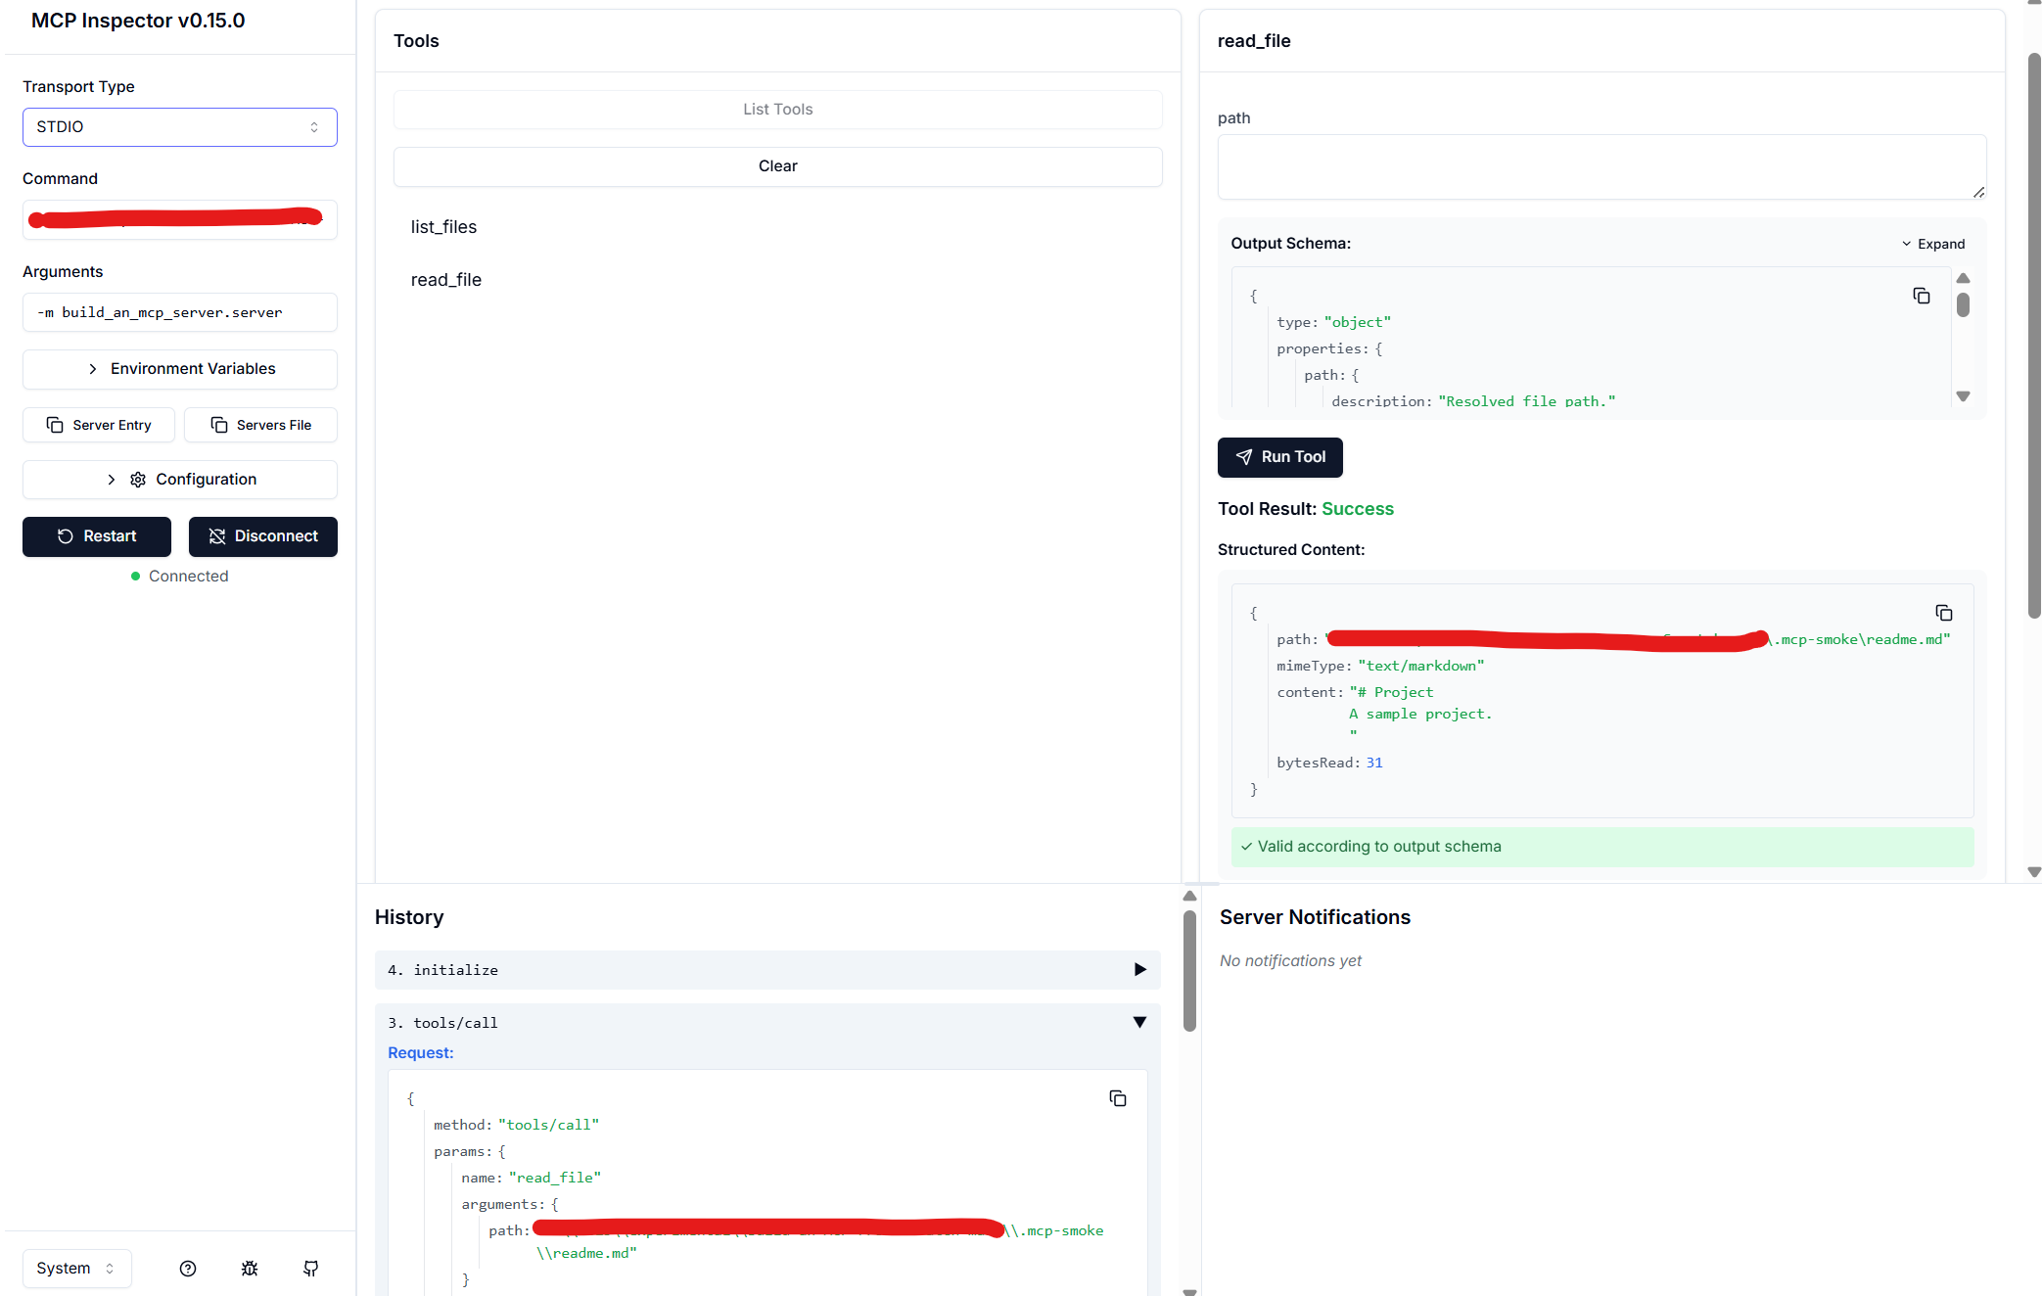
Figure 5.4 Inspector stdio tool call. Inspector has initialized the stdio server, listed tools, and called read_file against a file inside the configured .mcp-smoke root. The result shows a successful tool call with structured content, confirming that the already-tested Chapter 4 server is discoverable and callable through Inspector over stdio.
For repeatable command-line acceptance, use Inspector CLI. Keep the full scripts/inspector-stdio.mcp.json file in the repository or appendix; the main chapter only needs the behavior-focused checks.

List tools through Inspector CLI:

PowerShell:
npx -y @modelcontextprotocol/inspector `
--cli `
--config scripts/inspector-stdio.mcp.json `
--server build-an-mcp-server `
--method tools/list

Call one representative tool. Use the absolute path to the smoke file:

PowerShell:

npx -y @modelcontextprotocol/inspector `
--cli `
--config scripts/inspector-stdio.mcp.json `
--server build-an-mcp-server `
--method tools/call `
--tool-name read_file `
--tool-arg "path=C:\absolute\path\to\.mcp-smoke\readme.md"

The CLI form is useful when you want repeatable acceptance evidence without clicking through the UI. Treat it as acceptance evidence, not as a replacement for the automated stdio smoke test. The automated test owns the transport proof; Inspector confirms that the already-tested server is usable through a real MCP debugging client.

Inspector against Streamable HTTP
The production HTTP path for this book server is http_server.py, not the Chapter 3 teaching bridge. Streamable HTTP is still MCP; it is not REST and it does not create one HTTP route per tool. In this subsection, Inspector is used only as an acceptance client against the native /mcp endpoint. Automated Streamable HTTP compliance belongs in the transport-smoke tests, not in this manual check.

Reuse the same smoke workspace from the stdio check. In a fresh PowerShell terminal, re-create the path variables if needed:

PowerShell:

$SmokeRoot = (Resolve-Path .mcp-smoke).Path
$SmokeFile = (Resolve-Path .mcp-smoke\readme.md).Path

Start the Streamable HTTP server in one terminal:

PowerShell:

$env:FS_ALLOWED_DIRS = $SmokeRoot
$env:READ_ONLY = "true"
$env:ENABLE_GITHUB = "false"
$env:ENABLE_BROWSER = "false"
python -m build_an_mcp_server.http_server

The environment variables give the HTTP runtime the same configuration used by the stdio acceptance check. FS_ALLOWED_DIRS points filesystem tools at the smoke workspace. READ_ONLY=true keeps the check non-destructive. ENABLE_GITHUB=false and ENABLE_BROWSER=false keep optional integrations out of this acceptance path. The python -m build_an_mcp_server.http_server command starts the Chapter 4 native Streamable HTTP runtime on the local /mcp endpoint.

Then launch Inspector in another terminal:

PowerShell:

Npx -y @modelcontextprotocol/inspector

In the Inspector UI, choose Streamable HTTP and use this endpoint:

http://127.0.0.1:8000/mcp

The Inspector README documents Streamable HTTP configuration with type: "streamable-http" and a /mcp URL. It also documents Streamable HTTP entries in exported MCP config files.

Run the same acceptance check as stdio. First, connect to the endpoint. Then open Tools and confirm that list_files and read_file are visible. Select read_file, paste the absolute path from $SmokeFile, and run the tool:

{
"path": "C:\\absolute\\path\\to\\.mcp-smoke\\readme.md"
}

The result should show a successful tool call and structured content for the file. Then check Resources for filesystem://roots, and check Prompts for review_file and inspect_directory. Finally, run one controlled failure by calling read_file with a missing file inside the allowed root:

{
"path": "C:\\absolute\\path\\to\\.mcp-smoke\\missing.txt"
}

The point of this check is transport acceptance. The tool, resource, prompt, and failure behavior should already be covered by SDK-backed tests. Inspector over Streamable HTTP confirms that the same server behavior is reachable through the production HTTP entry point.
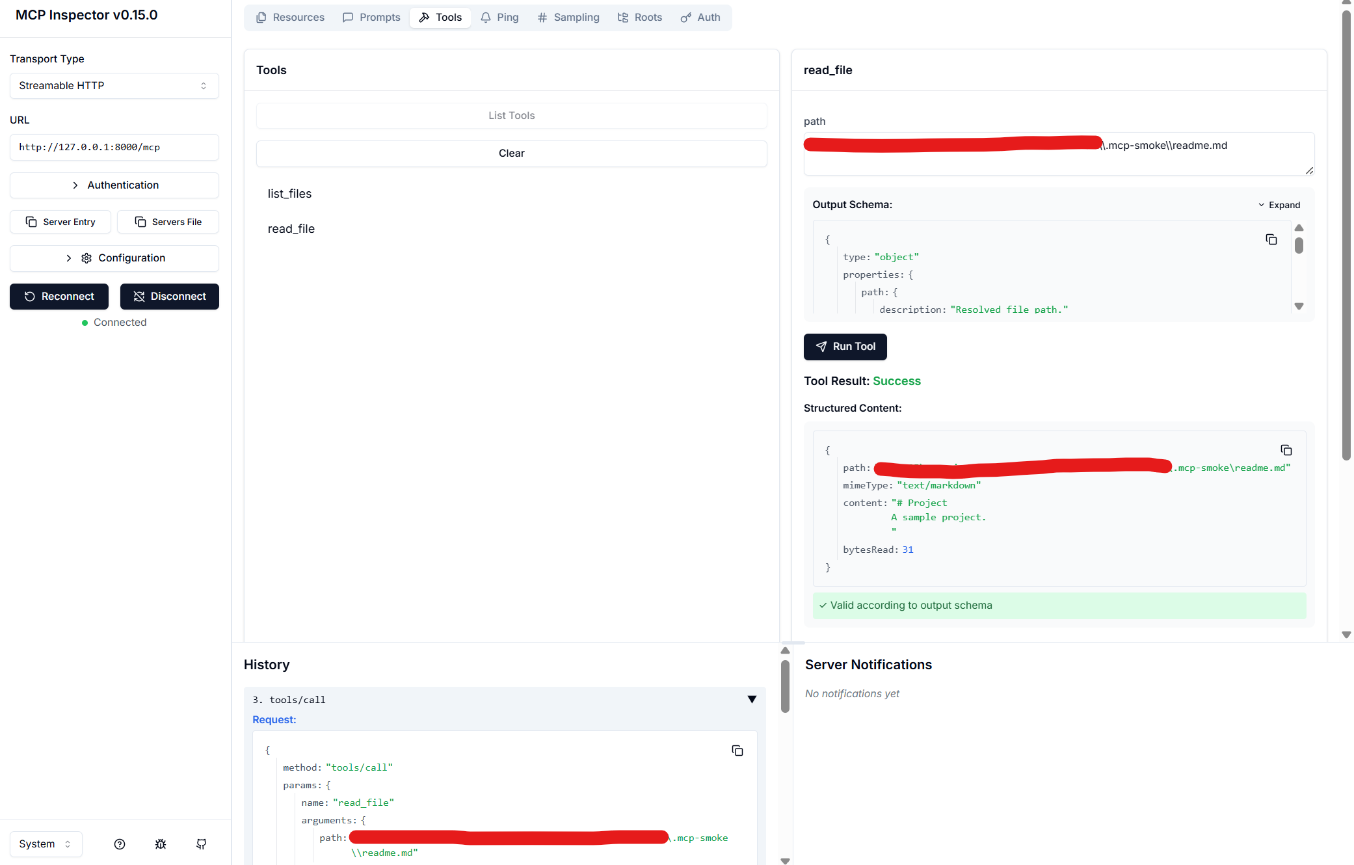
Figure 5.5 Inspector Streamable HTTP tool call. Inspector is connected to the Chapter 4 server at http://127.0.0.1:8000/mcp and has called read_file against a file inside the configured .mcp-smoke root. The successful structured result confirms that the already-tested server is callable through the native Streamable HTTP endpoint.
Use Inspector CLI for a scriptable HTTP acceptance check:

PowerShell:

npx -y @modelcontextprotocol/inspector `
--cli `
http://127.0.0.1:8000/mcp `
--transport http `
--method tools/list

This command connects to the running Streamable HTTP endpoint and asks the server for its tool list. The --transport http option is the Inspector CLI spelling for this remote HTTP check, while Inspector config files use type: "streamable-http".

Call the same representative tool with an absolute path:

PowerShell:

npx -y @modelcontextprotocol/inspector `
--cli `
http://127.0.0.1:8000/mcp `
--transport http `
--method tools/call `
--tool-name read_file `
--tool-arg "path=C:\absolute\path\to\.mcp-smoke\readme.md"

If the in-memory SDK tests pass but this check fails, look at http_server.py, the bind address, the /mcp route, process startup, environment variables, or server logs. Do not start by rewriting tool handlers.

Host acceptance checklist
Inspector, Claude Desktop, Cursor, and VS Code are acceptance targets. They are not the conceptual center of the chapter, and readers do not need every target to complete the testing path. Inspector is the preferred acceptance check because it exposes the server surface directly and keeps the focus on MCP behavior. One host check is enough to confirm that the already-tested server is visible through a real client.

Acceptance target | Minimum passing evidence
Inspector stdio | Connects to the stdio server, lists tools, calls read_file with an allowed absolute path, shows one controlled missing-file failure, and exposes filesystem://roots and the registered prompts.
Inspector Streamable HTTP | Connects to /mcp, lists tools, calls read_file with an allowed absolute path, and shows one controlled missing-file failure.
Claude Desktop | The local stdio server appears connected, read_file can be approved or invoked, and the response reflects the smoke-file heading.
Cursor | The MCP server loads, a real read_file call can be approved or inspected, and the response reflects the smoke-file heading. This chapter keeps Cursor at checklist level rather than walking through product-specific configuration.
VS Code | The MCP server loads, trust is confirmed if required, a real read_file call can be invoked, and the response reflects the smoke-file heading. This chapter keeps VS Code at checklist level rather than walking through product-specific configuration..

UI locations can change across versions. Screenshots in this chapter are acceptance evidence, not protocol documentation. Crop them to the smallest area that proves the claim. Show only connection state, public tool visibility, or smoke-file output. Do not show secrets, private chats, customer data, personal file listings, real tokens, or full local paths that should not be published.

The passing criterion is behavior: the server is discoverable, one representative operation succeeds, and controlled failures remain visible as failures when checked through Inspector. Host screenshots are secondary evidence. They confirm that a real host can use the already-tested server; they do not validate result-shape stability, lifecycle behavior, transport headers, or filesystem policy.

Claude Desktop acceptance
Claude Desktop is the single detailed host acceptance example in this chapter. It does not replace the automated tests or Inspector checks. Its job here is narrow: confirm that the already-tested stdio server can be loaded by a real host, expose its public tool surface, and complete one representative read_file call.

Use a minimal local stdio configuration for the Chapter 4 server. Use absolute paths for both the Python executable and the smoke workspace. On Windows, escape backslashes in JSON paths. Keep this configuration small; the purpose is to prove host-level tool use, not to document every Claude Desktop setting.

{
"mcpServers": {
"build-an-mcp-server": {
"command": "C:\\absolute\\path\\to\\.venv\\Scripts\\python.exe",
"args": ["-m", "build_an_mcp_server.server"],
"env": {
"FS_ALLOWED_DIRS": "C:\\absolute\\path\\to\\.mcp-smoke",
"READ_ONLY": "true",
"ENABLE_GITHUB": "false",
"ENABLE_BROWSER": "false"
}
}
}
}

This configuration starts the same stdio entry point used elsewhere in the chapter. FS_ALLOWED_DIRS points the server at the smoke workspace, READ_ONLY=true keeps the host check non-destructive, and ENABLE_GITHUB=false and ENABLE_BROWSER=false keep optional integrations out of this acceptance path.

After adding or updating this local MCP server entry, fully restart Claude Desktop. In a new chat, confirm that the build-an-mcp-server server is available, then run one representative host-level acceptance check by asking Claude to read the smoke file through the MCP server:

Use the build-an-mcp-server MCP server to read this file and tell me the heading only:

C:\absolute\path\to\.mcp-smoke\readme.md

Claude Desktop may ask for approval before using the tool. Approve the read_file call. The expected result is that Claude uses the MCP tool and reports the smoke-file heading: `Project`. The exact UI location can change, so the acceptance criterion is behavior rather than menu position: the server is available, the read_file tool can be invoked or approved, and the response reflects the smoke-file content.

If the server does not appear or the tool call fails, check the JSON syntax, absolute paths, configured smoke directory, and Claude Desktop logs before changing server code. At this stage, a host failure after pytest and Inspector pass is more likely to be a host configuration problem than a tool-handler problem.

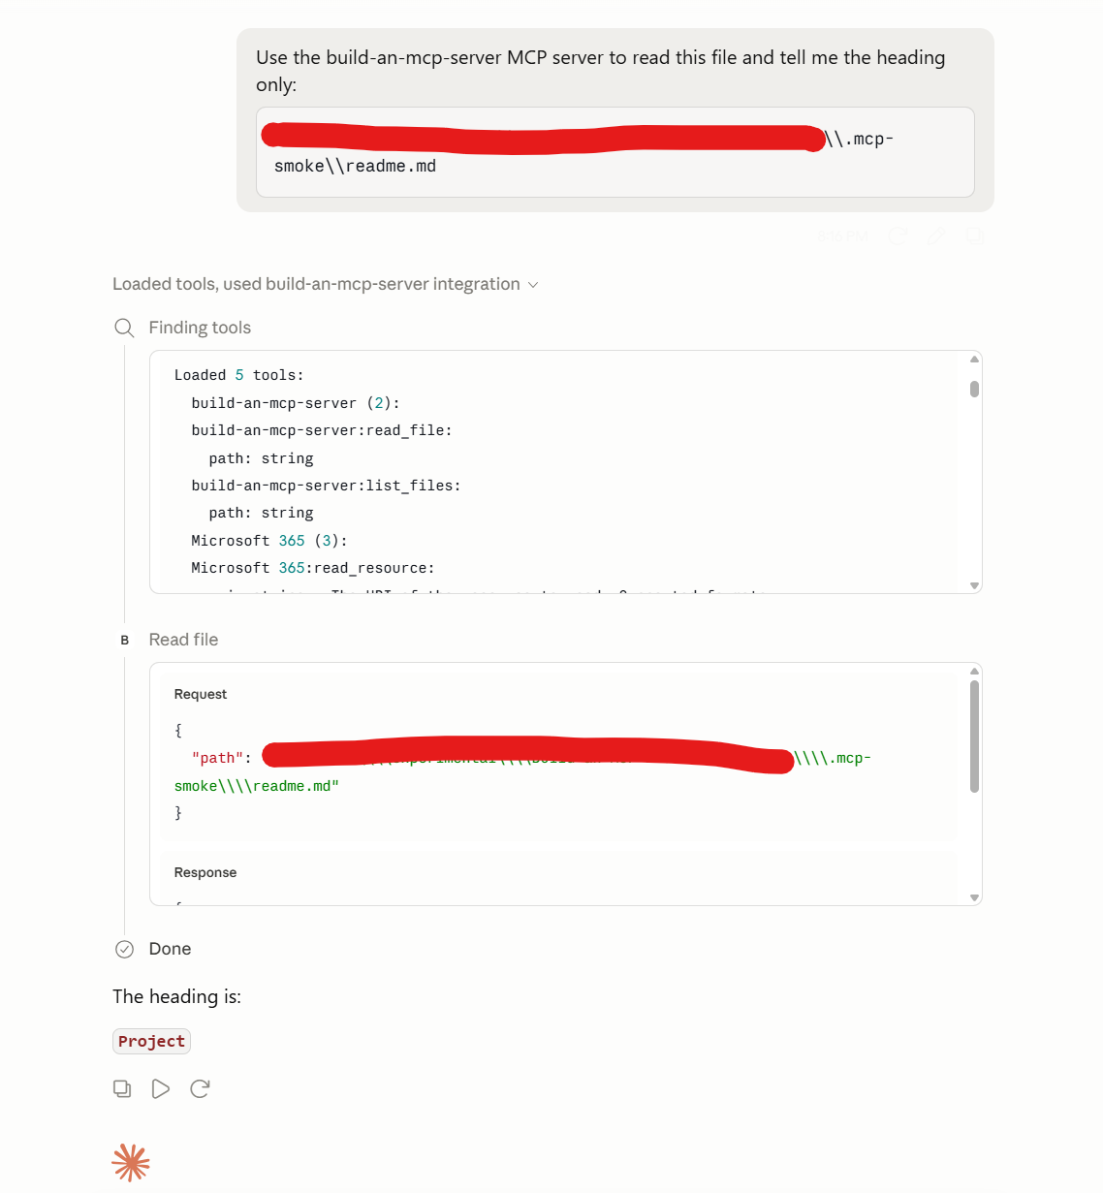
Figure 5.6 Claude Desktop acceptance. Claude Desktop shows the local build-an-mcp-server MCP server, invokes read_file against the smoke file, and returns the heading Project. This is acceptance evidence only; it should not include private chat content, secrets, personal file listings, or full local paths.

This host check does not replace the SDK-backed tests. It confirms that a real host can load the already-tested stdio server and use one representative tool through the host UI.

Cursor acceptance
Cursor is an optional host acceptance target. It does not replace the automated tests or Inspector checks. Its job in this chapter is narrower: confirm that the already-tested server can be loaded by a real coding host, expose its public MCP tool surface, and complete one representative tool call.

Use a minimal local stdio configuration. Place this file at .cursor/mcp.json in the project root. Replace the Python path and smoke directory with absolute paths for your machine. On Windows, use escaped backslashes or forward slashes in JSON paths.

{
"mcpServers": {
"build-an-mcp-server": {
"type": "stdio",
"command": "C:\\absolute\\path\\to\\.venv\\Scripts\\python.exe",
"args": ["-m", "build_an_mcp_server.server"],
"env": {
"FS_ALLOWED_DIRS": "C:\\absolute\\path\\to\\.mcp-smoke",
"READ_ONLY": "true",
"ENABLE_GITHUB": "false",
"ENABLE_BROWSER": "false"
}
}
}
}

After saving the file, reload Cursor or reopen the workspace. Confirm that the local MCP server is available, then open a new Agent chat and ask Cursor to use the MCP server to read the smoke file:

Use the build-an-mcp-server MCP server to read this file and tell me the heading only:
C:\absolute\path\to\.mcp-smoke\readme.md

Cursor may ask for approval before running the MCP tool. Approve the read_file call. The expected result is that Cursor uses the MCP server and reports the heading from the smoke file, such as Project.

The exact UI location can change across Cursor versions, so the acceptance criterion is behavior rather than menu position: the server loads, the MCP tool is available, the tool call can be approved or inspected, and the response reflects the smoke-file content.

If the server does not load, check the JSON syntax, absolute paths, configured smoke directory, environment variables, and Cursor MCP logs before changing server code. At this stage, a host failure after pytest and Inspector pass is more likely to be a host configuration problem than a tool-handler problem.

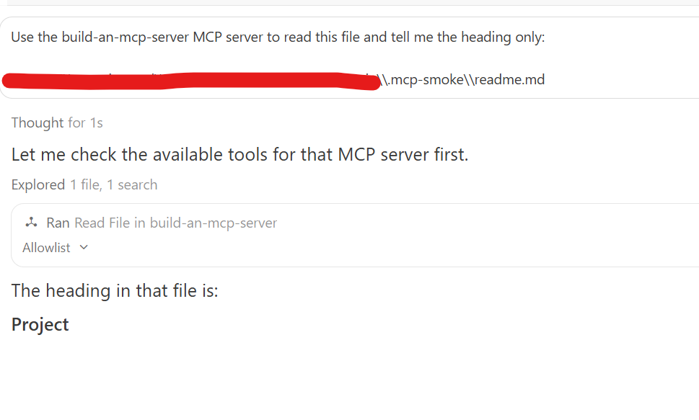
Figure 5.7 Cursor acceptance. Cursor has loaded build-an-mcp-server, invoked read_file against the smoke file, and returned the heading Project. This is host acceptance evidence only; it should not expose private chats, secrets, personal file listings, or full local paths.
This host check does not replace the SDK-backed tests. It confirms that a real coding host can load the already-tested stdio server and use one representative tool through its Agent UI.

VS Code acceptance
VS Code is an optional host acceptance target. It does not replace the automated tests or Inspector checks. Its job in this chapter is narrower: confirm that the already-tested server can be loaded by a real coding host, expose its MCP tool surface, and complete one representative tool call.

Use a minimal local stdio configuration. Place this file at .vscode/mcp.json in the project root. Replace the Python path and smoke directory with absolute paths for your machine. On Windows, use escaped backslashes or forward slashes in JSON paths.

{
"servers": {
"build-an-mcp-server": {
"type": "stdio",
"command": "C:\\absolute\\path\\to\\.venv\\Scripts\\python.exe",
"args": ["-m", "build_an_mcp_server.server"],
"env": {
"FS_ALLOWED_DIRS": "C:\\absolute\\path\\to\\.mcp-smoke",
"READ_ONLY": "true",
"ENABLE_GITHUB": "false",
"ENABLE_BROWSER": "false"
}
}
}
}

After adding the server, confirm trust if VS Code prompts for it. Then confirm that the server is enabled and started. MCP: List Servers or the MCP management UI can be used to inspect server state, and VS Code can show MCP output logs if startup fails.

Open the Chat view and run one representative host-level acceptance check:

Use the build-an-mcp-server MCP server to read this file and tell me the heading only:

C:\absolute\path\to\.mcp-smoke\readme.md

VS Code may ask for confirmation before invoking the tool. Approve the read_file call. The expected result is that VS Code uses the MCP tool and returns the heading from the smoke file, such as Project.

The exact UI location can change across VS Code versions, so the acceptance criterion is behavior rather than menu position: the server loads, trust is confirmed if required, the tool can be invoked, and the response reflects the smoke-file content.

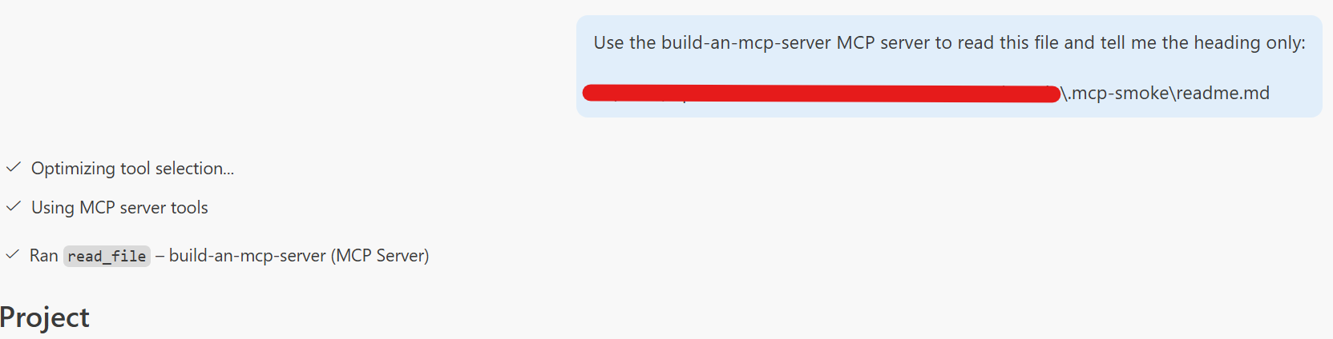
Figure 5.8 VS Code acceptance. VS Code has loaded build-an-mcp-server, invoked the read_file MCP tool against the .mcp-smoke file, and returned the smoke-file heading. This is host acceptance evidence only; it does not replace the SDK-backed tests.

If the server does not start, check the server configuration, trust state, absolute paths, environment variables, and MCP output logs before changing server code. At this stage, a host failure after pytest and Inspector pass is more likely to be a host configuration problem than a tool-handler problem.

Passing criteria - This section passes when all of the following are true:
- python -m pytest passes with only opt-in live integrations skipped.
- Inspector connects to the stdio server.
- Inspector connects to the Streamable HTTP endpoint at /mcp.
- Inspector CLI can list tools for at least one transport.
- At least one representative read_file call succeeds in Inspector using an allowed absolute path.
- At least one controlled read_file failure is visible as a tool-execution failure.
- Claude Desktop, Cursor, and VS Code host checks, if included, show real tool use rather than only configuration files.
- Figures show only connection state, server names, public tool/resource/prompt surfaces, or smoke-file output. They do not show secrets, private chat content, personal file listings, customer data, or full local paths.

These checks do not need to prove live GitHub or browser automation behavior unless those integrations were explicitly enabled and already validated through the opt-in tests from Section 5.4. They also do not test model reasoning. The host or client mediates tool discovery and invocation; this chapter verifies that the server is discoverable, callable, and consistent across the expected acceptance paths.

5.7 Using a minimal diagnostic client
Most server verification in this chapter should stay inside pytest. The in-memory SDK tests are faster, more precise, and easier to debug than a subprocess-based diagnostic client. A minimal client is useful only when the question is outside the in-memory path: can the stdio entry point run as a real child process, can the Streamable HTTP endpoint answer through a real URL, or can a failure be reproduced outside Inspector?

This client should stay tiny, transport-aware, and diagnostic. It should connect, initialize, list the server surface, make one representative call, print concise output, and exit. It should not become product code, a host framework, or a replacement for the SDK-backed test suite.

The script follows the standard SDK client shape: create a transport, wrap it in ClientSession, call await session.initialize(), then list server surfaces and optionally call a tool. The same shape is used for both stdio and Streamable HTTP. The difference is the transport boundary: stdio mode starts the Chapter 4 server as a child process, while Streamable HTTP mode expects the Chapter 4 HTTP server to already be running at the selected /mcp URL.

The full script lives in scripts/minimal_client.py in the companion repository. Listing 5.13 shows only the transport and diagnostic core.
Listing 5.13 Excerpt from the minimal diagnostic client
# scripts/minimal_client.py (excerpt)

from __future__ import annotations

import os
import sys
from collections.abc import AsyncIterator
from contextlib import asynccontextmanager
from pathlib import Path

from mcp.client.session import ClientSession
from mcp.client.stdio import StdioServerParameters, stdio_client
from mcp.client.streamable_http import streamable_http_client
from mcp.types import CallToolResult, TextContent

def _tool_text(result: CallToolResult) -> str:
return "\n".join(
item.text
for item in result.content
if isinstance(item, TextContent)
) #A

def _stdio_env(allowed_root: str | None) -> dict[str, str]:
env = os.environ.copy()

if allowed_root:
env["FS_ALLOWED_DIRS"] = str(Path(allowed_root).resolve())

if not env.get("FS_ALLOWED_DIRS"):
raise SystemExit(
"stdio mode requires --allowed-root or FS_ALLOWED_DIRS",
)

env.setdefault("READ_ONLY", "true")
env.setdefault("ENABLE_GITHUB", "false")
env.setdefault("ENABLE_BROWSER", "false")
return env #B

@asynccontextmanager
async def _stdio_session(
allowed_root: str | None,
) -> AsyncIterator[ClientSession]:
server = StdioServerParameters(
command=sys.executable,
args=["-m", "build_an_mcp_server.server"],
env=_stdio_env(allowed_root),
) #C

async with stdio_client(server) as (read_stream, write_stream):
async with ClientSession(read_stream, write_stream) as session:
await session.initialize()
yield session #D

@asynccontextmanager
async def _http_session(url: str) -> AsyncIterator[ClientSession]:
async with streamable_http_client(url) as (
read_stream,
write_stream,
):
async with ClientSession(read_stream, write_stream) as session:
await session.initialize()
yield session #E

async def _run(args) -> int:
if args.transport == "stdio":
session_cm = _stdio_session(args.allowed_root)
else:
session_cm = _http_session(args.url)

async with session_cm as session:
tools = await session.list_tools()
resources = await session.list_resources()
prompts = await session.list_prompts()

tool_names = sorted(tool.name for tool in tools.tools)
resource_uris = sorted(str(resource.uri) for resource in resources.resources)
prompt_names = sorted(prompt.name for prompt in prompts.prompts)

print(f"connected: {args.transport}")
print(f"tools: {', '.join(tool_names)}")
print(f"resources: {', '.join(resource_uris)}")
print(f"prompts: {', '.join(prompt_names)}") #F

if not args.read_file:
return 0

result = await session.call_tool(
"read_file",
{"path": args.read_file},
)

print(f"read_file.is_error: {bool(result.is_error)}")

structured = result.structured_content
if isinstance(structured, dict):
print(f"read_file.path: {structured.get('path')}")
print(f"read_file.mimeType: {structured.get('mimeType')}")
print(f"read_file.bytesRead: {structured.get('bytesRead')}") #G

text = _tool_text(result).strip().replace("\n", "\\n")
if text:
print(f"read_file.text: {text[:200]}") #H

return 1 if result.is_error else 0

#A Extract only text blocks from a tool result.
#B Build the child-process environment used by the stdio server.
#C Use the current Python interpreter to start the installed package.
#D Initialize before listing tools, resources, prompts, or calling tools.
#E Streamable HTTP mode expects the server to already be running at the given URL.
#F Print a concise summary of the discovered server surface.
#G Show the stable structured fields used by the Chapter 4 normalizer.
#H Keep terminal output short enough for logs and quick diagnosis.

The value of this script is not that it is clever. Its value is that it removes uncertainty. It uses the same SDK session shape as the test suite, but it exercises the selected transport outside the in-memory path. In stdio mode, it starts the real child process. In HTTP mode, it connects to a real /mcp endpoint. That makes it useful for diagnosing problems that sit between in-memory tests and a real host.

The examples below use Bash for compactness. Reuse the same smoke workspace used by the acceptance checks.

Bash:

mkdir -p .mcp-smoke
printf '# Project\nA sample project.\n' > .mcp-smoke/readme.md

Run the stdio diagnostic client from the project root:

Bash:

python scripts/minimal_client.py --transport stdio --allowed-root "$PWD/.mcp-smoke"

Call one representative tool with an allowed absolute path:

Bash:

python scripts/minimal_client.py --transport stdio --allowed-root "$PWD/.mcp-smoke" --read-file "$PWD/.mcp-smoke/readme.md"

For Streamable HTTP, start the server in one terminal with the same runtime settings:

Bash:

FS_ALLOWED_DIRS="$PWD/.mcp-smoke" \
READ_ONLY=true \
ENABLE_GITHUB=false \
ENABLE_BROWSER=false \
python -m build_an_mcp_server.http_server

Then run the client in another terminal:

Bash:

python scripts/minimal_client.py --transport http --url http://127.0.0.1:8000/mcp --read-file "$PWD/.mcp-smoke/readme.md"
This script intentionally does less than Inspector. It does not render schemas, manage host configuration, approve tool use, or emulate model behaviour. It answers one narrow question: can a real client initialize a session, list the server surface, and optionally call read_file through the selected transport?

Use it when a failure sits between pytest and a host. If the in-memory tests pass but stdio mode fails, look at server.py, subprocess startup, stdout/stderr behaviour, package installation, and the environment passed to the child process. If the in-memory tests pass but HTTP mode fails, look at http_server.py, the /mcp route, bind address, runtime environment, or process startup. If the minimal client passes and a host still fails, move to the host’s configuration, trust flow, or logs.

Do not extend this script into a general MCP client. Earlier chapters have already explained the host/client/server model. This chapter is about verifying the server. A minimal diagnostic client belongs in scripts/ as a smoke and reproduction tool, not in the runtime package and not as a replacement for automated tests.

5.8 Summary
- This chapter turned the Chapter 4 package into a verification target. The server still initializes through the MCP lifecycle, negotiates capabilities, and exposes tools, resources, and prompts through the same public MCP surface, but the chapter’s focus was evidence: what can be tested automatically, what should remain opt-in, and what belongs only in acceptance checks.
- The default test suite starts at the lowest stable boundaries: settings validation, filesystem helpers, path policy, normalizers, runtime-state behaviour, and server assembly. These tests catch local regressions before MCP sessions, transports, Inspector, or host applications are involved. The in-memory SDK tests are the backbone of the chapter. They build the server through factory.py, connect an SDK ClientSession, initialize the session, and verify tools, resources, prompts, capabilities, and controlled failures without depending on stdio, HTTP, Inspector, Claude Desktop, Cursor, or VS Code.
- Tools, resources, and prompts are verified through both discovery and use. tools/list and tools/call verify filesystem tools such as list_files and read_file; resources/list and resources/read verify filesystem://roots; prompts/list and prompts/get verify the registered prompt templates. Capability and policy checks verify that the public MCP surface matches runtime settings: read-only mode keeps write-capable tools absent, filesystem policy is visible through filesystem://roots, and optional GitHub or browser tools stay hidden unless explicitly enabled.
- Failure tests keep protocol behaviour separate from application policy. Unknown tools and malformed protocol requests should surface as MCP errors. Missing files, rejected paths, and adapter failures after a known tool is invoked are controlled tool-execution failures. They should be returned as tool results marked as errors, not hidden behind fake successful payloads such as {"ok": false}.
- Runtime and acceptance checks move outward only after the SDK-backed tests pass. server.py remains the local stdio entry point, http_server.py remains the native Streamable HTTP entry point, and the Chapter 3 HTTP bridge remains a teaching utility rather than the production HTTP test path. External integrations stay outside the default suite. GitHub and browser automation run only behind explicit opt-in commands, skip cleanly when prerequisites are missing, and must not print secrets.
- Inspector, Claude Desktop, Cursor, and VS Code are acceptance checks. They confirm that real clients can discover and exercise the already-tested server, but they do not replace automated tests for result shapes, lifecycle behaviour, capability gating, filesystem policy, or failure handling. The minimal diagnostic client under scripts/ is a reproduction tool only. It connects over stdio or Streamable HTTP, initializes, lists the server surface, optionally calls read_file, prints concise output, and exits. It should not become a general MCP client chapter.
- The next chapter can now build on a stable verification target: a server with tested package boundaries, checked MCP surfaces, controlled failure behaviour q, integration-boundary checks, and acceptance paths that confirm the server is discoverable and callable through real clients.

