Automatic Segmentation of Multiple Sclerosis Lesions in MRI
Working draft
Author: Toni
Supervisor: Manel Frigola
Last update: 2026-09-29

Contents

1. Introduction

1.1 Multiple sclerosis
Multiple sclerosis (MS) is a chronic, immune-mediated disease of the central nervous system and one of the most common causes of non-traumatic neurological disability in young adults. It affects an estimated 2.8 million people worldwide [1]. In MS, the immune system attacks the myelin sheath that insulates nerve fibres, causing inflammation, demyelination and, over time, axonal loss. These processes produce focal areas of damage, known as lesions or plaques, found mainly in the white matter of the brain and spinal cord.

1.2 The role of MRI
Magnetic resonance imaging (MRI) is the key imaging tool for diagnosing and monitoring MS. White-matter lesions appear hyperintense on T2-weighted sequences and, most clearly, on FLAIR (Fluid-Attenuated Inversion Recovery) images. FLAIR suppresses the signal of the cerebrospinal fluid, so lesions next to the ventricles stand out. The number, location and volume of lesions are part of the diagnostic criteria for MS [2]. The appearance of new or enlarging lesions over time is used to assess disease activity and response to treatment [3].

1.3 Lesion segmentation
Using these measurements in practice requires segmenting the lesions, that is, deciding for every voxel of the image whether it belongs to a lesion or not. Manual segmentation by experts is the reference standard, but it is time-consuming (it can take hours per patient) and subject to considerable inter- and intra-rater variability [4]. These limitations have motivated the development of automatic segmentation methods, which in recent years have been dominated by deep learning [5, 6].

1.4 Challenges
Automatic MS lesion segmentation remains difficult for several reasons:
- Class imbalance: lesions occupy a very small fraction of the brain.
- Size variability: lesion size ranges from a few voxels to large confluent regions, and small lesions are easily missed.
- Acquisition heterogeneity: image appearance depends on the scanner, field strength and acquisition protocol.
- Reference uncertainty: the annotations themselves are uncertain, especially at lesion boundaries.
Progress in the field therefore depends on public, well-annotated datasets that allow methods to be trained and compared under the same conditions. MSLesSeg [7] is the dataset this thesis builds on.

2. Starting point: the MSLesSeg study
This thesis builds on the dataset and benchmark published by Guarnera et al. [7]. This chapter summarises what the study provides, how its baseline models were evaluated, and the open questions it leaves, which motivate the objectives of this work (Chapter 3).

2.1 The MSLesSeg dataset
MSLesSeg is a public dataset for MS lesion segmentation released on figshare [8]. It contains MRI data from 75 patients (48 female, 27 male; age 18–59 years, mean 37 ± 10.3 years) acquired at an Italian hospital and private clinics on 1.5 T and 3 T scanners. Some patients were scanned at up to four timepoints, giving 115 studies in total. Each study includes three sequences (FLAIR, T1-weighted and T2-weighted) and a binary lesion mask.
All images were preprocessed with the same pipeline: conversion from DICOM to NIfTI, affine registration (12 degrees of freedom) to the MNI152 1 mm template with FLIRT [9], and skull stripping with BET [10]. The released volumes are 182 × 218 × 182 voxels of 1 mm³. No intensity normalisation is described.
Lesion masks were drawn by a junior rater trained by two senior experts (a neuroradiologist and a neurologist specialised in MS). Lesions were identified on FLAIR, with T1-w and T2-w used to resolve doubtful cases, and the masks were reviewed in periodic meetings with the senior raters. Unlike datasets that provide several annotations per image, such as ISBI 2015 [5], MSLesSeg provides a single expert-validated mask per study.
The dataset is divided into a training set of 53 patients (93 studies, one to four timepoints per patient) and a test set of 22 patients (one study each). It was also used in the ICPR 2024 Competition on Multiple Sclerosis Lesion Segmentation.

2.2 Baseline models and evaluation
The authors benchmarked four 3D deep-learning models: their own diffusion-based model, MSSegDiff [7, 15], which iteratively denoises a noisy mask conditioned on the MRI; SwinUNETR [11]; UNETR [12]; and TransBTS [13]. Models were trained with 5-fold cross-validation on the training patients and evaluated with voxel-wise metrics (Dice similarity coefficient, true positive rate and positive predictive value), lesion-wise metrics (lesion true positive rate, LTPR, and lesion false positive rate, LFPR), the absolute volume difference (AVD) and the average symmetric surface distance (ASSD). Table 2.1 summarises the reported results.
Model | Dice ↑ | TPR ↑ | PPV ↑ | LTPR ↑ | LFPR ↓ | AVD ↓ | ASSD ↓
MSSegDiff | 0.685 | 0.672 | 0.724 | 0.625 | 0.223 | 24.5 | 3.47
SwinUNETR | 0.679 | 0.668 | 0.716 | 0.702 | 0.296 | 25.1 | 3.62
UNETR | 0.642 | 0.675 | 0.650 | 0.733 | 0.433 | 90.2 | 4.52
TransBTS | 0.492 | 0.545 | 0.503 | 0.511 | 0.541 | 68.0 | 7.55
Table 2.1. Results reported by Guarnera et al. [7] (mean over five folds). Best value per column in bold.
In addition, the authors compared the masks submitted to the ICPR 2024 competition with a consensus mask obtained with STAPLE [14]. The automatic methods made similar errors, mainly on the contours of large or unusual lesions, and errors were larger for methods that used only FLAIR.

2.3 Open questions
The study provides a valuable public resource, but several aspects of its benchmark leave room for further work:
- The best model wins by a small margin. MSSegDiff and SwinUNETR differ by 0.007 in mean Dice, a difference within the variation between folds, and no statistical test is reported.
- Voxel-wise and lesion-wise metrics disagree. MSSegDiff has the highest Dice but the lowest LTPR of the three competitive models (0.625 versus 0.702 and 0.733): it detects fewer lesions. Because the Dice coefficient is dominated by large lesions, a model can obtain a good Dice while missing many small ones.
- No nnU-Net baseline. nnU-Net [16], the de-facto reference method in medical image segmentation, is not included in the comparison.
- Limited reproducibility. Training hyper-parameters are not reported, the table of cross-validation folds contains inconsistencies (Section 5.2), the released code [15] targets a different dataset (ISBI 2015), and the rule used to count lesions (which determines LTPR and LFPR) is not described. The paper also mentions test patients 54–77, whereas the released test set contains patients 54–75.
- Acquisition heterogeneity is not analysed. Scanner information is released with the data, but performance is not stratified by scanner.
These observations define the starting point of this thesis: a strong reference model, a focus on the detection of small lesions, rigorous statistical comparison, full reproducibility and an analysis of robustness across scanners.

3. Objectives

3.1 Research question
The open questions identified in Section 2.3 lead to the research question of this thesis:
Starting from a strong, reproducible baseline, can the detection of small multiple sclerosis lesions be improved and the number of false-positive lesions reduced, and how robust are these models across scanners and datasets?

3.2 General objective
The general objective is to develop and rigorously evaluate a deep-learning pipeline for MS lesion segmentation on the MSLesSeg dataset that improves the detection of small lesions with respect to a strong baseline, while remaining fully reproducible.

3.3 Specific objectives
The general objective is divided into five specific objectives, each building on the previous one (Table 3.1).
 | Objective | Success criterion
O1 | Build a reproducible training and evaluation pipeline and reproduce the reference benchmark with SwinUNETR [11]. | Voxel-wise and lesion-wise metrics of the same order as those reported in [7].
O2 | Train nnU-Net [16] as a strong baseline, a comparison missing from the reference study. | Complete cross-validation and test-set results with the same metrics as [7].
O3 | Improve the detection of small lesions and reduce false-positive lesions through targeted modifications of the baseline (e.g. lesion-aware loss functions, post-processing, uncertainty estimation). | Statistically significant improvement in LTPR and/or LFPR over the baseline without a significant loss of Dice.
O4 | Assess generalisation and robustness: performance by scanner manufacturer and on an external dataset without retraining. | Quantified performance gap between domains and analysis of its likely causes.
O5 | Ensure reproducibility by versioning code, data and experiments. | All results can be regenerated from the public repository with documented commands.
Table 3.1. Specific objectives and success criteria.

3.4 Scope
To keep the work focused, the following are outside the scope of this thesis:
- Designing a new architecture from scratch. The contribution consists of targeted, measurable modifications of an established architecture.
- Clinical deployment. The pipeline is a research tool and has not been validated for clinical use.
- Longitudinal analysis. Detection of new or enlarging lesions between visits is left as future work, although the dataset contains longitudinal data.

3.5 Expected contributions
- The first evaluation of nnU-Net on MSLesSeg, providing a strong reference for future work.
- A measured improvement in small-lesion detection, supported by paired statistical tests.
- An analysis of performance by lesion size and by scanner manufacturer, which the reference study does not report.
- A reproducible, public pipeline, including the patient-level cross-validation folds.
- Findings from the exploratory analysis of the dataset: the identification of the lesion counting rule used by the authors (6-connectivity) and of studies with data-quality issues not reported in the original publication (Chapter 4).

3.6 Evaluation principles
All experiments follow the same principles, so that results are comparable and conclusions are sound:
- Patient-level cross-validation: timepoints of the same patient never appear in both training and validation.
- Same metrics as the reference study, computed with the same lesion counting rule, complemented by lesion-wise metrics stratified by lesion size.
- Paired statistical tests per patient (Wilcoxon signed-rank test) and confidence intervals to compare models, instead of comparing means alone.
- The test set is used only once, for the final comparison of the selected models.
- Every experiment is logged (configuration, code version and metrics) and linked to an issue in the project repository.

3.7 Work plan
The work is organised in five milestones (Table 3.2), tracked as milestones and issues in the project repository.
Milestone | Due date | Main outputs
M1 · Data and exploratory analysis | 11 Oct 2026 | Environment, dataset verification, exploratory analysis, patient-level folds
M2 · Reproduction and nnU-Net baseline | 1 Nov 2026 | Metrics, SwinUNETR reproduction, nnU-Net baseline, statistical comparison
M3 · Own contribution | 6 Dec 2026 | Lesion-aware loss, post-processing, uncertainty estimation
M4 · External validation and analysis | 27 Dec 2026 | External dataset, robustness by scanner, error analysis
M5 · Thesis and defence | 24 Jan 2027 | Written thesis, reproducible repository, presentation
Table 3.2. Work plan.

4. Data and exploratory analysis
Before training any model, the whole MSLesSeg dataset was analysed to understand its content, to check its quality and to derive the design decisions of the following chapters. Every figure and number in this chapter is produced by ms_seg/eda.py and the notebook notebooks/2.0-tlb-eda.ipynb, and can be regenerated with a single command (dvc repro, Section 5.1).
The analysis is organised around four questions: what counts as a lesion (Section 4.3.3), what the data look like (Sections 4.1, 4.2 and 4.4–4.8), whether the data can be trusted (Section 4.3) and what all this implies for the models (Section 4.9).

4.1 Dataset content
Each study (one visit of one patient) contains three co-registered MRI sequences (FLAIR, T1-w and T2-w) and one binary lesion mask, all with 182 × 218 × 182 voxels of 1 mm³ in the MNI152 space (Figure 4.1). Table 4.1 summarises the size of the two official subsets.
 | Patients | Studies | Lesions
Training set | 53 | 93 | 2,688
Test set | 22 | 22 | 907
Total | 75 | 115 | 3,595
Table 4.1. Size of the MSLesSeg subsets. Lesions are counted as 6-connected components (Section 4.3.3).
In the training set, 28 patients have one timepoint, 15 have two, 5 have three and 5 have four; test patients have a single timepoint. There is one mask per study: it was drawn by a junior rater and reviewed and validated by two senior experts (Section 2.1), so it is a consensus annotation, but inter-rater variability cannot be measured on this dataset.
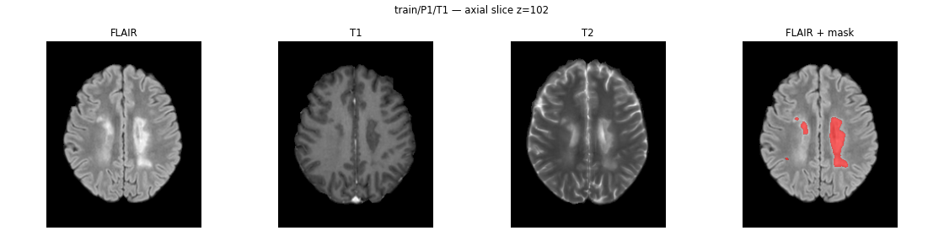
Figure 4.1. Study P1_T1: the three MRI sequences and the lesion mask (red) on the axial slice with the most lesion.
Implication. With 93 training studies the dataset is small for deep learning. This supports building on a well-established, self-configuring architecture with extensive data augmentation (nnU-Net [16]) rather than designing a new one. Because several studies belong to the same patient, all data splits must be made at patient level (Section 5.2).

4.2 Patients
Table 4.2 compares the demographics of the two subsets (first visit of each patient).
 | Training (53) | Test (22)
Age (years), mean ± SD | 36.4 ± 10.2 | 38.5 ± 10.5
Female | 32 (60 %) | 16 (73 %)
MS type | 50 RRMS, 3 SPMS | 21 RRMS, 1 PPMS
EDSS, median [IQR] | 2.0 [0.0–3.0] | 1.0 [0.25–3.0]
Table 4.2. Demographics of the training and test patients. RRMS: relapsing-remitting; SPMS: secondary progressive; PPMS: primary progressive; EDSS: Expanded Disability Status Scale (0 = normal, 10 = death due to MS).
The two subsets are comparable. The cohort is dominated by relapsing-remitting MS with mild disability, and the female majority is consistent with the known prevalence of the disease.
Implication. The test set is representative of the training population. As a limitation, models trained on this dataset may not generalise to progressive forms or to more severe disease, which are barely represented.

4.3 Data quality checks

4.3.1 Registration
After registration to MNI152 all brains should have a similar volume. The brain volume (non-zero FLAIR voxels) has a median of 1.90 million voxels, and 112 of the 115 studies lie between 1.63 and 2.33 million (Figure 4.2). Three studies, P44_T1, P45_T1 and P53_T1, have brains 1.73–1.84 times larger than the median and are cropped at the borders of the image: their registration failed to scale them to the template. In addition, the T1-w image of P49_T2 is empty (all voxels are zero).
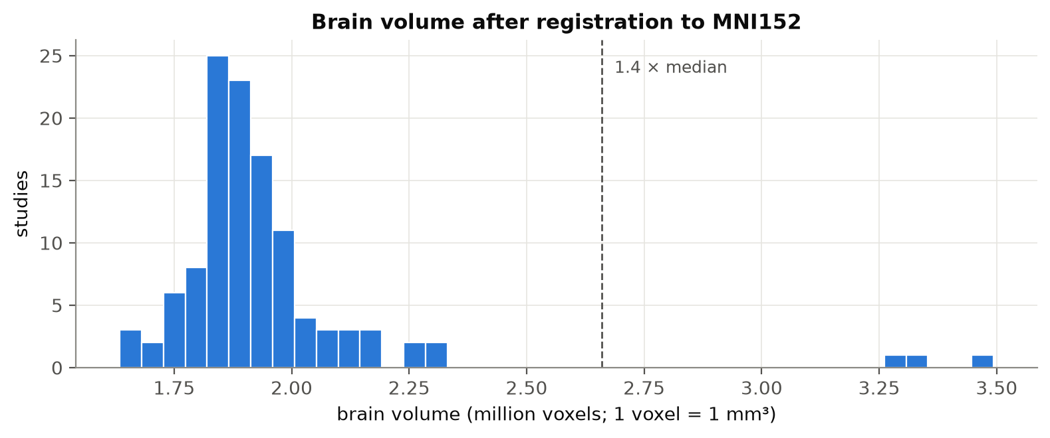
Figure 4.2. Brain volume of each study after registration. Three studies are far above the rest (dashed line: 1.4 × median).

4.3.2 Are the flagged studies usable?
For the four flagged studies the lesion masks were checked against their own images. No lesion voxel lies outside the brain, and the median FLAIR intensity inside the lesions is 1.29–1.54 times that of the whole brain, within the range of the other studies, as expected for MS lesions. The masks are therefore consistent with the images; the badly registered studies are only at a different scale.
The reference study does not mention excluded studies, missing images or failed registrations, and its cross-validation covers every training patient from 1 to 53 [7], so these studies were almost certainly used. They are kept for comparability, and a sensitivity analysis without them will be reported (Section 5.5).
The check also revealed two inconsistencies in the reference study. First, its technical validation mentions 24 test patients (P54–P77), whereas the dataset description and the released data contain 22 (P54–P75); this work uses the released split. Second, its table of cross-validation folds contains typos (Section 5.2).

4.3.3 How lesions are counted
The reference study reports the number of lesions per study and uses lesion-wise metrics (LTPR and LFPR), but it does not describe how a binary mask is split into individual lesions. Lesions are normally defined as connected components, and in 3D there are three possible neighbourhoods: two lesion voxels p = (x, y, z) and q = (x′, y′, z′) are neighbours if they share a face (6-connectivity, |x − x′| + |y − y′| + |z − z′| = 1), a face or an edge (18-connectivity) or a face, an edge or a corner (26-connectivity).
The three rules were applied to all 115 masks and compared with the number of lesions released by the authors for each study (Table 4.3).
Rule | Studies matching the authors' count | Mean lesions (train / test)
6-connectivity | 115 / 115 (100 %) | 28.9 / 41.2
18-connectivity | 49 / 115 (42.6 %) | 27.4 / 40.0
26-connectivity | 43 / 115 (37.4 %) | 27.2 / 39.7
Reference study [7] | — | 28.9 / 41.2
Table 4.3. Lesion counts obtained with each connectivity rule, compared with the counts released by the authors.
Only 6-connectivity reproduces the authors' numbers, in every study and without any minimum lesion size. The total lesion volume computed from the masks also matches the released values in all studies. This rule is adopted for all lesion counts and lesion-wise metrics in this thesis; otherwise LTPR and LFPR would not be comparable with the reference study. The voxel-wise Dice coefficient does not depend on it.

4.4 Lesion load
Lesion load varies enormously between studies (Figure 4.3): the total lesion volume ranges from 0.7 to 73 ml (median 6.0 ml) and the number of lesions from 3 to 193 (median 25). Lesion volume is only weakly correlated with disability (Spearman ρ = 0.33 with EDSS), in line with the well-known clinico-radiological paradox of MS.
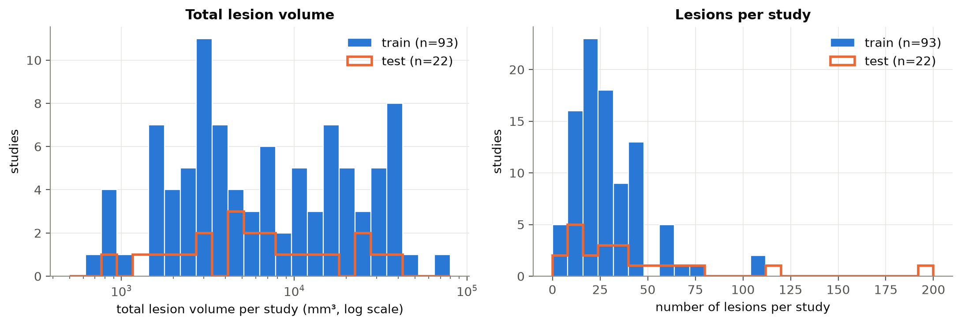
Figure 4.3. Total lesion volume (log scale) and number of lesions per study, training and test sets.
Implication. Segmentation metrics are expected to be lower and more variable for studies with little lesion, where every error weighs more. Results will also be reported by lesion-load group, not only as a global mean.

4.5 Class imbalance
Lesions occupy a median of 0.30 % of the brain volume (range 0.04–3.9 %): for every lesion voxel there are about 330 healthy voxels.
Implication. Accuracy is meaningless (predicting "no lesion" everywhere would be 99.7 % accurate). Training requires overlap-based losses (Dice combined with cross-entropy) and oversampling of patches that contain lesions, and evaluation relies on the overlap and lesion-wise metrics of Section 5.3.

4.6 Lesion size
The 3,595 lesions have a median size of 63 mm³, but their size spans five orders of magnitude (Figure 4.4 and Table 4.4).
Lesion size | Share of lesions | Share of lesion volume
≤ 10 mm³ | 10.7 % | 0.1 %
11–27 mm³ | 12.8 % | 0.7 %
28–100 mm³ | 42.3 % | 6.4 %
101–1,000 mm³ | 29.3 % | 21.3 %
> 1,000 mm³ | 5.0 % | 71.5 %
Table 4.4. Distribution of lesion sizes (all studies).
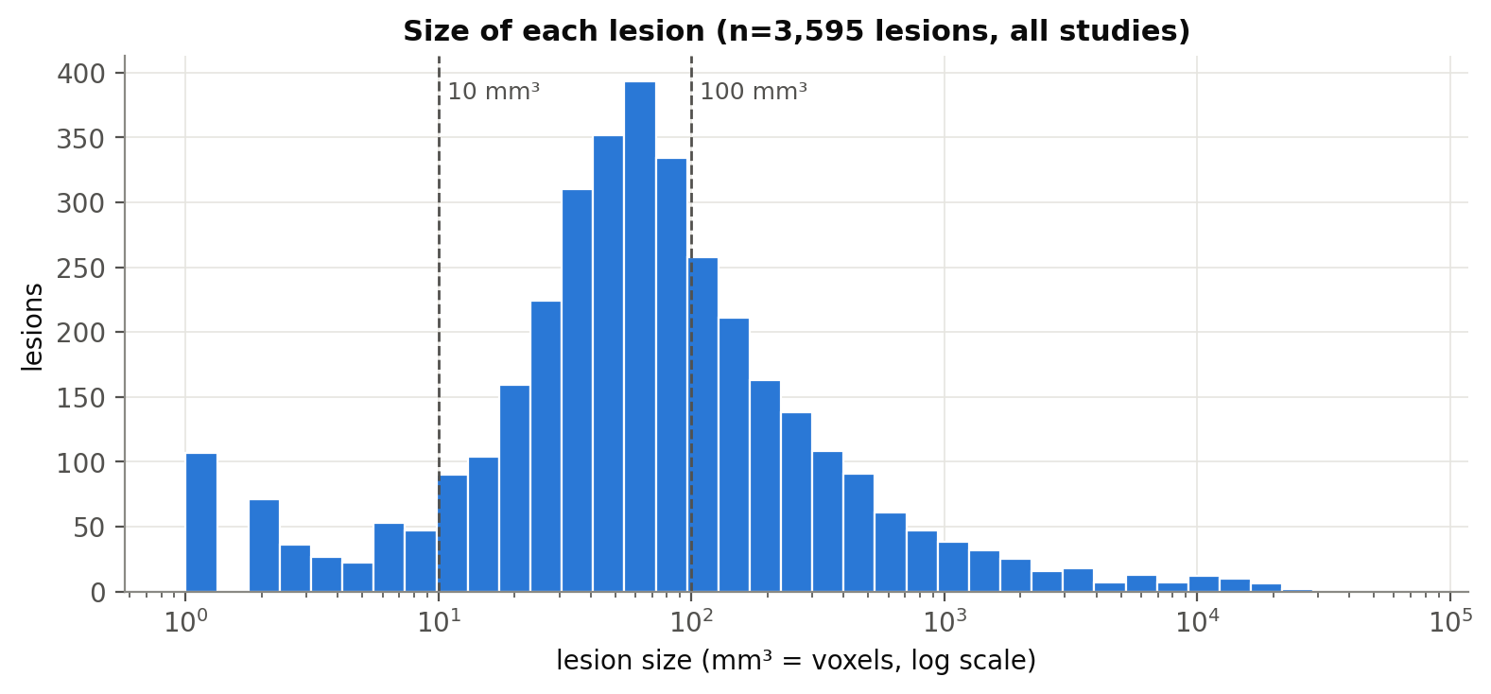
Figure 4.4. Size of each lesion (log scale). Two out of three lesions are 100 mm³ or smaller.
Two out of three lesions are small (≤ 100 mm³), yet together they account for only 7 % of the lesion volume, while 5 % of the lesions account for 72 % of it.
Implication. The voxel-wise Dice coefficient is dominated by a few large lesions: a model can miss most small lesions and still obtain a good Dice. Lesion-wise metrics and an analysis stratified by lesion size are therefore essential, and small-lesion detection is the main target for improvement (objective O3).

4.7 Scanners and intensities
The studies were acquired on eight scanner models from three manufacturers (Table 4.5), at 1.5 T and 3 T, with FLAIR slice thicknesses between 2 and 5 mm.
Manufacturer | Training studies | Test studies
Philips | 84 (90 %) | 16 (73 %)
GE | 4 (4 %) | 5 (23 %)
Siemens | 0 | 1 (5 %)
Unknown | 5 (5 %) | 0
Table 4.5. Scanner manufacturer by subset (FLAIR metadata).
Image intensities are not comparable between studies: the 99th percentile of the FLAIR brain intensity ranges from 130 to 1,675 arbitrary units and depends on the manufacturer (median 806 for GE versus 273 for Philips), but also varies widely within the same manufacturer (Figure 4.5). Lesions are clearly hyperintense on FLAIR (the median lesion intensity is 1.45 times the median brain intensity, median over studies) and much less so on T1-w (1.12) and T2-w (1.16). Moreover, non-Philips studies are much more frequent in the test set (27 %) than in the training set (4 %). The reference study only registers and skull-strips the images; it does not describe any intensity normalisation or harmonisation, nor results by scanner.
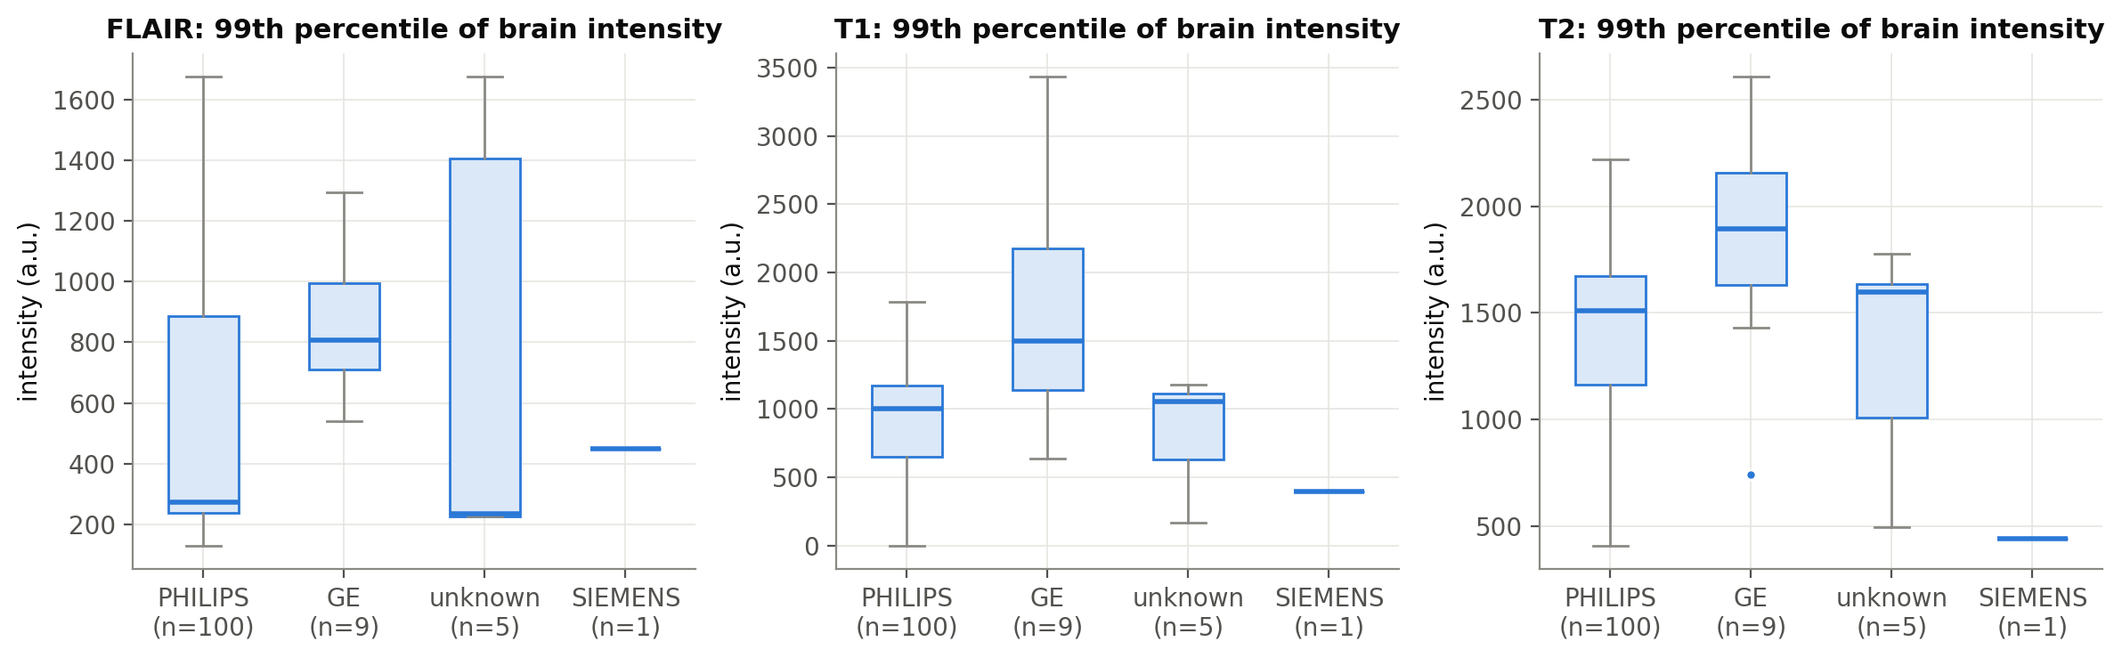
Figure 4.5. 99th percentile of the brain intensity by manufacturer and sequence.
Implication. Each image must be intensity-normalised (z-score within the brain) and intensity augmentation should be used during training. Results will be reported by manufacturer (Philips versus others) to measure robustness to the acquisition. FLAIR is the most informative sequence.

4.8 Longitudinal patients
For the 25 training patients with more than one timepoint, lesion volume is usually stable between consecutive visits (Figure 4.6): the median ratio between visits is 1.03 and 22 of the 40 pairs change by less than 20 %. Four pairs change by more than a factor of three (Table 4.6).
Patient | Visits | Lesion volume (mm³) | Ratio | EDSS
P20 | T1 → T2 | 744 → 5,807 | 7.81 | 3.0 → 0.0
P20 | T2 → T3 | 5,807 → 1,537 | 0.26 | 0.0 → 1.0
P49 | T1 → T2 | 34,709 → 7,763 | 0.22 | 2.0 → 2.5
P50 | T1 → T2 | 9,144 → 36,435 | 3.98 | 2.5 → 3.5
Table 4.6. Pairs of consecutive visits with a lesion-volume change larger than a factor of three.
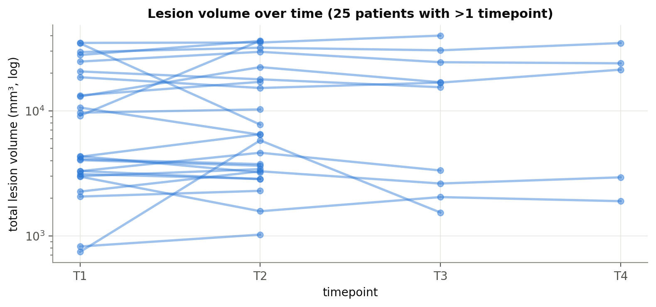
Figure 4.6. Total lesion volume over time for the 25 patients with more than one timepoint.
The increase in P50 is consistent with its clinical worsening. The changes in P20 and P49 are less clear: they may reflect real disease activity (active lesions swell and later shrink) or differences in annotation between visits. With a single annotation per study this cannot be resolved; these studies are kept and flagged for review.
Implication. Visits of the same patient are strongly correlated, which confirms that validation must be done at patient level. Detection of new lesions between visits is a possible extension (Section 3.4).

4.9 Summary and design decisions
Table 4.7 summarises the findings of the exploratory analysis and the decisions derived from them.
Finding | Decision
Small dataset; several visits per patient | Established architecture (nnU-Net) with data augmentation; patient-level folds
Lesions are 0.30 % of the brain | Dice + cross-entropy loss and lesion-oversampling; no accuracy
2/3 of lesions are small but 7 % of the volume | Lesion-wise metrics; results by lesion size; focus of the contribution
Large variability of lesion load | Results by lesion-load group
Intensities depend on scanner; more non-Philips in test | Per-image z-score normalisation; intensity augmentation; results by manufacturer
Lesions are counted with 6-connectivity | Same rule for all lesion-wise metrics
3 badly registered studies, 1 missing T1 | Kept (as in the reference study) + sensitivity analysis
22 released test patients (paper mentions 24) | Released split used; noted when comparing with [7]
Table 4.7. Main findings of the exploratory analysis and resulting design decisions.

5. Experimental framework
This chapter describes the common framework shared by all experiments: the tools that make the work reproducible, the cross-validation folds, the evaluation metrics and the analyses that will be used to compare models. Sections 5.1–5.3 are implemented; Sections 5.4 and 5.5 describe the planned analysis.

5.1 Reproducible workflow
The project follows the principle that every result must be regenerated from the public repository with documented commands (objective O5). Table 5.1 lists the tools used.
Need | Tool | Use in this project
Project structure | Cookiecutter Data Science | Standard folders: data/, ms_seg/ (code), notebooks/, reports/, configs/, tests/
Code versioning and planning | Git and GitHub | Public repository; work organised in five milestones and issues on a project board
Software environment | conda (environment.yml) | Same Python version and libraries on every machine
Data versioning and pipeline | DVC | The raw dataset is versioned by its checksum (MSLesSeg.dvc); dvc repro re-runs only the stages whose inputs changed
Experiment tracking | MLflow | Parameters, metrics, artefacts and code version of every run
Testing | pytest | Automatic tests for the folds and the metrics
Computing | Kaggle notebooks | Free GPU (about 30 hours per week) for training
Table 5.1. Tools of the reproducible workflow.
The data are not stored in Git: DVC keeps a small pointer file with the checksum of the dataset, so that each commit records exactly which version of the data was used. The pipeline currently has two stages, defined in dvc.yaml:
- eda: computes the statistics of every study and every lesion (data/interim/study_stats.csv, lesions.csv) used in Chapter 4.
- folds: builds the cross-validation folds from these statistics (configs/folds.json, Section 5.2).

5.2 Cross-validation folds
Models are developed with 5-fold cross-validation on the 53 training patients: each fold uses about four fifths of the patients for training and the remaining fifth for validation, and every patient is used for validation exactly once. The test set (P54–P75) is used only for the final comparison of the selected models.
Folds used in the reference study. Guarnera et al. [7] split the training patients into contiguous blocks (Table 5.2). Their table contains two typos: patient 23 appears in both the training and the validation set of fold 4 (data leakage), and patients 11–13 are never in a validation set. Moreover, once corrected, the blocks are very unbalanced, because the first patients have more timepoints: the validation sets would contain between 10 and 36 studies.
Fold | Training patients | Validation patients | Issue
1 | 1–43 | 44–53 | —
2 | 1–33, 44–53 | 34–43 | —
3 | 1–23, 34–53 | 24–33 | —
4 | 1–13, 23–53 | 14–23 | Patient 23 in training and validation
5 | 11–53 | 1–10 | Patients 11–13 never validated
Table 5.2. Cross-validation folds reported by Guarnera et al. [7] (Table 4 of the original publication).
Folds used in this work. New folds were built with two rules:
- Patient level: all timepoints of a patient belong to the same fold, so no patient appears in both training and validation.
- Balanced: patients are sorted by number of studies and lesion volume (largest first), and each one is assigned to the fold that currently has the fewest studies (ties: least lesion volume). The procedure is deterministic.
The resulting folds are balanced in number of studies and lesion volume (Table 5.3). The implementation (ms_seg/folds.py) checks automatically that no patient is in two folds and that every training patient is validated once.
Fold | Patients | Studies | Lesion volume (ml)
1 | 11 | 19 | 230.9
2 | 11 | 19 | 214.0
3 | 11 | 19 | 214.7
4 | 10 | 18 | 241.4
5 | 10 | 18 | 230.6
Table 5.3. Validation sets of the five folds used in this work (`configs/folds.json`).
Because the reference study evaluates its models on the test set, which is fixed, using different cross-validation folds does not prevent the comparison of test results.

5.3 Evaluation metrics
Models are evaluated with the seven metrics of the reference study [7], implemented in ms_seg/metrics.py. Let P be the predicted mask and G the reference (ground-truth) mask of a study, both binary, and |·| the number of voxels.
Voxel-wise metrics:
- Dice similarity coefficient: DSC = 2 |P ∩ G| / (|P| + |G|). Overall overlap (higher is better).
- True positive rate (sensitivity): TPR = |P ∩ G| / |G|. Fraction of the lesion volume that is detected (higher is better).
- Positive predictive value (precision): PPV = |P ∩ G| / |P|. Fraction of the predicted volume that is lesion (higher is better).
- Absolute volume difference: AVD = 100 · | |P| − |G| | / |G|, in % of the reference volume (lower is better).
- Average symmetric surface distance (ASSD, mm): mean distance from each boundary voxel of P to the boundary of G and from each boundary voxel of G to the boundary of P (lower is better).
Lesion-wise metrics. Lesions are the connected components of each mask with 6-connectivity, the rule that reproduces the authors' lesion counts (Section 4.3.3). A lesion is detected if it shares at least one voxel with the other mask.
- Lesion true positive rate: LTPR = reference lesions overlapped by P / reference lesions (higher is better).
- Lesion false positive rate: LFPR = predicted lesions that do not overlap G / predicted lesions (lower is better).
Metrics are computed per study and averaged over studies. The implementation was verified with automatic tests on synthetic masks with known results (for example, two cubes overlapping by half give DSC = 0.5, and two voxels touching only at a corner are counted as two lesions) and on the real masks: comparing each mask with itself gives perfect scores, and the lesion counts match the values released by the authors.

5.4 Statistical comparison (planned)
Mean metrics alone are not enough to decide whether one model is better than another: in the reference study, the two best models differ by 0.007 in Dice, less than the variation between folds. Models will therefore be compared per patient with the Wilcoxon signed-rank test for paired samples, and differences will be reported with 95 % bootstrap confidence intervals. The test set is used only once, for the final models.

5.5 Stratified and sensitivity analyses (planned)
The exploratory analysis showed that a global mean hides important differences. In addition to the overall metrics, results will be reported:
- by lesion size (≤ 10, 11–100, 101–1,000 and > 1,000 mm³), using lesion-wise detection rates, because small lesions are the majority but barely affect the Dice coefficient;
- by lesion load of the study (low, medium, high), because metrics are expected to be lower for studies with little lesion;
- by scanner manufacturer (Philips versus others), because the test set contains many more non-Philips studies than the training set;
- without the four flagged studies (P44_T1, P45_T1, P53_T1 and P49_T2), as a sensitivity analysis of the data-quality issues found in Section 4.3.

References
[1] Walton C. et al. Rising prevalence of multiple sclerosis worldwide: insights from the Atlas of MS, third edition. Multiple Sclerosis Journal 26(14), 1816–1821 (2020).
[2] Thompson A. J. et al. Diagnosis of multiple sclerosis: 2017 revisions of the McDonald criteria. The Lancet Neurology 17(2), 162–173 (2018).
[3] Filippi M. et al. Assessment of lesions on magnetic resonance imaging in multiple sclerosis: practical guidelines. Brain 142(7), 1858–1875 (2019).
[4] Egger C. et al. MRI FLAIR lesion segmentation in multiple sclerosis: does automated segmentation hold up with manual annotation? NeuroImage: Clinical 13, 264–270 (2017).
[5] Carass A. et al. Longitudinal multiple sclerosis lesion segmentation: resource and challenge. NeuroImage 148, 77–102 (2017).
[6] Commowick O. et al. Objective evaluation of multiple sclerosis lesion segmentation using a data management and processing infrastructure. Scientific Reports 8, 13650 (2018).
[7] Guarnera F. et al. MSLesSeg: baseline and benchmarking of a new Multiple Sclerosis Lesion Segmentation dataset. Scientific Data 12, 920 (2025).
[8] Guarnera F. et al. MSLesSeg dataset. figshare (2025). https://doi.org/10.6084/m9.figshare.27919209
[9] Jenkinson M., Smith S. A global optimisation method for robust affine registration of brain images. Medical Image Analysis 5(2), 143–156 (2001).
[10] Smith S. M. Fast robust automated brain extraction. Human Brain Mapping 17(3), 143–155 (2002).
[11] Hatamizadeh A. et al. Swin UNETR: Swin Transformers for semantic segmentation of brain tumors in MRI images. In BrainLes 2021, LNCS 12962 (2022).
[12] Hatamizadeh A. et al. UNETR: Transformers for 3D medical image segmentation. In Proc. IEEE/CVF WACV (2022).
[13] Wang W. et al. TransBTS: Multimodal brain tumor segmentation using Transformer. In MICCAI 2021, LNCS 12901 (2021).
[14] Warfield S. K., Zou K. H., Wells W. M. Simultaneous truth and performance level estimation (STAPLE). IEEE Transactions on Medical Imaging 23(7), 903–921 (2004).
[15] Rondinella A. et al. MSSegDiff: official implementation. https://github.com/alessiarondinella/MSSegDiff
[16] Isensee F. et al. nnU-Net: a self-configuring method for deep learning-based biomedical image segmentation. Nature Methods 18, 203–211 (2021).

