Multiple Sclerosis Lesion Segmentation in MRI
Starting point, objectives and exploratory data analysis of the MSLesSeg dataset

Working document
Author: Toni
Supervisor: Manel Frigola
Version: 0.3 — 24 September 2026
Repository: github.com/toni646/Esclerosi-Multiple
This document summarises the reference study the thesis builds on (Section 1), states what the thesis aims to do (Section 2) and reports a systematic exploratory analysis of the data (Section 3). All figures and numbers in Section 3 are produced by code in the repository and can be regenerated.

Contents

1. Starting point: the MSLesSeg reference study
The thesis builds on the dataset and benchmark published by Guarnera et al. in Scientific Data (2025) [1]. This section summarises what the paper reports, what can and cannot be reproduced from the released material, and the gaps it leaves open.

1.1 Clinical context and motivation
Multiple sclerosis (MS) is a chronic immune-mediated disease of the central nervous system in which inflammation damages myelin, producing focal lesions mostly in the white matter. On magnetic resonance imaging (MRI) these lesions appear hyperintense on T2-weighted and FLAIR sequences. The number and volume of lesions, and the appearance of new ones over time, are used to support diagnosis and to monitor disease activity and treatment response.
Delineating lesions manually is slow and shows substantial inter- and intra-rater variability. Automatic segmentation with deep learning can reduce this burden, but it requires public, well-annotated datasets. The authors argue that large, high-quality datasets for MS lesion segmentation are still lacking, and propose MSLesSeg to help fill this gap. Unlike datasets that provide several annotations per image (e.g. ISBI 2015 [9]), MSLesSeg provides one expert-validated mask per study, so that every method is evaluated against the same reference.

1.2 The MSLesSeg dataset
MSLesSeg contains MRI data from 75 patients (48 female, 27 male; age 18–59 years, mean 37 ± 10.3 at baseline) acquired at an Italian hospital and private clinics, with scanners of 1.5 T and 3 T. Each study includes three sequences: FLAIR, T1-weighted and T2-weighted, plus the lesion mask. Some patients were scanned at several timepoints (up to four), giving 115 studies in total. The data are publicly available on figshare [2].
Table 1. Native acquisition parameters reported by the authors (mean ± SD, before preprocessing).
Sequence | In-plane matrix (pixels) | Pixel spacing (mm) | Slice thickness (mm)
FLAIR | 455.8 × 455.8 (± 314.7) | 0.75 × 0.75 (± 0.32) | 2.61 (± 0.62)
T1-weighted | 288.7 × 288.7 (± 74.5) | 0.91 × 0.91 (± 0.32) | 1.14 (± 0.81)
T2-weighted | 473.8 × 473.8 (± 165.9) | 0.58 × 0.58 (± 0.27) | 4.24 (± 0.92)

The dataset is split into a training set of 53 patients (50 relapsing-remitting MS, RRMS; 3 secondary progressive, SPMS) with one to four timepoints each, and a test set of 22 patients (21 RRMS; 1 primary progressive, PPMS) with a single timepoint. The dataset was used for the ICPR 2024 Competition on Multiple Sclerosis Lesion Segmentation, in which 15 teams took part.

1.3 Preprocessing
All studies went through the same pipeline, implemented in Python with the FSL library:
- Anonymisation and conversion from DICOM to NIfTI.
- Co-registration to the MNI152 1 mm isotropic template with FLIRT [8], using a 12-degree-of-freedom affine transformation.
- Skull stripping with the Brain Extraction Tool (BET) [8].
The released images are 182 × 218 × 182 voxels of 1 mm³ in LAS orientation. The transformation matrices and the raw, unprocessed images are also released, so that segmentations can be mapped back to native space or alternative pipelines can be tested. No intensity normalisation is described in the paper.

1.4 Annotation protocol
Masks were produced by a junior rater trained by two senior experts (a neuroradiologist and a neurologist specialised in MS) using the JIM 9 software. Lesions were identified on the registered FLAIR image, with T1-w and T2-w used to resolve doubtful cases. Regions of interest were drawn and propagated across slices, and the final masks were reviewed and refined in periodic meetings with the senior raters.

1.5 Baseline models and evaluation protocol
The authors benchmark four 3D deep-learning models:
- MSSegDiff [1, 11] (their proposal): a diffusion-based segmentation pipeline. Noise is added to the ground-truth mask and a denoising U-Net with attention (BasicUNet with Squeeze-and-Attention blocks), conditioned on the MRI, learns to recover it. At inference, predictions from several denoising steps are merged with Step-Uncertainty-based Fusion.
- SwinUNETR [4]: Swin-Transformer encoder with a convolutional decoder.
- UNETR [5]: Vision-Transformer encoder with a convolutional decoder.
- TransBTS [6]: 3D CNN encoder followed by a Transformer for global context.
Models were trained with 5-fold cross-validation on training patients 1–53. The paper reports the patient ranges used for training and validation in each fold and states that all tests used patients 54 to 77. Training hyper-parameters (number of epochs, patch size, loss function, optimiser, learning rate) are not reported.
Table 2. Evaluation metrics used in the paper. TP, FP, FN are voxel counts unless stated otherwise.
Metric | Definition | What it measures
Dice (DSC) ↑ | 2TP / (2TP + FP + FN) | Voxel-wise overlap with the reference mask
TPR ↑ | TP / (TP + FN) | Voxel-wise sensitivity
PPV ↑ | TP / (TP + FP) | Voxel-wise precision
LTPR ↑ | Reference lesions overlapped by the prediction / reference lesions | Lesion-wise detection rate
LFPR ↓ | Predicted lesions not overlapping the reference / predicted lesions | Lesion-wise false-positive rate
AVD ↓ | |V_pred − V_ref| / V_ref | Relative error in total lesion volume
ASSD ↓ | Mean symmetric distance between the two surfaces (mm) | Boundary accuracy

1.6 Reported results
Table 3. Results reported in the paper (Table 5 of [1]; mean over the five folds). Best value per column in bold.
Model | DSC ↑ | TPR ↑ | PPV ↑ | LTPR ↑ | LFPR ↓ | AVD ↓ | ASSD ↓
MSSegDiff | 0.6851 | 0.6719 | 0.7241 | 0.6250 | 0.2226 | 24.45 | 3.474
SwinUNETR | 0.6786 | 0.6676 | 0.7157 | 0.7017 | 0.2957 | 25.12 | 3.622
UNETR | 0.6421 | 0.6751 | 0.6496 | 0.7332 | 0.4331 | 90.16 | 4.524
TransBTS | 0.4917 | 0.5447 | 0.5027 | 0.5110 | 0.5408 | 67.95 | 7.548
Table 4. Dice per fold reported in the paper (Table 6 of [1]).
Model | Fold 1 | Fold 2 | Fold 3 | Fold 4 | Fold 5
MSSegDiff | 0.6836 | 0.6801 | 0.6811 | 0.7067 | 0.6742
SwinUNETR | 0.6819 | 0.6838 | 0.6701 | 0.6885 | 0.6690
UNETR | 0.6541 | 0.6387 | 0.6374 | 0.6460 | 0.6347
TransBTS | 0.5045 | 0.4668 | 0.5231 | 0.5524 | 0.4118

The authors also ran a consensus analysis with the masks submitted by the ICPR 2024 participants, merged with STAPLE [7]. The AI methods made similar errors, mainly on the contours of large or unusual lesions, and the errors were larger for methods that used only the FLAIR sequence.

1.7 Code availability and reproducibility
Two repositories are linked from the paper: the preprocessing code (MSLesSeg-2024) and the MSSegDiff implementation (MSSegDiff) [11]. We inspected both. The MSSegDiff repository is the official implementation of an earlier paper by the same group and is written for the ISBI 2015 dataset (FLAIR, T2, MPRAGE and PD inputs); it contains no data loader, fold definition, configuration or trained weights for MSLesSeg. Table 5 summarises what this means for reproducing the benchmark.
Table 5. Reproducibility assessment of the reference study.
Element | In the paper | In the released code | Consequence for this thesis
Registration and skull stripping | Described | Yes (MSLesSeg-2024) | Released data are already preprocessed
Intensity normalisation | Not described | z-score per channel within the brain (MONAI NormalizeIntensityd), ISBI loader | Apply the same z-score; state it as an assumption
Data augmentation | Not described | Random flips, intensity scaling and shifting | Reuse as default for the MONAI baselines
Hyper-parameters | Not reported | Only ISBI defaults | Define, justify and document our own
Fold assignment | Patient ranges per fold | Not released | Define patient-level folds and publish them
Test set | Patients 54–77 (24) | — | Released data contain P54–P75 (22 patients)
Trained weights | — | Not released | Models must be retrained

An exact reproduction of MSSegDiff is therefore not possible from the published material. A faithful approximate reproduction is possible for SwinUNETR, which is available in MONAI [4] and whose results are close to MSSegDiff's.

1.8 Critical assessment and open gaps
- The best model wins by a small margin. MSSegDiff and SwinUNETR differ by 0.007 in mean Dice (0.685 vs 0.679), within the fold-to-fold variation, and no statistical test is reported.
- MSSegDiff misses more lesions. Its lesion-wise detection rate (LTPR 0.625) is the lowest of the three competitive models (0.70–0.73), even though its voxel-wise Dice is the highest. Voxel-wise metrics hide failures on small lesions, which Section 3 shows to be the majority.
- No nnU-Net baseline. nnU-Net [3] is the de-facto reference in medical image segmentation and is absent from the benchmark.
- Incomplete experimental description: no hyper-parameters, no released folds, and the reported test range (54–77) does not match the released test set (54–75). It is also not explicit whether the per-fold results in Table 4 were computed on the test set or on each fold's validation patients.
- The lesion counting rule is not described, although it determines LTPR and LFPR. Section 3.6 shows that it can be recovered from the released data (6-connectivity).
- Acquisition heterogeneity is not analysed. Scanner and protocol information is released with the data but performance is not stratified by scanner or field strength.

2. What this thesis aims to do

2.1 Research question
Starting from a strong, reproducible baseline, can the detection of small MS lesions be improved and the number of false-positive lesions reduced, and how robust are these models across scanners and datasets?
The thesis will not design a new architecture from scratch. Instead it will take a strong, well-established architecture and introduce targeted, measurable changes, each motivated by a specific weakness identified in the data or in the reference study.

2.2 Specific objectives
Table 6. Specific objectives and how each will be verified.
 | Objective | Success criterion
O1 | Build a reproducible pipeline and reproduce the reference benchmark with SwinUNETR (MONAI). | Dice and lesion-wise metrics of the same order as those reported in [1].
O2 | Train nnU-Net as a strong baseline, a comparison missing from the paper. | Complete 5-fold and test-set results with the same metrics.
O3 | Improve small-lesion detection and false positives (lesion-aware loss, post-processing, uncertainty estimation). | Statistically significant gain in LTPR/LFPR over the baseline, without loss of Dice.
O4 | Assess generalisation and robustness: external dataset without retraining, performance by scanner manufacturer. | Reported performance gap between domains and its likely causes.
O5 | Ensure reproducibility (MLOps): versioned code, data and experiments. | All results regenerable from the repository with documented commands.

2.3 Evaluation principles
- Folds defined at patient level, so that timepoints of the same patient never appear in both training and validation.
- Same metrics as the paper, plus lesion-wise metrics stratified by lesion size.
- Comparisons between models with paired tests per patient (Wilcoxon signed-rank) and confidence intervals, not only means.
- The test set is used only for the final comparison of the selected models.
- Every experiment is logged (configuration, code version, metrics) with MLflow and linked to an issue in the repository.

2.4 Work plan
Table 7. Milestones (tracked as GitHub milestones and issues).
Milestone | Due date | Main outputs
M1 · Data and exploratory analysis | 11 Oct 2026 | Environment, dataset verification, EDA (this document), patient-level folds
M2 · Reproduction and nnU-Net baseline | 1 Nov 2026 | Metrics implementation, SwinUNETR reproduction, nnU-Net baseline, statistical comparison
M3 · Own contribution | 6 Dec 2026 | Lesion-aware loss, post-processing, uncertainty estimation
M4 · External validation and analysis | 27 Dec 2026 | External dataset, robustness by scanner, error analysis, qualitative figures
M5 · Thesis and defense | 24 Jan 2027 | Written thesis, reproducible repository, presentation

3. Exploratory data analysis

3.1 Aim and scope
The aim of this analysis is to characterise the dataset before any model is trained: its composition, the patients, the quality and consistency of the images and masks, the lesion burden and size distribution, the degree of class imbalance and the heterogeneity introduced by different scanners. Each finding is translated into a concrete modelling decision (Section 3.12).

3.2 Methods
- Data. The preprocessed release of MSLesSeg (MSLesSeg Dataset.zip on figshare [2]): 115 studies, each with FLAIR, T1-w, T2-w and a binary mask, plus clinical and scanner metadata files.
- Brain mask. Voxels with FLAIR intensity > 0 (the images are skull-stripped and the background is exactly zero).
- Lesion. A connected component of the mask using 6-connectivity (voxels belong to the same lesion only if they share a face), computed with scipy.ndimage.label. This is the rule that reproduces the authors' lesion counts exactly (Section 3.6). As voxels are 1 mm³, sizes in voxels equal volumes in mm³.
- Intensities. 1st, 50th and 99th percentiles of each sequence within the brain mask, and the median intensity inside lesions.
- Statistics. Medians and interquartile ranges (IQR) are reported because most distributions are strongly skewed.
- Reproducibility. Statistics are computed by ms_seg/eda.py (cached in data/interim/), analysed in notebooks/2.0-tlb-eda.ipynb, and figures are saved to reports/figures/.

3.3 Dataset composition
Table 8. Composition of the released dataset.
Split | Patients | Studies | Lesions (6-connected)
Train | 53 | 93 | 2,688
Test | 22 | 22 | 907
Total | 75 | 115 | 3,595

In the training set, 28 patients have one timepoint, 15 have two, 5 have three and 5 have four, giving 93 studies from 53 patients. Every test patient has a single study. Ground-truth masks are included for the test set, so the official train/test split of the paper can be used.
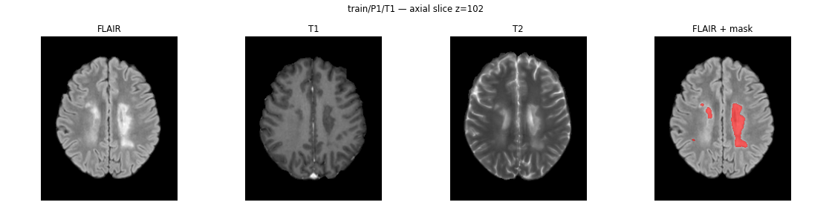
Figure 1. Example study (patient P1, first timepoint), axial slice with the largest lesion area: FLAIR, T1-w, T2-w and FLAIR with the reference mask overlaid in red.

3.4 Cohort characteristics
Table 9. Patient characteristics at the first available timepoint. EDSS: Expanded Disability Status Scale.
 | Train (n = 53) | Test (n = 22) | All (n = 75)
Age, mean ± SD (range) | 36.4 ± 10.2 (18–58) | 38.5 ± 10.5 (18–59) | 37 ± 10.2 (18–59)
Female / male | 32 / 21 | 16 / 6 | 48 / 27
RRMS / SPMS / PPMS | 50 / 3 / 0 | 21 / 0 / 1 | 71 / 3 / 1
EDSS, median (IQR) [range] | 2 (0–3) [0–6] | 1 (0.25–3) [0–5.5] | 2 (0–3) [0–6]

The demographics match those reported in the paper (48 female / 27 male; 50 RRMS + 3 SPMS in training; 21 RRMS + 1 PPMS in test). The cohort is dominated by RRMS with mild disability (median EDSS 2). Train and test are similar, although the test set has a slightly lower median EDSS. Total lesion volume shows a moderate positive correlation with EDSS (Spearman ρ = 0.33).

3.5 Data integrity and quality control
Table 10. Summary of the quality-control checks.
Check | Result | Status
All four files present and readable in every study | 115 / 115 studies | OK
Image geometry | All volumes 182 × 218 × 182, 1 mm isotropic, LAS | OK
Masks are binary and non-empty | Values {0, 1}; no empty mask | OK
Lesion volume vs. volume reported in the clinical file | 100% exact match | OK
Lesion count vs. count reported in the clinical file | Identical in 115/115 studies with 6-connectivity | OK
Empty sequence | T1-w of P49_T2 is (almost) empty | Flag
Registration (brain volume) | P44_T1, P45_T1, P53_T1 have 1.7–1.8× the median brain volume | Flag
Longitudinal consistency | 4 consecutive visit pairs with a >3× change in lesion volume | Flag
Mask–image alignment in the flagged studies | No lesion voxel outside the brain; lesions hyperintense on FLAIR (lesion/brain ratio 1.29–1.54) | OK

Both the lesion volumes and the lesion counts released by the authors are reproduced exactly (the counting rule is analysed in Section 3.6). The three flagged issues are described below.

Missing T1-weighted image (P49_T2)
The T1-w volume of study P49_T2 contains only a few thousand non-zero voxels: the sequence is effectively missing (Figure 2). The same study also shows a 4.5-fold drop in lesion volume with respect to the patient's first visit (Section 3.11).
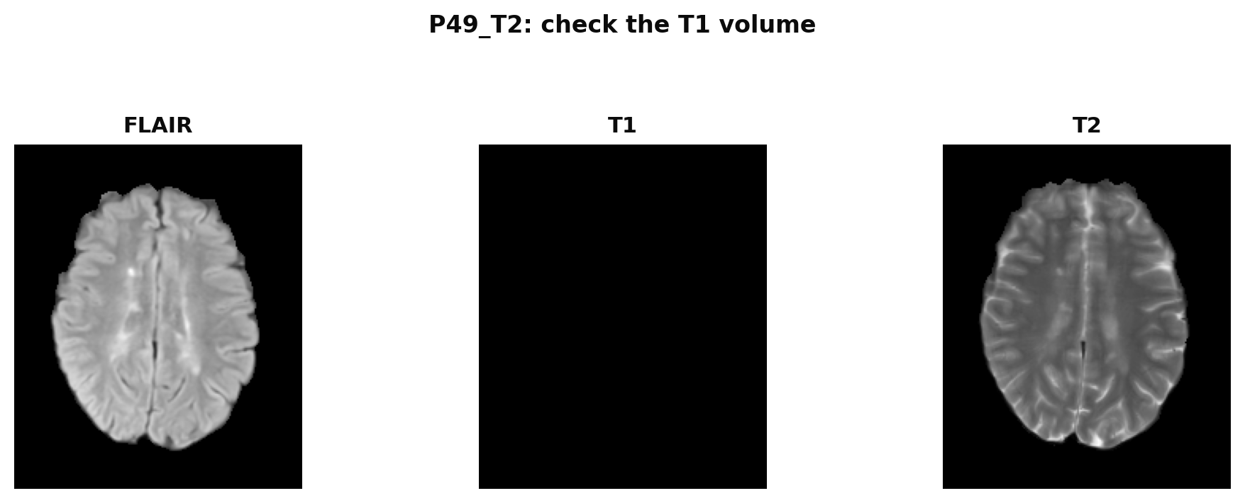
Figure 2. Study P49_T2: FLAIR and T2-w are present, the T1-w volume is empty.

Registration outliers
After registration to MNI152 all brains should have a similar volume. The median brain volume is 1.90 million voxels (IQR 1.84–1.96). Three training studies are clear outliers at 1.73–1.84 times the median (Figure 3). Visual inspection (Figure 4) shows that in these studies the brain was not scaled to the template: it appears enlarged and is cut at the borders of the field of view.
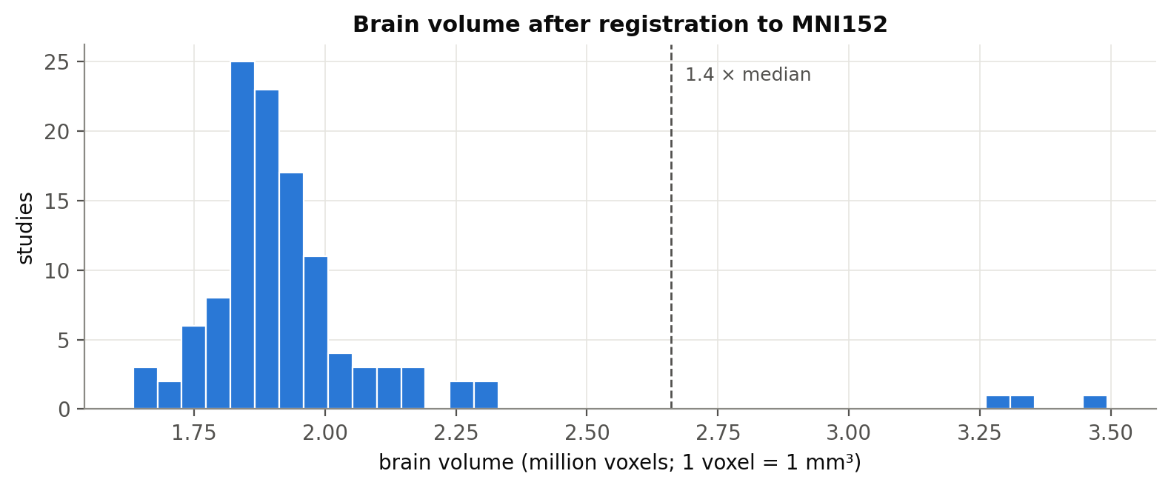
Figure 3. Distribution of brain volume after registration. The three studies to the right of the dashed line (1.4 × median) are P44_T1, P45_T1 and P53_T1.
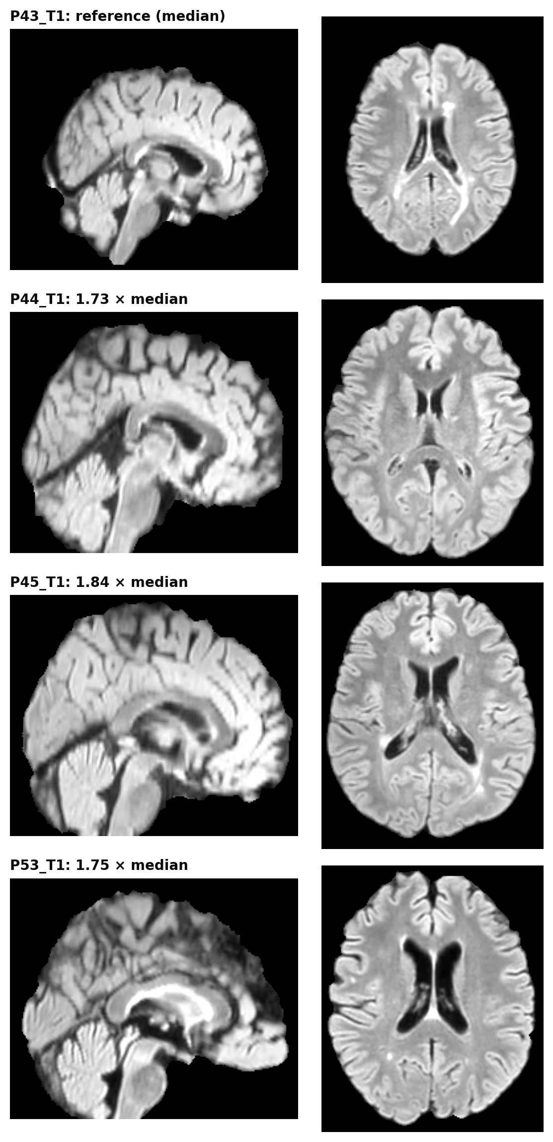
Figure 4. Mid-sagittal and mid-axial FLAIR slices of a reference study with median brain volume (top) and of the three outliers. The outliers are enlarged and cropped at the field-of-view borders.

Are the flagged studies usable?
To decide whether these studies can be used, we checked that the lesion mask is consistent with its own images. In all four studies (P49_T2, P44_T1, P45_T1, P53_T1) no lesion voxel falls outside the brain, and the voxels marked as lesion are clearly hyperintense on FLAIR: the ratio between the median FLAIR intensity inside lesions and in the whole brain is 1.29–1.54, within the range of the other studies (median 1.45, minimum 1.12). The masks are therefore correctly aligned with their images. The registration outliers are only at a different scale from the template, and P49_T2 only lacks the T1-w sequence.
How the reference study handled them. The paper does not mention any of these issues or any exclusion of studies, so the four studies were most likely used as released.
Decision for this thesis:
- Keep all studies in the main experiments, so that results are comparable with the reference study. For P49_T2 the missing T1-w channel is filled with zeros, which is what a model receives from the released file.
- Run a sensitivity analysis that repeats the main comparisons without the four flagged studies and reports whether the conclusions change.
- Report the issues and this decision in the thesis and communicate them to the dataset authors.

3.6 How lesions are counted: matching the authors
A lesion is a connected component of the binary mask, but the number of lesions depends on two choices that the paper does not describe: the connectivity rule (6: voxels must share a face; 18: a face or an edge; 26: a face, an edge or a corner) and whether components below a minimum size are discarded. Because the lesion-wise metrics LTPR and LFPR depend on this rule, it must match the authors' rule for results to be comparable.
We counted the lesions of every study with the three connectivity rules and five minimum sizes (1, 2, 3, 5 and 10 voxels) and compared each count with the lesion number released in the dataset's clinical file (Table 11).
Table 11. Agreement between our lesion counts and those released by the authors, for the best counting rules. The paper reports a mean of 28.9 lesions (train) and 41.2 (test).
Connectivity | Minimum size (voxels) | Exact match (% of studies) | Mean absolute difference | Mean (train) | Mean (test)
6 | 1 | 100.0 | 0.00 | 28.9 | 41.2
6 | 2 | 49.6 | 0.93 | 28.0 | 40.0
18 | 1 | 42.6 | 1.46 | 27.4 | 40.0
6 | 3 | 37.4 | 1.55 | 27.4 | 39.6
26 | 1 | 37.4 | 1.67 | 27.2 | 39.7
18 | 2 | 36.5 | 1.81 | 27.1 | 39.5

6-connectivity with no size filter reproduces the authors' count in all 115 studies, and the mean number of lesions reported in the paper (28.9 in train, 41.2 in test). This rule is used throughout this analysis and will be used to compute LTPR and LFPR, so that our lesion-wise results are directly comparable with the reference study. The more permissive 26-connectivity would merge lesions that only touch at an edge or corner and would lower the count by 1.7 lesions per study on average.

3.7 Lesion burden
Table 12. Lesion burden per study: median (IQR).
 | Train (93 studies) | Test (22 studies) | All (115 studies)
Total lesion volume (mm³) | 6,217 (2,857–17,877) | 5,602 (3,004–11,585) | 5,994 (2,883–17,005)
Range (mm³) | 744–72,872 | 919–42,098 | 744–72,872
Number of lesions | 24 (16–39) | 29 (15–50) | 25 (16–40)
Range | 3–111 | 4–193 | 3–193
Median lesion size per study (mm³) | 70 (52–93) | 76 (53–123) | 71 (53–94)

Lesion burden varies by two orders of magnitude between studies (from under 1 cm³ to more than 70 cm³), and the distribution is similar in train and test (Figure 5). One test study has an unusually high lesion count (193 lesions).
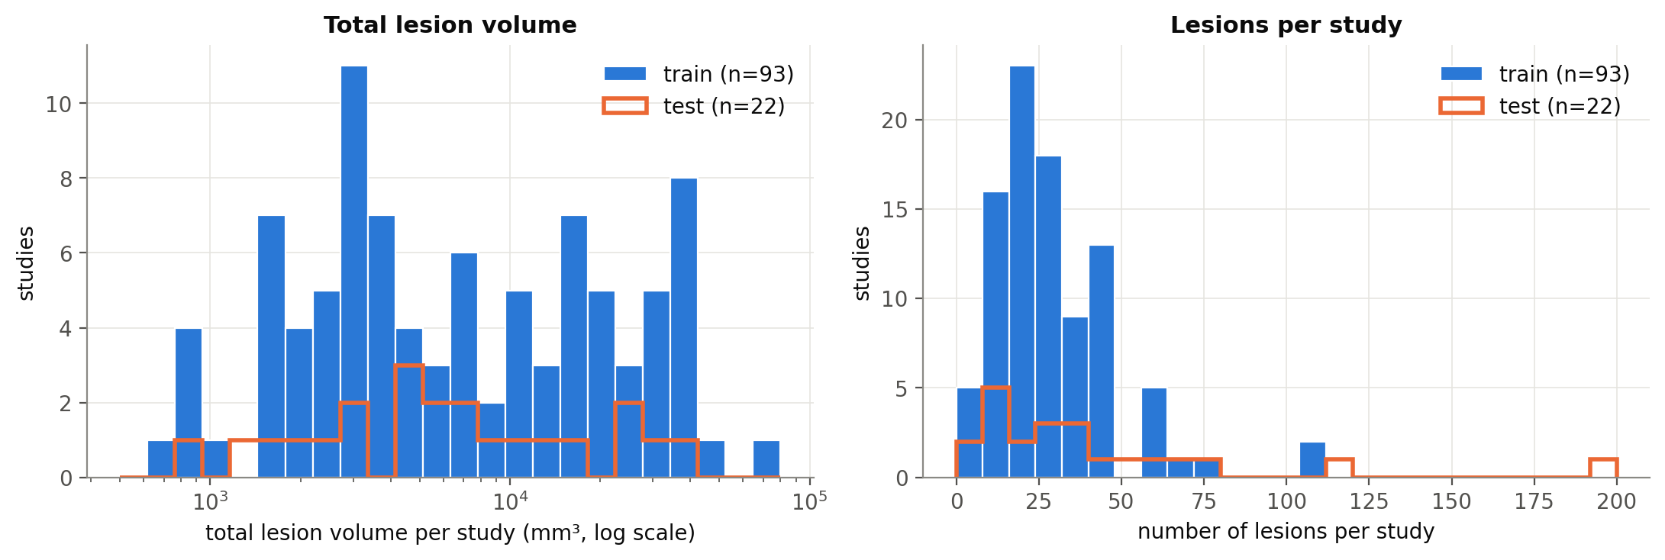
Figure 5. Total lesion volume (log scale) and number of lesions per study. Train as filled bars, test as an orange outline.

3.8 Class imbalance
Lesion voxels represent a median of 0.30% of the brain (IQR 0.14–0.93%, range 0.04–3.85%), i.e. roughly one lesion voxel for every 331 healthy brain voxels. A model predicting "no lesion" everywhere would be more than 99% accurate while being useless. Accuracy is therefore meaningless for this task, and training needs overlap-based losses (Dice or Dice + cross-entropy) and sampling of training patches around lesions.

3.9 Lesion size distribution
The 3,595 lesions have a median size of 63 mm³ (IQR 29–147); the largest is 67,904 mm³. The distribution is roughly log-normal with a long tail of very large, confluent lesions (Figure 6).
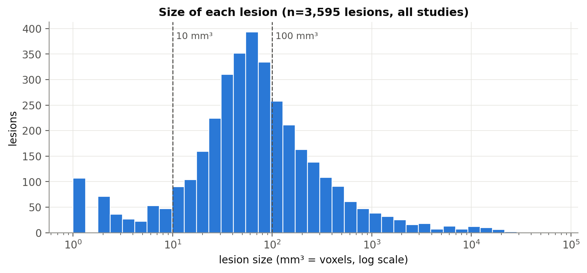
Figure 6. Size of each individual lesion across all studies (log scale).
Table 13. Lesions by size: share of the lesion count and of the total lesion volume.
Size class | Lesions | % of lesions | % of lesion volume
≤ 10 mm³ | 384 | 10.7 | 0.1
11-27 mm³ | 459 | 12.8 | 0.7
28-100 mm³ | 1,520 | 42.3 | 6.4
101-1000 mm³ | 1,054 | 29.3 | 21.3
>1000 mm³ | 178 | 5.0 | 71.5

This is the central finding of the analysis. 65.8% of lesions are 100 mm³ or smaller, but together they account for only 7.2% of the lesion volume. Conversely, the 5.0% of lesions larger than 1,000 mm³ make up 71.5% of the volume. Because voxel-wise Dice is dominated by large lesions, a model can obtain a good Dice while missing a large fraction of small lesions. This explains why MSSegDiff can have the best Dice and the worst LTPR in [1], justifies reporting lesion-wise metrics stratified by size, and motivates the small-lesion work planned for objective O3. In addition, 10.7% of lesions are 10 mm³ or smaller; at this scale partial-volume effects and annotation uncertainty are large, and a minimum-size threshold for lesion-wise evaluation should be decided and reported.

3.10 Acquisition heterogeneity
The scanner metadata released with the dataset lists 9 scanner models from 3 manufacturers (Figure 7): Philips (100 studies), GE (9) and Siemens (1); 5 studies have no scanner information. The field strength is not included in the metadata, and some models (e.g. Philips Ingenia) exist in both 1.5 T and 3 T versions, so the analysis is done by manufacturer and model.
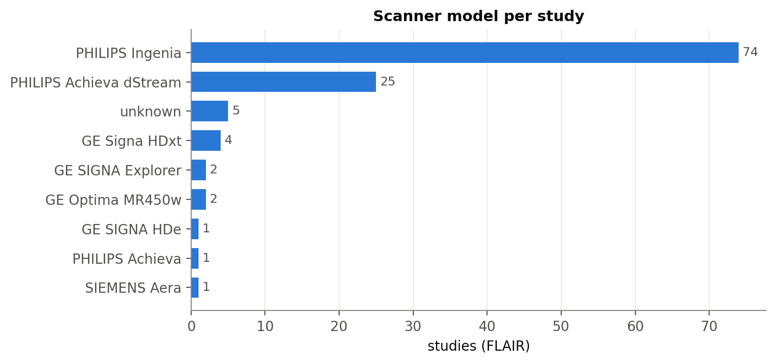
Figure 7. Scanner model per study (FLAIR acquisition).
The distribution of manufacturers differs between train and test: GE accounts for 4 of 93 training studies (4%) but 5 of 22 test studies (23%), and the only Siemens study is in the test set. The test set therefore contains a mild domain shift that should be considered when interpreting test results.
Image intensities are not normalised and depend strongly on scanner and protocol (Figure 8). The 99th percentile of FLAIR intensity within the brain ranges from 130 to 1,675 (median 273 for Philips vs 806 for GE). Per-image intensity normalisation is therefore required. Lesions remain clearly hyperintense on FLAIR relative to the rest of the brain (median ratio lesion/brain intensity 1.45), confirming FLAIR as the most informative sequence.
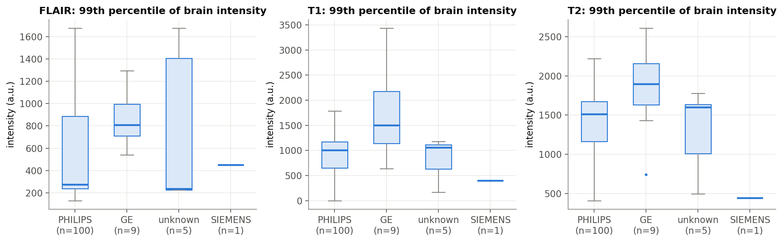
Figure 8. 99th percentile of brain intensity per study, grouped by manufacturer, for each sequence.
Native FLAIR slice thickness (before resampling to 1 mm) has a median of 3.0 mm (range 2.0–5.0 mm). The 1 mm isotropic images are therefore interpolated along the slice direction, which blurs small lesions and limits how precisely their boundaries can be defined.

3.11 Longitudinal consistency
25 training patients have more than one timepoint, giving 40 pairs of consecutive visits. The lesion volume is generally stable: the median ratio between consecutive visits is 1.03, and 22 of 40 pairs change by less than 20% (Figure 9). Four pairs change by more than a factor of three (Table 14). Such changes can be real (new active lesions or resolution of oedema) but may also reflect annotation or registration problems; P49_T2 also has a missing T1-w image.
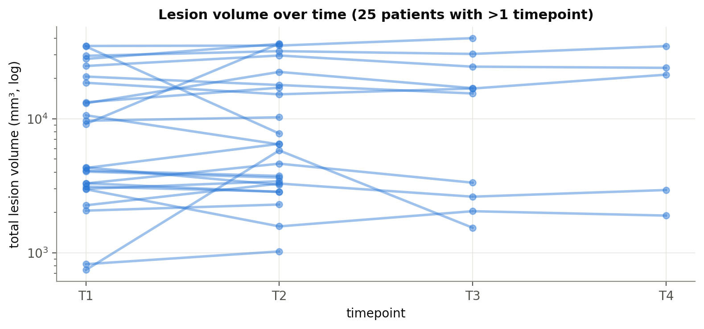
Figure 9. Total lesion volume across visits for the 25 training patients with more than one timepoint (log scale).
Table 14. Consecutive visits with a change in total lesion volume greater than three-fold.
Patient | Visit | Previous volume (mm³) | Volume (mm³) | Ratio
P20 | T1 → T2 | 744 | 5,807 | 7.81
P20 | T2 → T3 | 5,807 | 1,537 | 0.26
P49 | T1 → T2 | 34,709 | 7,763 | 0.22
P50 | T1 → T2 | 9,144 | 36,435 | 3.98

3.12 Implications for modelling
Table 15. From findings to decisions.
Finding | Decision
Authors count lesions with 6-connectivity, no size filter | Use the same rule for LTPR/LFPR so results are comparable with the paper
Strong class imbalance (lesions ≈ 0.3% of the brain) | Dice + cross-entropy loss; patch sampling biased towards lesions; never report accuracy
Most lesions are small but carry little volume | Report LTPR/LFPR stratified by size; define a minimum lesion size for evaluation; focus of objective O3
Intensities differ across scanners | Z-score normalisation per image and channel within the brain (as in the reference code and nnU-Net); intensity augmentation
Different manufacturer mix in train and test | Report test results by manufacturer; robustness analysis in objective O4
Longitudinal patients (1–4 visits) | Patient-level folds; each timepoint treated as an independent sample for segmentation
P49_T2 without T1-w (mask and other sequences correct) | Keep, with the T1-w channel as zeros; sensitivity analysis without it; report it
Registration outliers P44_T1, P45_T1, P53_T1 (masks aligned with images) | Keep, as the reference study most likely did; sensitivity analysis without them; ask the authors
Large longitudinal jumps (P20, P49, P50) | Visual review of masks; keep unless an error is confirmed
FLAIR is the most informative sequence; FLAIR-only methods err more [1] | Use FLAIR + T1-w + T2-w as input channels; ablation with FLAIR only

4. Open questions and next steps

4.1 Questions for the supervisor
- Is a GPU server or computing cluster available? If not, is there a budget for cloud GPUs? (In the meantime, Kaggle notebooks will be used.)
- Does the supervisor agree with keeping the flagged studies (P49_T2, P44_T1, P45_T1, P53_T1) and adding a sensitivity analysis without them, or should a clinician review them first?
- Is the proposed focus (small lesions and false positives, on top of nnU-Net) agreed?
- Is there access to an external dataset (e.g. MSSEG-2016 [10], ISBI 2015 [9]) for objective O4?

4.2 Questions for the authors of [1]
- Exact patient-to-fold assignment and training hyper-parameters used in the benchmark.
- Whether the per-fold results were computed on the test set or on each fold's validation patients, and why the paper mentions test patients 54–77 while the released test set contains 54–75.
- Field strength (1.5 T or 3 T) of each study.
- Whether the registration of P44_T1, P45_T1 and P53_T1 and the missing T1-w of P49_T2 are known issues.

4.3 Next steps
- Define and save patient-level cross-validation folds (issue #5).
- Implement and unit-test the evaluation metrics, including lesion-wise metrics by size (issue #7).
- Set up experiment tracking with MLflow (issue #8) and the Kaggle training environment.
- Reproduce SwinUNETR and train the nnU-Net baseline (issues #9 and #10).

References
[1] Guarnera F., Rondinella A., Crispino E., Russo G., Di Lorenzo C., Maimone D., Pappalardo F., Battiato S. MSLesSeg: baseline and benchmarking of a new Multiple Sclerosis Lesion Segmentation dataset. Scientific Data 12, 920 (2025). https://doi.org/10.1038/s41597-025-05250-y
[2] MSLesSeg dataset. figshare (2025). https://doi.org/10.6084/m9.figshare.27919209
[3] Isensee F., Jaeger P. F., Kohl S. A. A., Petersen J., Maier-Hein K. H. nnU-Net: a self-configuring method for deep learning-based biomedical image segmentation. Nature Methods 18, 203–211 (2021).
[4] Hatamizadeh A. et al. Swin UNETR: Swin Transformers for semantic segmentation of brain tumors in MRI images. BrainLes 2021, LNCS 12962 (2022).
[5] Hatamizadeh A. et al. UNETR: Transformers for 3D medical image segmentation. Proc. IEEE/CVF WACV (2022).
[6] Wang W. et al. TransBTS: Multimodal brain tumor segmentation using Transformer. MICCAI 2021, LNCS 12901 (2021).
[7] Warfield S. K., Zou K. H., Wells W. M. Simultaneous truth and performance level estimation (STAPLE). IEEE Transactions on Medical Imaging 23(7), 903–921 (2004).
[8] Jenkinson M., Smith S. A global optimisation method for robust affine registration of brain images. Medical Image Analysis 5(2), 143–156 (2001); Smith S. M. Fast robust automated brain extraction. Human Brain Mapping 17(3), 143–155 (2002).
[9] Carass A. et al. Longitudinal multiple sclerosis lesion segmentation: resource and challenge. NeuroImage 148, 77–102 (2017).
[10] Commowick O. et al. Objective evaluation of multiple sclerosis lesion segmentation using a data management and processing infrastructure. Scientific Reports 8, 13650 (2018).
[11] Rondinella A. et al. MSSegDiff: official implementation. https://github.com/alessiarondinella/MSSegDiff; preprocessing code: https://github.com/alessiarondinella/MSLesSeg-2024

