**PLEASE ADD THIS TO THE SLIDES**

**Summary of progress since the last meeting:**

**Phase 3:**

1.) Place Order Module is now complete (At previous meeting we had not started this phase.

This includes:

- Placing an order and having it sent through to the cashier page where it is then displayed

-Cashier can send an email notifcation to the user when their order is ready

-Cashier can then mark order as Collected (Not paid), Collected And Paid

Other:

-We implemented a security feature to make sure that only superuser can access the superuser pages, and that ordinary hacker users will not be able to copy the URL of the

-Menu bar becoming dynamic – can now dynamically add categories – html pages now need to be created

-Available balance shows on profile page – when users spend money this decreases

-Insufficient funds exception functionality

-Order number functionality

-For space usage the menu category list has now become a dropdown when the screen is compressed – more user friendly and visually appealing, less space wastage

-Relevant tests and documentation updates

**Sprints for the next few weeks:**

**Phase4 – Reporting and the algorithm:**

1.) Stacey highlighted the importance of having a history (monthly, weekly and daily)

-Security and auditability of the system is important due to the flow of money

2.)Usability testing with ordinary users

-One of the main architectural requirements

-Consent forms

-Bbflashback player to record users body language and facial expressions

-Tasks list

-Fill in questionnaire at the end to get feedback

-Incentive to thank users for participation

3.)Maintainability also one of the main architectural requirements

– All pages dynamic – currently all except menu page are.

-All settings are configurable eg pictures, canteen name

4.) The algorithm indicating which products the canteen spends the most on and which items are ordered more than others

5.) JS Reporting

**Phase 5 – Nice to have phase – nitty gritty details will be done here:**

1.)Pictures on menu page

2.)Pop up as well as email notification

New burndown charts:

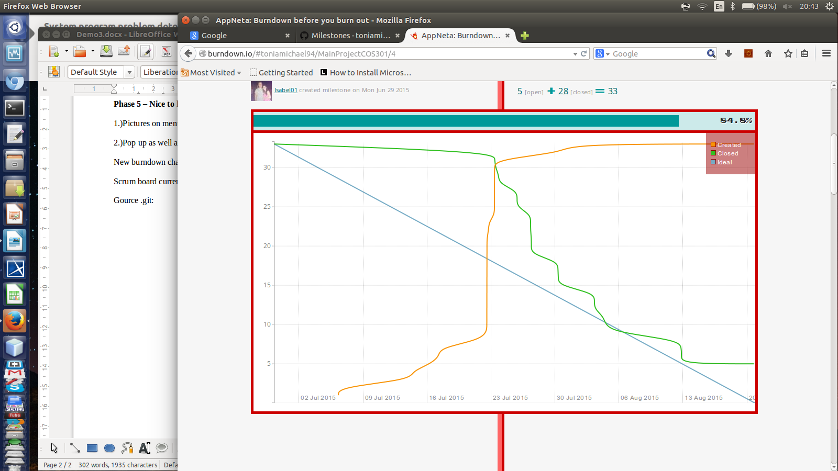

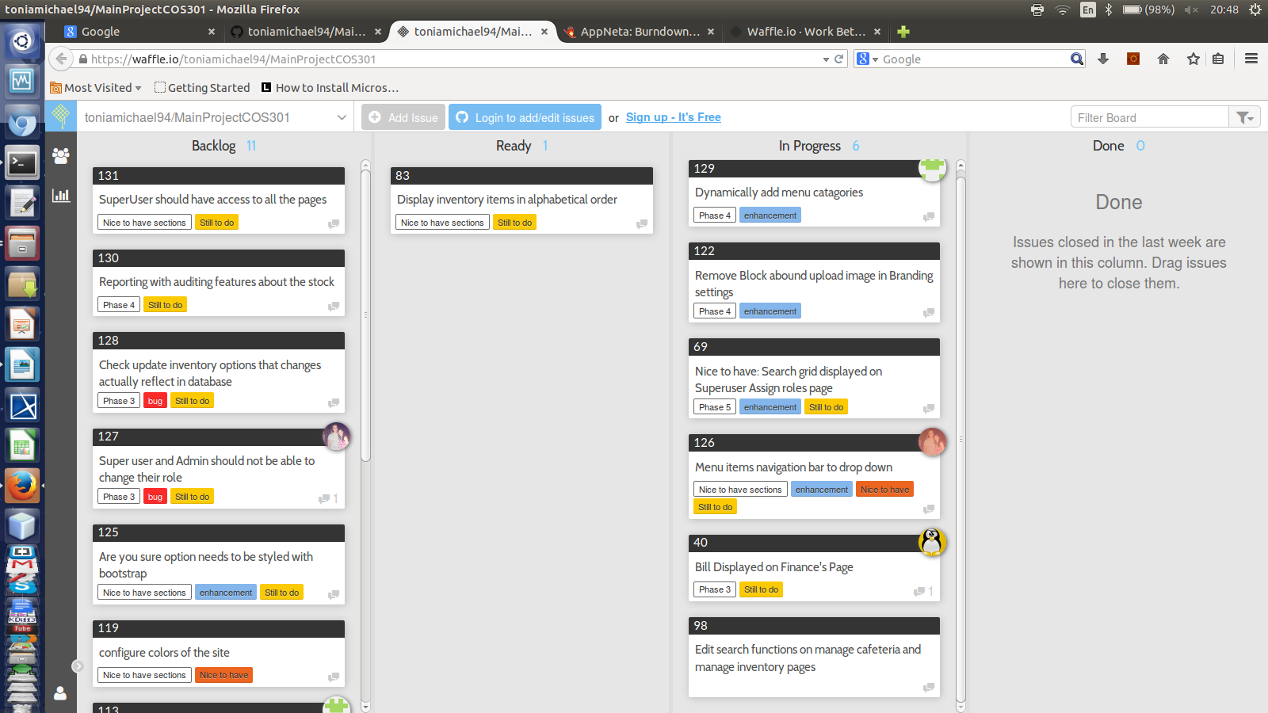

Scrum board currently:

Git group contributions and issue completion:

