Cafeteria Management System

**Client:**

Resolve

**Group name: T-RISE**

Rendani Dau 13381467

Elana Kuun 12029522

Semaka Malapane 13081129

Antonia Michael 13014171

Isabel Nel 13070305

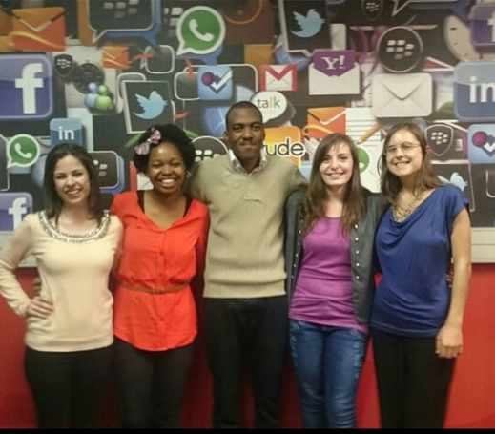

Contents

1. **The Team**
   1. **Antonia Michael**
      1. Interests
      2. Technical Skills
      3. Past experiences relevant for the project
      4. Non-technical strengths
      5. What makes you want to do the project
   2. **Rendani Dau**
      1. Interests
      2. Technical Skills
      3. Past experiences relevant for the project
      4. Non-technical strengths
      5. What makes you want to do the project
   3. **Elana Kuun**
      1. Interests
      2. Technical Skills
      3. Past experiences relevant for the project
      4. Non-technical strengths
      5. What makes you want to do the project
   4. **Semaka Malapane**
      1. Interests
      2. Technical Skills
      3. Past experiences relevant for the project
      4. Non-technical strengths
      5. What makes you want to do the project
   5. **Isabel Nel**
      1. Interests
      2. Technical Skills
      3. Past experiences relevant for the project
      4. Non-technical strengths
      5. What makes you want to do the project
2. **The Plan of Action**
   1. **The development methodology we will use**
   2. **How will you keep the client informed about the status of the project**
   3. **Any initial ideas we have around solving some of the technical challenges**
   4. **Technologies the team intends to use**
   5. **What the client will receive from us at the end of the project**

# **The team**

# 1.1 Antonia Michael

## 1.1.1 Interests

My interests include working with people, helping people, reading, tennis, greek dancing, and spending time with family and friends.

## 1.1.2 Technical Skills

My technical skills include: Java, C++, Html5, css, php, Bootstrap, Javascript, Semantic UI, Sql, php, python, WebGL, Latex, Github, shell script, AngularJS, NodeJS, Microsoft Office, Npm, HandleBars Server, Mongoose, Gemfury and Mocha unit testing.

## 1.1.3 Past experiences relevant for project

Programming

I have done an internship at a small IT company called Lepsta (Pty) Ltd, where I worked mainly on the front end of their new systems. I was mainly responsible to implement the GUI and front end functionality of their email client app called Ridicle, using AngularJS, Python, Semantic UI, and using Brackets as the platform. I also worked on a similar email client app there.

I also assisted in implementing a CMS Website for small enterprise, NCC Solutions. In addition, for COS 301 I was chosen to be part of the Infrastructure Integration team to integrate the code given to us from the functional teams. We used NodeJS, RoboMongo, Mongoose, Nodemailer, Npm, Gemfury and HandleBars server for our integration.

Business Analysis

I also worked as a business analyst at Lepsta (Pty) Ltd, where my duties included firstly, requirements management - gathering, defining, analysing and documenting business and functional requirements and designing a solution based on these requirements. Secondly, communicating requirements to programmers and other stakeholders ensuring that everyone understands what is required for the project to be a success. I also had to develop the business processes to provide a graphical flow of data, indicating the relationship between stakeholders and systems. I had to also design the test cases and implement the testing. Throughout the process I served as a communication channel, ensuring that all the teams knew exactly what was expected of them, and reported their progress and any concerns to me.

Project Management

At Lepsta (Pty) Ltd I also worked as a Project Manager. I developed a schedule for the project completion, allocating resources to the tasks. I also had to determine resources needed to complete the different phases of the project (i.e. time, money, technologies). I used a Gannt chart to allocate time frames for the different tasks in the project. I used a SCRUM board to keep track of the progress of the different tasks and to let the project needs see a visual representation of their tasks at hand. I had to keep regular communication with management to express the programmers' concerns and progress. It was also my job to develop team spirit and make sure that each member is contributing equally to the projects.

## 1.1.4 Non-Technical Strengths

My non-technical strengths include:

Firstly, I am a hard working, passionate and diligent student, who gives every task I do my full attention, and strive to only deliver good quality work. I work well with teams as I always consider each members view points and I dislike disputes, hence I always feel obliged to deliver more than my share in group projects in order to not let the large group of people that are depending on my efforts down.

Leadership skills -

1.) Head of Communications in The School of IT faculty House

2.) Selected by the Department of Computer Science to be an Infrastructure Team Leader for the module COS 301 for the implementation of The Buzz System,

3.) Was a class Representative for the module, Imperative Programming.

Public speaking and presentation skills - Got chosen as the best overall paper and presentation from our presentation at the 2014 ACEIE Information Science Conference held at The University of Pretoria. Was then selected by UP to present research paper at the 2014 Information Ethics Conference held at The University of Zululand, competing with students from UJ, UP and other universities. We obtained 2nd place.

Social responsibility skills - Tutored for the Basic Computer Training course (6 sessions) for underprivileged female students eager to pursue IT careers.

Organised and ran a Computer Training course for members of the community at UP Mamelodi Campus with a group of 4 other students - 40 hours of community work for JCP community development module in second year.

Debutantes Year at school (2010) – Hosted various events/programmes to raise funds for the Phehela Day and Night Centre and assisted with other similar charities.

Teaching skills - In addition, the computer literacy courses I have taught, I am currently a Tutor in the Computer Science Department at the University of Pretoria.

Other skills:

Communication skills, team work skills and people skills.

## 1.1.5 What makes you want to do the project

As soon as I read the proposal this project struck me because apart from the exciting challenge it poses, firstly, I thoroughly enjoyed working with databases in INF 214 (Information systems), as it was the first time in the degree that I knew we were learning a very relevant skill that we could directly apply in the industry. It would also be a very satisfying feeling to create a piece of software that the company can benefit from and use to make their cafeteria more efficient.

Secondly, I feel that completing this project will provide me with very important experience for the types of jobs I aim to persue (i.e. working with business systems and databases). I have always wanted to apply my IT skills to the business/ corporate environment.

I especially enjoyed the two modules, Netcentric computer systems and Database Management and Design in second year. In these modules we worked with systems, their databases and used Php, Sql, Mysql, Xxamp and Javascript, html and css, which I believe are skills that are going to come in very good use for this project.

Also, in the mini project for COS 301 (Software engineering) I worked with a MongoDB, writing schemas and using robomongo to view the database, which I also enjoyed. Hence, I feel that myself and my team will have the necessary skills needed for the project.

# 1.2 Rendani Dau

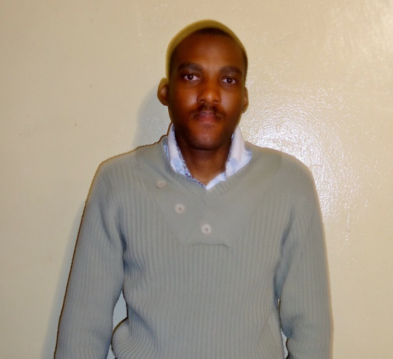

## 1.2.1 Interests

My interests include music, video games, hanging out with friends and any and everything related to Information Technology including but not limited to the latest technology trends and news and how technology can be used to better our everyday lives.

## 1.2.2 Technical Skills

My technical skills include: Programming skills in Java and C/C++. Web development technologies including HTML, JavaScript/jQuery, CSS, PHP, Bootstrap and NodeJS. Database programming using SQL (MySQL and Microsoft SQL) and Mongo DB. Programming in C\# including creating Windows Forms Applications, Advanced use of the .NET framework including linking databases (SQL Server, Microsoft Access, Oracle Database, etc.) to Windows Forms for CRUD functionality, creating Runtime Libraries (DLLs), creating client/server web applications with ASP.NET and creating reports with the SAP Crystal Reports plugin for Visual Studio. Also proficient with the Microsoft Office suite, Latex, XML and related technologies (XSL and DTD).

## 1.2.3 Past experiences relevant for project

I have successfully completed second year Informatics modules which predominately focused on Database design and management using SQL and programming in C\# with heavy focus on integrating SQL Server databases in Windows Forms applications and creating reports with Crystal Reports.

## 1.2.4 Non-Technical Strengths

My non-technical strengths include teamwork and communication skills which were honed by the COS301 Mini Project, thinking on my feet to solve problems and coming up with and voicing ideas.

## 1.2.5 What makes you want to do the project

This is one of the few projects that involves the use of technologies which I have extensive knowledge in and it coincides with my personal interests of using technology to better our everyday lives, in this case creating a Cafeteria Management System.

# 1.3 Elana Kuun

## 1.3.1 Interests

Programming is a big interest, I enjoy solving complex problems and creating working systems that other people can use. My hobbies include photography, playing music, and running. I like to read and write and I enjoy hiking trails and the outdoors. I am also very interested in psychology.

## 1.3.2 Technical Skills

Java, C++, HTML, CSS, PHP, JavaScript, XML, SQL, NodeJS, Mongoose, XQuery, JQuery

Some experience with databases, such as Neo4j, MongoDB, db4o, PostgreSQL.

## 1.3.3 Past experiences relevant for project

I have completed all my second and third year modules for my degree and believe this knowledge can assist me in this project. I particiapted in the COS 301 mini-project that prepared us for implementing big systems. I also completed two modules about databases and can code in Java which could be beneficial to this project as it relates to the required technologies.

## 1.3.4 Non-Technical Strengths

I am conscientious and work on a project until it is done. I take ownership of my work and deliver the best quality that I can. In a team I listen to the other team members and treat them with respect. I take everyone’s opinion into account, as well as voicing my own. When the situation calls for it I will take the lead. Communication is important and I do my best to keep other people up to date and follow the progress of the team. Being organised is important to me and I am always prepared. I always plan my work and stick to deadlines.

## 1.3.5 What makes you want to do the project

The project poses an interesting challenge and I am curious about how these types of systems work. This project is also very similar to the type of systems I want to develop in the future. I enjoy web development and the other various technologies that can be used in this project. I like the idea that this project can be used afterwards to solve a real problem.

# 1.4 Semaka Malapane

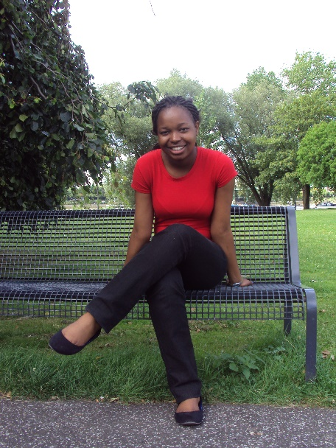

## 1.4.1 Interests

My interests are playing Sudoku, cards, puzzles, cooking, reading, shopping and spending time with friends and family.

## 1.4.2 Technical Skills

My technical skills include: C++, Java, CSS, PHP, HTML, JavaScript, NodeJS, node unit, Mongoose, WebGL, Microsoft Office, SQL and XML.

## 1.4.3 Past experiences relevant for project

I have successfully completed database management and design. Not only did I enjoy the module but it taught me the required skills - SQL and databases - for this project.

## 1.4.4 Non-Technical Strengths

My non-technical strengths include:

Team work and communication skills - The Software Engineering course offered us a mini project at the beginning of the year where we had to work in multiple different teams with different kinds of people. This gave me the opportunity to learn to work in a team setting and to communicate appropriately.

Public speaking and presentation skills - I participated in public speaking in 2011 and 2012. This taught me not only good speech writing but valuable presentation skills.

I also took part in a computer training course at the UP Mamelodi Campus in 2014 - this gave me the opportunity to better my public speaking and presentation skills.

Social responsibility skills - I tutored a Basic Computer Training course (6 sessions) for underprivileged female students.

I organised and ran a Computer Training course for members of the community at UP Mamelodi Campus with a group of 4 other students - 40 hours of community work for JCP community development module in second year.

## 1.4.5 What makes you want to do the project

This project seems like an interesting challenge. It will give us exposure to working with databases, which we aren't often exposed to. It will also be exciting at the end of the year to be able to see the end product of this working program.

# 1.5 Isabel Nel

## 1.5.1 Interests

During my past two years of studying Computer Science, I have developed a passion for software development. Finding creative solutions to problems in the form of software is something that daintily falls in my interests. I am also fond of the outdoors, helping others and baking. I also consider family very important and thus I love spending time with family and friends.

## 1.5.2 Technical Skills

My technical skills include: C++, Java, CSS, PHP, JavaScript, XML, HTML, SQL, WebGL, Microsoft Office and NodeJS.

## 1.5.3 Past experiences relevant for project

I have successfully completed my foundational programming modules and more specialized modules at the University of Pretoria, thus I am capable of producing adequate and usable software. I also participated in the mini-project of COS 301, which made use of the principles which will be used in Project Storm, which will help with the understanding of the project.

## 1.5.4 Non-Technical Strengths

I believe I am a good team player, with that I mean that I am a supportive person when it comes to team work, I respect my other team members and I am good in sharing my ideas and listening to other's ideas. I can take on a leadership position if need be, such as the position I was placed in for the mini-project of COS 301 as a middle level team lead.

## 1.5.5 What makes you want to do the project

As mentioned above the system described in the project proposal is closely related to the system that the University Of Pretoria uses for the students living in residences for the dining hall meals. I am a residence student at the university and it would be tons of fun to figure out exactly what needs to happen behind the scenes of such a system and to assist in the implementation of the Cafeteria Management System.

# **The Plan of action**

2.1 The development methodology we will use:

Business Requirements specification will be formulated in the following format:

1. **Functional requirements** will be created as follows: We will first formulate the use cases from the business rules given. From that we will create the services contracts and the use case diagrams (including the use case diagram for the whole system as individual components). Activity diagrams will then be drawn. Lastly, we will create the domain model for the system.

Non functionalrequirements will be created as follows:

1. **Software architecture documentation** - We will first devise the architectural responsibilities for the system.

We will then formulate the quality requirements, with reasons that each requirement was chosen, strategies to achieve the requirement and patterns to achieve the strategies.

After which the Integration requirements will be drafted. Here the integration channels, access channels, protocols and API specifications will be explained.

The Architecture constraints will then be formed, including the reference architecture, technologies, and operating systems that will be used. Lastly, we will decide on which architectural patterns best fit the requirements.

1. **Reporting requirements** specification will be drawn up from the client's requirements.

Before any implementation will be done we will consult with the client to make sure our documentation and ideas of implementation is correct and up to the clients standard.

1. **Implementation phase** - The use cases will be modularized and developed independently of each other. After thorough unit testing of the individual modules, these will be integrated into the whole system.
2. **Testing and verification** - separate unit testing of the individual modules will be done to check if the services contracts have been followed. Automated integration testing will also be done to check that the modules only integrate with the system if their services contract has been met.
3. **Documentation** - Technical reference and system user manual will be created. An instruction manual with screenshots will be created as well as additional documentation explaining the structure of the system.
4. Build and deployment scripts will be created.

## 2.2 How will you keep the client informed about the status of the project:

We will firstly email the client at the end of each week, stating the group's progress in the week, we will also set up a monthly meeting with the client to demo and get feedback. This can become a weekly meeting if required. However, we will email the client whenever we have questions or concerns. We will also require Resolve to give us deadlines for the deliverables that we should provide. (In this case e-mailing is just the most common and convenient way of communication, but if the client desires another way of communication we are willing to adapt to another method)

## 2.3 Any initial ideas we have around solving some of the technical challenges:

Since the Cafeteria Management System is web-based it would be optimal to have a user-friendly interface not just on the user side, but as well on the administrative side. The goal is then to keep the interface as simple as possible to be efficient to use for all users and administrative personnel. Another difficulty is making the actual implementation maintainable so that it can be altered if needed by the owner of the system, therefore sufficient documentation within the code will have to be made and descriptive names and so forth so that it is readable to external viewers.

## 2.4 Technologies the team intends to use:

At this point the following technologies have been considered, but this is subject to more research and contact with the client.

* A server provided by the CS department at UP that we have access to.
* Sql to create and manage the databases required.
* Github for version control.
* xml and java for the android apps.
* Swift programming language or objective-c for the android apps.
* Titanium studios - uses javascript uses middleware interpreter, completely cross platform - slow because it interpreting during run time.
* Xamarin - uses c # backend for the front end, runs natively on all platforms, platform specific frontend - uses xml gui

## 2.5 What the client will receive from us at the end of the project:

A flexible, pluggable, fully functional software application that will be maintainable, with detailed supporting documentation and an instruction manual.