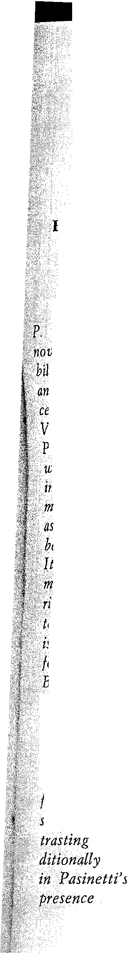
HISTORICAL EVENTS AS STRUCTURING ELEMENTS
IN NON-HISTORICAL NOVELS

In. recent years the figure of an Italian writer teaching in California, .P.M.Pasinetti, has received considerable international attention. His novels have inspired many a critic to explore the nuances of his acquired bilingualism (he writes with equal ease in ItaIian and in English), and to understand the syncretism of his narrative vision (Pasinetti places the action of his stories with equal skill in Berlin or in Rome, in Venice, in New York or in Los Angeles). As readers acquainted with Pasinetti's work since Venetian Red, we have become rather suspicious of words like "émigré" or "cosmopolitan" which have ben broadly used in the past and even now often come to the fore to place him on the map of our present literature. The expression " émigré, " hardly operative as a statement of facts for a transatlantic commuter - as Pasinetti is - between the country of his choice, the USA, and an "open country," Italy,· where he spends part of the year, contradicts the deep committment his art, where the elements of his personal adventure are experienced through the mediating screen of a subtle cultural irony and uplifted in learned structures of narrative inventions. The problems Pasinetti is aiming at as a writer, rather than being primarily spatial as they are for the Cosmopolitan or Weltbewohner, are qualitative and generational. Basically there is for him a gap to be bridged between two cultures- the humanistic and the technological. Such a gap may be emblematically represented by the contrasting moods of two countries, but also by two individuals, the urban ultraefficient technocrat who impresses the reader with the accelerated rhythm of his thoughts, and the sharply ironic, paradoxically intelligent and idyllic antagonist who patiently tries to recapture for himself and for society the reticent, forgotten rhythms of understanding and compassion. Between these two polarized images of contrasting individuals, there is a unifying continuum which we would traditionally call the historical atmosphere, always present and significant novels in Pasinetti's novels. It is because of this, because of the acknowledged presence of an historical pathos skillfully controlled and dissimulated

162
Pier Maria Pasinetti
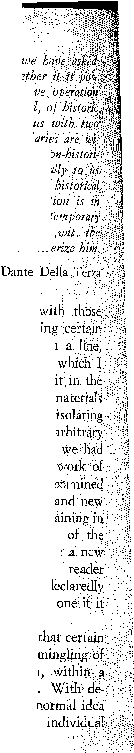
within the narrative textures 01 the writeris novels, that Pasinetti to answer the question relevant to us, as to

sible' to isolate within the Iramework 01 his or any narrative this delicate moment 01 lusion 01 background and loreground, atmosphere and personal evento Pasinetti has explained to lascinating examples from Verga and Proust what the
thin which history can be used as a supporting structure in cal novels. We then asked our friend to explain more
and to our readers how he has been personally able to use paradigms in his work 01 imagination, and il such an agreement with what he understands to be the task 01 a novelist. Pasinetti has answered this question with the sharp
learning and the gentlemanly graciousness which properly
The accidents of the literary profession combined af personal indination bave brought me - while specinc works of nction and teaching them - to focus on on a thread in the fiction, on a component in its structure, shall very simply refer to as the historical elemento To put most elementary terms: the use that nction writers make of taken from history. lt goes without saying that any such operation on a literary work of art 1s always an artificial and one: or at least, it would be so if we absurdly daimed that thus once and for alI devoured and digested the particular literature which we are studying and hopefulIy enjoying. The work will of course remain always open to new mapping, as there is no such thing as a criticaI Empyrean
nice order the supreme, dennitively comprehensive readings works we study. Rather, each new reading is somewhat like staging of a play; and in this case the stage director is the himself. An operation as the one l propose is therefore incomplete and arbitrary; but it will not be an irresponsible
is nrmly conducted on the texts themselves.

What l intend to do here, then, is to examine the use novelists have made of matetials offered by history. The historical events with nctional ones. The reverberation, fictional worId, of events generally accepted as historicaL finitions of this sort l may seem to be quite dose to the of what is referred to as the historical novel presenting

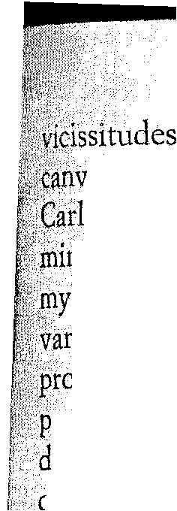
Historical Events in Non-Historical Novels
163
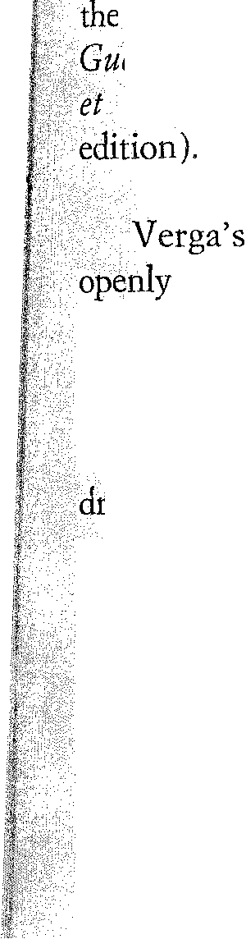
of nctional characters woven into some great historical
as. Renzo Tramaglino in Milan, Fabrice del Dongo at Waterloo,
il1⁶ Altoviti at the fall of the Venetian Republic. The indispensable inirrtG.rn of novelty with may be found in my discourse derives from ()hservation that the historical element is essential and qualifying in
ri()lls>works of nction which are not at all, so to speak, declared and

fessed historical novels. And incidentally, when I use the ex~~ssion " historical element " I do not postulate any limits as to its eg^{ree} of remoteness or vidnity in time. Historical events can be Ohtemporary to the author -the First War in Proust, to give one
example.
Within my present limits, the best thing to do is to work on a couple of very specific illustrations. Even so one cannot expect to dÒ thoroughly exhaustive work but mainly to indicate approaches and direàions that appear useful and p'romising.
For my present exerdse I have chosen passages from two works Which from any literary point of view may seem particularly far apart, f.e., Giovanni Verga's Mastro don Gesualdo, and Marcel Proust's Ala recherche du temps perdu. My Verga selections are: Part II, Chapters 2,3; Part. IV, Chapters 1,2, 3,4. My Proust selections are
afternoon reception at Madame de Villeparisis' in Le coté de
and the soirée at the Prince de Guermantes' in Sodome
Gomorrhe (VoI. II, pp. 182-298 and 633-725 in the Pléiade
historical Stoff and the way it is worked into the more

fictional action are too often neglected. One reason for that may be that the most conspicuous Verga characters are objects or indeed victims of a History they know nothing about; the main, or indeed the only relationship which some of the Malavoglias have with that kingdom 'of ltaly of which they technically are citizens, is the military
aft. But of course, from that very situation Verga drew effects of extraordinary interest; one needs only think of Luca's death, in the seafar away " toward Trieste." The Malavoglias' crudal year 1S 1866; from our present point of view, that would be the pivotal point in the novel's train of events. But I have chosen Mastro don Gesualdo which OfIers larger possibilities in my chosen area.
To begin with, it is of some interest to pIace Mastro don Gesualdo \Vithin the famous Verga project of a nctional cycle, on the typical

164
Pier Maria Pasinetti
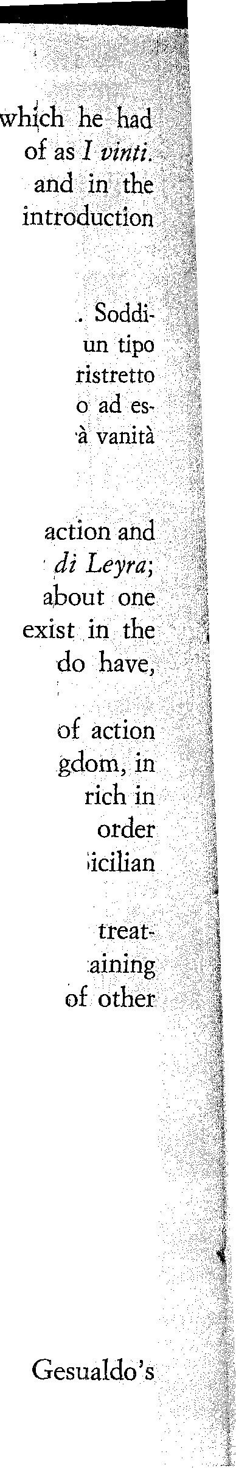
nineteenth-century novelistie theme of sodal ascent, first planned to call La marea and then definitively thought In a well known letter to his friend Salvatore Paola, celebrated introduction to I Malavoglia, intended as an 10 the whole projected cycle, he announced:
Nei Malavoglia non è ancora che la lotta pei bisogni

sfatti questi, la ricerca diviene avidità di ricchezze, e si incarnerà in borghese, Mastro don Gesualdo, incorniciato nel quadro ancota di una piccola città di provincia, ma del quale i colori
serè piu vivaci, e il disegno a farsi piu limpido e variato. Poi aristocratica nella Duchessa di Leyra ...
lt appears then that there would have been continuity in chronology between Mastro don Gesualdo and La Duchessa di
of the latter noveI, as everyone knows, Verga left only about
chapter. On the other hand, such continuity does not transition fromthe first to the second of the novels we do
I Malavoglia and Mastro don Gesualdo.

After J'Malavoglia, one might have expected continuity within the historical miIieu of Sidly as part of the ltalian
the period shortly after the unification of the country, a period economie upheavals and finandal passions; on the contrary, in to pIace historieally his examples of sodal ascent, and or aristocracy going to pieces, the author went backward in time.
1821 and 1848: the two dates are pivotal in any
ment of the period; and they constitute basie and significant sustainirig
points also in the private destinies of Mastro don Gesualdo, prominent characters, and generally in the lite of that village, or small town, whieh.is the novel's main stage. They correspond to the two sections which I have chosen for particular inspection.

There are considerable analogies between the narrative pattetns oE the two sections. Not only is the historical element reverberation oE revolutionary movements on the local scene - actively and irreplaceably connected with the story oE the protagonist andof other very relevant characters; it is also introduced at moments oE high tension, during crudal scenes ,or series oE crudal scenes.
In the first case, revolutionary agitation in the Sidlian town
coinddes with the labor pains ofBianca 'Irao, Mastro don

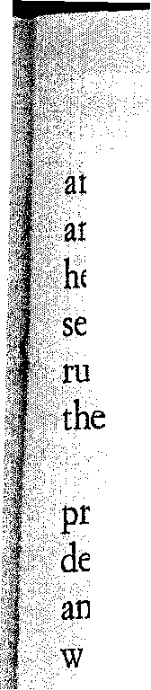
Historical Events in Non-Historical Novels
165
istocratic wife who will give birth to a daughter not his own; hdit coincides also with the last agony and the final demise of er.brbther, don Diego Trao. In the second case, 1848, this centraI asbn of European revolution presented h;:re in a provincial, almost stic version, coincides with the death of Bianca herself and with
revelation of the eponymous hero's mortaI illness.
So the narrative patterns of the two very important sequences

resent analogies and syrrimetries which the historical elements cidedly contribute to create. lt should also be added that such alogies - as is always the case when one explores a literary ork of art as a living organism, not as a corpse laid out in front
(jfthe anatomist - once they are singled out, pIace the differences illsubstance and treatment into sharper evidence.
The first series of episodes is treated by the narrator in a frequently comic-pathetic key; in the second series, though the rough patheticism is still there and will culminate in Gesualdo's famous goodbye to Diodata, funereal notes have a darker and more final sound.
Let us exanime the first series. Briefty, we are interested in the counterpoint between individuaI character and public action. Gesualdo's involvement in the giacobino-carbonaro historical moment is presented along a pattern of action quite dose to that of rustic farce, Obviously no Ristory i5 being made in the small Sicilia n town; it echoes events whose ~picenters are far away. From the ambiguous Canon-priest Lupi, Gesualdo hears that revolution has broken out in Palermo (" A Palermo hanno fatto la· rivoluzione ") and since revolution means " rivoltare il cesto, e quelli .ch'erano sotto salire a galla: gli affamati, i nlillatenenti. .. " Gesualdo obects: "Ebbene, cos'ero io vent'anni fa? "
So he associates the <:anon himself to his own rudimentary and sly scheme of action: . with precise stylistic adequacy, his political are a true mòsaic of folksy idioms:
... cavare le castagne dal fuoco con le zampe del gatto, tirar l'acqua al suo mulino, e se capitava d'acchiappare anche il mestolo un quarto d'ora, e di dare il gambetto a tutti quei pezzi grossi che non era riuscito a ingraziarsi neppure sposando una di loro ...
Re proceeds in the· sarne colloquial manner, withpathetic . inserts toward Bianca, especially later on, when the pathetiè-farcical plot thickens:


166
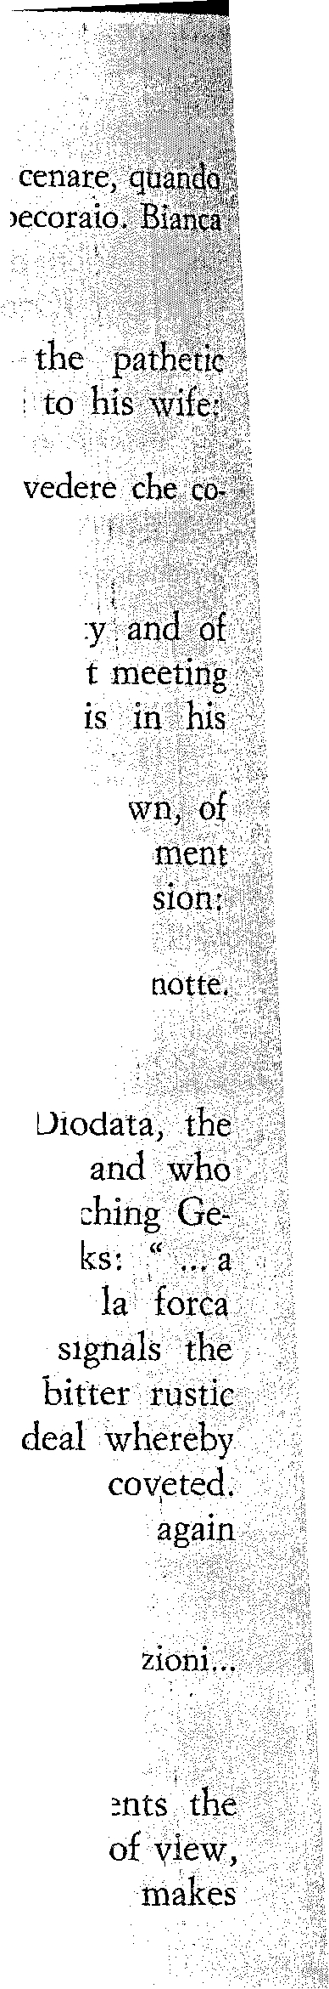
Pier Maria P asinetti
Verso le due di notte, don Gesualdo stava per mettersi a venne a cercarlo in gran mistero il canonico, traverstito da fu 11 li per abortire dallo spavento ...
Although the two men are clumsy with fear, essence of the scene is expressed in the hero's last !ine
" H' Sono contento d'andare magari verso il precipizio, per minci ad affeziona l'ti a me e alla casa ... "
Soon all illusions fall, at thc level both of domestidty. political plotting. While Gesualdo is on his way to the secretm in the night, someone warns him that "la giustizia"
house ..
And in fact, even at the leve! of this small provincialìÒ thi~; emblema tic dimension, of this concrete universal, themo of police intervention has come,'the moment of reaction andrepres
... era arrivata la Compagnia d'Arme, all'improvviso, a quattr'ore dia Il Capitano e altri Compagni d'Arme erano in casa di don Gesualdo.
He seeks refuge in the country, in the house of
faithful servant who has given him illegitimate chìldren
has been marriedoff by him to Nanni l'Orbo, Nanni,
sualdo alone with his wife in the middle af the night, asks: che giuoco giochiamo?" and' Gesualdo's antwer, "Ho dinanzi agli occhi, e tu vieni a parlarmi di gelosia ",
tone of the scene, which I would describe as that of
farce. Bitterness thicl<:ens when the two men mal<:e a
Nanni will receive from Gesualdo a piece of land which he In this context the supreme key-word in the book, La roba, makes its appearance:
" ... La roba 'serve per queste occasioni ... carceri, malattie e
Voi l'avete fatta, don Gesualdo, e serve per salvare la vostra pelle ... "
Verga, with a true novelist's genius and sagadty, apparition oi the police in Gesualdo's home from two points or in twù different versions. And far the second one he characteristic lIse af narration in the past perfect tense:

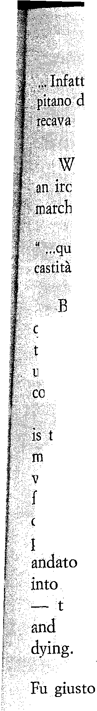
Historical Events in Non-Historical Novels
167
l/Bianca la sera innanzi s'era visto capitare a tre ore di notte il Ca1,Arme, un bell'uomo colla barba a collana e i baffi. alla miiitare, che ilbigHetto di alloggio.
e witness here, so to speak, a re-dimensioning of the police, nical cutting down to size, especially when Bianca's unde, the heséLimòli, brings his own contribution:
testi qua sono militari per modo di dire; come io ho fatto il voto di perché sono cavaliere di Malta. "
etween the nobleman and the bearded soldier a heroicomic quatre! would ensue, but we have instead a sharp break in tone, thf/sexton's boy arriving with some news which only Bianca hderstands intuitively; with a lacerating cry she looks for her àL to rush out of the house.
T'bis is the dose of Chapter 2; and the transition to Chapter 3 ypical Verga. The opening of Chapter 3 represents one of those 6111ents when a narrator seems to catch his breath, to readjust his ision on a wider perspective, picking up the narrative thread from llrther back, establishing useful points, resuming old ones in a
different key, summarizing; thus with his customary adoption of the past perfect tense (ex.: "L'ultima volta il dottor Tavuso se n'era
scrollanao le spalle ... ") he prepates the narrative terrain which he can insert a crudal pieceofnews almost inddentally
the news, in this case, that don Diego Trao, Bianca's brother the epitome of decaying and grotesquely proud aristocracy, is
quella notte che arrivava la Compagnia d'Arme. Una baraonda per tutto il paese. Al rumore insolito anche don Diego apri un istante gli
Reaction meanwhile is in full swing, law and order have won the And again we have a perfect mingling of the two levels, public domestic:
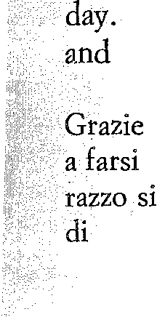
a Dio si tornava a respirare. I ben pensanti sul tardi cominciarono vedere di nuovo per le strade ... Le ragazze Margarone, stipate sul terrodevano d'invidia. Specie il tenente ci aveva dei baffoni come code cavallo, e due file di bottoni lungo il ventre che luccicavano di lontano.

168
Pier Maria Pasinetti
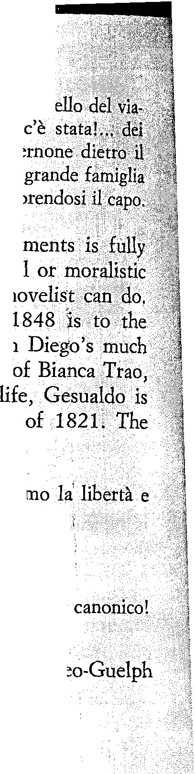
Talché in quell'aria di festa suonò più malinconico il campan tico. Correvano anche delle voci sinistre: "Una battaglia condannati a morte! " Uno di quelli che portavano il baldacchino disse che il viatico andava dai Trao. " Un'altra
che si estingue! " osservò gravemente l'Avvocato Fiscale
The mutuaI encroaching of public and private obtained without easy theatricality, without socioiogicai
abstractions, in other words, as only the art of the
1821 is to dòn Diego Trao's Iast agony what mortaI sickness of Mastro don Gesualdo himself, don undesired brother-in-law; and of course, to the death of
the hero's ill-chosen bride. At the level of public now very far from his grotesque carbonara moment Cunon now teIls him:
" S'ha da fare la dimostrazione, capite? Gridare che
Pio Nono an~he noi ... Se no ci pigliano la mano i villani ... "
Gesualdo's reaction:
" Ah? La stessa canzone della Carboneria? .. Vi ringrazio tanto, Non ne fo piti di rivoluzioni! "
The Canon, who could, I suppose, be labelled a opportunist, tries to corner him:
" VuoI dire che difendete il Borbone? ParIate chiaro. "
Gesualdo ineluctably takes refuge behind the key-word whole life:
" lo difendo la mia roba, caro voi! "
Meanwhile his wife, Bianca Trao, is dying. There is continuous mingling of private and public action. In fact, quite
in the closing pages of Chapter 2 (Part IV) not only do we observe the usual interweaving of public and private, but actually the former prevails over the latter. Bianca's death is not given directly. Visions and voices from the outside, far trom providing mere background effects, are actually given a lead1ng position inthe narrative:

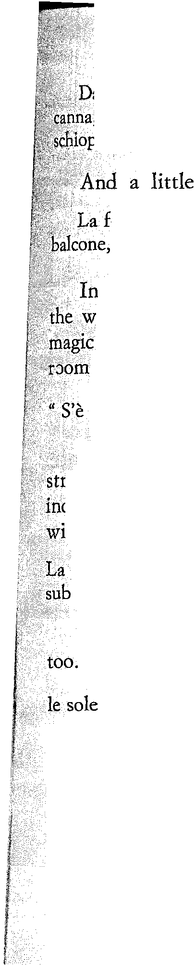
Historical Events in Non-Historical Novels
169
alla via del Rosario spuntava una bandiera tricolore in cima a una ,e dietro una fiumana di gente ... Di tanto in tanto partiva anche una ,pettata.
further:
folla era giunta lì, sotto la casa; si vedeva la bandiera all'altezza del
quasi volesse entrare. Si udivano degli urli: viva, morte.
the room ,one of the relatives tries to push Gesualdo to window by warning him: "Vogliono la vostra roba! " But the word does not operate, Gesualdo paces up and down the and closes the chapter with the cryptic line
fatta la festa, s'è fatta! "
With a narrative movement which is rather typical of Verga, the traight news of Bianca's death is given in the following chapter, dcidental1y, as of an event already taken for granted, minimized
'thin the larger framework:
povera morta se n'era andata alla sepoltura in fretta, fra quattro ceri, nel buglio della ge'nte ammutinata ...
For aH practical purposes, Gesualdo's death begins at this point In the small town,
finestre che rimanessero chiuse erano quelle di Gesualdo Motta.
Hidden in his cave like a wolf, he is considered the town's enemy; they inform him that he is a " borbonico" and a " nemico giurato dei poveretti e dei liberali ", or a " campione della mercanzia" . They compel him to escape, to move from one hiding pIace to ~hother; the last station in his journey will be the most luxurious and at the same time the most horrible - the Palermo palace of his son-in-law, the Duke of Leyra, where he will die. The religion of " la roba " has mockingly betrayed him. One of the last appearances
that key-word seems to me admirable. The doctor, Bomma, is examining Gesualdo, feeling on his bel1y the external signs of the cancer that will kill him:
E intanto i dolori e la gonfiezza crescevano: una pancia che la gambe non la reggevano piti. Bomma, picchiandovi sopra, una volta disse: "Qui c'è roba. "

170
Pier Maria P.asinetti
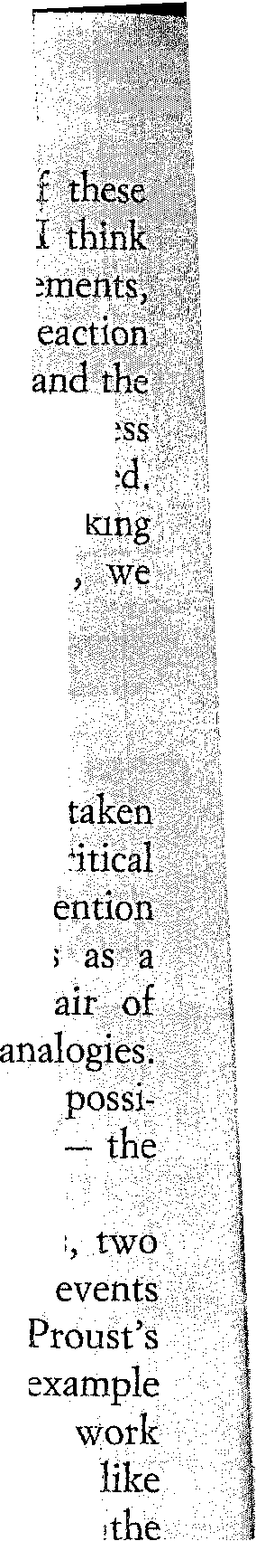
One could, of course, devote long pages to an analysiso last chapters. But in the framework of our particular readitig, we can legitimately conclude that without the historical··· ele
which I have summariIy attempted to isolate, Gesuald?'fit
and his tragedy, his blind instinctive returns to the word roba) . unal faiIure of those returns, would hardly function; their. effectiv~~~ would be numbed; the work in generaI would be vastly impove~ishe The «historical element» here powerfully contributes to. ma' . the literary work of art il fully living organism; with()llt it
would miss essentiai supporting points and perspectives.
The transition from examples taken from Verga to exampies t from Proustmay seem to imply an excessive degree ofei acrobatics. I do not think the contrast is as sharp as that. To m evident points, the themes of sodai ascent, of snobbishness
sodal force, of aristocratic breakdown, so present in the European uction, would offer possibie though schematic

In any event, here again I shall limi t myself to exemplifying bilities for reading and analysis in the direction I have chosen
uses of historical elements as supporting structures.
On the contemporary scene, Proust found two focal points,
clusters of public actions which involved the individuaI in the

of current history - the Dreyfus .affair and the Great War. political and historicai awareness is usually neglected. Yet for
the Great War plays an inunitely more important role in his than it does in a supposedly more history-conscious novel Mann's Zauberberg. (The last astonishing conversation between Narrator and the Baron de Charlus in Le temps retrouvé, as well the unal reception in the house of the new Princesse de
take pIace on the background of wartime Paris).
Of course there exist in Proust wider dimensions which also be "described as historical: the awareness of andent, presences which the characters carry within themselves,
or unknowingly. Working in this direction, and taking as a scheme the Swann-Guermantes bifurcation, one could perhaps come to some such concIusion .as this: that the ancestral Hebrew element in Swann, reçognized by the Narrator for ex ampIe in a celebrated passage in Sodome et Gomorrhe (whiCh I shall ha ve occasion t()

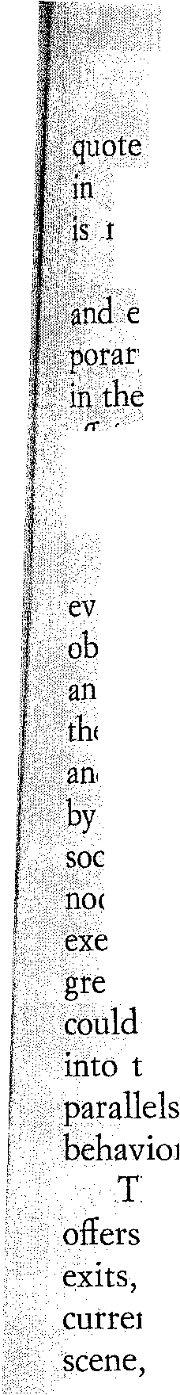
Historical Events in Non-Historical Novels
171
later) is symmetrically analogous to the Medieval element tre Guermantes', particularly, of course, the Duchess as she m.y:thiçized by the Narrator as a child in the Combray church.
Bere,however, I shall limit myself to some rapid indieations Htemplifications as to the way in whieh one of the two contem-
yclusters of events I mentioned above importantly operates
canvas of the Proustian narrative; and my choiee is the Dreyfus ll~~lt .••• I shall base my observations upon the two long sequences f~8ll1,Le coté de Guermantes and from Sodo me et Gomorrhe as I have indiçated them earlier.

To keep our feet 0n the ground, or rather, to stiek to the idence of the written text, let us begin with a simple generaI servation by' way of premise. In a given author, one finds again cf.again certain recurrent patterns, organized shapes, within which ecourse of the narrative is characteristically and usefully ordered
dchanneled. In Proust, of course, one such pattern is provided the scenic and dramatic structure of the large reception in high iety. There is nothing frivolous in this. Proust's receptions, after-

ons chez ... , soirées, can be studied, to say the least, the way mplary battles are studied at military schools; and with much ater intellectual and human profit. For that matter - and this be another way to show how the historical element is woven
the narrative - Proust on occasion adopts more or less explidt
between. individuaI behavior at the sodal level and the of nations atthe level of grosse Politik.
The pattern of the reception, of the high ranking sodal gathering, considerable possibilities:veritable parades of entrances and polyorchestration of talk, distribution of the material into and subcurrents of dialogue at different points on the
or different rooms in the house; a great variety of observatories is available to the Narrator, in space as well as in time. The final reception in Le temps retrouvé at the new Princesse de Guermantes', whieh is one of the highest points in the history of fiction writing,
not have been possible in its astounding effectiveness had it been preceded by a whole series of events analogously constructed.
The modulation of points of view on recurrent characters within the
repeated and ever different generaI pattern permits both the most solemn effects and the most varied degrees of irony, of humor, of all that makes Proust, among other things, one of the great comie geniuses in literature. (At the risk of appearing sacrilegious

172
Pier Maria Pasinetti
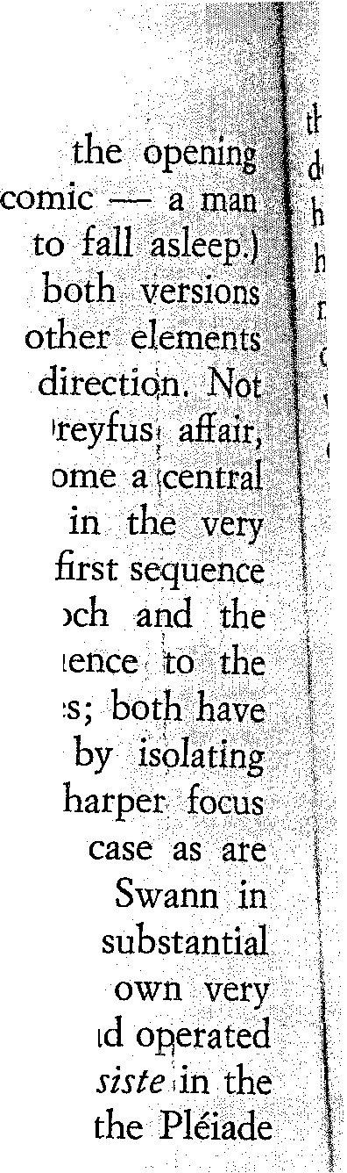
to more austere Proustians I must confess that even situation of the Recherche seems to me potentially asleep being awakened by the fear of not being able

The two sequences which I have proposed are of the same recurrent pattern; and they have also in common as to matter, construction, and narrative only is the same duster of historicai events, the importantly present in both to such an extent as to organizing e1ement; there happen to be symmetries construction and arrangement of the scenes. What in the
is represented by the verbai encounter between Bloch
Marquis de Norpois corresponds in the second encounter between Swann and the Prince de Guermantes;
the Dreyfus case as their centraI theme. As usuaI,·
a «symmetry» in a literary work one brings into
the differences in matter, tone, effects, so vast in this the differences between Bloch in the first sequence and the second, the two characters who ultimate1y qualify a part of the action inasmuch as they incarnate, in their different manners and styles, Dreyfusism, an issue which had

in that sodety something like a tornado: le cyclone Narrator's words (Le coté de Guermantes,in VoI. II of edition, p. 190).
The first sequence, if this can be of any interest, is c1early datable since Bloch has evidently just arrived from having at~ended one of the sessions of the triai against EmiIe Zola: Pebruary 1898. As a period piece, naturally the section indudes many rituai gestures
and the Narrator àploits some of them to obtain even comic, farcicai effects: for example, the equivocations as to the

of some of the top hats which gentlemen in those particular seasons used to carry into the salon and put ori the floor to the pIace where they were seated. Not to mention the comprehensive notion of a Iady having "her day" in the
of a particular day of the week in which she would be At Home to her visitors ..
The salon of Mme de VilIeparisis has a rather peculiari position; we cannot even begin to go into the intricate reasons for that. Let us simply recall that she is the oid mistress of retired ambassador, M. de ]\T<)rpois, a primary character i1'\ sequenceand more generally 111 the whole Recherche at least r since
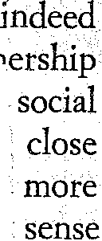


•
Historical Events in Non-Historical Novels
173

.!~i>()penlng of the second noveI of the cyc1e. The nature of Mme rY~leparisis' position in society permits the author to introduce stef?geneous characters, such as the Prussian envoy, prince Pfaffeniçim;~?o by his presence contributes modulations on a theme, Ger-
m, which will be a remarkable ingredient in the composition

~~eJsharacter of Charlus, possibly the most outstanding male ~piçyil}.the Recherche after that of the Narrator himself. Thc Baran r.:icRhàrlus, of course, is also present at the Villeparisis gathering. >;>"\l!enaturally cannot linger on the various characters' enttances ~pdiroles, savoring them one by one; nor can we try to analize eVel1sketchily the otchestration of the whole sequence. I must content J1)XSelfwith a peremptory statement, namely, that the most profltable ~~fic()fdetecting a structure in the long and complex scene is to \lis~.ali~e it as being organized around the historical event of the p~figclFthe Dreyfus affair. All characters of some televance must, oneway of the other, passer par là; it is a touchstone, an essentially g~alifYing elemento Andthe center of the scene, the culminating duet, isthe encounter between Bloch, a Jew, and Norpois, a nobleman ~~~ii~". diplomat " in the most archaic sense of the expression. On ()l1lfside we have Bloch's mercurial emotionalism; on the other, the ailibassador's typical manner of discourse, his false decisiveness, his §h~llow pseudo-flrmness, his pseudo-independence of judgement and platitudinous patriotism.
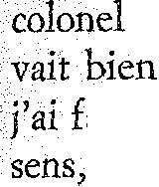
Bloch cherchait à pousser M. de Norpois sur le colone! Picquart.
----- Il est hors de conteste, répondit M. de Notpois, que la déposition du

devenait nécessaire pour peu que le gouvernement pensa qu'il pouy avoir anguille sous roche. Je sais qu'en soutenant- cette opinion

fait pousser à plus d'un de mes collègues des cris d'orfraie, mais, à mon le gouvernement avait le devoir de laisser parler le coloneI. On ne sort pas d'une pareille impasse par une simple pirouette, ou alors on risque
dans un bourbier. Pour l'offieier lui-mème, cette déposition à la première audience, une impression des plus favorables. Quand l'a vu, bien pris dans le joli uniforme des chasseurs, venir sur un ton parfaitement simple et frane taconter ce qu'il avait vu, ce qui'il avait cru, " Sur mon honneur de soldat (et iei la voix de M.de Norpois vibra d'un tremolo patriotique) telle est ma conviction, " il n'y a pas à nier que 'impression a été profonde.

" Voilà, il est dreyfusard, il n'y a plus l'ombre d'un doute, " pensa Bloch.
- Mais ce que lui a aliéné entièrement les sympathies qu'il avait pu
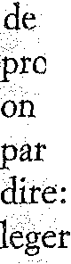

174
Pier Maria Pasinetti
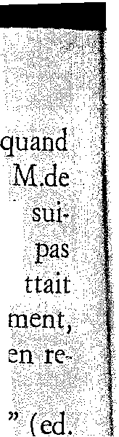
rallier d'abord, cela a été sa confrontation avec l'archiviste Gribelin:

on entendait ce vieux serviteur, cet homme qui n'a qu'une parole, (et Norpois accentua avec l'énergie des convictions sincères les mots,qùf virent), quand on le vit regarder dans les yeux de son supérieul',<ne craindre de lui tenir la dragée haute et de lui dire d'un ton qui n'~drnettl:t1 pas de réplique: " Voyons, mon colonel, vous savez bien qu'en ce ma. comme toujours, je dis la vérité ", le vent tourna, M. Picquart eùt bi muer ciel et terre dans le audiances suivantes, il fit bel et bon fiasco.
" Non, décidément il est antidreyEusard, c'est couru, sedit Bloch. cito pp« 240-241).
In this almost molièresque use of symmetrical repartee \ve a prize example of the comic and satirical ingredients in the sequence. In other words, we have an extremely" stylized " historical materials (as opposed, e.g., to the reportage on the affair in Jean Santeuil). But this by no means proves that the rejects, softens, or eludes " histoty; " if anything, lt shows has more importantly and sensitively woven its elements work of art, of which they have become essenti al supports.
Among those present at Mme de Villepatisis', Norpois most eloquent and at the same time the most deeply

to the sodal and morai problems involved in the Dreyfus Among other titled characters - who are not, however, like pois, public servants - there prevails what I would
calI a kind of aggressive morai and mentaIIaziness. More
the mind of the aristocratic Right seems to take certain
irreievant sodal patterns as a starting point, an a priori;: and applies them to a tragic situation which was, to use a phrase often applied in other historical situations everywhere, splitting the country in the middle ...
Hence, also, the satiric touches: Basin, duc de

deplores the pro-Dreyfus stance of his nephew, Robert de SainfLoup, who commits this fatai sodai biunder now that he is to be presented for membership in the Jockey Club; and both the Duke and Duchess deplore the attitude of Swann who, a Jew, has the inconceivable bad taste of being a dreyfusiste and thus showing his ingratitude to a sodety which had received him as one of its own; and so forth. The sequence will conclude with the exit of the Narrator pursued by the Baron de Charius who in a sort of grotesque grand finale picks up the centraI Dreyfus thread and works on it by manifesting his anti-dreyfusist and anti-semitic obsessions in a patho-
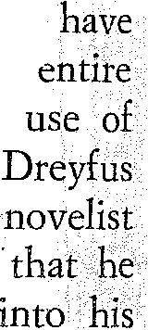
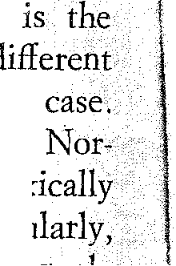

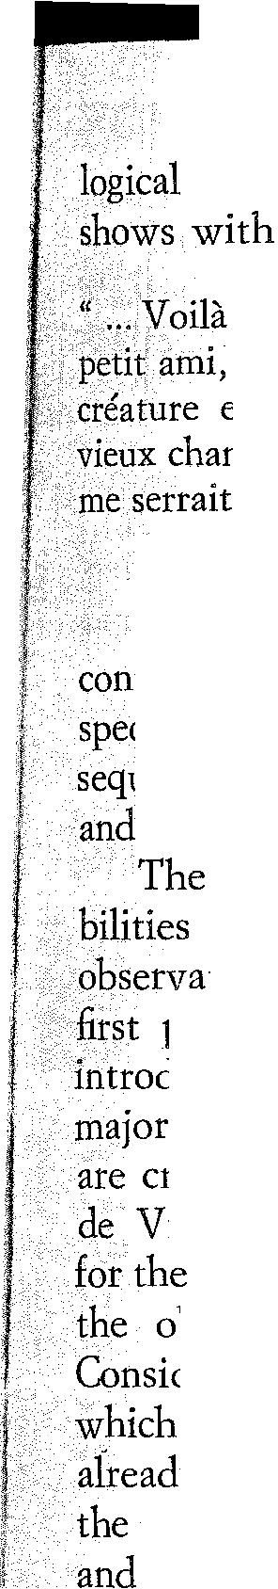
Historical Events in Non-Historical Novels
175
key, Why, he suggests, couldn't they organize liule private Bloch, for ex ampIe having Bloch's mother flogged?
qui serait fort bien fait et ne serait pas pour nous déplaire, hein! puisque nous aimons les spectacles exotiques et que frapper cette extra-européenne, ce serait donner une correction méritée à un chameau. " En disant ces mots affreux et presque fous, M. de Charlus
le bras à me faire mal.
(pp. 288-289).
Furthermore, as the Narrator returns to his home which is to that of the duc de Guermantes, he becomes the to a kind of subplot, a brief folksy version of the preceding a dispute between his own butler, naturally pro-Dreyfus, the Guermantes' butler who is just as naturally anti-Dreyfus.
Villeparisis sequence would of course ofler endless possifor further analysis. I shall confine myself to two more in keeping with my generaI line of study. In the pIace, here too, as in the very diflerent Verga examples, the
of crudal " publie " elements occurs during scenes of significance, sustaining and qualifving pieces of action that crudal also at the " private" level. The afternoon visit to Mme Villeparisis marks an important moment in the Narrator's life:
first time he meets there, being introduced to her " in society, "
object of his long adoration, the Duchesse de Guermantes.
the sophistieated but frivolous and naively cmel lines he auributes to her, it is legitimate to observe that we have here the beginning of one of the 110vel's centraI operations, dismantling of the myth of this woman who had been a supreme mysterious vision to the Narrator in the Combray church, in a magie aura of Medievai gentilesse.
My second observation concerns the pIace of the Villeparisis sequence in the course and the larger rhythm Of the Proustian narrative. 1t seems significant to me that it should be followed bv the series of scenes chiefly occupied with the siekness and death of the Narrator's grandmother. Those scenes constitute a return ta, and a reaffirmation of that wider point of view, rooted in the authenticity of his domestie milieu, from whieh the Narrator relentlessly examines and dismanties the Guermantes world. 1ndeed, in what I would calI. the morai structure of the work, Grandmother is a dominating figure. Never more clearly so than when she is shown in the sleep

176
Pier Maria Pasinetti
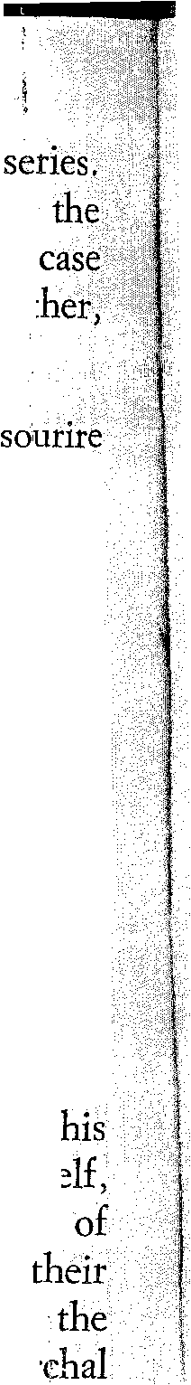
of death, in the celebrated passage which doses that long
By means of a crudal image the Narrator seems to imply that Medieval past of pure and fasdnating gentilesse, which in the cas of the Duchess runs into serious danger, is preserved in Grandmothe
entrusted to her:
La vie en se retirant venait d'emporter les désilIusions de la vie. Un semblait posé sur les lèvres de ma grand' mère. Sur ce lit funèbre, la comme le sculpteur du moyen age, l'avait couchée sous l'apparence d'une jeune fiIIe. ( (p. 345).
In the second of the two seguences which I have proposed" the soirée at the princesse de Guermantes in Sodome et Gomorrhe( death as a latent image is essential. Particularly, the imminent death; clearly announced, of one of Proust's most conspicuous characters, Charles Swann .As I have already suggested, Swann here occupies, mutatis mutandis, somewhat the position that Bloch occupied in the Villeparisis seguence. And the differences, of course, could hardly be sharper. Bloch was young, a successful dramatist, verbose, not at all incapable of coarseness. In the new scene the incarnatiort of Hebraism which as an object of persecution has its emblem in the innocent prisoner on Devil's Island, is this old Swann. Traits of former self as a sensualist (when for example, in spite of

he looks down the décolleté of Mme de Surgis) and as a mémber the establishment (he refuses to follow the dreyfusards in anti-militaristic campaign) become marginaI in comparison with image of the dying man, stupendously purified, his
traits, so to speak, wide open .
... SWann appartenait à cette forte race juive, à l'énergie vitale, à la résistance à la mort de qui les individus eux-memes semblent participer. Frappés
cun de maladies particulières, comme elle l'est, elle-meme, par la persécution, ils se déhattent indéfiniment dans des agonies terribles qui peuvent se longer au delà de tout terme vraisemblable, quand déjà on ne voit qu'une barbe de prophète surmontée d'un nez immense qui se dilate pour aspirer les derniers souffles, avant l'heure des prières rituelles et que cç>mmence le défilé ponctuel des parents éloignés ,,'avançant avec des mouvements mécaniques, comme sur una frise assyrienne. (pp. 704-705).
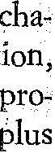
Confronted with this formidable new Swann, the unchanged de Guermantes has imperturbably followed his old line; it is to. him that admitting Swann into their sodety was a mistake

Historical Events in Non-Historical Novels
177

puisqu'il prend parti pour ce Dreyfus (qui, coupable ou non, ne fai t nullement partie de son milieu, qu'il n'aurait jamais rencontré) contre une société qui l'avait adopté ... Je le jugeais mieux. Il avait de l'esprit (dans son genre, bien entendu). Je sais bien qu'il avait déjà fai t l'insanité de son honteux mariage. (p. 678).
A coIlateral irony is in the fact that Swann's shameful wife Odette
, ,
" patriotic " feeHngs and is anti-Dreyfus.

The soirée at the princesse de Guermantes' is a more complex sequence than the afternoon at Mme de Villeparisis' but a generaI sttucture is not difficuI! to recognize. The opening situation has comie elements: the Narrator is not sure whether he has been invited, and this uncertainty will carry him from one guest to another, in a series af attempts to have himself formally introduced to the Prince. This is one of the two strategie lines upon which the long scene is structured. The other, more important Hne centers on Swann. In the wide range of dialogues and minute minor sub-scenes, the news is being spread that the Prince is to have a direct man-to-man confrontation with Swann; and that the purpose of this is to show Swann - a Jew and a dreyfusiste - the door.

Thus after the Narrator has happily conduded his long search for an introducer - whieh has permitted him vignettes and ironies af alI kinds - a new line of search and a new source of su spense opens up for him: finding out from ~wann what he and the Prince have
saying to one another. Swann's report to the Narrator wiIl come
within the immensely wide and varied network of dialogues and encounters; its final result will be the revelation that the Prince, far from showing Swann the door, has wanted to dear his conscience by admitting to having reached the conclusion that Dreyfus is innocent. There are ironies and comie touches here too; for instance, the Prince and Princess have independently arrived at the same view as to Dreyfus' innocence; and secretIy, each on his own, they have had HoIy Masses ceIebrated for the degraded ofhcer whose martyrdom on Devil'sIsland meanwhile is continuing.

So once more the Dreyfus theme is an essentiaI organizing elemento lt coincides here with what l have indieated as a centraI point in the sequence, the awareness of Swann's imminent death. lt is hardIy necessary to recall what this character has represented in the earIier parts of the Recherche - as important as any; indeed, an earIy protagonist. Hence, obviousIy, this is a moment of pivotal interest
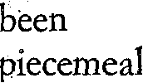

178
Pier Maria Pasinetti
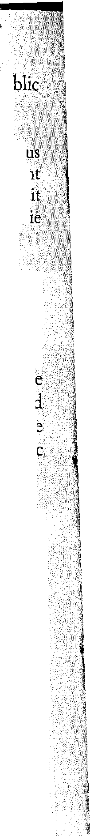
in the generaI construction of the work. The convergence of pu and private theme, Dreyfus aftair and Swann's death, is explidt:
, .. peut-etre chez lui, en ces derniers jours, la race faisait-elle apparaìtrepl accusé le type physique qui la caractérise, en meme temps que le sentifilen d'une solidarité morale avec les autres Juifs, solidarité que Swann semblai avoir oubliée toute sa vie, et que, greffées les unes sur les autres, la malad' mortelle 1'affaire Dreyfus la propagande antisémite, avaient reveil1ée.
The figure of dying Swann becomes ~ven more memorable in the tight of an ironie twist with whieh the sequence will come to its dose. The Narrator Ieaves the prince de Guermantes' palace in the carriageof the Duke and Duchess, who will soon be on their way to a masked baU and therefore do not ask him to follow them upstairs. But from th heights of their palace two oid female relatives descend, the " accurse mountaineers " with their funereal announcement: an unde of: thc' Duke has died an hour ago. The Duke's reaction is in the d~ssic
comie style.
Le due eut un instant d'alarme, Il voyait la'fameuse redoute s'effondrer pour lui du moment que, par ces maudites montagnardes, il était averti (le li mort de M. d'Osmond. Mais il se ressaisit bien vite et lança aux deux cousines ce mot oò il faisait entrer, avec la détérinination de ne pas renoficer à un plaisir, son incapacité d'assimiler exactement les tours de la langue française: " Il est mort! Mais non, on exagère, on exagère! "
In the generaI rhythm of the narrative, a strongly ironie contf>àst is established between the soIemn image of Swann's imminent death and the Duke's opportunistie and frivoIous brushing-off of a death announcement. I think that in the sodal and moraI structureof the Recherche, in the arrangement of action, of characters' destinies and. the reIations among them there is a quatity of exactness, of organization, not incomparable to that of une pièce bien faite. The r::J.cter I just mentioned, the duc de Guermantes, is a good a case any. When we see him for the Iast rime, many hundreds of
Iater, toward the end of Le temps retrouvé, he will be a
ruin, his eyes staring in the void, the betrayed lover of Odette, Swann's " shameful " wife.
Other lines could have been foIlowedto. illustrate, howèvet sketchily, the interpIay of public and private action, the use of the

Historical Events in Non-Historical Novels
179
historical element, in Praust's work; A Iarge area for our type of expIoration, oI course, would be the cluster of facts and scenes centering on the Creat War. One could follow, for exampIe, the Iineof development of Madame Verdurin fram anti-Dreyfus " patriot " to war chauvinist; the position of a Saint-Loup or a Charlus (the a'tter's image would appear seriously amputated without his frenzied talkon the war, oscil1ating between wisdom and folly); and a hllridred more.

All I can hope to have done in the present notes is to pay homage to a possibly neglected aspect inthe work of two very different masters, indicating ways by which they have operated in their fiction
counterpoint between individuaI character and public And .my permanent basic assumption, of course, has been they did so not as scientists, ethnologists, historians, sociologists, but as literary attists, contemplating their materials in the most
and complex ways possible, as fiction writers, who by are all and none of their characters, in that amalgam of ddàchment and omnipresence which is the very mark of the nove1ist the one who practices as it should be practiced this supreme and irreplaceable art.
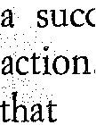
A PERSONAL APPENDIX

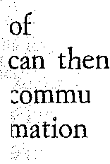
lt would be absurd to deny that my interest in this kind of study owes much to the fact that I am a practicing novelist. The problem of the interrelation between nctiòn and historical materials can be put in any number ways; here I want to mention the simplest and most practical one. lt be described as a specinc aspect of the novelist's generaI task of cOlIlmunicating with the reader, even at the bare level of transmitting infor-

For example, I have mentioned the masterful way in which Proust through several of his major characters handles the complexities, the nhsurdities, the inner contradictions af patricitism. When an author tackles such a theme in concrete terms (situation, speech) obviously his job implies trasmitting specific information to the reader and/or assuming such infar-
in him. Once upon a lime, when the prevalence of French culture considerably mare awesome than it does now, I used to envy Proust the casualness with which he could refer, say, to Colo nel Henry or Colonel PinJuart in his handling of the Dreyfus affair, or, in the war sections, inform l.ls in passing that the Due de Guermantes was stili unòer the influence af extreme anti-Caillautismf' True, we now have the Pléiade edition, Mr.

180
Pier Maria Pasinetti
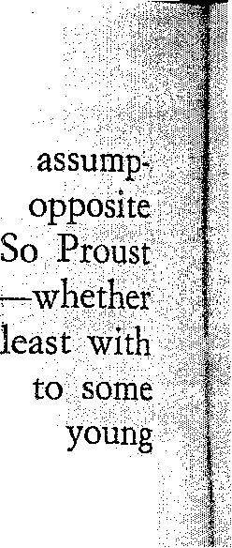
Painter, and all that, but Proust could hardly have worked on the
tion that they were to come; in fact, he was working on the assumption that his reader knew what he was talking about.
looked enviable in his assurance. But I see now that he did have
he knew, and cared, or not- a problem of communication, at
his future readers, even though he handled materials so familiar
of them as the Dreyfus affair or the first world war in France. What American of today, or for that matter, what young European, knowsmuch 'about the first war? To what extent would Charlus' long and comple.xtalk on the subject be understandable, enlightening, intellectually enjoyable to a young reader now? And yet, the chances are that this is one of the areas
of historical reference with which that young person would be
miliare

Even greater problems, therefore, exist for novelists who use of their pIaying cards in the fiction game historical situations
tum out to be remote from Iarge bodies of readers, present as .

My prize example in thissense is of course the predicament of the novelist. The situation can be described very simpIy: an enormous
of unused material on one side; scarce points of reference for
readers, including Italian ones, on the other. The two maio ré1asons
this -historical and literary- are fairly obvious in their generaI terms: immense inner variety of I talian history; the absence of a narrative tradition of the Russian or French type. The average reader of novels trying gather from his Italian readings a view of Italian history and society come up with a picture that is very spotty indeed. Here, incidentally, the best-seller system (which corresponds to what used to be the star system in Hollywood) is a considerable drawbac.k Some years ago The Leopard, a novel~memoir by a Sicilian prince, with its aIoof elegance and its underlying " plus ça change ... " philosophy, achieved a success far out of proportion with its very exceptional and limited view of Sicilian

and society; meanwhile the sales of a Sicilian writer of the past like Verga, of those of a contemporary one like Leonardo Sciascia are much Iowet in spite of the greater breadth and comple:xity of their vision. Or perhaps because of them.

Drawing desperate conclusions from all this would be wrong. At Ieast, I am unabIe to do so. I discover that I am more than ever convinced of the vitality and potenti al of Italian fiction writing, and less prone than ever to accept the attitude of cupio dissolvi which is implicit in the periodic announcements that " the novel is dead. " Actually I feel that ata time of &uch political and intèllectual confusion as our own, when as a citizen one (Iften feels like resurrecting a phrase we ~thought we had buried with the end of fascism, " You always find yourself being forced tochoose between two alternatives, both of them repulsive," the vision 01 man in
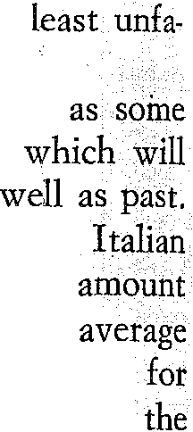

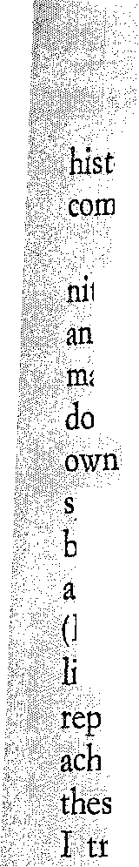
Historical Events in Non-Historical Novels
181
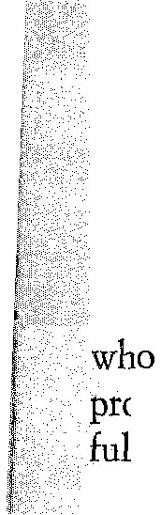
ory as explored by the, novelist with aH of its contradictions and plexities 1S of essenti al human and political value.
So tbehandling of historical materiaIs coincides with the very den'tionand method of literature in generaI - achieving universality through ever more intense exploration of one's particular Stoff, of one's concrete aterials. If your Stoff is not too easy to put across, then you should uble your effort at clarity, communicability, and translatability. My case is peculiarin the sense that I am an Italian writer but have
,pent long periods of time outside of Italy, and it so happens that I do the
asic English translation of my novels myself. I am convinced that such aisituation for a novellist makes bim see and use his native materials liriguistic, historical) more sharply and intensely. The conditions of it~tary life and society in ltaly, however, are such that I suspect my

ùtation there is marred, rather than enhanced, by whatever I have ieved in terms of broader appeal, translatability, cosmopolitanism; è are aH dreadful words but I shaH not bother to find better ones; what y to say is either basicalIy inexpressible or can onIy be shown through specinc texts and examples. The result of my situation is that a noveIlike

Venetian Red is still being sIowIy discovered in ItaIy (especially, and perharps oddly, among the very young) thirteen years after its nrst publication but has not yet achieved there the success it has had in France, at Ieast in terms of sales. A typicaI, older, and powerful ItaIian man of Iettets is often one who 1S apt to appear provincial in his attitude toward foreign cultural goods (especially if he can act one of his favorite roIes, that of the privileged and somewhat mysterious custodian of those goods) !md at the same time he may be reluctant in accepting those among us
have broken out of the province. I am not referring to certain prominent importers of American literature, who were sometimes wonder

writers and dear friends, like Elio Vittorini; my difference from them was that I had experienced America fuHy as a very young man and they did not; but they were literary artists, and that made aIl the difference, I respected their dreams and I guess they respected mine, But in the eyes of the man of letters I discribed above, any word of mine about America wouId count much Iess than his own, or if anything, it wouId count against my claims as an ltalian writer. With people like that it works both ways, and both are against you.

It will appear from these rambling notes that my two main troubles (at Ieast, in the strategy of literary recognition) have been represented precisely by the two main epicenters of my life as a man and as an' artist; i11 order of importance, at some distance apart, Venice and California. Venice has more than the generaI disadvantages I mentioned in terms of " communicability "; as a milieu it is actually too well known, and in the most doubtful ways. To give some exampIes, the Venice of .The Aspern

182
Pier Maria Pasinetti
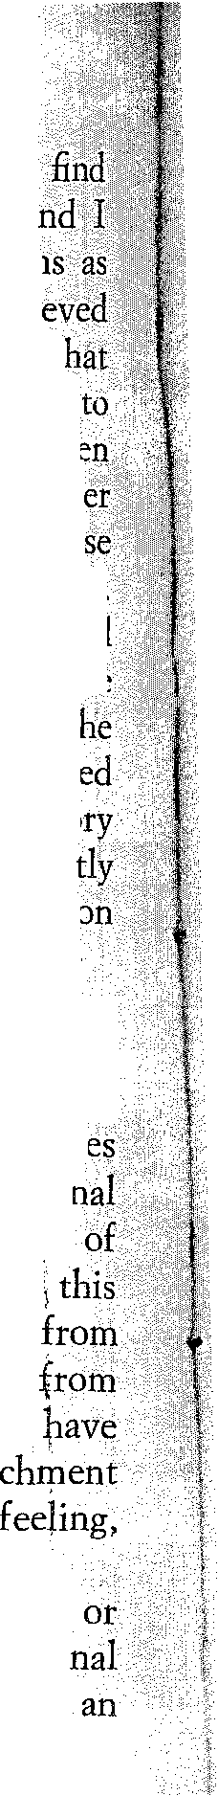
Papers or of Death in Venice isirrelevant to me; yet readers wilI
in works of that kind their consecrated, standard view òf Venice, 'ri don't mean non-ItaIian readers only but possibly non-Venetian ItaIian welI. Some older Italian Cl"itics and publishers' advisers, before I achi
any degree of recognition and, so to speak, authority, used to warn me! the locale, characters, and situation in my "Venetian" novels were bOlind be falsified, or at least not sufficiently " real," due to my having be away too long; the resulting fictional world was in danger of being neith here nor there, neither Venetian nor American. I dont't know that th6 particular persons were deeply acquainted with either Venice or my worlS For alI I know, they may have had difficulties even with my repeated emblematic use of the first war {historical '~communication" tr0l.lblè again) which as far as Italy goes was fought entirely in my region oi! country and is to us what the Civil War is to Southern writers in the Unite States. At any rate, I have preserved those curious remarks in my memo and often used them because they express by impIication, in conveniell sucdnct form, the exact apposite to my view of the Iiterary professi
and of the novelist's task.

I am almost ready now to take it as a rule that a significant modetn novel cannot be produced by a writer who has stuck to his native habitat. Distance is necessary in order to achieve full possession of òne's " native" materials, images, sounds. Awareness of "others" besid one's native self is indispensable and is reflected and aided by fictio techniques (angles of vision, narrating voices). The protagonist of one my novels, From the Academy Bridge, in some ways takes over authorial task of reconstruction and visual readjustment; he is a man
the Venice region who has a chance to stir up, revive, commemorate,
a pIace in CaIifornia, certa in personal and historical facts which formed his life. Whatever degree of understanding and human
he achieves is due to that distance which sharpens memory,
awareness. ,
I am at this point a writer of fiction who divides his time, more
less, between Venice and CaIifornia. This does not make my
life any easier; I sense, however, that il. does not make me doubly exile but rather a person doubly rooted; that this situation is essential to whatever contribution I may make to the art of fiction; that it will broaden my view without blurring it; in fact, that any achievement of mine \Vill somehow paradoxically be in the direction of greater complexity and the same rime greater darity and wider communicability. Am I victim of delusion of grandeur? In any event, it is preferable to work and be deluded in a grand design than to stagnate in a trifling one.
University o/ Cali/arnia; Las Angeles
PIER MARIA PASINETTl


