Introduction/Abstract

This database is for the management of a hospital, it gives the details about the doctors, patients, diseases, bills, and nurses. The tables are connected to each other when appropriate. You will be able to see how each of the hospital’s elements complement each other and see which diseases the patients may have.

Business Rules

**Doctors**

* All doctors must have a first and last name
* Doctor ID Numbers will be displayed on invoices
* A doctor ID will have less digits than nurse ID
* A doctor’s phone number must be known in case of emergencies

**Patients**

* Every patient must enter their last name
* Every patient will have a doctor, but not all doctors will have patients
* Every patient will have a nurse, that may or may not be unique to them
* Admission dates need to be recorded in order to track recovery
* Ailments and illnesses will be tracked in this table, but not symptoms

**Nurses**

* All nurses must have a specialty(department)

**Ailments**

* All ailments must have symptoms
* Ailment diagnosis’ will be given a number to make identification easier
* Illness names cannot be duplicated

**Bills**

* A patient’s bill must be more than $0
* All bills will be printed with the doctor’s ID and patient ID

ERD Model

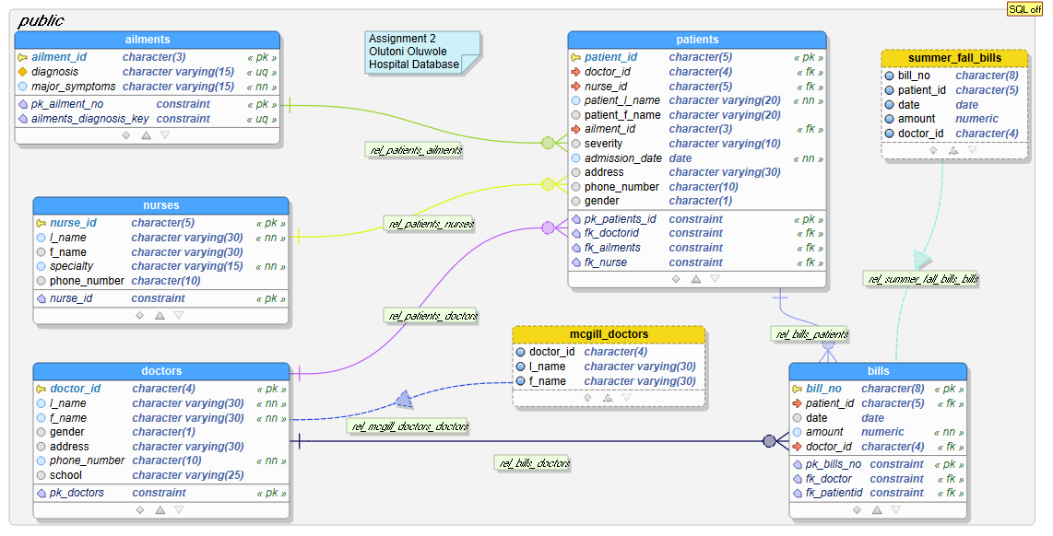

Metadata statement

SELECT * FROM information_schema.columns

WHERE table_name

IN ('doctors', 'bills', 'nurses', 'patients', 'ailments')

ORDER BY table_name;