
Firmware update procedure for Ubuntu LINUX

Copy following files in an own directory:
flash_typhoon_bootloader Start script
px_uploader.py Flash utility
yuneec_typhoon_h.fw The firmware itself

The file name for the firmware may change. "yuneec_typhoon_h.fw" is used here as example.

To find out what TTY port is used by the drone you have to disconnect and connect again the USB cable between drone and LINUX PC. Open a terminal and enter following commands:
dmesg | grep usb
dmesg | grep tty

The first command shows which USB devices where detected. The second commands shows which TTY port was assigned at the same time.
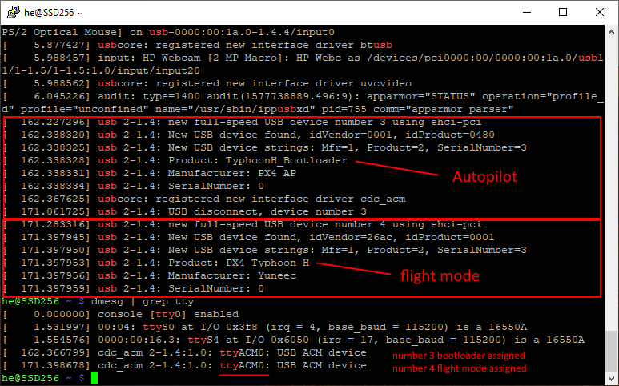
Here we see the port is "ttyACM0".
Also we can see that after power-on (USB connected again) the bootloader starts first and after a while the Autopilot starts. If Autopilot is running we cannot flash anymore. This is the reason why we have to start the script for flashing prior to power-up the MCU board which must only be powered via USB. If we plug-in the USB cable when the script is already running we will be able to catch the bootloader.

Now we edit the file "flash_typhoon_bootloader" to set the correct port. The file text should look like that:
python px_uploader.py --port /dev/ttyACM0 --force yuneec_typhoon_h.fw

In terminal, move to the directory where the three files are located and make the scripts executable:
chmod +x ./flash_typhoon_bootloader
chmod +x ./px_uploader.py

Make sure the USB connection is cut and no battery in the drone. (MCU-board powered off).

Start firmware update script:
./flash_typhoon_bootloader

Plug in the USB cable immediately. Wait and observe terminal output. Update process will start soon...
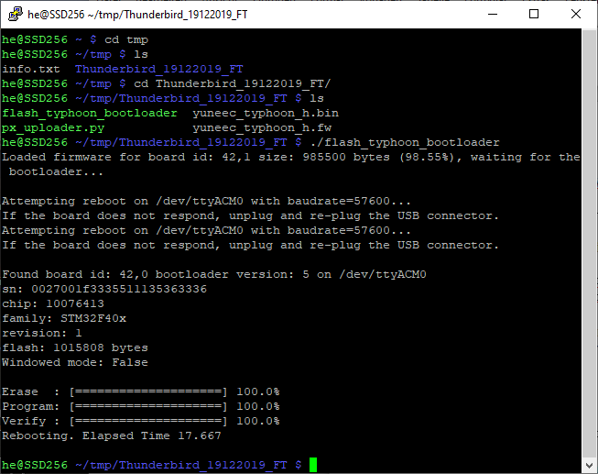
Reboot drone after firmware was flashed successfully. Done!

