
Firmware update procedure for Windows

Copy following files in an own directory:
flash_typhoon_bootloader Start script
px_uploader.py Flash utility
yuneec_typhoon_h.fw The firmware itself

The file name for the firmware may change. "yuneec_typhoon_h.fw" is used here as example.

Install Python for Windows if not yet done:
Windows key + R to open command field.
Type cmd

The Windows terminal will be opened. Keep it open, we need it all the time.
Type python

The Windows Store will be opened and offer Python installation. Follow the instructions to install Python.

If Python is correctly installed it should come up with its own command line >>>.

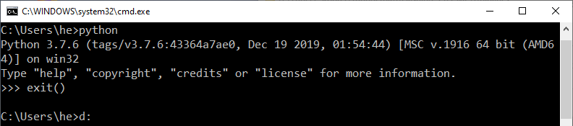
Leave it with exit().

Then download module 'serial' for Python::
https://pypi.org/project/pyserial/#files

File name is "pyserial-3.4-py2.py3-none-any.whl", double click on it to install.

Python is installed now and we can run Python scripts like "px_uploader.py".

To find out what TTY port is used by the drone you have to check the Device Manager.
Windows key + R to open command field.
Type devmgmt.msc

The Device Manager will appear. Plug-in the USB cable to connect the drone with the PC. In node "Connections (COM & LPT)" an item "Legacy FMU" with a COM number appears.
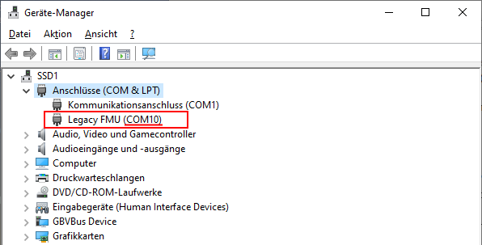
Here we see, the port is "COM10".

Now we edit the file "flash_typhoon_bootloader" to set the correct port and save it as "flash_typhoon_bootloader.bat" to make it executable. The file text should look like that:
python px_uploader.py --port COM10 --force "yuneec_typhoon_h.fw"

Note: After power-on the bootloader starts first and after a while the flight controller starts. If flight controller is running we cannot flash anymore. This is the reason why we have to start the script for flashing prior to power-up the MCU board which is powered only via USB cable. If we plug-in the USB cable when the script is already running we will be able to catch the bootloader.

Make sure the USB connection is cut and no battery in the drone. (MCU-board powered off).

Start firmware update script:
flash_typhoon_bootloader.bat

Plug in the USB cable immediately. Wait and observe terminal output.
Update process will start soon …

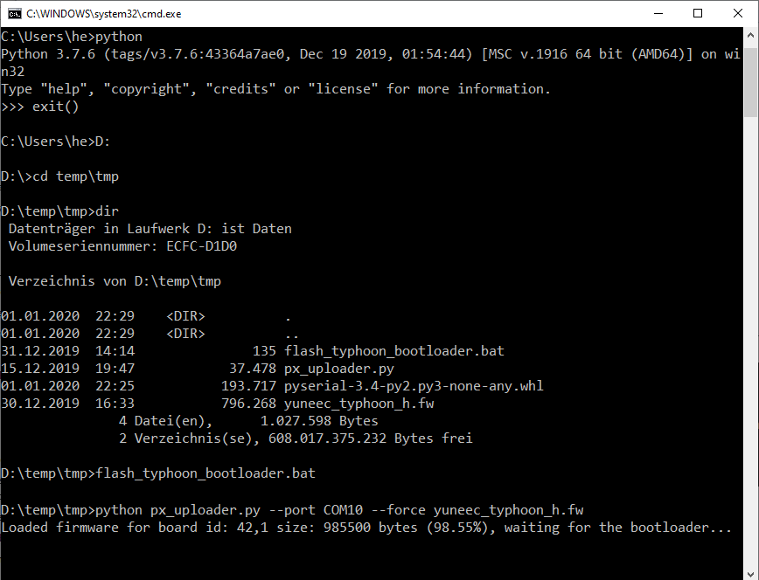
Reboot drone after firmware was flashed successfully. Done!

Note: This procedure is not finally tested yet!

