Thunderbird
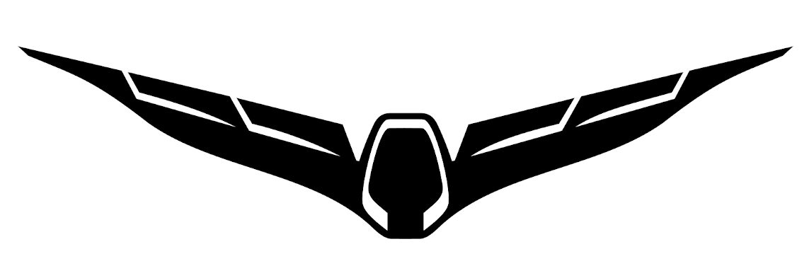

A customized firmware for Yuneec Typhoon H
based on PX4 Autopilot
by Toni Rosendahl

User manual

Table of content
Brief description 4
First steps 5
Power on/off 5
Arming/disarming 5
Flying 6
Sensor calibrations and settings 7
Compass orientation settings 7
Calibration 9
Bind procedure 10
Drone flight modes 11
Startup 11
Initialization 11
Ready 11
GNSS assisted flight modes 11
Mission mode 11
Position mode 11
Stabilized flight modes 11
Altitude mode 11
Stabilize mode 12
Manual flight modes 12
Rattitude mode 12
Manual, Acro or Rate mode 12
Fail-safe mode 12
Drone status LED codes 13
Drone status LED basic rules, regardless of color coding 13
RGB status LED details 13
Parameter settings 14
Change parameters 14
Save parameter sets 16
Restore parameter from file 16
Firmware update procedure using Ubuntu LINUX 17
Find serial port 17
Flashing 18
Firmware update procedure for Windows 19
Preparation 19
Find serial port 20
Flashing 20
Annex 22
Recommended settings 22
Some helpful MAVLink Console commands 23
Help 23
File system 24
Devices 25
System 26
Parameter change sheet 27
Cheat sheet 28


Brief description

"Thunderbird" is a customized firmware for Yuneec Typhoon H (aka H480) based on PX4 Autopilot. It's also a synonym for a Typhoon H with this PX4 based firmware.

With Thunderbird firmware you are able to use a lot of advanced features of PX4 Autopilot with stock hardware of Yuneec Typhoon H (H480) in combination with RC controller ST16.

With the advanced software tool "QGroundControl" (QGC) you can configure, calibrate and control the Thunderbird.
QGroundControl allows you to setup and tune all parameters of the drone, but allows you also to do the wrong things. You should know what you do if you touch the parameters or settings.

The firmware was invented and developed by Toni Rosendahl.

First appearance (with a funny headline) was here:
https://yuneecpilots.com/threads/typhoon-h-480-px4-v1-10-stability-issues.18205

The whole project can be found at github: https://github.com/tonirosendahl/Thunderbird
Discover more about PX4 Autopilot: https://docs.px4.io/

The firmware is Open Source. Please join the community and contribute!

Important note:

You are responsible for all what you do. So, do only something if you know what you do.

Read the manuals for:
- PX4 Autopilot: https://docs.px4.io/master/en/index.html
- QGroundControl: https://docs.qgroundcontrol.com/en/

Operate Thunderbird in open area, away from people, vehicles and property.
Always be careful in what you do.

§ Follow local rules and regulations.

First steps

You have a complete new drone with different behavior compared to stock Typhoon H.
Get familiar with it and learn to fly the new drone. Be careful at the beginning, start in open and free area. Keep it away from trees.

You do not have to do anything on ST16 side. Stock settings there are OK.

It is highly recommended to read how to operate the PX4.
https://docs.px4.io/master/en/flying/

Power on/off

To power-on the drone hold the power button down for more than 8sec until the status-LED and LEDs on motor arms are on.
The drone keeps silence, it plays no sound.
To power-off the drone remove the battery. Powering off is currently not possible by power button.

Arming/disarming
Arming and disarming requires the speed selector to be in FAST (rabbit) mode.

The well known red button on the ST16 does NOT arm or disarm the drone.
We need a CSC command: Hold the throttle stick in the bottom right corner until motors starting.

Important note:

Tough it is not very likely the above described CSC command may disarm the drone when hold the bottom right position of the throttle stick too long. To spiral down right is not a good idea to bring the drone down.

Flying
In default settings, the top position of the flight mode switch is Stabilize/Manual (same as Typhoon H with switched-off GPS), middle position is Position mode (Typhoon with the GPS aka Angle mode) and bottom one is RTH.
Mission, Acro or Rattitude modes are not there by default. Be careful with Acro or Rattitude mode!

Flight modes can be assigned to switches by using channel settings and also by switch assignment in QGroundControl or in combination of both.

Compared to stock Typhoon H you have to pay attention to following:

- In Position mode, the Thunderbird flies smoother. This is fine but you need more room because the "break path" is a bit longer than expected.
- In Stability mode, you have to maintain the altitude by yourself. Throttle stick means thrust in this case. If you pull the stick fully down, the Thunderbird comes down and I mean really down like a free falling stone.
- In all non-GNSS-assisted flight modes forget the ST16 screen. Keep both eyes on the drone.
- The Thunderbird is no race drone! Keep in mind that its weight is ~2kg and it is fast. There is no such thing like FPV available due to latency of the video downlink.

Important note:

The ST16 is not monitoring the voltage. It waits on the Voltage Warning Flags that never come from Thunderbird. All pilots should be aware about that and monitor the voltage by themselves.
Don’t drain the battery down to the minimum capacity. It is better to be conservative and bring it home with enough fuel in the tank.

At BAT_EMERGEN_THR (Default 7%) it will raise fail-save and land wherever it is without prior warning.

Sensor calibrations and settings

Sensor calibrations can only be done by QGroundControl. Connect the drone to QGC by long, flexible USB cable.
After changes changes, repairs and parameter file upload you need to check compass orientation and do a complete calibration.

Compass orientation settings
For Typhoon H exists two different compass chips. Older GPS boards have HMC5883, newer boards have IST8310 applied as compass chip (magnetometer). To find out which one you have, connect the drone to QGC and go to Mavlink console:

Type: cd /dev
then ls and you will get a list of drivers for the hardware.
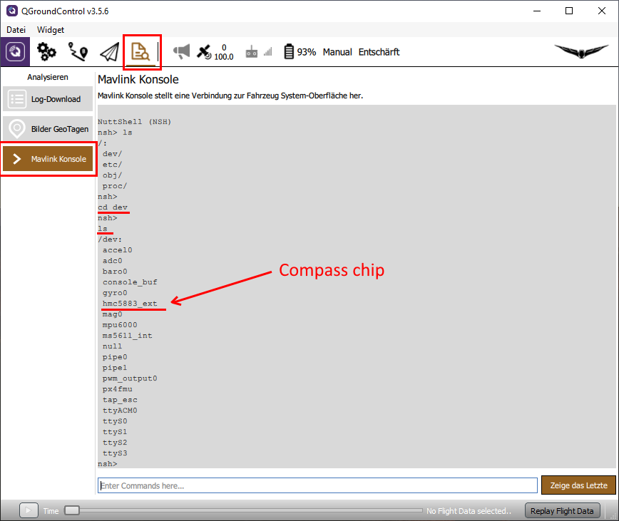
There could be "hmc5883_ext" or "ist8310_ext" as compass chip.
Note: If not all sensors are listed disconnect and reconnect to update the list.
Important: If you have the "hmc5883_ext", you have to change External Compass Orientation to "ROTATION_YAW_270".
For "ist8310_ext" it must be "ROTATION_YAW_180".

Never change Autopilot orientation. It must be kept at "ROTATION_NONE".

Go to Settings > Sensors > Set Orientation
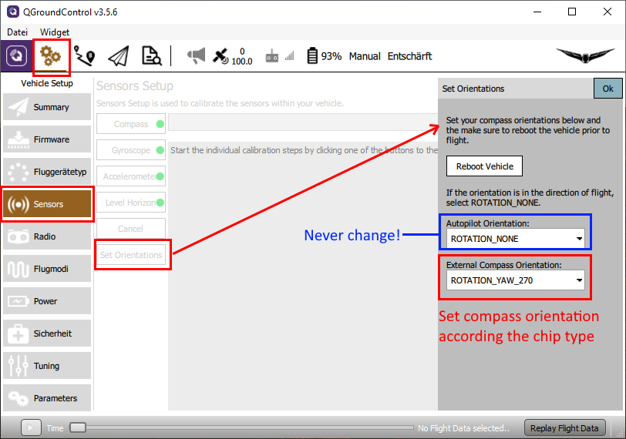

Then set External Compass Orientation to the correct value depending on you compass hardware. Save with "OK" and reboot the Thunderbird.

After changes do at least a compass calibration.

Read more: https://docs.qgroundcontrol.com/en/SetupView/SetupView.html

Calibration
Remove the camera.
Go to Settings > Sensors and follow the instructions on the screen for Compass, Gyroscope, Accelerometer and Level Horizon. Do not try to calibrate ESC's. It will not work and is not required.

Prepare some fitting wooden blocks that keep the drone in backward, forward and lateral positions.

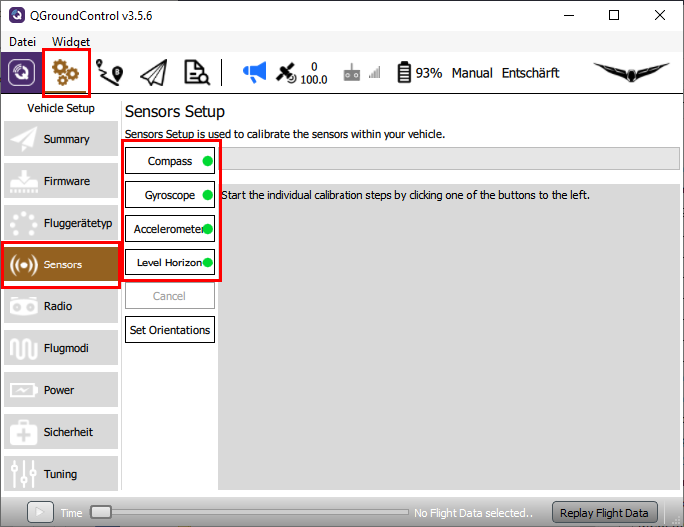
Learn more: https://docs.qgroundcontrol.com/en/SetupView/sensors_px4.html
Currently there is no "wireless" way to calibrate. Be careful with the cable. Best use a longer micro USB data cable.

Bind procedure

Ceate a new model on ST16. Type is Typhoon H. Call it "My Thunderbird" or whatever you want.
The bind process for camera CGO3+ is as usual.

To bind the 2.4GHz receiver the drone must be in bind mode. We have to use QGroundControl (QGC). Connect the drone to QGC by USB cable.
Go to Mavlink console. Type: typhoon_bind start > Enter.

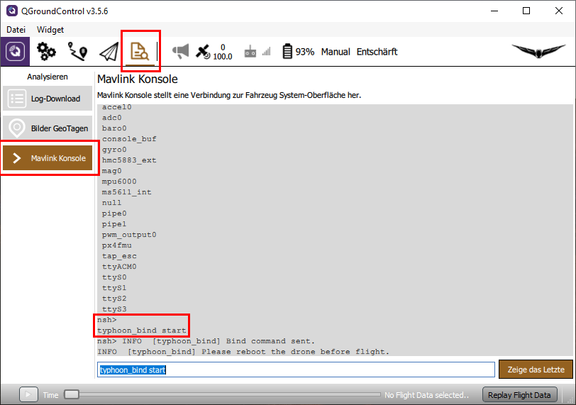
Then go to Bind menu of the ST16 as usual and tap on "Refresh".
Select the receiver and tap on "Bind". Reboot the drone. Done!

Drone flight modes

Startup

Initialization
The GNSS and navigation systems are not ready. The home position is not set.
The drone can be forced to fly in non-GNSS modes but RTH will not be available during that flight. GNSS-assisted flight modes are degraded to "Stabilize" with or without altitude hold. The GNSS-assisted modes will become available when the GNSS and estimator become ready. This will happen also during flight, but the RTH remains inoperable until you land and take-off again, as there is no home position set for this flight. The drone takes a minute or two to start up, to be fully mission capable. This never happens indoors, but it is perfectly flyable there.
Status LED: GREEN blinking. The ST16 shows "Acquiring" in GPS mode display and "Start" as a flight mode.

Ready
The drone is ready. It has full navigation capability and home position is set.
Status LED: GREEN solid. ST16 GPS status changes from "Acquiring" to "Ready" and flight mode display shows also "Ready". You are good to go, no need to wait any further.

GNSS assisted flight modes

Mission mode
The Thunderbird is fully automatic. This is the automated flight mode and easiest of them all since the drone flies itself from take-off to motor shutdown.
Status LED: PURPLE blinking, ST16 flight mode display: "Waypoint".

Position mode
The Thunderbird flies like a stock Typhoon in Angle Mode.
Status LED: PURPLE solid, ST16 flight mode display: "Angle".
Note: All sensors and GNSS must be fully operational and perfectly calibrated for these modes.

Stabilized flight modes

Altitude mode
Stabilized mode with altitude hold and assisted throttle. Auto-throttle is active, throttle stick controls altitude.
The Thunderbird flies like a stock Typhoon in Angle Mode without GPS.
Status LED: BLUE blinking.

Stabilize mode
Throttle controls altitude. The Thunderbird controls thrust to maintain the altitude. If the Position mode was requested with no valid positioning solution, meaning you took off before the estimator and GNSS were ready, this is what you will get instead as a fallback.
This flight mode is not mapped to the mode selector switch by default at the standard parameter settings. But you can summon this by requesting a position mode from a drone that took off before it was ready. Same as "Stability" mode, known from Blade Chroma or Blade 350QX.
Status LED: BLUE solid, ST16 flight mode display: "THR".
Note: These modes do not require GPS magnetometer being operational. Indoor flight is possible and magnetic interference are no issue. These modes can be used to recover the drone from GPS/magnetometer issues, if you'll ever encounter any. These modes require active controlling and visual line of sight, but they are still rather easy to fly.

Manual flight modes

Rattitude mode
"Assisted Acrobatics" enabled. Release the sticks and the drone should self-recover if there is enough altitude.
Status LED: WHITE purple blinking, ST16 flight mode display: "Rate".

Manual, Acro or Rate mode
Sticks control angular acceleration, no self-leveling, no braking, direct thrust control, absolutely zero assistance from the drone. The GPS, magnetometer, barometer and accelerometer are sleeping, only the gyro data is used. You are in control now.
Same as "Agility" mode, known from Blade Chroma or Blade 350QX.
Status LED: WHITE solid, ST16 flight mode display: "Rate".

Note: These modes are not set to the mode selector switch in my default parameter file. You have to enable these by yourself. The "Purple solid" is a very difficult mode to fly, but allows you do anything with the drone.

Fail-safe mode
Fail-safes are activated (RTH) or the drone attempts auto-land with a failed GPS.
Status LED: RED blinking.

Drone status LED codes

Drone status LED basic rules, regardless of color coding

- When the LED is SOLID regardless of color, you have the full control.
- When the LED is BLINKING, the Thunderbird is actively doing something (like assisting you somehow).
- Than lighter the color, than more challenging and rewarding is it to fly.
- Red light means malfunction, fail-safe mode or manual requested RTH.

RGB status LED details

Green: Startup
GREEN blinking: The GNSS and navigation systems are not ready and home position is not set. The ST16 shows "Acquiring" in GPS mode display and "Start" as a flight mode.
GREEN solid: The drone is ready. The green light will not appear when the drone is airborne. ST16 GPS status changes from "Acquiring" to "Ready" and flight mode display shows also "Ready". You are good to go, no need to wait any further.

Purple: GNSS-assisted flight
PURPLE blinking: Mission mode. ST16 flight mode display: "Waypoint".
PURPLE solid: Position mode. ST16 flight mode display: "Angle".

Blue: Stabilized flight
BLUE blinking: Altitude mode
BLUE solid: Stabilize mode. ST16 flight mode display: "THR".
White: Manual flight modes
WHITE purple blinking: Rattitude mode or "Assisted Acrobatics".
ST16 flight mode display: "Rate".
WHITE solid: Manual, Acro or Rate mode. ST16 flight mode display: "Rate" (not tested yet).
Red: Fail-safe, RTH, malfunction
RED blinking: The drone has degraded performance, but is airborne, still operational and attempts an automatic recovery. The LED blinks red when the fail-safes are activated (RTH) or the drone attempts auto-land with a failed GPS. It may change between red and previous color code for some time. However, it is recommended to bring it home at this point.
RED solid: Malfunction, arming is prohibited. ST16 flight mode display: "EMER".

Parameter settings

Parameter settings needs to be done with QGroundControl. Changed parameters are not stored in the model on ST16.
It is recommended to store last working parameter set into a file before you change something. Make a note what parameter you have changes and why (see Parameter change sheet at the end of this document). The stored parameter file is a backup and can be used to restore the whole parameter set in case of problems.

Change parameters
Power up the drone and connect it via USB to QGroundControl.
Go to Settings (icon with gearwheels) > Parameters. Parameter sets are grouped by its functionality. To find a parameter you can use the search function.

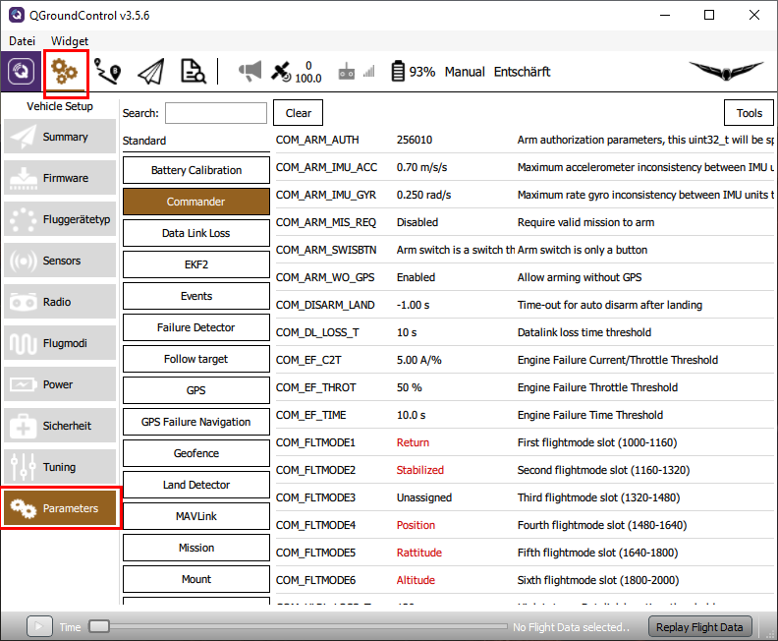
Click on the parameter you want to change. The Parameter editor appears on the right.

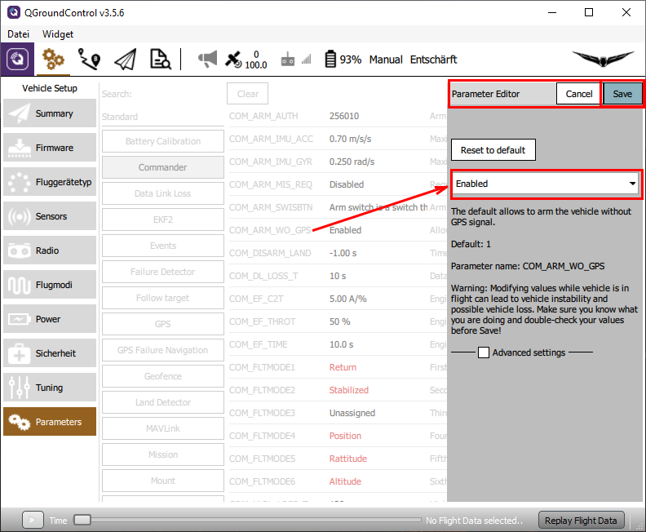

Change parameter (select from list or enter value) and Save. Some parameters require reboot of the drone.

Save parameter sets
Go to Settings (icon with gearwheels) > Parameters > Tools > Save to file... Enter useful path and filename to remember what parameter set it was and save it.

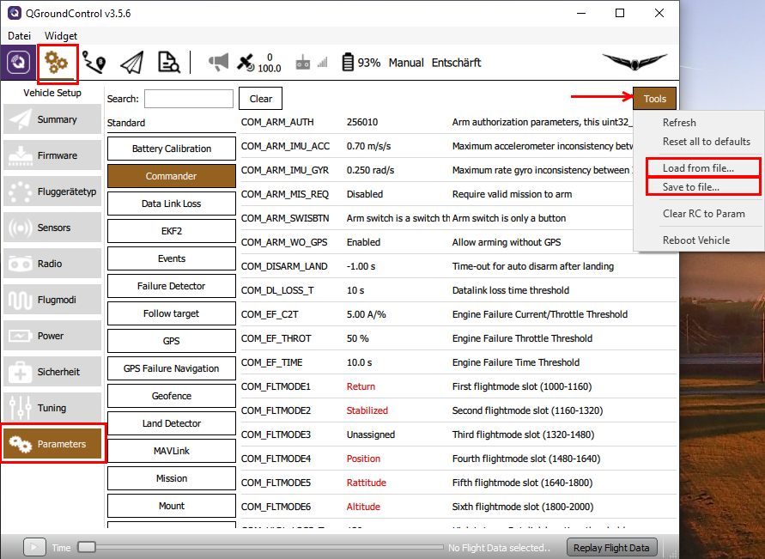

Restore parameter from file

The parameter file from the last working configuration can be used to restore parameter settings in case of problems with the new one.

Go to Settings (icon with gearwheels) > Parameters > Tools > Load from file... Select parameter file with last working settings and upload it to the drone.
Reboot the drone.
Check Compass orientation depending on compass chip and do proper calibration.

Firmware update procedure using Ubuntu LINUX

Copy following files in a separate directory:
flash_typhoon_bootloader Start script
px_uploader.py Flash utility
yuneec_typhoon_h.fw The firmware itself

The file name for the firmware may change. "yuneec_typhoon_h.fw" is used here as example.

Find serial port
To find out what TTY port is used by the drone you have to disconnect and connect again the USB cable between drone and LINUX PC. Open a terminal and enter following commands:
dmesg | grep usb
dmesg | grep tty

The first command shows which USB devices where detected. The second commands shows which TTY port was assigned at the same time.
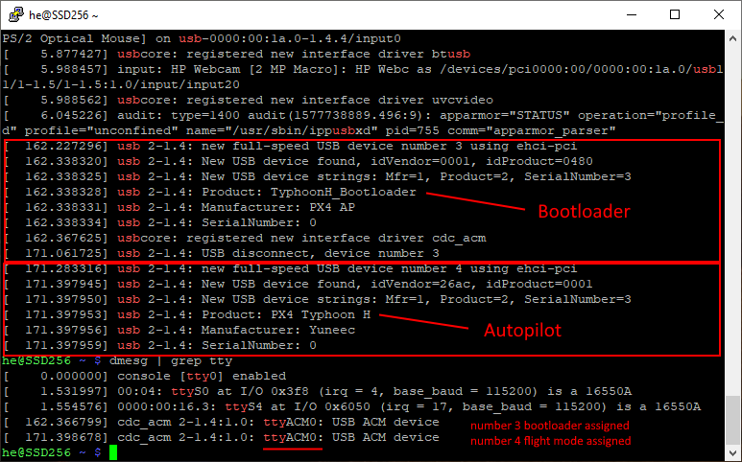
Here we found, the port is "ttyACM0".
Also we can see that after power-on (USB connected again) the bootloader starts first and after a while the Autopilot starts. If Autopilot is running we cannot flash anymore. This is the reason why we have to start the script for flashing prior to power-up the MCU board which must only be powered via USB. If we plug-in the USB cable when the script is already running we will be able to catch the bootloader.

Flashing
Now we edit the file "flash_typhoon_bootloader" to set the correct port. The file text should look like that:
python px_uploader.py --port /dev/ttyACM0 --force yuneec_typhoon_h.fw

In terminal, move to the directory where the three files are located and make the scripts executable:
chmod +x ./flash_typhoon_bootloader
chmod +x ./px_uploader.py

Make sure the USB connection is cut and no battery in the drone. (MCU-board powered off).

Start firmware update script:
./flash_typhoon_bootloader

Plug in the USB cable immediately. Wait and observe terminal output. Update process will start soon...
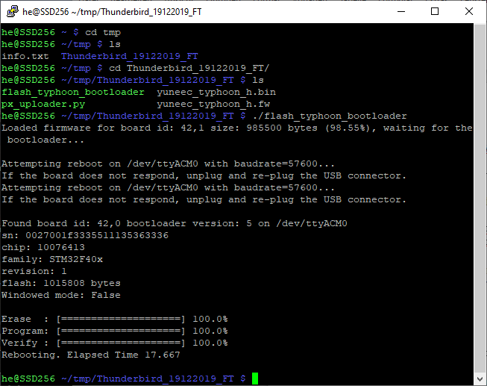
Reboot drone after firmware was flashed successfully. Done!
Do all checks and calibrations like for a new drone.

Firmware update procedure for Windows

Preparation

Copy following files in an own directory:
flash_typhoon_bootloader Start script
px_uploader.py Flash utility
yuneec_typhoon_h.fw The firmware itself

The file name for the firmware may change. "yuneec_typhoon_h.fw" is used here as example.

Install Python for Windows if not yet done:
Windows key + R to open command field.
Type cmd

The Windows terminal will be opened. Keep it open, we need it all the time.
Type python

The Windows Store will be opened and offer Python installation. Follow the instructions to install Python.

If Python is correctly installed it should come up with its own command line >>>.

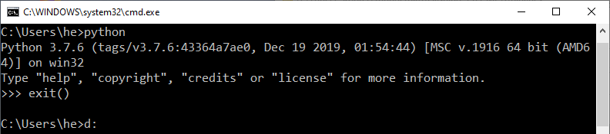
Leave it with exit().

Then download module 'serial' for Python::
https://pypi.org/project/pyserial/#files

File name is "pyserial-3.4-py2.py3-none-any.whl", double click on it to install.

Python is installed now and we can run Python scripts like "px_uploader.py".

Find serial port
To find out what TTY port is used by the drone you have to check the Device Manager.
Windows key + R to open command field.
Type devmgmt.msc

The Device Manager will appear. Plug-in the USB cable to connect the drone with the PC. In node "Connections (COM & LPT)" an item "Legacy FMU" with a COM number appears.
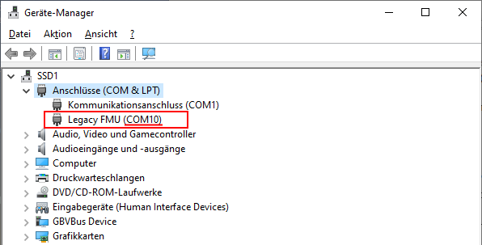
Here we found, the port is "COM10".

Now we edit the file "flash_typhoon_bootloader" to set the correct port and save it as "flash_typhoon_bootloader.bat" to make it executable. The file text should look like that:
python px_uploader.py --port COM10 --force "yuneec_typhoon_h.fw"

Flashing

Note: After power-on the bootloader starts first and after a while the flight controller starts. If flight controller is running we cannot flash anymore. This is the reason why we have to start the script for flashing prior to power-up the MCU board which is powered by flight battery. If we plug-in the USB cable when the script is already running we will be able to catch the bootloader.

Make sure the USB connection is cut. (MCU-board powered off).

Start firmware update script:
flash_typhoon_bootloader.bat

Plug in the USB cable. Then hold the start button of the aircraft down until flashing is complete, disconnect and connect USB cable again. Wait and observe terminal output.
Update process will start soon …

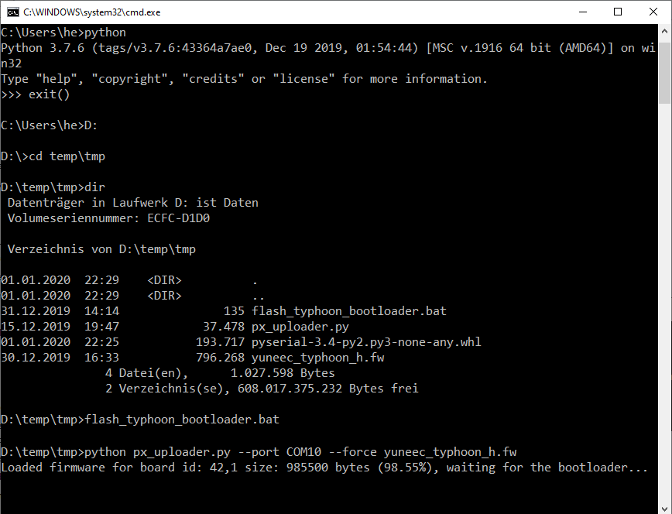
Reboot drone after firmware was flashed successfully. Done!
Do all checks and calibrations like for a new drone.

Annex

Recommended settings
Parameter reference: https://docs.px4.io/v1.9.0/en/advanced_config/parameter_reference.html

Parameter | from | to | Description
MPC_Z_VEL_MAX_DN | 1.000 | 3.000 | Max. descent speed [m/s] as it was at H480
MPC_Z_VEL_MAX_UP | 3.0 | 5.0 | Max. ascent speed [m/s] as it was at H480
MC_RATT_TH | 0.80 | 0.60 | Threshold for Stability in Rattitude mode [%] for more Acro to get smoother rolls or loopings
COM_ARM_WO_GPS | Disabled (0) | Enabled (1) | For indoor flights. For GNSS-assisted flights wait for solid green LED status.

Note: All tuning measurements and parameter setting may influence flight behavior and security. Do it on your own risk.

Some helpful MAVLink Console commands

The MAVLink Console opens a PX4 NSH shell to send commands and receive results when the aircraft is powered on and connected to QGroundControl.

More about the NSH shell: https://dev.px4.io/v1.9.0/en/debug/system_console.html

Help

? Shows a list of commands and Build-in Apps:

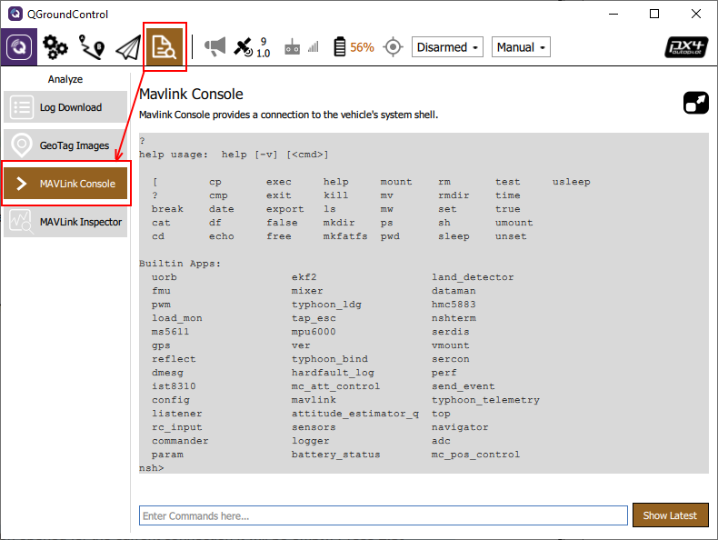
Those shell commands maybe helpful just for information or for troubleshooting. Please execute commands only if you know what you do. Refer to the PX4 Autopilot documentation and QGroundControl manual.

Following commands can be executed without problems, do not change anything and are only used to show some information.
How to use custom command typhoon_bind please refer to the Thunderbird user manual.

File system

ls List files or dirctories
cd fs/microsd Change directory to list the files on micro SD card
ls -l List the files or directories on micro SD card
cd / Change directory to root directory
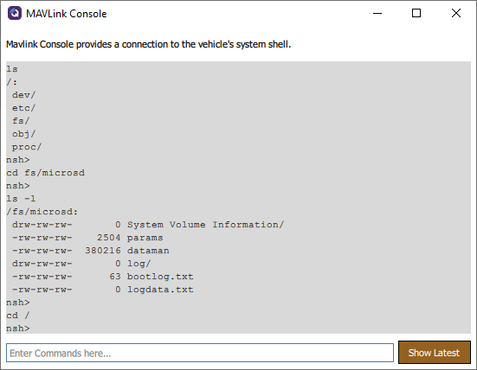
With the commands above you can check if you have an SD card inserted and if it is readable.

To download flight logs (ULOG files: *.ulg) use QGroundControl Analyze > Log Download.
Click on Refresh to see updated list of ULOG files.

Devices

ls List directories in root diectory
cd dev Change directory to ‘dev’
ls List devices of the drone

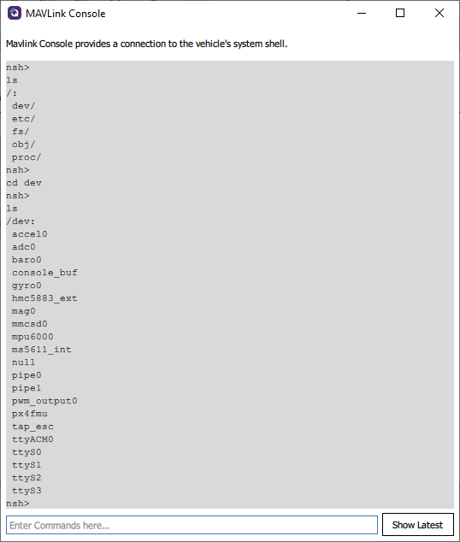

System

df Show memory sizes
df -h Show memory sizes in ‘human readable’ format
free Show free/used memory
date Show system time
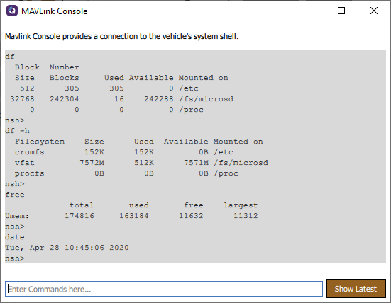

Parameter change sheet

It is recommended to note your parameter settings and its history. Print this sheet.

Note: Channel settings on ST16 are stored to the related models. If you want to reset Channel settings, create a new model from scratch.
Parameter settings in QGroundControl are not stored in the model on ST16.

Date | Parameter | from | to | Description/reason

Cheat sheet
Proposal for brief description to print it.

Flight mode switch setting (fill table with your own settings)
FlightMode | Switch | Position
Position (Angle mode) | Flight mode switch S4 | middle
Altitude (GNSS support off) | Flight mode switch S4 | upper
Stabilized (Manual) | Aux switch B2 | upper
Rattitude | Aux switch B2 | lower
Acro
Mission
RTH | Flight mode switch S4 | lower

Power on/off
Power on: Hold power button on drone for 8sec until LEDs are on
Power off: remove battery

Motor Start / Stop
Hold throttle stick in the lower right corner

Flying
- Check location (rules and regulations)
- Free space for GPS signals, no potential reflectors to avoid multi-path reception
- Drone battery full, ST16 battery full
- Check battery voltage during flight

