
How to enable more flight modes

This is an example how to set up more flight modes for the Thunderbird. I recommend to create a new model and do all steps with it. Call the model "Crazy Destroyer" or something like that ;-).

I have exchanged the AUX button B2 of the ST16 by a switch in order to use AUX channel 12 to switch between two sets of flight modes;

- Set One (B2 up) has "Altitude" in upper position of the flight mode switch S4, "Position hold" in the middle position and "Return to home" in the lower position.
- Set Two (B2 down) has "Rattitude" in upper position of the flight mode switch S4, "Stabilized" in the middle position and "Return to home" in the lower position.

Set One is the same as GPS off/on. Set two contains more advanced flight modes. "Acro" was left off because I'm too old for this stuff.

Step 1: Channel settings at ST16

Open channel settings and select A01.
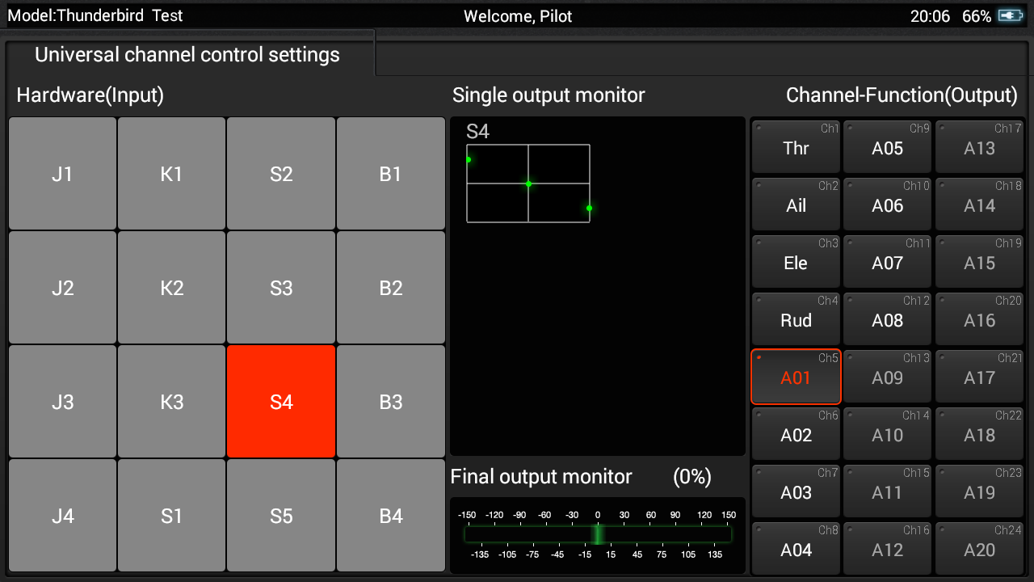

Tap on B2 and hold it to get menu. Select "Edit" from the menu.
Set "Accumulation", Pos.0 to "Act" and -50%. Tap on Save.
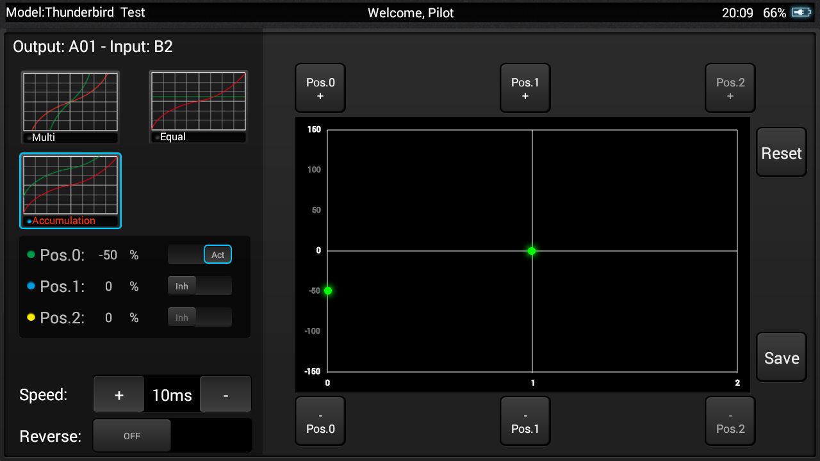
Now you should get a mixed channel for flight modes:
- B2 up: 100% > 0 > -100%
- B2 down: 50% > -50% > -150%

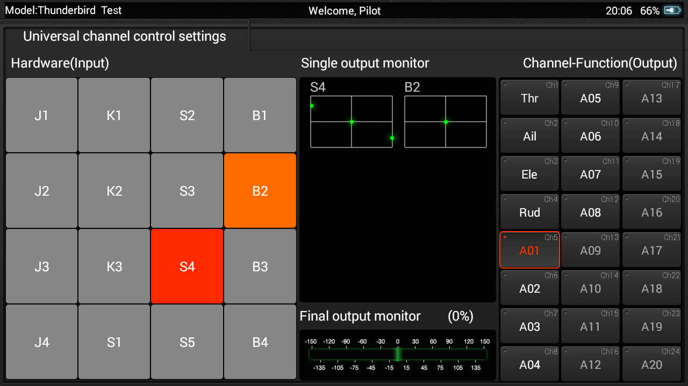
Remark: Channel A02 (RTH channel) must still have values 0 > 0 > 150% in both positions of B2 switch. Check this!

Step 2: Assign flight modes in QGroundControl

Bind the new model to Thunderbird and connect it to QGroundControl by USB cable.
Now we have more possibilities to add flight modes (COM_FLTMODE2 and COM_FLTMODE5):

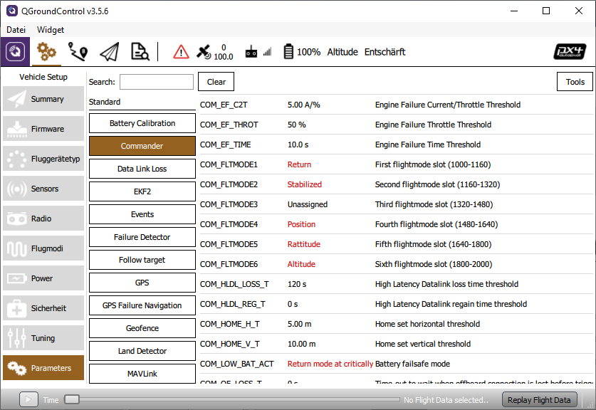

Go to "Settings" > "Flight modes" and assign flight modes to the mode items.

- Mode channel remains Channel 5.
- Flight mode 1 is lower position of the Flight mode switch S4, remains "Return" for both Sets.
- Flight mode 2 belongs to Set Two, middle position, will be assigned to "Stabilized".
- Flight mode 3 remains "Unassigned".
- Flight mode 4 belongs to Set One, middle position, remains "Position".
- Flight mode 5 belongs to Set Two, upper position, will be assigned to "Rattitude".
- Flight mode 6 belongs to Set One, upper position, will be assigned to "Altitude".

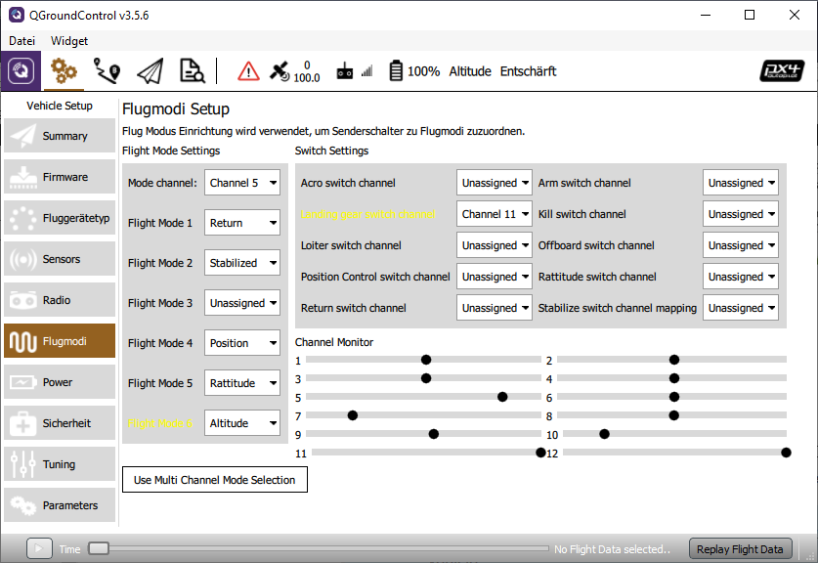
Test all switch positions carefully in flight mode settings of QGroundControl. The active switch combination is marked in Yellow (day time color setting of QGroundControl).

See also: https://docs.px4.io/master/en/getting_started/flight_modes.html

Buy some more propeller and go out testing flight modes on your own risk.

Mode-switch | AUX-switch | FlightMode | Pos % | Log value
up | up | Altitude | +100% | 3412.0
up | down | Rattitude | +50% | 2730.0
middle | up | Position hold | 0% | 2048.0
middle | down | Stability | -50% | 1365.0
down | up | RTH | -100% | 683.0
down | down | RTH | -150% | 0.0

Recommended settings

Parameter | from | to | Description
MPC_Z_VEL_MAX_DN | 1.000 | 3.000 | Max. descent speed [m/s] as it was at H480
MPC_Z_VEL_MAX_UP | 3.0 | 5.0 | Max. ascent speed [m/s] as it was at H480
MC_RATT_TH | 0.80 | 0.60 | Threshold for Stability in Rattitude mode [%] for more Acro to get smoother rolls and loopings

