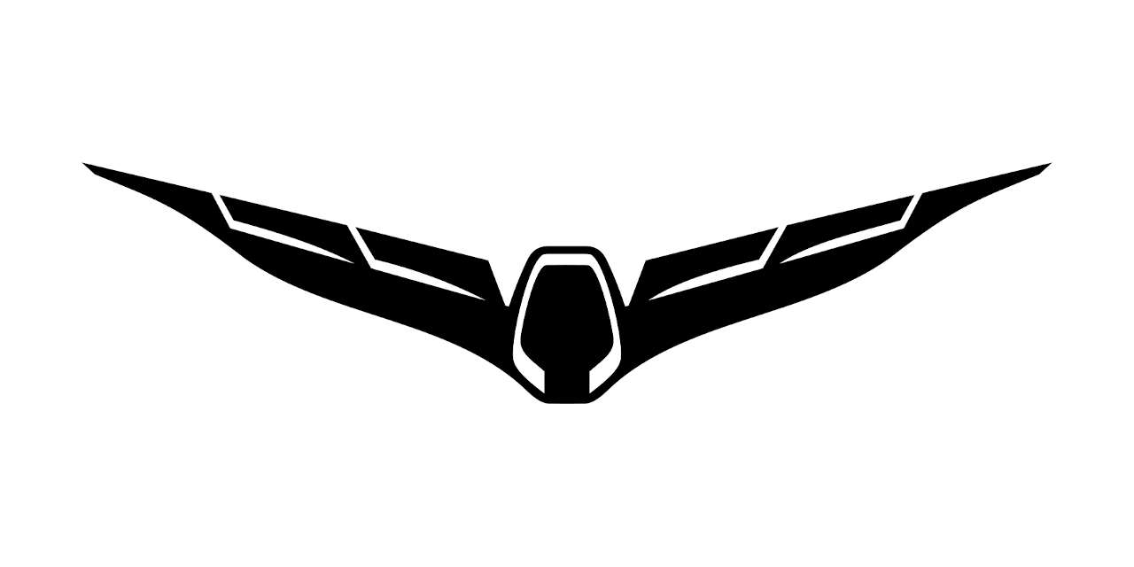
Bind drone (SR24) to ST16

On ST16 we create a new model, type is Typhoon H. Call it "My Thunderbird" or whatever you want.

The bind process for camera CGO3+ is as usual.

To bind the 2.4GHz receiver the drone must be in bind mode. This is no more possible by lift the back end of the copter.
We have to use QGroundControl (aka QGC). Connect the drone tp QGC by USB cable.
Go to Mavlink console. This is a nice tool. We can see a lot interesting here, i.e. the hardware driver:
cd /dev
ls
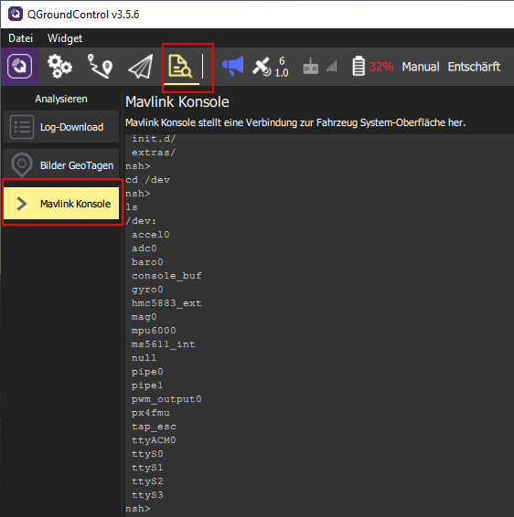

Or how many memory is free/used:
free

But hey, we want to bind. Type:
typhoon_bind start

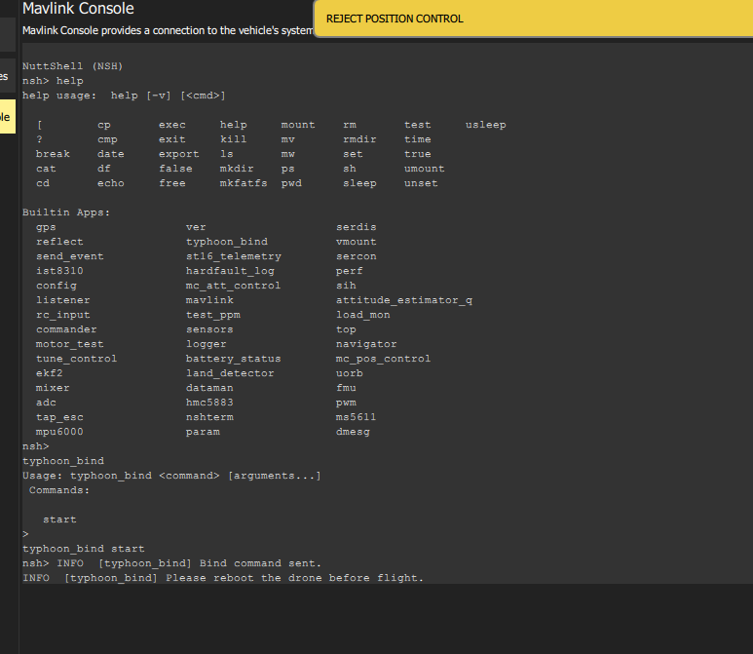
Then go to Bind menu of the ST16 as usual and tap on "Refresh". Select the receiver and tap on "Bind". Done!

