LTM4609. Wide Input range (9-36V) with VOUT 24V @ 4A max

This document presents results of simulation on LTM4609. The following graphs shows the behavior of the component at 2 different load for each 3 different input voltage:
VIN=9V Iout=20uA
VIN=9V Iout=4A
VIN=12V Iout=20uA
VIN=12V Iout=4A
VIN=36V Iout=20uA
VIN=36V Iout=4A
Output voltage is always 24V.

Here is the schematic of the corresponding simulation around the LTM4609.
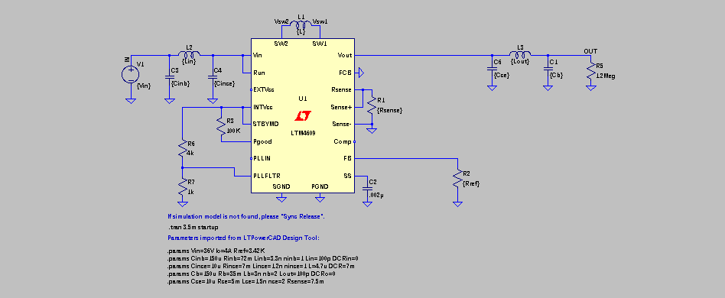
VIN=9V, VOUT=24V, IOUT=20uA
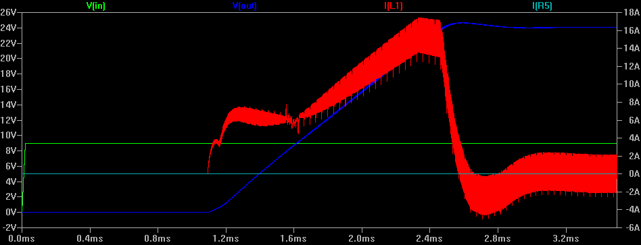
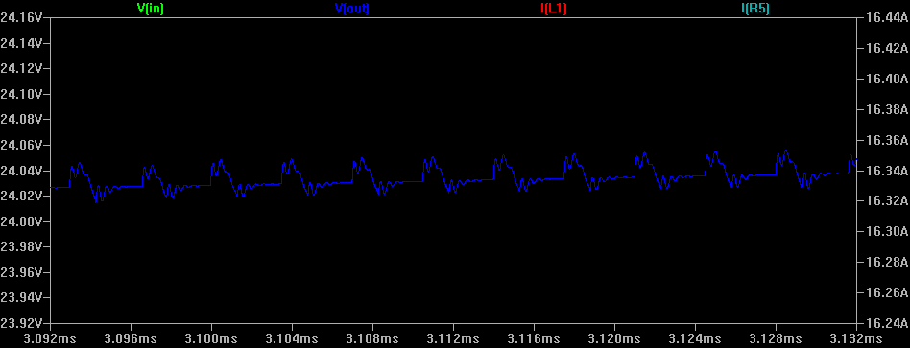
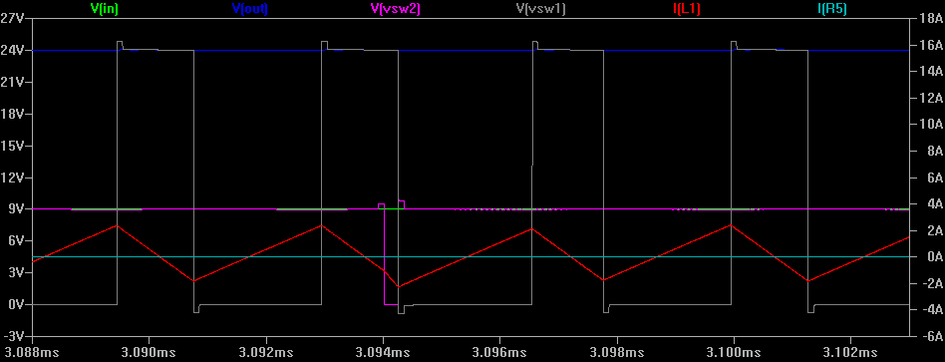

VIN=9V, VOUT=24V, IOUT=4A
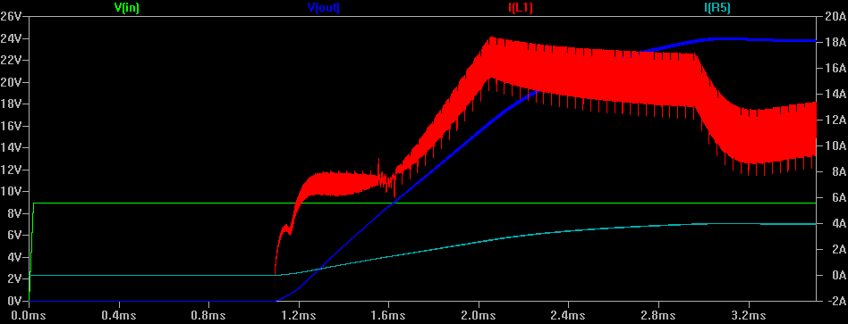
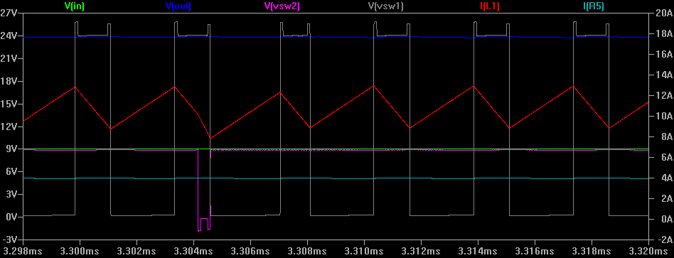
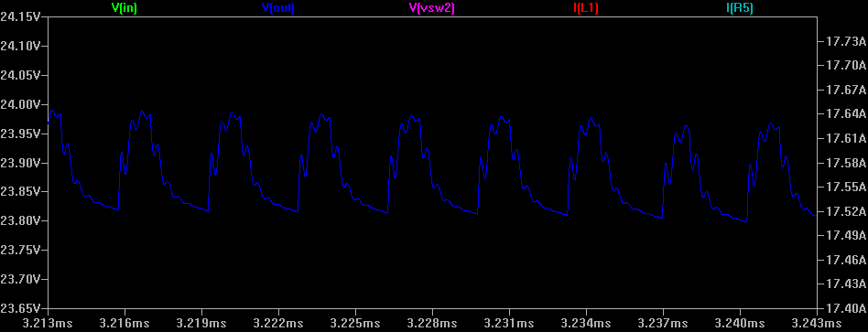

VIN=12V, VOUT=24V, IOUT=20uA
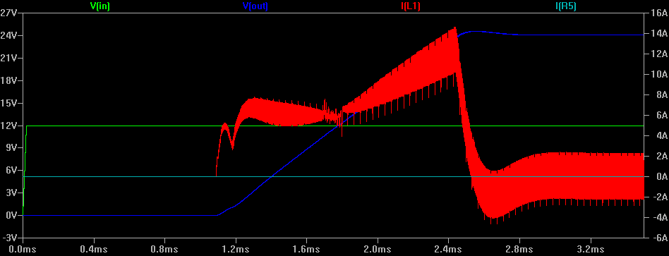
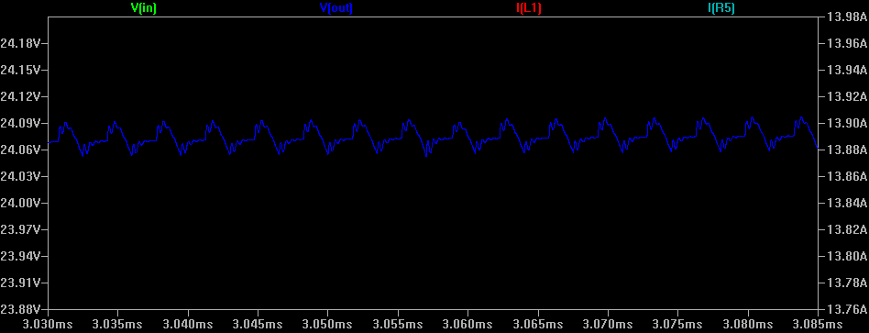
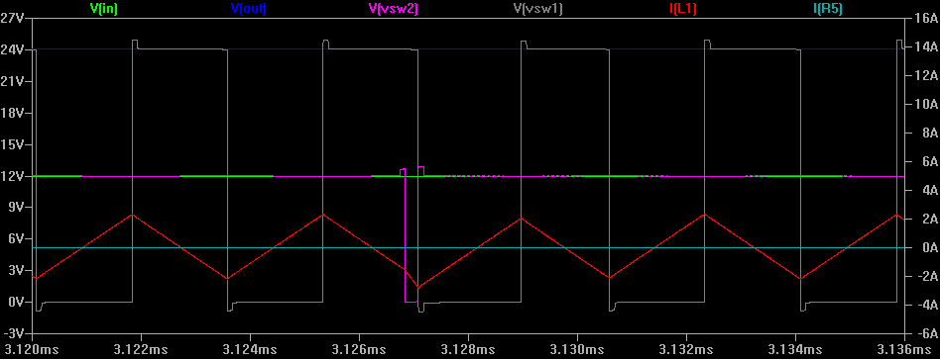

VIN=12V, VOUT=24V, IOUT=4A
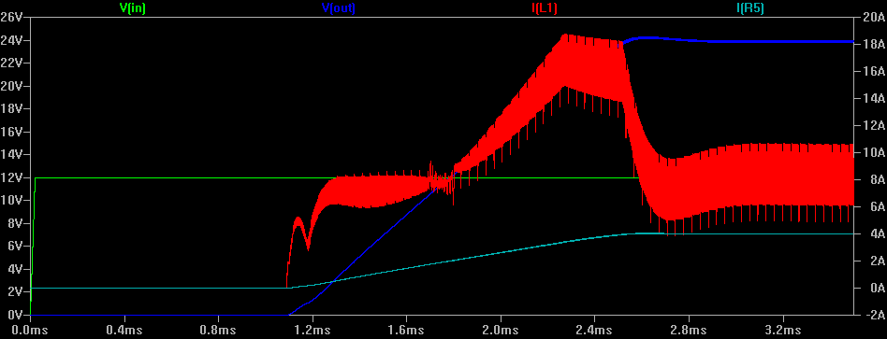
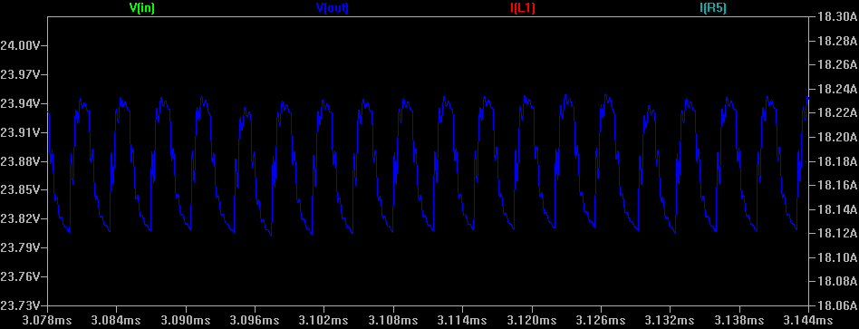
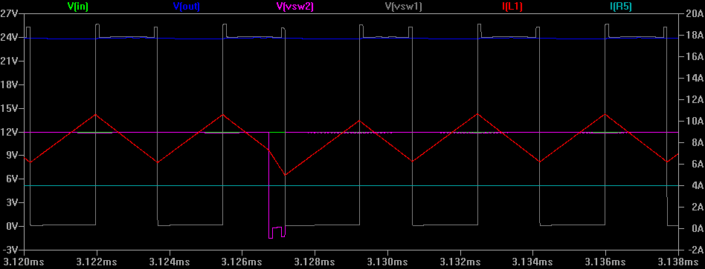

VIN=36V, VOUT=24V, IOUT=20uA
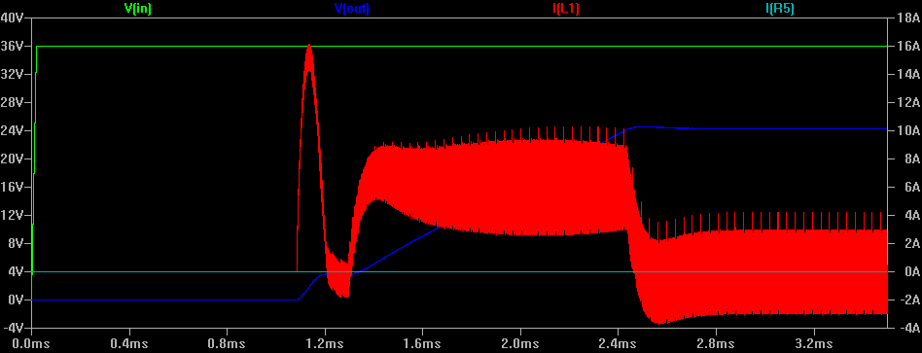
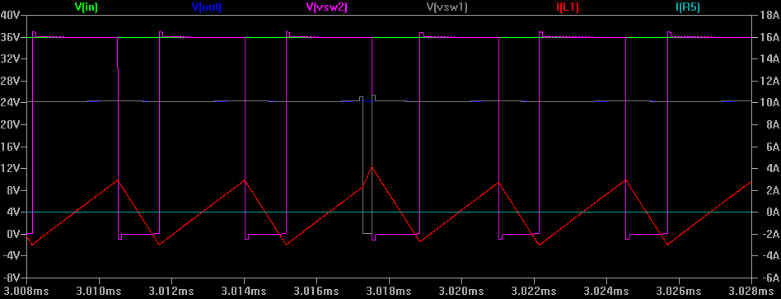
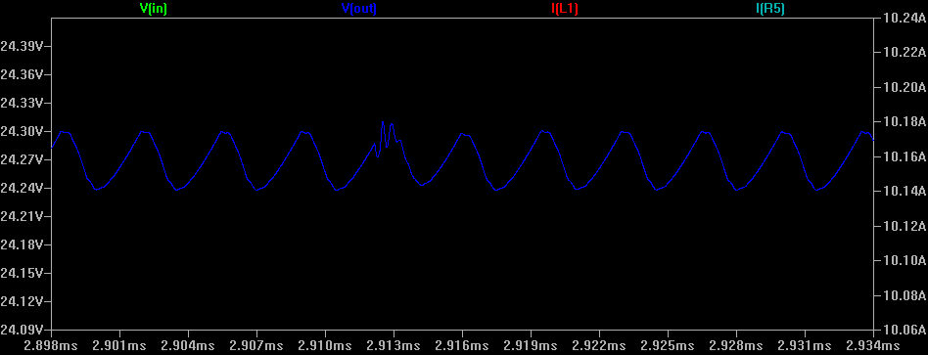
VIN=36V, VOUT=24V, IOUT=4A
