Tony Nguyen

Dr. Shawn Bowers

CPSC 321 01

15 December 2023

Extra Credit

1. Question 1

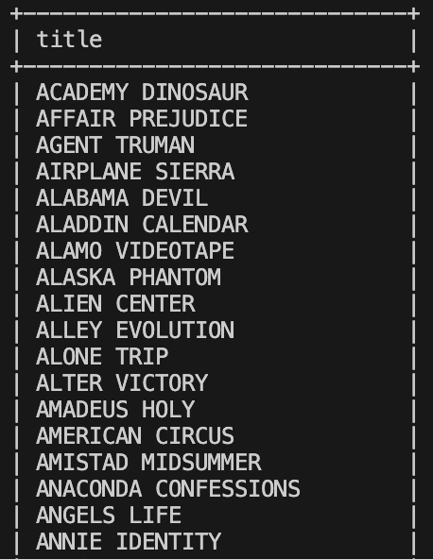

…

1. Question 2

…



1. Question 3

…

