Tony Nguyen

Dr. Shawn Bowers

CPSC 321 01

17 October 2023

Homework 4

1. Find the countries with low inflation and a high GDP.

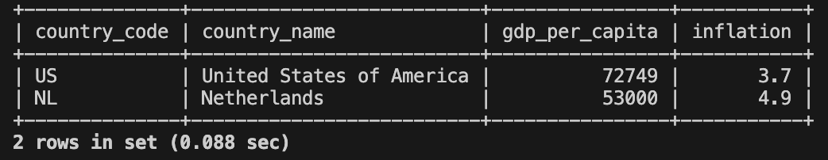

1. Find all provinces that have a small total area that are in a country with high inflation.

1. Rewrite (2) using JOIN.

1. Find the unique set of all provinces that have at least one city with a population greater than a specific value.

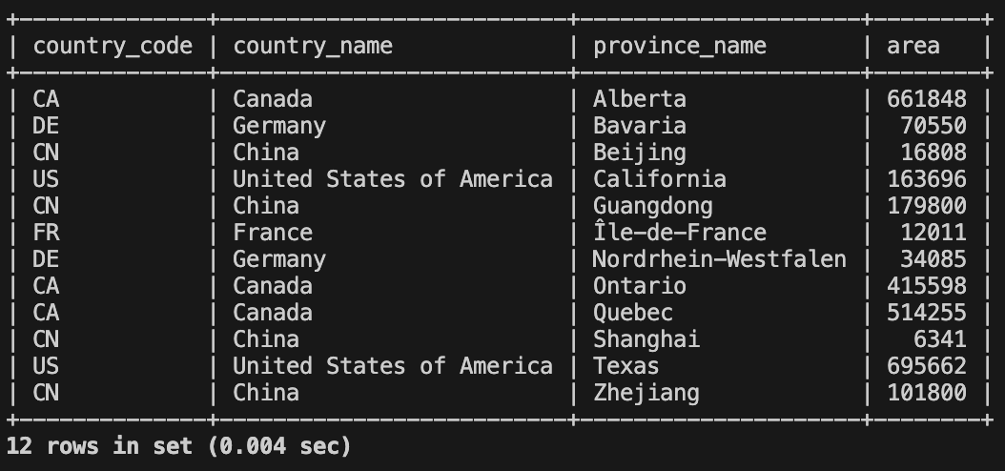

1. Rewrite (4) using JOIN.

1. Find the unique set of all provinces with at least two cities having a population greater than a specific value.

1. Rewrite (6) using JOIN.

1. Find pairs of different cities with the same population.

1. Find all countries with a high GDP and low inflation that border a country with a low GDP and high inflation.

1. Rewrite (9) using JOIN.

1. Find pairs of neighboring countries that share a border and have a significant difference in GDP per capita. Specifically, retrieve pairs of countries with a border length greater than 300 kilometers and where the difference in GDP per capita between the countries is greater than $5,000.

1. Issues and Challenges

* I don’t have any significant issues completing this assignment.
* Something I find challenging most is to think of cases where DISTINCT would be necessary or not, as there is not “rule of thumb” for this.