Tony Nguyen

Dr. Shawn Bowers

CPSC 321 01

28 November 2023

Homework 7

**Part 1**

1. Given the original schema and the functional dependencies (FDs), the primary key for the original schema is (award_type, award_year). From there, we can have the following information about the decomposed tables:

* movie_info1(director, studio, studio_loc)
  + Candidate key: director.
  + Highest normal form: 2NF since we have a transitive dependency of studio 🡪 studio_loc.
* movie_info2(title, director, studio)
  + Candidate key: (title, director).
  + Highest normal form: 1NF since we have a partial key dependency of director 🡪 studio.
* movie_info3(award_type, award_year, title)
  + Candidate key: (award_type, award_year).
  + Highest normal form: BCNF since there is no redundancy caused by FDs.
* movie_info4(award_type, award_year, studio_loc)
  + Candidate key: (award_type, award_year)
  + Highest normal form: BCNF, as there is no bad FD, thanks to Transitivity.

1. Schema decomposition using the BCNF algorithm.

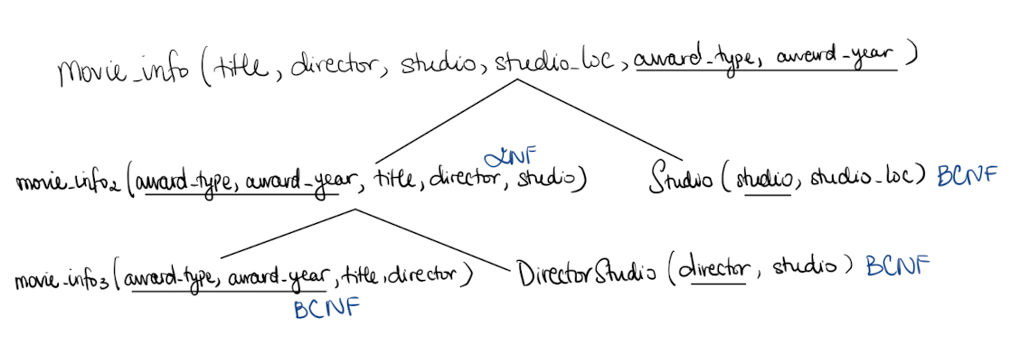

**Part 2**

1. Draw an ERD for the ski resort.

1. Database schema translation for Question 3.

* SkiResort(name, location, total_elevation).
* SkiRun(name, level, total_length).
* SkiLift(name, capacity, chair_type).
* ResortRun(resort_name, run_name).
  + ResortRun.run_name 🡪 SkiRun.name.
  + ResortRun.resort_name 🡪 SkiResort.name.
* ResortLift(resort_name, lift_name).
  + ResortLift.resort_name 🡪 SkiResort.name.
  + ResortLift.lift_name 🡪 SkiLift.name.
* RunLift(run_name, lift_name).
  + Note: Only contains SkiRun-SkiLift pairs that are connected.
  + RunLift.lift_name 🡪 SkiLift.name.
  + RunLift.run_name 🡪 SkiRun.name.

1. Create an ERD for the micromobility vehicles.

1. Database schema translation for Question 5.

* VehicleType(id, form, make, trim_level, weight, max_range, max_speed, model).
* Vehicle(code, circulation_date, initial_cost, purchase_condition).
* VehicleStatus(vehicle_code, time_stamp, circulation_status, reservation_status, fuel_pctg, disabled_status, latitude, longitude, range_left).
  + Note: Only Vehicle that has a VehicleStatus will be on this table.
  + VehicleStatus.vehicle_code 🡪 Vehicle.code.
* Customer(id, first_name, last_name, email, card_type, card_num, card_exp).
* Rental(rental_num, start_lat, start_long, end_lat, end_long, amount_charged).
* PricePlan(code, name, unlock_price, price_per_min, min_after_unlock).
* VehicleAndVehicleType(vehicle_code, vehicle_type_id).
  + VehicleAndVehicleType.vehicle_code 🡪 Vehicle.code.
  + VehicleAndVehicleType.vehicle_type_id 🡪 VehicleType.id.
* PreferedVehicle(c_id, vt_id, date_added).
  + PreferedVehicle.c_id 🡪 Customer.id.
  + PreferedVehicle.vt_id 🡪 VehicleType.id.
* CustomerRental(c_id, rental_num).
  + Note: Only Customer who rents a vehicle will be on this table.
  + CustomerRental.c_id 🡪 Customer.id.
  + CustomerRental.rental_num 🡪 Rental.rental_num.
* RentVehicle(rental_num, v_code).
  + Note: Only rented vehicles will be on this table.
  + RentVehicle.rental_num 🡪 Rental.rent_num.
  + RentVehicle.v_code 🡪 Vehicle.code.
* RentalPrice(rent_num, p_code).
  + Note: Only price plans that have been used by a rental will be on the table.
  + RentalPrice.rent_num 🡪 Rental.rent_num.
  + RentalPrice.p_code 🡪 PricePlan.code.

1. Create an ERD for HW2 Question 1.

1. Database relation translation for Question 7.

* Song(title, track_id, year).
  + Song.track_id 🡪 Track.track_name.
* Artist(name, birth_year).
* Track(track_name, year).
* MusicGroup(name, year_formed).
* Album(title, year, group, record_label).
  + Album.group 🡪 MusicGroup.name.
  + Album.record_label 🡪 RecordLabel.name.
* RecordLabel(name).
* MusicGenre(label, description).
* SongAndArtist(song_title, artist_name).
  + SongAndArtist.song_title 🡪 Song.title.
  + SongAndArtist.artist_name 🡪 Artist.name.
* TrackAndArtist(track_name, artist_name).
  + TrackAndArtist.track_name 🡪 Track.track_name.
  + TrackAndArtist.artist_name 🡪 Artist.name.
* AlbumAndTrack(album_title, track_name, group).
  + AlbumAndTrack.album_title 🡪 Album.title.
  + AlbumAndTrack.track_name 🡪 Track.track_name.
  + AlbumAndTrack.group 🡪 Music.group.
* GroupAndArtist(group_name, artist_name, start_date, end_date).
  + GroupAndArtist.group_name 🡪 MusicGroup.name
  + GroupAndArtist.artist_name 🡪 Artist.name.
* GroupAndGenre(group_name, genre).
  + GroupAndGenre.group_name 🡪 MusicGroup.name.
  + GroupAndGenre.genre 🡪 MusicGenre.label.
* Influence(group_name, influenced_by).
  + Influence.group_name 🡪 MusicGroup.name.
  + Influence.influenced_by 🡪 MusicGroup.name.
* Compared with HW2, the only change I made was to implement the TrackAndArtist schema. I did so as there is a possibility that the artist(s) who perform a given track is not the one(s) who wrote the associated song.