Tony Nguyen

Dr. Shawn Bowers

CPSC 321 01

10 December 2023

Homework 8

1. Question 1

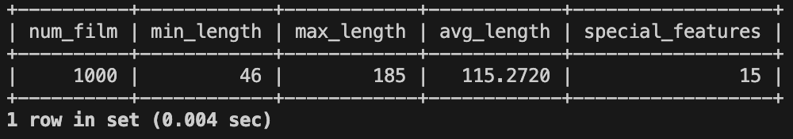

1. Question 2

1. Question 3

1. Question 4

1. Question 5

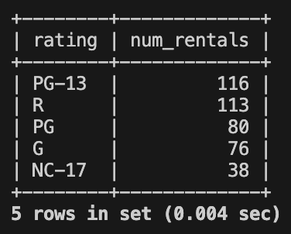

1. Question 6

1. Question 7

1. Question 8

1. Question 9

1. Question 10

1. Question 11

1. Question 12

…

