Tony Nguyen

Dr. Shawn Bowers

CPSC 324

03 March 2024

Homework 3

1. **Question 1**

* A screenshot of a computer

  Description automatically generated
* I don’t think any notes need to be taken here. The GUI is pretty self-explanatory on its own.
* Probably the only question I have so far is what is the difference between dragging ratio into dimensions and metrics.
  + Dimension contains unaggregated data
  + Metrics contain aggregated data

1. **Question 2**

* I think I got the part for my question above. Dimension is the fields, and the number is more like representations for the fields.
* 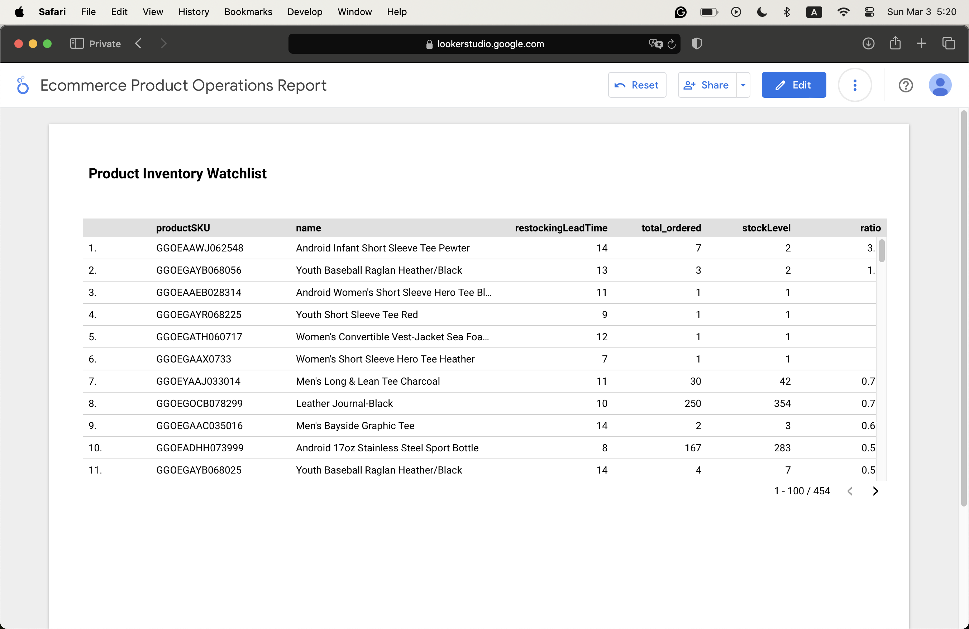

1. **Question 3**

* First, create an explorer.
* Hit “Create New Data”, then choose “Big Query.”
* Click “Custom Query”, then put in the SQL commands
* Hit “Connect”, then “Apply.”
* Make sure you get the data in the metric fields
* Click the Pie chart symbol, then Save
* 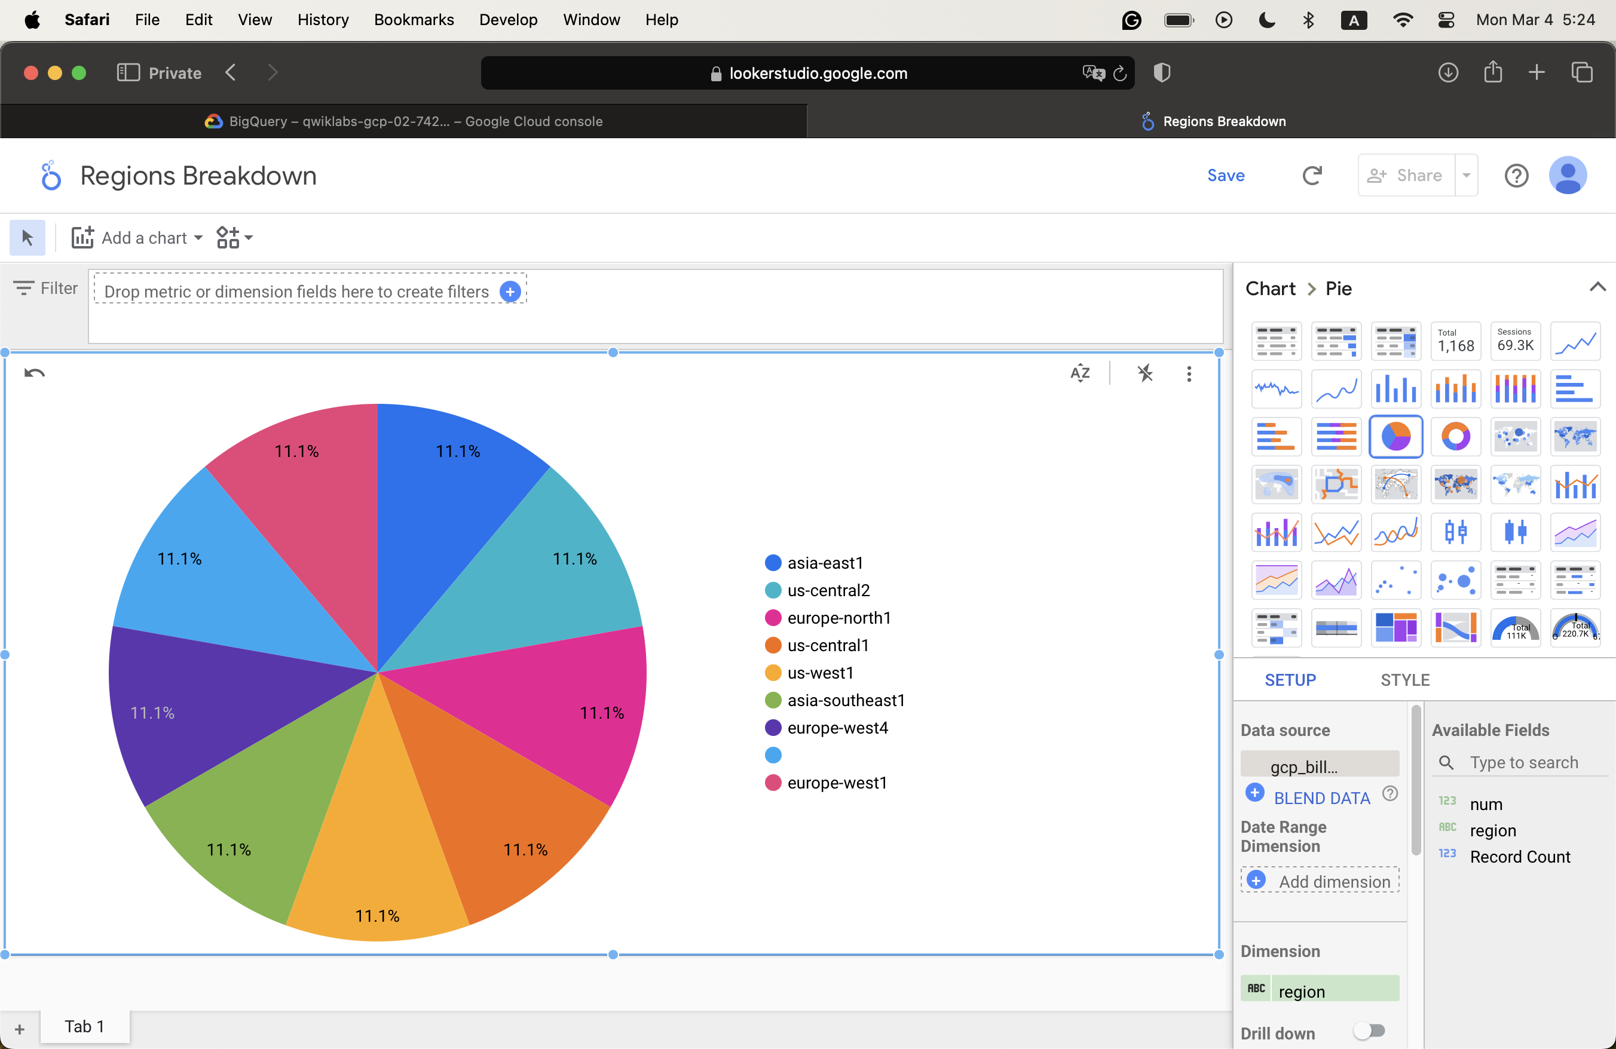

1. **Question 4**

* Write the SQL query as usual.
* Click “More” and select “Query settings.”
  + Choose “Set a destination table for query results
  + Put in the Dataset name (should create before)
  + Put in the Table ID
  + Choose “Write if empty.”
* Click “Schedule” and choose “New scheduled query.”
  + Put in the scheduled query name
  + Put in the scheduled query interval option
  + Set the destination table

c.

* A screenshot of a graph

  Description automatically generated

d.

* I don’t run into any issues. However, there are some notes that I can take
* A dashboard does not need all of the details of the table. It only needs an aggregate view
* With that, to reduce the cost, we first aggregate the logs into another dataset called “Reports” and then create a table of aggregated data
* Periodically, it will reload to fetch new data
* A diagram of a data processing process

  Description automatically generated

1. **Question 5**

* 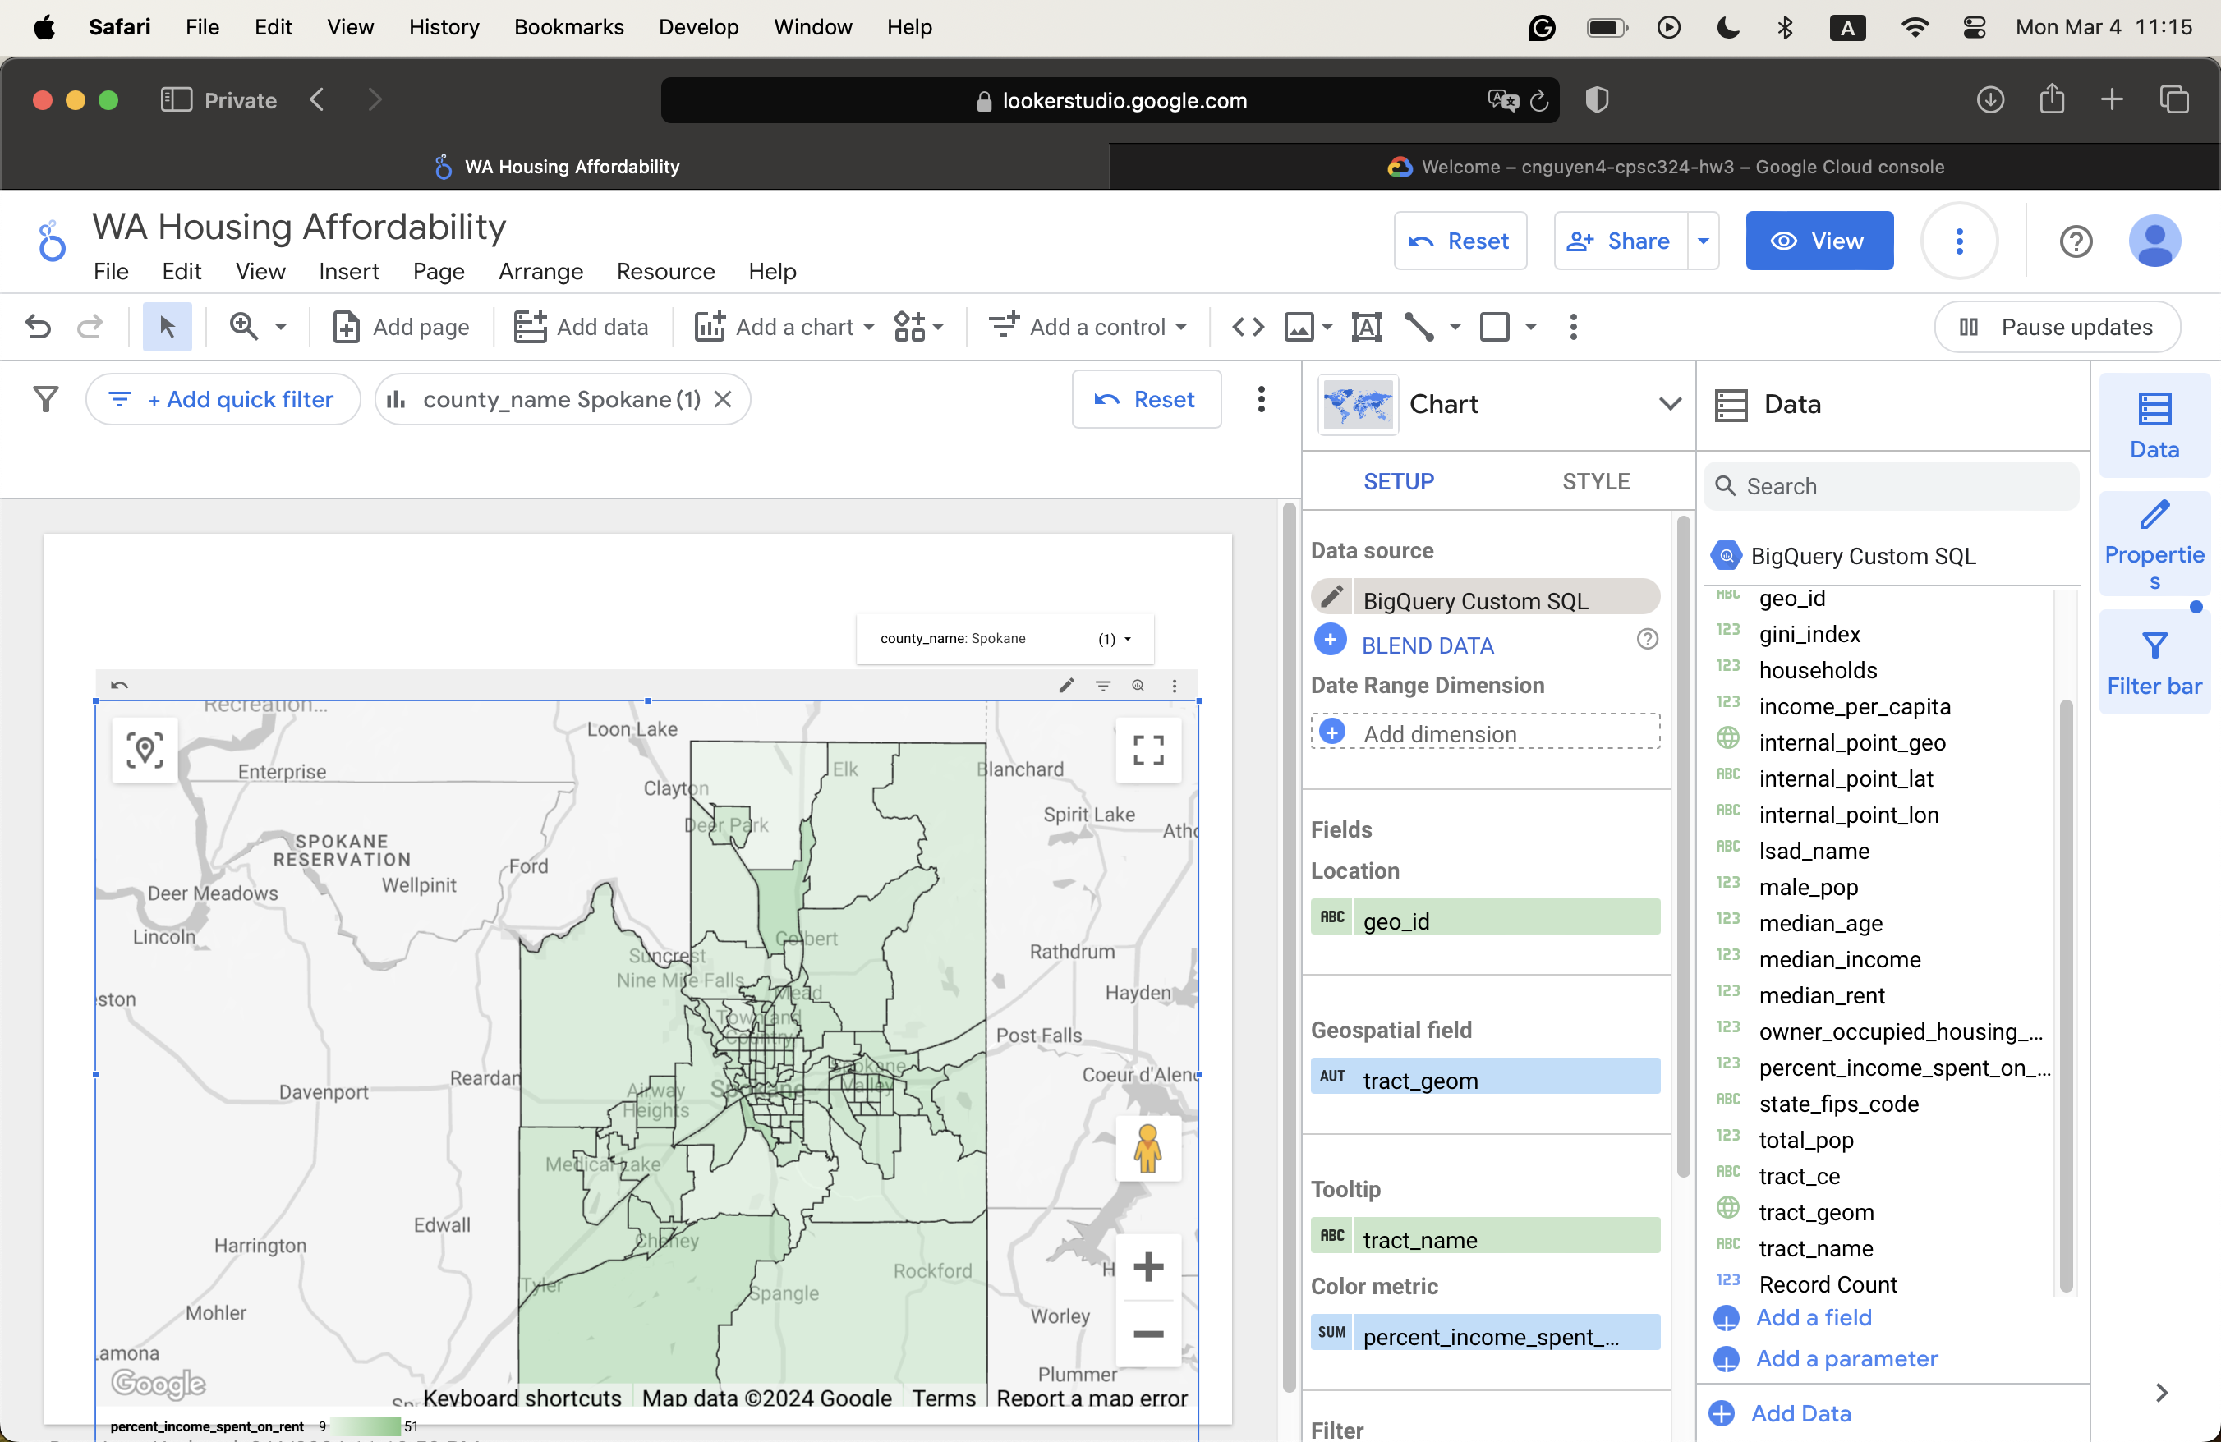

1. **Question 6**

* Looker Studio overview/workflow
  + Create a report
  + Connect to a dataset
  + Transform data for use in visualization
  + Visualize existing data report
  + Share the data
  + Update and refine the report
* Drilling data
  + Use to view more information and context in a single field/chart
  + In their menu option, click the arrow to select the granularity of the data
  + Click “Filter on” to activate
  + Basically, it is a way to “move” from this data subset to another one
* Connectors, Data Sources, and Credentials
  + Connectors: Connect Looker Studio to the underlying data. This creates a Data Source.
    - Can be third-party sources or Google products
  + Data Sources can be reusable if created from the home page. If they are created from the report, you need to edit it in the report.
  + Credentials: Determine who has access to the data

1. **Question 7**

c.

* The “All-in-One” Search Tool by Data Bloo
  + This design looks clean and popping.
  + It has a good user interface, straightforward tabs, and subsections, as well as a good color choice that harmonizes the components.
* The SFO Data Sample Report
  + It has a simple and modern look
  + A creative transparent background that looks unique
  + However, the color tone is a bit too bright, in my opinion

d.

* I would say that it needs to have a clear and simple design
  + Since Looker Studio or any other BI tools allow you to create an informative “dashboard’/summary of your data, it can easily have too many details that make it harder for you to realize what is going on.
  + As the focus of the users should be on the data representation, the navigation and design should be simple so as not to distract them.
* The data should have clear labels to denote what is going on with the design. It should also represent meaningful data, not just random charts.
* Visualization wins over words.

1. **Question 8**

b.

* How have the average salaries changed over the years?
  + Using a time series chart
* What is the difference in salary across different countries?
  + Using a bar chart
* What is the distribution of employment type (in-person, remote, hybrid)?
  + Using a pie chart
* What are the average salaries of different job titles?
  + Using a table visualization

c.

* <https://lookerstudio.google.com/reporting/2ab409f5-f39b-4170-8fdb-f2f62884985a>

d.

* I think my design checks all of the points I mentioned above in Question 7.
* The aesthetic and color choice work well, in my opinion.
* I used clear labels to depict the information, making it easier for users to see the report.
* If I had more time, I would probably add more pages, in addition to a menu design to help navigate around.

1. **Question 9**

b.

* What is the proportion of overall reviews?
  + Using a pie chart
* How many times have different reviewers reviewed the game?
  + Using a table visualization
* How many reviews are there per time period (date, month, year, etc.)?
  + Using a bar chart

c.

* <https://lookerstudio.google.com/reporting/c85ddba7-2d8d-454d-a530-093c970de14a>

1. **Question 10**

d.

* What is the number of UFOs spotted by country?
  + Use a Google Map table
* How many UFOs are spotted per time period?
  + Use a bar chart
* What is the proportion of UFO shapes spotted?
  + Use a pie chart
* What is the average duration of UFOs spotted by cities
  + Use a table visualization

e.

* https://lookerstudio.google.com/reporting/270cd9e2-c643-4d8f-9b4d-52a012baff7e.