Run two 5000-replicates simulation studies. In each simulation replicate, generate a SMART data with 2-2-2 design (two stage-1 treatment options, binary intermediate outcome, and two stage-2 treatment options). The total sample size use n=200. The intermediate response rate P(R=1|A1)=1/3. The sequence-specific variances are constantly equal to 10, and the strategy values will be as follows

Every column in Table 1 provides the strategy values in each value pattern. Table 2 gives the probability of rejecting the null hypothesis of global test under each value pattern. The number in the first column of Table 2 stands for type I error, and the other numbers are the statistical power of this test.

Table 1: Strategy values of simulation

|  |  |  |  |  |  |  |  |
| --- | --- | --- | --- | --- | --- | --- | --- |
| Strategy | Scenario 0 | Scenario 1 | Scenario 2 | Scenario 3 | Scenario 4 | Scenario 5 | Scenario 6 |
| (0;0,0) | 0 | 0.00 | 0.00 | 0.00 | 0.00 | 0.00 | 0.00 |
| (0;0,1) | 0 | 0.00 | 0.87 | 0.93 | 0.00 | 1.23 | 1.32 |
| (0;1,0) | 0 | 0.00 | 1.75 | 2.49 | 0.00 | 2.47 | 3.52 |
| (0;1,1) | 0 | 0.00 | 2.62 | 3.42 | 0.00 | 3.70 | 4.84 |
| (1;0,0) | 0 | 4.48 | 3.63 | -1.25 | 6.33 | 5.13 | -1.76 |
| (1;0,1) | 0 | 4.48 | 4.50 | 0.31 | 6.33 | 6.36 | 0.44 |
| (1;1,0) | 0 | 4.48 | 5.38 | 2.48 | 6.33 | 7.06 | 3.52 |
| (1;1,1) | 0 | 4.48 | 6.25 | 4.03 | 6.33 | 8.83 | 5.72 |

Table 2: probability of rejecting the null hypothesis of the global test

|  |  |  |  |  |  |  |  |
| --- | --- | --- | --- | --- | --- | --- | --- |
| Design | Scenario 0 | Scenario 1 | Scenario 2 | Scenario 3 | Scenario 4 | Scenario 5 | Scenario 6 |
| Design 1 | 0.0478 | 0.662 | 0.6674 | 0.6602 | 0.9444 | 0.947 | 0.9474 |

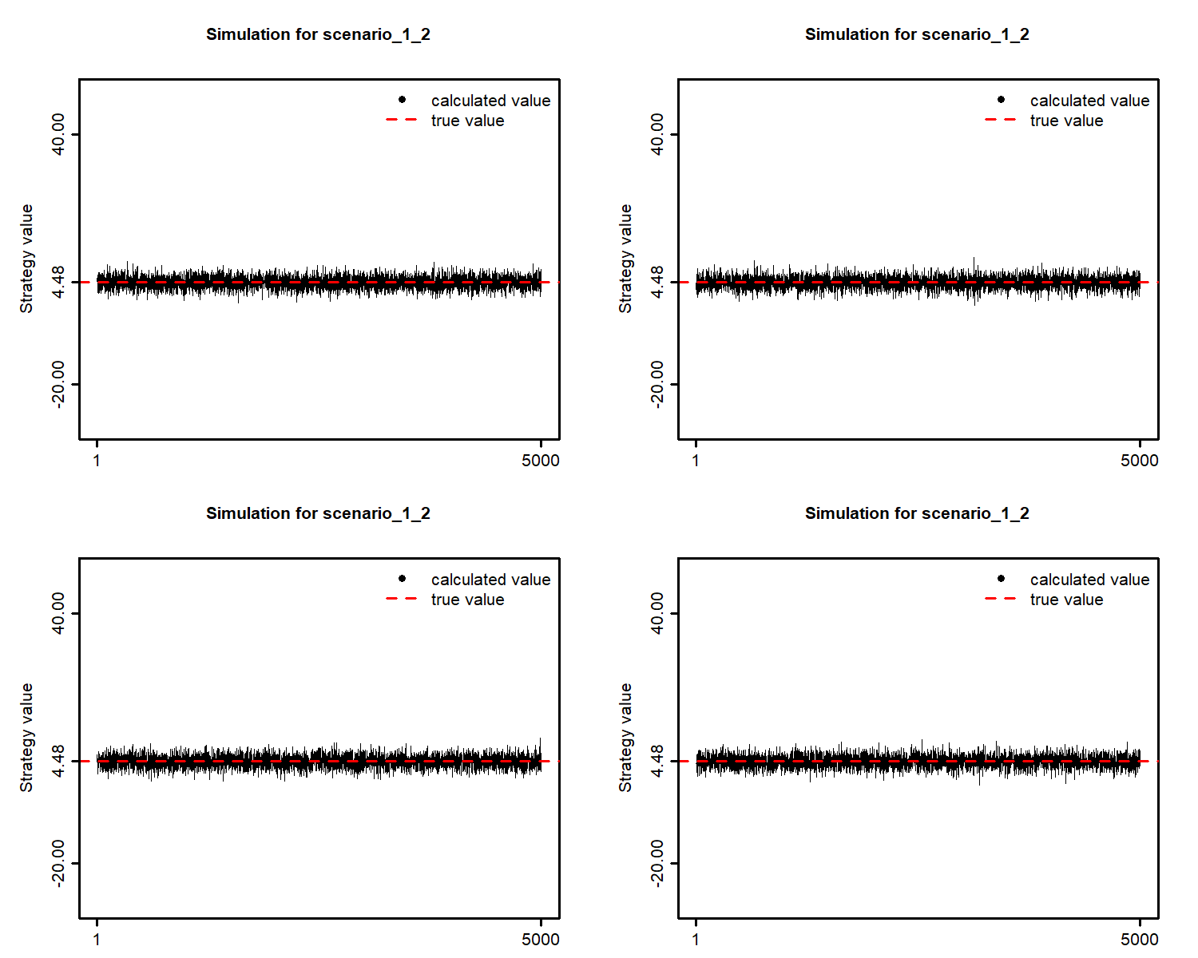

Run two 5000-replicates simulation studies. In each simulation replicate, generate a SMART data with a design as shown below (two stage-1 treatment options; two stage-2 treatment options for non-responder and only one option for responder). The total sample size use n=200. The intermediate response rate P(R=1|A1)=1/3. The sequence-specific variances are constantly equal to 10, and the sequence-specific means are set to be

Every column in Table 3 provides the strategy values in each value pattern. Table 24gives the probability of rejecting the null hypothesis of global test under each value pattern. The number in the first column of Table 4 stands for type I error, and the other numbers are the statistical power of this test.

Table 3: Sequence-specific means of simulation

|  |  |  |  |  |  |  |  |
| --- | --- | --- | --- | --- | --- | --- | --- |
| Strategy value | Scenario 0 | Scenario 1 | Scenario 2 | Scenario 3 | Scenario 4 | Scenario 5 | Scenario 6 |
| (0;0,0) | 0 | 0.00 | 0.00 | 0.00 | 0.00 | 0.00 | 0.00 |
| (0;1,1) | 0 | 0.00 | 1.92 | 3.21 | 0.00 | 2.75 | 4.58 |
| (1;1,0) | 0 | 4.48 | 4.00 | 0.40 | 6.33 | 5.90 | 0.57 |
| (1,0,0) | 0 | 4.48 | 5.92 | 4.42 | 6.33 | 8.65 | 6.30 |

Table 4: probability of rejecting the null hypothesis of the global test

|  |  |  |  |  |  |  |  |
| --- | --- | --- | --- | --- | --- | --- | --- |
| Design | Scenario 0 | Scenario 1 | Scenario 2 | Scenario 3 | Scenario 4 | Scenario 5 | Scenario 6 |
| 2 | 0.0502 | 0.7550 | 0.7526 | 0.7698 | 0.9734 | 0.9762 | 0.9758 |

Run two 5000-replicates simulation studies. In each simulation replicate, generate a SMART data with 2-2-2 design (two stage-1 treatment options, binary intermediate outcome, and two stage-2 treatment options). The total sample size use n=200. The intermediate response rate P(R=1|A1)=1/3. The sequence-specific variances are constantly equal to 10, and the strategy values will be as follows

Every column in Table 5 provides the strategy values in each value pattern. Table 6 gives the probability of rejecting the null hypothesis of global test under each value pattern. The number in the first column of Table 6 stands for type I error, and the other numbers are the statistical power of this test.

Table 5: Strategy values of simulation (randomize play-the-winner)

|  |  |  |  |  |  |  |  |
| --- | --- | --- | --- | --- | --- | --- | --- |
| Strategy | Scenario 0 | Scenario 1 | Scenario 2 | Scenario 3 | Scenario 4 | Scenario 5 | Scenario 6 |
| (0;0,0) | 0 | 0.00 | 0.00 | 0.00 | 0.00 | 0.00 | 0.00 |
| (0;0,1) | 0 | 0.00 | 0.87 | 0.93 | 0.00 | 1.23 | 1.32 |
| (0;1,0) | 0 | 0.00 | 1.75 | 2.49 | 0.00 | 2.47 | 3.52 |
| (0;1,1) | 0 | 0.00 | 2.62 | 3.42 | 0.00 | 3.70 | 4.84 |
| (1;0,0) | 0 | 4.48 | 3.63 | -1.25 | 6.33 | 5.13 | -1.76 |
| (1;0,1) | 0 | 4.48 | 4.50 | 0.31 | 6.33 | 6.36 | 0.44 |
| (1;1,0) | 0 | 4.48 | 5.38 | 2.48 | 6.33 | 7.06 | 3.52 |
| (1;1,1) | 0 | 4.48 | 6.25 | 4.03 | 6.33 | 8.83 | 5.72 |

Table 6: probability of rejecting the null hypothesis of the global test (randomize play-the-winner)

|  |  |  |  |  |  |  |  |
| --- | --- | --- | --- | --- | --- | --- | --- |
| Design | Scenario 0 | Scenario 1 | Scenario 2 | Scenario 3 | Scenario 4 | Scenario 5 | Scenario 6 |
| Design 1 | 0.0522 | 0.668 | 0.5746 | 0.6158 | 0.9462 | 0.883 | 0.9236 |

Run two 5000-replicates simulation studies. In each simulation replicate, generate a SMART data with 2-2-2 design (two stage-1 treatment options, binary intermediate outcome, and two stage-2 treatment options). The total sample size use n=200. The intermediate response rate P(R=1|A1)=1/3. The sequence-specific variances are constantly equal to 10, and the strategy values will be as follows

Every column in Table 7 provides the strategy values in each value pattern. Table 8 gives the probability of rejecting the null hypothesis of global test under each value pattern. The number in the first column of Table 8 stands for type I error, and the other numbers are the statistical power of this test.

Table 7: Strategy values of simulation (unblanced randomization)

|  |  |  |  |  |  |  |  |
| --- | --- | --- | --- | --- | --- | --- | --- |
| Strategy | Scenario 0 | Scenario 1 | Scenario 2 | Scenario 3 | Scenario 4 | Scenario 5 | Scenario 6 |
| (0;0,0) | 0 | 0.00 | 0.00 | 0.00 | 0.00 | 0.00 | 0.00 |
| (0;0,1) | 0 | 0.00 | 0.87 | 0.93 | 0.00 | 1.23 | 1.32 |
| (0;1,0) | 0 | 0.00 | 1.75 | 2.49 | 0.00 | 2.47 | 3.52 |
| (0;1,1) | 0 | 0.00 | 2.62 | 3.42 | 0.00 | 3.70 | 4.84 |
| (1;0,0) | 0 | 4.48 | 3.63 | -1.25 | 6.33 | 5.13 | -1.76 |
| (1;0,1) | 0 | 4.48 | 4.50 | 0.31 | 6.33 | 6.36 | 0.44 |
| (1;1,0) | 0 | 4.48 | 5.38 | 2.48 | 6.33 | 7.06 | 3.52 |
| (1;1,1) | 0 | 4.48 | 6.25 | 4.03 | 6.33 | 8.83 | 5.72 |

Table 8: probability of rejecting the null hypothesis of the global test (unbalanced randomization)

|  |  |  |  |  |  |  |  |
| --- | --- | --- | --- | --- | --- | --- | --- |
| Design | Scenario 0 | Scenario 1 | Scenario 2 | Scenario 3 | Scenario 4 | Scenario 5 | Scenario 6 |
| Design 1 | 0.042 | 0.5852 | 0.569 | 0.6498 | 0.9042 | 0.8918 | 0.943 |

Run two 5000-replicates simulation studies. In each simulation replicate, generate a SMART data with a design as shown below (two stage-1 treatment options; two stage-2 treatment options for non-responder and only one option for responder). The total sample size use n=200. The intermediate response rate P(R=1|A1)=1/3. The sequence-specific variances are constantly equal to 10, and the sequence-specific means are set to be

Every column in Table 9 provides the strategy values in each value pattern. Table 10 gives the probability of rejecting the null hypothesis of global test under each value pattern. The number in the first column of Table 10 stands for type I error, and the other numbers are the statistical power of this test.

Table 9: Sequence-specific means of simulation

|  |  |  |  |  |  |  |  |
| --- | --- | --- | --- | --- | --- | --- | --- |
| Strategy value | Scenario 0 | Scenario 1 | Scenario 2 | Scenario 3 | Scenario 4 | Scenario 5 | Scenario 6 |
| (0;0,0) | 0 | 0.00 | 0.00 | 0.00 | 0.00 | 0.00 | 0.00 |
| (0;1,0) | 0 | 0.00 | 1.92 | 3.21 | 0.00 | 2.75 | 4.58 |
| (1;1,0) | 0 | 4.48 | 4.00 | 0.40 | 6.33 | 5.90 | 0.57 |
| (1,0,0) | 0 | 4.48 | 5.92 | 4.42 | 6.33 | 8.65 | 6.30 |

Table 10: probability of rejecting the null hypothesis of the global test (randomized play-the-winner)

|  |  |  |  |  |  |  |  |
| --- | --- | --- | --- | --- | --- | --- | --- |
| Design | Scenario 0 | Scenario 1 | Scenario 2 | Scenario 3 | Scenario 4 | Scenario 5 | Scenario 6 |
| 2 | 0.047 | 0.7576 | 0.5908 | 0.6676 | 0.9748 | 0.8972 | 0.9432 |

Run two 5000-replicates simulation studies. In each simulation replicate, generate a SMART data with a design as shown below (two stage-1 treatment options; two stage-2 treatment options for non-responder and only one option for responder). The total sample size use n=200. The intermediate response rate P(R=1|A1)=1/3. The sequence-specific variances are constantly equal to 10, and the sequence-specific means are set to be

Every column in Table 11 provides the strategy values in each value pattern. Table 12 gives the probability of rejecting the null hypothesis of global test under each value pattern. The number in the first column of Table 12 stands for type I error, and the other numbers are the statistical power of this test.

Table 11: Sequence-specific means of simulation

|  |  |  |  |  |  |  |  |
| --- | --- | --- | --- | --- | --- | --- | --- |
| Strategy value | Scenario 0 | Scenario 1 | Scenario 2 | Scenario 3 | Scenario 4 | Scenario 5 | Scenario 6 |
| (0;0,0) | 0 | 0.00 | 0.00 | 0.00 | 0.00 | 0.00 | 0.00 |
| (0;1,0) | 0 | 0.00 | 1.92 | 3.21 | 0.00 | 2.75 | 4.58 |
| (1;1,0) | 0 | 4.48 | 4.00 | 0.40 | 6.33 | 5.90 | 0.57 |
| (1,0,0) | 0 | 4.48 | 5.92 | 4.42 | 6.33 | 8.65 | 6.30 |

Table 12: probability of rejecting the null hypothesis of the global test (unbalanced randomization)

|  |  |  |  |  |  |  |  |
| --- | --- | --- | --- | --- | --- | --- | --- |
| Design | Scenario 0 | Scenario 1 | Scenario 2 | Scenario 3 | Scenario 4 | Scenario 5 | Scenario 6 |
| 2 | 0.0486 | 0.6704 | 0.6804 | 0.7286 | 0.9412 | 0.9532 | 0.9644 |

