  - Orbital4Kids
About the program
Orbital4Kids is a 3D model of atoms and molecules in which the first 18 atoms, from H to Ar, are developed and prepared for use in teaching and learning students from elementary to secondary school. The program has been developed to be easy to teach in the classroom, developed from the Java language program using 3D visualization techniques such as ray tracing.

Future Program Development Guidelines
1. Since only the first 18 elements can be created in this program, it may be possible to develop further by adding the types of elements from the periodic table. to display more than before.
- The presentation format program can be developed to be easier and more colorful to make it easier to use and attract more people interested in studying.
- Add audio formats to presentations

Procedure for installing the program
- This is done by copying the file "Orbital4Kids2004.exe" or "Orbital4Kids2004.jar" onto drive C or D to the desired directory, such as C:\Program Files\Orbital4Kids.
- To create a Short-Cut on Desktop, go to the file "Orbital4Kids2004" and right-click Select Create Shortcut and copy the icon to the Windows desktop.
- If you do not have a Java 2 Runtime Environment installed, install the program first by clicking the "j2sdk-1_4_2_06-windows-i586-p.exe" icon to install it.
- After the process, you can run the program by double-clicking on the icon of the Short-Cut created.

Using Orbital4Kids

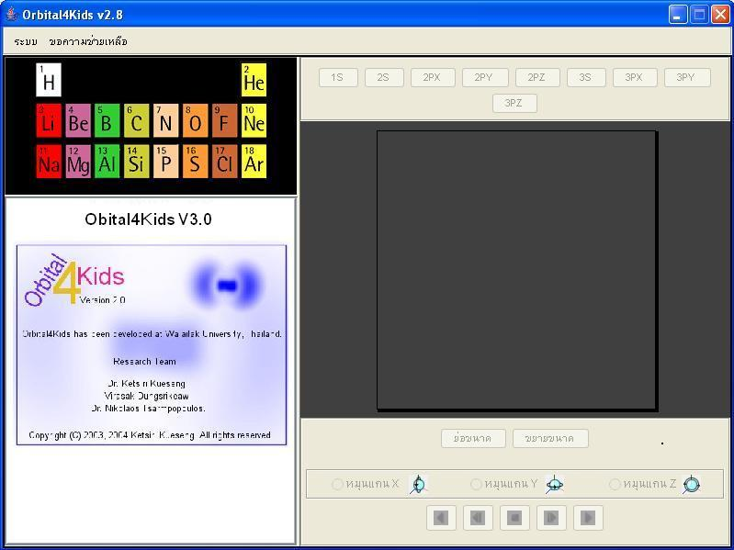
The figure shows the main menu of the Orbital4Kids program.
When the program is opened, it will display a window, as shown in the figure showing the main menu of the Orbital4Kids program. As follows:
- Part 1 Bar Menu
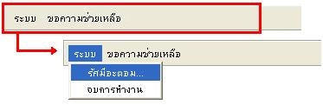
It is a menu to control and assist in using the program, consisting of the following menus:
- The "System" menu consists of the following submenus:
- “Atomic radius” It serves to display the atomic radius trend table. Boiling point(BP) and melting point.(MP) In the periodic table
- “Finish the work” This is the menu used to close the program.
- "Get help" menu

The duties of providing assistance to the users of the program include:
- “Application” Shows the process of using the program. Orbital4Kids
- "About the program" displays information about the Orbital4Kids program.

- Part 2: Periodic Table Display Window is used to display the first 18 elements in the periodic table that are displayed in the program.
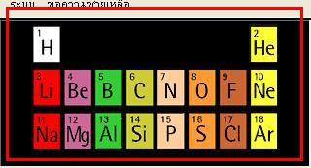

It is used to select the elements that are needed to be displayed in 3D, consisting of the first 18 elements in the periodic table: H, He, Li, Be, B, C, N, O, F, Ne, Na, Mg, Al, Si, P, S, Cl , Ar Sort by number in the periodic table
Which 3D image This will appear in the 3D rendering section. Next

- Part 3: The window displays the information of the elements at that time.
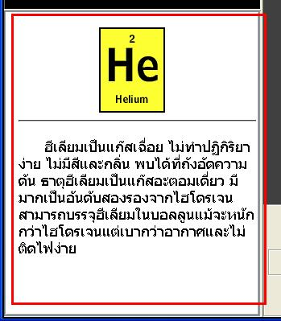

In the window, the details of the selected element will be displayed., Symbols, information and properties of the element

- Part 4 is used to look at the different orbitals of each element.
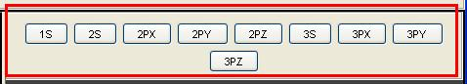

Includes a button to browse orbital You can choose to see the combination of each orbital According to the arrangement of electrons in each element.

- Part 5: 3D Display Window
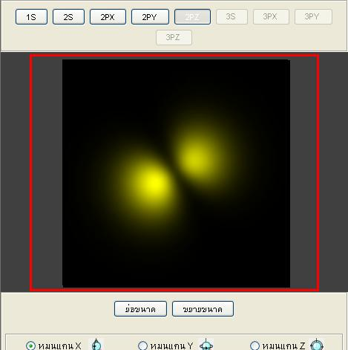

In this section, you can control the display of the image with the mouse . By pressing and sliding the mouse. in different directions, or right-click the mouse to zoom in or out.

- Part 6 Control Window is the part used to control the 3D display view with the buttons as shown in the figure.

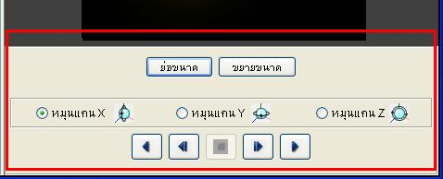

The view control can be controlled by means of the following controls:
- Used to minimize the size of the display. orbital Visible at a greater distance.
- It is used to magnify the size of the orbital display to be seen at close range.

It is a button used to control the direction of rotation of the orbital in various axes, interspersed with the X, Y and Z axes. As will be discussed next.
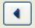
- It is used to control it. orbital Rotate to the left continuously.

- It is used to control it. orbital Rotate to the left in steps.
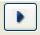
- It is used to control it. orbital Continuous rotation to the right

- It is used to control it. orbital Rotate to the right in steps.
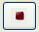
- It is used to control it. orbital Stop Spinning

How to use the program
- When running the Orbital4Kids program, the program's window will appear.
- The user can select the types of elements that appear in the periodic table section of this program.
- When the user selects the desired element. The information about the element will appear in the window at the bottom, which will show details about the element.
- Perform the orbital selection to be displayed in the upper right pane of the program, with buttons to choose from 1S, 2S, 2PX, 2PY, 2PZ, 3S, 3PX, 3PY, and 3PZ according to the arrangement of electrons in each element.
- The 3D display screen will display an image that can be selected to control the 3D view using the mouse or by using the control buttons.

