Project Submission Form

Mission 0 @ Mission Ready HQ.

# Project Information

* Project Title: Nexrail Marketing
* GitHub Repo URL: <https://github.com/tonkatommy/MRHQ-L5-Mission-0.git>
* Project Overview: Tasked to build a one-page website with responsive design.
* Technologies Used: React, MaterialUI

# Screenshots

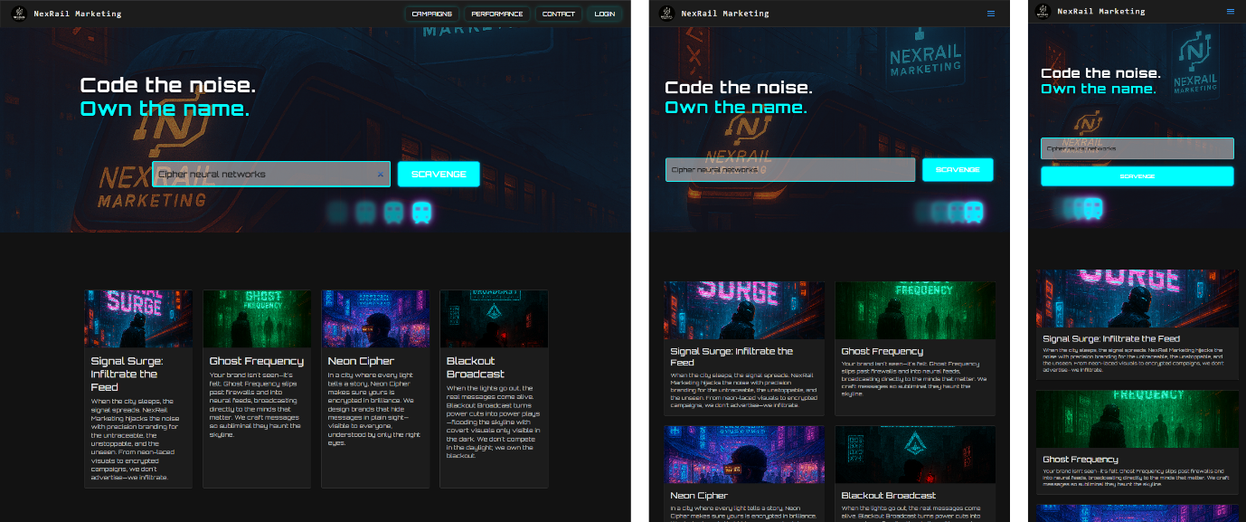

The website actively responding to adjusting the screen size.

# Submission Confirmation

* I confirm that this submission is my original work, and I have included all required materials.
* Thank you for the opportunity to participate.